Reward influences simultaneous competition for feature-based attention: Insights from Steady-State Visually Evoked Potentials

Ivan Grahek1☨*, Antonio Schettino1,2☨, Gilles Pourtois1, Ernst H.W. Koster1,

& Søren K. Andersen3

1. *Department of Experimental Clinical and Health Psychology, Ghent University, Henri Dunantlaan 2, B-9000, Ghent, Belgium*
2. *Institute for Globally Distributed Open Research and Education (IGDORE)*
3. *School of Psychology, University of Aberdeen, William Guild Building, Aberdeen, AB24 3FX, United Kingdom*

# Abstract

Keywords: attention; attentional control; EEG; feature-based attention; reward; motivation; steady-state visually evoked potentials; frequency tagging

**To do list**

* Insert the new results
* Decide on baseline – rew – non rew vs. baseline – training – test

# Introduction

Selective attention is crucial for adaptive behavior as it facilitates the processing of relevant stimuli in our environment, and the suppression of irrelevant stimuli (Chun, Golomb, & Turk-Browne, 2011; Desimone & Duncan, 1995). This process depends on the physical salience of a stimulus (e.g., a loud noise) and on our current goals (e.g., searching for our keys; Corbetta & Shulman, 2002; Posner, 1980; Theeuwes, 2010). Motivation is another crucial factor which determines how stimuli. Goal-driven attentional control is enhanced when individuals are motivated with extrinsic rewards (Botvinick & Braver, 2015; Pessoa, 2015). Attention can also be guided by previous reward history: stimuli which used to be associated with rewards can capture attention independently from top-down attentional control (Anderson, 2016; Awh, Belopolsky, & Theeuwes, 2012; Chelazzi, Perlato, Santandrea, & Della Libera, 2013; Failing & Theeuwes, 2017).

Goal-directed attention, as well as other cognitive control processes, are enhanced when individuals are anticipating that they can earn rewards for good task-performance (for a review see: Krebs & Woldorff, 2017). A number of fMRI and EEG studies have demonstrated that these reward-based enhancements in preparation for the upcoming stimulus are driven by enhanced activity in the frontoparietal regions crucial for attentional control (Krebs, Boehler, Roberts, Song, & Woldorff, 2012; Pessoa & Engelmann, 2010; Schevernels, Krebs, Santens, Woldorff, & Boehler, 2014), and by enhanced task-set representations in these areas (Etzel, Cole, Zacks, Kay, & Braver, 2016; Wisniewski, Reverberi, Momennejad, Kahnt, & Haynes, 2015). While these studies implicate the frontoparietal activity in reward-based improvements in attentional control, it remains unclear how the activity in these regions is translated into the enhanced processing of the relevant stimuli in the visual cortex.

Another set of studies has focused on the processing of stimuli previously related to rewards, often in situations in which the reward history is opposed to current goals (Anderson, 2016; Chelazzi et al., 2013; Failing & Theeuwes, 2017). Behavioral studies have found evidence for the involuntary attentional capture by the stimuli which have previously been linked to rewards, which can result in impaired task performance when such stimuli act as distractors (Anderson, Laurent, & Yantis, 2011; Boehler, Hopf, Stoppel, & Krebs, 2012; Failing & Theeuwes, 2014). Studies focused on the neural mechanism of these effects have provided some evidence for the reward-related changes in the early stages of visual cortical processing (i.e., increase in the P1 component; Donohue et al., 2016; Hickey, Chelazzi, & Theeuwes, 2010; Luque et al., 2017; MacLean & Giesbrecht, 2015). However, other studies have failed to find evidence for such early modulations, and found changes in later stages of processing (increased N2pc component and improved decoding in later processing stages; Qi, Zeng, Ding, & Li, 2013; Tankelevitch, Spaak, Rushworth, & Stokes, 2019). Importantly, these studies have been able to assess the processing of only one feature at a time, for example the processing of a visual search display when it contains a high reward distractors. Thus it remains unclear how stimuli of different values simultaneously compete for attentional resources and at which level of visual processing the reward-history effects exert their effect.

Theoretical frameworks propose that the allocation of attention toward stimuli which are (or used to be) predictive of rewards is facilitated, while the processing of other stimuli is suppressed (Anderson, 2016; Awh et al., 2012; Chelazzi et al., 2013; Failing & Theeuwes, 2017). Further, Roelfsema and colleagues proposed that this effect relies on the plasticity of the visual cortex induced by the join effect of top-down attentional control and dopamine (Roelfsema, van Ooyen, & Watanabe, 2010). However, studies which have focused on neural processing of the stimuli related to rewards have mostly focused on them being either targets or distractors. Only one study to date has provided evidence for the enhanced representation of reward-related stimuli and suppression of the other stimuli. In an fMRI Hickey and Peelen (Hickey & Peelen, 2015) demonstrated that representations of objects paired with rewards were easier to decode from the object-selective visual cortex, while the representation of other objects were harder to decode.

In this study we sought to directly test the mechanism through which rewards influence goal-directed attention at the level of processing of both targets and distractors in the task. Participants performed a random-dot kinematogram (RDK) task in which on each trial they had a goal to attend to either blue or red dots and detect their coherent movements. We investigated how the two stimulus features linked to different reward schedules simultaneously competed for attentional control in baseline, when individuals were able to earn extra monetary rewards (training phase), and when such rewards were no longer available (test phase). We recorded steady-state visual evoked potentials (SSVEPs) to track stimulus processing in the visual cortex. SSVEPs represent the oscillatory response of the visual cortex to flickering stimuli (Norcia, Appelbaum, Ales, Cottereau, & Rossion, 2015). They provide a continuous measure of feature-based attention deployed across multiple stimuli simultaneously, and are a reliably modulated by goal-directed attention in the paradigm which we used (Andersen & Müller, 2010). Crucially, different stimuli can be tagged with different frequencies allowing for the simultaneous measurement of the amount of attention allocated to each of the stimuli.

This design enabled us to investigate two main questions. First, on each trial participants had a goal to attend to either blue or red dots. This meant that in the training and test phase the feature linked to high rewards was the target on some trials and a distractor on others. This allowed us to investigate how stimuli of different values simultaneously compete for goal-directed attention. Second, in the test phase individuals were no longer able to earn rewards. This allowed us to test how previous, but no longer relevant, stimulus values interact with goal-directed attention. In both cases there are several mechanisms through which reward-based effects can emerge based on the existing theoretical models (Chelazzi et al., 2013; Failing & Theeuwes, 2017; Roelfsema et al., 2010). They can result from the improved processing of the targets (facilitation), reduced processing of the distractors (suppression), or both. Crucially, the incentive-based enhancement of goal-directed attention can be the product of facilitated processing of the high value stimuli and/or the suppression of the processing of the low value stimuli.

# Methods

## Participants

We tested 48 participants with normal or corrected-to-normal vision and no history of psychiatric or neurological disorders. Four participants were excluded due to technical problems during recording. Four additional participants were discarded due to excessive artifacts in the EEG signal (i.e., the percentage of rejected epochs in one or more conditions exceeded 35%). Thus, the final data set consisted of 40 participants (27 females, 13 males; median age = 22). Participants received a fixed payoff of 20 €, plus up to 6 € extra as performance-contingent monetary rewards (on average 25.5 €). The study was approved by the ethics committee of Ghent University.

## Stimuli and task

We used the Random Dot Kinematogram (RDK) task (S K Andersen & Müller, 2010), in which participants were presented with two overlapping circular RDKs of isoluminant colors (red and blue) on a grey background. Viewing distance was fixed with a chinrest at 55 cm from the 21-inch CRT screen (resolution of 1024 x 768 pixels, 120 Hz refresh rate). At the beginning of each trial, participants were instructed which of the two RDKs to attend by a verbal audio cue: “red” (241 ms) or “blue” (266 ms). The two RDKs had a diameter corresponding to 20.61 degrees of visual angle and consisted of 125 randomly and independently moving dots each (0.52 degrees of visual angle per dot). The two RDKs flickered at a different frequencies (10 or 12 Hz). One-third of trials contained one, two, or three coherent motion intervals, occurring with equal probability in the attended (targets) or unattended (distractors) color RDK. During these intervals, dots in one of the RDKs moved with 75% coherence in one of four cardinal directions (up, down, left, or right) for 300 ms. Participants had to detect the coherent movement as fast as possible by pressing the space key on a standard AZERTY USB keyboard. Response time was limited to 1,500 ms post-RDK onset and no response was recorded before 200 ms. Correct responses were followed by a tone (200 ms sine wave of either 800 or 1,200 Hz, counterbalanced across participants). Responses that were too late or incorrect were followed by a 200 ms square wave tone of 400 Hz.

The experiment started with 4 practice blocks of 60 trials. After each block, participants received feedback on their performance. After finishing the practice phase, participants completed 12 blocks of 50 trials divided into 3 phases (*baseline*, *training*, and *test*). Each phase contained 100 trials on which participants were instructed to attend to the red color and 100 trials in which they were instructed to attend to the blue color. Out of those 100 trials, 40 trials contained no dot motion, and 60 trials contained one, two, or three dot motions (120 motions in total). During baseline, participants were simply doing the described task. In the training phase, the task was identical but participants could earn additional monetary rewards (up to 6 €) based on their performance. They were instructed that one of the colors would be paired with high probability (80%) and the other color with low probability (20%) of earning 10 extra cents for each correct detection. The mapping between color and reward probability was counterbalanced across participants. The receipt of the reward was signaled by a new tone that replaced the usual correct tone. If the correct tone was a sine wave of 800 Hz, the reward tone was a sine wave of 1,200 Hz and vice versa. At the end of each of the 4 blocks of the training phase, participants got feedback on both their performance and the amount of extra money earned within the block. The third phase, test, was identical to baseline (i.e., no monetary rewards assigned). The whole task lasted for approximately 50 minutes, plus a few minutes of break in between blocks. After completing the task, participants filled in two questionnaires aimed at assessing their reward sensitivity (BIS-BAS; Franken et al., 2005) and depression levels (BDI-II; Van der Does, 2002).

This experiment was realized using Cogent 2000 developed by the Cogent 2000 team at the FIL and the ICN and Cogent Graphics developed by John Romaya at the LON at the Wellcome Department of Imaging Neuroscience.

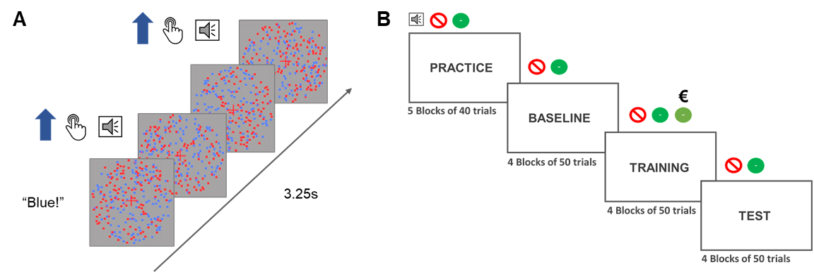

**Figure 1. Depiction of a signle trial and the phases of the experiment. A)** Each trial started with an audio cue (”Blue” or ”Red”) which instructed participants which color to attend to in that trial. The trial lasted for 3.25 seconds during which dots of either of the colors could move from 0 to 3 times. If the participants were instructed to attend to the blue dots and the blue dots moved coherently participants should have pressed the response button. In that case they would hear the auditory feedback signaling the correct detection of the movements. **B)** The experiment started with a practice and a baseline block in which the participants heard an audio cue at the begginning of the trial and two types of feedback sounds (incorrect or correct). In the training block a third sound was introduced to signal that the participants were both correct and received a reward for that response. They would still at times hear the the old correct feedback which would signal that they were correct, but not rewarded. The test phase was the same as the baseline phase.

## EEG recording and data pre-processing

Electroencephalographic activity (EEG) was recorded with an ActiveTwo amplifier (BioSemi, Inc., The Netherlands) at a sampling rate of 512 Hz. Sixty-four Ag/AgCl electrodes were fitted into an elastic cap, following the international 10/10 system (Chatrian, Lettich, & Nelson, 1985). The common mode sense (CMS) active electrode and the driven right leg (DRL) passive electrode were used as reference and ground electrodes, respectively. Additional external electrodes were applied to the left and right mastoids, as well as on the outer canthi of each eye and in the inferior and superior areas of the left orbit (to record horizontal and vertical electrooculogram, EOG).

Data pre-processing was performed offline with custom MATLAB scripts and functions included in EEGLAB v14.1.1b (Delorme & Makeig, 2004). After subtracting the mean value of the signal (DC offset), the continuous EEG data were epoched between 0 and 3,250 ms, corresponding to the beginning and end of the RDK trial, respectively. After referencing to *Cz*, FASTER v1.2.3b (Nolan, Whelan, & Reilly, 2010) was used for artifact identification and rejection using the following settings: (i) over the whole normalized EEG signal, channels with variance, mean correlation, and Hurst exponent exceeding *z* = ±3 were interpolated via a spherical spline procedure (Perrin, Pernier, Bertrand, & Echallier, 1989); (ii) the mean across channels was computed for each epoch and, if amplitude range, variance, and channel deviation exceeded *z* = ±3, the whole epoch was removed; (iii) within each epoch, channels with variance, median gradient, amplitude range, and channel deviation exceeding *z* = ±3 were interpolated; (iv) grand-averages with amplitude range, variance, channel deviation, and maximum EOG value exceeding *z* = ±3 were removed; (v) epochs containing more than 12 interpolated channels were discarded. All remaining epochs were scanned with SCADS (Junghöfer, Elbert, Tucker, & Rockstroh, 2000) and rejected when flagged as containing residual artifacts. For details, see our commented code at https://osf.io/5hryf/. After pre-processing, the average number of interpolated channels was 4.08 (*SD* = 1.75, range 0 – 7) and the mean percentage of rejected epochs was 9.74% (*SD* = 6.77, range 0 – 32.50; similar rejection rate across conditions). After re-referencing to averaged mastoids, trials in each condition were averaged separately for each participant, resulting in the following grand-averages: (i) baseline, red attended; (ii) baseline, blue attended; (iii) training, red attended; (iv) training, blue attended; (v) test, red attended; (vi) test, blue attended.

Electrodes with maximum SSVEP amplitudes were identified by calculating isocontour voltage maps based on grand-averaged data collapsed across all conditions. After removing linear trends, Fast Fourier Transforms on the EEG signal in a time window from 500 ms (to exclude the typically strong phasic visual evoked response to picture onset) to 3,250 ms after stimulus onset was applied, and amplitudes were obtained by extracting the absolute values of the resulting complex Fourier coefficients. We extracted SSVEP amplitude at 10 and 12 Hz from each individual electrode cluster, separately for each condition (averaged across trials). The amplitudes were normalized for each participant and frequency separately by dividing amplitudes by the average amplitude across two conditions in the baseline. To account for inter-individual variations in topographical SSVEP amplitude distributions, we identified and averaged activity from the four electrodes displaying, for each participant, the largest frequency-specific amplitude.

For the behavioral data, reaction times and sensitivity were analyzed. The analyses were done on the averaged data for each participant and condition. Sensitivity index d` (Macmillan & Creelman, 2004) was calculated using the *psycho* R package (for the method see: Pallier, 2002) with adjustments for extreme values (Hautus, 1995).

## Statistical analyses

Behavioral and EEG data were analyzed using Bayesian multilevel regressions. We fitted and compared multiple models of varying complexity to predict sensitivity (d`), reaction times for correct responses, and SSVEP amplitudes. Each of the fitted models included both constant and varying effects (also known as fixed and random). Participant-specific characteristics are known to affect both behavioral performance (e.g., response speed) and EEG signal (e.g., skull thickness, skin conductance, hair); therefore, we decided to model this variability by adding varying intercepts in our models. Additionally, the studied effects (e.g., reward sensitivity and selective attention) are known to vary in magnitude over participants, so we opted for including varying slopes in our models. It should be noted that, because of the simultaneous estimation of group-level and participant-level parameters, multilevel models display a property called *shrinkage*. In brief, estimates that strongly deviate from the mean (e.g., a participant performing the task much worse than the average of the total sample) will be pulled toward the group mean (McElreath, 2016). This advantageous property prevents extreme values from having large effects on the results.

Models were fitted in R using the package *brms* (Bürkner, 2016) that employs the probabilistic programming language *Stan* (Carpenter et al., 2016)to implement Markov Chain Monte Carlo (MCMC) algorithms in order to estimate posterior distributions of the parameters of interest. Each of the models were fitted using weakly regularizing prior distributions (default priors in *brms*) and Gaussian likelihood. Four MCMC simulations (“chains”) with 6,000 iterations (3,000 warmup) and a thinning interval of 1 were run to estimate parameters in each of the fitted models. Further analyses were done following the recommendations for Bayesian multilevel modeling using *brms* (Bürkner, 2016, 2017; Nalborczyk & Bürkner, 2019). We confirmed that all models converged by examining trace plots, autocorrelation, and variance between chains (Gelman-Rubin statistic; Gelman & Rubin, 1992). We compared models based on their fit to the actual data using the Bayesian *R*2 (Gelman, Goodrich, Gabry, & Ali, 2017), and their out-of-sample predictive performance using the Widely Applicable Information Criterion (WAIC; Watanabe, 2010). The best model was selected and the posterior distributions of conditions of interest were examined. Differences between conditions were assessed by computing the mean and the 95% highest density interval (HDI) of the difference between posterior distributions of the respective conditions (Kruschke, 2014). Additionally, we calculated the evidence ratios (ERs) for our hypotheses as the ratios between the percentage of posterior samples on each side of the zero of a difference distribution between two conditions. ERs can be interpreted as the probability of a hypothesis (e.g. “Condition A is larger than condition B”) against its alternative (“Condition B is larger than condition A”).

# Results

## Behavioral results

We fitted three models to predict both d` and reaction times (in milliseconds) separately (*Figure 2* and *Table 1*). First, we fitted the *Null model* with one constant and multiple varying intercepts across participants. This model was fitted in order to explore the possibility that the data would be best explained by simple random variation between participants. To investigate the effect of reward phase (baseline, training, test), we fitted the *Reward phase model* that included only reward phase as the constant predictor and varying intercepts and slopes across participants for this effect. To investigate the possible interaction between reward phase and reward probability, we fitted the *Interaction model* including these two effects and their interaction as constant effects. The intercepts and slopes of main effects and their interaction were allowed to vary across participants. Please note that there are two additional models that, although possible to fit, are not plausible in the context of our experiment. Specifically, the model with only the effect of reward probability overlooks the fact that this effect would necessarily be most pronounced in the training phase, thus interacting with the effect of reward phase. The same logic applies to the model with additive effects of reward phase and probability (i.e., these effects cannot act independently in our experimental design).

|  |  |  |  |
| --- | --- | --- | --- |
| Table 1  *Means and 95% HDIs (in square brackets) of sensitivity and reaction times.* | | | |
| Reward phase | Reward probability | Sensitivity (d`) | Reaction times (milliseconds) |
| Baseline | High | 1.65 [-0.04, 2.68] | 547.07 [485.64, 619.34] |
| Baseline | Low | 1.45 [ 0.04, 2.30] | 553.88 [480.45, 631.36] |
| Training | High | 1.69 [-0.29, 2.73] | 525.11 [467.12, 599.49] |
| Training | Low | 1.61 [ 0.46, 2.68] | 538.55 [465.32, 584.63] |
| Test | High | 1.62 [-0.20, 2.73] | 528.66 [457.08, 599.83] |
| Test | Low | 1.61 [ 0.74, 2.88] | 539.76 [455.80, 623.21] |

**Figure 2.** Distributions and means of raw sensitivity and reaction times per condition.

## Sensitivity

As can be seen in *Table 1*, this task was quite challenging as participants were able to detect only about 60% of the movements across different experimental conditions. Nonetheless, it should be noted that this is a signal detection task, so the performance of 50% is not chance level. Of all the tested models, the interaction model best predicted sensitivity (*Table 2*). This result points to the importance of the interaction between reward phase and reward probability in predicting sensitivity. The posterior distributions of the interaction model (*Figure 3*) revealed that sensitivity improved in the training phase compared to the baseline for both low (*M =* 0.04; 95% HDI [0.02, 0.06]; ER = 999.00) and high rewarded color (*M =* 0.02; 95% HDI [0.00, 0.04]; ER = 33.48). This improvement was more pronounced for low compared to high reward probability (*M =* 0.02; 95% HDI [-0.01, 0.05]; ER = 8.43). Conversely, evidence for the difference between training and test phases was much weaker. Participants were slightly less accurate in test compared to training in the low rewarded condition (*M =* -0.01; 95% HDI [-0.04, 0.01]; ER = 8.43), while there was very little difference in the high rewarded condition (*M =* -0.01; 95% HDI [-0.03, 0.02]; ER = 2.42).

These results suggest that participants were reliably more accurate in the training phase compared to baseline, and more so for the low rewarded color. There was also evidence for a drop in their accuracy in the test phase for the low rewarded, but not high rewarded color.

|  |  |  |  |  |
| --- | --- | --- | --- | --- |
| Table 2  *Mean and standard errors (in parenthesis) of WAIC and Bayesian R2 for each model predicting sensitivity and reaction times.* | | | | |
| Model | | *WAIC (SE)* | | *Bayesian R2 (SE)* |
| *Sensitivity* | | | | |
| Null | | 446.33 (23.43) |  | 0.22 (0.05) |
| Reward phase | | 451.47 (22.74) |  | 0.24 (0.05) |
| Reward phase * Reward probability | | 200.57 (21.27) |  | 0.76 (0.22) |
| *Reaction times* |
| Null | | 2,541.30 (26.80) |  | 0.58 (0.03) |
| Reward phase | | 2,511.86 (27.49) |  | 0.64 (0.03) |
| Reward phase * Reward probability | | 2,324.94 (23.46) |  | 0.87 (0.02) |

|  |  |  |  |
| --- | --- | --- | --- |
| Table 3  *Means and 95% HDIs of the posterior distributions of reaction times and sensitivity in each condition.* | | | |
| Reward phase | Reward probability | Sensitivity (d`) | Reaction times (milliseconds) |
| Baseline | High | 1.74 [1.55, 1.90] | 551.15 [538.76, 563.40] |
| Baseline | Low | 1.50 [1.31, 1.69] | 556.82 [543.65, 570.10] |
| Training | High | 1.78 [1.59, 1.96] | 528.87 [516.89, 541.25] |
| Training | Low | 1.68 [1.49, 1.87] | 542.01 [530.03, 554.53] |
| Test | High | 1.75 [1.58, 1.93] | 533.06 [518.87, 547.36] |
| Test | Low | 1.68 [1.49, 1.87] | 540.89 [526.07, 555.71] |

**Figure 2. Raw and modelled data.** On all four plots raw data for each participant is represented with grey dots along with the distribution of the raw data. Results from the winning models are presented in blue (dark blue – 50% CIs and light blue – 95% CIs). **A)** Sensitivity (d`) across three phases of the experiment when the target color is linked to the high or low probability of earning a reward. **B)** Reaction times (ms) for the three phases of the experiment when the target is related to high or low probability of earning a reward. **C)** The SSVEP amplitudes for the color related to high reward probability on trials in which it acts as the target or as the distractor. **D)** The SSVEP amplitudes for the color linked to low rewards on trials when it acts as the target of as the distractor.

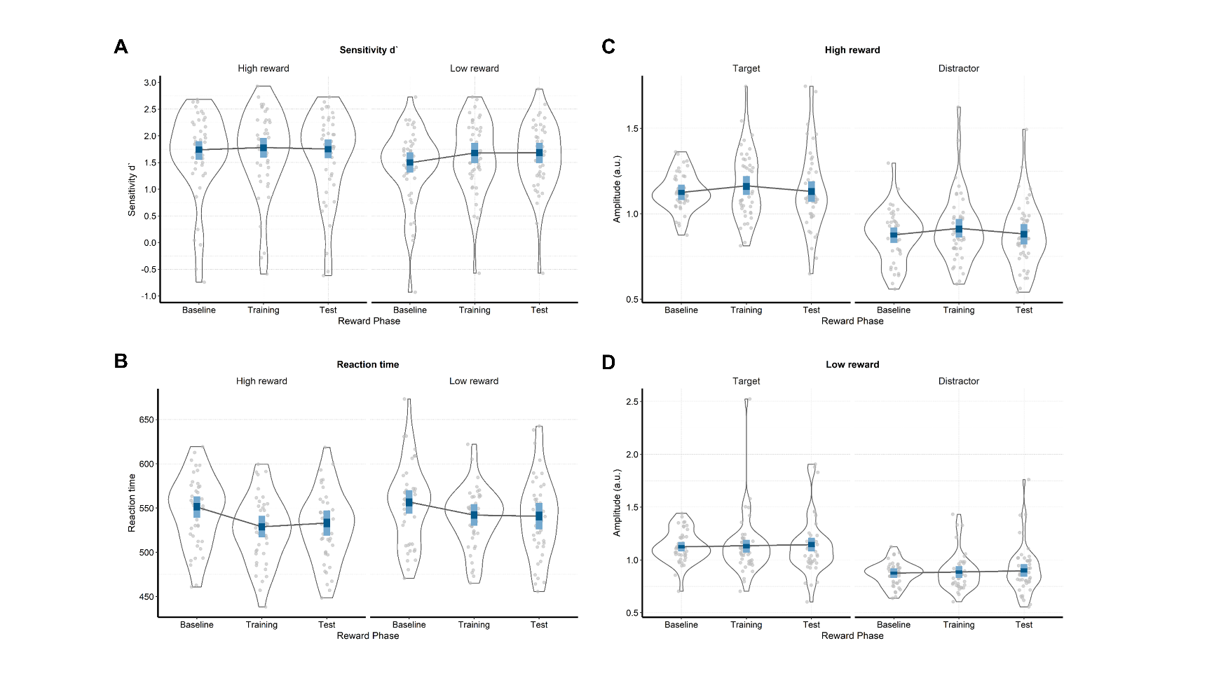

## Reaction times

The interaction model (Reward phase x Reward probability) also best predicted reaction times (*Table 2*). Participants were reliably faster in the training compared to the baseline phase in both the high rewarded (*M =* -21.16; 95% HDI [-29.79, -12.27]; ER = *Inf.*, i.e. whole posterior distribution above zero) and the low rewarded conditions (*M =* -14.47; 95% HDI [-24.71, -4.63]; ER = 332.33). Moreover, this difference was larger in the high compared to low rewarded condition (*M =* -6.69; 95% HDI [-18.01, 4.77]; ER = 7.20). We found little evidence for any changes in reaction times between the training and the test phase. Participants were approximately equally fast in training and test for both the high (*M =* 2.26; 95% HDI [-6.80, 11.00]; ER = 2.26), and the low reward condition (*M =* -0.15; 95% HDI [-10.86, 10.26]; ER = 1.05).

These results indicate that participants were faster in the condition in which they could earn rewards, and more so in the condition with higher probability of earning a reward. Also, there was no evidence for any changes in reaction times when rewards were no longer available.

Supplementary analyses carried out to assess possible training effects indicated some evidence for the presence of training effects in sensitivity and scant evidence for such effects in reaction times. These results can be found in *Appendix 1*.

## SSVEP amplitudes

As shown in *Figure 4*, activity averaged over conditions was mainly localized at central occipital channels (i.e., *Oz*, *POz*, *O2*, *PO3*). Also, the FFT-amplitude spectra showed the expected peaks at the frequencies of 10 and 12 Hz.

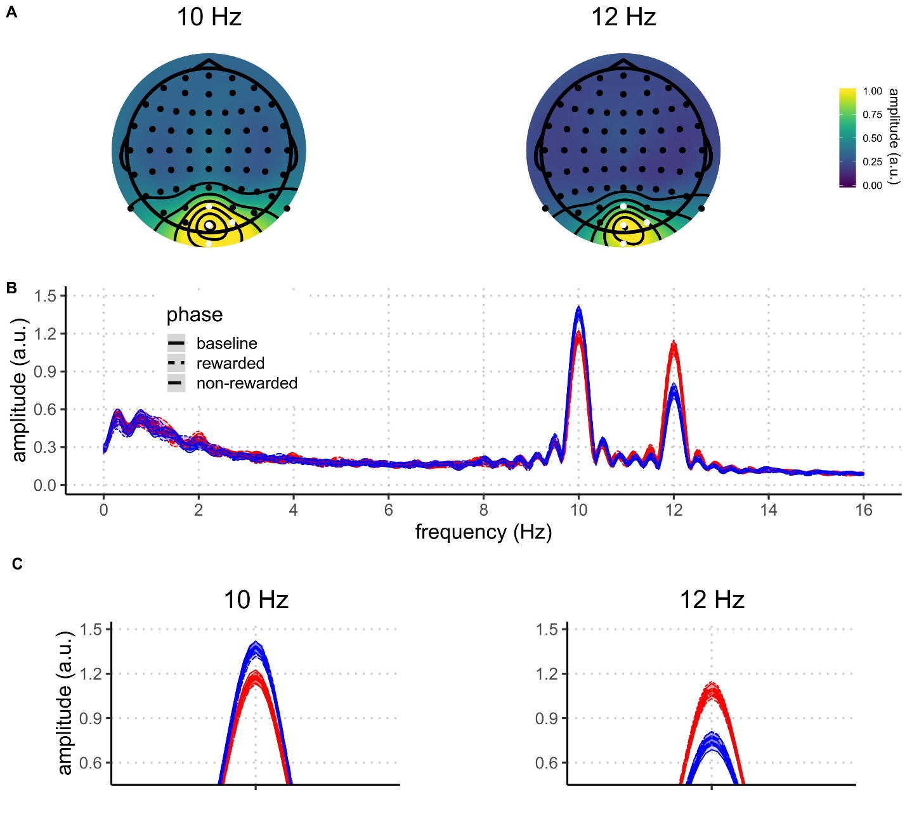

**Figure 3.** Grand average FFT-amplitude spectra derived from EEG signals at each participant's best four-electrode cluster for the 10 and 12 Hz signal. Data in the figure are filtered with 1Hz high-pass filter for visualization purposes.

We fitted seven models to predict the trial-averaged SSVEP amplitudes (in a.u. due to the normalization) across conditions (*Figure 5* and *Table 4*). The *Null model* included one constant and multiple varying intercepts across participants. The *Attention model* included the constant effect of attention; the *Reward phase model* included the constant effect of reward phase; the *Reward phase + attention* model included the additive effects of reward phase and attention; and the *Reward phase x attention* model also included the interaction between reward phase and attention. The *Reward probability x reward phase + attention* model consisted of the constant effects of reward probability and phase, their interaction, and the independent effect of attention. The last model was the *Interaction* model which included all constant effects and their interaction (*Reward probability x reward phase x attention*). All models, except for the *Null* *model*, included varying slopes and intercepts across participants for all constant effects. As was the case for the behavioral data, several models were not fitted because they were not plausible in the context of our experiment (e.g., the models that include both reward phase and probability, but not their interaction).

|  |  |  |  |
| --- | --- | --- | --- |
| Table 4  *Means and 95% HDIs of recorded SSVEP amplitudes in each condition.* | | | |
| Attention | Reward phase | Reward probability | Amplitudes (a.u.) |
| Attended | Baseline | High | 1.13 [0.92, 1.52] |
| Attended | Baseline | Low | 1.13 [0.86, 1.52] |
| Attended | Training | High | 1.16 [0.80, 1.60] |
| Attended | Training | Low | 1.13 [0.76, 1.71] |
| Attended | Test | High | 1.13 [0.61, 1.61] |
| Attended | Test | Low | 1.13 [0.59, 1.84] |
| Unattended | Baseline | High | 0.87 [0.47, 1.17] |
| Unattended | Baseline | Low | 0.87 [0.49, 1.11] |
| Unattended | Training | High | 0.91 [0.54, 1.38] |
| Unattended | Training | Low | 0.89 [0.50, 1.28] |
| Unattended | Test | High | 0.88 [0.48, 1.23] |
| Unattended | Test | Low | 0.91 [0.44, 1.42] |

The interaction model best predicted SSVEP amplitudes across conditions (*Table 5*). The analysis of the posterior distributions of the interaction model (*Figure 6*) revealed a strong effect of attention: in all conditions, SSVEP amplitudes were higher for the attended compared to the unattended stimuli. At baseline, the posterior distribution of the difference between attended and unattended stimuli did not include zero, thus resulting in infinite probability that the attended stimuli would elicit higher SSVEP amplitudes compared to the unattended ones (for high reward probability: *M =* 0.17; 95% HDI [0.09, 0.24]; ER = *Inf.*; for low reward probability: *M =* 0.19; 95% HDI [0.11, 0.27]; ER = *Inf.*). In the training phase, amplitudes were higher in the attended condition for both high rewarded (*M =* 0.19; 95% HDI [0.11, 0.27]; ER = *Inf.*) and low rewarded stimuli (*M =* 0.11; 95% HDI [-0.02, 0.23]; ER = 22.81). Similarly, in the test phase amplitudes were higher in the attended condition for highly rewarded stimuli (*M =* 0.14; 95% HDI [0.05, 0.23]; ER = 999) and for low rewarded stimuli (*M =* 0.14; 95% HDI [0.00, 0.26]; ER = 51.63). These results reveal a very robust effect of attention across all experimental conditions.

|  |  |  |  |
| --- | --- | --- | --- |
| Table 6  *Means and 95% HDIs of the posterior distributions of the SSVEP amplitudes for each condition.* | | | |
| Attention | Reward phase | Reward probability | Amplitudes (a.u.) |
| Attended | Baseline | High | 1.12 [1.08, 1.17] |
| Attended | Baseline | Low | 1.12 [1.08, 1.17] |
| Attended | Training | High | 1.16 [1.11, 1.22] |
| Attended | Training | Low | 1.13 [1.07, 1.19] |
| Attended | Test | High | 1.13 [1.07, 1.19] |
| Attended | Test | Low | 0.90 [0.84, 0.96] |
| Unattended | Baseline | High | 0.88 [0.83, 0.92] |
| Unattended | Baseline | Low | 0.87 [0.83, 0.92] |
| Unattended | Training | High | 0.91 [0.86, 0.97] |
| Unattended | Training | Low | 0.89 [0.83, 0.94] |
| Unattended | Test | High | 0.88 [0.82, 0.94] |
| Unattended | Test | Low | 0.90 [0.84, 0.96] |

|  |  |  |  |
| --- | --- | --- | --- |
| Table 5  *Model comparison indices for EEG results* | | | |
| Model | *WAIC (SE)* |  | *Bayesian R2 (SE)* |
| Null | 65.34 (62.67) |  | 0.08 (0.02) |
| Reward phase | 16.17 (59.31) |  | 0.14 (0.02) |
| Attention | -341.85 (70.91) |  | 0.40 (0.02) |
| Reward phase + Attention | -428.76 (67.19) |  | 0.46 (0.02) |
| Reward phase * Attention | -424.98 (67.36) |  | 0.46 (0.02) |
| Reward probability * Reward phase + Attention | -647.37 (74.90) |  | 0.59 (0.01) |
| Reward phase * Reward probability * Attention | -638.31 (74.97) |  | 0.59 (0.01) |
|  | | | |

The posterior distributions also indicated that reward phase and probability interacted differently across attended and unattended stimuli. Focusing on the attended stimuli first, there was no evidence for a difference between training and baseline when stimuli were highly rewarded (*M =* 0.02; 95% HDI [-0.06, 0.09]; ER = 2.06), but there was weak evidence for lower amplitudes in training when the stimuli were lowly rewarded (*M =* 0.04; 95% HDI [-0.04, 0.12]; ER = 6.69). There was little evidence that amplitudes were lower in training compared to test for the high reward condition (*M =* 0.03; 95% HDI [-0.05, 0.11]; ER = 3.02). For the low reward condition, there was weak evidence that amplitudes were higher in test compared to training (*M =* 0.05; 95% HDI [-0.04, 0.14]; ER = 5.80). For the unattended stimuli, the amplitudes slightly lowered from baseline to training in the high rewarded condition (*M =* 0.04; 95% HDI [-0.03, 0.11]; ER = 5.76), but not in the low rewarded condition (*M =* 0.04; 95% HDI [-0.10, 0.18]; ER = 2.48). Amplitudes did not reliably change from training to test for neither the high reward (*M =* 0.02; 95% HDI [-0.07, 0.11]; ER = 1.78) nor the low reward condition (*M =* 0.02; 95% HDI [-0.07, 0.11]; ER = 1.88).

To summarize, in the attended condition SSVEP amplitudes did not change across reward phases for high rewarded stimuli. However, for low rewarded stimuli, there was some evidence that they lowered from baseline to training and increased from training to test. For the unattended condition, amplitudes elicited by the low rewarded color did not change across reward phases. For the high rewarded color, there was some evidence that amplitudes decreased from baseline to training and increased from training to test.

We also observed an unexpected (albeit weak) baseline difference between the two reward probability conditions, both in the unattended (*M =* 0.05; 95% HDI [-0.03, 0.14]; ER = 8.90) and attended conditions (*M =* 0.03; 95% HDI [-0.06, 0.11]; ER = 2.73). This was surprising because participants had no way of knowing which color would be rewarded in the training phase; in addition, they were informed about the possibility of earning rewards only when they completed the baseline phase. However, this baseline difference does not affect our results given that our comparisons of interest are between reward phases for the same reward probability.

# Discussion

In this study we investigated the neural mechanisms through which rewards enhance goal-directed attention. We compared the amount of attention allocated toward targets and distractors of different values. Compared to baseline, the introduction of rewards improved detection sensitivity and reaction times in the random dot kinematogram task. Further, dots linked to higher reward probability were detected faster, which was accompanied by an increased amount of attention allocated toward these stimuli, as measured by the amplitude of the corresponding SSVEP. This was true both when the high reward feature was a target and a distractor. When rewards were no longer available the amount of attention went back to baseline level, but participants were still faster to detect the movement of the high value targets. These findings have several important implications for the understanding of the relationship between rewards and goal-directed attention.

Our behavioral findings are in line with studies which explored the influence of previous but no longer relevant reward associations on attention. These studies typically find that stimuli previously related to high rewards involuntarily capture attention, which is demonstrated by the increased reaction times in visual search and spatial cueing tasks on trials when these stimuli act as distractors (Anderson, Laurent, & Yantis, 2011; Della Libera & Chelazzi, 2009; Failing & Theeuwes, 2014). While these studies usually use two different tasks in the training and the test phase, here we show comparable results within a single task. Our participants were faster to detect dot movements when the feature linked to high rewards was a target compared to the trials on which this feature was a distractor. This difference was present both in the phase when participants could earn rewards, but also in the phase in which they were aware that no more rewards could be earned. This persistent effect can be understood as the long-lasting effect of reward history on selective attention, even when this effect is in opposed to the current goals of the participant (Anderson, 2016; Failing & Theeuwes, 2017).

At the neural level, we have directly replicated the finding that the SSVEP amplitudes are strongly influenced by goal-directed attention (Andersen, Müller, & Hillyard, 2012; Andersen & Müller, 2010). Across all of the phases of the experiment, the SSVEP amplitudes in the frequency of the target stimuli were higher than the amplitudes in the frequency of the distractors. This robust effect was modulated by reward. Model comparisons have provided evidence that the models which take into account the reward manipulation account the data much better than the model which includes only the effect of goal-directed attention. This result is in line with the previous findings using fMRI (Krebs et al., 2012; Pessoa & Engelmann, 2010) and EEG (Schevernels et al., 2014) which have demonstrated that rewards enhances attentional control. Our findings also corroborate the theoretical models which posit motivation as being a crucial factor in the control of attention (Brown & Alexander, 2017; Holroyd & McClure, 2015; Shenhav, Botvinick, & Cohen, 2013; Verguts, Vassena, & Silvetti, 2015).

Crucially, our experiment allowed us to better understand the mechanisms through which rewards influence goal-directed attention. While previous studies have mostly focused on the anticipatory influence of rewards on attentional control, we have been able to probe the mechanisms through which this improvement operates at the level of processing the stimuli in the task. Our results indicate that the enhancement in goal-directed attention comes from the facilitated processing of stimuli linked to high reward probability. This facilitation is likely localized in the V1-V3 areas of the visual cortex, in which the attentional modulation of the SSVEP signal in the current paradigm occurs (Andersen & Müller, 2010; Andersen, Hillyard, & Müller, 2008). It is likely that the enhanced anticipatory frontoparietal activity reported in fMRI studies of reward attention (Krebs & Woldorff, 2017) leads to the increase in the processing of reward-related targets in the visual cortex which we observe. Our finding is in line with the previous fMRI studies indicating improved processing of stimuli linked to high rewards (Hickey & Peelen, 2015b; Serences, 2008). Importantly, the facilitated processing of the high value feature linked was present both when that feature is a target and a distractor. When the high reward feature was a distractor, the facilitated processing of the feature was in collision with the goal to attend to the other feature. This finding is in line with the theories proposing that reward associations can counteract top-down attentional control (Chelazzi et al., 2013; Anderson, 2016; Failing & Theeuwes, 2018). Notably, facilitated processing of the distractor in this case did not lead to worse or slower detection of the targets compared to baseline. However, participants were slower in detecting the movement of the targets on these trials compared to the trials on which the targets were the high rewarded feature.

Our paradigm allowed us to simultaneously measure the processing of stimuli linked to both high and low value. Some initial evidence for the suppression of the stimuli linked to low compared to high rewards has been found at the behavioral and neural level (Hickey & Peelen, 2015; Padmala & Pessoa, 2011). Suppression of the features linked to low or no rewards has also been proposed as one of the potential mechanisms through which incentives impact attention (Chelazzi et al., 2013; Anderson, 2016; Failing & Theeuwes, 2018). In this study we have not found evidence for this proposal. Suppression was not present neither when the low reward feature was presented as a target, nor when it was presented as a distractor. The amount of attention allocated toward this feature remained unchanged throughout the experiment. There are two features of our experiment which could explain this finding. First, in our experiment both of the stimuli features were related to rewards, but they differed in reward probability. For example, the study which showed evidence for the suppression of the non-rewarded feature did so in the context in which suppression occurred for the representations of objects which were never rewarded (Hickey & Peelen, 2015). In our paradigm it could be adaptive for participants not to suppress the low rewarded feature because correct responses to the movements of this feature would still earn them a reward on 20% of trials. Second, while the attended feature changed trial-by-trial in our experiment, the experiment of Hickey and Peelen consisted out of small blocks of 16 trials in which the attended feature was always the same (e.g., searching for a car in a complex picture). When searching for one object or feature across a number of future trials, it is possible that the optimal solution for the cognitive system is to suppress the processing of the other features or objects (i.e., distractors). However, if the attended feature is likely to change on each trial, as in our experiment, the suppression of the low rewarded feature could be maladaptive as it would carry a cost of reconfiguring the control signals on every trial (for a computational implementation of a reconfiguration cost see: Musslick, Shenhav, Botvinick, & Cohen, 2015). Both of these explanations could be tested within our experimental paradigm. Replacing the low rewarded feature with a no-reward feature, or introducing mini-blocks could lead to a better understanding of the boundary conditions of attentional suppression in the context of rewards.

In the test phase the behavior displayed the same patterns as in the training phase. Individuals were faster to detect movements of the dots in color related to high reward probability. This finding follows the reward-history effects reported in several paradigms (Anderson, Laurent, & Yantis, 2011; Della Libera & Chelazzi, 2009; Failing & Theeuwes, 2014). However, our results show that the amount of attention allocated toward the high value feature was the same in the test phase as in the baseline. This result indicates that the longer lasting effect of reward history was not mediated by attention measured by the SSVEPs. One possibility is that our measure captures the more sustained aspect of attention, while the effects of reward-history on the visual processing rely on more transient attentional capture (Donohue et al., 2016; Hickey et al., 2010; Luque et al., 2017; MacLean & Giesbrecht, 2015). However, there are at least two studies which have not found evidence for the effects of reward history on the early visual processing (Qi et al., 2013; Tankelevitch et al., 2019). This leaves open the possibility that the effects of reward history are not necessarily driven by purely attentional mechanisms. One interesting possibility which should be explored in further studies is that rewards initially improve performance by enhancing attentional mechanisms, but later rely on more direct stimulus-response mappings. Finally, it is important to note that our study was not primarily designed to assess the reward-history effects. Although the number of trials in the training phase is approximately is similar to those in studies demonstrating reward history effects, we used the same task in the training and test phase, which is not common for such studies. In addition, our paradigm involves a cue on every trial inducing a direct goal which is not the case with most of the studies assessing the influence of reward-history on attention. Further research using SSVEPs in tasks designed to explicitly address the reward-history effects could help disentangle between the possible explanations of our findings.

This is the first electrophysiological study which was able to investigate the simultaneous deployment of attention to stimuli of different values when they act as either targets or distractors. Thus it provides a novel insight into the flexible dynamics of attentional deployment based on value of different stimuli. Our results reveal the mechanism through which reward can improve goal-directed attention. We show that monetary rewards can influence goal-directed attention. Further, we demonstrate that the feature linked to high rewards receives more attention both when it acts as a target and a distractor. Finally, this biased competition is no longer present once the rewards are no longer available. This result corroborates the importance of motivation in guiding attention (Botvinick & Braver, 2015; Chelazzi et al., 2013; Failing & Theeuwes, 2017; Pessoa, 2015). These findings provide a clear mechanisms through which motivation can influence attention in the visual cortex which is in line with the existing models (Roelfsema et al., 2010). Finally, this study demonstrates the value of using the SSVEPs to investigate the simultaneous competition for attentional resources of stimuli of different values. This technique can be used to further test the existing theoretical models which relate attention and motivation. Crucially, this technique allows for measuring the processing of both targets and distractors, while dissociating between the effects of goal-driven attention and reward.

# Appendix 1

In order to assess potential training effects on behavioral performance, we split each reward phase into two halves (*Supplementary Figure 1* and *Supplementary Table 1*). If training effects were influencing the behavioral outcome, we could expect performance improvement through baseline and training. To investigate this possibility, we fitted the *Interaction model* that was identical as the one described in the results section. We then compared behavioral performance between the first and the second part of the baseline phase, and between the second part of baseline and the first part of training phase.

|  |  |  |  |
| --- | --- | --- | --- |
| Supplementary Table 1  *Means and 95% HDIs of sensitivity and reaction times across six phases of the experiment* | | | |
| Reward phase | Reward probability | Sensitivity (d`) | Reaction times (milliseconds) |
| Baseline1 | High | 1.49 [-0.36, 2.62] | 548.73 [479.43, 613.76] |
| Baseline1 | Low | 1.30 [ 0.09, 2.35] | 551.97 [458.26, 621.44] |
| Baseline2 | High | 1.60 [-0.27, 2.56] | 545.60 [454.56, 620.36] |
| Baseline2 | Low | 1.45 [ 0.08, 2.33] | 556.21 [486.84, 650.73] |
| Training1 | High | 1.56 [-0.08, 2.65] | 521.47 [437.90, 587.57] |
| Training1 | Low | 1.58 [ 0.47, 2.45] | 542.80 [463.65, 593.47] |
| Training2 | High | 1.59 [ 0.08, 2.56] | 528.96 [462.00, 598.58] |
| Training2 | Low | 1.47 [ 0.00, 2.62] | 534.72 [479.38, 618.25] |
| Test1 | High | 1.51 [-0.07, 2.57] | 528.30 [457.88, 596.17] |
| Test1 | Low | 1.49 [ 0.36, 2.50] | 536.86 [444.89, 621.00] |
| Test2 | High | 1.50 [-0.38, 2.49] | 528.92 [448.24, 606.00] |
| Test2 | Low | 1.53 [ 0.65, 2.55] | 542.76 [450.11, 617.44] |

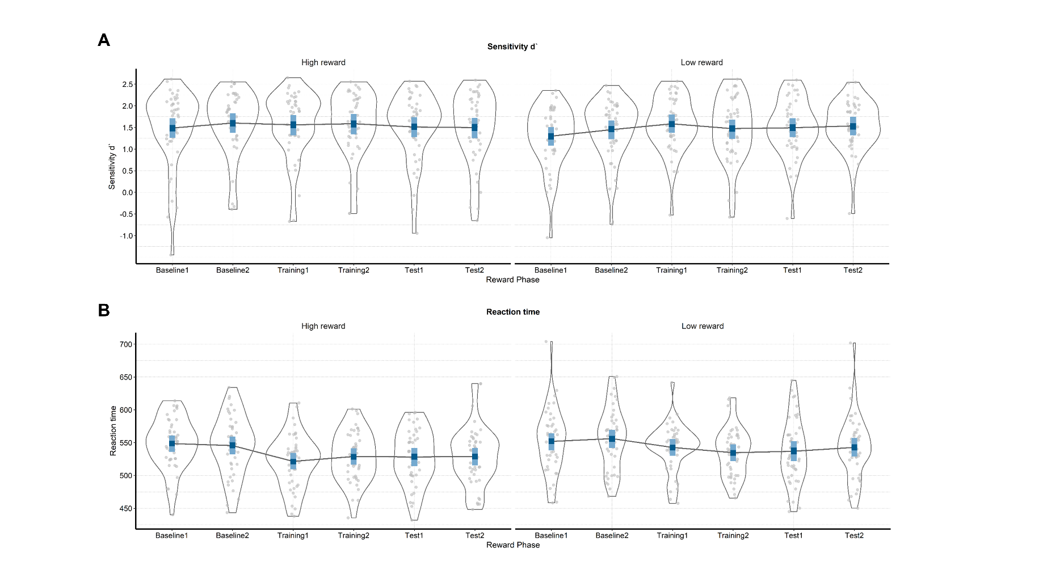

**Supplementary Figure 1. Raw and modelled behavioral data in each half of each phase of the experiment.** On both plots raw participant data is represented with grey dots and their distribution. The winning model is presented in blue (dark blue – 50% CIs and light blue – 95% CIs). **A)** Sensitivity (d`) across the phases of the experiment for the conditions in which the target color is linked to either high or low reward probability. **B)** Reaction times (ms) in the six phases when the target is related to high or low reward probability.

The posterior distributions for sensitivity (*Supplementary Figure 2* and *Supplementary Table 2*) revealed performance improvement from the first to the second part of the baseline for both high (*M =* 0.02; 95% HDI [-0.01, 0.05]; ER = 7.77) and low (*M =* 0.04; 95% HDI [0.01, 0.08]; ER = 141.86) reward probability conditions. When comparing the second part of baseline to the first part of training, there was no difference in the high reward probability condition (*M =* 0.01; 95% HDI [-0.03, 0.04]; ER = 1.82). However, in the low probability condition, sensitivity was higher in the first part of training (*M =* 0.03; 95% HDI [-0.01, 0.06]; ER = 9.31). These results indicate that participants improved not only throughout the baseline phase, but also from the end of baseline to the first part of the training (albeit for low rewarded color only). This might indicate some presence of training effects in the sensitivity data.

The posterior distributions of reaction times (*Supplementary Figure 2* and *Supplementary Table 2*) revealed no differences between the first and the second part of baseline for neither high (*M =* 2.74; 95% HDI [-8.78, 13.75]; ER = 2.17) nor low (*M =* 3.08; 95% HDI [-8.53, 14.75]; ER = 2.37) reward probability condition. The comparison between the second part of baseline and the first part of training revealed a very reliable improvement in both high (*M =* 23.34; 95% HDI [12.06, 35.22]; ER = *Inf.*) and low (*M =* 12.86; 95% HDI [1.09, 25.28]; ER = 54.55) reward probability conditions. These results clearly point to the absence of training effects in reaction time data.

Taken together, these results indicate that our effects were not driven by the improved performance over the course of the task. Although there is some evidence that sensitivity was improving during the baseline phase, reaction times clearly indicate that the main shift in performance happens in the beginning of training, when rewards are introduced. Importantly, the strongest behavioral effects in our study were found on reaction time data, as indicated in the results section.

|  |  |  |  |
| --- | --- | --- | --- |
| Supplementary Table 2  *Means and 95% HDIs of sensitivity and reaction times across six phases of the experiment* | | | |
| Reward phase | Reward probability | Sensitivity (d`) | Reaction times (milliseconds) |
| Baseline 1 | High | 1.49 [1.26, 1.71] | 548.63 [535.91, 560.72] |
| Baseline 1 | Low | 1.30 [1.08, 1.51] | 551.89 [538.38, 564.15] |
| Baseline 2 | High | 1.60 [1.38, 1.83] | 545.50 [532.36, 559.34] |
| Baseline 2 | Low | 1.45 [1.23, 1.66] | 556.12 [542.01, 569.51] |
| Training 1 | High | 1.56 [1.32, 1.79] | 521.46 [509.29, 534.18] |
| Training 1 | Low | 1.58 [1.38, 1.80] | 542.74 [529.90, 555.54] |
| Training 2 | High | 1.59 [1.34, 1.81] | 528.94 [516.56, 541.59] |
| Training 2 | Low | 1.47 [1.24, 1.68] | 534.70 [521.78, 547.53] |
| Test 1 | High | 1.51 [1.28, 1.74] | 528.27 [514.43, 542.01] |
| Test 1 | Low | 1.49 [1.28, 1.71] | 536.87 [522.00, 552.32] |
| Test 2 | High | 1.50 [1.25, 1.72] | 528.92 [515.37, 542.04] |
| Test 2 | Low | 1.54 [1.32, 1.75] | 542.76 [528.68, 557.15] |

Similar analyses could not be performed for the EEG data, because splitting the number of trials in each phase would significantly affect the signal-to-noise ratio. However, our EEG results point to changes in SSVEP amplitudes in only one of the reward probability conditions. If amplitude changes were mainly driven by training effects, the differences across reward phases would be expected for both reward probability conditions. This observation, combined with the lack of strong training effects in behavior, suggests that our EEG results are not driven by training effects.

## Software for data visualization and analysis

Visualization and statistical analyses were performed using R v3.4.4 (R Core Team, 2017) via RStudio v1.1.453 (RStudio Team, 2015). We used the following packages (and their respective dependencies):

• data manipulation: tidyverse v1.2.1 (Wickham, 2017);

• statistical analyses: Rmisc v1.5 (Hope, 2013), brms v2.3.1 (Bürkner, 2016); psych

• visualization: cowplot v0.9.2 (Wilke, 2016), yarrr v0.1.5 (Phillips, 2016), viridis v0.5.1 (Garnier, 2018), eegUtils v0.2.0 (Craddock, 2018), BEST (J. K. Kruschke & Meredith, 2017);

• report generation: pacman v0.4.6 (Rinker & Kurkiewicz, n.d.), knitr v1.20 (Xie, 2018); here.

# Acknowledgements

This work was supported by the Special Research Fund (BOF) of Ghent University [grant #01D02415 awarded to IG; grant # BOF14/PDO/123 awarded to AS] and the Concerted Research Action Grant of Ghent University [grant number BOF16/GOA/017 awarded to EHWK]. Add funding for Gilles and Søren. The funding sources had no involvement in the study design; collection, analysis, and interpretation of data; writing of the report; and decision to submit the article for publication.

We would like to thank Ladislas Nalborczyk for discussions about statistical analyses of the data and Dr. Inez Greven for help with data collection.

# Author contributions

IG, AS, and SKA conceived the study. SKA and IG programmed the experimental paradigm. SKA, GP, and EHWK contributed reagents/materials/tools. IG collected the data, supervised by AS. IG and AS analyzed the data. IG and AS wrote the main manuscript text. IG, AS, GP, EHWK, and SKA reviewed and critically revised the manuscript.

# Data availability

Raw and pre-processed data, materials, and analysis scripts are available at: https://osf.io/kjds3/.

# References

Andersen, S. K., Müller, M. M., & Hillyard, S. A. (2012). Tracking the allocation of attention in visual scenes with steady-state evoked potentials. In *Cognitive neuroscience of attention* (pp. 197–216).

Andersen, S K, & Müller, M. M. (2010). Behavioral performance follows the time course of neural facilitation and suppression during cued shifts of feature-selective attention. *Proceedings of the National Academy of Sciences of the United States of America*, *107*(31), 13878–13882. https://doi.org/10.1073/pnas.1002436107

Andersen, Søren K., Hillyard, S. A., & Müller, M. M. (2008). Attention Facilitates Multiple Stimulus Features in Parallel in Human Visual Cortex. *Current Biology*, *18*(13), 1006–1009. https://doi.org/10.1016/j.cub.2008.06.030

Anderson, B. A. (2016). The attention habit: How reward learning shapes attentional selection. *Annals of the New York Academy of Sciences*, *1369*(1), 24–39. https://doi.org/10.1111/nyas.12957

Anderson, B. a, Laurent, P. a, & Yantis, S. (2011). Value-driven attentional capture. *Proceedings of the National Academy of Sciences*, *108*(25), 10367–10371. https://doi.org/10.1073/pnas.1104047108

Awh, E., Belopolsky, A. V., & Theeuwes, J. (2012). Top-down versus bottom-up attentional control: A failed theoretical dichotomy. *Trends in Cognitive Sciences*, *16*(8), 437–443. https://doi.org/10.1016/j.tics.2012.06.010

Boehler, C. N., Hopf, J. M., Stoppel, C. M., & Krebs, R. M. (2012). Motivating inhibition - reward prospect speeds up response cancellation. *Cognition*, *125*(3), 498–503. https://doi.org/10.1016/j.cognition.2012.07.018

Botvinick, M. M., & Braver, T. S. (2015). Motivation and Cognitive Control : From Behavior to Neural Mechanism. *Annual Review of Psychology*, (September 2014), 1–31. https://doi.org/10.1146/annurev-psych-010814-015044

Brown, J. W., & Alexander, W. H. (2017). Foraging Value, Risk Avoidance, and Multiple Control Signals: How the Anterior Cingulate Cortex Controls Value-based Decision-making. *Journal of Cognitive Neuroscience*, *29*(10), 1656–1673. https://doi.org/10.1162/jocn_a_01140

Bürkner, P.-C. (2016). brms: An R package for Bayesian multilevel models using Stan. *Journal of Statistical Software*, *80*(1), 1–28.

Bürkner, P.-C. (2017). Advanced Bayesian Multilevel Modeling with the R Package brms. *ArXiv:1705.11123*.

Carpenter, B., Gelman, A., Hoffman, M., Lee, D., Goodrich, B., Betancourt, M., … Riddell, A. (2016). Stan: A probabilistic programming language. *Journal of Statistical Software*, *2*(20), 1–37.

Chatrian, G. E., Lettich, E., & Nelson, P. L. (1985). Ten percent electrode system for topographic studies of spontaneous and evoked EEG activities. *American Journal of EEG Technology*, *25*(2).

Chelazzi, L., Perlato, A., Santandrea, E., & Della Libera, C. (2013). Rewards teach visual selective attention. *Vision Research*, *85*, 58–62. https://doi.org/10.1016/j.visres.2012.12.005

Chun, M. M., Golomb, J. D., & Turk-Browne, N. B. (2011). A Taxonomy of External and Internal Attention. *Annual Review of Psychology*, *62*(1), 73–101. https://doi.org/10.1146/annurev.psych.093008.100427

Corbetta, M., & Shulman, G. L. (2002). Control of Goal-Directed and Stimulus-Driven Attention in the Brain. *Nature Reviews Neuroscience*, *3*(3), 215–229. https://doi.org/10.1038/nrn755

Craddock, M. (2018). craddm/eegUtils: eegUtils (Version v0.2.0). Zenodo.

Della Libera, C., & Chelazzi, L. (2009). Learning to attend and to ignore is a matter of gains and losses. *Psychological Science*, *20*(6), 778–784. https://doi.org/10.1111/j.1467-9280.2009.02360.x

Delorme, A., & Makeig, S. (2004). EEGLAB: an open sorce toolbox for analysis of single-trail EEG dynamics including independent component anlaysis. *Journal of Neuroscience Methods*, *134*, 9–21. https://doi.org/10.1016/j.jneumeth.2003.10.009

Desimone, R., & Duncan, J. (1995). Neural Mechanisms of Selective Visual. *Annual Review of Neuroscience*, *18*(1), 193–222. https://doi.org/10.1146/annurev.ne.18.030195.001205

Donohue, S. E., Hopf, J.-M., Bartsch, M. V., Schoenfeld, M. A., Heinze, H.-J., & Woldorff, M. G. (2016). The Rapid Capture of Attention by Rewarded Objects. *Journal of Cognitive Neuroscience*, *28*(4), 529–541. https://doi.org/10.1162/jocn_a_00917

Etzel, J. A., Cole, M. W., Zacks, J. M., Kay, K. N., & Braver, T. S. (2016). Reward Motivation Enhances Task Coding in Frontoparietal Cortex. *Cerebral Cortex*, *26*(4), 1647–1659. https://doi.org/10.1093/cercor/bhu327

Failing, M. F., & Theeuwes, J. (2014). Exogenous visual orienting by reward. *Journal of Vision*, *14*(2014), 1–9. https://doi.org/10.1167/14.5.6.doi

Failing, M., & Theeuwes, J. (2017). Selection history: How reward modulates selectivity of visual attention. *Psychonomic Bulletin and Review*, 1–25. https://doi.org/10.3758/s13423-017-1380-y

Franken, I. H. A., Muris, P., & Rassin, E. (2005). Psychometric properties of the Dutch BIS/BAS scales. *Journal of Psychopathology and Behavioral Assessment*, *27*(1), 25–30. https://doi.org/10.1007/s10862-005-3262-2

Garnier, S. (2018). viridis: Default Color Maps from ‘matplotlib.’ R package version 0.3.

Gelman, A., Goodrich, B., Gabry, J., & Ali, I. (2017). R-squared for Bayesian regression models. *Unpublished via Http://Www. Stat. Columbia. Edu/~ Gelman/Research/Unpublished.* Retrieved from http://www.stat.columbia.edu/~gelman/research/unpublished/bayes_R2.pdf

Gelman, A., & Rubin, D. B. (1992). Inference from Iterative Simulation Using Multiple Sequences. *Statistical Science*, *7*(4), 457–472. https://doi.org/10.1214/ss/1177011136

Hautus, M. J. (1995). Corrections for extreme proportions and their biasing effects on estimated values of d′. *Behavior Research Methods, Instruments, & Computers*, *27*(1), 46–51. https://doi.org/10.3758/BF03203619

Hickey, C., Chelazzi, L., & Theeuwes, J. (2010). Reward Changes Salience in Human Vision via the Anterior Cingulate. *Journal of Neuroscience*, *30*(33), 11096–11103. https://doi.org/10.1523/JNEUROSCI.1026-10.2010

Hickey, C., & Peelen, M. V. (2015a). Neural mechanisms of incentive salience in naturalistic human vision. *Neuron*, *85*(3), 512–518. https://doi.org/10.1016/j.neuron.2014.12.049

Hickey, C., & Peelen, M. V. (2015b). Neural Mechanisms of Incentive Salience in Naturalistic Human Vision Report Neural Mechanisms of Incentive Salience in Naturalistic Human Vision. *Neuron*, *85*(3), 512–518. https://doi.org/10.1016/j.neuron.2014.12.049

Holroyd, C. B., & McClure, S. M. (2015). Hierarchical control over effortful behavior by rodent medial frontal cortex: A computational model. *Psychological Review*, *122*(1), 54–83. https://doi.org/10.1037/a0038339

Hope, R. M. (2013). Rmisc: Ryan miscellaneous. R package version, 1(5).

Junghöfer, M., Elbert, T., Tucker, D. O. N. M., & Rockstroh, B. (2000). Statistical control of artifacts in dense array EEG 0 MEG studies. *Wiley Online Library*, 523–532. Retrieved from http://onlinelibrary.wiley.com/doi/10.1111/1469-8986.3740523/full

Krebs, R. M., Boehler, C. N., Roberts, K. C., Song, A. W., & Woldorff, M. G. (2012). The involvement of the dopaminergic midbrain and cortico-striatal-thalamic circuits in the integration of reward prospect and attentional task demands. *Cerebral Cortex*, *22*(3), 607–615. https://doi.org/10.1093/cercor/bhr134

Krebs, R. M., & Woldorff, M. G. (2017). Cognitive control and reward. *The Wiley Handbook of Cognitive Control*, 422–439. https://doi.org/10.1002/9781118920497.ch24

Kruschke, J. K., & Meredith, M. (2017). BEST: Bayesian Estimation Supersedes the t-Test.

Kruschke, John K. (2014). *Doing Bayesian data analysis: A tutorial with R, JAGS, and Stan, second edition*. *Doing Bayesian Data Analysis: A Tutorial with R, JAGS, and Stan, Second Edition* (2nd ed.). Elsevier Inc. https://doi.org/10.1016/B978-0-12-405888-0.09999-2

Luque, D., Beesley, T., Morris, R. W., Jack, B. N., Griffiths, O., Whitford, T. J., & Le Pelley, M. E. (2017). Goal-Directed and Habit-Like Modulations of Stimulus Processing during Reinforcement Learning. *The Journal of Neuroscience*, *37*(11), 3009–3017. https://doi.org/10.1523/jneurosci.3205-16.2017

MacLean, M. H., & Giesbrecht, B. (2015). Neural evidence reveals the rapid effects of reward history on selective attention. *Brain Research*, *1606*, 86–94. https://doi.org/10.1016/j.brainres.2015.02.016

Macmillan, N. A., & Creelman, C. D. (2004). *Detection theory: A user’s guide*. Psychology press.

McElreath, R. (2016). *Statistical Rethinking: A Bayesian Course with Examples in R and Stan*. Chapman Hall - CRC.

Musslick, S., Shenhav, A., Botvinick, M. M., & Cohen, J. D. (2015). A computational model of control allocation based on the Expected Value of Control. *Reinforcement Learning and Decision Making Conference*, *59*(1978), 2014.

Nalborczyk, L., & Bürkner, P.-C. (2019). An Introduction to Bayesian Multilevel Models Using brms: A Case Study of Gender Effects on Vowel Variability in Standard Indonesian. *Journal of Speech, Language, and Hearing Research*.

Nolan, H., Whelan, R., & Reilly, R. B. (2010). FASTER: Fully Automated Statistical Thresholding for EEG artifact Rejection. *Journal of Neuroscience Methods*, *192*(1), 152–162. https://doi.org/10.1016/j.jneumeth.2010.07.015

Norcia, A. M., Appelbaum, L. G., Ales, J. M., Cottereau, B. R., & Rossion, B. (2015). The steady-state visual evoked potential in vision research : A review. *Journal of Vision*, *15*(6), 1–46. https://doi.org/10.1167/15.6.4.doi

Padmala, S., & Pessoa, L. (2011). Reward reduces conflict by enhancing attentional control and biasing visual cortical processing. *Journal of Cognitive Neuroscience*, *23*(11), 3419–3432. https://doi.org/10.1162/jocn_a_00011

Pallier, C. (2002). Computing discriminability and bias with the R software. Retrieved July 25, 2019, from http://www.pallier.org/pdfs/aprime.pdf

Perrin, F., Pernier, J., Bertrand, O., & Echallier, J. F. (1989). Spherical splines for scalp potential and current density mapping. *Electroencephalography and Clinical Neurophysiology*, *72*(2), 184–187. https://doi.org/10.1016/0013-4694(89)90180-6

Pessoa, L. (2015). Multiple influences of reward on perception and attention. *Visual Cognition*, *23*(1–2), 272–290. https://doi.org/10.1080/13506285.2014.974729

Pessoa, L., & Engelmann, J. B. (2010). Embedding reward signals into perception and cognition. *Frontiers in Neuroscience*, *4*(September), 1–8. https://doi.org/10.3389/fnins.2010.00017

Phillips, N. (2016). Yarrr: A companion to the e-book YaRrr!: The Pirate’s Guide to R. R package version 0.1.

Posner, M. I. (1980). Orienting of attention. *The Quarterly Journal of Experimental Psychology*, *32*(1), 3–25. https://doi.org/10.1080/00335558008248231

Qi, S., Zeng, Q., Ding, C., & Li, H. (2013). Neural correlates of reward-driven attentional capture in visual search. *Brain Research*, *1532*, 32–43. https://doi.org/10.1016/j.brainres.2013.07.044

R Core Team. (2017). R: A Language and Environment for Statistical Computing. R Foundation for Statistical Computing.

Rinker, T., & Kurkiewicz, D. (n.d.). pacman: Package Management for R.

Roelfsema, P. R., van Ooyen, A., & Watanabe, T. (2010). Perceptual learning rules based on reinforcers and attention. *Trends in Cognitive Sciences*, *14*(2), 64–71. https://doi.org/10.1016/j.tics.2009.11.005

RStudio Team. (2015). Integrated Development for R. RStudio, Inc.

Schevernels, H., Krebs, R. M., Santens, P., Woldorff, M. G., & Boehler, C. N. (2014). Task preparation processes related to reward prediction precede those related to task-difficulty expectation. *NeuroImage*, *84*, 639–647. https://doi.org/10.1016/j.neuroimage.2013.09.039

Serences, J. T. (2008). Value-Based Modulations in Human Visual Cortex. *Neuron*, *60*(6), 1169–1181. https://doi.org/10.1016/j.neuron.2008.10.051

Shenhav, A., Botvinick, M., & Cohen, J. (2013). The expected value of control: An integrative theory of anterior cingulate cortex function. *Neuron*, *79*(2), 217–240. https://doi.org/10.1016/j.neuron.2013.07.007

Tankelevitch, L., Spaak, E., Rushworth, M. F. S., & Stokes, M. G. (2019). Previously reward-associated stimuli capture spatial attention in the absence of changes in the corresponding sensory representations as measured with {MEG}. *BioRxiv*, 622589. https://doi.org/10.1101/622589

Theeuwes, J. (2010). Top-down and bottom-up control of visual selection. *Acta Psychologica*, *135*(2), 77–99. https://doi.org/10.1016/j.actpsy.2010.02.006

Van der Does, A. J. W. (2002). *Handleiding bij de Nederlandse versie van beck depression inventory—second edition (BDI-II-NL). [The Dutch version of the Beck depression inventory].* Amsterdam: Harcourt.

Verguts, T., Vassena, E., & Silvetti, M. (2015). Adaptive effort investment in cognitive and physical tasks: a neurocomputational model. *Frontiers in Behavioral Neuroscience*, *9*(March). https://doi.org/10.3389/fnbeh.2015.00057

Watanabe, S. (2010). Asymptotic Equivalence of Bayes Cross Validation and Widely Applicable Information Criterion in Singular Learning Theory, *11*, 3571–3594. Retrieved from http://arxiv.org/abs/1004.2316

Wickham, H. (2017). Tidyverse: Easily install and load ’tidyverse’ packages. R package version, 1(1).

Wilke, C. O. (2016). cowplot: streamlined plot theme and plot annotations for ‘ggplot2.’ CRAN Repos.

Wisniewski, D., Reverberi, C., Momennejad, I., Kahnt, T., & Haynes, J.-D. (2015). The Role of the Parietal Cortex in the Representation of Task-Reward Associations. *Journal of Neuroscience*, *35*(36), 12355–12365. https://doi.org/10.1523/jneurosci.4882-14.2015

Xie, Y. (2018). knitr: A General-Purpose Package for Dynamic Report Generation in R.