Working title: Feature-based Attention and Reward: Insights from Steady-State Visually Evoked Potentials

Ivan Grahek1☨*, Antonio Schettino1,2☨, Gilles Pourtois1, Ernst H.W. Koster1,

& Søren K. Andersen3

1. *Department of Experimental Clinical and Health Psychology, Ghent University, Henri Dunantlaan 2, B-9000, Ghent, Belgium*
2. *Institute for Globally Distributed Open Research and Education (IGDORE)*
3. *School of Psychology, University of Aberdeen, William Guild Building, Aberdeen, AB24 3FX, United Kingdom*

# Abstract

# Introduction

# Methods

## Participants

We tested 48 participants with normal or corrected-to-normal vision and no history of psychiatric or neurological disorders. Eight participants were excluded due to technical problems (4) or excessive artifacts (4) in the EEG recordings. Thus, the final data set consisted out of 40 participants (XX female; median age). Participants received 20 € plus up to 6 € extra as monetary rewards (on average 25.5 €). The study was approved by the ethics committee of Ghent University.

## Stimuli and task

We used the Random Dot Kinematogram (RDK) task (Andersen & Müller, 2010), in which participants were presented with two overlapping circular RDKs of isoluminant colors (red and blue) on a grey background. Viewing distance was fixed with a chinrest at 55 cm from the 21-inch CRT screen (resolution of 1024 x 768 pixels, 120 Hz refresh rate). The two RDKs consisted of 125 randomly and independently moving dots (each 0.52 degrees of visual angle). The size of the cloud was 20.61 degrees of visual angle. Each RDK was flickering at a different frequency (10 or 12 Hz). The mapping between color and frequency was counterbalanced across participants. On one-third of trials, most of the dots (75%) in one of the RDKs moved coherently in one of four cardinal directions (up, down, left, or right). Participants had to detect the coherent movement as fast as possible by pressing the space key on a standard AZERTY USB keyboard. Response time was limited to 1,500 ms. At the beginning of each trial, participants were instructed which of the two RDKs to attend by a verbal audio cue (“red” vs. “blue”). Each trial could contain zero, one, two, or three coherent movements. Correct responses were followed by a tone (1,000 ms sine wave of either 800 or 1,200 Hz, counterbalanced across participants). Responses that were too late or incorrect were followed by a 1,000 ms square wave tone of 400 Hz.

The experiment started with 4 practice blocks of 60 trials. After each block, participants received feedback on their performance (percentage of correctly detected movements and percentage of correct responses). After finishing the practice phase, participants completed 12 blocks divided into 3 phases. The first phase was the baseline, in which participants were doing the described task. In the second phase the task was identical, but participants were instructed that they could earn additional monetary rewards (up to 6 €) based on their performance. They were instructed that one of the colors would be paired with high probability (80%) and the other color with low probability (20%) of earning 10 extra cents for each correct detection. The receipt of the reward was signaled by a new tone that replaced the usual correct tone. If the correct tone was a sine wave of 800 Hz, the reward tone was a sine wave of 1,200 Hz and vice versa. At the end of each of the 4 blocks of the reward phase, participants got feedback on their performance and feedback on the amount of extra money earned within the block. The third phase was the extinction phase, identical to baseline (i.e., no monetary rewards assigned). The whole task lasted for approximately 50 minutes, plus a few minutes of break and participants were encouraged to take brakes in between blocks. Upon completing the task, participants filled in two questionnaires in order to measure reward sensitivity (BIS-BAS; Franken et al., 2005) and depression levels (BDI-II; Van der Does, 2002).

This experiment was realised using Cogent 2000 developed by the Cogent 2000 team at the FIL and the ICN and Cogent Graphics developed by John Romaya at the LON at the Wellcome Department of Imaging Neuroscience.

## EEG recording and pre-processing

Electroencephalographic activity (EEG) was recorded with an ActiveTwo amplifier (BioSemi, Inc., The Netherlands) at a sampling rate of 512 Hz and online low-pass filtered at 100 Hz. Sixty-four Ag/AgCl electrodes were fitted into an elastic cap, following the international 10/10 system (Chatrian, Lettich, & Nelson, 1985). The common mode sense (CMS) active electrode and the driven right leg (DRL) passive electrode were used as reference and ground electrodes, respectively. Additional external electrodes were applied to the left and right mastoids, as well as on the outer canthi of each eye and in the inferior and superior areas of the left orbit (to record horizontal and vertical electrooculogram, EOG).

Data pre-processing was performed offline with custom MATLAB scripts and functions included in EEGLAB v14.1.1b (Delorme & Makeig, 2004). After subtracting the mean value of the signal (DC offset), the continuous EEG data were epoched between 0 and 3,250 ms, corresponding to the beginning and end of the RDK trial, respectively. After referencing to *Cz*, FASTER v1.2.3b (Nolan, Whelan, & Reilly, 2010) was used for artifact identification and rejection using the following settings: (i) over the whole EEG signal, channels with variance, mean correlation, and Hurst exponent exceeding *z* = ±3 were interpolated via a spherical spline procedure (Perrin, Pernier, Bertrand, & Echallier, 1989); (ii) the mean across channels was computed for each epoch and, if amplitude range, variance, and channel deviation exceeded *z* = ±3, the whole epoch was removed; (iii) within each epoch, channels with variance, median gradient, amplitude range, and channel deviation exceeding *z* = ±3 were interpolated; (iv) grand-averages with amplitude range, variance, channel deviation, and maximum EOG value exceeding *z* = ±3 were removed; (v) epochs containing more than 12 interpolated channels were discarded. All remaining epochs were scanned with SCADS (Junghöfer, Elbert, Tucker, & Rockstroh, 2000) and rejected when flagged as artefactual. For details, see our commented code at <https://osf.io/xxxxx/>. After pre-processing, the average number of interpolated channels was 4.08 (*SD* = 1.75, range 0 – 7) and the mean percentage of rejected epochs was 9.74% (*SD* = 6.77, range 0 – 32.50; similar rejection rate across conditions). After re-referencing to averaged mastoids, trials in each condition were averaged separately for each participant, resulting in the following grand-averages: (i) baseline, red attended; (ii) baseline, blue attended; (iii) acquisition, red attended; (iv) acquisition, blue attended; (v) extinction, red attended; (vi) extinction, blue attended.

Electrodes with maximum ssVEP amplitudes were identified by calculating isocontour voltage maps based on grand-averaged data collapsed across all conditions. As shown in *Figure 2*, activity was mainly localized at central occipital channels (i.e., Oz, POz, O2, PO3). To account for inter-individual variations in topographical ssVEP amplitude distributions, we identified and averaged activity from the four electrodes displaying, for each participant, the largest frequency-specific amplitude. After removing linear trends, we extracted ssVEP amplitude at 10 and 12 Hz from each individual electrode cluster, separately for each condition (averaged across trials). Fast Fourier Transforms on the EEG signal in a time window from 500 ms (to exclude the typically strong phasic visual evoked response to picture onset) to 3,250 ms after stimulus onset was applied, and amplitudes were obtained by extracting the absolute values of the resulting complex Fourier coefficients. The amplitudes were normalized for each subject and each frequency by dividing amplitudes by the average amplitude for all conditions.

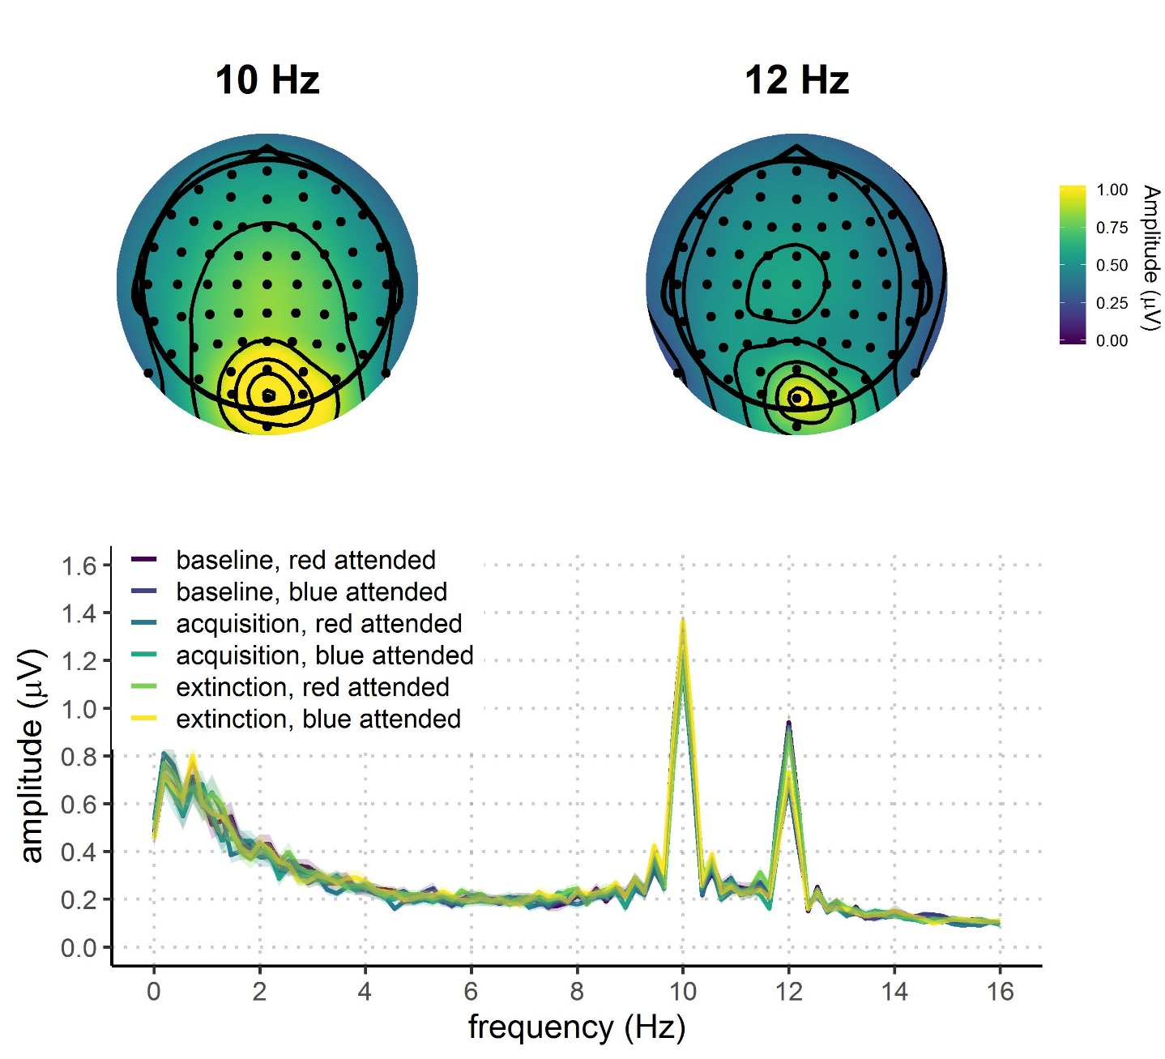

**Figure 2.** Grand average FFT-amplitude spectra derived from EEG signals at each participant's best four-electrode cluster for the 10 and 12 Hz signal.

## Statistical analyses

Behavioral and EEG data were analyzed using Bayesian multilevel regressions. We fitted and compared multiple models of varying complexity to predict hit rates, reaction times, and ssVEP amplitudes. Each of the fitted models included both constant and varying effects (also known as fixed and random). Both EEG signal and behavioral performance are known to be dependent upon participant-specific characteristic (e.g., skull thickness, skin conductance, and hair; response speed, etc.), therefore we decided to model this variability by adding varying intercepts in our models. Additionally, the studied effects (e.g., reward sensitivity and selective attention) are known to vary in magnitude over participants, so we opted for including varying slopes in our models. It should be noted that, because of the simultaneous estimation of group-level and participant-level parameters, multilevel models display a property called *shrinkage*. This means that the estimates that strongly deviate from the mean (e.g., a participant performing the task much worse than the average of the sample) will be shrunk toward the group mean (McElreath, 2016). This advantageous property prevents extreme values from having large effects on results.

Models were fitted in R using the package *brms* (Bürkner, 2016) that employs the probabilistic programming language *Stan* (Carpenter et al., 2016)to implement Markov Chain Monte Carlo (MCMC) algorithms in order to estimate posterior distributions of the parameters of interest. Each of the models were fitted using weakly regularizing prior distributions (default priors in *brms*) and Gaussian likelihood. Four MCMC simulations (“chains”) with 10,000 iterations (2,000 warmup) and a thinning interval of 1 were run to estimate parameters in each of the fitted models. Further analyses were done following the recommendations for Bayesian multilevel modeling using *brms* (Nalborczyk et al., 2018). We confirmed that all models converged by examining trace plots, autocorrelation, and variance between chains (Gelman-Rubin statistic; Gelman & Rubin, 1992). We compared models based on their fit to the actual data using the Bayesian *R*2 (Gelman, Goodrich, Gabry, & Ali, 2017), and their out-of-sample predictive performance using the Widely Applicable Information Criterion (WAIC; Watanabe, 2010). The best model was selected and the posterior distributions of conditions of interest were examined. Differences between conditions were assessed by computing the mean and the 95% highest density interval (HDI) of the difference between posterior distributions of the respective conditions (Kruschke, 2014). Additionally, we calculated the evidence ratios (ERs) for our hypotheses as the ratios between the percentage of posterior samples on each side of the zero of a difference distribution between two conditions. ERs can be interpreted as the probability of a hypothesis (e.g. “Condition A is larger than condition B”) against its alternative (“Condition B is larger than condition A”).

# Results

## Behavioral results

We fitted three models to predict both hit rates (proportion of hits) and reaction times (in milliseconds) separately (*Figure 2* and *Table 1*). First, we fitted the *Null model* with no constant effects and varying intercepts across subject. This model was fitted in order to investigate the possibility that the data would be best explained by simple random variation between subjects. To investigate the effect of reward phase (baseline, acquisition, extinction), we fitted the *Reward phase model* that included only reward phase as the constant predictor and varying intercepts and slopes across subjects for this effect. To investigate the possible interaction between reward phase and reward probability, we fitted the *Interaction model* including these two effects and their interaction as constant effects. The intercepts and slopes of main effects and their interaction were allowed to vary across participants. Please note that there are two additional models that, although possible to fit, are not plausible in the context of our experiment. Specifically, the model with only the effect of reward probability overlooks the fact that this effect would necessarily be most pronounced in the acquisition phase, thus interacting with the effect of reward phase. The same logic applies to the model with additive effects of reward phase and probability (i.e., these effects cannot act independently in our experimental design).

|  |  |  |  |
| --- | --- | --- | --- |
| Table 1  *Means and 95% HDIs (in square brackets) of hit rates and reaction times.* | | | |
| Reward phase | Reward probability | Hit rates (proportion) | Reaction times (milliseconds) |
| Baseline | High | 0.60 [0.32, 0.70] | 547.18 [460.90, 612.74] |
| Baseline | Low | 0.59 [0.32, 0.70] | 552.93 [470.68, 631.36] |
| Acquisition | High | 0.62 [0.37, 0.80] | 526.00 [457.23, 599.49] |
| Acquisition | Low | 0.63 [0.47, 0.77] | 538.41 [465.32, 605.14] |
| Extinction | High | 0.61 [0.32, 0.74] | 528.21 [448.50, 599.83] |
| Extinction | Low | 0.61 [0.39, 0.79] | 538.21 [464.21, 642.55] |

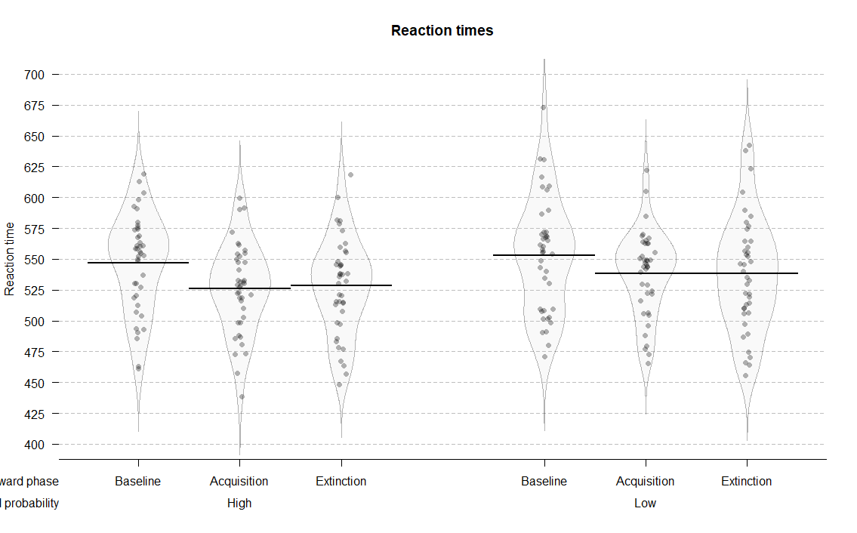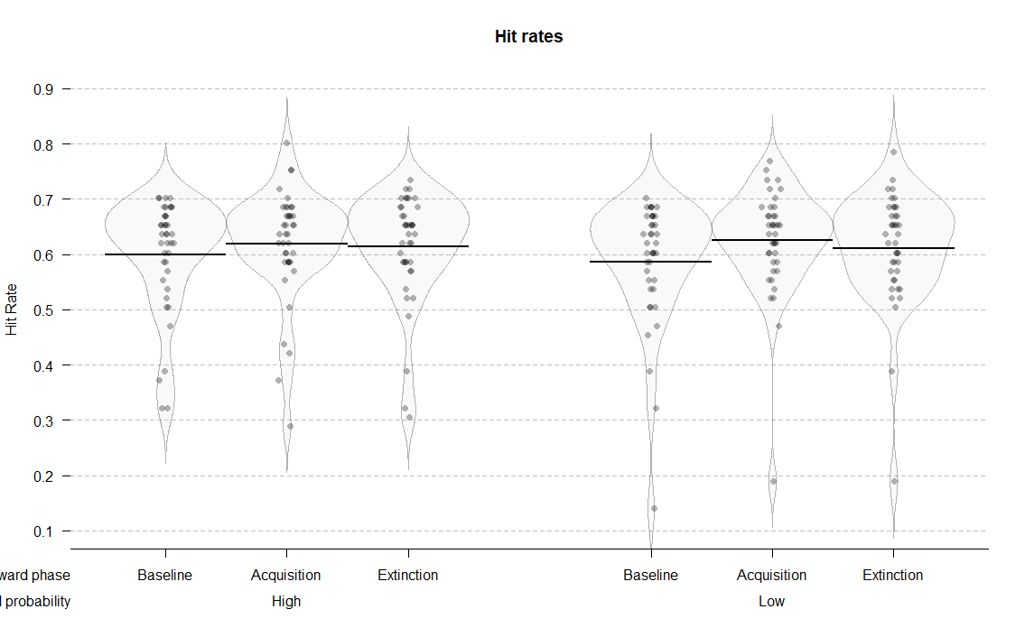

**Figure 3.** Distributions and means of raw hit rates and reaction times per condition.

## Hit rates

Of all the tested models, the interaction model best predicted hit rates (*Table 2*). This result points to the importance of the interaction between reward phase and reward probability in predicting hit rates. The posterior distribution of the interaction model (*Figure 3*) revealed that hit rates improved in the acquisition phase compared to the baseline for both low (*M =* 0.04; 95% HDI [0.02, 0.06]; ER = 999.00) and high rewarded color (*M =* 0.02; 95% HDI [0.00, 0.04]; ER = 33.48). This improvement was more pronounced for low compared to high reward probability (*M =* 0.02; 95% HDI [-0.01, 0.05]; ER = 8.43). Conversely, evidence for the difference between acquisition and extinction phases was much weaker. Participants were slightly less accurate in extinction compared to acquisition in the low rewarded condition (*M =* -0.01; 95% HDI [-0.04, 0.01]; ER = 8.43), while there was very little difference in the high rewarded condition (*M =* -0.01; 95% HDI [-0.03, 0.02]; ER = 2.42).

These results suggest that participants were reliably more accurate in the acquisition phase compared to baseline, and more so for the low rewarded color. There was also evidence for a drop in their accuracy in the extinction phase for the low rewarded, but not high rewarded color.

|  |  |  |  |  |
| --- | --- | --- | --- | --- |
| Table 2  *Mean and standard errors (in parenthesis) of WAIC and Bayesian R2 for each model predicting hit rates and reaction times.* | | | | |
| Model | | *WAIC (SE)* | | *Bayesian R2 (SE)* |
| *Hit rates* | | | | |
| Null | | -475.41 (32.92) |  | 0.34 (0.05) |
| Reward phase | | -471.65 (33.43) |  | 0.36 (0.05) |
| Reward phase x Reward probability | | -709.13 (23.99) |  | 0.82 (0.03) |
| *Reaction times* |
| Null | | 2,346.29 (32.74) |  | 0.49 (0.04) |
| Reward phase | | 2,329.70 (35.38) |  | 0.56 (0.04) |
| Reward phase x Reward probability | | 2,154.64 (25.19) |  | 0.84 (0.03) |

|  |  |  |  |
| --- | --- | --- | --- |
| Table 3  *Means and 95% HDIs of the posterior distributions of reaction times and hit rates in each condition.* | | | |
| Reward phase | Reward probability | Hit rates (proportion) | Reaction times (milliseconds) |
| Baseline | High | 0.60 [0.57, 0.63] | 547.19 [534.84, 559.56] |
| Baseline | Low | 0.59 [0.55, 0.62] | 552.97 [539.22, 567.24] |
| Acquisition | High | 0.62 [0.59, 0.65] | 526.03 [513.90, 538.04] |
| Acquisition | Low | 0.63 [0.59, 0.66] | 538.50 [525.69, 550.34] |
| Extinction | High | 0.61 [0.58, 0.65] | 528.29 [515.32, 541.69] |
| Extinction | Low | 0.61 [0.57, 0.65] | 538.35 [522.97, 554.23] |

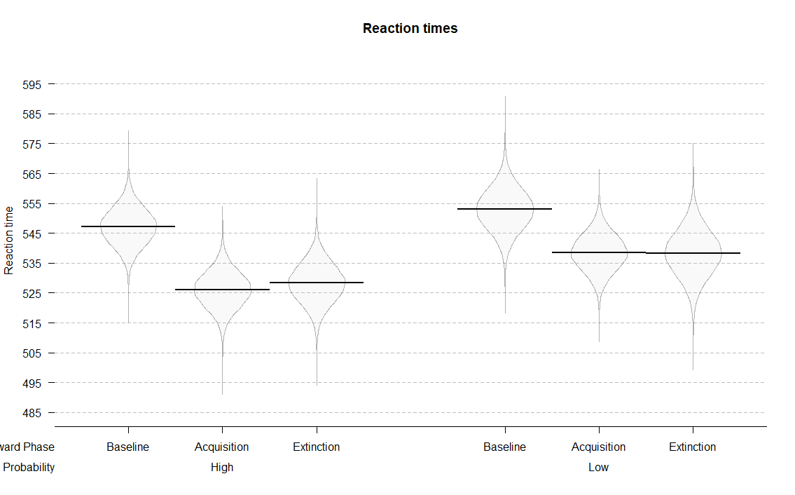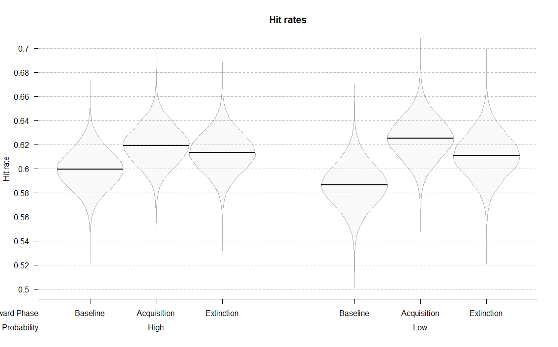

**Figure 4.** Posterior distributions of the interaction models for hit rates and reaction times across conditions.

## Reaction times

The interaction model (Reward phase x Reward probability) also best predicted reaction times (*Table 2*). Participants were reliably faster in the acquisition compared to the baseline phase in both the high rewarded (*M =* -21.16; 95% HDI [-29.79, -12.27]; ER = *Inf.*, i.e. whole posterior distribution above zero) and the low rewarded condition (*M =* -14.47; 95% HDI [-24.71, -4.63]; ER = 332.33). Moreover, this difference was larger in the high compared to low rewarded condition (*M =* -6.69; 95% HDI [-18.01, 4.77]; ER = 7.20). We found little evidence for any changes in reaction times between the acquisition and the extinction phase. Participants were approximately equally fast in acquisition and extinction for both the high (*M =* 2.26; 95% HDI [-6.80, 11.00]; ER = 2.26), and the low reward condition (*M =* -0.15; 95% HDI [-10.86, 10.26]; ER = 1.05).

These results indicate that participants were faster in the condition in which they could earn rewards, and more so in the condition with higher probability of earning a reward. Also, there was no evidence for any changes in reaction times when rewards were no longer available.

Supplementary analyses carried out to assess possible training effects indicated some evidence for the presence of training effects in hit rates and scant evidence for such effects in reaction times. These results can be found in Appendix 1.

## ssVEP amplitudes

We fitted seven models to predict the trial-averaged ssVEP amplitudes (in *µV*) across conditions (*Figure 5* and *Table 4*). The *Null model* included only varying intercepts across subjects. The *Attention model* included the constant effect of attention; the *Reward phase model* included the constant effect of reward phase; the *Reward phase + attention* model included the additive effects of reward phase and attention; and the *Reward phase x attention* model also included the interaction between reward phase and attention. The *Reward probability x reward phase + attention* model consisted of the constant effects of reward probability and phase, their interaction, and the independent effect of attention. The last model was the *Interaction* model which included all constant effects and their interaction (*Reward probability x reward phase x attention*). All models, except for the *Null* *model*, included varying slopes and intercepts across participants for all constant effects. As in the case of behavioral data, several models were not fitted because they were not plausible in the context of our experiment (e.g., the models that include both reward phase and probability, but not their interaction).

|  |  |  |  |
| --- | --- | --- | --- |
| Table 4  *Means and 95% HDIs of recorded ssVEP amplitudes in each condition.* | | | |
| Attention | Reward phase | Reward probability | Amplitudes (µV) |
| Attended | Baseline | High | 1.11 [0.77, 1.42] |
| Attended | Baseline | Low | 1.09 [0.41, 1.44] |
| Attended | Acquisition | High | 1.10 [0.77, 1.50] |
| Attended | Acquisition | Low | 1.04 [0.55, 1.40] |
| Attended | Extinction | High | 1.07 [0.72, 1.47] |
| Attended | Extinction | Low | 1.09 [0.76, 1.59] |
| Unattended | Baseline | High | 0.95 [0.65, 1.43] |
| Unattended | Baseline | Low | 0.89 [0.58, 1.32] |
| Unattended | Acquisition | High | 0.91 [0.57, 1.30] |
| Unattended | Acquisition | Low | 0.90 [0.62, 1.21] |
| Unattended | Extinction | High | 0.93 [0.51, 1.37] |
| Unattended | Extinction | Low | 0.92 [0.60, 1.34] |

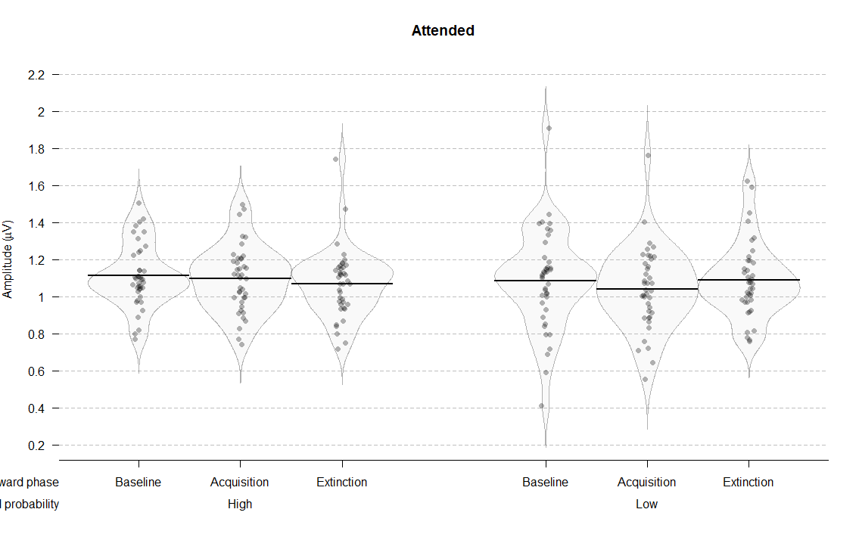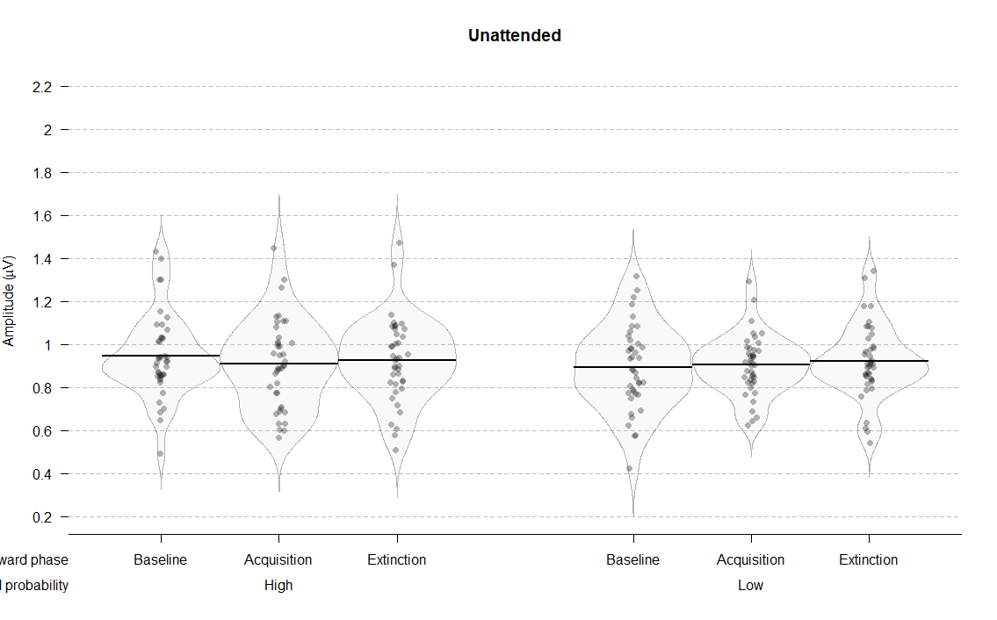

**Figure 5.** Distributions, means, and credible intervals of ssVEP amplitudes per condition.

The interaction model best predicted ssVEP amplitudes across conditions (*Table 5*). This result points to the better predictive ability when all three effects and their interaction is taken into account. The analysis of the posterior distributions of the interaction model (*Figure 5*) revealed a strong effect of attention, thus replicating previous studies.: in all conditions, ssVEP amplitudes were higher for the attended compared to the unattended stimuli. At baseline, the posterior distribution of the difference between attended and unattended stimuli did not include zero, thus resulting in infinite probability that the attended stimuli would elicit higher ssVEP amplitudes compared to the unattended ones (for high reward probability: *M =* 0.17; 95% HDI [0.09, 0.24]; ER = *Inf.*; for low reward probability: *M =* 0.19; 95% HDI [0.11, 0.27]; ER = *Inf.*). In the acquisition phase, amplitudes were higher in the attended condition for both high rewarded (*M =* 0.19; 95% HDI [0.11, 0.27]; ER = *Inf.*) and low rewarded stimuli (*M =* 0.11; 95% HDI [-0.02, 0.23]; ER = 22.81). Similarly, in the extinction phase amplitudes were higher in the attended condition for highly rewarded stimuli (*M =* 0.14; 95% HDI [0.05, 0.23]; ER = 999) and for low rewarded stimuli (*M =* 0.14; 95% HDI [0.00, 0.26]; ER = 51.63). These results reveal a very robust effect of attention across all experimental conditions.

|  |  |  |  |
| --- | --- | --- | --- |
| Table 5  *Model comparison indices for EEG results* | | | |
| Model | *WAIC (SE)* |  | *Bayesian R2 (SE)* |
| Null | -122.16 (38.14) |  | 0.00 (0.00) |
| Reward phase | -115.47 (38.14) |  | 0.02 (0.01) |
| Attention | -211.10 (41.72) |  | 0.21 (0.04) |
| Reward phase + attention | -200.35 (41.10) |  | 0.22 (0.04) |
| Reward phase x attention | -193.05 (40.69) |  | 0.23 (0.04) |
| Reward probability x reward phase + attention | -272.18 (42.75) |  | 0.43 (0.04) |
| Reward phase x reward probability x attention | -300.60 (40.58) |  | 0.53 (0.05) |
|  | | | |

|  |  |  |  |
| --- | --- | --- | --- |
| Table 6  *Means and 95% HDIs of the posterior distributions of the ssVEP amplitudes for each condition.* | | | |
| Attention | Reward phase | Reward probability | Amplitudes (µV) |
| Attended | Baseline | High | 1.11 [1.06, 1.16] |
| Attended | Baseline | Low | 1.09 [1.02, 1.15] |
| Attended | Acquisition | High | 1.10 [1.04, 1.15] |
| Attended | Acquisition | Low | 1.04 [0.97, 1.11] |
| Attended | Extinction | High | 1.07 [1.01, 1.13] |
| Attended | Extinction | Low | 0.95 [0.84, 1.06] |
| Unattended | Baseline | High | 0.95 [0.89, 1.01] |
| Unattended | Baseline | Low | 0.89 [0.83, 0.96] |
| Unattended | Acquisition | High | 0.91 [0.84, 0.97] |
| Unattended | Acquisition | Low | 0.93 [0.82, 1.04] |
| Unattended | Extinction | High | 0.93 [0.85, 1.00] |
| Unattended | Extinction | Low | 0.95 [0.84, 1.06] |

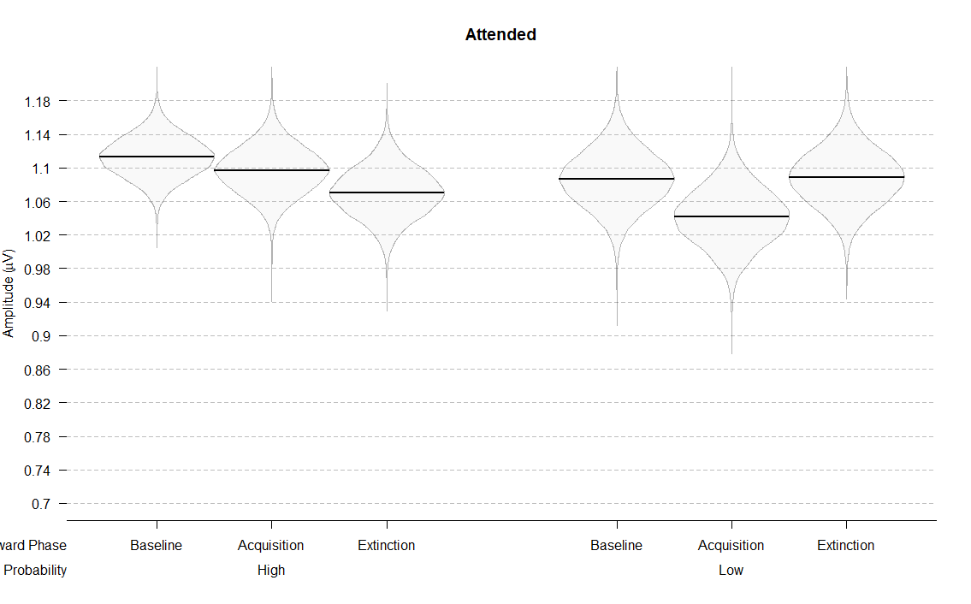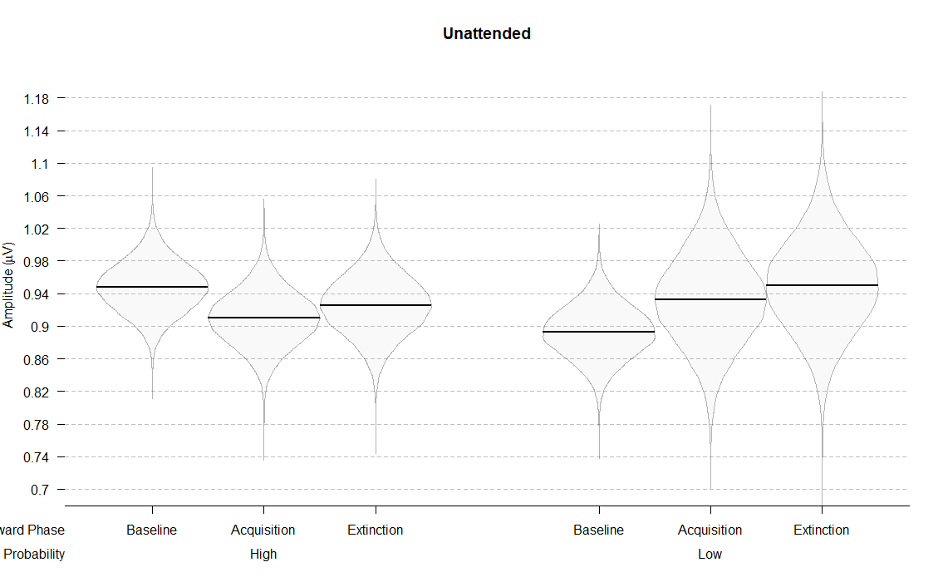

**Figure 5.** Posterior distributions of the interaction models for ssVEP amplitudes across conditions.

The posterior distributions also indicated that reward phase and probability interacted differently across attended and unattended stimuli. Focusing on the attended stimuli first, there was no evidence for a difference between acquisition and baseline when stimuli were highly rewarded (*M =* 0.02; 95% HDI [-0.06, 0.09]; ER = 2.06), but there was weak evidence for lower amplitudes in acquisition when the stimuli were lowly rewarded (*M =* 0.04; 95% HDI [-0.04, 0.12]; ER = 6.69). There was little evidence that the amplitudes were lower in acquisition compared to extinction for the high reward condition (*M =* 0.03; 95% HDI [-0.05, 0.11]; ER = 3.02). For the low reward condition, there was weak evidence that amplitudes were higher in extinction compared to acquisition (*M =* 0.05; 95% HDI [-0.04, 0.14]; ER = 5.80). For the unattended stimuli, the amplitudes slightly lowered from baseline to acquisition in the high rewarded condition (*M =* 0.04; 95% HDI [-0.03, 0.11]; ER = 5.76), but not in the low rewarded condition (*M =* 0.04; 95% HDI [-0.10, 0.18]; ER = 2.48). Amplitudes did not reliably change from acquisition to extinction for neither the high reward (*M =* 0.02; 95% HDI [-0.07, 0.11]; ER = 1.78) nor the low reward condition (*M =* 0.02; 95% HDI [-0.07, 0.11]; ER = 1.88).

To summarize, in the attended condition ssVEP amplitudes did not change across reward phases for high rewarded stimuli. However, for low rewarded stimuli, there was some evidence that they lowered from baseline to acquisition and increased from acquisition to extinction. For the unattended condition, amplitudes elicited by the low rewarded color did not change across reward phases. For the high rewarded color, there was some evidence that amplitudes decreased from baseline to acquisition and increased from acquisition to extinction.

We also observed an unexpected (albeit weak) baseline difference between the two reward probability conditions, both in the unattended (*M =* 0.05; 95% HDI [-0.03, 0.14]; ER = 8.90) and attended conditions (*M =* 0.03; 95% HDI [-0.06, 0.11]; ER = 2.73). This was surprising because participants had no way of knowing which color would be rewarded in the acquisition phase; in addition, they were informed about the possibility of earning rewards only when they completed the baseline phase. However, this baseline difference does not affect our results given that our comparisons of interest are between reward phases for the same reward probability.

# Discussion

# Appendix 1

In order to assess potential training effects on behavioral performance, we split each reward phase into two halves (*Supplementary Figure 1* and *Supplementary Table 1*). If training effects were influencing the behavioral outcome, we could expect performance improvement through baseline and acquisition. To investigate this possibility, we fitted the *Interaction model* that was identical as the one described in the results section. We then compared behavioral performance between the first and the second part of the baseline phase, and between the second part of baseline and the first part of acquisition phase.

|  |  |  |  |
| --- | --- | --- | --- |
| Supplementary Table 1  *Means and 95% HDIs of hit rates and reaction times across six phases of the experiment* | | | |
| Reward phase | Reward probability | Hit rates (proportion) | Reaction times (milliseconds) |
| Baseline1 | High | 0.59 [0.28, 0.76] | 548.80 [471.00, 613.76] |
| Baseline1 | Low | 0.57 [0.25, 0.85] | 551.68 [458.26, 629.69] |
| Baseline2 | High | 0.62 [0.37, 0.81] | 546.07 [443.45, 620.36] |
| Baseline2 | Low | 0.61 [0.41, 0.78] | 554.75 [479.48, 650.73] |
| Acquisition1 | High | 0.61 [0.33, 0.80] | 522.80 [437.90, 604.61] |
| Acquisition1 | Low | 0.64 [0.47, 0.86] | 541.89 [457.58, 593.47] |
| Acquisition2 | High | 0.64 [0.31, 0.76] | 529.67 [462.00, 598.58] |
| Acquisition2 | Low | 0.63 [0.45, 0.79] | 536.08 [471.00, 618.25] |
| Extinction1 | High | 0.62 [0.33, 0.77] | 529.58 [457.88, 596.17] |
| Extinction1 | Low | 0.61 [0.43, 0.85] | 535.20 [444.89, 629.69] |
| Extinction2 | High | 0.62 [0.28, 0.78] | 526.88 [456.00, 639.89] |
| Extinction2 | Low | 0.62 [0.35, 0.78] | 541.75 [450.11, 633.28] |

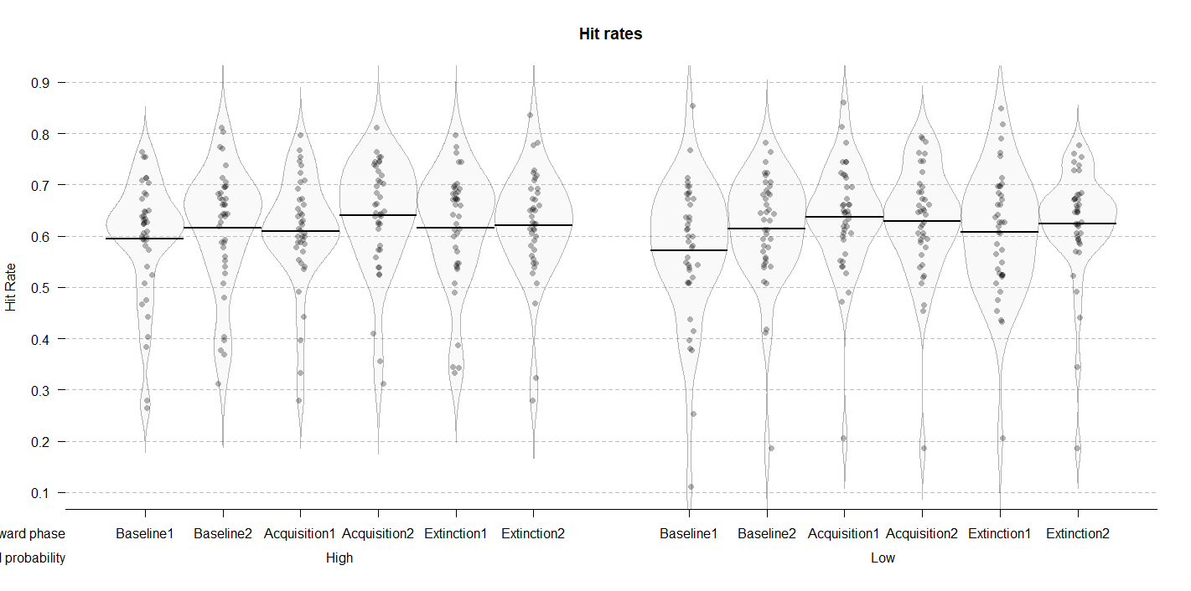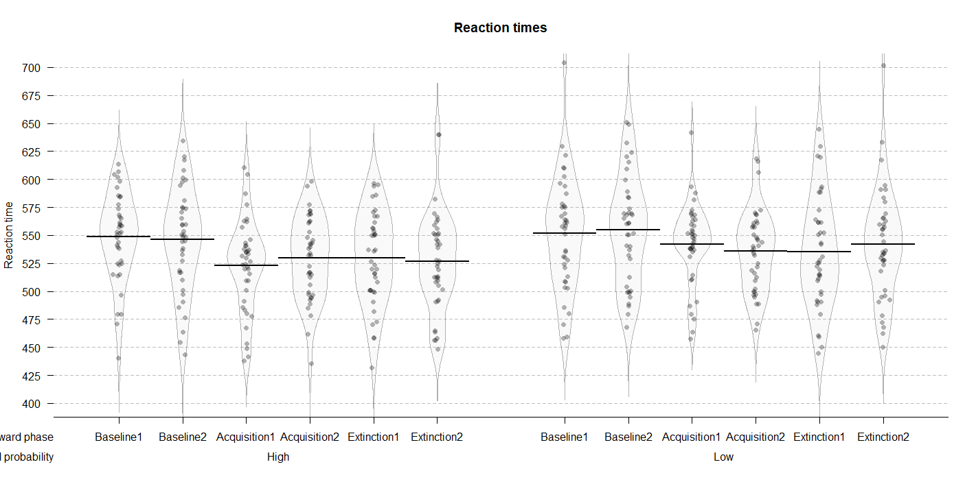

**Supplementary Figure 1.** Distributions and means of raw hit rates and reaction times per condition.

The posterior distributions for hit rates (*Supplementary Figure 2* and *Supplementary Table 2*) revealed performance improvement from the first to the second part of the baseline for both high (*M =* 0.02; 95% HDI [-0.01, 0.05]; ER = 7.77) and low (*M =* 0.04; 95% HDI [0.01, 0.08]; ER = 141.86) reward probability conditions. When comparing the second part of baseline to the first part of acquisition, there was no difference in the high reward probability condition (*M =* 0.01; 95% HDI [-0.03, 0.04]; ER = 1.82). However, in the low probability condition, hit rates were higher in the first part of acquisition (*M =* 0.03; 95% HDI [-0.01, 0.06]; ER = 9.31). These results indicate that participants improved not only throughout the baseline phase, but also from the end of baseline to the first part of the acquisition (albeit for low rewarded color only). This can indicate some presence of training effects on the accuracy data.

The posterior distributions of reaction times (*Supplementary Figure 2* and *Supplementary Table 2*) revealed no differences between the first and the second part of baseline for neither high (*M =* 2.74; 95% HDI [-8.78, 13.75]; ER = 2.17), nor low (*M =* 3.08; 95% HDI [-8.53, 14.75]; ER = 2.37) reward probability condition. The comparison between the second part of baseline and the first part of acquisition revealed a very reliable improvement in both high (*M =* 23.34; 95% HDI [12.06, 35.22]; ER = *Inf.*) and low (*M =* 12.86; 95% HDI [1.09, 25.28]; ER = 54.55) reward probability conditions. These results clearly point to the absence of training effects in reaction time data.

Taken together, these results indicate that our effects were not driven by the improved performance over the course of the task. Although there is some evidence that hit rates were improving during the baseline phase, reaction times clearly indicate that the main shift in performance happens in the beginning of acquisition, when rewards are introduced. Importantly, the strongest behavioral effects in our study were found on the reaction time data, as indicated in the results section.

|  |  |  |  |
| --- | --- | --- | --- |
| Table 2  *Means and 95% HDIs of the posterior distributions of the ssVEP amplitudes for each of the conditions* | | | |
| Reward phase | Reward probability | Hit rates (proportion) | Reaction times (milliseconds) |
| Baseline 1 | High | 0.59 [0.56, 0.63] | 548.95 [535.99, 561.51] |
| Baseline 1 | Low | 0.62 [0.58, 0.65] | 546.20 [531.50, 560.00] |
| Baseline 2 | High | 0.57 [0.53, 0.61] | 551.83 [537.82, 566.18] |
| Baseline 2 | Low | 0.61 [0.57, 0.65] | 554.91 [539.42, 571.04] |
| Acquisition 1 | High | 0.61 [0.57, 0.64] | 522.87 [509.89, 535.59] |
| Acquisition 1 | Low | 0.64 [0.60, 0.67] | 529.79 [516.87, 542.59] |
| Acquisition 2 | High | 0.64 [0.60, 0.68] | 542.05 [528.28, 556.21] |
| Acquisition 2 | Low | 0.63 [0.59, 0.67] | 536.26 [521.92, 549.75] |
| Extinction 1 | High | 0.62 [0.58, 0.65] | 529.68 [515.80, 543.76] |
| Extinction 1 | Low | 0.62 [0.58, 0.66] | 526.96 [512.84, 540.61] |
| Extinction 2 | High | 0.61 [0.56, 0.65] | 535.39 [518.62, 552.17] |
| Extinction 2 | Low | 0.62 [0.58, 0.67] | 541.87 [525.02, 557.85] |

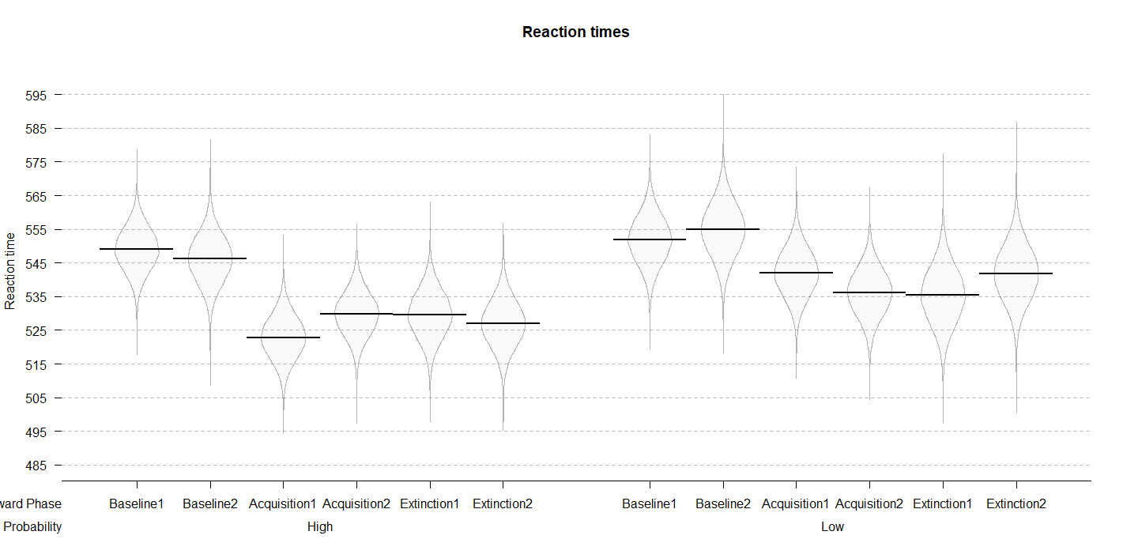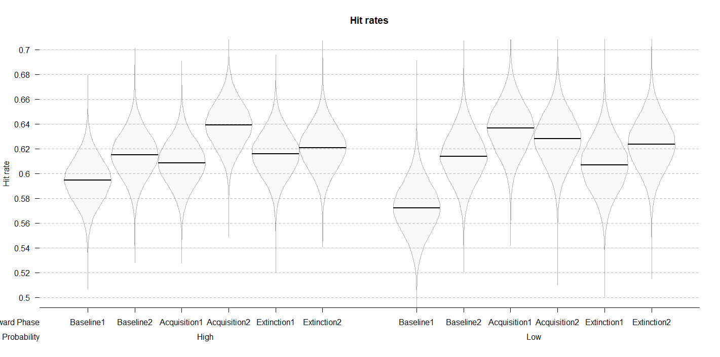

**Figure 2.** Posterior distributions of the interaction models for hit rates and reaction times across six reward phase conditions.

Similar analyses could not have been performed for the EEG data. Splitting the number of trials in each phase into two would significantly affect our signal-to-noise ratio. However, our EEG results point to the changes in the ssVEP amplitudes in only one of the reward probability conditions. If changes in the amplitudes were mainly driven by training effects, the differences across reward phases would be expected for both reward probability conditions. This observation, combined with the lack of strong training effects in behavior, suggests that our EEG results are not driven by training effects.

## Software for data visualization and analysis

Visualization and statistical analyses were performed using R v3.4.4 (R Core Team, 2017) via RStudio v1.1.453 (RStudio Team, 2015). We used the following packages (and their respective dependencies):

• data manipulation: tidyverse v1.2.1 (Wickham, 2017);

• statistical analyses: Rmisc v1.5 (Hope, 2013), brms v2.3.1 (Bürkner, 2016);

• visualization: cowplot v0.9.2 (Wilke, 2016), yarrr v0.1.5 (Phillips, 2016), viridis v0.5.1 (Garnier, 2018), eegUtils v0.2.0 (Craddock, 2018), BEST (J. K. Kruschke & Meredith, 2017);

• report generation: pacman v0.4.6 (Rinker & Kurkiewicz, n.d.), knitr v1.20 (Xie, 2018).

# Acknowledgements

This work was supported by the Special Research Fund (BOF) of Ghent University [grant #01D02415 awarded to IG; grant # BOF14/PDO/123 awarded to AS] and the Concerted Research Action Grant of Ghent University [grant number BOF16/GOA/017 awarded to EHWK]. Add funding for Gilles and Søren. The funding sources had no involvement in the study design; collection, analysis, and interpretation of data; writing of the report; and decision to submit the article for publication.

We would like to thank Ladislas Nalborczyk for discussions about statistical analyses of the data and Dr. Inez Greven for help with data collection.

# Author contributions

IG, AS, and SKA conceived the study. SKA and IG programmed the experimental paradigm. SKA, GP, and EHWK contributed reagents/materials/tools. IG collected the data, supervised by AS. IG and AS analyzed the data. IG and AS wrote the main manuscript text. IG, AS, GP, EHWK, and SKA reviewed and critically revised the manuscript.

# Data availability

Raw and pre-processed data, materials, and analysis scripts are available at <https://osf.io/xxxxx/>. (use as template: https://osf.io/9dcsm/)

# References

Andersen, S. K., & Müller, M. M. (2010). Behavioral performance follows the time course of neural facilitation and suppression during cued shifts of feature-selective attention. *Proceedings of the National Academy of Sciences of the United States of America*, *107*(31), 13878–13882. https://doi.org/10.1073/pnas.1002436107

Bürkner, P.-C. (2016). brms: An R package for Bayesian multilevel models using Stan. *Journal of Statistical Software*, *80*(1), 1–28.

Carpenter, B., Gelman, A., Hoffman, M., Lee, D., Goodrich, B., Betancourt, M., … Riddell, A. (2016). Stan: A probabilistic programming language. *Journal of Statistical Software*, *2*(20), 1–37.

Chatrian, G. E., Lettich, E., & Nelson, P. L. (1985). Ten percent electrode system for topographic studies of spontaneous and evoked EEG activities. *American Journal of EEG Technology*, *25*(2).

Craddock, M. (2018). craddm/eegUtils: eegUtils (Version v0.2.0). Zenodo.

Delorme, A., & Makeig, S. (2004). EEGLAB: an open sorce toolbox for analysis of single-trail EEG dynamics including independent component anlaysis. *Journal of Neuroscience Methods*, *134*, 9–21. https://doi.org/10.1016/j.jneumeth.2003.10.009

Franken, I. H. A., Muris, P., & Rassin, E. (2005). Psychometric properties of the Dutch BIS/BAS scales. *Journal of Psychopathology and Behavioral Assessment*, *27*(1), 25–30. https://doi.org/10.1007/s10862-005-3262-2

Garnier, S. (2018). viridis: Default Color Maps from ‘matplotlib.’ R package version 0.3.

Gelman, A., Goodrich, B., Gabry, J., & Ali, I. (2017). R-squared for Bayesian regression models. *Unpublished via Http://Www. Stat. Columbia. Edu/~ Gelman/Research/Unpublished.* Retrieved from http://www.stat.columbia.edu/~gelman/research/unpublished/bayes_R2.pdf

Gelman, A., & Rubin, D. B. (1992). Inference from Iterative Simulation Using Multiple Sequences. *Statistical Science*, *7*(4), 457–472. https://doi.org/10.1214/ss/1177011136

Hope, R. M. (2013). Rmisc: Ryan miscellaneous. R package version, 1(5).

Junghöfer, M., Elbert, T., Tucker, D. O. N. M., & Rockstroh, B. (2000). Statistical control of artifacts in dense array EEG 0 MEG studies. *Wiley Online Library*, 523–532. Retrieved from http://onlinelibrary.wiley.com/doi/10.1111/1469-8986.3740523/full

Kruschke, J. K. (2014). *Doing Bayesian data analysis: A tutorial with R, JAGS, and Stan, second edition*. *Doing Bayesian Data Analysis: A Tutorial with R, JAGS, and Stan, Second Edition* (2nd ed.). Elsevier Inc. https://doi.org/10.1016/B978-0-12-405888-0.09999-2

Kruschke, J. K., & Meredith, M. (2017). BEST: Bayesian Estimation Supersedes the t-Test.

McElreath, R. (2016). *Statistical Rethinking: A Bayesian Course with Examples in R and Stan*. Chapman Hall - CRC.

Nolan, H., Whelan, R., & Reilly, R. B. (2010). FASTER: Fully Automated Statistical Thresholding for EEG artifact Rejection. *Journal of Neuroscience Methods*, *192*(1), 152–162. https://doi.org/10.1016/j.jneumeth.2010.07.015

Perrin, F., Pernier, J., Bertrand, O., & Echallier, J. F. (1989). Spherical splines for scalp potential and current density mapping. *Electroencephalography and Clinical Neurophysiology*, *72*(2), 184–187. https://doi.org/10.1016/0013-4694(89)90180-6

Phillips, N. (2016). Yarrr: A companion to the e-book YaRrr!: The Pirate’s Guide to R. R package version 0.1.

R Core Team. (2017). R: A Language and Environment for Statistical Computing. R Foundation for Statistical Computing.

Rinker, T., & Kurkiewicz, D. (n.d.). pacman: Package Management for R.

RStudio Team. (2015). Integrated Development for R. RStudio, Inc.

Van der Does, A. J. W. (2002). *Handleiding bij de Nederlandse versie van beck depression inventory—second edition (BDI-II-NL). [The Dutch version of the Beck depression inventory].* Amsterdam: Harcourt.

Watanabe, S. (2010). Asymptotic Equivalence of Bayes Cross Validation and Widely Applicable Information Criterion in Singular Learning Theory, *11*, 3571–3594. Retrieved from http://arxiv.org/abs/1004.2316

Wickham, H. (2017). Tidyverse: Easily install and load ’tidyverse’ packages. R package version, 1(1).

Wilke, C. O. (2016). cowplot: streamlined plot theme and plot annotations for ‘ggplot2.’ CRAN Repos.

Xie, Y. (2018). knitr: A General-Purpose Package for Dynamic Report Generation in R.