Working title: Feature-based Attention and Reward: Insights from Steady-state Visually Evoked Potentials

Ivan Grahek1☨*, Antonio Schettino1,2☨, Gilles Pourtois1, Ernst H.W. Koster1,

& Søren K. Andersen3

1. *Department of Experimental Clinical and Health Psychology, Ghent University, Henri Dunantlaan 2, B-9000, Ghent, Belgium*
2. *Institute for Globally Distributed Open Research and Education (IGDORE)*
3. *School of Psychology, University of Aberdeen, William Guild Building, Aberdeen, AB24 3FX, United Kingdom*

# Abstract

# Introduction

# Methods

## Participants

We tested 48 participants with normal or corrected-to-normal vision and no history of psychiatric or neurological disorders. Due to technical problems (4) or excessive artifacts (4) in the EEG recordings, 8 participants were excluded. Thus, the final data set consisted out of 40 participants (XX female; median age). Participants received 20€ plus up to 6€ extra as monetary rewards (on average 25,5€). The study was approved by the ethics committee of Ghent University.

## Stimuli and task

We used the Random Dot Kinematogram (RDK) task (Andersen & Müller, 2010) in which participants were presented with two overlapping circular RDKs of isoluminant colors (red and blue) on grey background. Viewing distance was fixed with a chinrest to 80cm from the 21-inch CRT screen (1024 X 768 and 120 Hz refresh rate). The two RDKs consisted out of 125 randomly and independently moving dots (size and visual angle). The size of the cloud was XXX degrees of visual angle. Each RDK was flickering at a different frequency (10 or 12Hz). The mapping between color and frequency was counterbalanced across participants. On one third of trials most of the dots (75%) moved coherently in one of the RDKs (up, down, left, or right). Participants’ task was to detect the coherent movement as fast as possible by pressing the space key on keyboard. Response time was limited to 1500ms. At the beginning of each trial, participants were instructed by a verbal audio cue (“red” vs. “blue”) which of the two RDKs to attend. Each trial could contain zero, one, two, or three coherent movements. Correct responses were followed by a tone (1 s sine wave of either 800 or 1200 Hz, counterbalanced across participants). Responses that were too late or incorrect were followed by a 1 s square wave tone of 400 Hz.

The experiment started with 4 practice blocks of 60 trials. After each block participants received feedback on their performance (percentage of correctly detected movements and percentage of correct responses). After finishing the practice phase participants completed 12 blocks of the experiment divided into 3 phases. The first phase was the baseline in which participants were doing the described task. In the second phase the task was the same, but participants were instructed that they can earn additional monetary rewards (up to 6€) based on their performance. They were instructed that one of the colors is paired with high probability (80%) and the other color is paired with low probability (20%) of earning 10 extra cents for each correct detection. The receipt of the reward was signaled by a new tone that replaced the usual correct tone. If the correct tone was a sine wave of 800Hz the reward tone was a sine wave of 1200Hz and vice versa. At the end of each of the 4 blocks of the reward phase participants got feedback on their performance and feedback on the amount of extra money earned within the block. The third phase was the extinction phase that was the same as baseline and participants could not earn any monetary rewards. The whole task lasted for approximately 50 minutes (including EEG preparation the participants were in the lab for 1:45 hours) and participants were encouraged to take brakes in between the blocks. Upon completing the task, participants filled-in two questionnaires in order to measure reward sensitivity (BIS-BAS; Franken et al., 2005) and depression levels (BDI-II; Van der Does, 2002).

## EEG recording and pre-processing

Electroencephalographic activity (EEG) was recorded with an ActiveTwo amplifier (BioSemi, Inc., The Netherlands) at a sampling rate of 512 Hz and online band-pass filtered at 0.016 – 100 Hz. Sixty-four Ag/AgCl electrodes were fitted into an elastic cap, following the international 10/10 system (Chatrian, Lettich, & Nelson, 1985). The common mode sense (CMS) active electrode and the driven right leg (DRL) passive electrode were used as reference and ground electrodes, respectively. Additional external electrodes were applied to the left and right mastoids, as well as on the outer canthi of each eye and in the inferior and superior areas of the left orbit (to record horizontal and vertical electrooculogram, EOG).

Data pre-processing was performed offline with custom MATLAB scripts and functions included in EEGLAB v14.1.1b (Delorme & Makeig, 2004). After subtracting the mean value of the signal (DC offset), the continuous EEG data were epoched between 0 and 3,250 ms, corresponding to the beginning and end of the RDK trial, respectively. After referencing to *Cz*, FASTER v1.2.3b (Nolan, Whelan, & Reilly, 2010) was used for artifact identification and rejection using the following settings: (i) over the whole EEG signal, channels with variance, mean correlation, and Hurst exponent exceeding *z* = ±3 were interpolated via a spherical spline procedure (Perrin, Pernier, Bertrand, & Echallier, 1989); (ii) the mean across channels was computed for each epoch and, if amplitude range, variance, and channel deviation exceeded *z* = ±3, the whole epoch was removed; (iii) within each epoch, channels with variance, median gradient, amplitude range, and channel deviation exceeding *z* = ±3 were interpolated; (iv) grand-averages with amplitude range, variance, channel deviation, and maximum EOG value exceeding *z* = ±3 were removed; (v) epochs containing more than 12 interpolated channels were discarded. All remaining epochs were scanned with SCADS (Junghöfer, Elbert, Tucker, & Rockstroh, 2000) and rejected when flagged as artefactual. For details, see our commented code at <https://osf.io/xxxxx/>. After pre-processing, the average number of interpolated channels was 4.08 (*SD* = 1.75, range 0 – 7) and the mean percentage of rejected epochs was 9.74% (*SD* = 6.77, range 0 – 32.50; similar rejection rate across conditions). After re-referencing to averaged mastoids, trials in each condition were averaged separately for each participant, resulting in the following grand-averages: (i) baseline, red attended; (ii) baseline, blue attended; (iii) acquisition, red attended; (iv) acquisition, blue attended; (v) extinction, red attended; (vi) extinction, blue attended.

Electrodes with maximum ssVEP amplitudes were identified by calculating isocontour voltage maps based on grand-averaged data collapsed across all conditions. As shown in *Figure 2*, activity was mainly localized at central occipital channels (i.e., Oz, POz, O2, PO3). To account for inter-individual variations in topographical ssVEP amplitude distributions, we identified and averaged activity from the four electrodes displaying, for each participant, the largest frequency-specific amplitude. After removing linear trends, we extracted ssVEP amplitude at 10 and 12 Hz from each individual electrode cluster, separately for each condition (averaged across trials). Fast Fourier Transforms on the EEG signal in a time window from 500 ms (to exclude the typically strong phasic visual evoked response to picture onset) to 3,250 ms after stimulus onset was applied, and amplitudes were obtained by extracting the absolute values of the resulting complex Fourier coefficients. The amplitudes were normalized for each subject and each frequency by dividing amplitudes by the average amplitude for all conditions.

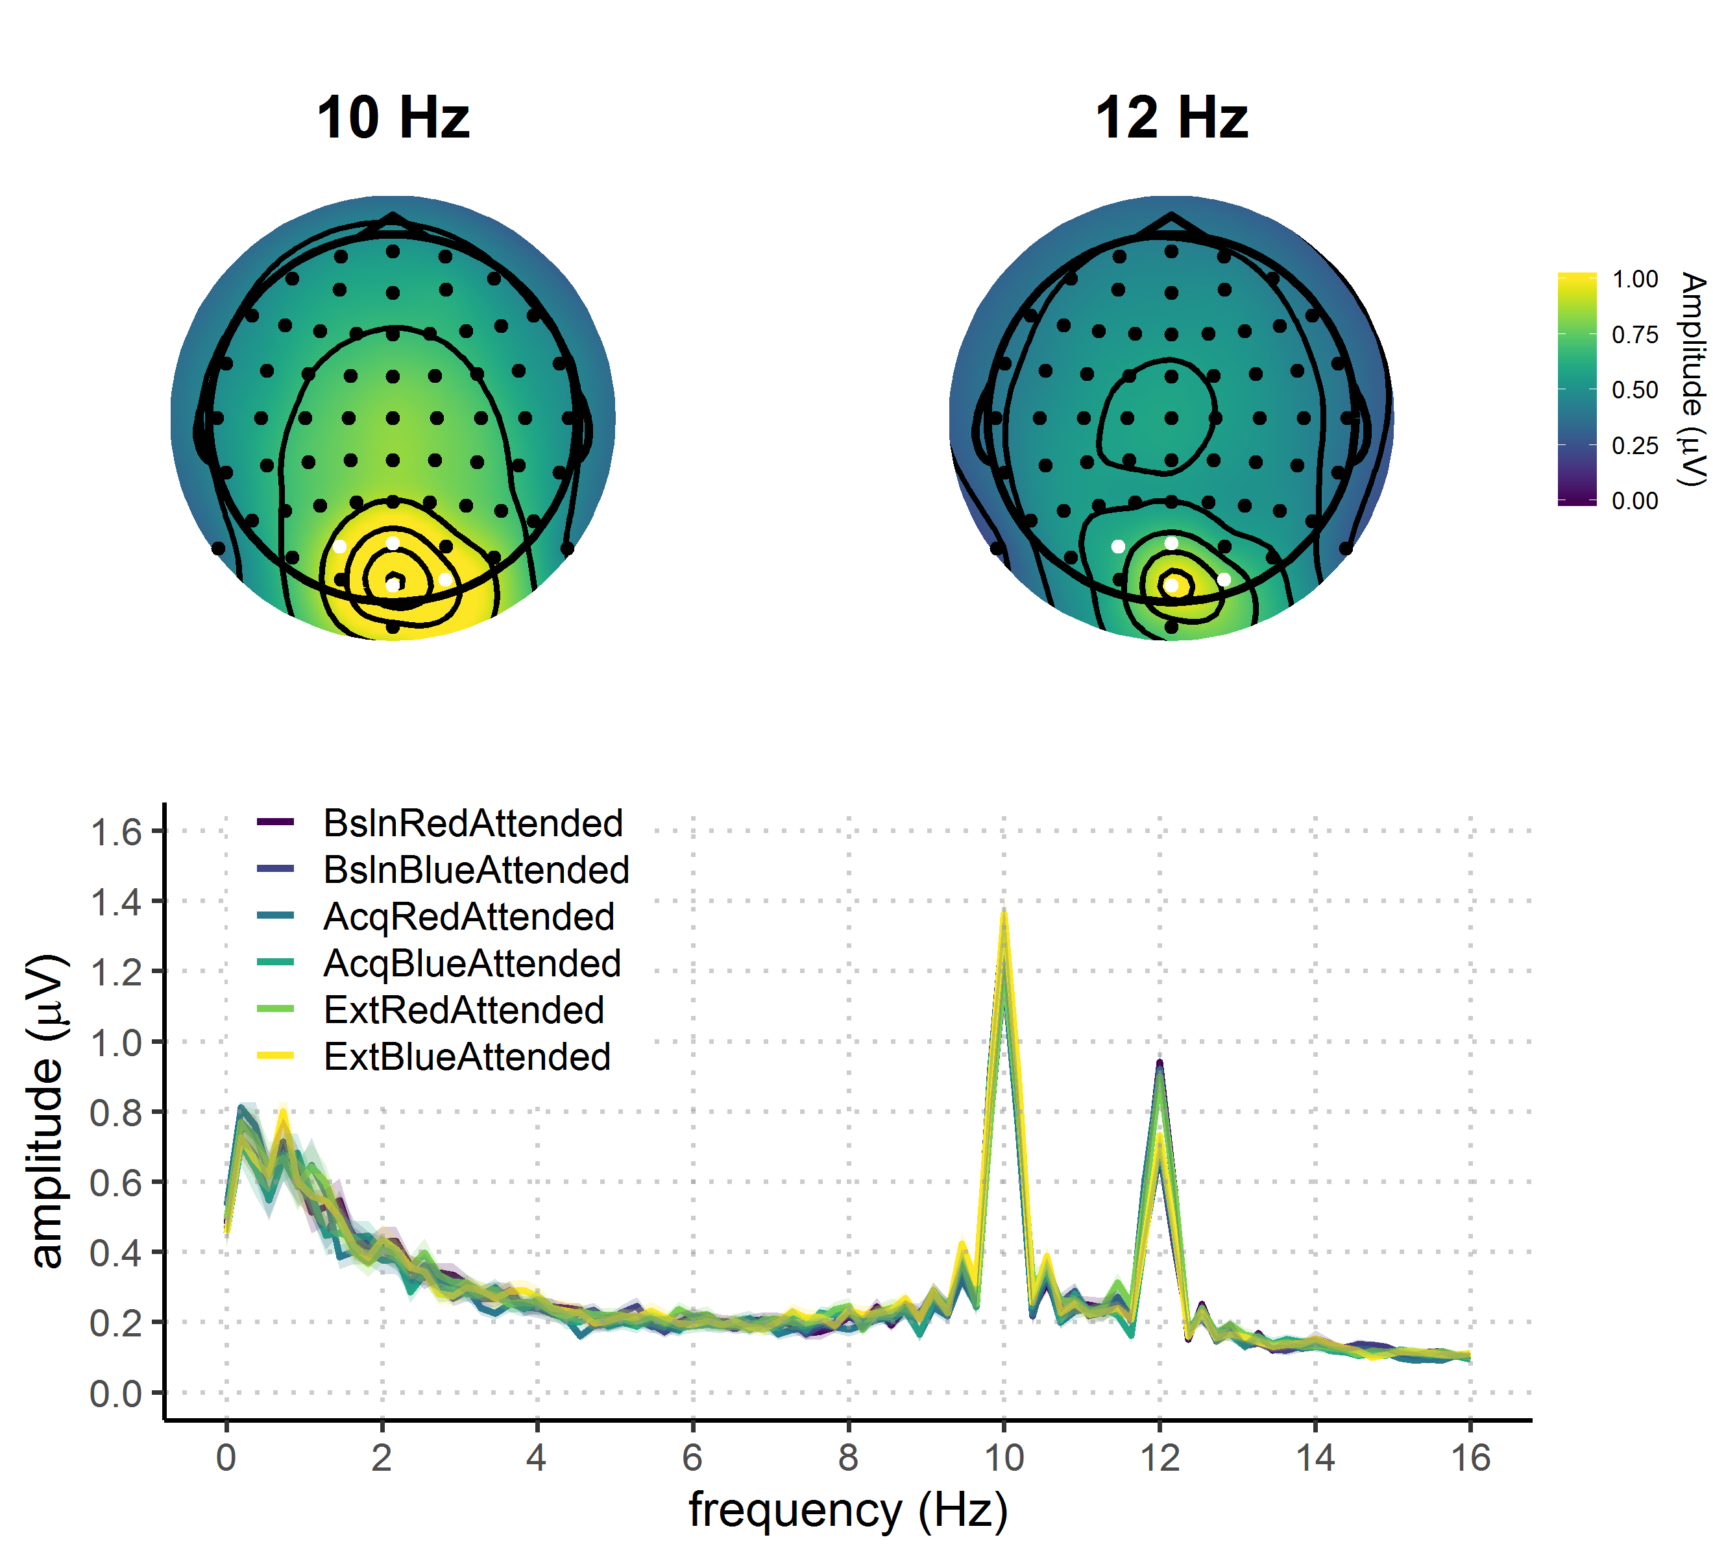

**Figure 2.** Grand average FFT-amplitude spectra derived from EEG signals at each participant's best four-electrode cluster for the 10 and 12 Hz signal.

## Statistical analyses

Behavioral and EEG data were analyzed using bayesian multilevel regressions. We fitted and compared multiple models of varying complexity to predict hit rates, reaction times, and SSVEP amplitudes. Each of the fitted models included both constant and varying effects (also known as fixed and random). Both EEG signal and behavioral performance are known to be dependent upon participant-specific characteristic (e.g., skull thinness, skin conductance, and hair; speed of responding etc.) therefore we decided to model this variability by adding varying intercepts in our models. Additionally, the studied effects (e.g., reward sensitivity and selective attention) are known to vary in magnitude over participants so we opted for including varying slopes in our models. Models were fitted using the R package *brms* (Bürkner, 2016) that employs the probabilistic programming language *Stan* (Carpenter et al., 2016)to implement Markov Chain Monte Carlo (MCMC) algorithms in order to estimate posterior distributions of the parameters of interest. Each of the models was fitted using weakly regularizing prior distributions (default priors in *brms* were used) and Gaussian likelihood. Four MCMC simulations (“chains”) with 10000 iterations (2000 warmup) and a thinning interval of 1 were run to estimate parameters in each of the fitted models. Further analyses were done following the recommendations for Bayesian multilevel modeling using *brms* (Nalborczyk et al., 2018). We have confirmed that all of the models have converged well by examining the trace plots, autocorrelation, and the variance between chains (Gelman-Rubin statistic; Gelman & Rubin, 1992). We compared models based on their fit to the actual data using the Bayesian *R*2 (Gelman, Goodrich, Gabry, & Ali, 2017), and their out-of-sample predictive performance using the Widely Applicable Information Criterion (WAIC; Watanabe, 2010). The best model was selected and the posterior distribution of parameters and conditions of interest was examined. Differences between conditions of interest were assessed by computing the mean and the 95% highest density interval (HDI) of the difference distribution between posterior distributions of the respective conditions (Kruschke, 2014). Additionally, we calculated the evidence ratios (ERs) for our hypotheses as the ratios between the percentage of posterior samples on each side of the zero of a difference distribution between two conditions. ERs can be interpreted as the probability of a hypothesis (e.g. “Condition A is larger than condition B”) against its alternative (“Condition B is larger than condition A”).

# Results

## Behavioral results

We fitted three models to predict both hit rates (proportion of hits) and reaction times (milliseconds) separately (Figure 3). First we fitted the *Null model* with no constant effects and varying intercepts across subject. This model was fitted in order to investigate the possibility that the data is best explained just random by variation between subjects. In order to investigate the effect of phase we fitted the *Reward phase model* that included only reward phase as the constant predictor and varying intercepts and slopes across subjects for this effect. To investigate the possible interaction between reward phase and reward probability, we fitted the *Interaction model* with these two effects and their interaction as constant effects. The intercepts and slopes of main effects and their interaction were allowed to vary across participants. It is important to note there that there are two additional models that, although possible to fit, do not make sense in the context of our experiment. The model with only the effect of reward probability overlooks the fact that this effect will necessarily be most pronounced in the acquisition phase, thus interacting with the effect of reward phase. The same logic applies to the model with additive effects of reward phase and probability.

## Hit rates

Raw hit rates are given in table in and figure

|  |  |  |  |
| --- | --- | --- | --- |
| Table 1  *Means and 95% HDIs of raw hit rates and reaction times* | | | |
| Reward phase | Reward probability | Hit rates (proportion) | Reaction times (milliseconds) |
| Baseline | High | 0.60 [0.32, 0.70] | 547.18 [460.9, 612.74] |
| Baseline | Low | 0.59 [0.32, 0.70] | 552.93 [470.68, 631.36] |
| Acquisition | High | 0.62 [0.37, 0.80] | 526.00 [457.23, 599.49] |
| Acquisition | Low | 0.63 [0.47, 0.77] | 538.41 [465.32, 605.14] |
| Extinction | High | 0.61 [0.32, 0.74] | 528.21 [448.5, 599.83] |
| Extinction | Low | 0.61 [0.39, 0.79] | 538.21 [464.21, 642.55] |

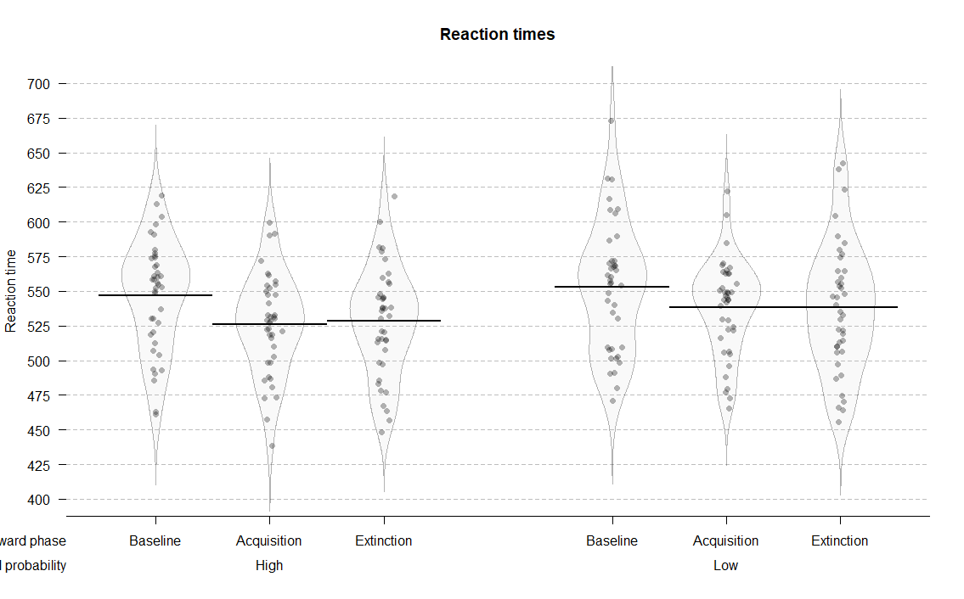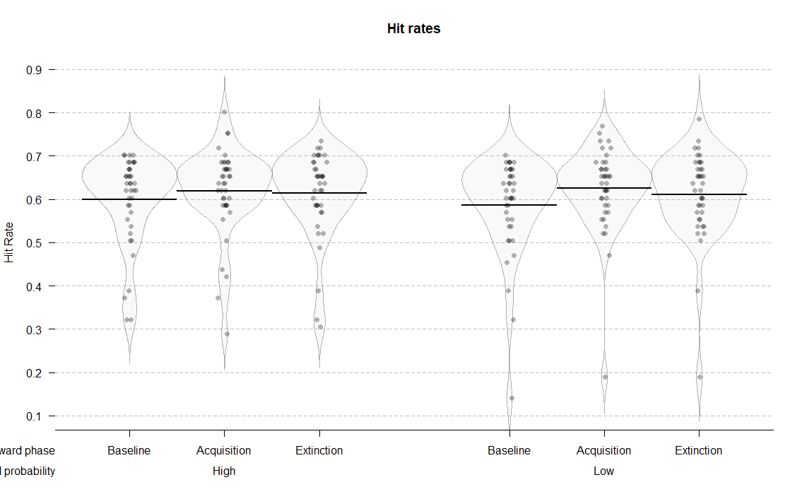

**Figure 3.** Distributions and means of raw hit rates and reaction times per condition.

Of all the tested models…The interaction model best predicted the hit rates (Table 1). This result points to the importance of the interaction between reward phase and reward probability in predicting hit rates. The posterior distribution of the interaction model (Figure 4) revealed that hit rates improved in the acquisition phase compared to the baseline for both low (*M =* 0.04; 95% HDI [0.02, 0.06]; ER = 999.00) than for the high rewarded color (*M =* 0.02; 95% HDI [0.00, 0.04]; ER = 33.48). This change was more pronounced for low than for the high condition (*M =* 0.02; 95% HDI [-0.01, 0.05]; ER = 8.43). The evidence for the difference between the acquisition and the extinction phase was much weaker. Participants were less accurate in the extinction phase compared to the acquisition phase in the low rewarded condition (*M =* -0.01; 95% HDI [-0.04, 0.01]; ER = 8.43), while there was very little difference in the high rewarded condition (*M =* -0.01; 95% HDI [-0.03, 0.02]; ER = 2.42). These results suggest that the participants were reliably more accurate in the acquisition phase compared to baseline, and more so for the low rewarded color. There was also evidence for the drop in their accuracy in the extinction phase for the low rewarded, but not high rewarded color.

|  |  |  |  |  |
| --- | --- | --- | --- | --- |
| Table 2  *Model comparison indices for behavioral results* | | | | |
| Model/Model comparison | | *WAIC (SE)* | | *Bayesian R2 (SE)* |
| *Hit rates* | | | | |
| Null | | -475.41 (32.92) |  | 0.34 (0.05) |
| Reward phase | | -471.65 (33.43) |  | 0.36 (0.05) |
| Interaction | | -709.13 (23.99) |  | 0.82 (0.03) |
| *Reaction times* |
| Null | | 2346.29 (32.74) |  | 0.49 (0.04) |
| Reward phase | | 2329.70 (35.38) |  | 0.56 (0.04) |
| Interaction | | 2154.64 (25.19) |  | 0.84 (0.03) |

|  |  |  |  |
| --- | --- | --- | --- |
| Table 3  *Means and 95% HDIs of the posterior distributions of reaction times and hit rates for each of the conditions* | | | |
| Reward phase | Reward probability | Hit rates (proportion) | Reaction times (milliseconds) |
| Baseline | High | 0.60 [0.57, 0.63] | 547.19 [534.84, 559.56] |
| Baseline | Low | 0.59 [0.55, 0.62] | 552.97 [539.22, 567.24] |
| Acquisition | High | 0.62 [0.59, 0.65] | 526.03 [513.90, 538.04] |
| Acquisition | Low | 0.63 [0.59, 0.66] | 538.5 [525.69, 550.34] |
| Extinction | High | 0.61 [0.58, 0.65] | 528.29 [515.32, 541.69] |
| Extinction | Low | 0.61 [0.57, 0.65] | 538.35 [522.97, 554.23] |

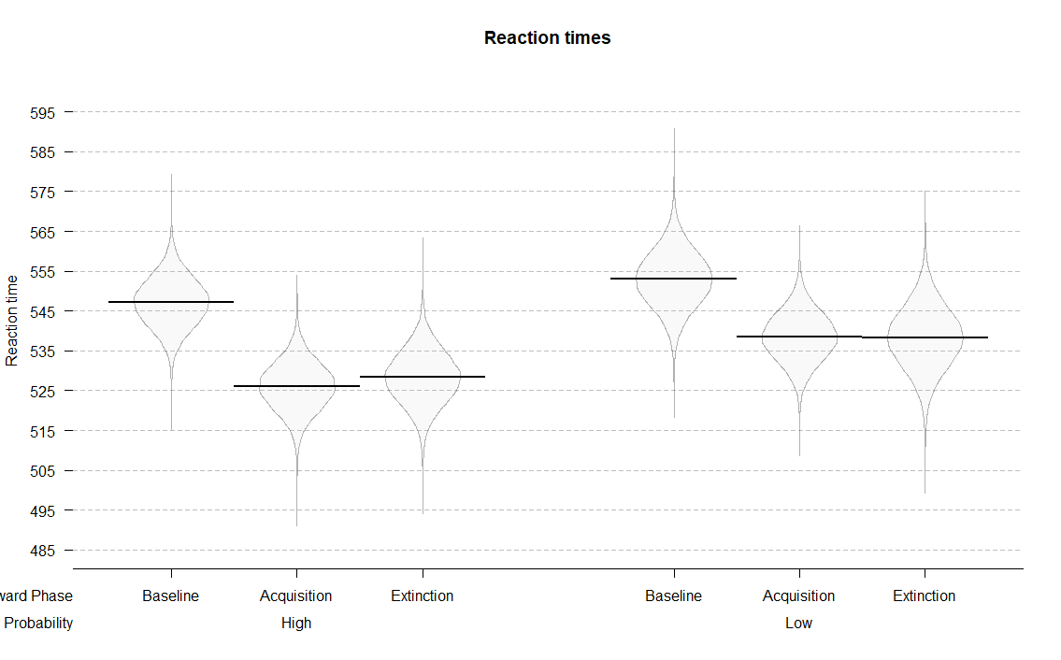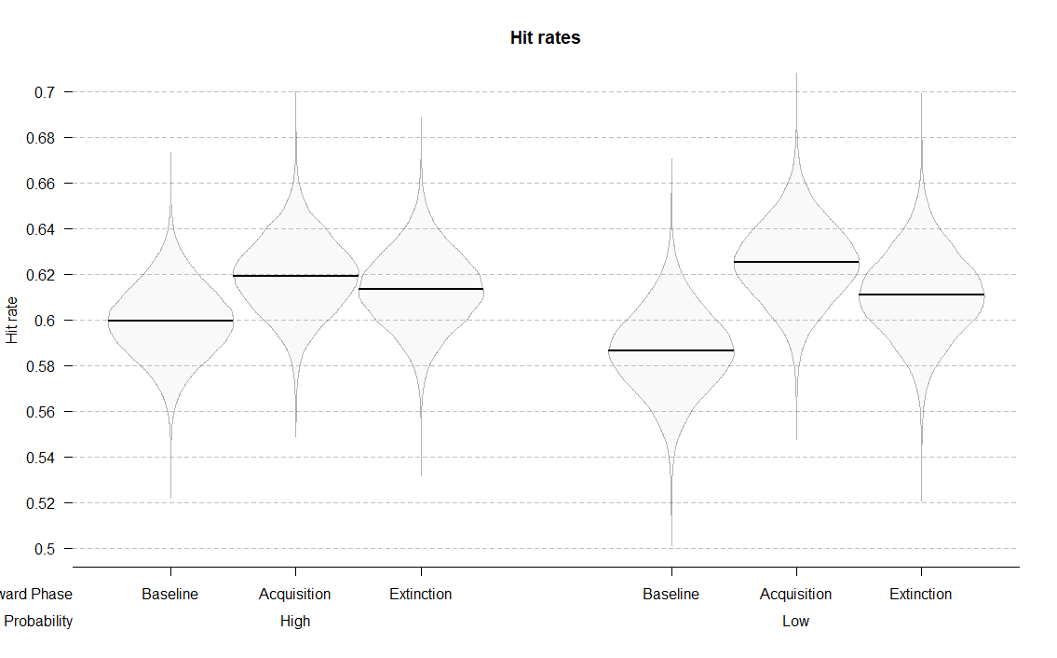

**Figure 4.** Posterior distributions of the interaction models for hit rates and reaction times across conditions.

## Reaction times

The interaction model was also the best one in predicting reaction times (Table 1). Participants were reliably faster in the acquisition compared to the baseline phase in both the high reward (*M =* -21.16; 95% HDI [-29.79, -12.27]; ER = Inf., i.e. the whole posterior distribution was above zero) and the low rewarded condition (*M =* -14.47; 95% HDI [-24.71, -4.63]; ER = 332.33). Moreover, this difference was larger in the high compared to low rewarded condition (*M =* -6.69; 95% HDI [-18.01, 4.77]; ER = 7.20). We found little evidence for the change in reaction times between the acquisition and the extinction phase. Participants were approximately equally fast in acquisition and extinction for both the high (*M =* 2.26; 95% HDI [-6.80, 11.00]; ER = 2.26), and the low reward condition (*M =* -0.15; 95% HDI [-10.86, 10.26]; ER = 1.05). These results indicate that the participants were faster in the condition in which they could earn rewards, and more so in the condition with higher probability of earning a reward. Also, there was no evidence for the change in the reaction times when the rewards were no longer available.

In order to exclude the possibility that our results were affected by training effects we ran additional analyses. These analyses indicated some evidence for the presence of training effects in hit rates and no evidence for such effects in reaction times. The results of these analyses can be found in Appendix 1.

## ssVEP amplitudes

|  |  |  |  |
| --- | --- | --- | --- |
| Table 4  *Means and 95% HDIs of the ssVEP amplitudes for each of the conditions* | | | |
| Attention | Reward phase | Reward probability | Amplitudes (µV) |
| Attended | Baseline | High | 1.11 [0.77, 1.42] |
| Attended | Baseline | Low | 1.09 [0.41, 1.44] |
| Attended | Acquisition | High | 1.10 [0.77, 1.50] |
| Attended | Acquisition | Low | 1.04 [0.55, 1.40] |
| Attended | Extinction | High | 1.07 [0.72, 1.47] |
| Attended | Extinction | Low | 1.09 [0.76, 1.59] |
| Unattended | Baseline | High | 0.95 [0.65, 1.43] |
| Unattended | Baseline | Low | 0.89 [0.58, 1.32] |
| Unattended | Acquisition | High | 0.91 [0.57, 1.30] |
| Unattended | Acquisition | Low | 0.90 [0.62, 1.21] |
| Unattended | Extinction | High | 0.93 [0.51, 1.37] |
| Unattended | Extinction | Low | 0.92 [0.60, 1.34] |

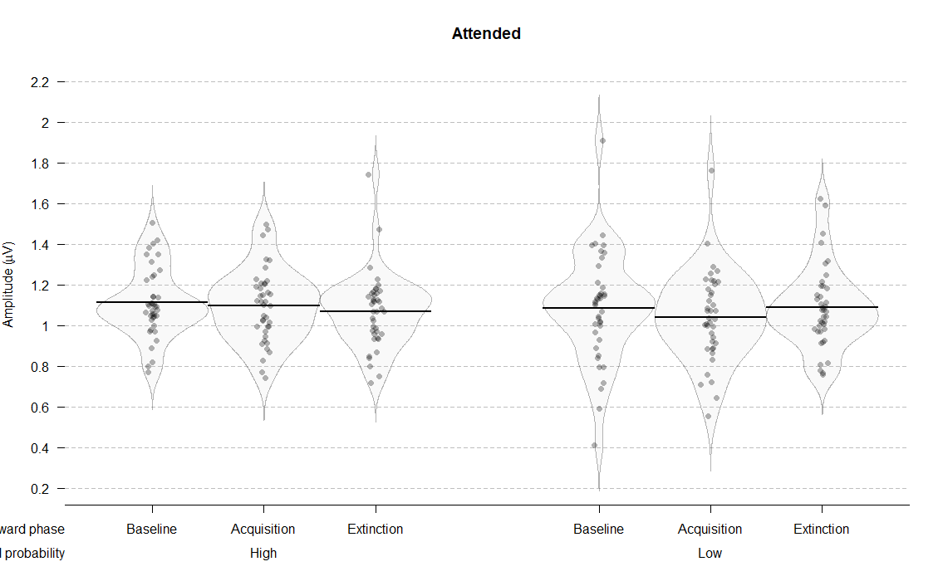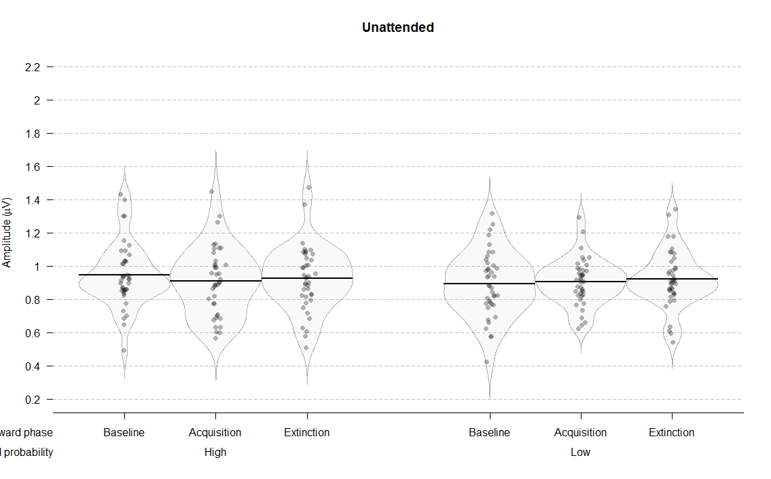

**Figure 5.** Distributions, means, and credible intervals of ssVEP amplitudes per condition.

We fitted seven models to predict the average ssVEP amplitudes (µV) across conditions (Figure 5). The *Null model* included only varying intercepts across subjects. The *Attention model* included the constant effect of attention, the *Reward phase model* included the constant effect of reward phase, the *Reward phase and attention* model included the additive effects of reward phase and attention, and the *Reward phase X attention* model also included the interaction between reward phase and attention. The *Reward probability X reward phase + attention* model consisted out of the constant effects of reward probability and phase, their interaction, and the effect of attention. The last model was the *Interaction* model which included both the main effects of all of the three factors, and their interaction. All of the models, except for the *Null* *model*, included varying slopes and intercepts for all of the constant effects. As in the case of behavioral data, several models were not fitted because they were not meaningful in the context of our experiment (e.g., the models that include both reward phase and probability, but not their interaction).

The interaction model was best in predicting the ssVEP amplitudes across conditions (Table 2). This result points to the better predictive ability when all three effects and their interaction is taken into account. The analysis of the posterior distribution of the interaction model (Figure 6) revealed a strong effect of attention, thus replicating previous studies. In all of the conditions the ssVEP amplitudes were higher for the attended compared to the unattended stimuli. In baseline the distribution for the difference between the attended and the unattended stimulus didn’t include zero thus resulting in infinite probability that the attended stimuli produce higher amplitudes compared to the unattended ones (for high reward probability: *M =* 0.17; 95% HDI [0.09, 0.24]; ER = Inf.; for low reward probability: *M =* 0.19; 95% HDI [0.11, 0.27]; ER = Inf.). In the acquisition phase amplitudes were also higher in the attended condition for both high rewarded stimuli (*M =* 0.19; 95% HDI [0.11, 0.27]; ER = Inf.) and low rewarded stimuli (*M =* 0.11; 95% HDI [-0.02, 0.23]; ER = 22.81). Similarly, in the extinction phase amplitudes were higher in the attended condition for highly rewarded stimuli (*M =* 0.14; 95% HDI [0.05, 0.23]; ER = 999) and for low rewarded stimuli (*M =* 0.14; 95% HDI [0.00, 0.26]; ER = 51.63). These results reveal a very robust effect of attention across all of the experimental conditions.

|  |  |  |  |
| --- | --- | --- | --- |
| Table 5  *Model comparison indices for EEG results* | | | |
| Model/Model comparison | *WAIC (SE)* |  | *Bayesian R2 (SE)* |
| Null | -122.16 (38.14) |  | 0.00 (0.00) |
| Reward phase | -115.47 (38.14) |  | 0.02 (0.01) |
| Attention | -211.10 (41.72) |  | 0.21 (0.04) |
| Reward phase + attention | -200.35 (41.10) |  | 0.22 (0.04) |
| Reward phase X attention | -193.05 (40.69) |  | 0.23 (0.04) |
| Reward probability X reward phase + attention | -272.18 (42.75) |  | 0.43 (0.04) |
| Interaction | -300.60 (40.58) |  | 0.53 (0.05) |
|  | | | |

|  |  |  |  |
| --- | --- | --- | --- |
| Table 6  *Means and 95% HDIs of the posterior distributions of the ssVEP amplitudes for each of the conditions* | | | |
| Attention | Reward phase | Reward probability | Amplitudes (µV) |
| Attended | Baseline | High | 1.11 [1.06, 1.16] |
| Attended | Baseline | Low | 1.09 [1.02, 1.15] |
| Attended | Acquisition | High | 1.10 [1.04, 1.15] |
| Attended | Acquisition | Low | 1.04 [0.97, 1.11] |
| Attended | Extinction | High | 1.07 [1.01, 1.13] |
| Attended | Extinction | Low | 0.95 [0.84, 1.06] |
| Unattended | Baseline | High | 0.95 [0.89, 1.01] |
| Unattended | Baseline | Low | 0.89 [0.83, 0.96] |
| Unattended | Acquisition | High | 0.91 [0.84, 0.97] |
| Unattended | Acquisition | Low | 0.93 [0.82, 1.04] |
| Unattended | Extinction | High | 0.93 [0.85, 1.00] |
| Unattended | Extinction | Low | 0.95 [0.84, 1.06 ] |

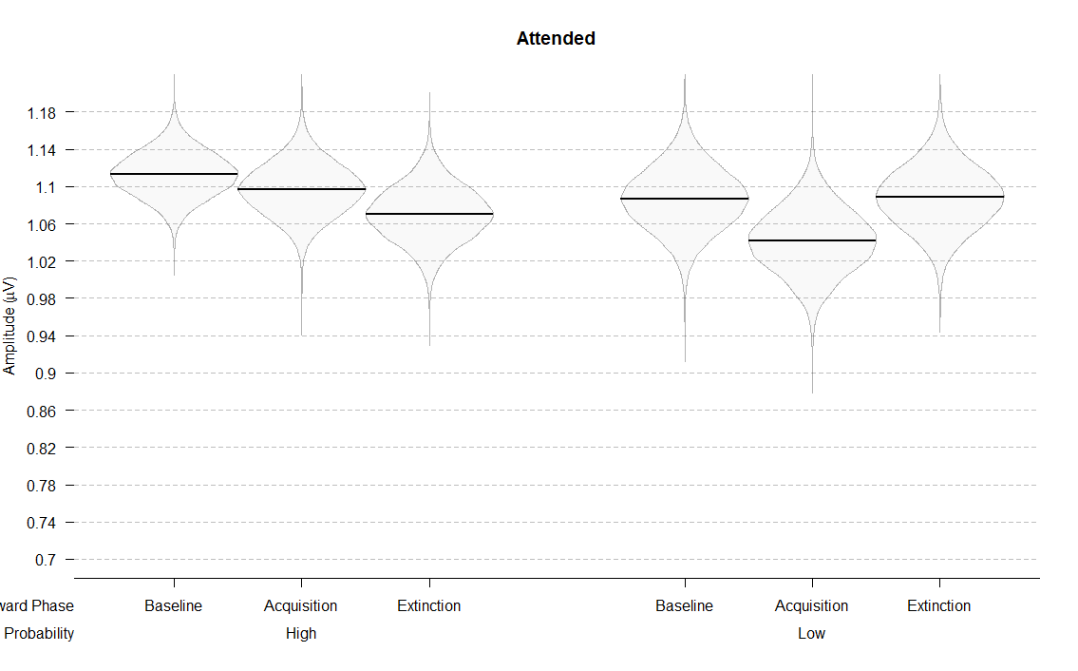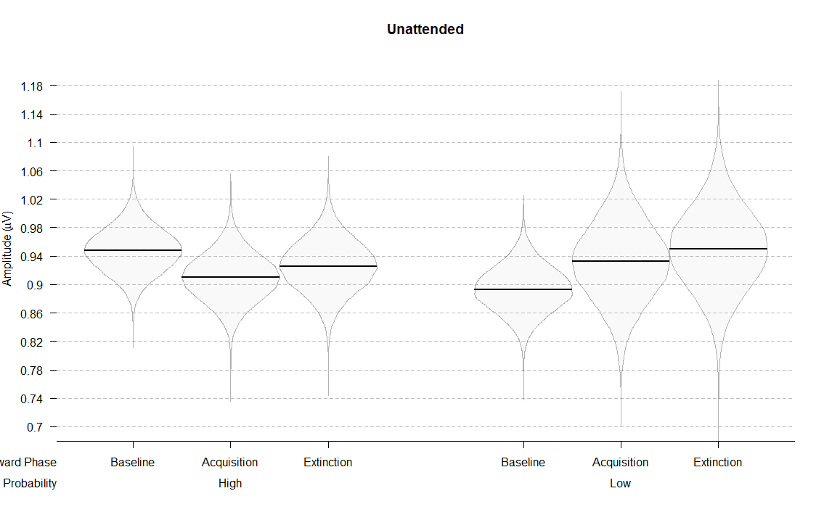

**Figure 6.** Posterior distributions of the interaction models for ssVEP amplitudes across conditions. Amplitudes for the attended stimuli are plotted on the left, and amplitudes for the unattended stimuli are plotted on the right.

The posterior distribution also indicated that reward phase and probability interacted differently across attended and unattended stimuli. Focusing on the attended stimuli first, there was no evidence for a difference between acquisition and baseline when the stimuli were highly rewarded (*M =* 0.02; 95% HDI [-0.06, 0.09]; ER = 2.06), but there was some evidence for lower amplitudes in acquisition when the stimuli were lowly rewarded (*M =* 0.04; 95% HDI [-0.04, 0.12]; ER = 6.69). There was little evidence that the amplitudes were lower in the acquisition compared to extinction for the high reward condition (*M =* 0.03; 95% HDI [-0.05, 0.11]; ER = 3.02). However, for the low reward condition, there was some evidence that the amplitudes were higher in the extinction compared to acquisition (*M =* 0.05; 95% HDI [-0.04, 0.14]; ER = 5.80).

For the unattended stimuli, the amplitudes lowered from baseline to acquisition in the high rewarded condition (*M =* 0.04; 95% HDI [-0.03, 0.11]; ER = 5.76), but not in the low rewarded condition (*M =* 0.04; 95% HDI [-0.10, 0.18]; ER = 2.48). Amplitudes did not change from acquisition to extinction for neither the high reward (*M =* 0.02; 95% HDI [-0.07, 0.11]; ER = 1.78) nor the low reward condition (*M =* 0.02; 95% HDI [-0.07, 0.11]; ER = 1.88).

To summarize, in the attended condition the amplitudes did not change across the reward phases for the high reward stimuli. However, for the low rewarded stimuli, there was some evidence that they lowered from baseline to acquisition, and increased from acquisition to extinction. For the unattended condition, the amplitudes of the low rewarded color did not change across reward phases. For the high rewarded color, there was some evidence that the amplitudes lowered from baseline to acquisition, and increased from acquisition to extinction.

Surprisingly, there was a baseline difference between the two reward probability conditions that in the unattended (*M =* 0.05; 95% HDI [-0.03, 0.14]; ER = 8.90), and a similar trend in the attended condition (*M =* 0.03; 95% HDI [-0.06, 0.11]; ER = 2.73). This was surprising because participants had no way of knowing which color will be rewarded in the acquisition phase and were informed about the possibility of earning rewards only when they completed the baseline phase. However, this baseline difference does not in any way affect our results given that our comparisons of interest are between reward phases for the same reward probability.

# Discussion

# Appendix 1

In order to investigate potential training effects on behavioral performance we split each of the reward phases into two (Figure 1 and Table 1). If training effects were influencing behavioral performance, it would be expected that the performance keeps one improving through baseline and acquisition. In order to investigate this possibility, we fitted the *Interaction model* that was identical as the one described in the results section. We then compared behavioral performance between the first and the second part of the baseline phase, and between the second part of baseline and the first part of acquisition phase.

|  |  |  |  |
| --- | --- | --- | --- |
| Table 1  *Means and 95% HDIs of raw hit rates and reaction times across six phases of the experiment* | | | |
| Reward phase | Reward probability | Hit rates (proportion) | Reaction times (milliseconds) |
| Baseline1 | High | 0.59 [0.28, 0.76] | 548.80 [471.00, 613.76] |
| Baseline1 | Low | 0.57 [0.25, 0.85] | 551.68 [458.26, 629.69] |
| Baseline2 | High | 0.62 [0.37, 0.81] | 546.07 [443.45, 620.36] |
| Baseline2 | Low | 0.61 [0.41, 0.78] | 554.75 [479.48, 650.73] |
| Acquisition1 | High | 0.61 [0.33, 0.80] | 522.80 [437.90, 604.61] |
| Acquisition1 | Low | 0.64 [0.47, 0.86] | 541.89 [457.58, 593.47] |
| Acquisition2 | High | 0.64 [0.31, 0.76] | 529.67 [462.00, 598.58] |
| Acquisition2 | Low | 0.63 [0.45, 0.79] | 536.08 [471.00, 618.25] |
| Extinction1 | High | 0.62 [0.33, 0.77] | 529.58 [457.88, 596.17] |
| Extinction1 | Low | 0.61 [0.43, 0.85] | 535.20 [444.89, 629.69] |
| Extinction2 | High | 0.62 [0.28, 0.78] | 526.88 [456.00, 639.89] |
| Extinction2 | Low | 0.62 [0.35, 0.78] | 541.75 [450.11, 633.28] |

**Figure 1.** Distributions and means of raw hit rates and reaction times per condition.

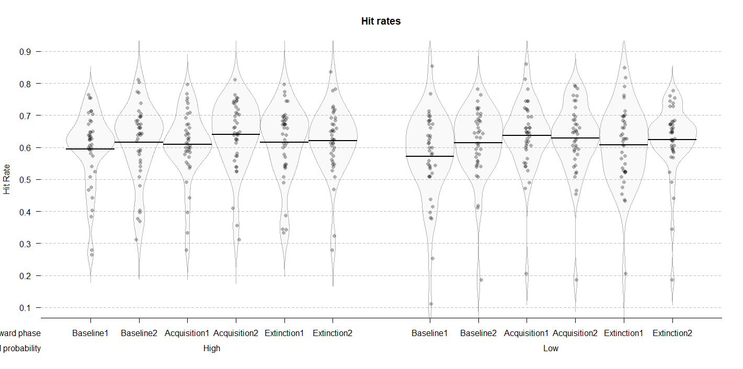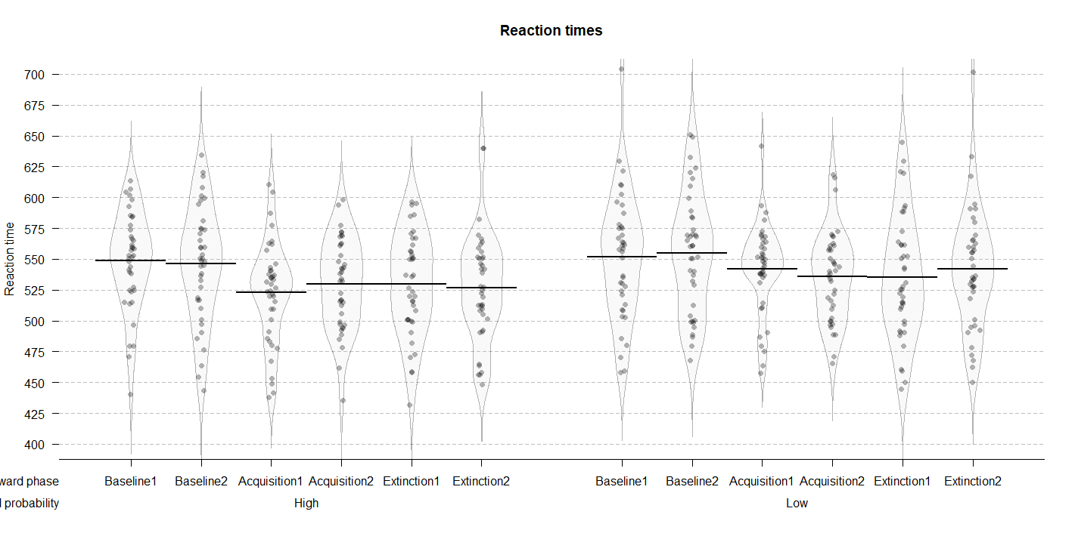

The posterior distribution for the hit rates (Figure 2 and Table 2) revealed the improvement from the first to the second part of baseline for both high (*M =* 0.02; 95% HDI [-0.01, 0.05]; ER = 7.77) and low (*M =* 0.04; 95% HDI [0.01, 0.08]; ER = 141.86) reward probability conditions. When comparing the second part of baseline to the first part of acquisition there was no difference in the high reward probability condition (*M =* 0.01; 95% HDI [-0.03, 0.04]; ER = 1.82). However, in the low probability condition, hit rates were higher in the first part of acquisition (*M =* 0.03; 95% HDI [-0.01, 0.06]; ER = 9.31). These results indicate that the participants improved throughout the baseline phase, and that they improved from the end of baseline to the first part of the acquisition for the low rewarded color. This can indicate some presence of training effects on the accuracy data.

The posterior distribution of the reaction times (Figure 2 and Table 2) revealed no differences between the first and the second part of baseline for neither high (*M =* 2.74; 95% HDI [-8.78, 13.75]; ER = 2.17), nor low (*M =* 3.08; 95% HDI [-8.53, 14.75]; ER = 2.37) reward probability condition. The comparison between the second part of baseline and the first part of acquisition revealed a very reliable improvement in both high (*M =* 23.34; 95% HDI [12.06, 35.22]; ER = Inf.) and low (*M =* 12.86; 95% HDI [1.09, 25.28]; ER = 54.55) reward probability conditions. These results clearly point to the absence of training effects in reaction time data.

Taken together, these results indicate that our effects were not driven by the improved performance over the course of the task. Although there is some evidence that the hit rates were improving during the baseline phase, the reaction time data clearly indicates that the main shift in performance happens in the beginning of acquisition, when rewards are introduced. Importantly, the strongest behavioral effects in our study were found on the reaction time data, as indicated in the results section.

|  |  |  |  |
| --- | --- | --- | --- |
| Table 2  *Means and 95% HDIs of the posterior distributions of the ssVEP amplitudes for each of the conditions* | | | |
| Reward phase | Reward probability | Hit rates (proportion) | Reaction times (milliseconds) |
| Baseline 1 | High | 0.59 [0.56, 0.63] | 548.95 [535.99, 561.51] |
| Baseline 1 | Low | 0.62 [0.58, 0.65] | 546.20 [531.50, 560.00] |
| Baseline 2 | High | 0.57 [0.53, 0.61] | 551.83 [537.82, 566.18] |
| Baseline 2 | Low | 0.61 [0.57, 0.65] | 554.91 [539.42, 571.04] |
| Acquisition 1 | High | 0.61 [0.57, 0.64] | 522.87 [509.89, 535.59] |
| Acquisition 1 | Low | 0.64 [0.60, 0.67] | 529.79 [516.87, 542.59] |
| Acquisition 2 | High | 0.64 [0.60, 0.68] | 542.05 [528.28, 556.21] |
| Acquisition 2 | Low | 0.63 [0.59, 0.67] | 536.26 [521.92, 549.75] |
| Extinction 1 | High | 0.62 [0.58, 0.65] | 529.68 [515.80, 543.76] |
| Extinction 1 | Low | 0.62 [0.58, 0.66] | 526.96 [512.84, 540.61] |
| Extinction 2 | High | 0.61 [0.56, 0.65] | 535.39 [518.62, 552.17] |
| Extinction 2 | Low | 0.62 [0.58, 0.67] | 541.87 [525.02, 557.85] |

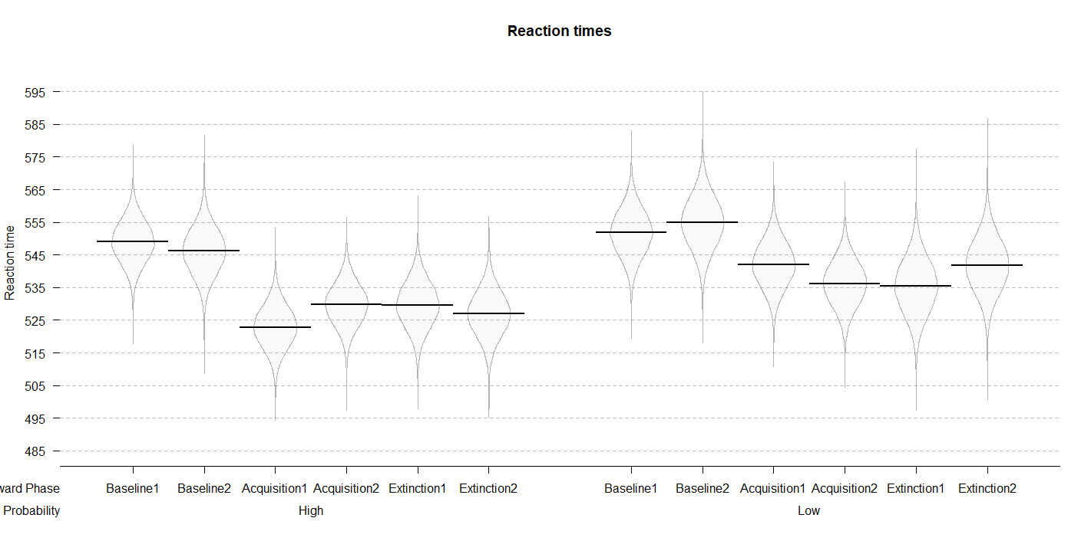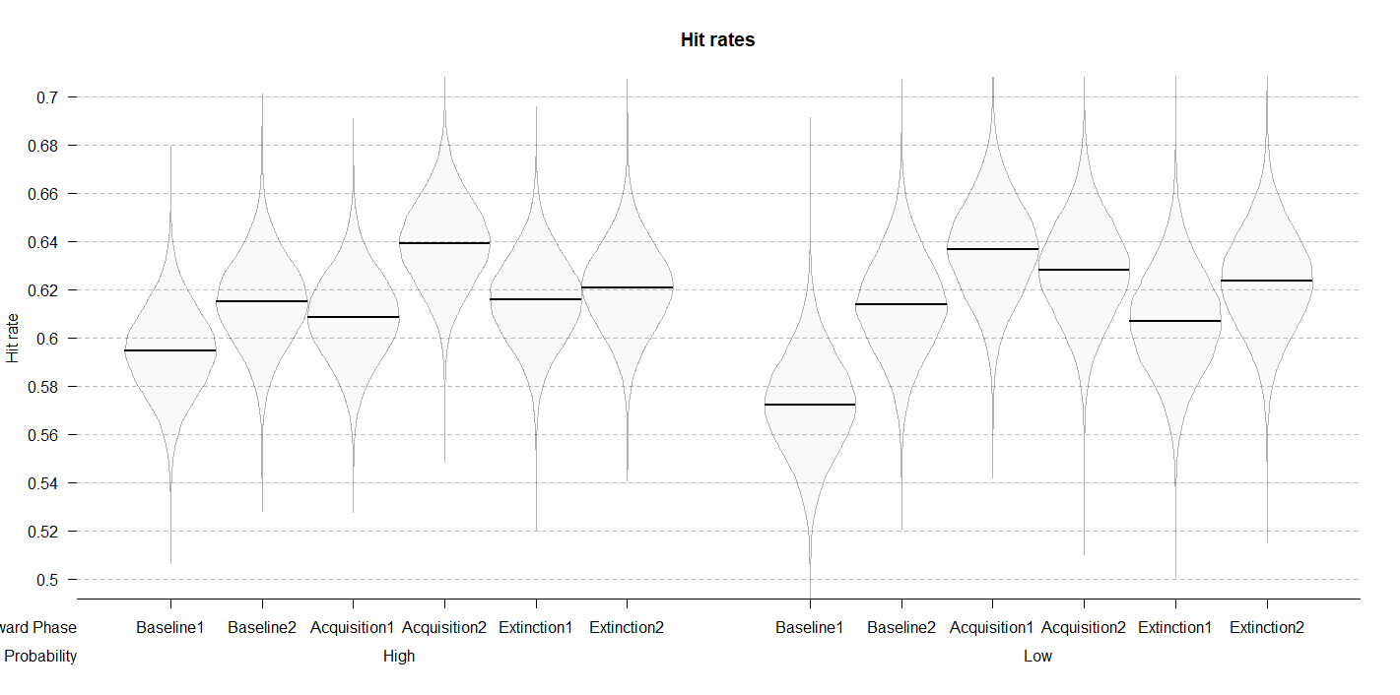

**Figure 2.** Posterior distributions of the interaction models for hit rates and reaction times across six reward phase conditions.

Similar analyses could not have been performed for the EEG data. Splitting the number of trials in each phase into two would significantly affect our signal-to-noise ratio. However, our EEG results point to the changes in the ssVEP amplitudes in only one of the reward probability conditions. If changes in the amplitudes were mainly driven by training effects, the differences across reward phases would be expected for both of the reward probability conditions. This combined with the lack of strong training effects in behavior leads us to conclude that we can be confident that our EEG results are not driven by training effects.

## Software for data visualization and analysis

Visualization and statistical analyses were performed using R v3.4.4 (R Core Team, 2017) via RStudio v1.1.453 (RStudio Team, 2015). We used the following packages (and their respective dependencies):

• data manipulation: tidyverse v1.2.1 (Wickham, 2017);

• statistical analyses: Rmisc v1.5 (Hope, 2013), brms v2.3.1 (Bürkner, 2016);

• visualization: cowplot v0.9.2 (Wilke, 2016), yarrr v0.1.5 (Phillips, 2016), viridis v0.5.1 (Garnier, 2018), eegUtils v0.2.0 (Craddock, 2018), BEST (J. K. Kruschke & Meredith, 2017);

• report generation: pacman v0.4.6 (Rinker & Kurkiewicz, n.d.), knitr v1.20 (Xie, 2018).

# Acknowledgements

This work was supported by the Special Research Fund (BOF) of Ghent University [grant #01D02415 awarded to IG; grant # BOF14/PDO/123 awarded to AS] and the Concerted Research Action Grant of Ghent University [grant number BOF16/GOA/017 awarded to EHWK]. Add funding for Gilles and Søren. The funding sources had no involvement in the study design; collection, analysis, and interpretation of data; writing of the report; and decision to submit the article for publication.

We would like to thank Ladislas Nalborczyk for discussions about statistical analyses of the data and Dr. Inez Greven for help with data collection.

# Author contributions

IG, AS, and SKA conceived the study. SKA and IG programmed the experimental paradigm. SKA, GP, and EHWK contributed reagents/materials/tools. IG collected the data, supervised by AS. IG and AS analyzed the data. IG and AS wrote the main manuscript text. IG, AS, GP, EHWK, and SKA reviewed and critically revised the manuscript.

# Data availability

Raw and pre-processed data, materials, and analysis scripts are available at <https://osf.io/xxxxx/>. (use as template: https://osf.io/9dcsm/)

# References

Andersen, S. K., & Müller, M. M. (2010). Behavioral performance follows the time course of neural facilitation and suppression during cued shifts of feature-selective attention. *Proceedings of the National Academy of Sciences of the United States of America*, *107*(31), 13878–13882. https://doi.org/10.1073/pnas.1002436107

Bürkner, P.-C. (2016). brms: An R package for Bayesian multilevel models using Stan. *Journal of Statistical Software*, *80*(1), 1–28.

Carpenter, B., Gelman, A., Hoffman, M., Lee, D., Goodrich, B., Betancourt, M., … Riddell, A. (2016). Stan: A probabilistic programming language. *Journal of Statistical Software*, *2*(20), 1–37.

Chatrian, G. E., Lettich, E., & Nelson, P. L. (1985). Ten percent electrode system for topographic studies of spontaneous and evoked EEG activities. *American Journal of EEG Technology*, *25*(2).

Craddock, M. (2018). craddm/eegUtils: eegUtils (Version v0.2.0). Zenodo.

Delorme, A., & Makeig, S. (2004). EEGLAB: an open sorce toolbox for analysis of single-trail EEG dynamics including independent component anlaysis. *Journal of Neuroscience Methods*, *134*, 9–21. https://doi.org/10.1016/j.jneumeth.2003.10.009

Franken, I. H. A., Muris, P., & Rassin, E. (2005). Psychometric properties of the Dutch BIS/BAS scales. *Journal of Psychopathology and Behavioral Assessment*, *27*(1), 25–30. https://doi.org/10.1007/s10862-005-3262-2

Garnier, S. (2018). viridis: Default Color Maps from ‘matplotlib.’ R package version 0.3.

Gelman, A., Goodrich, B., Gabry, J., & Ali, I. (2017). R-squared for Bayesian regression models. *Unpublished via Http://Www. Stat. Columbia. Edu/~ Gelman/Research/Unpublished.* Retrieved from http://www.stat.columbia.edu/~gelman/research/unpublished/bayes_R2.pdf

Gelman, A., & Rubin, D. B. (1992). Inference from Iterative Simulation Using Multiple Sequences. *Statistical Science*, *7*(4), 457–472. https://doi.org/10.1214/ss/1177011136

Hope, R. M. (2013). Rmisc: Ryan miscellaneous. R package version, 1(5).

Junghöfer, M., Elbert, T., Tucker, D. O. N. M., & Rockstroh, B. (2000). Statistical control of artifacts in dense array EEG 0 MEG studies. *Wiley Online Library*, 523–532. Retrieved from http://onlinelibrary.wiley.com/doi/10.1111/1469-8986.3740523/full

Kruschke, J. K. (2014). *Doing Bayesian data analysis: A tutorial with R, JAGS, and Stan, second edition*. *Doing Bayesian Data Analysis: A Tutorial with R, JAGS, and Stan, Second Edition* (2nd ed.). Elsevier Inc. https://doi.org/10.1016/B978-0-12-405888-0.09999-2

Kruschke, J. K., & Meredith, M. (2017). BEST: Bayesian Estimation Supersedes the t-Test.

Nolan, H., Whelan, R., & Reilly, R. B. (2010). FASTER: Fully Automated Statistical Thresholding for EEG artifact Rejection. *Journal of Neuroscience Methods*, *192*(1), 152–162. https://doi.org/10.1016/j.jneumeth.2010.07.015

Perrin, F., Pernier, J., Bertrand, O., & Echallier, J. F. (1989). Spherical splines for scalp potential and current density mapping. *Electroencephalography and Clinical Neurophysiology*, *72*(2), 184–187. https://doi.org/10.1016/0013-4694(89)90180-6

Phillips, N. (2016). Yarrr: A companion to the e-book YaRrr!: The Pirate’s Guide to R. R package version 0.1.

R Core Team. (2017). R: A Language and Environment for Statistical Computing. R Foundation for Statistical Computing.

Rinker, T., & Kurkiewicz, D. (n.d.). pacman: Package Management for R.

RStudio Team. (2015). Integrated Development for R. RStudio, Inc.

Van der Does, A. J. W. (2002). *Handleiding bij de Nederlandse versie van beck depression inventory—second edition (BDI-II-NL). [The Dutch version of the Beck depression inventory].* Amsterdam: Harcourt.

Watanabe, S. (2010). Asymptotic Equivalence of Bayes Cross Validation and Widely Applicable Information Criterion in Singular Learning Theory, *11*, 3571–3594. Retrieved from http://arxiv.org/abs/1004.2316

Wickham, H. (2017). Tidyverse: Easily install and load ’tidyverse’ packages. R package version, 1(1).

Wilke, C. O. (2016). cowplot: streamlined plot theme and plot annotations for ‘ggplot2.’ CRAN Repos.

Xie, Y. (2018). knitr: A General-Purpose Package for Dynamic Report Generation in R.