Working title: Feature-based Attention and Reward: Insights from Steady-State Visually Evoked Potentials

Ivan Grahek1☨*, Antonio Schettino1,2☨, Gilles Pourtois1, Ernst H.W. Koster1,

& Søren K. Andersen3

1. *Department of Experimental Clinical and Health Psychology, Ghent University, Henri Dunantlaan 2, B-9000, Ghent, Belgium*
2. *Institute for Globally Distributed Open Research and Education (IGDORE)*
3. *School of Psychology, University of Aberdeen, William Guild Building, Aberdeen, AB24 3FX, United Kingdom*

# Abstract

Keywords: attention; EEG; feature-based attention; reward; motivation; steady-state visually evoked potentials; frequency tagging

# Introduction

Due to capacity limitations, we can only process a small subset of the information which reach our senses. This is why selective attention is a crucial process, as it determines which of the incoming stimuli will be further processed (Chun, Golomb, & Turk-Browne, 2011; Desimone & Duncan, 1995). Theories of attention postulate that stimuli are selected based on their physical salience (bottom-up), or based on current goals (top-down) (Corbetta & Shulman, 2002; Posner, 1980; Theeuwes, 2010). Salient stimuli, such as sudden flashes of light or loud noises, capture our attention in an involuntary fashion (Theeuwes, 2004; Yantis, 1993). Alternatively, attention can be voluntarily oriented toward a specific location. For example, participants are faster to detect a target in a location which has been cued as the one in which the stimulus is likely to appear (Posner, 1980). Such effects are thought to be a product of goal-directed attention.

Recent research on the influence of reward history on visual selective attention has provided a potential third mechanism that guides attention (Awh, Belopolsky, & Theeuwes, 2012). This mechanism is proposed to be neither top-down nor bottom-up. The most widely used experimental approach used to demonstrate the effects based on such a mechanism is the training-test session design (for reviews see: Anderson, 2016; Chelazzi, Perlato, Santandrea, & Della Libera, 2013; Failing & Theeuwes, 2017). During training participants perform an attention task in which different features or objects are paired with different reward magnitudes or probabilities of obtaining a reward. For example, correct detection of a red stimulus in a visual search array is always followed by receipt of a high monetary reward, while other colors are paired with low or no reward. In the following test phase participants are informed that they cannot earn any more rewards.

Using this paradigm it was demonstrated that objects paired with high rewards are easier to select as targets and harder to ignore as distractors (Della Libera & Chelazzi, 2009). The opposite is true for objects related to low rewards. In a series of studies using a visual search task, distractors related to high rewards were harder to ignore even when no more rewards could be earned and participants were instructed to ignore the color information (Anderson, Laurent, & Yantis, 2011). This effect, termed *value-driven attentional bias*, was present even if the training and test phases were separated by several weeks (Anderson & Yantis, 2013). Similar results were found in a visual search task, even when the distractor stimuli related to rewards were always task-irrelevant (Pearson, Donkin, Tran, Most, & Le Pelley, 2015), as well as in a variant of the spatial cueing task (Failing & Theeuwes, 2014).

Neuroimaging studies have mainly focused on the effects of rewards on attention during the training phase. In an fMRI experiment Hickey and Peelen (2015) shown that the representation of objects (cars, trees, or people in naturalistic images) in object-selective visual cortex paired with high rewards was enhanced, while the representation of objects paired with low rewards was suppressed. Using electroencephalography in a visual search task it was demonstrated that previous rewards facilitate perceptual activity and lead to an increase in the deployment of attention (Hickey, Chelazzi, & Theeuwes, 2010). These authors have shown an amplification of early visual processing in extrastriate visual cortex (increased P1 component) and an increase in visuospatial attention (increased N2pc component) contralateral to the color associated with a high reward on the previous trial. This effect was present when that color was in the location of either the distractor or a target. A similar modulation of the N2pc component was found when object categories were linked to different reward schedules (Donohue et al., 2016). Another ERP study used a training-test design and found a larger P1 component for stimuli associated with high rewards up to 7 days after the training (MacLean & Giesbrecht, 2015).

The aforementioned behavioral and neuroimaging studies have led to the proposal that rewards can bias visual selective attention it in spite of current goals and with no changes in the physical salience of the stimuli (Anderson, Laurent, & Yantis, 2011; Awh, Belopolsky, & Theeuwes, 2012; Chelazzi, Perlato, Santandrea, & Della Libera, 2013; Failing & Theeuwes, 2017). This idea has generated considerable interest, given its potential impact on current cognitive theories, as well as its clinical implications (Anderson, Chiu, DiBartolo, & Leal, 2017; Anderson, Leal, Hall, Yassa, & Yantis, 2014).

However, there are still a number of issues unanswered. First, most published studies, especially using electrophysiological measures, have focused on transient attention, i.e., focusing on the quick processing of briefly presented stimuli. This approach could favor the fast and automatic effects of reward history on attention. Second, the attentional capture in the existing paradigms is always inferred: trials with and without the distractor associated with a reward are compared. However, the competition between stimuli linked to different reward probabilities has not been directly investigated. In this way, the proposal that stimuli related to high rewards capture more attention compared to the other stimuli, has not been directly tested. Finally, most of the research on value-based attention has been focused on spatial attention, while the feature-based attention has received less attention. Importantly, relating features (e.g. different colors) to different reward schedules in a visual search task makes it difficult to fully disentangle the effects of feature-based and spatial attention.

In this study we have set out to directly compare the simultaneous processing of the features linked to different reward schedules. Furthermore, we compared how the goal-directed attention is influenced by rewards. We did so by investigating the simultaneous deployment of attention to the stimuli currently or previously linked to high or low probability of earning a monetary reward. To this end, we used steady-state visual evoked potentials (SSVEPs) to track stimulus processing in the early visual cortex. SSVEPs represent the oscillatory response of the visual cortex to flickering stimuli (Norcia, Appelbaum, Ales, Cottereau, & Rossion, 2015). They provide a continuous measure of feature-based attention deployment across multiple stimuli simultaneously, and are a reliably modulated by goals such as paying attention to a certain stimulus feature. For example, in a random-dot kinematogram (RDK) task, dots of different colors can be frequency-tagged with different flickering rates. If participants are instructed to pay attention to the movement of red dots, the amplitude in their frequency is reliably increased, while the amplitude in the frequencies of the other stimuli is decreased (Andersen & Müller, 2010). Using the RDK task, we investigated the simultaneous deployment of attention to two features (red and blue dots) across three phases of the experiment. On each trial participants were instructed to attend to one of the two colors, first without any reward (baseline), then with each color associated with different probabilities of earning a rewards (reward). In the last phase (extinction), participants were informed that they would not earn any more rewards. This design enabled us to investigate the influence of reward on attention simultaneously for both features. This design enabled us to investigate the influence of rewards on goal-directed attention simultaneously for both features.

In this setting the cognitive control account and the value-driven attention view both predict that the amount of attention allocated toward the high rewarded feature should be increased, and the amount of attention allocated toward the low rewarded feature should be decreased during the reward phase. However, they provide diverging predictions about the extinction phase. Namely, if attention is allocated in order to maximize value (cognitive control account), the amount of attention allocated toward each of the features should be the same in the baseline and in the extinction phase. However, the value-driven account would predict that more attention will be allocated toward the feature that was previously linked to a high probability of earning a reward. The current paradigm allowed us to test these predictions. The paradigm also provided us with an electrophysiological measure of the amount of attention that is simultaneously being allocated toward the high and low rewarded feature. This enabled us to more directly test the idea that more attention is paid toward the feature linked to the high probability of earning a reward.

# Methods

## Participants

We tested 48 participants with normal or corrected-to-normal vision and no history of psychiatric or neurological disorders. Four participants were excluded due to technical problems during recording. Four additional participants were discarded due to excessive artifacts in the EEG signal (i.e., the percentage of rejected epochs in one or more conditions exceeded 35%). Thus, the final data set consisted of 40 participants (27 females, 13 males; median age = 22). Participants received a fixed payoff of 20 €, plus up to 6 € extra as performance-contingent monetary rewards (on average 25.5 €). The study was approved by the ethics committee of Ghent University.

## Stimuli and task

We used the Random Dot Kinematogram (RDK) task (Andersen & Müller, 2010), in which participants were presented with two overlapping circular RDKs of isoluminant colors (red and blue) on a grey background. Viewing distance was fixed with a chinrest at 55 cm from the 21-inch CRT screen (resolution of 1024 x 768 pixels, 120 Hz refresh rate). At the beginning of each trial, participants were instructed which of the two RDKs to attend by a verbal audio cue: “red” (241 ms) or “blue” (266 ms). The two RDKs had a diameter corresponding to 20.61 degrees of visual angle and consisted of 125 randomly and independently moving dots each (0.52 degrees of visual angle per dot). The two RDKs flickered at a different frequencies (10 or 12 Hz). One-third of trials contained one, two, or three coherent motion intervals, occurring with equal probability in the attended (targets) or unattended (distractors) color RDK. During these intervals, dots in one of the RDKs moved with 75% coherence in one of four cardinal directions (up, down, left, or right) for 300 ms. Participants had to detect the coherent movement as fast as possible by pressing the space key on a standard AZERTY USB keyboard. Response time was limited to 1,500 ms post-RDK onset and no response was recorded before 200 ms. Correct responses were followed by a tone (200 ms sine wave of either 800 or 1,200 Hz, counterbalanced across participants). Responses that were too late or incorrect were followed by a 200 ms square wave tone of 400 Hz.

The experiment started with 4 practice blocks of 60 trials. After each block, participants received feedback on their performance. After finishing the practice phase, participants completed 12 blocks of 50 trials divided into 3 phases (*baseline*, *acquisition*, and *extinction*). Each phase contained 100 trials on which participants were instructed to attend to the red color and 100 trials in which they were instructed to attend to the blue color. Out of those 100 trials, 40 trials contained no dot motion, and 60 trials contained one, two, or three dot motions (120 motions in total). During baseline, participants were simply doing the described task. In the acquisition phase, the task was identical but participants could earn additional monetary rewards (up to 6 €) based on their performance. They were instructed that one of the colors would be paired with high probability (80%) and the other color with low probability (20%) of earning 10 extra cents for each correct detection. The mapping between color and reward probability was counterbalanced across participants. The receipt of the reward was signaled by a new tone that replaced the usual correct tone. If the correct tone was a sine wave of 800 Hz, the reward tone was a sine wave of 1,200 Hz and vice versa. At the end of each of the 4 blocks of the acquisition phase, participants got feedback on both their performance and the amount of extra money earned within the block. The third phase, extinction, was identical to baseline (i.e., no monetary rewards assigned). The whole task lasted for approximately 50 minutes, plus a few minutes of break in between blocks. After completing the task, participants filled in two questionnaires aimed at assessing their reward sensitivity (BIS-BAS; Franken et al., 2005) and depression levels (BDI-II; Van der Does, 2002).

This experiment was realized using Cogent 2000 developed by the Cogent 2000 team at the FIL and the ICN and Cogent Graphics developed by John Romaya at the LON at the Wellcome Department of Imaging Neuroscience.

**Figure 1. The design of the task. Depiction of a single trial and of the phases of the experiment.**

## Behavior

XXXXXXXXXXXXXXXXXXXXX

## EEG recording and pre-processing

Electroencephalographic activity (EEG) was recorded with an ActiveTwo amplifier (BioSemi, Inc., The Netherlands) at a sampling rate of 512 Hz. Sixty-four Ag/AgCl electrodes were fitted into an elastic cap, following the international 10/10 system (Chatrian, Lettich, & Nelson, 1985). The common mode sense (CMS) active electrode and the driven right leg (DRL) passive electrode were used as reference and ground electrodes, respectively. Additional external electrodes were applied to the left and right mastoids, as well as on the outer canthi of each eye and in the inferior and superior areas of the left orbit (to record horizontal and vertical electrooculogram, EOG).

Data pre-processing was performed offline with custom MATLAB scripts and functions included in EEGLAB v14.1.1b (Delorme & Makeig, 2004). After subtracting the mean value of the signal (DC offset), the continuous EEG data were epoched between 0 and 3,250 ms, corresponding to the beginning and end of the RDK trial, respectively. After referencing to *Cz*, FASTER v1.2.3b (Nolan, Whelan, & Reilly, 2010) was used for artifact identification and rejection using the following settings: (i) over the whole normalized EEG signal, channels with variance, mean correlation, and Hurst exponent exceeding *z* = ±3 were interpolated via a spherical spline procedure (Perrin, Pernier, Bertrand, & Echallier, 1989); (ii) the mean across channels was computed for each epoch and, if amplitude range, variance, and channel deviation exceeded *z* = ±3, the whole epoch was removed; (iii) within each epoch, channels with variance, median gradient, amplitude range, and channel deviation exceeding *z* = ±3 were interpolated; (iv) grand-averages with amplitude range, variance, channel deviation, and maximum EOG value exceeding *z* = ±3 were removed; (v) epochs containing more than 12 interpolated channels were discarded. All remaining epochs were scanned with SCADS (Junghöfer, Elbert, Tucker, & Rockstroh, 2000) and rejected when flagged as containing residual artifacts. For details, see our commented code at https://osf.io/5hryf/. After pre-processing, the average number of interpolated channels was 4.08 (*SD* = 1.75, range 0 – 7) and the mean percentage of rejected epochs was 9.74% (*SD* = 6.77, range 0 – 32.50; similar rejection rate across conditions). After re-referencing to averaged mastoids, trials in each condition were averaged separately for each participant, resulting in the following grand-averages: (i) baseline, red attended; (ii) baseline, blue attended; (iii) acquisition, red attended; (iv) acquisition, blue attended; (v) extinction, red attended; (vi) extinction, blue attended.

Electrodes with maximum SSVEP amplitudes were identified by calculating isocontour voltage maps based on grand-averaged data collapsed across all conditions. After removing linear trends, Fast Fourier Transforms on the EEG signal in a time window from 500 ms (to exclude the typically strong phasic visual evoked response to picture onset) to 3,250 ms after stimulus onset was applied, and amplitudes were obtained by extracting the absolute values of the resulting complex Fourier coefficients. We extracted SSVEP amplitude at 10 and 12 Hz from each individual electrode cluster, separately for each condition (averaged across trials). The amplitudes were normalized for each participant and frequency separately by dividing amplitudes by the average amplitude across all six conditions. To account for inter-individual variations in topographical SSVEP amplitude distributions, we identified and averaged activity from the four electrodes displaying, for each participant, the largest frequency-specific amplitude.

## Statistical analyses

Behavioral and EEG data were analyzed using Bayesian multilevel regressions. We fitted and compared multiple models of varying complexity to predict hit rates, reaction times for correct responses, and SSVEP amplitudes. Each of the fitted models included both constant and varying effects (also known as fixed and random). Participant-specific characteristics are known to affect both behavioral performance (e.g., response speed) and EEG signal (e.g., skull thickness, skin conductance, hair); therefore, we decided to model this variability by adding varying intercepts in our models. Additionally, the studied effects (e.g., reward sensitivity and selective attention) are known to vary in magnitude over participants, so we opted for including varying slopes in our models. It should be noted that, because of the simultaneous estimation of group-level and participant-level parameters, multilevel models display a property called *shrinkage*. In brief, estimates that strongly deviate from the mean (e.g., a participant performing the task much worse than the average of the total sample) will be pulled toward the group mean (McElreath, 2016). This advantageous property prevents extreme values from having large effects on the results.

Models were fitted in R using the package *brms* (Bürkner, 2016) that employs the probabilistic programming language *Stan* (Carpenter et al., 2016)to implement Markov Chain Monte Carlo (MCMC) algorithms in order to estimate posterior distributions of the parameters of interest. Each of the models were fitted using weakly regularizing prior distributions (default priors in *brms*) and Gaussian likelihood. Four MCMC simulations (“chains”) with 10,000 iterations (2,000 warmup) and a thinning interval of 1 were run to estimate parameters in each of the fitted models. Further analyses were done following the recommendations for Bayesian multilevel modeling using *brms* (Bürkner, 2016, 2017; Nalborczyk & Bürkner, 2019). We confirmed that all models converged by examining trace plots, autocorrelation, and variance between chains (Gelman-Rubin statistic; Gelman & Rubin, 1992). We compared models based on their fit to the actual data using the Bayesian *R*2 (Gelman, Goodrich, Gabry, & Ali, 2017), and their out-of-sample predictive performance using the Widely Applicable Information Criterion (WAIC; Watanabe, 2010). The best model was selected and the posterior distributions of conditions of interest were examined. Differences between conditions were assessed by computing the mean and the 95% highest density interval (HDI) of the difference between posterior distributions of the respective conditions (Kruschke, 2014). Additionally, we calculated the evidence ratios (ERs) for our hypotheses as the ratios between the percentage of posterior samples on each side of the zero of a difference distribution between two conditions. ERs can be interpreted as the probability of a hypothesis (e.g. “Condition A is larger than condition B”) against its alternative (“Condition B is larger than condition A”).

# Results

## Behavioral results

We fitted three models to predict both hit rates (proportion of hits) and reaction times (in milliseconds) separately (*Figure 2* and *Table 1*). First, we fitted the *Null model* with one constant and multiple varying intercepts across participants. This model was fitted in order to explore the possibility that the data would be best explained by simple random variation between participants. To investigate the effect of reward phase (baseline, acquisition, extinction), we fitted the *Reward phase model* that included only reward phase as the constant predictor and varying intercepts and slopes across participants for this effect. To investigate the possible interaction between reward phase and reward probability, we fitted the *Interaction model* including these two effects and their interaction as constant effects. The intercepts and slopes of main effects and their interaction were allowed to vary across participants. Please note that there are two additional models that, although possible to fit, are not plausible in the context of our experiment. Specifically, the model with only the effect of reward probability overlooks the fact that this effect would necessarily be most pronounced in the acquisition phase, thus interacting with the effect of reward phase. The same logic applies to the model with additive effects of reward phase and probability (i.e., these effects cannot act independently in our experimental design).

|  |  |  |  |
| --- | --- | --- | --- |
| Table 1  *Means and 95% HDIs (in square brackets) of hit rates and reaction times.* | | | |
| Reward phase | Reward probability | Hit rates (proportion) | Reaction times (milliseconds) |
| Baseline | High | 0.60 [0.32, 0.70] | 547.18 [460.90, 612.74] |
| Baseline | Low | 0.59 [0.32, 0.70] | 552.93 [470.68, 631.36] |
| Acquisition | High | 0.62 [0.37, 0.80] | 526.00 [457.23, 599.49] |
| Acquisition | Low | 0.63 [0.47, 0.77] | 538.41 [465.32, 605.14] |
| Extinction | High | 0.61 [0.32, 0.74] | 528.21 [448.50, 599.83] |
| Extinction | Low | 0.61 [0.39, 0.79] | 538.21 [464.21, 642.55] |

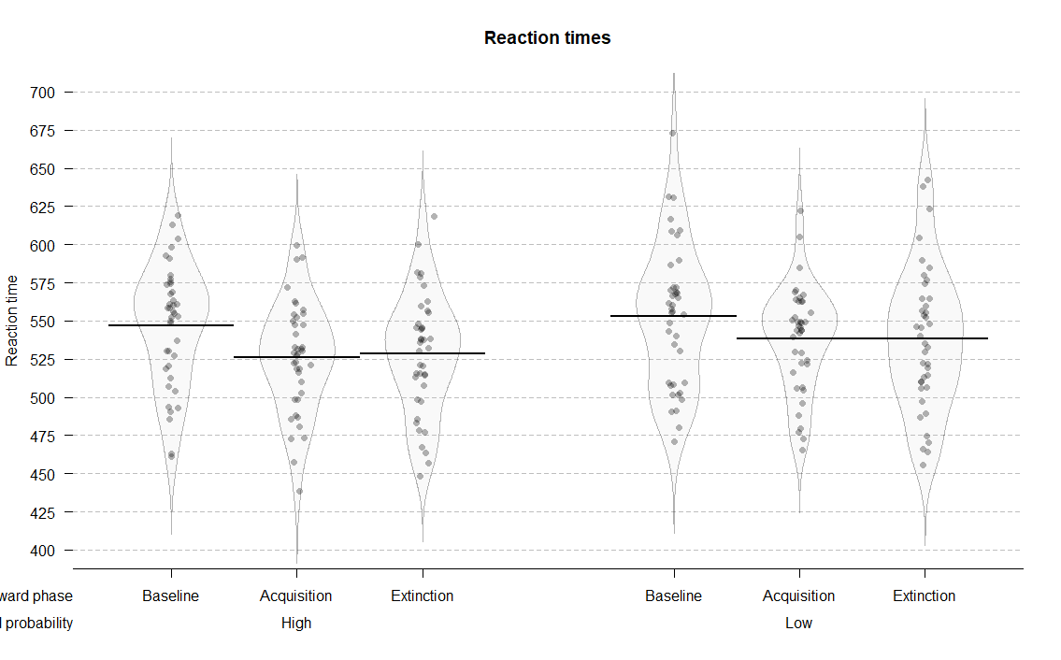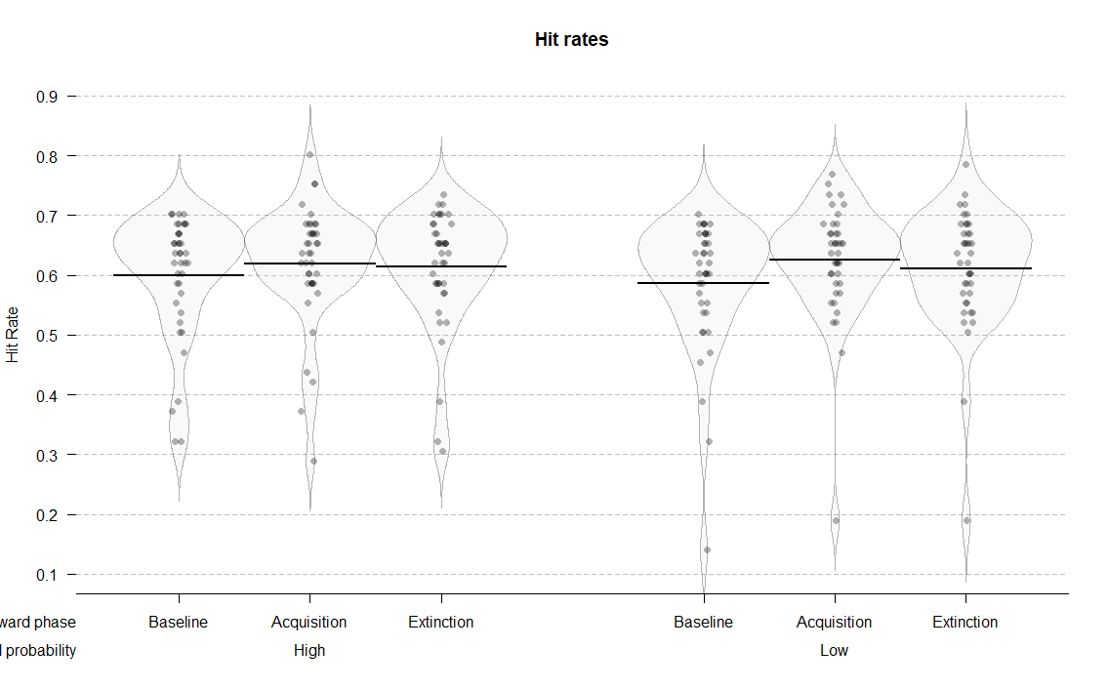

**Figure 2.** Distributions and means of raw hit rates and reaction times per condition.

## Hit rates

As can be seen in *Table 1*, this task was quite challenging as participants were able to detect only about 60% of the movements across different experimental conditions. Nonetheless, it should be noted that this is a signal detection task, so the performance of 50% is not chance level. Of all the tested models, the interaction model best predicted hit rates (*Table 2*). This result points to the importance of the interaction between reward phase and reward probability in predicting hit rates. The posterior distributions of the interaction model (*Figure 3*) revealed that hit rates improved in the acquisition phase compared to the baseline for both low (*M =* 0.04; 95% HDI [0.02, 0.06]; ER = 999.00) and high rewarded color (*M =* 0.02; 95% HDI [0.00, 0.04]; ER = 33.48). This improvement was more pronounced for low compared to high reward probability (*M =* 0.02; 95% HDI [-0.01, 0.05]; ER = 8.43). Conversely, evidence for the difference between acquisition and extinction phases was much weaker. Participants were slightly less accurate in extinction compared to acquisition in the low rewarded condition (*M =* -0.01; 95% HDI [-0.04, 0.01]; ER = 8.43), while there was very little difference in the high rewarded condition (*M =* -0.01; 95% HDI [-0.03, 0.02]; ER = 2.42).

These results suggest that participants were reliably more accurate in the acquisition phase compared to baseline, and more so for the low rewarded color. There was also evidence for a drop in their accuracy in the extinction phase for the low rewarded, but not high rewarded color.

|  |  |  |  |  |
| --- | --- | --- | --- | --- |
| Table 2  *Mean and standard errors (in parenthesis) of WAIC and Bayesian R2 for each model predicting hit rates and reaction times.* | | | | |
| Model | | *WAIC (SE)* | | *Bayesian R2 (SE)* |
| *Hit rates* | | | | |
| Null | | -475.41 (32.92) |  | 0.34 (0.05) |
| Reward phase | | -471.65 (33.43) |  | 0.36 (0.05) |
| Reward phase x Reward probability | | -709.13 (23.99) |  | 0.82 (0.03) |
| *Reaction times* |
| Null | | 2,346.29 (32.74) |  | 0.49 (0.04) |
| Reward phase | | 2,329.70 (35.38) |  | 0.56 (0.04) |
| Reward phase x Reward probability | | 2,154.64 (25.19) |  | 0.84 (0.03) |

|  |  |  |  |
| --- | --- | --- | --- |
| Table 3  *Means and 95% HDIs of the posterior distributions of reaction times and hit rates in each condition.* | | | |
| Reward phase | Reward probability | Hit rates (proportion) | Reaction times (milliseconds) |
| Baseline | High | 0.60 [0.57, 0.63] | 547.19 [534.84, 559.56] |
| Baseline | Low | 0.59 [0.55, 0.62] | 552.97 [539.22, 567.24] |
| Acquisition | High | 0.62 [0.59, 0.65] | 526.03 [513.90, 538.04] |
| Acquisition | Low | 0.63 [0.59, 0.66] | 538.50 [525.69, 550.34] |
| Extinction | High | 0.61 [0.58, 0.65] | 528.29 [515.32, 541.69] |
| Extinction | Low | 0.61 [0.57, 0.65] | 538.35 [522.97, 554.23] |

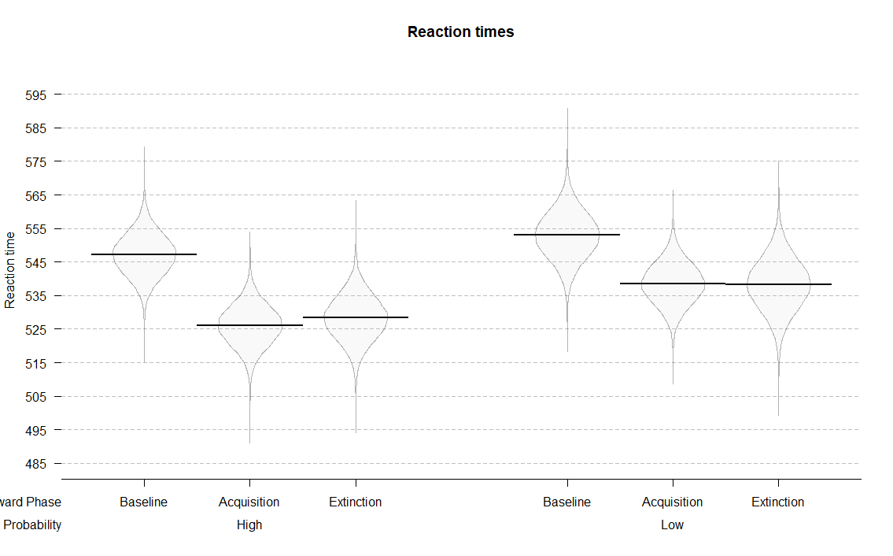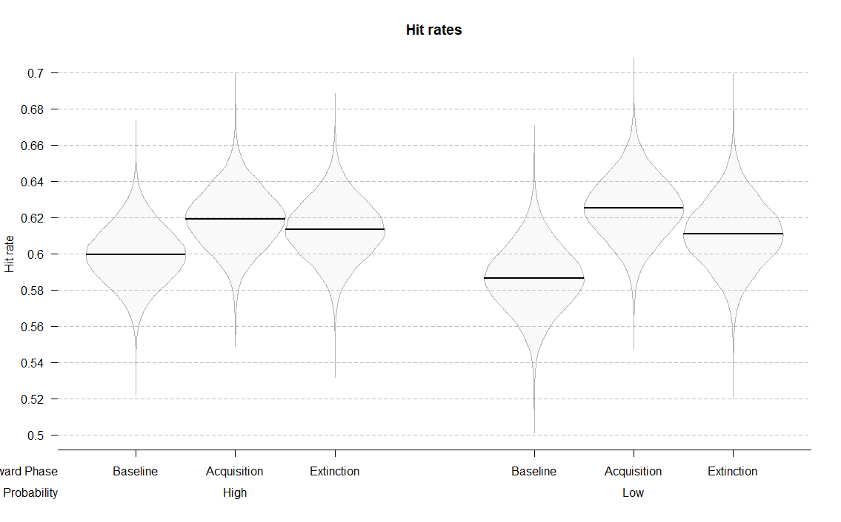

**Figure 3.** Posterior distributions of the interaction models for hit rates and reaction times across conditions.

## Reaction times

The interaction model (Reward phase x Reward probability) also best predicted reaction times (*Table 2*). Participants were reliably faster in the acquisition compared to the baseline phase in both the high rewarded (*M =* -21.16; 95% HDI [-29.79, -12.27]; ER = *Inf.*, i.e. whole posterior distribution above zero) and the low rewarded conditions (*M =* -14.47; 95% HDI [-24.71, -4.63]; ER = 332.33). Moreover, this difference was larger in the high compared to low rewarded condition (*M =* -6.69; 95% HDI [-18.01, 4.77]; ER = 7.20). We found little evidence for any changes in reaction times between the acquisition and the extinction phase. Participants were approximately equally fast in acquisition and extinction for both the high (*M =* 2.26; 95% HDI [-6.80, 11.00]; ER = 2.26), and the low reward condition (*M =* -0.15; 95% HDI [-10.86, 10.26]; ER = 1.05).

These results indicate that participants were faster in the condition in which they could earn rewards, and more so in the condition with higher probability of earning a reward. Also, there was no evidence for any changes in reaction times when rewards were no longer available.

Supplementary analyses carried out to assess possible training effects indicated some evidence for the presence of training effects in hit rates and scant evidence for such effects in reaction times. These results can be found in *Appendix 1*.

## SSVEP amplitudes

As shown in *Figure 4*, activity averaged over conditions was mainly localized at central occipital channels (i.e., *Oz*, *POz*, *O2*, *PO3*). Also, the FFT-amplitude spectra showed the expected peaks at the frequencies of 10 and 12 Hz.

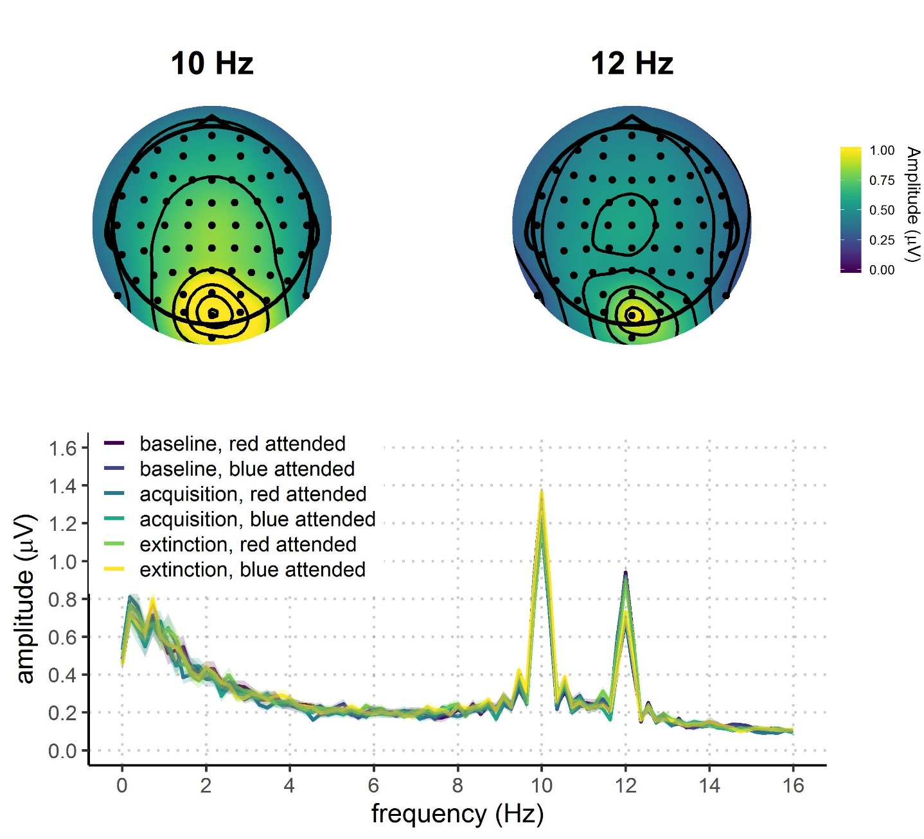

**Figure 4.** Grand average FFT-amplitude spectra derived from EEG signals at each participant's best four-electrode cluster for the 10 and 12 Hz signal. Data in the figure are filtered with 1Hz high-pass filter for visualization purposes.

We fitted seven models to predict the trial-averaged SSVEP amplitudes (in a.u. due to the normalization) across conditions (*Figure 5* and *Table 4*). The *Null model* included one constant and multiple varying intercepts across participants. The *Attention model* included the constant effect of attention; the *Reward phase model* included the constant effect of reward phase; the *Reward phase + attention* model included the additive effects of reward phase and attention; and the *Reward phase x attention* model also included the interaction between reward phase and attention. The *Reward probability x reward phase + attention* model consisted of the constant effects of reward probability and phase, their interaction, and the independent effect of attention. The last model was the *Interaction* model which included all constant effects and their interaction (*Reward probability x reward phase x attention*). All models, except for the *Null* *model*, included varying slopes and intercepts across participants for all constant effects. As was the case for the behavioral data, several models were not fitted because they were not plausible in the context of our experiment (e.g., the models that include both reward phase and probability, but not their interaction).

|  |  |  |  |
| --- | --- | --- | --- |
| Table 4  *Means and 95% HDIs of recorded SSVEP amplitudes in each condition.* | | | |
| Attention | Reward phase | Reward probability | Amplitudes (a.u.) |
| Attended | Baseline | High | 1.11 [0.77, 1.42] |
| Attended | Baseline | Low | 1.09 [0.41, 1.44] |
| Attended | Acquisition | High | 1.10 [0.77, 1.50] |
| Attended | Acquisition | Low | 1.04 [0.55, 1.40] |
| Attended | Extinction | High | 1.07 [0.72, 1.47] |
| Attended | Extinction | Low | 1.09 [0.76, 1.59] |
| Unattended | Baseline | High | 0.95 [0.65, 1.43] |
| Unattended | Baseline | Low | 0.89 [0.58, 1.32] |
| Unattended | Acquisition | High | 0.91 [0.57, 1.30] |
| Unattended | Acquisition | Low | 0.90 [0.62, 1.21] |
| Unattended | Extinction | High | 0.93 [0.51, 1.37] |
| Unattended | Extinction | Low | 0.92 [0.60, 1.34] |

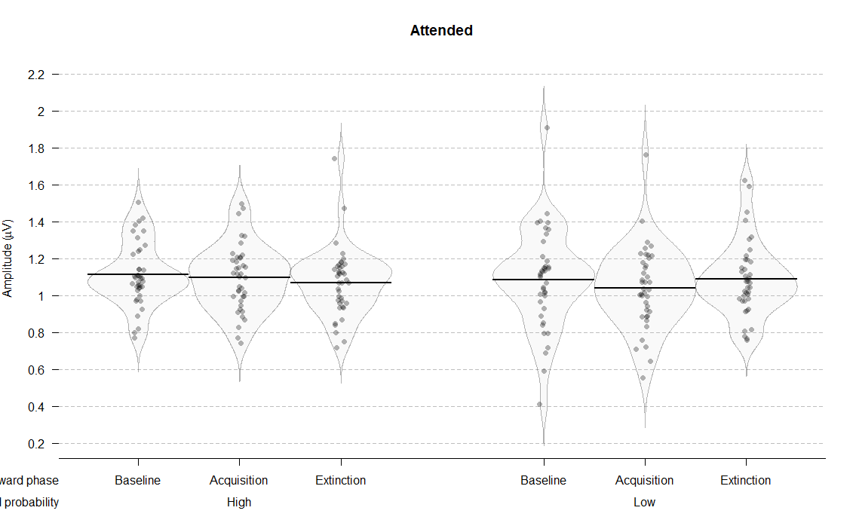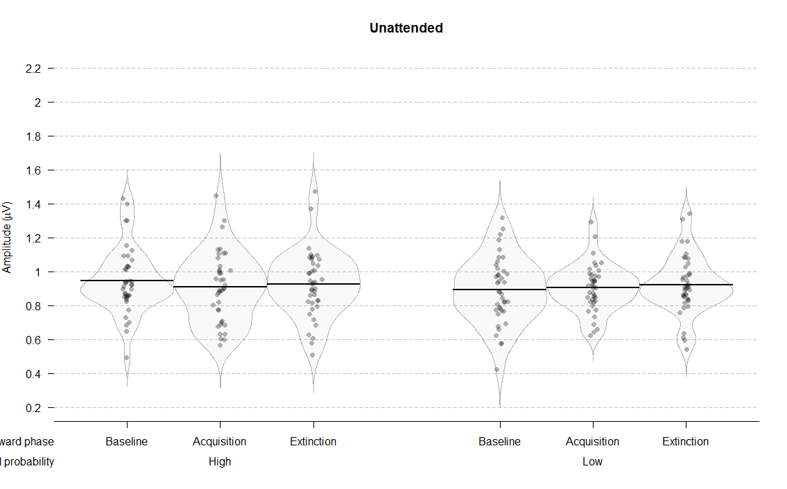

**Figure 5.** Distributions, means, and credible intervals of SSVEP amplitudes per condition.

The interaction model best predicted SSVEP amplitudes across conditions (*Table 5*). The analysis of the posterior distributions of the interaction model (*Figure 6*) revealed a strong effect of attention: in all conditions, SSVEP amplitudes were higher for the attended compared to the unattended stimuli. At baseline, the posterior distribution of the difference between attended and unattended stimuli did not include zero, thus resulting in infinite probability that the attended stimuli would elicit higher SSVEP amplitudes compared to the unattended ones (for high reward probability: *M =* 0.17; 95% HDI [0.09, 0.24]; ER = *Inf.*; for low reward probability: *M =* 0.19; 95% HDI [0.11, 0.27]; ER = *Inf.*). In the acquisition phase, amplitudes were higher in the attended condition for both high rewarded (*M =* 0.19; 95% HDI [0.11, 0.27]; ER = *Inf.*) and low rewarded stimuli (*M =* 0.11; 95% HDI [-0.02, 0.23]; ER = 22.81). Similarly, in the extinction phase amplitudes were higher in the attended condition for highly rewarded stimuli (*M =* 0.14; 95% HDI [0.05, 0.23]; ER = 999) and for low rewarded stimuli (*M =* 0.14; 95% HDI [0.00, 0.26]; ER = 51.63). These results reveal a very robust effect of attention across all experimental conditions.

|  |  |  |  |
| --- | --- | --- | --- |
| Table 6  *Means and 95% HDIs of the posterior distributions of the SSVEP amplitudes for each condition.* | | | |
| Attention | Reward phase | Reward probability | Amplitudes (a.u.) |
| Attended | Baseline | High | 1.11 [1.06, 1.16] |
| Attended | Baseline | Low | 1.09 [1.02, 1.15] |
| Attended | Acquisition | High | 1.10 [1.04, 1.15] |
| Attended | Acquisition | Low | 1.04 [0.97, 1.11] |
| Attended | Extinction | High | 1.07 [1.01, 1.13] |
| Attended | Extinction | Low | 0.95 [0.84, 1.06] |
| Unattended | Baseline | High | 0.95 [0.89, 1.01] |
| Unattended | Baseline | Low | 0.89 [0.83, 0.96] |
| Unattended | Acquisition | High | 0.91 [0.84, 0.97] |
| Unattended | Acquisition | Low | 0.93 [0.82, 1.04] |
| Unattended | Extinction | High | 0.93 [0.85, 1.00] |
| Unattended | Extinction | Low | 0.95 [0.84, 1.06] |

|  |  |  |  |
| --- | --- | --- | --- |
| Table 5  *Model comparison indices for EEG results* | | | |
| Model | *WAIC (SE)* |  | *Bayesian R2 (SE)* |
| Null | -122.16 (38.14) |  | 0.00 (0.00) |
| Reward phase | -115.47 (38.14) |  | 0.02 (0.01) |
| Attention | -211.10 (41.72) |  | 0.21 (0.04) |
| Reward phase + attention | -200.35 (41.10) |  | 0.22 (0.04) |
| Reward phase x attention | -193.05 (40.69) |  | 0.23 (0.04) |
| Reward probability x reward phase + attention | -272.18 (42.75) |  | 0.43 (0.04) |
| Reward phase x reward probability x attention | -300.60 (40.58) |  | 0.53 (0.05) |
|  | | | |

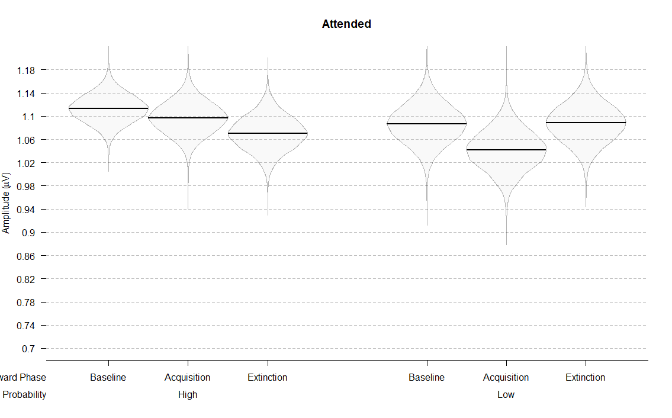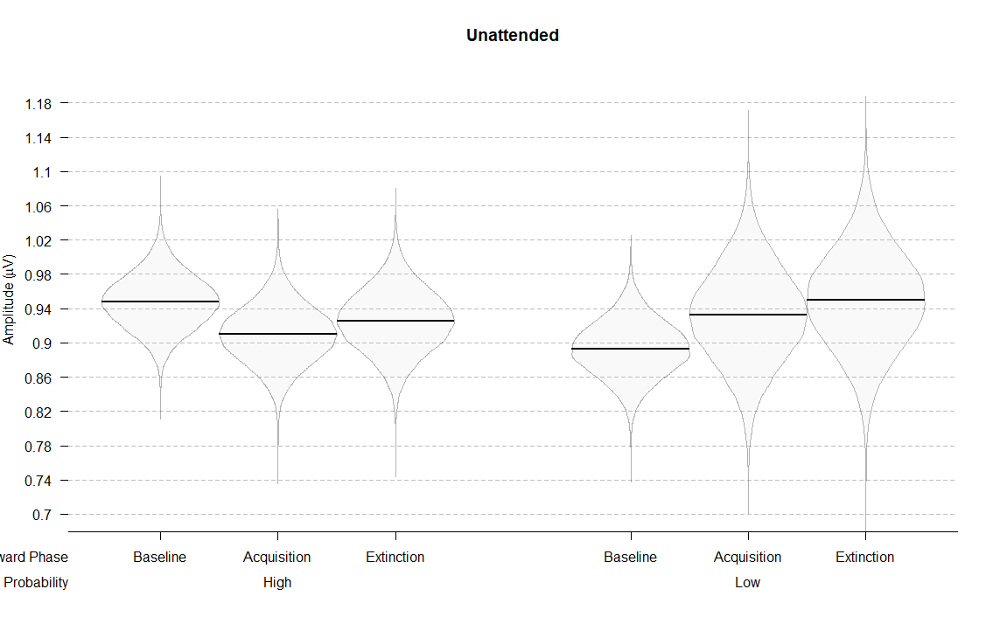

**Figure 6.** Posterior distributions of the interaction models for SSVEP amplitudes across conditions.

The posterior distributions also indicated that reward phase and probability interacted differently across attended and unattended stimuli. Focusing on the attended stimuli first, there was no evidence for a difference between acquisition and baseline when stimuli were highly rewarded (*M =* 0.02; 95% HDI [-0.06, 0.09]; ER = 2.06), but there was weak evidence for lower amplitudes in acquisition when the stimuli were lowly rewarded (*M =* 0.04; 95% HDI [-0.04, 0.12]; ER = 6.69). There was little evidence that amplitudes were lower in acquisition compared to extinction for the high reward condition (*M =* 0.03; 95% HDI [-0.05, 0.11]; ER = 3.02). For the low reward condition, there was weak evidence that amplitudes were higher in extinction compared to acquisition (*M =* 0.05; 95% HDI [-0.04, 0.14]; ER = 5.80). For the unattended stimuli, the amplitudes slightly lowered from baseline to acquisition in the high rewarded condition (*M =* 0.04; 95% HDI [-0.03, 0.11]; ER = 5.76), but not in the low rewarded condition (*M =* 0.04; 95% HDI [-0.10, 0.18]; ER = 2.48). Amplitudes did not reliably change from acquisition to extinction for neither the high reward (*M =* 0.02; 95% HDI [-0.07, 0.11]; ER = 1.78) nor the low reward condition (*M =* 0.02; 95% HDI [-0.07, 0.11]; ER = 1.88).

To summarize, in the attended condition SSVEP amplitudes did not change across reward phases for high rewarded stimuli. However, for low rewarded stimuli, there was some evidence that they lowered from baseline to acquisition and increased from acquisition to extinction. For the unattended condition, amplitudes elicited by the low rewarded color did not change across reward phases. For the high rewarded color, there was some evidence that amplitudes decreased from baseline to acquisition and increased from acquisition to extinction.

We also observed an unexpected (albeit weak) baseline difference between the two reward probability conditions, both in the unattended (*M =* 0.05; 95% HDI [-0.03, 0.14]; ER = 8.90) and attended conditions (*M =* 0.03; 95% HDI [-0.06, 0.11]; ER = 2.73). This was surprising because participants had no way of knowing which color would be rewarded in the acquisition phase; in addition, they were informed about the possibility of earning rewards only when they completed the baseline phase. However, this baseline difference does not affect our results given that our comparisons of interest are between reward phases for the same reward probability.

# Discussion

Our results show that rewards influence the deployment of voluntary attention at both behavioral and neural levels. The introduction of rewards improved behavioral performance in the task, and the stimuli linked to higher probability of obtaining a reward were detected faster. The absence of rewards in the extinction phase did not influence behavior. This result provides a conceptual replication of the value-driven effects found in studies using visual search and cueing tasks (Anderson et al., 2011; Failing & Theeuwes, 2014). This replication is significant given the large differences between our task and the previously used tasks. In our paradigm, participants were instructed which features to pay attention to, and they were doing so over the much longer periods of time than in previously used paradigms. This result thus provides additional support to the robustness of the value-driven attentional effects (Anderson, 2016; Chelazzi et al., 2013; Failing & Theeuwes, 2017).

At the neural level we have directly replicated the finding that the SSVEP amplitudes are strongly influenced by voluntary attention (Andersen & Müller, 2010; Andersen, Müller, & Hillyard, 2012). Across all of the phases of the experiment, the SSVEP amplitudes in the frequency of the attended stimuli were robustly higher than the amplitudes in the frequency of the unattended stimuli. This strong gating effect was modulated by reward. Model comparisons have provided evidence that the models which take into account the reward manipulation account better for the data compared to the model that includes only the effect of voluntary attention. This result further corroborates models of cognitive control which posit motivation as the crucial component in the voluntary allocation of attention (Brown & Alexander, 2017; Holroyd & McClure, 2015; Shenhav, Botvinick, & Cohen, 2013; Verguts, Vassena, & Silvetti, 2015).

The SSVEP results further indicate that when participants were attending to the stimuli paired with high reward probability, the amplitudes did not change during the phases of the experiment. This result is somewhat surprising given that previous neuroimaging studies demonstrated enhanced processing of targets paired with high rewards (Hickey et al., 2010; Hickey, Peelen, Hickey, & Peelen, 2015). One of the possible explanations for this result is that it is due to the high difficulty of our task. As can be seen from the behavioral data, on average participants had 60% correct responses. Having this in mind, it is possible that our participants were already at the ceiling in terms of the allocation of attentional resources. This would suggest that there was no room for the further increase in the SSVEP amplitudes. However, it was possible to adaptively allocate less resources to certain features.

When the participants were attending to the low rewarded stimuli, the SSVEP amplitudes decreased in the reward phase and went back to the baseline level in the extinction phase. The opposite was true when looking at the unattended stimuli. While the low rewarded stimuli did not change over the experiment, the amount of attention being allocated toward the high rewarded stimuli dropped in the reward phase, and stayed at that level in the extinction. The finding of suppression in processing of the stimuli related with low rewards is comparable to the results found in the fMRI study focusing on the visual cortex (Hickey et al., 2015). Our result suggests that the voluntary allocation of attention was flexibly adapted depending on the possibility of earning extra monetary rewards in the experiment. This is the first electrophysiological study that has looked into the simultaneous deployment of attention to stimuli linked both to high and low reward probability. As such it provides a novel insight into the flexible dynamics of attentional deployment based on value of different stimuli. Also, this result is contrary to the prediction made by the value-based attention account, but in line with the prediction made by cognitive control models. Namely, the value-driven attentional account posits that linking stimuli to high reward probability induces a long lasting attentional bias toward such stimuli. However, our data suggests the opposite. Attention is flexibly deployed in order to maximize the probability of obtaining a reward, but then goes back to the baseline levels once the possibility of earning rewards is gone.

These results point to the importance of several factors in the allocation of attention based on goals and reward history. First, our electrophysiological measure displayed an interesting decoupling from the behavior. While the behavioral data seems to be in line with the persistent effect of reward history, the neural data suggests that this effect does not arise from the long-lasting change in the amount of attention being allocated based on previous rewards. This is contrast to some of the existing electrophysiological studies (MacLean & Giesbrecht, 2015), but it is important to point out that there are very few such studies to date. Future studies could explore further why such a decoupling occurs. Tentatively, there is a possibility that the persistent behavioral effect is driven by a more motor effect, rather than a one mediated by attention. Interestingly, the value-driven attentional bias has mostly been demonstrated by the speeded responses to the previously rewarded stimuli compared to neutral stimuli. It is possible that such an effect is driven by the motor pairing of a stimulus and a fast response.

Another important factor in the allocation of reward-guided attention is the type of the task used. Our results demonstrate the importance of more rigorous tests of the idea that reward history can counteract goal-driven allocation of attention. The tasks used in most studies only infer that the goals of participants have changed in the test phase, or that they are induced in the instruction prior to the experiment (Anderson et al., 2011; Anderson, 2013; Failing & Theeuwes, 2014). We have demonstrated that, in the task in which participants have a goal on every trial, we did not observe the value-driven attentional bias in our measure of sustained attention. We believe that such an experimental setup provides a more rigorous way of looking at the competition between the goal-driven and value-driven attention. However, it is important to stress that our paradigm could favor the goal-directed effects on attention, while the previous paradigm could have favored the value-driven effects.

# Conclusion

# Appendix 1

In order to assess potential training effects on behavioral performance, we split each reward phase into two halves (*Supplementary Figure 1* and *Supplementary Table 1*). If training effects were influencing the behavioral outcome, we could expect performance improvement through baseline and acquisition. To investigate this possibility, we fitted the *Interaction model* that was identical as the one described in the results section. We then compared behavioral performance between the first and the second part of the baseline phase, and between the second part of baseline and the first part of acquisition phase.

|  |  |  |  |
| --- | --- | --- | --- |
| Supplementary Table 1  *Means and 95% HDIs of hit rates and reaction times across six phases of the experiment* | | | |
| Reward phase | Reward probability | Hit rates (proportion) | Reaction times (milliseconds) |
| Baseline1 | High | 0.59 [0.28, 0.76] | 548.80 [471.00, 613.76] |
| Baseline1 | Low | 0.57 [0.25, 0.85] | 551.68 [458.26, 629.69] |
| Baseline2 | High | 0.62 [0.37, 0.81] | 546.07 [443.45, 620.36] |
| Baseline2 | Low | 0.61 [0.41, 0.78] | 554.75 [479.48, 650.73] |
| Acquisition1 | High | 0.61 [0.33, 0.80] | 522.80 [437.90, 604.61] |
| Acquisition1 | Low | 0.64 [0.47, 0.86] | 541.89 [457.58, 593.47] |
| Acquisition2 | High | 0.64 [0.31, 0.76] | 529.67 [462.00, 598.58] |
| Acquisition2 | Low | 0.63 [0.45, 0.79] | 536.08 [471.00, 618.25] |
| Extinction1 | High | 0.62 [0.33, 0.77] | 529.58 [457.88, 596.17] |
| Extinction1 | Low | 0.61 [0.43, 0.85] | 535.20 [444.89, 629.69] |
| Extinction2 | High | 0.62 [0.28, 0.78] | 526.88 [456.00, 639.89] |
| Extinction2 | Low | 0.62 [0.35, 0.78] | 541.75 [450.11, 633.28] |

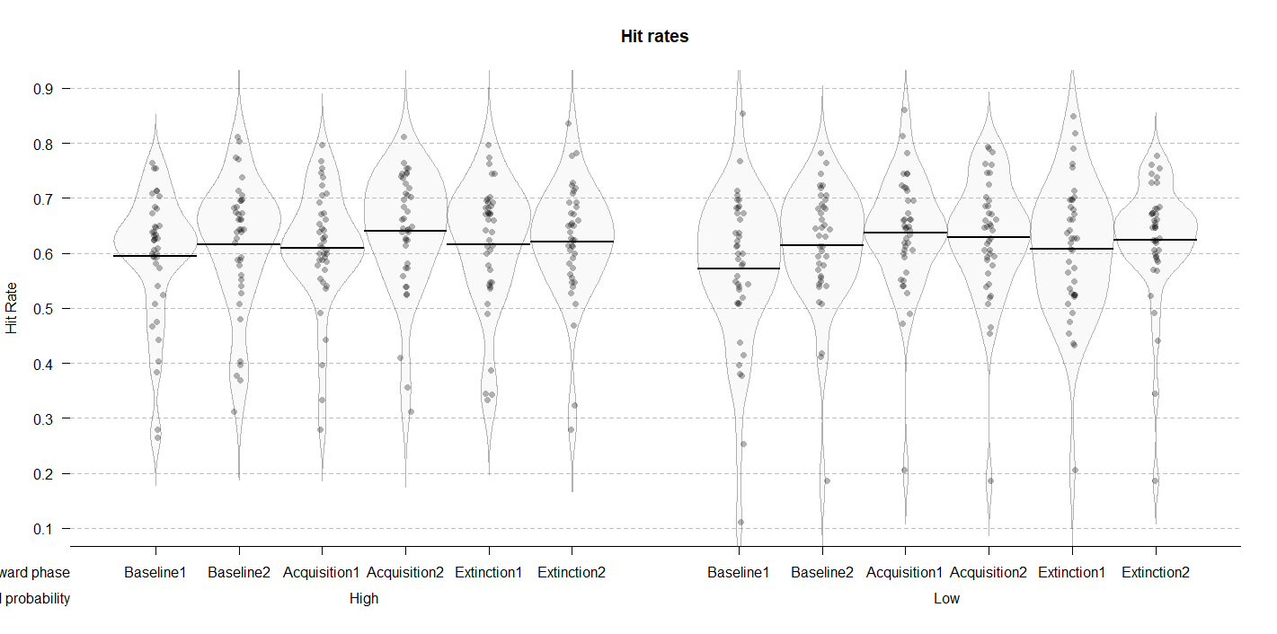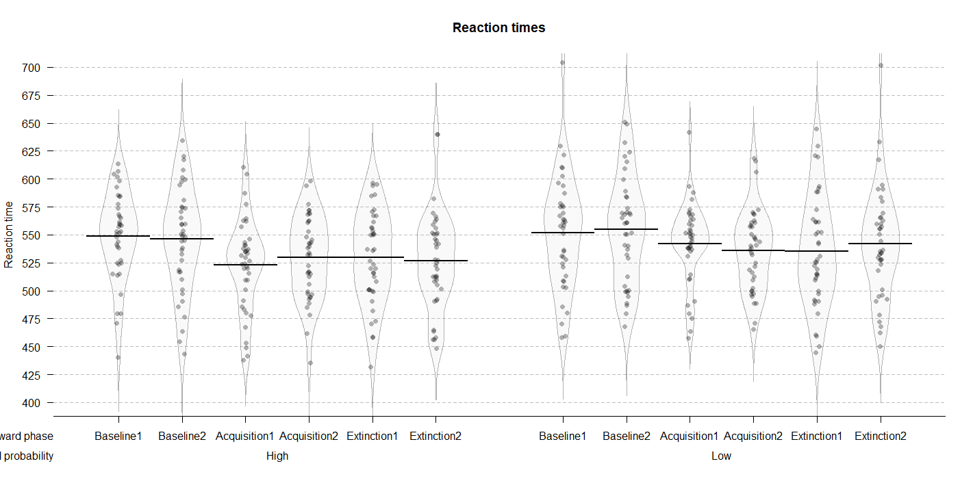

**Supplementary Figure 1.** Distributions and means of raw hit rates and reaction times per condition.

The posterior distributions for hit rates (*Supplementary Figure 2* and *Supplementary Table 2*) revealed performance improvement from the first to the second part of the baseline for both high (*M =* 0.02; 95% HDI [-0.01, 0.05]; ER = 7.77) and low (*M =* 0.04; 95% HDI [0.01, 0.08]; ER = 141.86) reward probability conditions. When comparing the second part of baseline to the first part of acquisition, there was no difference in the high reward probability condition (*M =* 0.01; 95% HDI [-0.03, 0.04]; ER = 1.82). However, in the low probability condition, hit rates were higher in the first part of acquisition (*M =* 0.03; 95% HDI [-0.01, 0.06]; ER = 9.31). These results indicate that participants improved not only throughout the baseline phase, but also from the end of baseline to the first part of the acquisition (albeit for low rewarded color only). This might indicate some presence of training effects on the hit rate data.

The posterior distributions of reaction times (*Supplementary Figure 2* and *Supplementary Table 2*) revealed no differences between the first and the second part of baseline for neither high (*M =* 2.74; 95% HDI [-8.78, 13.75]; ER = 2.17) nor low (*M =* 3.08; 95% HDI [-8.53, 14.75]; ER = 2.37) reward probability condition. The comparison between the second part of baseline and the first part of acquisition revealed a very reliable improvement in both high (*M =* 23.34; 95% HDI [12.06, 35.22]; ER = *Inf.*) and low (*M =* 12.86; 95% HDI [1.09, 25.28]; ER = 54.55) reward probability conditions. These results clearly point to the absence of training effects in reaction time data.

Taken together, these results indicate that our effects were not driven by the improved performance over the course of the task. Although there is some evidence that hit rates were improving during the baseline phase, reaction times clearly indicate that the main shift in performance happens in the beginning of acquisition, when rewards are introduced. Importantly, the strongest behavioral effects in our study were found on reaction time data, as indicated in the results section.

|  |  |  |  |
| --- | --- | --- | --- |
| Supplementary Table 2  *Means and 95% HDIs of hit rates and reaction times across six phases of the experiment* | | | |
| Reward phase | Reward probability | Hit rates (proportion) | Reaction times (milliseconds) |
| Baseline 1 | High | 0.59 [0.56, 0.63] | 548.95 [535.99, 561.51] |
| Baseline 1 | Low | 0.62 [0.58, 0.65] | 546.20 [531.50, 560.00] |
| Baseline 2 | High | 0.57 [0.53, 0.61] | 551.83 [537.82, 566.18] |
| Baseline 2 | Low | 0.61 [0.57, 0.65] | 554.91 [539.42, 571.04] |
| Acquisition 1 | High | 0.61 [0.57, 0.64] | 522.87 [509.89, 535.59] |
| Acquisition 1 | Low | 0.64 [0.60, 0.67] | 529.79 [516.87, 542.59] |
| Acquisition 2 | High | 0.64 [0.60, 0.68] | 542.05 [528.28, 556.21] |
| Acquisition 2 | Low | 0.63 [0.59, 0.67] | 536.26 [521.92, 549.75] |
| Extinction 1 | High | 0.62 [0.58, 0.65] | 529.68 [515.80, 543.76] |
| Extinction 1 | Low | 0.62 [0.58, 0.66] | 526.96 [512.84, 540.61] |
| Extinction 2 | High | 0.61 [0.56, 0.65] | 535.39 [518.62, 552.17] |
| Extinction 2 | Low | 0.62 [0.58, 0.67] | 541.87 [525.02, 557.85] |

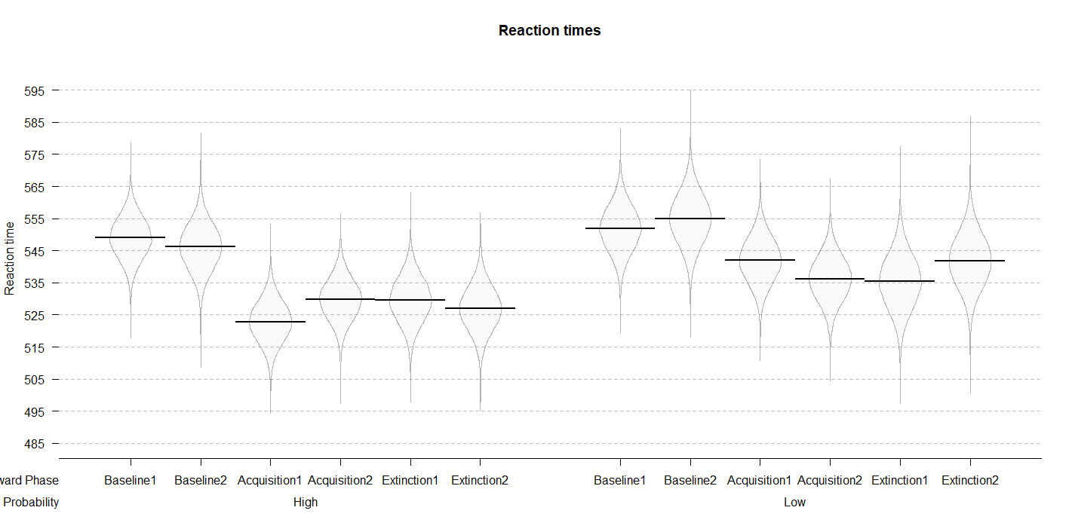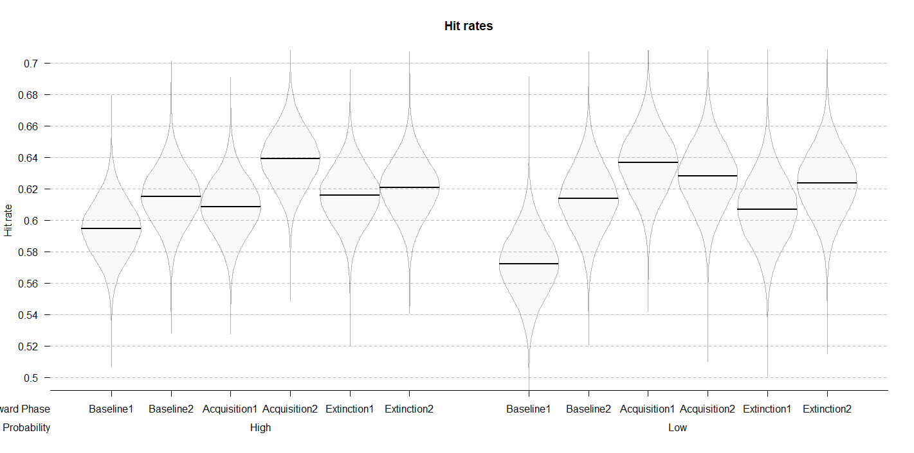

**Figure 2.** Posterior distributions of the interaction models for hit rates and reaction times across six reward phase conditions.

Similar analyses could not be performed for the EEG data, because splitting the number of trials in each phase would significantly affect the signal-to-noise ratio. However, our EEG results point to changes in SSVEP amplitudes in only one of the reward probability conditions. If amplitude changes were mainly driven by training effects, the differences across reward phases would be expected for both reward probability conditions. This observation, combined with the lack of strong training effects in behavior, suggests that our EEG results are not driven by training effects.

## Software for data visualization and analysis

Visualization and statistical analyses were performed using R v3.4.4 (R Core Team, 2017) via RStudio v1.1.453 (RStudio Team, 2015). We used the following packages (and their respective dependencies):

• data manipulation: tidyverse v1.2.1 (Wickham, 2017);

• statistical analyses: Rmisc v1.5 (Hope, 2013), brms v2.3.1 (Bürkner, 2016);

• visualization: cowplot v0.9.2 (Wilke, 2016), yarrr v0.1.5 (Phillips, 2016), viridis v0.5.1 (Garnier, 2018), eegUtils v0.2.0 (Craddock, 2018), BEST (J. K. Kruschke & Meredith, 2017);

• report generation: pacman v0.4.6 (Rinker & Kurkiewicz, n.d.), knitr v1.20 (Xie, 2018).

# Acknowledgements

This work was supported by the Special Research Fund (BOF) of Ghent University [grant #01D02415 awarded to IG; grant # BOF14/PDO/123 awarded to AS] and the Concerted Research Action Grant of Ghent University [grant number BOF16/GOA/017 awarded to EHWK]. Add funding for Gilles and Søren. The funding sources had no involvement in the study design; collection, analysis, and interpretation of data; writing of the report; and decision to submit the article for publication.

We would like to thank Ladislas Nalborczyk for discussions about statistical analyses of the data and Dr. Inez Greven for help with data collection.

# Author contributions

IG, AS, and SKA conceived the study. SKA and IG programmed the experimental paradigm. SKA, GP, and EHWK contributed reagents/materials/tools. IG collected the data, supervised by AS. IG and AS analyzed the data. IG and AS wrote the main manuscript text. IG, AS, GP, EHWK, and SKA reviewed and critically revised the manuscript.

# Data availability

Raw and pre-processed data, materials, and analysis scripts are available at: https://osf.io/kjds3/.

# References

Andersen, S. K., & Müller, M. M. (2010). Behavioral performance follows the time course of neural facilitation and suppression during cued shifts of feature-selective attention. *Proceedings of the National Academy of Sciences of the United States of America*, *107*(31), 13878–13882. https://doi.org/10.1073/pnas.1002436107

Andersen, S. K., Müller, M. M., & Hillyard, S. A. (2012). Tracking the allocation of attention in visual scenes with steady-state evoked potentials. In *Cognitive neuroscience of attention* (pp. 197–216).

Anderson, B. (2013). A value-driven mechanism of attentional selection. *Journal of Vision*, *13*, 1–16. https://doi.org/10.1167/13.3.7.doi

Anderson, B. A. (2016). The attention habit: How reward learning shapes attentional selection. *Annals of the New York Academy of Sciences*, *1369*(1), 24–39. https://doi.org/10.1111/nyas.12957

Anderson, B. A., Chiu, M., DiBartolo, M. M., & Leal, S. L. (2017). On t﻿he distinction between value-driven attention and selection history: Evidence from individuals with depressive symptoms. *Psychonomic Bulletin & Review*, (February). https://doi.org/10.3758/s13423-017-1240-9

Anderson, B. A., Leal, S. L., Hall, M. G., Yassa, M. A., & Yantis, S. (2014). The attribution of value-based attentional priority in individuals with depressive symptoms. *Cognitive, Affective & Behavioral Neuroscience*, *14*(4), 1221–1227. https://doi.org/10.3758/s13415-014-0301-z

Anderson, B. A., & Yantis, S. (2013). Persistence of value-driven attentional capture. *Journal of Experimental Psychology: Human Perception and Performance*, *39*(1), 6–9. https://doi.org/10.1037/a0030860

Anderson, B. a, Laurent, P. a, & Yantis, S. (2011). Value-driven attentional capture. *Proceedings of the National Academy of Sciences*, *108*(25), 10367–10371. https://doi.org/10.1073/pnas.1104047108

Awh, E., Belopolsky, A. V., & Theeuwes, J. (2012). Top-down versus bottom-up attentional control: A failed theoretical dichotomy. *Trends in Cognitive Sciences*, *16*(8), 437–443. https://doi.org/10.1016/j.tics.2012.06.010

Brown, J. W., & Alexander, W. H. (2017). Foraging Value, Risk Avoidance, and Multiple Control Signals: How the Anterior Cingulate Cortex Controls Value-based Decision-making. *Journal of Cognitive Neuroscience*, *29*(10), 1656–1673. https://doi.org/10.1162/jocn_a_01140

Bürkner, P.-C. (2016). brms: An R package for Bayesian multilevel models using Stan. *Journal of Statistical Software*, *80*(1), 1–28.

Bürkner, P.-C. (2017). Advanced Bayesian Multilevel Modeling with the R Package brms. *ArXiv:1705.11123*.

Carpenter, B., Gelman, A., Hoffman, M., Lee, D., Goodrich, B., Betancourt, M., … Riddell, A. (2016). Stan: A probabilistic programming language. *Journal of Statistical Software*, *2*(20), 1–37.

Chatrian, G. E., Lettich, E., & Nelson, P. L. (1985). Ten percent electrode system for topographic studies of spontaneous and evoked EEG activities. *American Journal of EEG Technology*, *25*(2).

Chelazzi, L., Perlato, A., Santandrea, E., & Della Libera, C. (2013). Rewards teach visual selective attention. *Vision Research*, *85*, 58–62. https://doi.org/10.1016/j.visres.2012.12.005

Chun, M. M., Golomb, J. D., & Turk-Browne, N. B. (2011). A Taxonomy of External and Internal Attention. *Annual Review of Psychology*, *62*(1), 73–101. https://doi.org/10.1146/annurev.psych.093008.100427

Corbetta, M., & Shulman, G. L. (2002). Control of Goal-Directed and Stimulus-Driven Attention in the Brain. *Nature Reviews Neuroscience*, *3*(3), 215–229. https://doi.org/10.1038/nrn755

Craddock, M. (2018). craddm/eegUtils: eegUtils (Version v0.2.0). Zenodo.

Della Libera, C., & Chelazzi, L. (2009). Learning to attend and to ignore is a matter of gains and losses. *Psychological Science*, *20*(6), 778–784. https://doi.org/10.1111/j.1467-9280.2009.02360.x

Delorme, A., & Makeig, S. (2004). EEGLAB: an open sorce toolbox for analysis of single-trail EEG dynamics including independent component anlaysis. *Journal of Neuroscience Methods*, *134*, 9–21. https://doi.org/10.1016/j.jneumeth.2003.10.009

Desimone, R., & Duncan, J. (1995). Neural Mechanisms of Selective Visual. *Annual Review of Neuroscience*, *18*(1), 193–222. https://doi.org/10.1146/annurev.ne.18.030195.001205

Donohue, S. E., Hopf, J.-M., Bartsch, M. V., Schoenfeld, M. A., Heinze, H.-J., & Woldorff, M. G. (2016). The Rapid Capture of Attention by Rewarded Objects. *Journal of Cognitive Neuroscience*, *28*(4), 529–541. https://doi.org/10.1162/jocn_a_00917

Failing, M. F., & Theeuwes, J. (2014). Exogenous visual orienting by reward. *Journal of Vision*, *14*(2014), 1–9. https://doi.org/10.1167/14.5.6.doi

Failing, M., & Theeuwes, J. (2017). Selection history: How reward modulates selectivity of visual attention. *Psychonomic Bulletin and Review*, 1–25. https://doi.org/10.3758/s13423-017-1380-y

Franken, I. H. A., Muris, P., & Rassin, E. (2005). Psychometric properties of the Dutch BIS/BAS scales. *Journal of Psychopathology and Behavioral Assessment*, *27*(1), 25–30. https://doi.org/10.1007/s10862-005-3262-2

Garnier, S. (2018). viridis: Default Color Maps from ‘matplotlib.’ R package version 0.3.

Gelman, A., Goodrich, B., Gabry, J., & Ali, I. (2017). R-squared for Bayesian regression models. *Unpublished via Http://Www. Stat. Columbia. Edu/~ Gelman/Research/Unpublished.* Retrieved from http://www.stat.columbia.edu/~gelman/research/unpublished/bayes_R2.pdf

Gelman, A., & Rubin, D. B. (1992). Inference from Iterative Simulation Using Multiple Sequences. *Statistical Science*, *7*(4), 457–472. https://doi.org/10.1214/ss/1177011136

Hickey, C., Chelazzi, L., & Theeuwes, J. (2010). Reward Changes Salience in Human Vision via the Anterior Cingulate. *Journal of Neuroscience*, *30*(33), 11096–11103. https://doi.org/10.1523/JNEUROSCI.1026-10.2010

Hickey, C., & Peelen, M. V. (2015). Neural mechanisms of incentive salience in naturalistic human vision. *Neuron*, *85*(3), 512–518. https://doi.org/10.1016/j.neuron.2014.12.049

Hickey, C., Peelen, M. V, Hickey, C., & Peelen, M. V. (2015). Neural Mechanisms of Incentive Salience in Naturalistic Human Vision Report Neural Mechanisms of Incentive Salience in Naturalistic Human Vision. *Neuron*, *85*(3), 512–518. https://doi.org/10.1016/j.neuron.2014.12.049

Holroyd, C. B., & McClure, S. M. (2015). Hierarchical control over effortful behavior by rodent medial frontal cortex: A computational model. *Psychological Review*, *122*(1), 54–83. https://doi.org/10.1037/a0038339

Hope, R. M. (2013). Rmisc: Ryan miscellaneous. R package version, 1(5).

Junghöfer, M., Elbert, T., Tucker, D. O. N. M., & Rockstroh, B. (2000). Statistical control of artifacts in dense array EEG 0 MEG studies. *Wiley Online Library*, 523–532. Retrieved from http://onlinelibrary.wiley.com/doi/10.1111/1469-8986.3740523/full

Kruschke, J. K. (2014). *Doing Bayesian data analysis: A tutorial with R, JAGS, and Stan, second edition*. *Doing Bayesian Data Analysis: A Tutorial with R, JAGS, and Stan, Second Edition* (2nd ed.). Elsevier Inc. https://doi.org/10.1016/B978-0-12-405888-0.09999-2

Kruschke, J. K., & Meredith, M. (2017). BEST: Bayesian Estimation Supersedes the t-Test.

MacLean, M. H., & Giesbrecht, B. (2015). Neural evidence reveals the rapid effects of reward history on selective attention. *Brain Research*, *1606*, 86–94. https://doi.org/10.1016/j.brainres.2015.02.016

McElreath, R. (2016). *Statistical Rethinking: A Bayesian Course with Examples in R and Stan*. Chapman Hall - CRC.

Nalborczyk, L., & Bürkner, P.-C. (2019). An Introduction to Bayesian Multilevel Models Using brms: A Case Study of Gender Effects on Vowel Variability in Standard Indonesian. *Journal of Speech, Language, and Hearing Research*.

Nolan, H., Whelan, R., & Reilly, R. B. (2010). FASTER: Fully Automated Statistical Thresholding for EEG artifact Rejection. *Journal of Neuroscience Methods*, *192*(1), 152–162. https://doi.org/10.1016/j.jneumeth.2010.07.015

Norcia, A. M., Appelbaum, L. G., Ales, J. M., Cottereau, B. R., & Rossion, B. (2015). The steady-state visual evoked potential in vision research : A review. *Journal of Vision*, *15*(6), 1–46. https://doi.org/10.1167/15.6.4.doi

Pearson, D., Donkin, C., Tran, S. C., Most, S. B., & Le Pelley, M. E. (2015). Cognitive control and counterproductive oculomotor capture by reward-related stimuli. *Visual Cognition*, *6285*(May 2015), 1–26. https://doi.org/10.1080/13506285.2014.994252

Perrin, F., Pernier, J., Bertrand, O., & Echallier, J. F. (1989). Spherical splines for scalp potential and current density mapping. *Electroencephalography and Clinical Neurophysiology*, *72*(2), 184–187. https://doi.org/10.1016/0013-4694(89)90180-6

Phillips, N. (2016). Yarrr: A companion to the e-book YaRrr!: The Pirate’s Guide to R. R package version 0.1.

Posner, M. I. (1980). Orienting of attention. *The Quarterly Journal of Experimental Psychology*, *32*(1), 3–25. https://doi.org/10.1080/00335558008248231

R Core Team. (2017). R: A Language and Environment for Statistical Computing. R Foundation for Statistical Computing.

Rinker, T., & Kurkiewicz, D. (n.d.). pacman: Package Management for R.

RStudio Team. (2015). Integrated Development for R. RStudio, Inc.

Shenhav, A., Botvinick, M., & Cohen, J. (2013). The expected value of control: An integrative theory of anterior cingulate cortex function. *Neuron*, *79*(2), 217–240. https://doi.org/10.1016/j.neuron.2013.07.007

Theeuwes, J. (2004). Top-down search strategies cannot override attentional capture. *Psychonomic Bulletin & Review*, *11*(1), 65–70.

Theeuwes, J. (2010). Top-down and bottom-up control of visual selection. *Acta Psychologica*, *135*(2), 77–99. https://doi.org/10.1016/j.actpsy.2010.02.006

Van der Does, A. J. W. (2002). *Handleiding bij de Nederlandse versie van beck depression inventory—second edition (BDI-II-NL). [The Dutch version of the Beck depression inventory].* Amsterdam: Harcourt.

Verguts, T., Vassena, E., & Silvetti, M. (2015). Adaptive effort investment in cognitive and physical tasks: a neurocomputational model. *Frontiers in Behavioral Neuroscience*, *9*(March). https://doi.org/10.3389/fnbeh.2015.00057

Watanabe, S. (2010). Asymptotic Equivalence of Bayes Cross Validation and Widely Applicable Information Criterion in Singular Learning Theory, *11*, 3571–3594. Retrieved from http://arxiv.org/abs/1004.2316

Wickham, H. (2017). Tidyverse: Easily install and load ’tidyverse’ packages. R package version, 1(1).

Wilke, C. O. (2016). cowplot: streamlined plot theme and plot annotations for ‘ggplot2.’ CRAN Repos.

Xie, Y. (2018). knitr: A General-Purpose Package for Dynamic Report Generation in R.

Yantis, S. (1993). Stimulus-Driven Attentional Capture. *Current Directions in Psychological Science*, *2*(5). https://doi.org/10.1111/1467-8721.ep10768973