Dynamic interplay between reward and voluntary attention determines stimulus processing in the visual cortex

Ivan Grahek1☨*, Antonio Schettino1,2☨, Ernst H.W. Koster1, & Søren K. Andersen3

1. *Department of Experimental Clinical and Health Psychology, Ghent University, Henri Dunantlaan 2, B-9000, Ghent, Belgium*
2. *Institute for Globally Distributed Open Research and Education (IGDORE)*
3. *School of Psychology, University of Aberdeen, William Guild Building, Aberdeen, AB24 3FX, United Kingdom*

# **Abstract**

Reward enhances stimulus processing in the visual cortex, but the mechanisms through which this effect occurs remain unclear. Reward prospect can both increase the deployment of voluntary attention and increase the salience of previously neutral stimuli. In this study we orthogonally manipulated these two factors while human participants performed a global motion detection task. We recorded steady-state visual evoked potentials (SSVEPs) to simultaneously measure the processing of attended and unattended stimuli linked to different reward probabilities. The processing of the high rewarded feature was enhanced independently of voluntary attention, but this gain diminished once rewards were no longer available. Neither the voluntary attention nor the salience account alone can fully explain these results. Instead, we propose how these two accounts can to be integrated to allow for the flexible balance between reward-driven increase in salience and voluntary attention.

Keywords: voluntary attention; attentional control; reward; motivation; EEG; feature-based attention; steady-state visual evoked potentials; frequency tagging; Bayesian multilevel modeling

# Introduction

Maximizing rewards and avoiding punishments are main determinants of human behavior. In order to increase reward probability, reward-related information needs to be prioritized. Selective attention is crucial for adaptive behavior as it facilitates processing of relevant and suppression of irrelevant information in our environment (Chun, Golomb, & Turk-Browne, 2011; Desimone & Duncan, 1995). This process depends on our current goals (e.g., searching for our keys) and the physical salience of stimuli (e.g., a loud noise; Corbetta & Shulman, 2002; Posner, 1980; Theeuwes, 2010). Recent research has indicated that motivation can influence selective attention by impacting both of these factors. Reward expectation can enhance voluntary selective attention and reward associations can increase the salience of previously neutral stimuli. In most situations, attention is guided by the combination of both voluntary allocation of attention and reward history of stimuli (Awh, Belopolsky, & Theeuwes, 2012). For example, while we are searching for keys (goal-relevant target) our attention can be captured by a cake (goal-irrelevant distractor). These two ways in which rewards influence selective attention have been commonly studied in isolation and the neural mechanisms through which they jointly guide attention remain unclear. Specifically, it remains unclear how voluntary selective attention and reward history interact to determine the processing of goal-relevant and irrelevant stimuli in the visual cortex.

Voluntary selective attention is thought to be enhanced when individuals anticipate that they can earn rewards for good task-performance (Botvinick & Braver, 2015; Krebs & Woldorff, 2017; Pessoa, 2015). A number of fMRI and EEG studies found reward-based enhancements in preparation for upcoming target stimuli driven by enhanced activity in frontoparietal regions involved in attentional control (Krebs, Boehler, Roberts, Song, & Woldorff, 2012; Pessoa & Engelmann, 2010; Schevernels, Krebs, Santens, Woldorff, & Boehler, 2014) and by enhanced task-set representations in these regions (Etzel, Cole, Zacks, Kay, & Braver, 2016; Wisniewski, Reverberi, Momennejad, Kahnt, & Haynes, 2015). While these studies suggest that reward influences attentional control via modulations in the frontoparietal network, it remains unclear how such modulations translate to affect the processing of attended and unattended stimuli in visual cortex.

Within a largely independent research line, a set of studies has focused on the processing of stimuli associated with earning rewards. These studies have demonstrated that stimuli currently or previously associated with rewards capture attention in an automatic fashion, and even in cases when this conflicts with the current goals (Anderson, 2016; Awh, Belopolsky, & Theeuwes, 2012; Chelazzi, Perlato, Santandrea, & Della Libera, 2013; Failing & Theeuwes, 2017). Behavioral studies have demonstrated that stimuli predictive of rewards capture attention, and that they can do so in subsequent trials when rewards are no longer present (Anderson, Laurent, & Yantis, 2011; Della Libera & Chelazzi, 2009; Failing & Theeuwes, 2014). At the neural level it has been shown that stimuli related to rewards receive increased sensory processing (Serences, 2008). Studies focusing specifically on attention have shown that attentional capture by rewarding stimuli can be related to changes in the early processing of such stimuli in the visual cortex (i.e., increase in the P1 component; Donohue et al., 2016; Hickey, Chelazzi, & Theeuwes, 2010; Luque et al., 2017; MacLean & Giesbrecht, 2015). However, other studies have not found evidence for such early modulations in the visual cortex, and instead reported changes at later stages of stimulus processing (increased N2pc component and improved decoding in later processing stages; Qi, Zeng, Ding, & Li, 2013; Tankelevitch, Spaak, Rushworth, & Stokes, 2019). One fMRI study (Hickey & Peelen, 2015) provided evidence for the simultaneous enhancement in representation of reward-related stimuli and suppression of stimuli devoid of a specific motivational value. More specifically, using a multivoxel pattern analysis and decoding technique, these authors found a gain increase in object-selective visual cortex for stimuli paired with rewards, while those not associated with this incentive were suppressed.

Importantly, the effects of reward history and voluntary attention are often difficult to dissociate, and they are commonly confounded in cognitive tasks (Maunsell, 2004). Thus the open question is whether the reward-related changes in stimulus processing in visual cortex occur as a consequence of voluntary selective attention, changes in stimulus salience, or a combination of both. One option (the *voluntary selective attention view*) is that rewards influence the processing of stimuli by increasing the amount of voluntary attention deployed toward these stimuli. This hypothesis can be derived from the models which are focused on the role of motivation in the allocation of attention and cognitive control (Brown & Alexander, 2017; Holroyd & McClure, 2015; Shenhav, Botvinick, & Cohen, 2013; Verguts, Vassena, & Silvetti, 2015). These models propose that the amount of attention allocated toward stimuli is dependent on the amount of rewards which can be earned by doing so. Another possibility (*the salience view*) is that rewards increase the salience of stimuli, and thus capture attention automatically, independently of voluntary attention. This view can be derived from theoretical models focused on the role of reward history in guiding selective attention (Anderson, 2016; Awh et al., 2012; Chelazzi et al., 2013; Failing & Theeuwes, 2017). These models propose that the processing of stimuli related to high rewards is facilitated, while the processing of other stimuli is suppressed, and that this effect is long lasting, even when rewards are no longer available.

In this study, we orthogonally manipulated voluntary attention and reward probability in order to test the predictions of these models within a single paradigm. To this end, participants performed a continuous global motion discrimination task (Andersen, Muller, & Hillyard, 2009; Andersen & Müller, 2010). On each trial, two superimposed random dot kinematograms (RDKs) of different color (red and blue) were presented concurrently and participants were cued on a trial-by-trial basis to attend to one of them. Thus, these two RDKs served as goal-relevant (attended) and goal-irrelevant (unattended) stimuli, respectively. Critically, after a baseline period used as control condition, these two colors were systematically associated with a low or high probability of earning a reward in a training phase. We subsequently examined the influence of the previous reward history in the test phase, in which rewards were no longer available. The two RDKs flickered at different frequencies, thereby driving separate steady-state visual evoked potentials (SSVEPs). SSVEPs offer the unique advantage of simultaneously tracking the processing of multiple stimuli as the specific oscillatory response of each stimulus can be extracted (frequency tagging), and the two resulting signals can be compared to each other (Andersen & Müller, 2010; Kashiwase, Matsumiya, Kuriki, & Shioiri, 2012; Müller, Teder-Sälejärvi, & Hillyard, 1998). Voluntary attention is known to increase SSVEP amplitudes of attended stimuli (Morgan, Hansen, & Hillyard, 1996). Further, SSVEP amplitudes are highly sensitive to changes in the physical salience of stimuli and are increased for more salient stimuli (Andersen, Muller, & Martinovic, 2012). Hence, analyzing SSVEPs in this design provided us with the ability to simultaneously track the visual processing of attended and unattended stimuli related to high or low rewards respectively. This design thus enabled us to dissociate the effects of voluntary attention and reward, which are often difficult to distinguish (Maunsell, 2004).

We tested predictions arising from the theoretical models developed to account for the effects of rewards on cognitive control (Brown & Alexander, 2017; Holroyd & McClure, 2015; Shenhav et al., 2013; Verguts et al., 2015) and the effects of reward history on attention (Anderson, 2016; Awh et al., 2012; Chelazzi et al., 2013; Failing & Theeuwes, 2017) respectively. The first class of models predict that reward influences sensory processing through voluntary attention (Figure 1A), and the second class of models predict that rewards directly influence the salience of stimuli (Figure 1B). Both groups of models predict behavioral improvements and enhanced processing (higher SSVEP amplitudes) of the stimuli related to high rewards. However, the salience view predicts that the processing of the high reward stimuli will be enhanced irrespective of voluntary attention, while the voluntary attention view predicts that the processing of the high reward stimuli will be enhanced only when they are attended. The salience view also predicts the suppressed processing of the low reward stimuli, while the voluntary attention view predicts that the processing of these stimuli will be suppressed only when they are not attended. Finally, the salience view predicts that these effects will persist when rewards are no longer available (test phase), while the voluntary attention view predicts that the processing of both high and low reward stimuli will retreat to baseline levels.

# Methods

## Participants

We tested 48 participants with normal or corrected-to-normal vision and no history of psychiatric or neurological disorders. Four participants were excluded due to technical problems during EEG recording and one person was excluded due to noisy EEG data. Thus, the final data set consisted of 43 participants (39 females, 14 males; median age = 22). Participants received a fixed payoff of 20 €, plus up to 6 € depending on task performance (on average 25.5 €). The study was approved by the ethics committee of Ghent University.

## Stimuli and task

We used the coherent motion detection task (Andersen & Müller, 2010; *Figure 1A*), in which participants were presented with two overlapping circular RDKs of isoluminant colors (red and blue) on a grey background. Viewing distance was fixed with a chinrest at 55 cm from the 21-inch CRT screen (resolution of 1024 x 768 pixels, 120 Hz refresh rate). At the beginning of each trial, participants were instructed which of the two RDKs to attend by a verbal audio cue: “red” (241 ms) or “blue” (266 ms). The two RDKs had a diameter corresponding to 20.61 degrees of visual angle and consisted of 125 randomly and independently moving dots each (0.52 degrees of visual angle per dot). The two RDKs flickered at different frequencies (10 or 12 Hz). One-third of trials contained one, two, or three coherent motion intervals, occurring with equal probability in the attended and unattended color RDK. During these intervals, dots in one of the RDKs moved with 75% coherence in one of four cardinal directions (up, down, left, or right) for 300 ms. Participants had to detect the occurrence of coherent motion in the attended RDK as fast as possible by pressing the space key on a standard AZERTY USB keyboard while ignoring such coherent motion in the unattended RDK. Responses occurring between 200 ms and 1500 ms after coherent motion onset of the attended or unattended dots were counted as hits or false alarms, respectively. Correct responses were followed by a tone (200 ms sine wave of either 800 or 1,200 Hz, counterbalanced across participants). Late or incorrect responses were followed by an error sound (200 ms square wave tone of 400 Hz).

The experiment started with 4 practice blocks of 60 trials in each block. After each block, participants received feedback on their performance. After finishing the practice phase, participants completed 12 blocks (each consisting of 50 trials) divided into 3 phases (*baseline*, *training*, and *test*; *Figure 1B*) of 4 blocks each. Each phase contained 100 trials on which participants were instructed to attend to the red color and 100 trials in which they were instructed to attend to the blue color. Out of those 100 trials, 40 trials contained no dot motion, while 60 trials contained one, two, or three dot motions (20 of each). The trials in which participants attended one or the other color and the trials with different number of motions were intermixed. Participants did the coherent motion detection task, as described above, throughout all three phases (baseline, training, and test). In the training phase, participants could earn additional monetary rewards (up to 6 €) based on their actual performance. They were instructed that one of the colors would be paired with high probability (80%) and the other color with low probability (20%) of earning 10 extra cents for each correct motion detection. The mapping between color and reward probability was counterbalanced across participants. Receipt of the reward was signaled by a new tone that replaced the usual correct tone. If the correct tone was a sine wave of 800 Hz, the reward tone was a sine wave of 1,200 Hz and vice versa. At the end of each of 4 training blocks, participants received feedback regarding both their performance and the amount of reward earned within the block. The third phase (test) was identical to baseline (i.e., no monetary rewards assigned). The entire task lasted for approximately 50 minutes, including short breaks in between blocks. After finishing the task, participants completed two questionnaires aimed at assessing reward sensitivity (BIS-BAS; Franken et al., 2005) and depression levels (BDI-II; Van der Does, 2002). The collection of the questionnaire data is not reported here as it was collected for exploratory purposes in order to form a larger database of neural and self-report measures of reward processing. This experiment was realized using Cogent 2000 developed by the Cogent 2000 team at the FIL and the ICN and Cogent Graphics developed by John Romaya at the LON at the Wellcome Department of Imaging Neuroscience.

## EEG recording and pre-processing

Electroencephalographic activity (EEG) was recorded with an ActiveTwo amplifier (BioSemi, Inc., The Netherlands) at a sampling rate of 512 Hz. Sixty-four Ag/AgCl electrodes were fitted into an elastic cap, following the international 10/10 system (Chatrian, Lettich, & Nelson, 1985). The common mode sense (CMS) active electrode and the driven right leg (DRL) passive electrode were used as reference and ground electrodes, respectively. Additional external electrodes were applied to the left and right mastoids, as well as on the outer canthi of each eye and in the inferior and superior areas of the left orbit (to record horizontal and vertical electrooculogram, EOG).

Data pre-processing was performed offline with custom MATLAB scripts and functions included in EEGLAB v14.1.1b (Delorme & Makeig, 2004). After subtracting the mean value of the signal (DC offset), the continuous EEG data were epoched between 0 and 3,250 ms, corresponding to the beginning and end of the trial, respectively. After referencing to *Cz*, FASTER v1.2.3b (Nolan, Whelan, & Reilly, 2010) was used for artifact identification and rejection using the following settings: (i) over the whole normalized EEG signal, channels with variance, mean correlation, and Hurst exponent exceeding *z* = ±3 were interpolated via a spherical spline procedure (Perrin, Pernier, Bertrand, & Echallier, 1989); (ii) the mean across channels was computed for each epoch and, if amplitude range, variance, and channel deviation exceeded *z* = ±3, the whole epoch was removed; (iii) within each epoch, channels with variance, median gradient, amplitude range, and channel deviation exceeding *z* = ±3 were interpolated; (iv) grand-averages with amplitude range, variance, channel deviation, and maximum EOG value exceeding *z* = ±3 were removed; (v) epochs containing more than 12 interpolated channels were discarded. Subsequently, automated routines were used to reject all trials with blinks or horizontal eye-movements exceeding 25 microvolt. For details, see our commented code at https://osf.io/q762a/. After pre-processing, the average number of interpolated channels was 3.61 (*SD* = 1.23, range 1 – 6) and the mean percentage of rejected epochs was 8.77% (*SD* = 6.71, range 0 – 27.78). After re-referencing to averaged mastoids, trials in each condition were averaged separately for each participant, resulting in the following averages: (i) baseline, red attended; (ii) baseline, blue attended; (iii) training, red attended; (iv) training, blue attended; (v) test, red attended; (vi) test, blue attended.

After removing linear trends, SSVEP amplitudes were computed as the absolute of the complex Fourier coefficients of the trial averaged EEG in a time-window from 500 ms (to exclude the typically strong phasic visual evoked response to picture onset) to 3,250 ms after stimulus onset. Electrodes with maximum SSVEP amplitudes were identified by calculating isocontour voltage maps based on grand-averaged data collapsed across all conditions. Based on this, a cluster consisting of the four electrodes Oz, O2, POz, and Iz was chosen for further analysis. SSVEP amplitudes were normalized (rescaled) for each participant and frequency (10 and 12 Hz) separately by dividing amplitudes by the average amplitude of the two conditions in the baseline.

## Statistical analyses

Behavioral and EEG data were analyzed using Bayesian multilevel regressions. We fitted and compared multiple models of varying complexity to predict observer sensitivity (d′, i.e. participants’ ability to distinguish between target and distractor coherent motion), reaction times for correct responses, and SSVEP amplitudes. For the behavioral data, mean reaction times of correct detections (hits) and sensitivity (d′) were analyzed. Sensitivity index d′ (Macmillan & Creelman, 2004) was calculated with adjustments for extreme values (Hautus, 1995) using the *psycho* R package (for the method see: Pallier, 2002).

Each of the fitted models included both constant and varying effects (also known as fixed and random). Participant-specific characteristics are known to affect both behavioral performance (e.g., response speed) and EEG signal (e.g., skull thickness, skin conductance, hair); therefore, we decided to model this variability by adding varying intercepts in our models. Additionally, the studied effects (i.e., selective attention and reward sensitivity) are known to vary in magnitude over participants, so we opted for including varying slopes in our models[1].

Models were fitted in R using the *brms* package (Bürkner, 2016) which employs the probabilistic programming language *Stan* (Carpenter et al., 2016)to implement Markov Chain Monte Carlo (MCMC) algorithms in order to estimate posterior distributions of the parameters of interest (details about the fitted models can be found in the data analysis scripts). Each of the models were fitted using weakly informative prior distributions (described below) and Gaussian likelihood. Four MCMC simulations (“chains”) with 6,000 iterations (3,000 warmup) and no thinning were run to estimate parameters in each of the fitted models. Further analyses were done following the recommendations for Bayesian multilevel modeling using *brms* (Bürkner, 2016, 2017; Nalborczyk & Bürkner, 2019). We confirmed that all models converged by examining trace plots, autocorrelation, and variance between chains (Gelman-Rubin statistic; Gelman & Rubin, 1992). We compared models based on their fit to the actual data using the Bayesian *R*2 (Gelman, Goodrich, Gabry, & Ali, 2017), and their out-of-sample predictive performance using the Widely Applicable Information Criterion (WAIC; Watanabe, 2010). The best model was selected and the posterior distributions of conditions of interest were examined. Differences between conditions were assessed by computing the mean and the 95% highest density interval (HDI) of the difference between posterior distributions of the respective conditions (Kruschke, 2014). Additionally, we calculated the evidence ratios (ERs) for our hypotheses as the ratios between the percentage of posterior samples on each side of the zero of a difference distribution between two conditions. ERs can be interpreted as the probability of a hypothesis (e.g. “Condition A is larger than condition B”) against its alternative (“Condition B is larger than condition A”).

### Behavioral data

We fitted three models to predict sensitivity (d′) and reaction times (in milliseconds) separately (*Figure 2* for the raw data and *Supplementary Table 1* for the descriptive statistics). First, we fitted the *Null model* with a constant and varying intercepts across participants. This model was fitted in order to explore the possibility that the data would be best explained by simple random variation between participants. To investigate the effect of reward phase (baseline, training, test), we fitted the *Reward phase* model which included only reward phase as the constant predictor, as well as varying intercepts and slopes across participants for this effect. To investigate the possible interaction between reward phase and reward, we fitted the *Reward phase × Reward* *Probability* model including the intercepts and slopes of these two effects and their interaction as both constant and varying effects. All models had a Gaussian distribution as the prior for the intercept (for sensitivity: centered at 1.8 with a standard deviation of 1; for reaction times: centered at 500 with a standard deviation of 200). The models with slopes also included a Gaussian distribution as prior for the slopes (for sensitivity: centered at 0 with a standard deviation of 2; for reaction times: centered at 0 with a standard deviation of 200). The means for the priors for the intercepts were selected based on the previous study with the same task (Andersen & Müller, 2010). The standard deviations of all of the prior distributions were chosen so that the distributions are very wide and thus only weakly informative. Note that there are two additional models that, although possible to fit, are not plausible in the context of our experiment. Specifically, the model including only the effect of reward probability overlooks the fact that this effect would necessarily be most pronounced in the training phase, thus interacting with the effect of reward phase. The same logic applies to the model with additive effects of reward phase and probability (i.e., these effects could not act independently in our experimental design).

### SSVEP amplitudes

We fitted seven models to predict the trial-averaged SSVEP amplitudes (in a.u. due to the normalization) across conditions (*Figure 2C, Figure 2D,* and *Supplementary* *Table 2*). The *Null model* included one constant and multiple varying intercepts across participants. The *Attention model* included the constant effect of attention; the *Reward Phase model* included the constant effect of reward phase; the *Reward Phase + Attention* model included the additive effects of reward phase and attention; and the *Reward Phase × Attention* model also included the interaction between reward phase and attention. The *Reward probability × Reward phase + Attention* model consisted of the constant effects of reward and phase, their interaction, and the independent effect of attention. The last model was the *Reward probability × Reward phase × Attention* model which included all constant effects and their interaction. All models, except for the *Null* *model*, included varying intercepts and slopes across participants for all of the constant effects. All models included a Gaussian distribution as the prior for the intercept (centered at 1 with a standard deviation of 1). The mean across both attended and unattended conditions is approximately 1 in this paradigm (Andersen & Müller, 2010), while the normalized amplitudes are in the 0-2 range (the normalized amplitude of 2 for the attended stimulus would equal the physical removal of the unattended stimulus) which is why we opted for the standard deviation of 1 for the prior distributions. In addition, the models with slopes included a Gaussian distribution as the prior for the slopes (centered at 0 with a standard deviation of 1). As was the case for the behavioral data, several models were not fitted because they were not plausible in the context of our experiment (e.g., models that include both reward phase and probability, but not their interaction, are implausible because reward probability cannot affect the baseline phase).

# Results

## Behavioral results

### Sensitivity d′

Of all the tested models, the *Reward phase × Reward probability* model best predicted sensitivity (*Table 1*). The posterior distributions of the interaction model (*Figure 2A* and *Table 2*) revealed that sensitivity improved in the training phase compared to the baseline for both the low reward (*M =* 0.14; 95% HDI [0.01, 0.27]; ER = 57.82) and the high reward color (*M =* 0.04; 95% HDI [-0.08, 0.17]; ER = 3.10). This improvement was more pronounced for low compared to high reward (*M =* 0.10; 95% HDI [-0.08, 0.27]; ER = 6.25). Conversely, there was no evidence for a difference between training and test phases in the low reward condition (*M =* 0.00; 95% HDI [-0.13, 0.13]; ER = 1.09), and a small reduction in sensitivity in the high reward condition (*M =* -0.08; 95% HDI [-0.20, 0.05]; ER = 8.52). These results suggest a higher sensitivity for coherent motion detection in the training phase compared to baseline, that was more pronounced for the low relative to the high reward color. There was also very little evidence of a change in sensitivity from the training to the test phase.

|  |  |  |  |  |
| --- | --- | --- | --- | --- |
| Table 1  *Mean and standard errors (in parenthesis) of WAIC and Bayesian R2 for each model predicting sensitivity and reaction times.* | | | | |
| Model | | *WAIC (SE)* | | *Bayesian R2 (SE)* |
| *Sensitivity* | | | | |
| Null | | 533.3 (26.5) |  | 0.27 (0.05) |
| Reward phase | | 541.0 (26.5) |  | 0.27 (0.05) |
| Reward phase × Reward probability | | 202.7 (19.1) |  | 0.84 (0.01) |
| *Reaction times* |  |  |  |  |
| Null | | 2,500.2 (31.6) |  | 0.50 (0.04) |
| Reward phase | | 2,483.0 (35.3) |  | 0.56 (0.04) |
| Reward phase × Reward probability | | 2,322.5 (30.0) |  | 0.82 (0.02) |

|  |  |  |  |
| --- | --- | --- | --- |
| Table 2  *Means and 95% HDIs of the posterior distributions of reaction times and sensitivity in each condition.* | | | |
| Reward phase | Reward probability | Sensitivity (d′) | Reaction times (milliseconds) |
| Baseline | High | 1.64 [1.39, 1.87] | 546.54 [534.33, 559.30] |
| Baseline | Low | 1.48 [1.25, 1.69] | 551.13 [539.34, 563.50] |
| Training | High | 1.69 [1.44, 1.93] | 524.91 [512.94, 536.30] |
| Training | Low | 1.62 [1.41, 1.84] | 537.99 [526.48, 550.32] |
| Test | High | 1.61 [1.36, 1.84] | 528.97 [515.90, 541.99] |
| Test | Low | 1.62 [1.41, 1.84] | 539.85 [525.63, 554.34] |

### Reaction times

The *Reward phase × Reward probability* model also best predicted the reaction times (*Figure 2B* and *Table 1*). In the training, compared to the baseline phase, participants were reliably faster in detecting the motions of both the high (*M =* -21.60; 95% HDI [-29.90, -12.80]; ER > 12,000*.*, i.e. the whole posterior distribution was below zero thus the ER is larger than the total number of posterior samples) and the low reward colors (*M =* -13.10; 95% HDI [-21.70, -4.69]; ER = 999). Moreover, this difference between baseline and training was larger for detecting motions of the high relative to low reward color (*M =* -8.49; 95% HDI [-18.60, 2.06]; ER = 17.18). We found less evidence for changes in reaction times between the training and the test phase. There was a very small increase in the reaction times in the test compared to training phase for the high reward color (*M =* 4.07; 95% HDI [-4.52, 13.10]; ER = 4.40), and no difference for the low reward (*M =* 1.87; 95% HDI [-6.93, 10.70]; ER = 1.98). These results indicate that participants were faster in detecting coherent motions in the condition in which they could earn rewards (training), and more so for high than low reward color. Also, there was a very small increase in the reaction times for the high reward condition and no difference in the low reward condition when the rewards were no longer available (test). Supplementary analyses carried out to assess possible training effects indicated some evidence for the presence of training effects in sensitivity and scant evidence for such effects in reaction times (*Supplementary materials*).

## SSVEP amplitudes

As shown in *Figure 3* SSVEP amplitudes averaged over conditions peaked at central occipital channels (i.e., *Oz*, *POz*, *O2*, *Iz*). Also, the amplitude spectra showed the expected peaks at the frequencies of 10 and 12 Hz.

The *Reward probability × Reward phase + Attention* model best predicted SSVEP amplitudes across conditions (*Table 3*). However, the *Reward probability × Reward phase × Attention* was only slightly worse than the winning model. Here we draw inferences from the winning model, but note that the conclusions do not substantially change when analyzing the model which includes the three-way interaction. The analysis of the posterior distributions of the winning model (*Figure 2* and *Table 3*) revealed a strong effect of voluntary selective attention: in all conditions, SSVEP amplitudes were higher when the eliciting stimulus was attended compared to when it was unattended. In the winning model, this effect did not interact with the other factors in the model, i.e. the magnitude of selective attention was unaffected by reward probability and reward phase. The posterior distribution of the difference between attended and unattended stimuli did not include zero, thus resulting in infinite probability that the attended stimuli would elicit higher SSVEP amplitudes compared to the unattended ones (*M =* 0.24; 95% HDI [0.20, 0.29]; ER > 12,000). These results reveal a very robust effect of voluntary selective attention across all experimental conditions: the SSVEP response was systematically larger when the driving stimulus was attended.

|  |  |  |  |
| --- | --- | --- | --- |
| Table 3  *Model comparison indices for EEG results* | | | |
| Model | *WAIC (SE)* |  | *Bayesian R2 (SE)* |
| Null | -22.3 (56.2) |  | 0.01 (0.01) |
| Reward phase | -31.8 (55.0) |  | 0.05 (0.01) |
| Attention | -436.5 (66.4) |  | 0.37 (0.02) |
| Reward phase + Attention | -464.7 (64.9) |  | 0.40 (0.02) |
| Reward phase × Attention | -461.3 (65.2) |  | 0.41 (0.02) |
| Reward probability × Reward phase + Attention | -696.1 (71.9) |  | 0.55 (0.02) |
| Reward probability × Reward phase × Attention | -690.4 (71.9) |  | 0.55 (0.02) |
|  | | | |

|  |  |  |  |
| --- | --- | --- | --- |
| Table 4  *Means and 95% HDIs of the posterior distributions of the SSVEP amplitudes for each condition.* | | | |
| Attention | Reward phase | Reward probability | Amplitudes (a.u.) |
| Attended | Baseline | High | 1.12 [1.08, 1.16] |
| Attended | Baseline | Low | 1.12 [1.07, 1.17] |
| Attended | Training | High | 1.15 [1.10, 1.19] |
| Attended | Training | Low | 1.11 [1.07, 1.16] |
| Attended | Test | High | 1.11 [1.06 ,1.17] |
| Attended | Test | Low | 1.13 [1.07, 1.19] |
| Unattended | Baseline | High | 0.88 [0.83, 0.92] |
| Unattended | Baseline | Low | 0.88 [0.84, 0.92] |
| Unattended | Training | High | 0.90 [0.85, 0.95] |
| Unattended | Training | Low | 0.87 [0.82, 0.91] |
| Unattended | Test | High | 0.87 [0.82, 0.92] |
| Unattended | Test | Low | 0.88 [0.83, 0.94] |

The winning model also included the interaction between reward phase and reward probability, but this interaction remained the same for both attended and unattended stimuli. SSVEP amplitudes were higher in the training phase than at baseline for the high reward color (*M =* 0.02; 95% HDI [-0.01, 0.06]; ER = 9.53), both when it was attended and unattended. However, there was no evidence of difference for the change in SSVEP amplitudes from baseline to training for the low reward color (*M =* 0.01; 95% HDI [-0.03, 0.05]; ER = 2.58). Comparing the training to the test phase, the amplitudes of the high reward color were reduced (*M = -*0.03; 95% HDI [-0.07, 0.01]; ER = 13.71), while the amplitudes of the low reward color did not change (*M =* -0.02; 95% HDI [-0.06, 0.02]; ER = 3.72). To summarize, visual processing of the high reward color stimulus was enhanced in the phase in which participants could earn monetary rewards and returned to baseline in the subsequent test phase without rewards. Thus, change occurred irrespective of whether that color was attended or not. Finally, visual processing of the low reward color remained constant across the three phases of the experiment.

# Discussion

In this study we investigated the neural mechanisms through which voluntary selective attention and reward history jointly guide visual processing. We compared the processing of attended and unattended stimuli of different reward probabilities on a continuous global motion discrimination task. Compared to baseline, the introduction of rewards speeded up task performance, especially for the higher reward stimuli, which was accompanied by enhanced processing of these stimuli in the visual cortex (higher SSVEPs). This sensory gain was present both when the high reward stimulus was attended and unattended, thus indicating that rewards influenced visual processing independently of voluntary selective attention. When rewards were no longer available, sensory processing of high reward stimuli returned to baseline levels, but participants were still faster to detect coherent motions of high reward stimuli.

The introduction of rewards improved behavioral performance on the task and facilitated the visual processing of stimuli associated with high rewards. This effect on SSVEP amplitudes is likely localized in the V1-V3 areas of the visual cortex, as reported in the previous studies using the same task (Andersen et al., 2009; Andersen & Müller, 2010; Andersen, Hillyard, & Müller, 2008). Crucially, this effect was the same both when the high reward stimulus was attended and unattended. Thus, this effect was independent of the effect of voluntary selective attention as reflected in the enhanced processing of the attended compared to unattended stimuli (Andersen & Müller, 2010). This pattern of results suggests that the effect of reward acted independently of visual selective attention. This finding supports the predictions of the models which propose that the effect of reward history on visual processing is independent from voluntary attention (Anderson, 2016; Awh et al., 2012; Chelazzi et al., 2013; Failing & Theeuwes, 2017). Further, this finding can help refine the existing models which are focused on the role of rewards in the allocation of cognitive control. These models (Brown & Alexander, 2017; Holroyd & McClure, 2015; Shenhav et al., 2013; Verguts et al., 2015) are largely focused on the activity in the frontroparietal regions, for example the dorsolateral Prefrontal Cortex and the Anterior Cingulate Cortex, which are known to increase their activation in anticipation of rewards (Krebs, Boehler, Roberts, Song, & Woldorff, 2012; Pessoa & Engelmann, 2010; Schevernels, Krebs, Santens, Woldorff, & Boehler, 2014). However, these models are not explicit about their predictions of how the top-down signals from these areas modulate the processing of stimuli at the level of the visual cortex. Our findings suggest that increased rewards act to enhance the processing of the stimuli related to high rewards independently of other top-down voluntary attention effects, which is similar to the way in which physical salience of stimuli acts in the same paradigm we used (Andersen et al., 2012). Interestingly, this is in contrast with the recent finding showing that a flagship cognitive control effect, post-error adjustments, operates through enhancement of voluntary selective attention as measured by SSVEPs in the adapted version of the task used here (Steinhauser & Andersen, 2019). This indicates a possible dissociation between the effects of reward and other cognitive control effects on selective attention. Such dissociation between the cognitive control and reward effects are an important question which should be further addressed both theoretically and empirically.

In the test phase, the behavioral data displayed similar patterns as in the training phase. Individuals were faster to detect motions of the dots in color related to high compared to low reward. This finding follows the reward-history effects reported in several paradigms (Anderson, Laurent, & Yantis, 2011; Della Libera & Chelazzi, 2009; Failing & Theeuwes, 2014). However, our SSVEP results show that the visual processing of the high reward stimuli returned to baseline levels, diverging from the behavioral pattern of results. This result indicates that the longer lasting effect of reward history was not mediated by the prolonged gain enhancement in sensory processing as measured by the SSVEPs, contrary to the predictions of the models accounting for the effects of reward history on attention (Anderson, 2016; Awh et al., 2012; Chelazzi et al., 2013; Failing & Theeuwes, 2017). This result is predicted by the models which relate cognitive control and reward, as they predict that the reward-related enhancements should retreat to baseline levels when rewards are no longer available (Brown & Alexander, 2017; Holroyd & McClure, 2015; Shenhav et al., 2013; Verguts et al., 2015). This finding suggest that visual processing can be adapted in a much more flexible way than predicted by the models focused on the reward-history effects on attention. Of note, it is possible that our SSVEP measure captures the more general aspect of feature processing in the visual cortex, while the effects of reward history could be specifically locked to the onset of the rewarded stimulus (Donohue et al., 2016; Hickey et al., 2010; Luque et al., 2017; MacLean & Giesbrecht, 2015). However, there are at least two studies which have not found evidence for the effects of reward history on early visual processing (Qi et al., 2013; Tankelevitch et al., 2019). This leaves open the possibility that the effects of reward history are not necessarily driven purely by gains in sensory processing. One interesting possibility, which should be explored in future studies, is that rewards initially improve performance by enhancing stimulus salience, but later rely on more direct stimulus-response mappings. Finally, it is important to note that our paradigm involves a cue on every trial which induces a direct goal, while this is not the case in most of the studies assessing the influence of reward-history on attention. Further research using SSVEPs in tasks designed to explicitly address the reward-history effects could help disentangle between the possible explanations of our findings.

Our paradigm allowed us to simultaneously measure the processing of stimuli linked to both high and low value. Some initial evidence for the suppression of the stimuli linked to low compared to high rewards has been found at the behavioral and neural level (Hickey & Peelen, 2015; Padmala & Pessoa, 2011). Suppression of the features linked to low or no rewards has also been proposed as one of the potential mechanisms through which incentives impact attention (Chelazzi et al., 2013; Anderson, 2016; Failing & Theeuwes, 2018). On the contrary, in this study we found no evidence for this proposal. Suppression was neither observed when the low value color was attended nor when it was unattended. The amount of attention allocated toward this feature remained unchanged throughout the experiment. There are two features of our experiment which could explain this finding. First, in our experiment both colors were related to rewards, but they differed in reward value. For example, the study which showed evidence for the suppression of the non-rewarded feature did so in the context in which suppression occurred for the representations of objects which were never rewarded (Hickey & Peelen, 2015). In our paradigm it could be beneficial for participants not to suppress the low value color because correct responses to the motions of this color would still earn them a reward on 20% of trials. Second, while the attended color changed trial-by-trial in our experiment, the experiment of Hickey and Peelen consisted out of small blocks of 16 trials in which the attended object was always the same (e.g., searching for a car in a complex picture). When searching for one object or feature across a number of future trials, it is possible that the optimal solution for the cognitive system is to suppress the processing of the other features or objects (i.e., goal-irrelevant stimuli). However, if the attended feature is likely to change on each trial, as in our experiment, the suppression of the low rewarded feature could be maladaptive as it would carry a cost of reconfiguring the control signals on every trial (for a computational implementation of a reconfiguration cost see: Musslick, Shenhav, Botvinick, & Cohen, 2015).

The design of this study and the use of the SSVEPs allowed us to independently assess the influence of voluntary attention and reward on sensory processing in the visual cortex. This enabled us to directly compare the magnitudes of the two effects on sensory processing. While both of these factors displayed an effect on visual processing, it is important to note that the effect of voluntary attention on visual processing (30% increase for the attended vs. the unattended stimuli) was an order of magnitude stronger than the effect of reward (3% increase from baseline to training for the high reward stimuli). Thus, even though reward associations can influence processing in opposition to voluntary attention, the magnitude of this effect is very small compared to the effect of voluntary attention. Most theoretical models to date have focused on how top-down and reward-driven attention jointly guide stimulus processing (Awh et al., 2012), but how much each of these processes contribute to stimulus processing still has to be incorporated into the theoretical models. This finding is especially important in the light of recent studies investigating the relevance of reward-driven automatic biases in attention in clinical disorders such as addiction (Anderson, 2016) and depression (Anderson, Leal, Hall, Yassa, & Yantis, 2014). While it is possible that more automatic biases in attention play a role in these disorders, it is also important to focus on the influence of more goal-directed processes which are likely to have a bigger impact on cognition in clinical disorders (Grahek, Shenhav, Musslick, Krebs, & Koster, 2019).

In conclusion, in this study we directly assessed how voluntary attention and reward jointly guide attention. Our findings provide a novel insight into the flexible dynamics of visual processing based on these two factors. They demonstrate that rewards can act independently of voluntary attention to enhance sensory processing in the visual cortex. However, sensory processing is flexibly readjusted when rewards are no longer available. This result points to the dynamical interplay between top-down and reward effects in the visual cortex which needs to be accounted for in theoretical models of motivation-cognition interactions. The effect can be flexibly removed as soon as the reward structure in the environment changes.

# Supplementary materials

**Means of the raw behavioral and SSVEP data**

|  |  |  |  |
| --- | --- | --- | --- |
| Supplementary Table 1  *Means and 95% HDIs (in square brackets) of the raw data for sensitivity and reaction times* | | | |
| Reward phase | Value | Sensitivity (d′) | Reaction times (milliseconds) |
| Baseline | High | 1.64 [-0.04, 2.68] | 546.59 [485.64, 619.34] |
| Baseline | Low | 1.47 [ 0.04, 2.30] | 551.10 [490.50, 631.36] |
| Training | High | 1.69 [ 0.29, 2.73] | 524.99 [467.12, 599.49] |
| Training | Low | 1.62 [ 0.46, 2.68] | 537.94 [465.32, 584.63] |
| Test | High | 1.60 [-0.20, 2.73] | 528.98 [457.08, 599.83] |
| Test | Low | 1.62 [ 0.74, 2.88] | 539.75 [455.80, 623.21] |

|  |  |  |  |
| --- | --- | --- | --- |
| Supplementary Table 2  *Means and 95% HDIs of the raw data for the recorded SSVEP amplitudes in each condition* | | | |
| Attention | Reward phase | Value | Amplitudes (a.u.) |
| Attended | Baseline | High | 1.13 [0.92, 1.52] |
| Attended | Baseline | Low | 1.13 [0.86, 1.52] |
| Attended | Training | High | 1.16 [0.80, 1.60] |
| Attended | Training | Low | 1.13 [0.76, 1.71] |
| Attended | Test | High | 1.13 [0.61, 1.61] |
| Attended | Test | Low | 1.13 [0.59, 1.84 |
| Unattended | Baseline | High | 0.87 [0.47, 1.17] |
| Unattended | Baseline | Low | 0.87 [0.49, 1.11] |
| Unattended | Training | High | 0.91 [0.54, 1.38] |
| Unattended | Training | Low | 0.89 [0.50, 1.28] |
| Unattended | Test | High | 0.88 [0.48, 1.23] |
| Unattended | Test | Low | 0.91 [0.44, 1.42] |

**Additional analyses to assess possible training effects**

In order to assess potential training effects on behavioral performance, we split each reward phase into two halves (*Supplementary Figure 1* and *Supplementary Table 3*). If training effects were influencing the behavioral outcome, we could expect performance improvement through baseline and training. To investigate this possibility, we fitted the *Reward phase × Value* model that was identical to the one described in the results section. We then compared behavioral performance between the first and the second part of the baseline phase, and between the second part of baseline and the first part of training phase.

|  |  |  |  |
| --- | --- | --- | --- |
| Supplementary Table 3  *Means and 95% HDIs of the raw data for sensitivity and reaction times across six phases of the experiment* | | | |
| Reward phase | Value | Sensitivity (d′) | Reaction times (milliseconds) |
| Baseline1 | High | 1.48 [-0.36, 2.62] | 548.84 [479.43, 613.76] |
| Baseline1 | Low | 1.32 [ 0.09, 2.35] | 548.43 [458.26, 610.63] |
| Baseline2 | High | 1.60 [-0.27, 2.56] | 544.34 [454.56, 620.36] |
| Baseline2 | Low | 1.47 [ 0.08, 2.33] | 554.01 [479.48, 632.80] |
| Training1 | High | 1.54 [-0.08, 2.65] | 521.40 [437.90, 587.57] |
| Training1 | Low | 1.59 [ 0.47, 2.45] | 542.34 [463.65, 593.47] |
| Training2 | High | 1.59 [ 0.08, 2.56] | 528.74 [462.00, 598.58] |
| Training2 | Low | 1.48 [ 0.00, 2.62] | 533.94 [479.38, 618.25] |
| Test1 | High | 1.48 [-0.07, 2.47 | 528.58 [457.88, 596.17] |
| Test1 | Low | 1.50 [ 0.36, 2.50] | 536.54 [444.89, 621.00] |
| Test2 | High | 1.49 [-0.38, 2.49] | 529.30 [448.24, 606.00] |
| Test2 | Low | 1.55 [ 0.65, 2.55] | 543.01 [450.11, 617.44] |

The posterior distributions for sensitivity (*Supplementary Figure 1A* and *Supplementary Table 4*) revealed performance improvement from the first to the second part of the baseline for both high (*M =* 0.12; 95% HDI [-0.05, 0.28]; ER = 11.05) and low (*M =* 0.15; 95% HDI [0.01, 0.32]; ER = 36.04) value conditions. When comparing the second part of baseline to the first part of training, there was only a very small improvement in sensitivity in the high value condition (*M =* 0.06; 95% HDI [-0.11, 0.22]; ER = 2.94), and a much bigger one in the low value condition (*M =* 0.11; 95% HDI [-0.04, 0.28]; ER = 10.90). These results indicate that participants improved not only throughout the baseline phase, but also from the end of baseline to the first part of the training (albeit for low rewarded color only). This might indicate some presence of training effects in the sensitivity data.

The posterior distributions of reaction times (*Supplementary Figure 1B* and *Supplementary Table 2*) revealed only a very small difference between the first and the second part of baseline for high (*M =* -4.52; 95% HDI [-15.0,0 5.77]; ER = 4.21) value condition, while the low value condition was somewhat slower in the second part of the baseline (*M =* 5.60 95% HDI [-4.76, 16.20]; ER = 5.71). The comparison between the second part of baseline and the first part of training revealed a very reliable speeding in both high (*M =* 22.90; 95% HDI [12.60, 33.80]; ER > 6000) and low (*M =* 11.60; 95% HDI [0.70, 22.10]; ER = 57.82) value conditions. These results clearly point to the absence of large training effects in the reaction time data.

Taken together, these results indicate that our effects were not driven by the improved performance over the course of the task. Although there is some evidence that sensitivity was improving during the baseline phase, reaction times clearly indicate that the main shift in performance happens in the beginning of training, when rewards are introduced. Importantly, the strongest behavioral effects in our study were found on reaction time data, as indicated in the results section.

Similar analyses could not be performed for the EEG data, because splitting the number of trials in each phase would significantly affect the signal-to-noise ratio. However, our EEG results point to changes in SSVEP amplitudes in only one of the value conditions. If amplitude changes were mainly driven by training effects, the differences across reward phases would be expected for both value conditions. This observation, combined with the lack of strong training effects in behavior, suggests that our EEG results are not driven by training effects.

**Figure 1. Predictions from the salience and voluntary selective attention views. A.** If rewards influence the processing of stimuli through changes in voluntary attention, the processing of the high reward stimulus will be enhanced when it is attended, while the processing of the low reward stimulus will be suppressed when it is unattended (training phase). The processing of the stimuli related to high and low rewards will retreat back to baseline once the rewards are no longer available (test phase). **B.** If rewards increase salience of a stimulus independently of voluntary attention, the processing of the high reward stimulus will be enhanced and the processing of the low reward stimulus will be suppressed in both the attended and unattended condition (training phases). Further, this effect will persist even when rewards are no longer available (test phase).

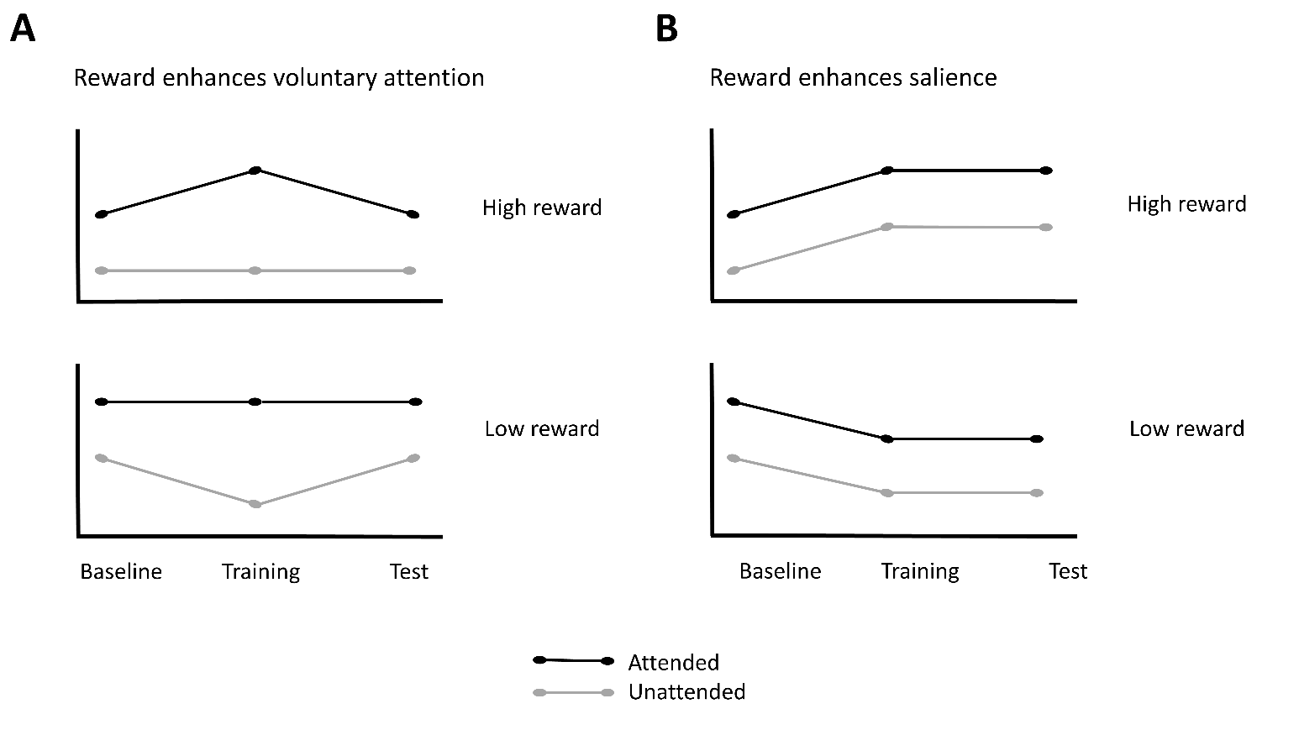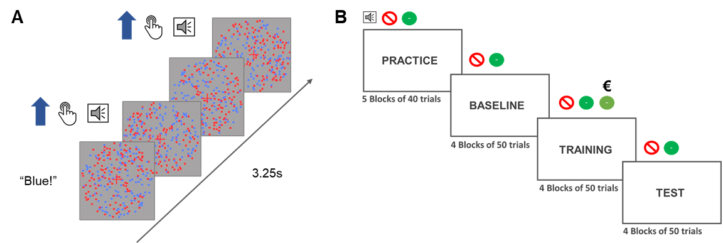

**Figure 1. Depiction of a single trial and the phases of the experiment. A.** Each trial started with an audio cue (”Blue” or ”Red”) which instructed participants which color to attend to in that trial. The trial lasted for 3.25 seconds during which dots of either of the colors could move from 0 to 3 times in total. If the participants were instructed to attend to the blue dots and the blue dots moved coherently, they had to press the response button. In that case they would hear the auditory feedback signaling the correct detection of the motions. **B.** The experiment started with a practice and a baseline block in which the participants heard an audio cue at the beginning of the trial and two types of feedback sounds (incorrect or correct). In the training block a third sound was introduced to signal that the participants were both correct and received a reward for that response. They would still at times hear the old correct feedback which would signal that they were correct, but not rewarded. The test phase was the same as the baseline phase.



**Figure 2. Raw and modelled data.** Violin plots displaying raw data for each participant (grey dots), separately for each condition. Results from the winning models are presented in blue (dark blue – 50% HDIs and light blue – 95% HDIs). **A.** Sensitivity (d′) **B.** Reaction times (ms) **C.** SSVEP amplitudes (arbitrary units) in response to the color related to high reward on trials in which it is attended or unattended. **D.** SSVEP amplitudes for the color linked to low reward on trials when it was attended or unattended.

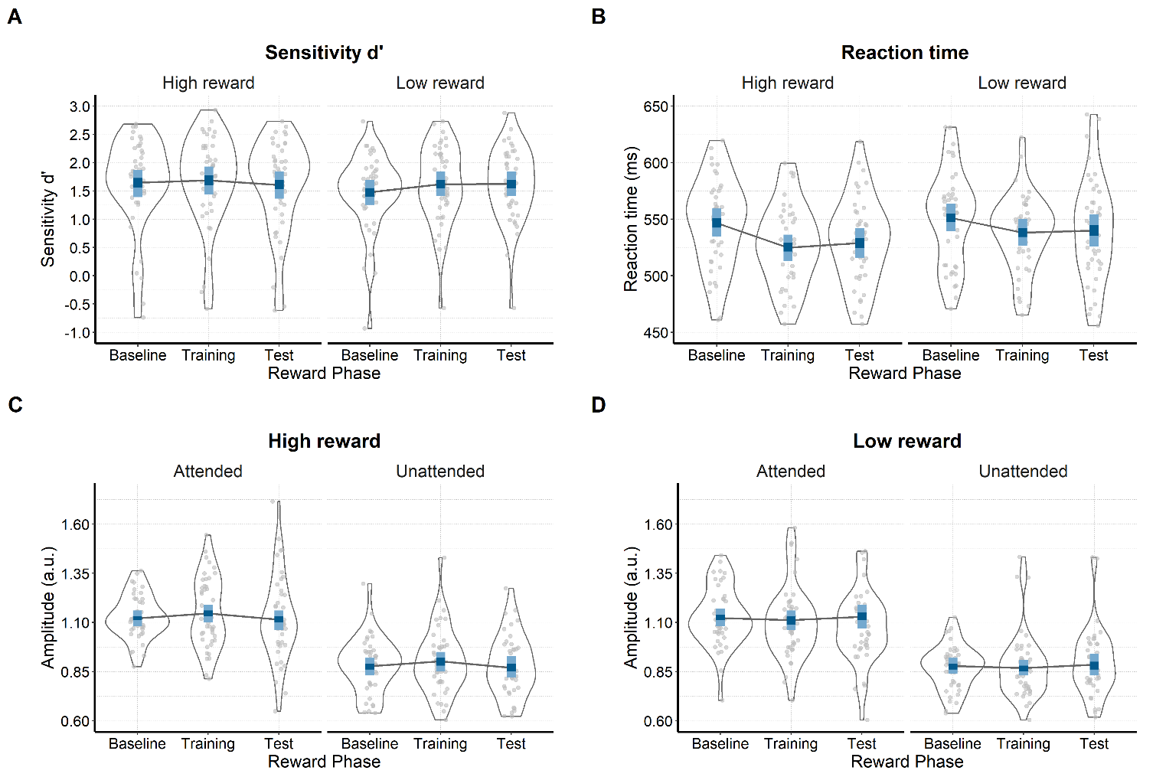

**Figure 1. Predictions from the salience and voluntary selective attention views. A.** If rewards influence the processing of stimuli through changes in voluntary attention, the processing of the high reward stimulus will be enhanced when it is attended, while the processing of the low reward stimulus will be suppressed when it is unattended (training phase). The processing of the stimuli related to high and low rewards will retreat back to baseline once the rewards are no longer available (test phase). **B.** If rewards increase salience of a stimulus independently of voluntary attention, the processing of the high reward stimulus will be enhanced and the processing of the low reward stimulus will be suppressed in both the attended and unattended condition (training phases). Further, this effect will persist even when rewards are no longer available (test phase).



**Figure 2. Raw and modelled data.** Violin plots displaying raw data for each participant (grey dots), separately for each condition. Results from the winning models are presented in blue (dark blue – 50% HDIs and light blue – 95% HDIs). **A.** Sensitivity (d′) **B.** Reaction times (ms) **C.** SSVEP amplitudes (arbitrary units) in response to the color related to high reward on trials in which it is attended or unattended. **D.** SSVEP amplitudes for the color linked to low reward on trials when it was attended or unattended.

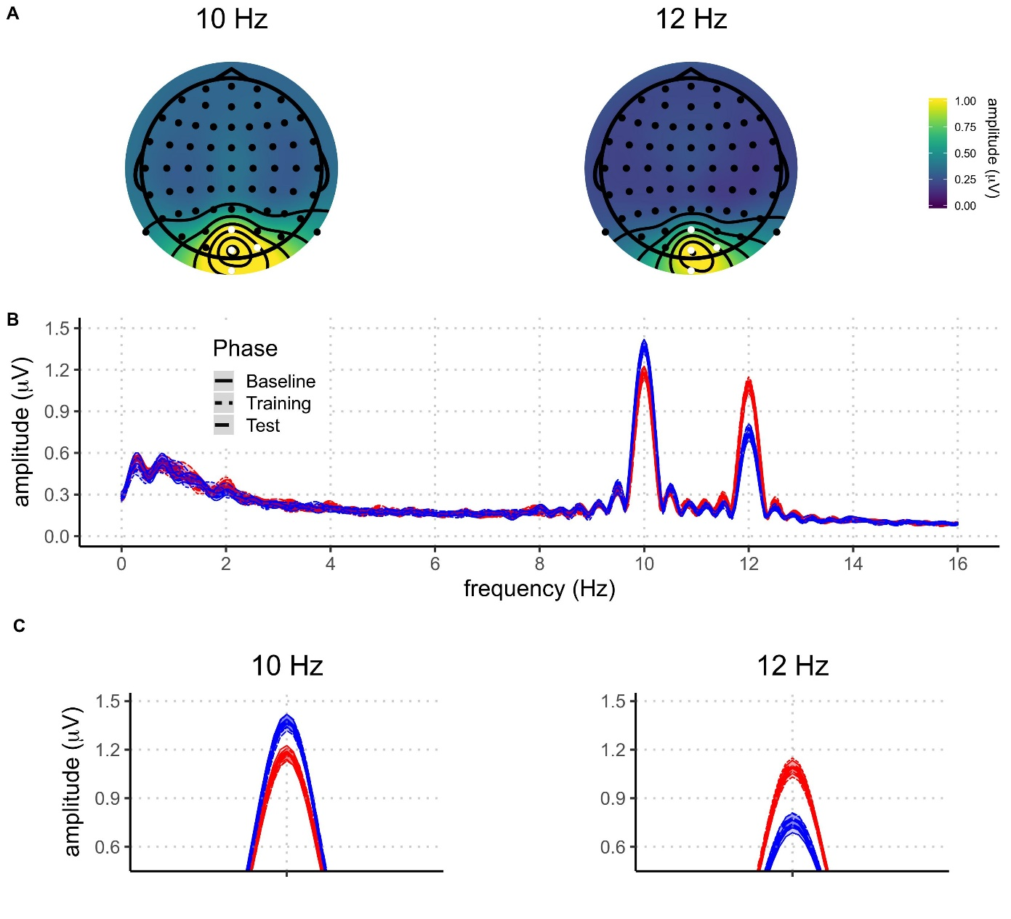

**Figure 3.** **A)** Topographies of SSVEP amplitudes, averaged across all participants and conditions, at 10 Hz and 12 Hz. Electrodes selected for the analysis are highlighted in white. **B)** Grand average amplitude spectra (zero-padded to 8 times the length of the data for plotting purpose) derived from EEG signals at best four-electrode cluster plotted for the different experimental conditions (blue: attended; red: unattended; solid: baseline phase; dotted: rewarded phase; dashed: non-rewarded phase). The shaded areas around the means indicate 95% confidence intervals.

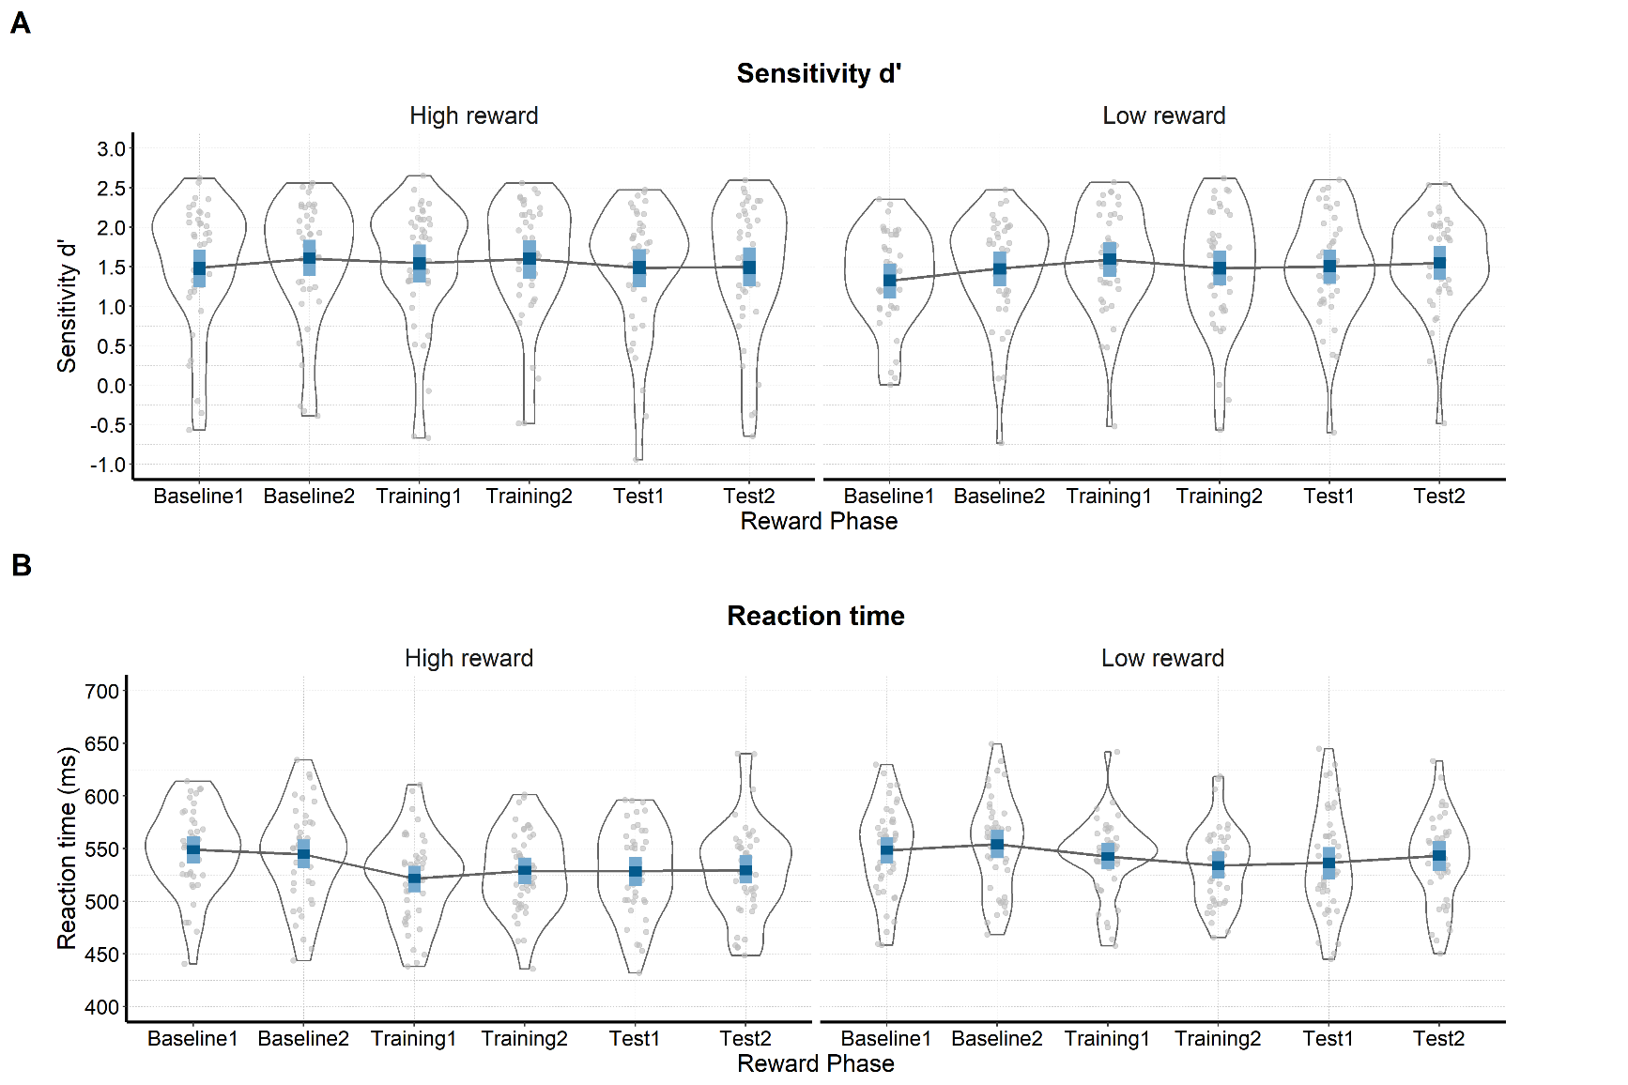

**Supplementary Figure 1. Raw and modelled behavioral data in each half of each phase of the experiment.** On both plots raw participant data is represented with grey dots and their distribution. The winning model is presented in blue (dark blue – 50% HDIs and light blue – 95% HDIs). **A.** Sensitivity (d′) across the phases of the experiment for the conditions in which the attended color is linked to either high or low value. **B)** Reaction times (ms) in the six phases when the attended stimulus is related to high or low reward probability.

|  |  |  |  |
| --- | --- | --- | --- |
| Supplementary Table 4  *Means and 95% HDIs of sensitivity and reaction times across six phases of the experiment* | | | |
| Reward phase | Value | Sensitivity (d′) | Reaction times (milliseconds) |
| Baseline 1 | High | 1.48 [1.24, 1.71] | 548.86 [535.97, 561.35] |
| Baseline 1 | Low | 1.32 [1.09, 1.53] | 548.38 [535.83, 560.97] |
| Baseline 2 | High | 1.60 [1.38, 1.84] | 544.34 [531.22, 558.49] |
| Baseline 2 | Low | 1.47 [1.25, 1.69] | 553.98 [540.67, 567.69] |
| Training 1 | High | 1.54 [1.30, 1.78] | 521.42 [508.48, 533.66] |
| Training 1 | Low | 1.59 [1.37, 1.81 | 542.35 [530.05, 555.45] |
| Training 2 | High | 1.60 [1.35, 1.83] | 528.74 [515.92, 541.36] |
| Training 2 | Low | 1.48 [1.26, 1.70] | 533.91 [521.41, 547.24] |
| Test 1 | High | 1.49 [1.24, 1.72] | 528.64 [514.39, 542.24] |
| Test 1 | Low | 1.50 [1.28, 1.71] | 536.51 [520.49, 551.37] |
| Test 2 | High | 1.49 [1.25, 1.74] | 529.32 [516.53, 543.70] |
| Test 2 | Low | 1.55 [1.33, 1.76] | 543.01 [528.56, 557.28] |

# Acknowledgements

This work was supported by the Special Research Fund (BOF) of Ghent University [grant #01D02415 awarded to IG; grant # BOF14/PDO/123 awarded to AS], the Concerted Research Action Grant of Ghent University [grant number BOF16/GOA/017 awarded to EHWK], and the Biotechnology and Biological Sciences Research Council [BB/P002404/1 awarded to SKA]. The funding sources had no involvement in the study design; collection, analysis, and interpretation of data; writing of the report; and decision to submit the article for publication.

We would like to thank Prof. Gilles Pourtois for his help with conceiving the study and for the very useful discussions of the results. Further, we thank Gilles for all of the materials he provided for this study. We would also like to thank Dr. Ladislas Nalborczyk for discussions about statistical analyses of the data, Prof. Ruth Krebs for her comments on a previous version of the manuscript, and Dr. Inez Greven for help with data collection.

# Author contributions

Author contributions are coded according to the CRediT taxonomy (Allen, Scott, Brand, Hlava, & Altman, 2014). For details, see <https://www.casrai.org/credit.html>.

​**Conceptualization**: IG, AS, EHWK, SKA. **Data curation**: IG, AS. **Formal analysis**: IG, AS. **Funding acquisition**: IG, AS, EHWK, SKA. ​**Investigation**: IG, AS. ​**Methodology**: IG, AS, SKA. **Project administration**: IG, AS. ​**Resources**: EHWK, SKA. **Software**: SKA, IG, AS. ​**Supervision**: AS, SKA. ​**Validation**: IG, AS. ​**Visualization**: IG, AS. **Writing – original draft**: IG, AS. **Writing – review & editing**: IG, AS, EHWK, SKA.

# Competing interests

The authors have no competing interests to report.

# Data availability

Raw and pre-processed data, materials, and analysis scripts are available at https://osf.io/kjds3/.

## Software for data visualization and analysis

Visualization and statistical analyses were performed using R v3.4.4 (R Core Team, 2017) via RStudio v1.1.453 (RStudio Team, 2015). We used the following packages (and their respective dependencies):

• data manipulation: tidyverse v1.2.1 (Wickham, 2017);

• statistical analyses: Rmisc v1.5 (Hope, 2013), brms v2.3.1 (Bürkner, 2016);

• visualization: cowplot v0.9.2 (Wilke, 2016), yarrr v0.1.5 (Phillips, 2016), viridis v0.5.1 (Garnier, 2018), eegUtils v0.2.0 (Craddock, 2018), BEST (Kruschke & Meredith, 2017);

• report generation: pacman v0.4.6 (Rinker & Kurkiewicz, n.d.), knitr v1.20 (Xie, 2018);

# References

Allen, L., Scott, J., Brand, A., Hlava, M., & Altman, M. (2014). Publishing: Credit where credit is due. *Nature*, *508*(7496), 312–313. https://doi.org/10.1038/508312a

Andersen, S. K., Muller, M. M., & Hillyard, S. A. (2009). Color-selective attention need not be mediated by spatial attention. *Journal of Vision*, *9*(6), 2–2. https://doi.org/10.1167/9.6.2

Andersen, S. K., Muller, M. M., & Martinovic, J. (2012). Bottom-Up Biases in Feature-Selective Attention. *Journal of Neuroscience*, *32*(47), 16953–16958. https://doi.org/10.1523/JNEUROSCI.1767-12.2012

Andersen, S K, & Müller, M. M. (2010). Behavioral performance follows the time course of neural facilitation and suppression during cued shifts of feature-selective attention. *Proceedings of the National Academy of Sciences of the United States of America*, *107*(31), 13878–13882. https://doi.org/10.1073/pnas.1002436107

Andersen, Søren K., Hillyard, S. A., & Müller, M. M. (2008). Attention Facilitates Multiple Stimulus Features in Parallel in Human Visual Cortex. *Current Biology*, *18*(13), 1006–1009. https://doi.org/10.1016/j.cub.2008.06.030

Anderson, B. A. (2016). The attention habit: How reward learning shapes attentional selection. *Annals of the New York Academy of Sciences*, *1369*(1), 24–39. https://doi.org/10.1111/nyas.12957

Anderson, B. a, Laurent, P. a, & Yantis, S. (2011). Value-driven attentional capture. *Proceedings of the National Academy of Sciences*, *108*(25), 10367–10371. https://doi.org/10.1073/pnas.1104047108

Anderson, Brian A. (2016). What is abnormal about addiction-related attentional biases? *Drug and Alcohol Dependence*, *167*, 8–14. https://doi.org/10.1016/j.drugalcdep.2016.08.002

Anderson, Brian A, Leal, S. L., Hall, M. G., Yassa, M. A., & Yantis, S. (2014). The attribution of value-based attentional priority in individuals with depressive symptoms. *Cognitive, Affective & Behavioral Neuroscience*, *14*(4), 1221–1227. https://doi.org/10.3758/s13415-014-0301-z

Awh, E., Belopolsky, A. V., & Theeuwes, J. (2012). Top-down versus bottom-up attentional control: A failed theoretical dichotomy. *Trends in Cognitive Sciences*, *16*(8), 437–443. https://doi.org/10.1016/j.tics.2012.06.010

Botvinick, M. M., & Braver, T. S. (2015). Motivation and Cognitive Control : From Behavior to Neural Mechanism. *Annual Review of Psychology*, (September 2014), 1–31. https://doi.org/10.1146/annurev-psych-010814-015044

Brown, J. W., & Alexander, W. H. (2017). Foraging Value, Risk Avoidance, and Multiple Control Signals: How the Anterior Cingulate Cortex Controls Value-based Decision-making. *Journal of Cognitive Neuroscience*, *29*(10), 1656–1673. https://doi.org/10.1162/jocn_a_01140

Bürkner, P.-C. (2016). brms: An R package for Bayesian multilevel models using Stan. *Journal of Statistical Software*, *80*(1), 1–28.

Bürkner, P.-C. (2017). Advanced Bayesian Multilevel Modeling with the R Package brms. *ArXiv:1705.11123*.

Carpenter, B., Gelman, A., Hoffman, M., Lee, D., Goodrich, B., Betancourt, M., … Riddell, A. (2016). Stan: A probabilistic programming language. *Journal of Statistical Software*, *2*(20), 1–37.

Chatrian, G. E., Lettich, E., & Nelson, P. L. (1985). Ten percent electrode system for topographic studies of spontaneous and evoked EEG activities. *American Journal of EEG Technology*, *25*(2).

Chelazzi, L., Perlato, A., Santandrea, E., & Della Libera, C. (2013). Rewards teach visual selective attention. *Vision Research*, *85*, 58–62. https://doi.org/10.1016/j.visres.2012.12.005

Chun, M. M., Golomb, J. D., & Turk-Browne, N. B. (2011). A Taxonomy of External and Internal Attention. *Annual Review of Psychology*, *62*(1), 73–101. https://doi.org/10.1146/annurev.psych.093008.100427

Corbetta, M., & Shulman, G. L. (2002). Control of Goal-Directed and Stimulus-Driven Attention in the Brain. *Nature Reviews Neuroscience*, *3*(3), 215–229. https://doi.org/10.1038/nrn755

Craddock, M. (2018). craddm/eegUtils: eegUtils (Version v0.2.0). Zenodo.

Della Libera, C., & Chelazzi, L. (2009). Learning to attend and to ignore is a matter of gains and losses. *Psychological Science*, *20*(6), 778–784. https://doi.org/10.1111/j.1467-9280.2009.02360.x

Delorme, A., & Makeig, S. (2004). EEGLAB: an open sorce toolbox for analysis of single-trail EEG dynamics including independent component anlaysis. *Journal of Neuroscience Methods*, *134*, 9–21. https://doi.org/10.1016/j.jneumeth.2003.10.009

Desimone, R., & Duncan, J. (1995). Neural Mechanisms of Selective Visual. *Annual Review of Neuroscience*, *18*(1), 193–222. https://doi.org/10.1146/annurev.ne.18.030195.001205

Donohue, S. E., Hopf, J.-M., Bartsch, M. V., Schoenfeld, M. A., Heinze, H.-J., & Woldorff, M. G. (2016). The Rapid Capture of Attention by Rewarded Objects. *Journal of Cognitive Neuroscience*, *28*(4), 529–541. https://doi.org/10.1162/jocn_a_00917

Etzel, J. A., Cole, M. W., Zacks, J. M., Kay, K. N., & Braver, T. S. (2016). Reward Motivation Enhances Task Coding in Frontoparietal Cortex. *Cerebral Cortex*, *26*(4), 1647–1659. https://doi.org/10.1093/cercor/bhu327

Failing, M. F., & Theeuwes, J. (2014). Exogenous visual orienting by reward. *Journal of Vision*, *14*(2014), 1–9. https://doi.org/10.1167/14.5.6.doi

Failing, M., & Theeuwes, J. (2017). Selection history: How reward modulates selectivity of visual attention. *Psychonomic Bulletin and Review*, 1–25. https://doi.org/10.3758/s13423-017-1380-y

Franken, I. H. A., Muris, P., & Rassin, E. (2005). Psychometric properties of the Dutch BIS/BAS scales. *Journal of Psychopathology and Behavioral Assessment*, *27*(1), 25–30. https://doi.org/10.1007/s10862-005-3262-2

Garnier, S. (2018). viridis: Default Color Maps from ‘matplotlib.’ R package version 0.3.

Gelman, A., Goodrich, B., Gabry, J., & Ali, I. (2017). R-squared for Bayesian regression models. *Unpublished via Http://Www. Stat. Columbia. Edu/~ Gelman/Research/Unpublished.* Retrieved from http://www.stat.columbia.edu/~gelman/research/unpublished/bayes_R2.pdf

Gelman, A., & Rubin, D. B. (1992). Inference from Iterative Simulation Using Multiple Sequences. *Statistical Science*, *7*(4), 457–472. https://doi.org/10.1214/ss/1177011136

Grahek, I., Shenhav, A., Musslick, S., Krebs, R. M., & Koster, E. H. W. (2019). Motivation and cognitive control in depression. *Neuroscience & Biobehavioral Reviews*, *102*(March), 371–381. https://doi.org/10.1016/j.neubiorev.2019.04.011

Hautus, M. J. (1995). Corrections for extreme proportions and their biasing effects on estimated values of d′. *Behavior Research Methods, Instruments, & Computers*, *27*(1), 46–51. https://doi.org/10.3758/BF03203619

Hickey, C., Chelazzi, L., & Theeuwes, J. (2010). Reward Changes Salience in Human Vision via the Anterior Cingulate. *Journal of Neuroscience*, *30*(33), 11096–11103. https://doi.org/10.1523/JNEUROSCI.1026-10.2010

Hickey, C., & Peelen, M. V. (2015). Neural mechanisms of incentive salience in naturalistic human vision. *Neuron*, *85*(3), 512–518. https://doi.org/10.1016/j.neuron.2014.12.049

Holroyd, C. B., & McClure, S. M. (2015). Hierarchical control over effortful behavior by rodent medial frontal cortex: A computational model. *Psychological Review*, *122*(1), 54–83. https://doi.org/10.1037/a0038339

Hope, R. M. (2013). Rmisc: Ryan miscellaneous. R package version, 1(5).

Kashiwase, Y., Matsumiya, K., Kuriki, I., & Shioiri, S. (2012). Time courses of attentional modulation in neural amplification and synchronization measured with steady-state visual-evoked potentials. *Journal of Cognitive Neuroscience*, *24*(8), 1779–1793. https://doi.org/10.1162/jocn_a_00212

Krebs, R M, & Woldorff, M. G. (2017). Cognitive control and reward. In T. Egner (Ed.), *Wiley Handbook of Cognitive Control* (pp. 422–439). Wiley-Blackwell.

Krebs, Ruth M., Boehler, C. N., Roberts, K. C., Song, A. W., & Woldorff, M. G. (2012). The involvement of the dopaminergic midbrain and cortico-striatal-thalamic circuits in the integration of reward prospect and attentional task demands. *Cerebral Cortex*, *22*(3), 607–615. https://doi.org/10.1093/cercor/bhr134

Kruschke, J. K., & Meredith, M. (2017). BEST: Bayesian Estimation Supersedes the t-Test.

Kruschke, John K. (2014). *Doing Bayesian data analysis: A tutorial with R, JAGS, and Stan, second edition*. *Doing Bayesian Data Analysis: A Tutorial with R, JAGS, and Stan, Second Edition* (2nd ed.). Elsevier Inc. https://doi.org/10.1016/B978-0-12-405888-0.09999-2

Luque, D., Beesley, T., Morris, R. W., Jack, B. N., Griffiths, O., Whitford, T. J., & Le Pelley, M. E. (2017). Goal-Directed and Habit-Like Modulations of Stimulus Processing during Reinforcement Learning. *The Journal of Neuroscience*, *37*(11), 3009–3017. https://doi.org/10.1523/jneurosci.3205-16.2017

MacLean, M. H., & Giesbrecht, B. (2015). Neural evidence reveals the rapid effects of reward history on selective attention. *Brain Research*, *1606*, 86–94. https://doi.org/10.1016/j.brainres.2015.02.016

Macmillan, N. A., & Creelman, C. D. (2004). *Detection theory: A user’s guide*. Psychology press.

Maunsell, J. H. R. (2004). Neuronal representations of cognitive state: Reward or attention? *Trends in Cognitive Sciences*, *8*(6), 261–265. https://doi.org/10.1016/j.tics.2004.04.003

McElreath, R. (2016). *Statistical Rethinking: A Bayesian Course with Examples in R and Stan*. Chapman Hall - CRC.

Morgan, S. T., Hansen, J. C., & Hillyard, S. A. (1996). Selective attention to stimulus location modulates the steady-state visual evoked potential, *93*(10), 4770–4774.

Müller, M. M., Teder-Sälejärvi, W., & Hillyard, S. A. (1998). The time course of cortical facilitation during cued shifts of spatial attention. *Nature Neuroscience*, *1*(7), 631–634.

Musslick, S., Shenhav, A., Botvinick, M. M., & Cohen, J. D. (2015). A computational model of control allocation based on the Expected Value of Control. *Reinforcement Learning and Decision Making Conference*, *59*(1978), 2014.

Nalborczyk, L., & Bürkner, P.-C. (2019). An Introduction to Bayesian Multilevel Models Using brms: A Case Study of Gender Effects on Vowel Variability in Standard Indonesian. *Journal of Speech, Language, and Hearing Research*.

Nolan, H., Whelan, R., & Reilly, R. B. (2010). FASTER: Fully Automated Statistical Thresholding for EEG artifact Rejection. *Journal of Neuroscience Methods*, *192*(1), 152–162. https://doi.org/10.1016/j.jneumeth.2010.07.015

Padmala, S., & Pessoa, L. (2011). Reward reduces conflict by enhancing attentional control and biasing visual cortical processing. *Journal of Cognitive Neuroscience*, *23*(11), 3419–3432. https://doi.org/10.1162/jocn_a_00011

Pallier, C. (2002). Computing discriminability and bias with the R software. Retrieved July 25, 2019, from http://www.pallier.org/pdfs/aprime.pdf

Perrin, F., Pernier, J., Bertrand, O., & Echallier, J. F. (1989). Spherical splines for scalp potential and current density mapping. *Electroencephalography and Clinical Neurophysiology*, *72*(2), 184–187. https://doi.org/10.1016/0013-4694(89)90180-6

Pessoa, L. (2015). Multiple influences of reward on perception and attention. *Visual Cognition*, *23*(1–2), 272–290. https://doi.org/10.1080/13506285.2014.974729

Pessoa, L., & Engelmann, J. B. (2010). Embedding reward signals into perception and cognition. *Frontiers in Neuroscience*, *4*(September), 1–8. https://doi.org/10.3389/fnins.2010.00017

Phillips, N. (2016). Yarrr: A companion to the e-book YaRrr!: The Pirate’s Guide to R. R package version 0.1.

Posner, M. I. (1980). Orienting of attention. *The Quarterly Journal of Experimental Psychology*, *32*(1), 3–25. https://doi.org/10.1080/00335558008248231

Posner, MI I. (1980). Orienting of attention. *Quarterly Journal of Experimental Psychology*, *32*(1), 3–25. https://doi.org/10.1080/00335558008248231

Qi, S., Zeng, Q., Ding, C., & Li, H. (2013). Neural correlates of reward-driven attentional capture in visual search. *Brain Research*, *1532*, 32–43. https://doi.org/10.1016/j.brainres.2013.07.044

R Core Team. (2017). R: A Language and Environment for Statistical Computing. R Foundation for Statistical Computing.

Rinker, T., & Kurkiewicz, D. (n.d.). pacman: Package Management for R.

Roelfsema, P. R., van Ooyen, A., & Watanabe, T. (2010). Perceptual learning rules based on reinforcers and attention. *Trends in Cognitive Sciences*, *14*(2), 64–71. https://doi.org/10.1016/j.tics.2009.11.005

RStudio Team. (2015). Integrated Development for R. RStudio, Inc.

Schevernels, H., Krebs, R. M., Santens, P., Woldorff, M. G., & Boehler, C. N. (2014). Task preparation processes related to reward prediction precede those related to task-difficulty expectation. *NeuroImage*, *84*, 639–647. https://doi.org/10.1016/j.neuroimage.2013.09.039

Serences, J. T. (2008). Value-Based Modulations in Human Visual Cortex. *Neuron*, *60*(6), 1169–1181. https://doi.org/10.1016/j.neuron.2008.10.051

Shenhav, A., Botvinick, M., & Cohen, J. (2013). The expected value of control: An integrative theory of anterior cingulate cortex function. *Neuron*, *79*(2), 217–240. https://doi.org/10.1016/j.neuron.2013.07.007

Steinhauser, M., & Andersen, S. K. (2019). Rapid adaptive adjustments of selective attention following errors revealed by the time course of steady-state visual evoked potentials. *NeuroImage*, *186*(July 2018), 83–92. https://doi.org/10.1016/j.neuroimage.2018.10.059

Tankelevitch, L., Spaak, E., Rushworth, M. F. S., & Stokes, M. G. (2019). Previously reward-associated stimuli capture spatial attention in the absence of changes in the corresponding sensory representations as measured with {MEG}. *BioRxiv*, 622589. https://doi.org/10.1101/622589

Theeuwes, J. (2010). Top-down and bottom-up control of visual selection. *Acta Psychologica*, *135*(2), 77–99. https://doi.org/10.1016/j.actpsy.2010.02.006

Van der Does, A. J. W. (2002). *Handleiding bij de Nederlandse versie van beck depression inventory—second edition (BDI-II-NL). [The Dutch version of the Beck depression inventory].* Amsterdam: Harcourt.

Verguts, T., Vassena, E., & Silvetti, M. (2015). Adaptive effort investment in cognitive and physical tasks: a neurocomputational model. *Frontiers in Behavioral Neuroscience*, *9*(March). https://doi.org/10.3389/fnbeh.2015.00057

Watanabe, S. (2010). Asymptotic Equivalence of Bayes Cross Validation and Widely Applicable Information Criterion in Singular Learning Theory, *11*, 3571–3594. Retrieved from http://arxiv.org/abs/1004.2316

Wickham, H. (2017). Tidyverse: Easily install and load ’tidyverse’ packages. R package version, 1(1).

Wilke, C. O. (2016). cowplot: streamlined plot theme and plot annotations for ‘ggplot2.’ CRAN Repos.

Wisniewski, D., Reverberi, C., Momennejad, I., Kahnt, T., & Haynes, J.-D. (2015). The Role of the Parietal Cortex in the Representation of Task-Reward Associations. *Journal of Neuroscience*, *35*(36), 12355–12365. https://doi.org/10.1523/jneurosci.4882-14.2015

Xie, Y. (2018). knitr: A General-Purpose Package for Dynamic Report Generation in R.

1. Due to the simultaneous estimation of group-level and participant-level parameters, multilevel models display a property called shrinkage. In brief, estimates that strongly deviate from the mean (e.g., a participant performing the task much worse than the average of the total sample) will be pulled toward the group mean (McElreath, 2016). This advantageous property prevents extreme values from having large effects on the results.