Technologies used on the Test:

Java JDK 11
Spring Boot
H2 in memory DB
Maven

The source code can be downloaded from https://github.com/igrs08/accella.git

How to run the Application

1) Import the application as a Maven project on Eclipse
2) Copy the .jar file from the target folder

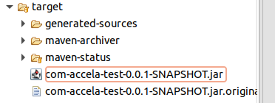

3)Run it from the cmd as java -jar accela-test-0.0.1-SNAPSHOT.jar

4) The screen below will be displayed
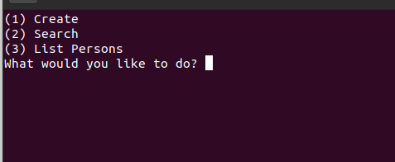

*Please notice that in order to edit an address you will have to edit a person.

5) All the DB operations can be check as below. H2 DB will be always started when the application is launched.
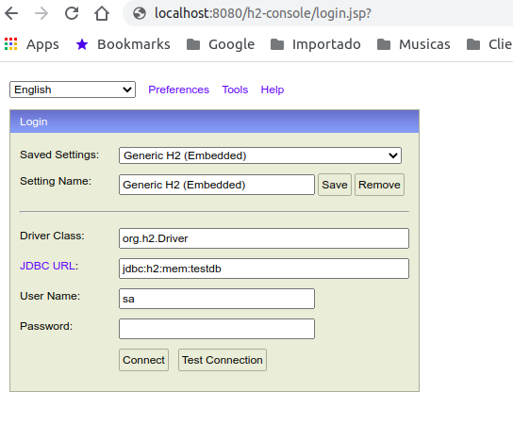

**Unfortunately I could not figure out a way to create Unit tests for a console application, Sorry about that.

