EC2 Instance Storage

An EBS (Elastic Block Store) Volume is a network drive you can attach
to your instances while they run
• It allows your instances to persist data, even after their termination
• They can only be mounted to one instance at a time (at the CCP level)
• They are bound to a specific availability zone
• Analogy: Think of them as a “network USB stick”
• Free tier: 30 GB of free EBS storage of type General Purpose (SSD) or
Magnetic per month

EBS Volume
• It’s a network drive (i.e. not a physical drive)
• It uses the network to communicate the instance, which means there might be a bit of
latency
• It can be detached from an EC2 instance and attached to another one quickly
• It’s locked to an Availability Zone (AZ)
• An EBS Volume in us-east-1a cannot be attached to us-east-1b
• To move a volume across, you first need to snapshot it
• Have a provisioned capacity (size in GBs, and IOPS)
• You get billed for all the provisioned capacity
• You can increase the capacity of the drive over time
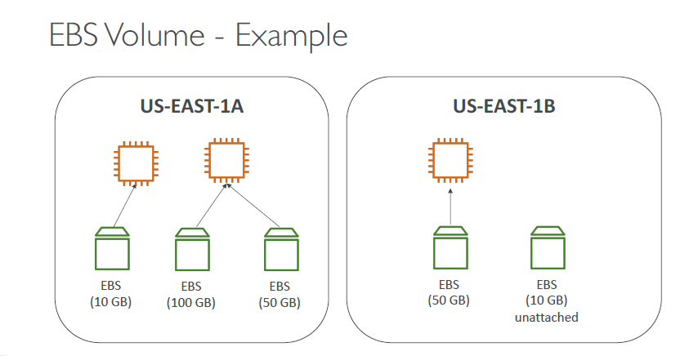

EBS Snapshots
• Make a backup (snapshot) of your EBS volume at a point in time
• Not necessary to detach volume to do snapshot, but recommended
• Can copy snapshots across AZ or Region
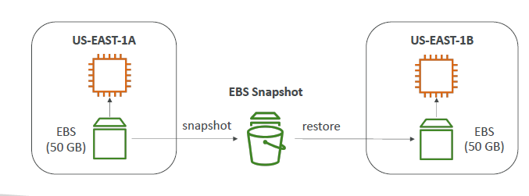

EBS Snapshots Features
• EBS Snapshot Archive
• Move a Snapshot to an ”archive tier” that is
75% cheaper
• Takes within 24 to 72 hours for restoring
the archive

• Recycle Bin for EBS Snapshots
• Setup rules to retain deleted snapshots so
you can recover them after an accidental
deletion
• Specify retention (from 1 day to 1 year)

EC2 Image Builder
• Used to automate the creation of Virtual Machines or container images
• => Automate the creation, maintain, validate and test EC2 AMIs
• Can be run on a schedule (weekly, whenever packages are updated, etc…)
• Free service (only pay for the underlying resources)
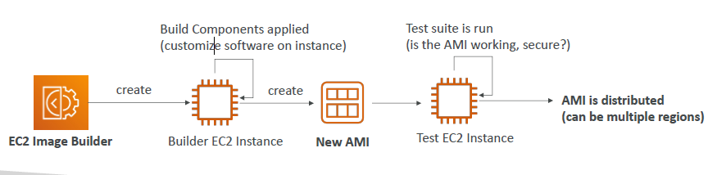
EC2 Instance Store
• EBS volumes are network drives with good but “limited” performance
• If you need a high-performance hardware disk, use EC2 Instance Store
• Better I/O performance
• EC2 Instance Store lose their storage if they’re stopped (ephemeral)
• Good for buffer / cache / scratch data / temporary content
• Risk of data loss if hardware fails
• Backups and Replication are your responsibility

EFS – Elastic File System
• Managed NFS (network file system) that can be mounted on 100s of EC2
• EFS works with Linux EC2 instances in multi-AZ
• Highly available, scalable, expensive (3x gp2), pay per use, no capacity planning
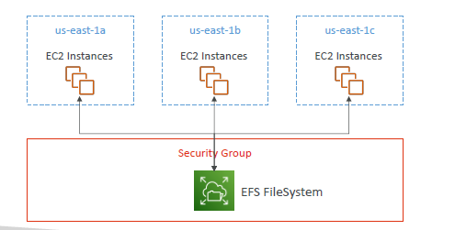

EFS Infrequent Access (EFS-IA)
• Storage class that is cost-optimized for files not
accessed every day
• Up to 92% lower cost compared to EFS Standard
• EFS will automatically move your files to EFS-IA
based on the last time they were accessed
• Enable EFS-IA with a Lifecycle Policy
• Example: move files that are not accessed for 60
days to EFS-IA
• Transparent to the applications accessing EFS

Shared Responsibility Model for EC2 Storage
AWS
• Infrastructure
• Replication for data for EBS
volumes & EFS drives
• Replacing faulty hardware
• Ensuring their employees
cannot access your data

Customer
• Setting up backup / snapshot
procedures
• Setting up data encryption
• Responsibility of any data on
the drives
• Understanding the risk of

Amazon FSx for Windows File Server
• A fully managed, highly reliable, and
scalable Windows native shared
file system
• Built on Windows File Server
• Supports SMB protocol &
Windows NTFS
• Integrated with Microsoft Active
Directory
• Can be accessed from AWS or

Amazon FSx for Lustre
• A fully managed, high-performance, scalable file storage for High Performance
Computing (HPC)
• The name Lustre is derived from “Linux” and “cluster”
• Machine Learning, Analytics, Video Processing, Financial Modeling, …
• Scales up to 100s GB/s, millions of IOPS, sub-ms latencies

EC2 Instance Storage - Summary
• EBS volumes:
• network drives attached to one EC2 instance at a time
• Mapped to an Availability Zones
• Can use EBS Snapshots for backups / transferring EBS volumes across AZ
• AMI: create ready-to-use EC2 instances with our customizations
• EC2 Image Builder: automatically build, test and distribute AMIs
• EC2 Instance Store:
• High performance hardware disk attached to our EC2 instance
• Lost if our instance is stopped / terminated
• EFS: network file system, can be attached to 100s of instances in a region
• EFS-IA: cost-optimized storage class for infrequent accessed files
• FSx for Windows: Network File System for Windows servers
• FSx for Lustre: High Performance Computing Linux file system

QUIZ
1-Which EC2 Storage would you use to create a shared network file system for your EC2 Instances?
EBS Volume
EC2 Instance Store
EBS Snapshots
EFS
2-Which service can be used to automate image management processes?
AMI
EC2 Image Builder
EBS Snapshots
IAM
3-Which of the following is a fully managed native Microsoft Windows file system?
EFS
FSx
EBS

4-What are AMIs NOT used for?
Add your own software license
Add your own configuration
Add your own operating-system
Add your own IP addresses

5-EBS Volumes CANNOT be attached to multiple EC2 instances at a time.
True
False

6-An EBS Volume is a network drive you can attach to your instances while they run, so your instances' data persist even after their termination.
True
False

7-Which statement is CORRECT regarding EC2 Instance Store?
It is not good to use as a disk to cache content
It has a better I/O performance, but the data is lost if the EC2 Instance is terminated
Your data is always safe with EC2 Instance Store

8-What is an EBS Snapshot?
The operating-system on an EC2 Instance
A backup of your EBS Volume at a point in time
The amount of CPU and RAM of an EC2 Instance
9-Where can you find a third party's AMI so you can use it to launch your EC2 Instance?
Public AMIs
My own AMIs
AWS Marketplace AMIs

10-What is an EBS Volume tied to?
A region
A data center
An edge location
An availability zone

