The 1000 Genomes Browser Tutorial

http://1000genomes.org/
Updated on 05/05/2011

To facilitate immediate analysis of the 1000 Genomes data by the whole scientific community, the Ensembl genome browser was adopted to display SNP calls made by the project, even before they are integrated into dbSNP. The look and feel of the 1000 Genome Browser are very similar to the Ensembl browser. We will cover some basic browsing tips in this tutorial. Please refer to Ensembl tutorials for greater details (http://www.ensembl.org/info/website/tutorials/index.html).

Please note that the 1000 Genomes SNPs have been submitted to dbSNP and will each be allocated a dbSNP rsID. Until that point any SNP IDs on the 1000 Genomes Browser are temporary and will not be maintained.

Getting Started with the 1000 Genomes Browser

 Go to http://www.1000genomes.org.
 click on the “Browser” tab you will get to the Browser home page:

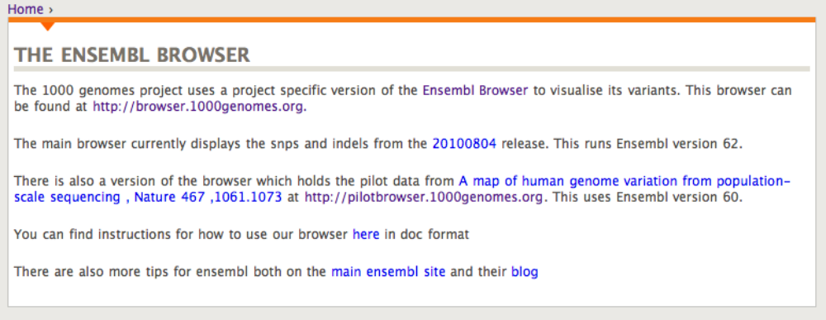

 click on the browser link http://browser.1000genomes.org/ you will see the following search box:

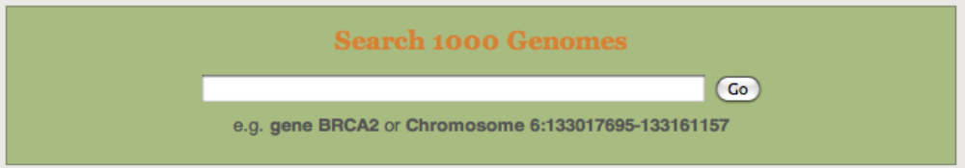

 Enter a gene name/symbol/identifier in the text box. Gene PTPN22 is used as an example in this tutorial.
 Click [Go].

When you search for a chromosome region, the browser will jump to a chromosomal location page centers around the region you specified.

When you search for a gene or gene product, the search results can be in one or all of the following categories:
Gene
Transcript
Peptide

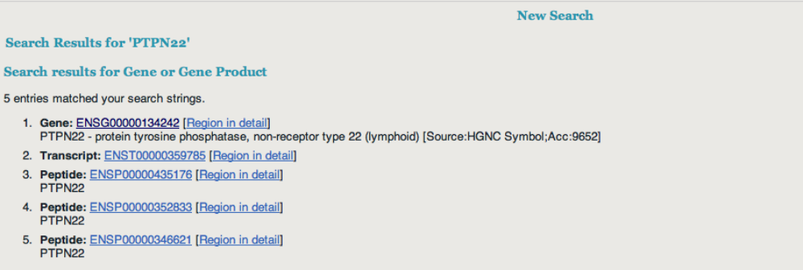

 Click on a gene in the search result page takes you to a gene page
 Click on a transcript in the search result page takes you to a transcript page
 Click on a peptide in the search result page takes you to a peptide page

We will go through gene page, transcript page and chromosomal location page in the following sections. Peptide page is very similar to transcript page in terms of variation display so we will not discuss it separately. At the end, we will describe briefly how to export data to your local machine and how to add your own tracks of data; we will also introduce two useful tools – Variation Effect Predictor and Data Slicer.

Access variation data through gene page

 Click on a gene in the search result page takes you to a gene page:

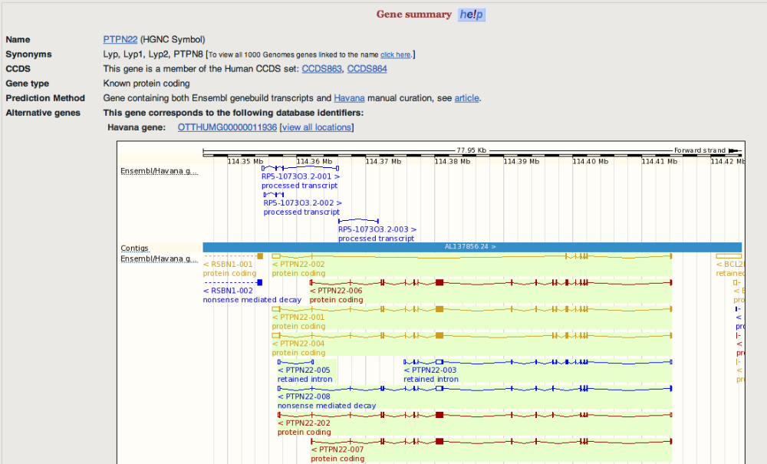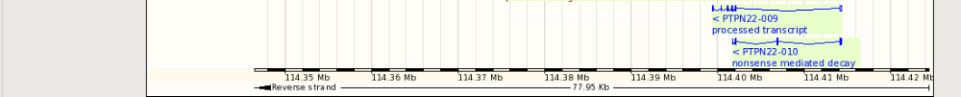

The page contains the whole span of the gene; all transcripts for the gene are displayed as well.

 Click on “Variation Image” under

“Genetic Variation” at the left panel to go to the Variation Image Page

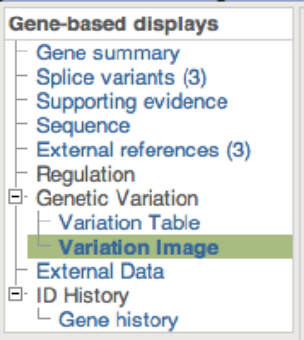

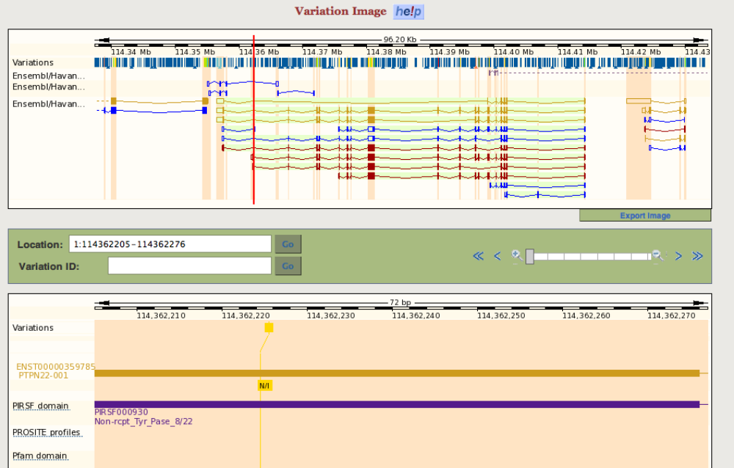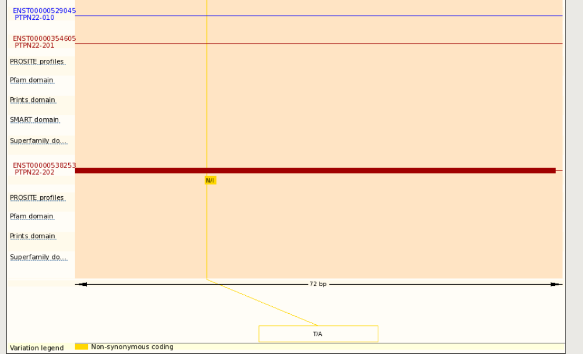

The top panel is the view of the whole gene span plus flanking regions. The bottom panel is a zoomed in view of the first coding exon. Since the snapshot is a partial view, here is the URL for you to browse:
http://browser.1000genomes.org/Homo_sapiens/Gene/Variation_Gene/Image?db=core;g=ENSG00000134242;r=1:114362205-114362276

You may zoom out at the “Location” bar to see wider regions as below:

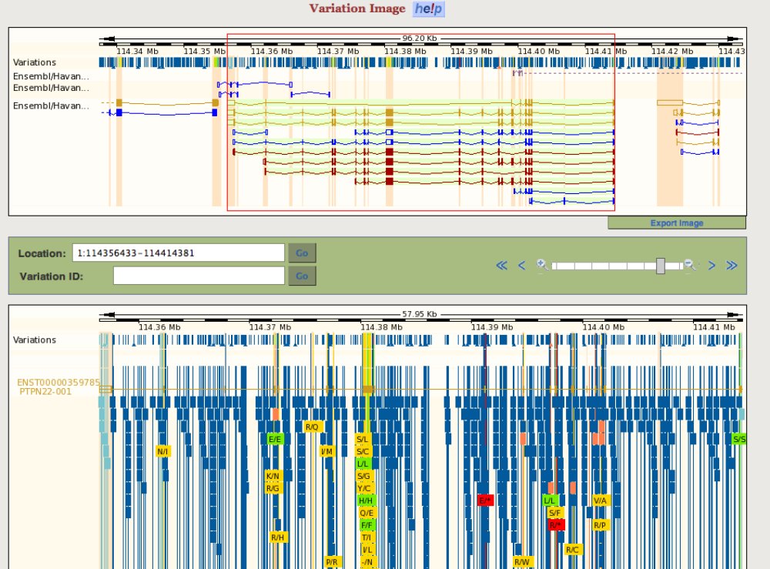
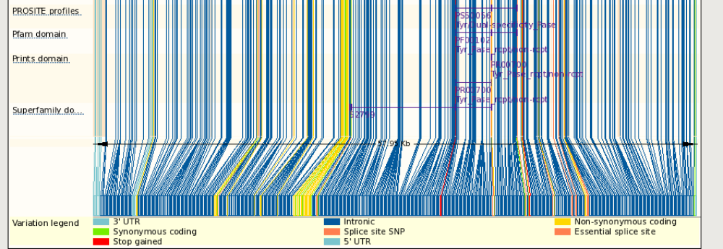

Since the snapshot is a partial capture of the actual display, here is a link for the complete view:

http://browser.1000genomes.org/Homo_sapiens/Gene/Variation_Gene/Image?db=core;g=ENSG00000134242;r=1:114356433-114414381

In a Variation Image Page, right under each transcript track, SNPs are displayed and color-coded based on their predicted function such as intronic, synonymous

coding, non-synonymous coding. For non-synonymous SNPs, the amino acid change is also labeled.

At the bottom of a Variation Image Page is a collective display of SNPs, color-coded by their function.

 Single click on any SNP to get further information of the snp:

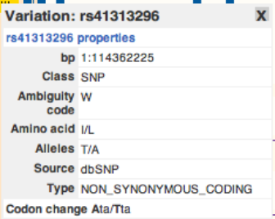

 Click on “Variation Table” under “Genetic Variation” to get a list of SNPs in the gene region with detail annotations. The SNPs are grouped by their functional types (intronic, non-synonymous coding etc.).

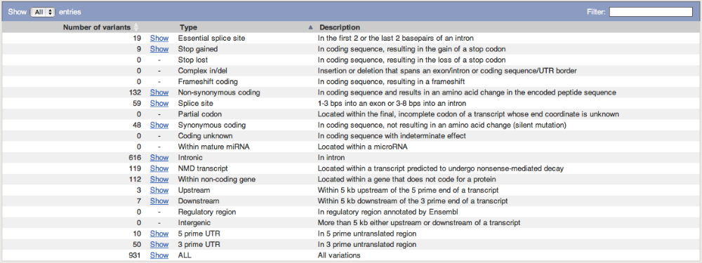

 Single click on “Show” to get a list of SNPs in a given category. Alleles, amino acid changes, SIFT and PolyPhen annotations are displayed if exist.

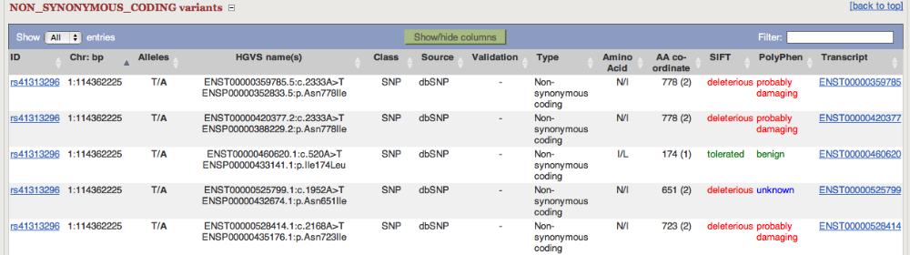

Please note that you can show and hide the columns in the variation table and also filter the content using the “Filter” box at the top right corner of the table.
Access variation data through transcript page

 Click on a transcript in the search result page takes you to a transcript page:

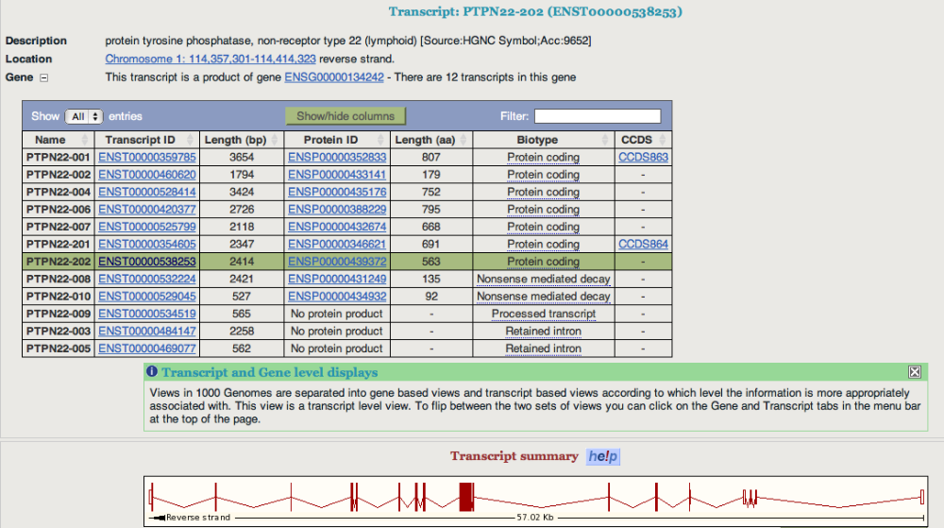

 click on “Variations” link under “Protein Information” on the left panel will show you the predicted functions of the SNPS in the region

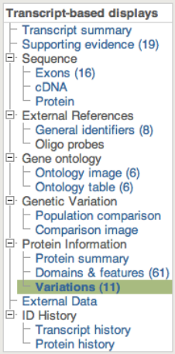

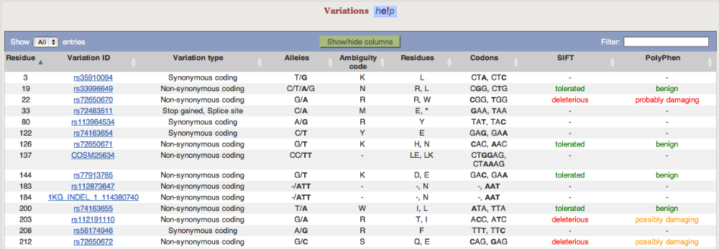

 Click on a variation ID to bring up a Variation tab:

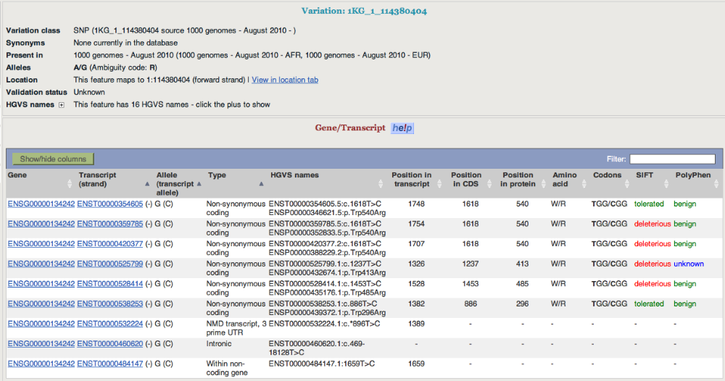

 Click on “Population genetics” at the left panel to see allele frequency of the variation and other information

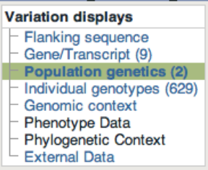

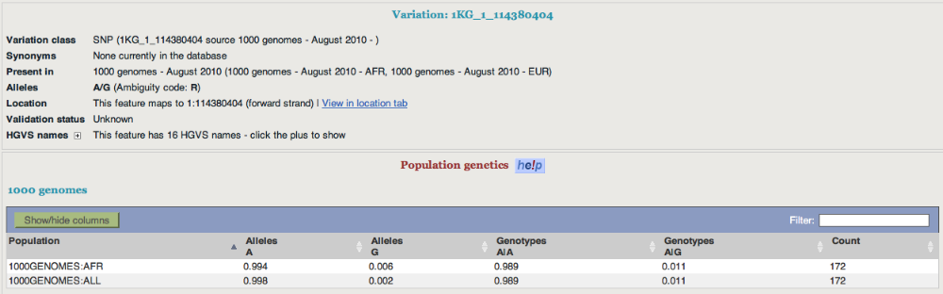

 Click on “Flanking sequence” on the left panel to get additional information about the variation:

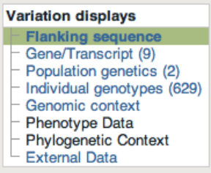

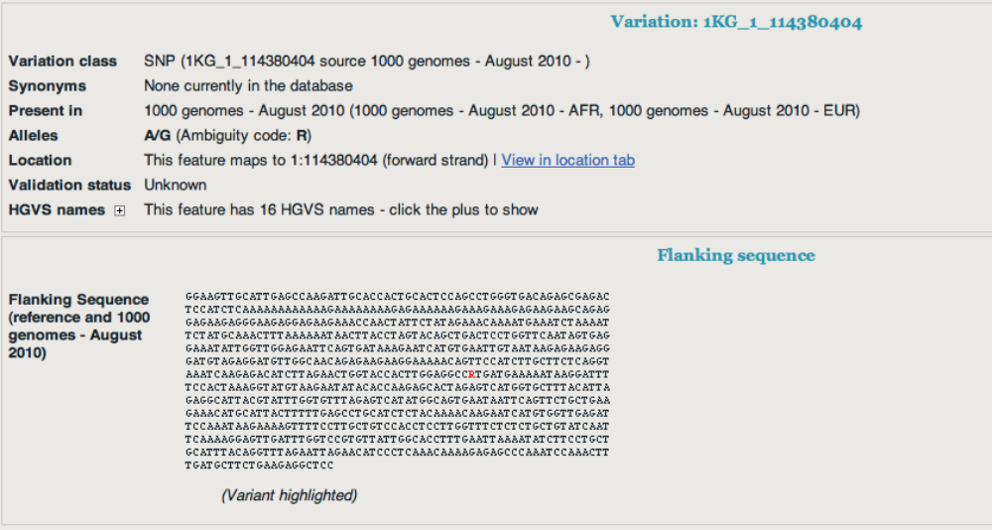

 Click on

“Individual genotypes” on the left panel to see genotypes

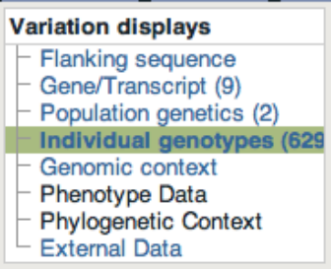

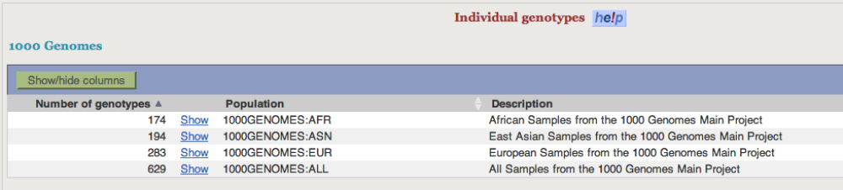

 Click on “Show” to see genotypes in each sample of a given population:

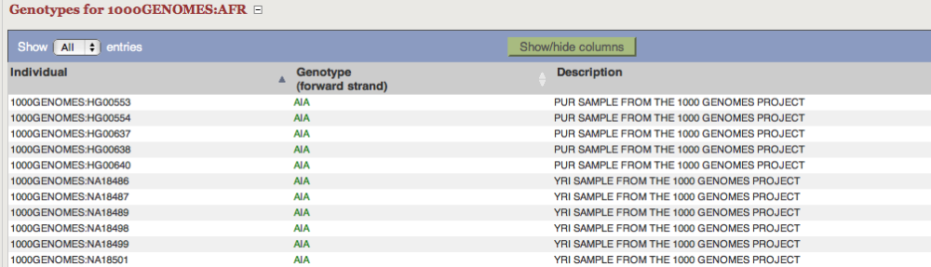

 Click on “Genomic context” to see variations and genes around the variation

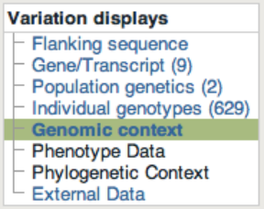

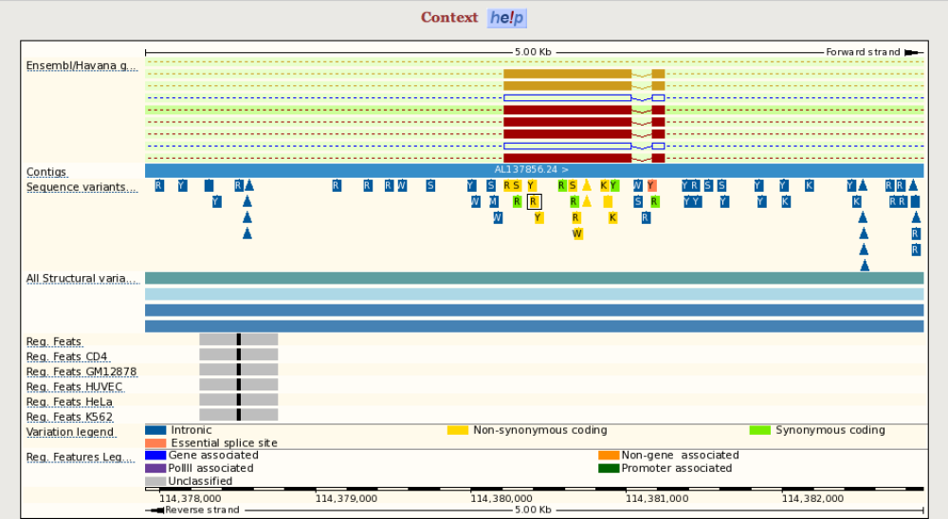
Access variation data through Location View

 in a transcript page or a gene page, click on the highlighted chromosome location of a gene/transcript

It takes you to a Location View. The bottom panel of the page contains variations discovered from different individuals sequenced in the 1000 Genome project, by default variations from all populations are on a single track. 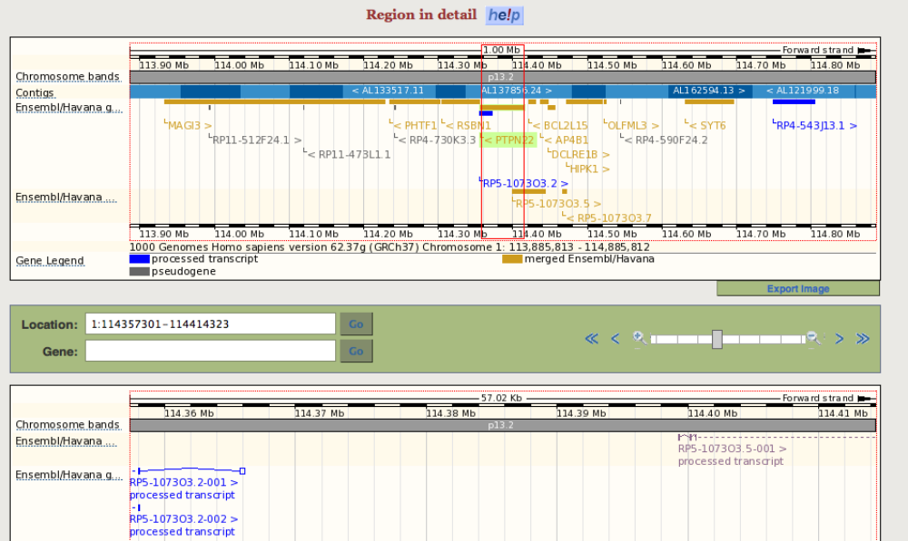. 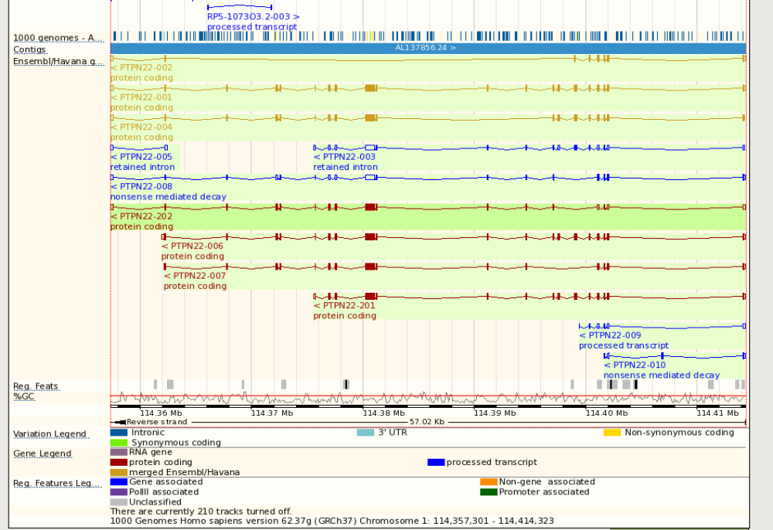

 Click on “Configure this page” on the left panel to view/edit current display settings.

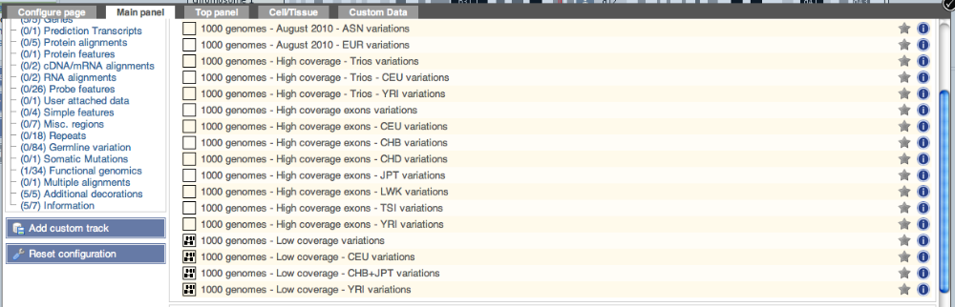

 after add some tracks, click on “V” sign at the top right corner of the configuration page to save the setting. Now you will see 4 more tracks added, one for each low_coverage population:

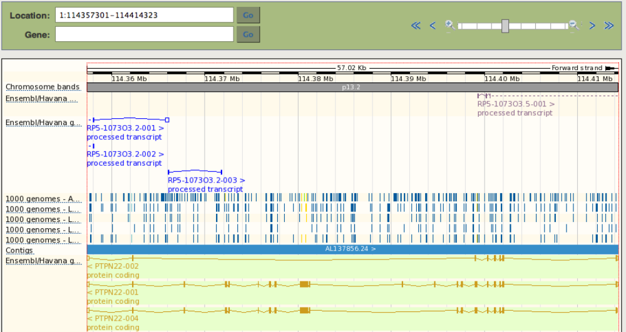

In Location view, the tracks can also be turned off and set as different displays, without going to the Configuration page as follow.

 mouse over a track name, a popup window would appear for you to change settings of the track. In example below, the “1000 genomes – August 2010 variations” track is switched to variation density display from the previous compact display. Unlike in compact display, in density display the variations are not color-coded by their function.

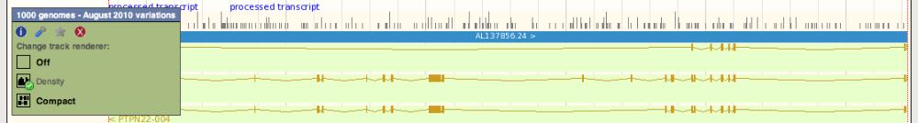

By Default all SNP tracks are display in the density plot. This enables the tracks to be loaded more quickly. When the density reaches one snp per line the display automatically switches to the compact view coloured for consequences but you can force the compact view on by using the configuration menu

 click on the “Linkage Data” under “Genetic Variation” on the left panel
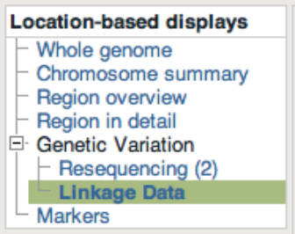

 Select population(s) by clicking the “Select Populations” button at the

left panel

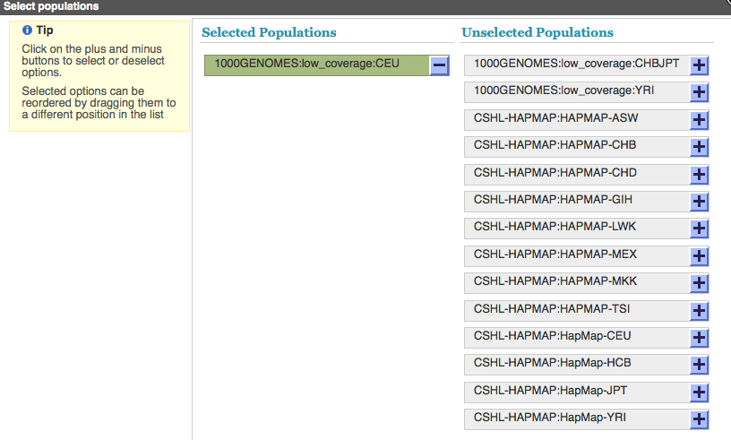
The linkage data for the chosen population is displayed as r2 and d’

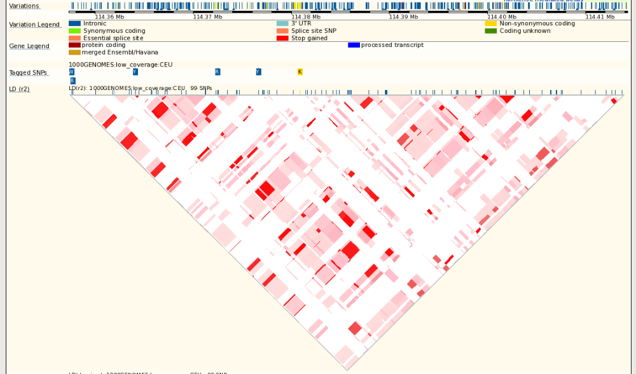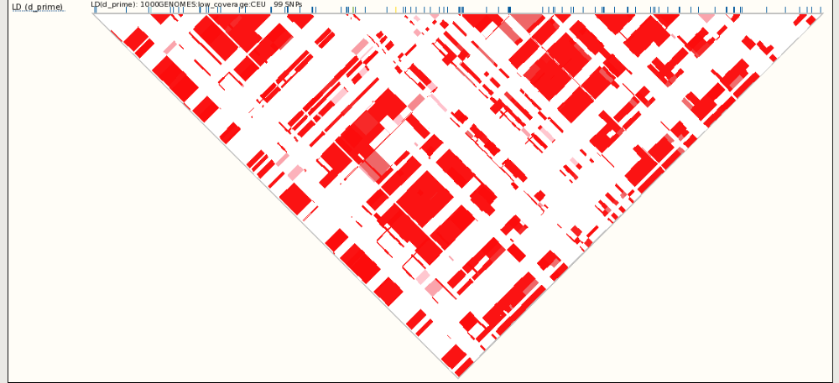

Here is the URL for the whole page:

http://browser.1000genomes.org/Homo_sapiens/Location/LD?db=core;g=ENSG00000134242;r=1:114357301-114414323;t=ENST00000538253;pop1=1000GENOMES:low_coverage:CEU

Export Data

It is possible to save data from the browser to an output file using “Export Data” function locates at the left panel.

 click on “Export Data”

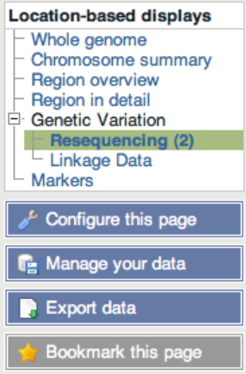

You get the following pop-up screen.

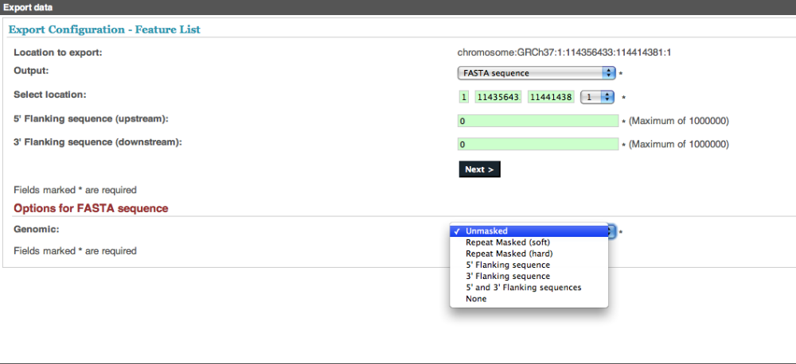

You may choose from the output pull-down menu the type of data you want to export:

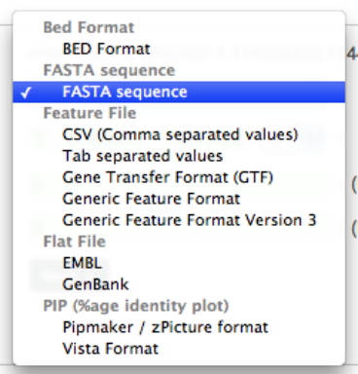

 click on “Next” after you choose the output data type and its options

The output data can be saved to three different formats:
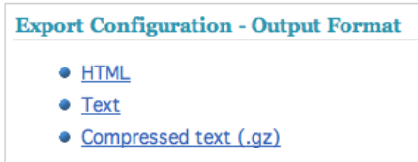

Choose one format and you will be able to get the data such as below:
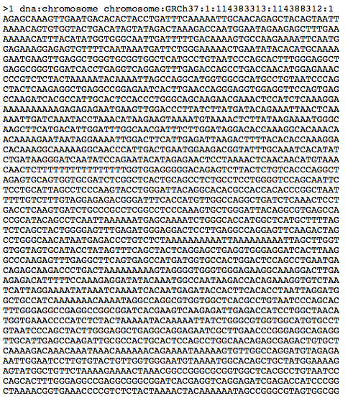
Variant Effect Predictor

The variant effect predictor takes a list of variant positions and alleles, and predicts the effects of each of these on any overlapping features (transcripts, regulatory features) annotated in Ensembl.

The tool can be accessed by clicking “Manage your data” at the left hand panel.

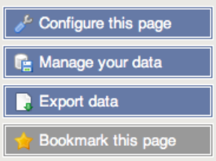

You get:

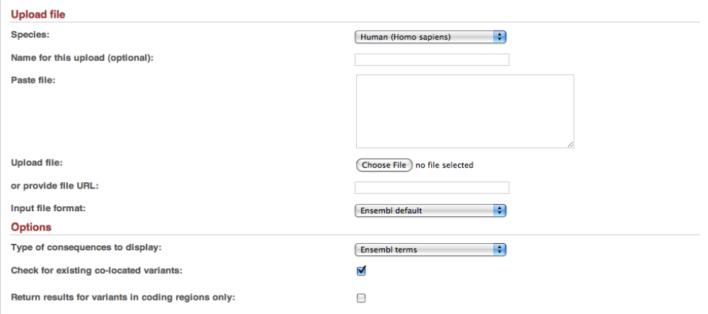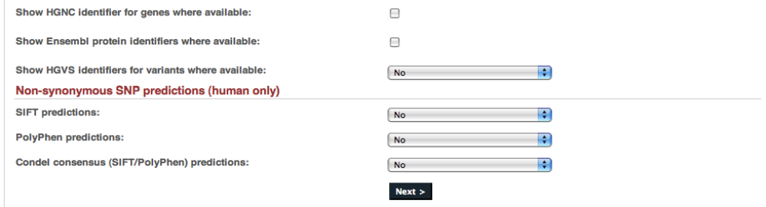

Input file format specification:

The tool will accept substitutions, insertions and deletions as input, uploaded as a list of tab separated values. Data must be supplied in a VCF file format or a simple tab-separated format, containing five columns, all required:
- chromosome - just the name or number, with no 'chr' prefix
- start
- end
- allele - pair of alleles separated by a '/', with the reference allele first
- strand - defined as + (forward) or - (reverse).

One example is:
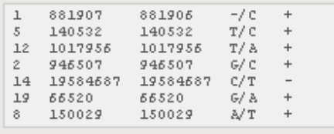

Output file format specification:
The tool predicts the consequence of this variation, the amino acid position and change (if the variation falls within a protein) and the SNP identifier of known SNPs that occur at this position. The output columns are:
- uploaded variation - as chromosome_start_alleles
- location - in standard coordinate format (chr:start or chr:start-end)
- allele - the variant allele used to calculate the consequence
- gene - Ensembl stable ID of affected gene
- transcript - Ensembl stable ID of affected transcript
- consequence - consequence type of this variation
- relative position in cDNA - base pair position in cDNA sequence
- relative position in CDS - base pair position in coding sequence
- relative position in protein - amino acid position in protein
- amino acid change - only given if the variation affects the protein-coding sequence
- codons - the alternate codons with the variant base highlighted as bold (HTML) or upper case (text)
- corresponding variation - identifier of existing variation

- extra - this column contains extra information as key=value pairs separated by ";". The keys are as follows:
  - HGNC - the HGNC gene identifier
  - ENSP - the Ensembl protein identifier of the affected transcript
  - HGVSc - the HGVS coding sequence name
  - HGVSp - the HGVS protein sequence name
  - SIFT - the SIFT prediction and/or score, with both given as prediction(score)
  - PolyPhen - the PolyPhen prediction and/or score
  - Condel - the Condel consensus prediction and/or score

Empty values are denoted by '-'. One example is:

Data Slicer

The 1000 Genomes project produces alignment data in the format of BAM files (http://samtools.sourceforge.net/SAM-1.3.pdf) and variation data in the format of VCF files (http://vcftools.sourceforge.net/specs.html). The files are usually very large in size and cumbersome to handle. Data Slicer allows you to get a fraction of data that is within a chromosomal region you specified.

 click on “Manage your data” on the left panel

 click on “Data slicer” under “Data Converters" and you will get the following page:

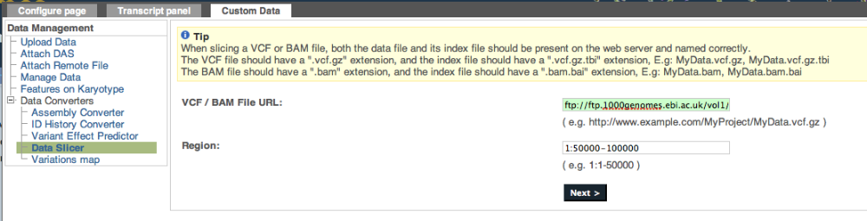

Enter an URL for a BAM or a VCF file and specify a chromosomal region. The example here is from the project ftp site:

ftp://ftp.1000genomes.ebi.ac.uk/vol1/ftp/data/HG01623/alignment/HG01623.mapped.SOLID.bfast.IBS.low_coverage.20101123.bam

 click “Next” you will see a sliced file with reduced size and a preview of the top lines.

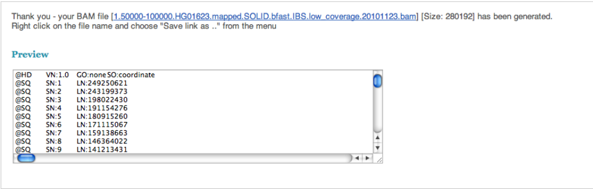

You may download the file by right click the file name and follow instruction in the popup window.
Attach Remote File

You may have alignment data or variation data you wish to view in the browser. The browser allows you to upload your own data and display them as separate tracks.

 click on “Manage your data” on the left panel.

 click on “Attach Remote File”, you will get the following page:

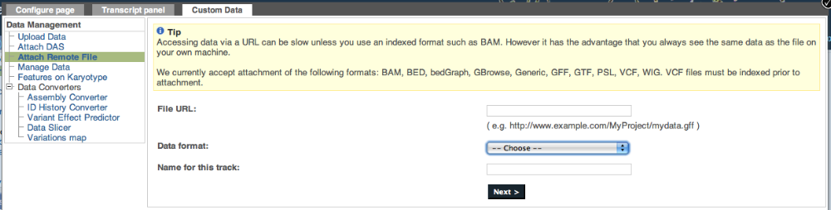

 enter URL for a file (file can be in format of BAM, BED, VCF and others that contain chromosomal coordinates), specify file format and give a name for the track to be displayed.

You may use URL for BAMs and VCF files from the 1000 Genomes project ftp site to this uploading. The file must have a bai or tbi index associated with it for this to work. Here is an example of a VCF file URL from the project ftp site:

ftp://ftp.1000genomes.ebi.ac.uk/vol1/ftp/release/20100804/supporting/EUR.2of4intersection_allele_freq.20100804.sites.vcf.gz

Please note only BAMs from the EBI ftp site will work, all other BAMs must be visible over http

 click “Next” and the page will let you know if the uploading is successful or not.

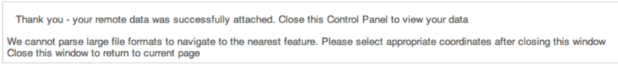

 close the Configuration page and you will see the newly added track “TEST”:

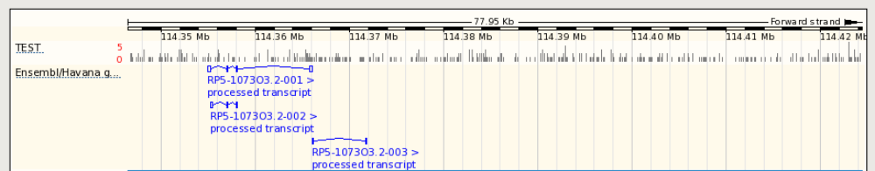

This is what a displayed BAM will look like when zoomed in

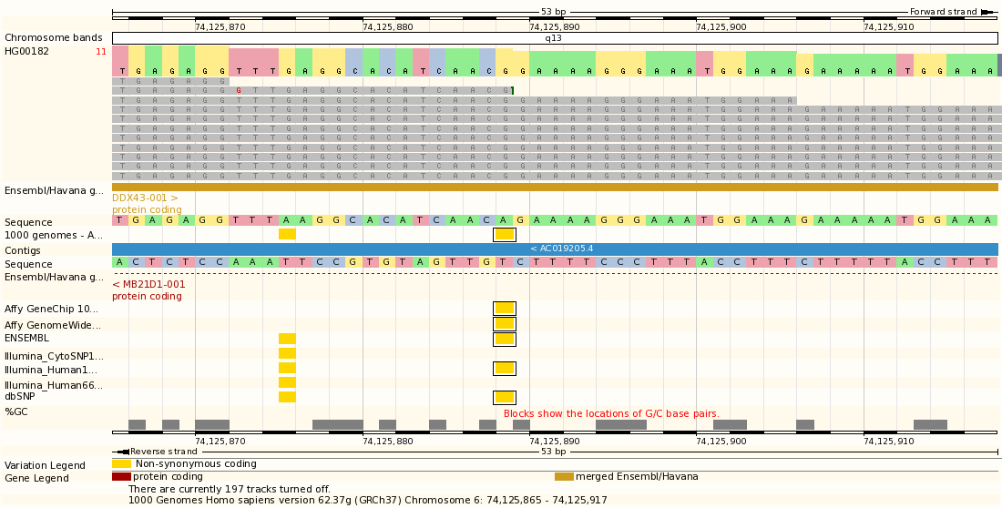

As a summary, SNP data of the 1000 Genomes Project can be visualized through different entry points in a gene page, a transcript page and a chromosomal location page. External VCF and BAM files can also be viewed from the 1000 genomes ftp site and other locations.

If you have any question in using the browser, please don’t hesitate in contacting us by writing to info@1000genomes.org

