The 1000 Genomes Pilot Browser Tutorial

http://1000genomes.org/
Updated on 05/05/2011

To facilitate immediate analysis of the 1000 Genomes data by the whole scientific community, the Ensembl genome browser was adopted to display SNP calls made by the project, even before they are integrated into dbSNP. The look and feel of the 1000 Genome Browser are very similar to the Ensembl browser. We will cover some basic browsing tips in this tutorial. Please refer to Ensembl tutorials for greater details (http://www.ensembl.org/info/website/tutorials/index.html).

Please note that the 1000 Genomes SNPs have been submitted to dbSNP and will each be allocated a dbSNP rsID. Until that point any SNP IDs on the 1000 Genomes Browser are temporary and will not be maintained.

Getting Started with the 1000 Genomes Browser

 Go to http://www.1000genomes.org.
 click on the “Browser” tab you will get to the Browser home page:

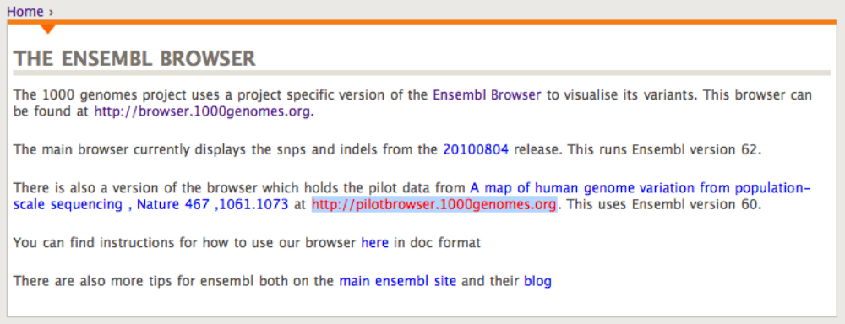

 click on the browser link http://pilotbrowser.1000genomes.org/index.html you will see the following search box:



 Enter a gene name/symbol/identifier in the text box. Gene PTPN22 is used as an example in this tutorial.
 Click [Go].

When you search for a chromosome region, the browser will jump to a chromosomal location page centers around the region you specified.

When you search for a gene or gene product, the search results can be in one or all of the following categories:
Gene
Transcript
Peptide

 Click on a gene in the search result page takes you to a gene page
 Click on a transcript in the search result page takes you to a transcript page
 Click on a peptide in the search result page takes you to a peptide page

We will go through gene page, transcript page and chromosomal location page in the following sections. Peptide page is very similar to transcript page in terms of variation display so we will not discuss it separately. At the end, we will describe briefly how to export data to your local machine and introduce a useful tool – Variation Effect Predictor.

Access variation data through gene page

 Click on a gene in the search result page takes you to a gene page:

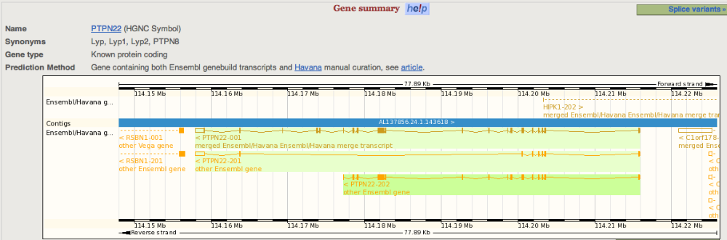

The page contains the whole span of the gene; all transcripts for the gene are displayed as well.

 Click on “Variation Image” under “

Genetic Variation” at the left panel to go to the Variation Image Page

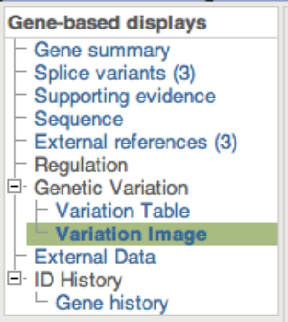

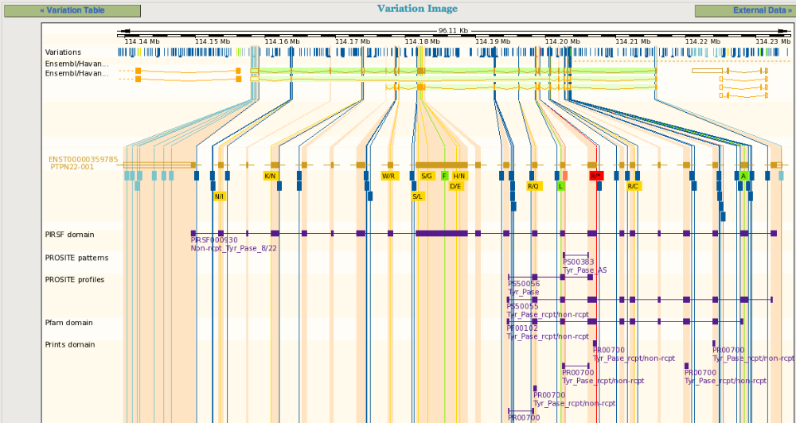

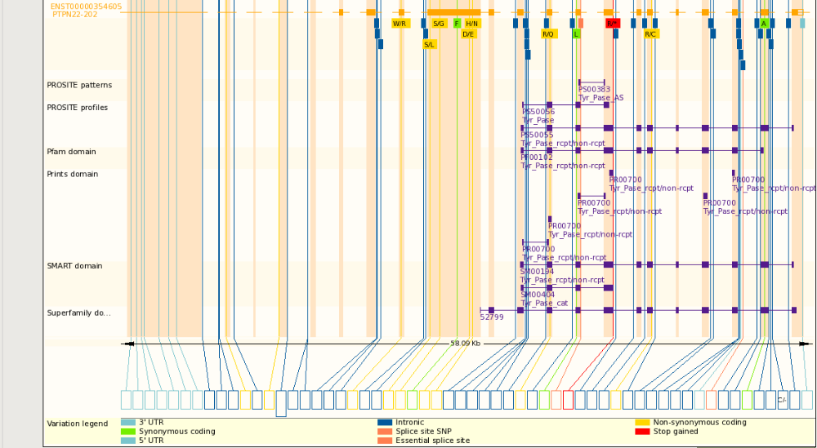

Since the snapshot is a partial capture of the actual display

, here is a link for the complete view:
http://pilotbrowser.1000genomes.org/Homo_sapiens/Gene/Variation_Gene/Image?db=core;g=ENSG00000134242;r=1:114177233-114215857;t=ENST00000354605

In a Variation Image Page, right under each transcript track, SNPs are displayed and color coded based on their predicted function such as intronic, synonymous

coding, non-synonymous coding. For non-synonymous SNPs, the amino acid change is also labeled.
At the bottom of a Variation Image Page is a collective display of SNPs, color-coded by their function.

 Single click on any SNP to get further information of the snp

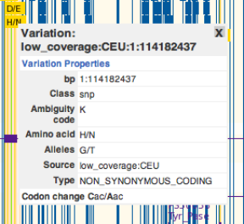

 Click on “Variation Table” under “Genetic Variation” to get a list of SNPs in the gene region with detail annotations. The SNPs are grouped by their functional types (intronic, non-synonymous coding etc.).

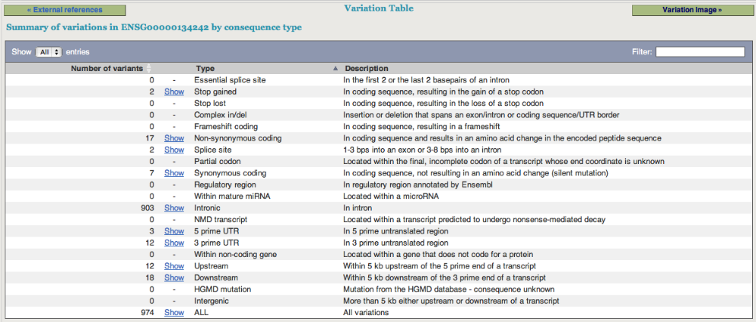

 Single click on “Show” to get a list of SNPs in a given category:

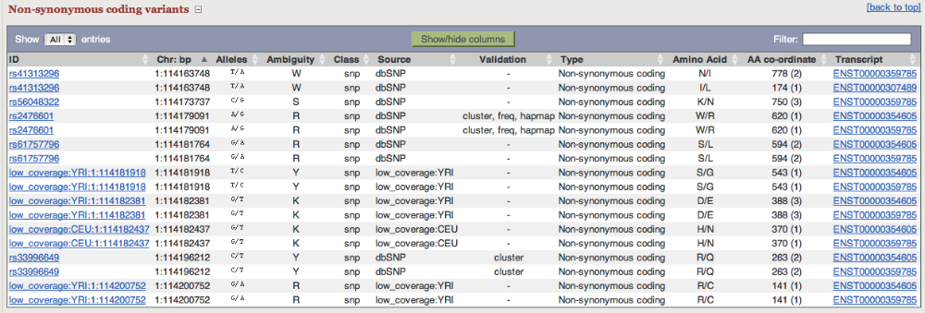

Please note that you can show and hide the columns in the variation table and also filter the content using the “Filter” box at the top right corner of the table.
Access variation data through transcript page

 Click on a transcript in the search result page takes you to a transcript page:

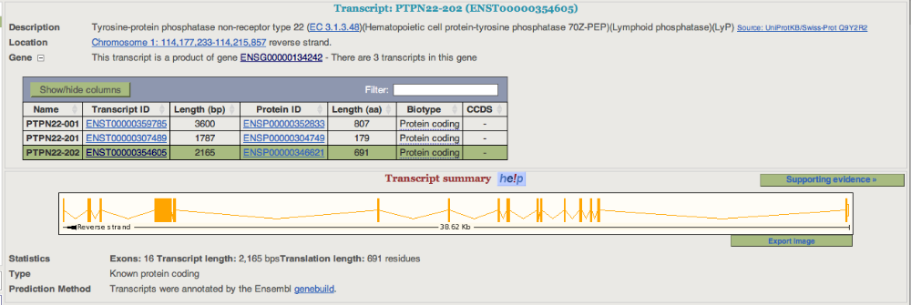

 Click on “Comparison Image” under “Genetic Variation” on the left panel

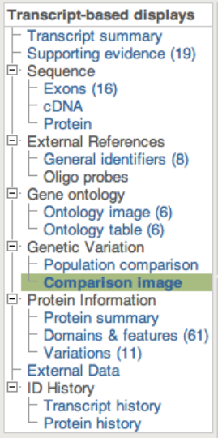

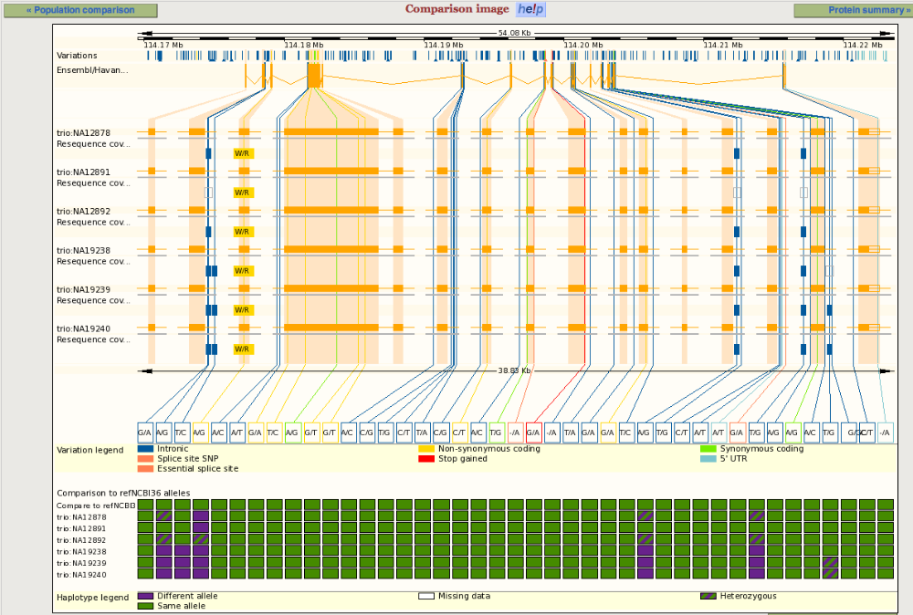

This is a snapshot of a Comparison Image Page. In this page, haplotypes are displayed for the six individuals who have been sequenced to high coverage (~60x) in the trio pilot study of the 1000 Genomes Project. The predicted functions of the SNPs are color-coded; the nucleotide changes for each SNP position are annotated at the bottom of the page. Below the reference transcript track is a track of ALL SNPs, including dbSNP SNPs, and SNPs discovered in all individuals sequenced in the 1000 Genome project so far. Many SNPs in this track are not variable in the six the trio pilot individuals hence no nucleotide change are noted for those positions.

Please note that in transcript view, only SNPs in the 100bp of both ends of introns are displayed by default. You may change this in the “Configure this page” pop-up window to display SNPs in an entire intron; however the page might be loaded much slower for some genes.

 Single click on any SNP to get further information of the snp:

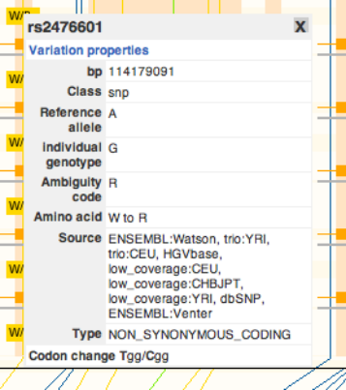

 Click on “Population Comparison” under “Genetic Variation” on the left panel gives you a list of SNPs with detailed annotation; one individual per block for the six the trio pilot individuals.

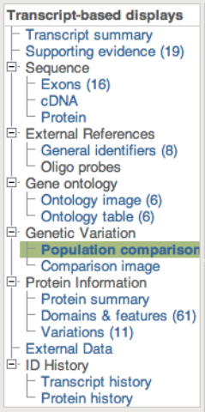

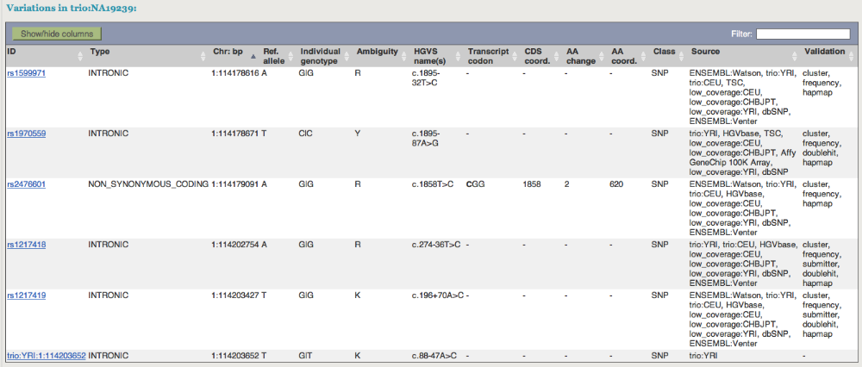

 Click on a SNP rs number or SNP ID would bring up a SNP detail page, which contains flanking sequence and other useful information:

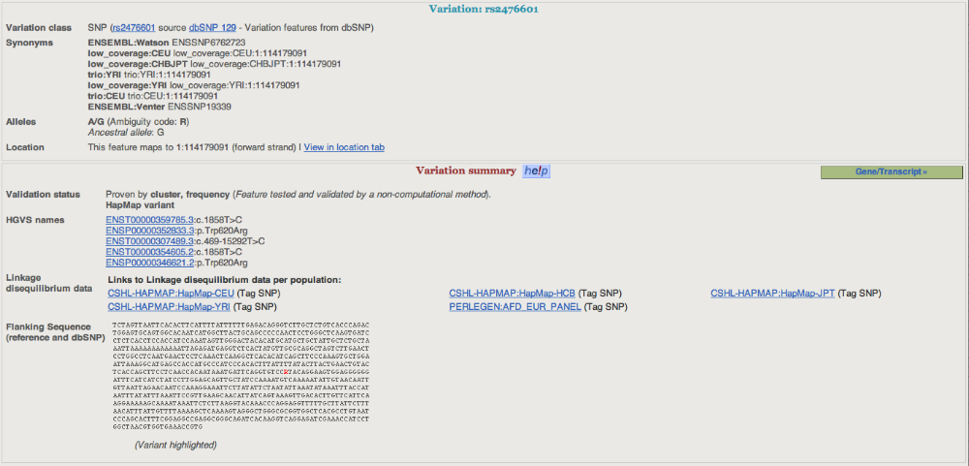

 Click on “Population genetics” at the left panel to see allele frequency of the variation and other information

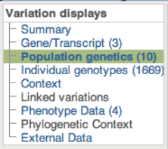

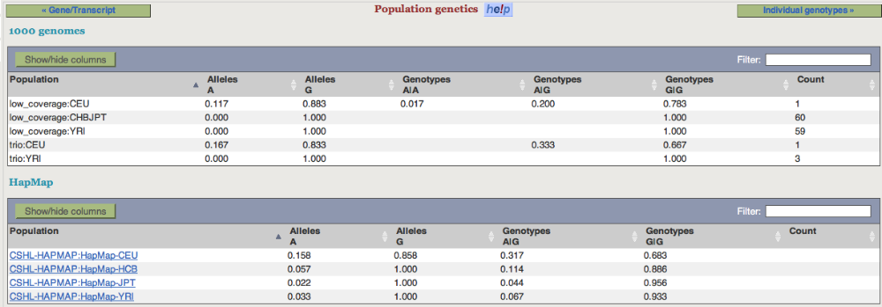

 Click on

“Individual genotypes” on the left panel to see genotypes in each sample

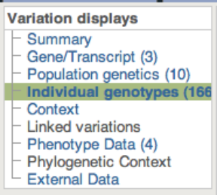

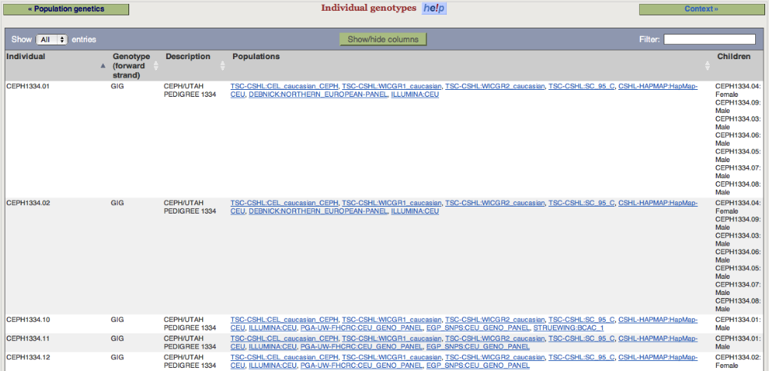

 Now go back to the transcript tab and click on “Variations” link under “Protein Information” on the left panel will show you the predicted functions of the SNPS in the region

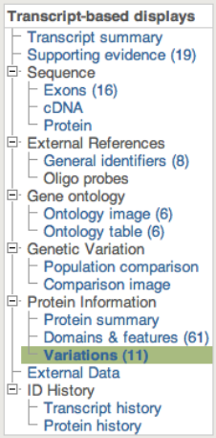

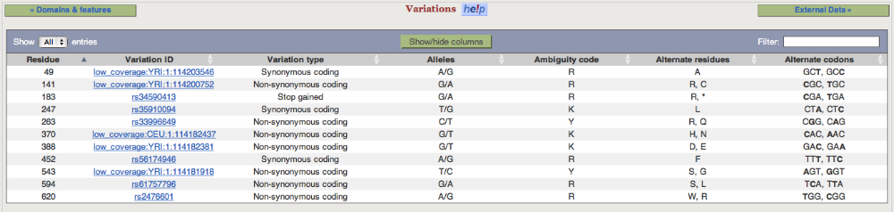
Access variation data through Location View

 In a transcript page or a gene page, click on the highlighted chromosome location of a gene/transcript

It takes you to a Location View. The bottom panel of the page contains variations discovered from different individuals sequenced in the 1000 Genome project, one population a track.

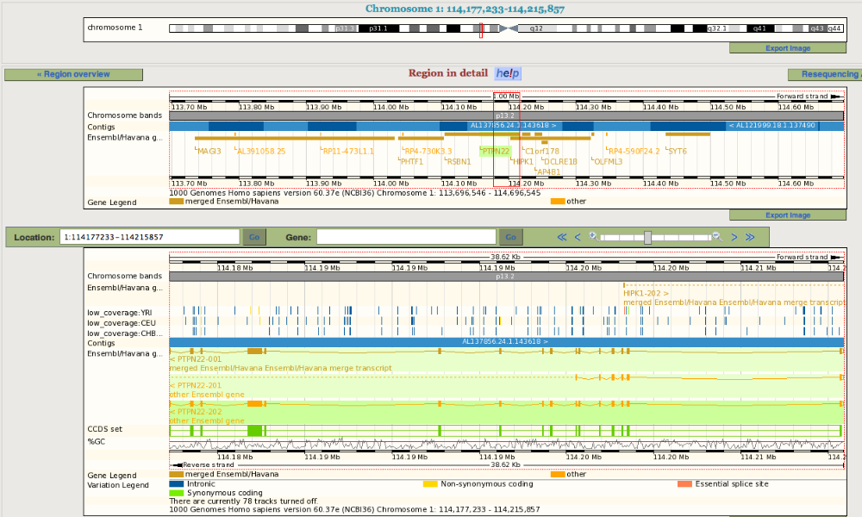

 Click on “Configure this page” on the left panel to view/edit current display settings.

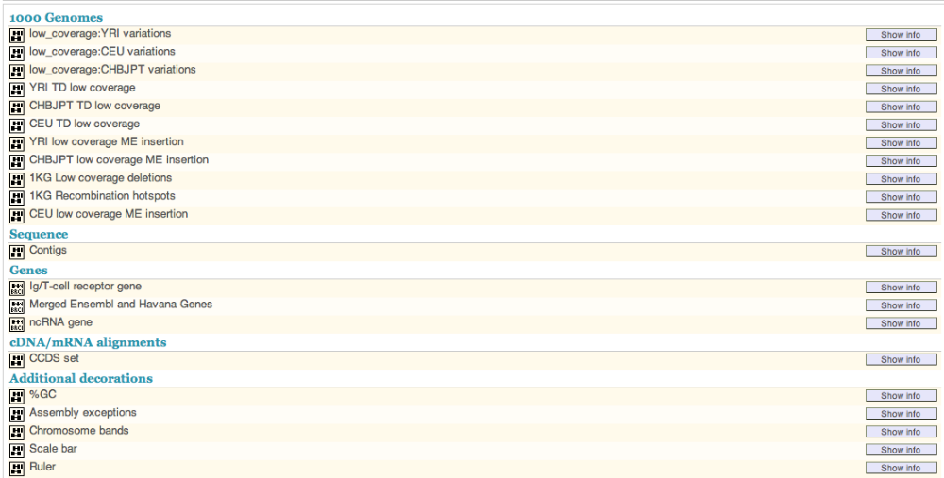

If you want to see a whole list of tracks belong to a category such as “1000 Genomes”, click on the category name. In the resulting page you will be able to view/add/remove tracks.

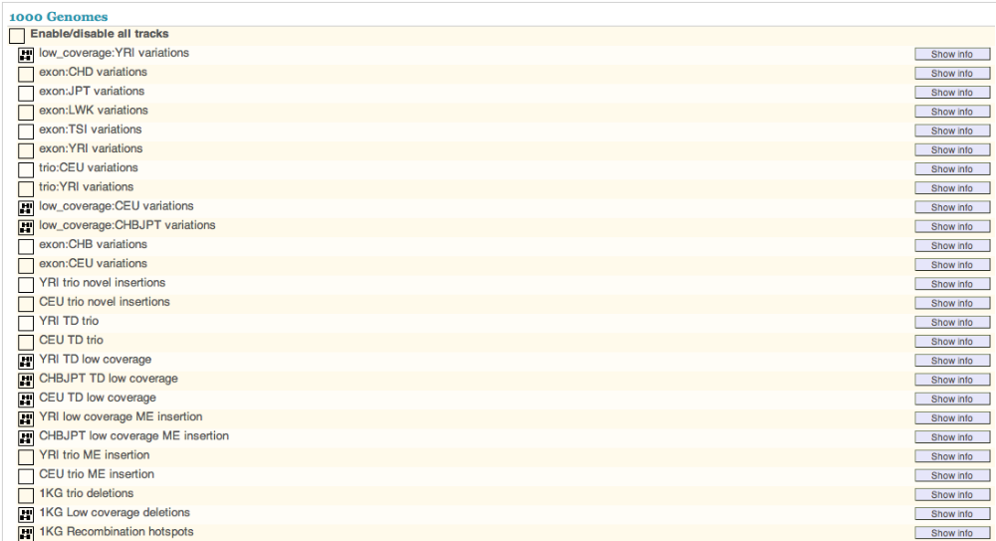

 Click on “V” sign at the top right corner of the configuration page to save the setting.

If you wish to see alignment data for the 1000 Genomes Project, edit the “1000 Genomes BAM” tracks:

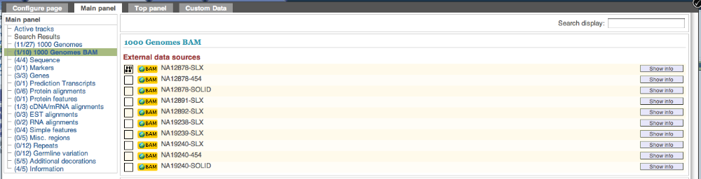

You will see sequence coverage and read alignment for the chosen individual as shown in the snapshot below:

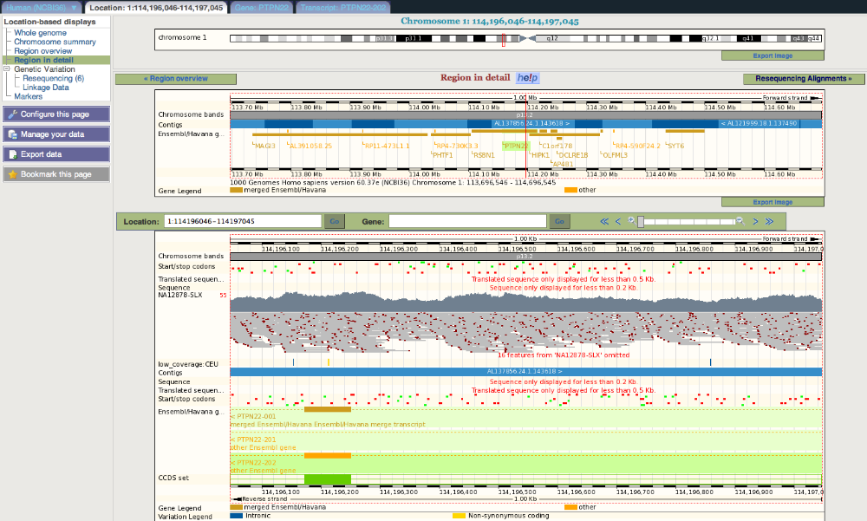

 Click on “Resequencing” under “Genetic Variation” on the left panel gives you sequence alignment of the trio individuals. Alternatively clicking on “Resequencing Alignments” on the top right corner of the page brings you to the same alignment view:

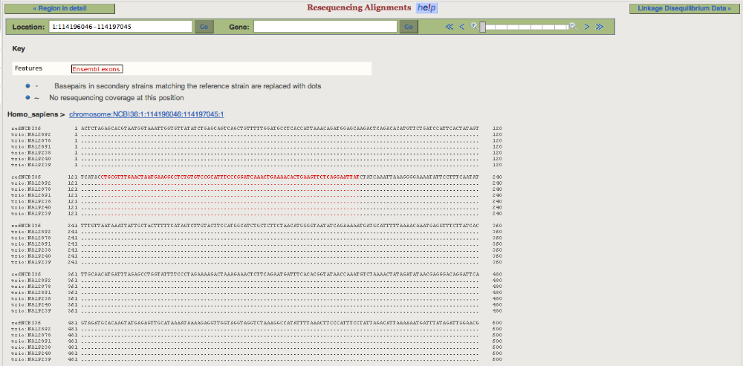

Nucleotides that are different from the reference sequence are highlighted. When a position is tri-allelic, special characters are used:

Y = C/T

R = A/G
K = G/T
M = A/C
S = G/C
W = A/T

Please note that only the six the trio pilot individuals’ sequences are displayed. The Resequencing Alignment view can also be accessed as the follow:

 Go to http://www.1000genomes.org.
 click on the “Browser”

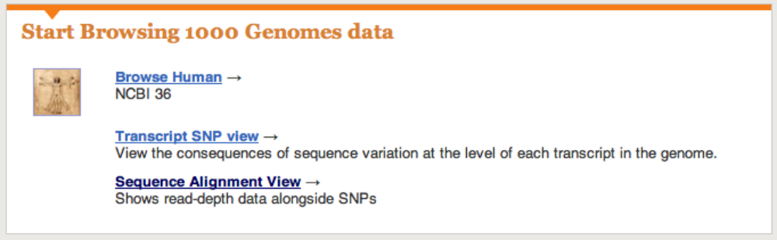

 click on “Sequence Alignment View”
 Enter chromosome and start and end positions and click “go”

 From the Alignment page, click “Linkage Disequilibrium Data” on the top right corner or by choosing the “Linkage Data” under “Genetic Variation” on the left panel

 Select population(s) by clicking the “Select Populations” button at the left panel:
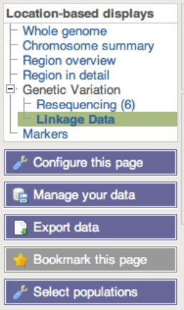

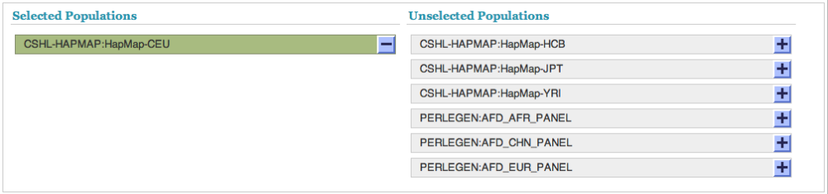

The linkage data for the chosen population is displayed as r2 and d’

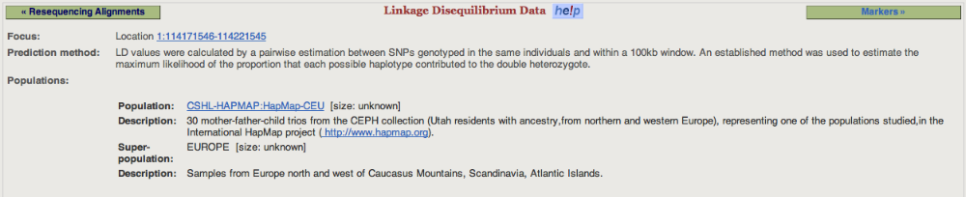
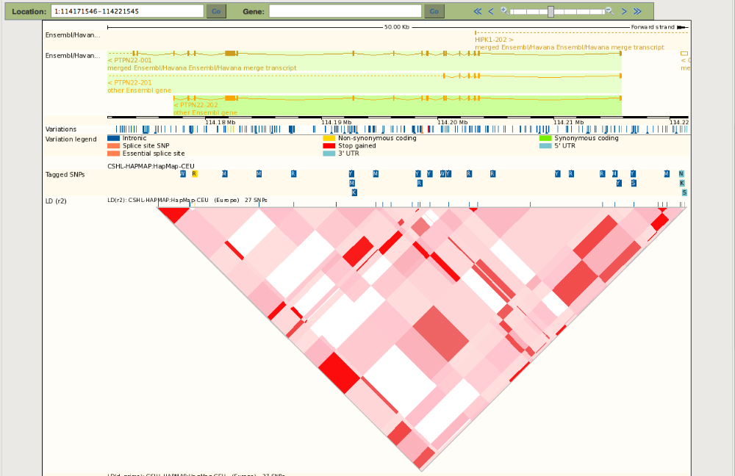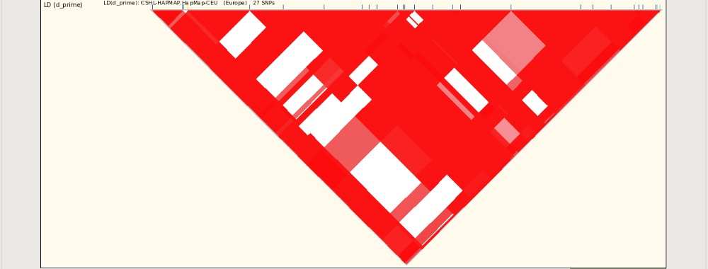

Export Data

It is possible to save data from the browser to an output file using “Export Data” function locates at the left panel.

 click on “Export Data”

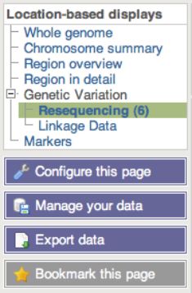

You get the following pop-up screen.

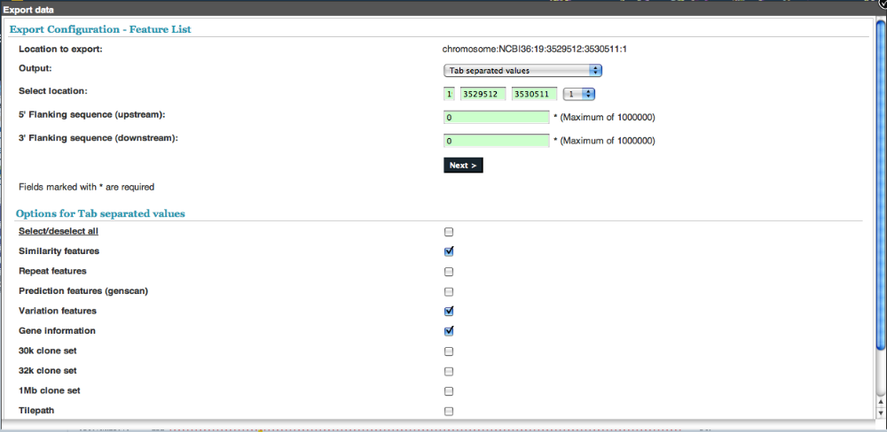

You may choose from the output pull-down menu the type of data you want to export:

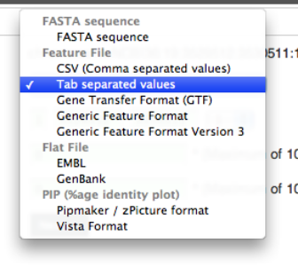

You may specify what options and features you want to include in the download by ticking checkboxes next to different options.

 click on “NEXT” after you choose the output data type and its options

The output data can be saved to three different formats:
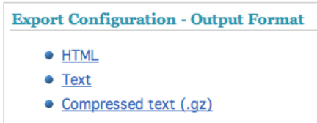

Choose one format and you will be able to get the data such as below:

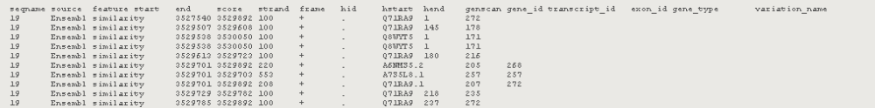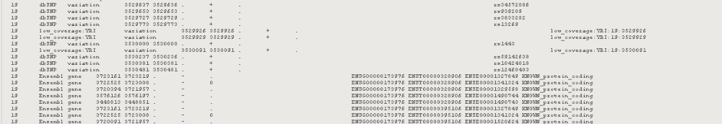

Variant Effect Predictor

The variant effect predictor takes a list of variant positions and alleles, and predicts the effects of each of these on any overlapping features (transcripts, regulatory features) annotated in Ensembl.

The tool can be accessed by clicking “Manage your data” at the left hand panel.

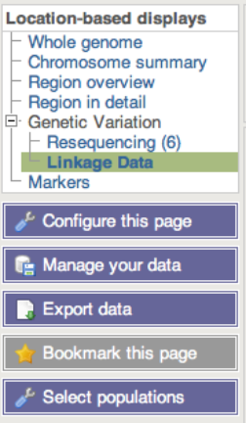

You get:

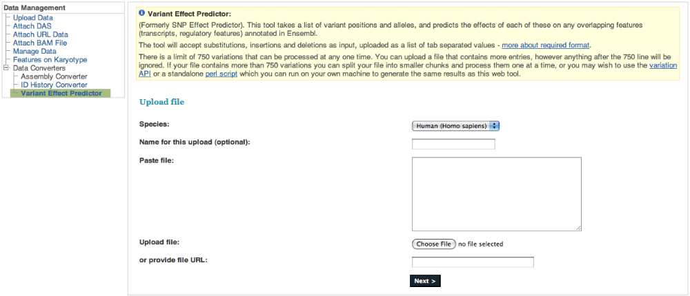

Input file format specification:

The tool will accept substitutions, insertions and deletions as input, uploaded as a list of tab separated values. Data must be supplied in a simple tab-separated format, containing five columns, all required:
- chromosome - just the name or number, with no 'chr' prefix
- start
- end
- allele - pair of alleles separated by a '/', with the reference allele first
- strand - defined as + (forward) or - (reverse).

One example is:
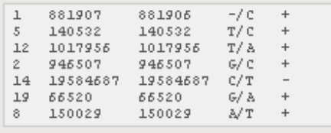

Output file format specification:
The tool predicts the consequence of this variation, the amino acid position and change (if the variation falls within a protein) and the SNP identifier of known SNPs that occur at this position. The output columns are:
- uploaded variation - as chromosome_start_alleles
- location - in standard coordinate format (chr:start or chr:start-end)
- gene - Ensembl stable ID of affected gene
- transcript - Ensembl stable ID of affected transcript
- consequence - consequence type of this variation
- relative position in cDNA - base pair position in coding sequence
- relative position in protein - amino acid position in protein amino acid change - only given if the variation affects the protein-coding sequence
- corresponding variation - stable ID of SNP, if known

Empty values are denoted by '-'. One example is:

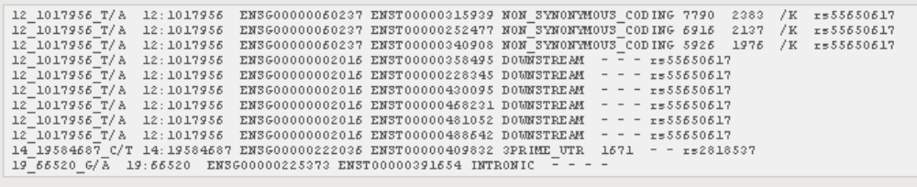

As a summary, SNP data of the 1000 Genomes Project can be visualized through different entry points in a gene page, a transcript page and a chromosomal location page. Sequence read alignments extracted from BAM files are accessible from the Location page. If you have any question in using the browser, please don’t hesitate in contacting us by writing to info@1000genomes.org

