Supplementary Materials 1

Trophic niche partitioning in charismatic giant clams

Summary:
Materials and Methods
Sample collection (Fig. 1)
Habitat assessment (Fig. 2)
Laboratory analysis
SIA statistical analysis
ITS2 sequence analysis
Results
Stable isotope analysis (Table 1-3, Fig. 3)
Symbiodiniaceae diversity and community structure (Fig. 4)
Phylogenetic signal analysis (Fig. 5)
Discussion
Geographic distribution of the 6 giant clams species of interest (Fig. 6)

Other Supplementary Materials for this manuscript include the following:
Data S2 to S5

Materials and Methods
Sample collection
Giant clam cohorts were raised at the hatchery in open-circuit raceways with coarse filtered seawater pumped from the Tabunan lagoon (Semirara Island, Philippines, 12°05'13.62" N, 121°20'45.66" E) before being transferred to sandy areas of the lagoon at 2-5 m depth (Supplementary Fig. 1). Five of the six giant clam species (Tridacna gigas, Tridacna derasa, Hippopus porcellanus, Hippopus hippopus and Tridacna squamosa) were sampled in the north of the lagoon while the Tridacna maxima samples were collected less than 400 m away in the southwest of the lagoon. The samples from the five species in the north were collected from a 30 m² area and the Tridacna maxima from a 10 m² area. To ensure that both areas had similar conditions, light and temperature hobo loggers were deployed in November 2019. All the samples for SIA analysis were collected across three days in November 2019. Each mantle was clamped ~0.5 cm from the edge using sterile hemostat forceps and sterile surgical scissors. Mean wet mass of clips varied from 0.095±0.035 g (T. derasa; ±SD) to 0.177±0.046 g (H. porcellanus). On each sampling day, duplicate samples of 3 L of seawater from the Tabunan lagoon were collected and filtered through two 47 mm glass fiber filters (GFF pore size 0.45 μM to collect particulate organic matter. All the filters were placed in a petri dish and dried at ambient temperature before analysis. Mantle clips collected for symbiont community analysis came from giant clams sampled in the Philippines. While initially all samples for symbiont community analysis were from Semirara Island, T. derasa and T. maxima samples did not pass library QC, leading to data analysis from Silaqui samples (Supplementary 3).
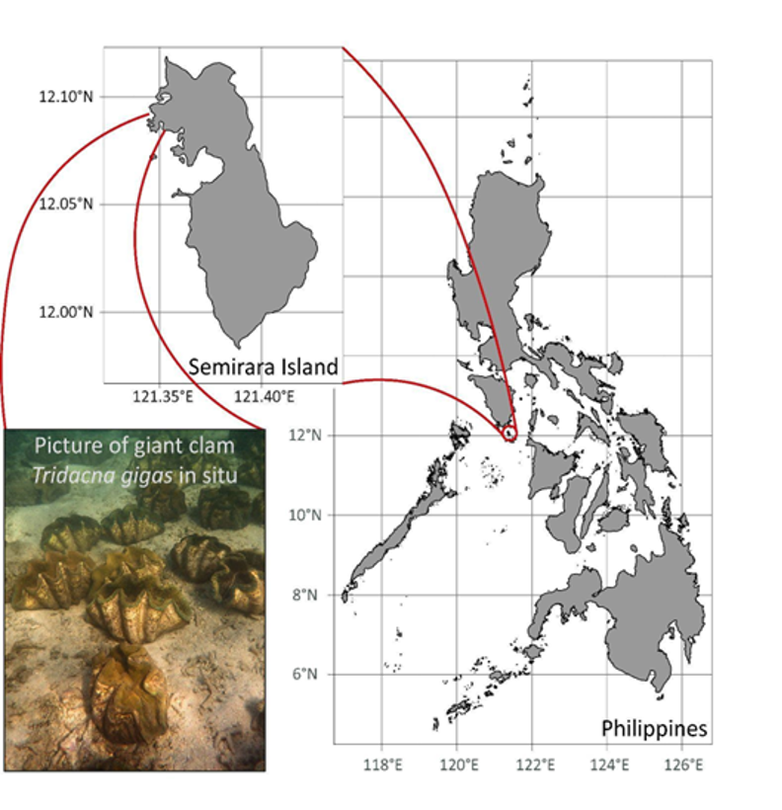
Supplementary Figure 1: Map of the study site highlighting Semirara Island and the Tabunan lagoon. Picture: Isis Guibert.

Habitat assessment
Light intensity and temperature were highly similar in both areas of the Tabunan lagoon (Supplementary Fig. 2). Visual observations showed that both areas were characterized by sandy sediment, 2-5 m depth and patches of seagrass around the sampled areas.

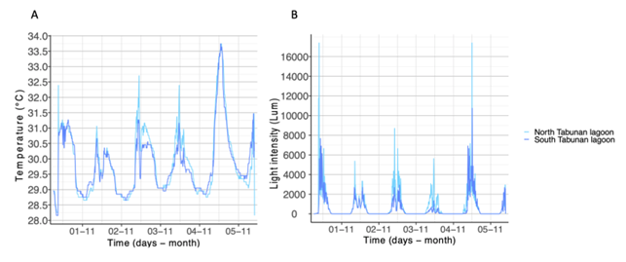

Supplementary Figure 2. Light intensity (A) and temperature (B) of the two areas sampled in the Tabunan Lagoon in November.

Laboratory analyses
Mantle samples for SIA were lacerated with a razor blade, placed in 5 ml of Milli-Q water and sonicated (S-150D, BRANSON, United -States) for 30 s at 5 W to extract algal symbionts. The supernatant, containing the symbionts, was retained. This process was repeated to maximize symbiont yield. The combined symbiont fractions were centrifuged at 3,000 RCF for 10 min. The lacerated mantle was homogenized in 5 ml of Milli-Q water with a Tissue-Tearor (Ultra Turrax T25, IKA labortechnik staufen, Germany) and centrifuged at 2,000 RCF for 10 min to separate giant clam host tissue from any residual symbionts. The supernatant was collected and centrifuged again for 5 min at 2,200 RCF. The supernatant containing the clean host fraction was kept for analysis. Host and symbiont fractions were stored at -40°C overnight and then freeze-dried (Alpha 1-4 LCS-Plus, Christ, Germany). Dry clam host tissue (0.9±0.1 mg) and symbionts (0.7± 0.1mg) were weighed into tin capsules. POM from the Tabunan lagoon was scraped off each filter and acidified in silver capsules using two applications of 5 μL of HPLC-grade 6N HCL to remove inorganic carbonates. Isotopic ratios of carbon (δ¹³C) and nitrogen (δ¹⁵N) were measured at the Stable Isotope Ratio Mass Spectrometry Laboratory at the University of Hong Kong with an environmental analyser (Eurovector EA3028, Italy) coupled to a stable isotope ratio mass spectrometer (Nu Instruments Perspective, UK). Vienna PeeDee belemnite (δ¹³C=0.011‰) and atmospheric nitrogen (δ¹⁵N=0.004‰) were used as standards for C and N, respectively, and accuracy for both was better than 0.1‰.
Total genomic DNA was sent to Macrogen, South Korea, for ITS2 amplicon sequencing. Amplicon libraries were prepared using the Herculase II Fusion DNA Polymerase Nextera XT Index Kit V2 using the primers ITSintfor2² and ITS2-reverse³ targeting the ITS2 region of the ribosomal RNA operon. Libraries were sequenced on the Illumina MiSeq platform to generate 2 x 300 bp reads.

ITS2 sequence analysis
Raw paired reads were subjected to quality control (QC) using mothur v.1.39.5 [1,2]. Reads were screened for Symbiodiniaceae sequences within the range of 184–310 bp and algorithmically searched in a genus-separated manner using the BLAST+ suite of executables [2] and Minimum Entropy Decomposition (MED) [3]. Post-QC, ITS2 sequences were loaded to both local and remote SymPortal databases to identify specific sets of ITS2 sequences re-occurring in multiple samples called defining intragenomic variants (DIVs). The presence and abundance of these DIVs were used to define the ITS2 type profiles. Raw data are available on Figshare (See data section).

Results
Stable isotope analysis

Supplementary Table 1. Summary statistics of stable isotope analysis of paired clam host and algal symbiont samples. Mean (±SD) carbon to nitrogen ratio (C:N), carbon (δ¹³C) and nitrogen (δ¹⁵N) stable isotope values, and difference between host and symbiont isotope values (Δ¹³C and Δ¹⁵N) of six giant clam species collected from Cover Bay, Semirara Island, Philippines.

Species | n | C:N |  | δ¹³C (‰) |  | δ¹⁵N (‰) |  | Δ¹³C (‰) | Δ¹⁵N (‰)
 |  | Host | Symb | Host | Sym | Host | Sym | Δ¹³C (‰) | Δ¹⁵N (‰)
T. gigas | 27 | 5.7±1.3 | 5.7±1.3 | -14.4±1.2 | -15.0±1.1 | 4.9±0.3 | 4.9±0.1 | 0.5±0.5 | 0.1±0.3
T. derasa | 28 | 5.6±1.4 | 6.0±0.7 | -12.3±0.9 | -13.1±0.7 | 4.7±0.3 | 4.3±0.2 | 0.8±0.7 | 0.4±0.3
H. porcellanus | 23 | 6.0±0.7 | 5.7±0.3 | -16.7±0.4 | -17.8±0.5 | 4.8±0.1 | 4.4±0.3 | 1.1±0.4 | 0.4±0.3
T. maxima | 9 | 7.0±2.2 | 6.4±1.5 | -17.7±0.7 | -18.9±0.9 | 4.7±0.2 | 4.2±0.2 | 1.2±0.9 | 0.5±0.3
H. hippopus | 25 | 5.5±1.2 | 5.5±0.5 | -15.2±0.9 | -16.5±0.8 | 5.2±0.3 | 4.4±0.4 | 1.3±0.6 | 0.8±0.4
T. squamosa | 26 | 4.8±1.7 | 6.1±0.6 | -14.9±1.3 | -16.7±1.4 | 5.0±0.3 | 4.2±0.3 | 1.7±0.9 | 0.7±0.3

Supplementary Table 2. Standard ellipses areas and overlap metrics of six giant clam hosts and their associated algal symbionts in isotopic space. Stable Isotope Bayesian Ellipses in R (SIBER) analysis was used to fit standard ellipses area corrected for sample size (SEA_{C}) that captured 40% of the variation of the data to host (Host SEA_{C}) and symbiont (Symbiont SEA_{C}) isotope values. The mode of the last 100 posterior ellipses from a Bayesian generated distribution was used as to compute the Bayesian standard ellipse area of the host group (Host SEA_{B}), the symbiont group (Symbiont SEA_{B}), and the area of overlap between the two. The area of overlap of host and symbiont was expressed as a proportion of Host SEA_{B} (SEA_{B}H) and Symbiont SEA_{B} (SEA_{B}S).

Species | Host SEA_{C} (‰²) | Host SEA_{B} (‰²) | Symbiont SEA_{C} (‰²) | Symbiont SEA_{B} (‰²) | SEA_{C} area of overlap (‰²) | EA_{B} area of overlap (‰²) | SEA_{B}H | SEA_{B}S
T. gigas | 1.19 | 1.13 | 0.43 | 0.41 | 0.40 | 0.29 | 0.24 | 0.90
T. derasa | 0.60 | 0.59 | 0.34 | 0.32 | 0.10 | 0.00 | 0.00 | 0.00
H. porcellanus | 0.14 | 0.14 | 0.39 | 0.37 | 0.00 | 0.00 | 0.00 | 0.00
T. maxima | 0.51 | 0.41 | 0.73 | 0.60 | 0.00 | 0.00 | 0.00 | 0.00
H. hippopus | 0.70 | 0.65 | 0.93 | 0.88 | 0.00 | 0.00 | 0.00 | 0.00
T. squamosa | 0.95 | 0.87 | 0.89 | 0.86 | 0.00 | 0.00 | 0.00 | 0.00

Supplementary Table 3. Comparison of the placement and overlap in isotopic space of six giant clam hosts and their associated algal symbionts. Host and symbiont placements were assessed by measuring the distance between the ellipse centroids of the two groups (DEC) and running a residual permutation procedure (RPP). Host and symbionts occupied distinct space on the isotopic biplot when p<0.05. Overlap between the two groups was assessed using a Bayesian analysis to generate a posterior distribution of ellipses fit to encompass 95% of the variation of each group. The mode of the last 100 posterior ellipses and their overlap was used as the Bayesian ellipse area of the host group (Host MEA_{B}), the symbiont group (Symbiont MEA_{B}), and the area of overlap between the two. The proportion of host and symbiont MEA_{B} overlapping that of the other was also calculated (respectively, MEA_{B}H and MEA_{B}S).

Species | DEC (‰) | RPP  p-value | Host MEA_{B} (‰²) | Symbiont MEA_{B} (‰²) | Area of overlap (‰²) | MEA_{B}H | MEA_{B}S
T. gigas | 0.50 | 0.116 | 6.97 | 2.61 | 2.31 | 0.32 | 0.98
T. derasa | 0.93 | <0.001 | 3.65 | 2.02 | 1.63 | 0.41 | 0.82
H. porcellanus | 1.14 | <0.001 | 0.78 | 2.15 | 0.41 | 0.49 | 0.17
T. maxima | 1.27 | <0.001 | 2.37 | 3.97 | 0.82 | 0.24 | 0.20
H. hippopus | 1.57 | <0.001 | 4.05 | 5.28 | 2.01 | 0.43 | 0.34
T. squamosa | 1.89 | <0.001 | 5.56 | 5.26 | 1.42 | 0.28 | 0.31

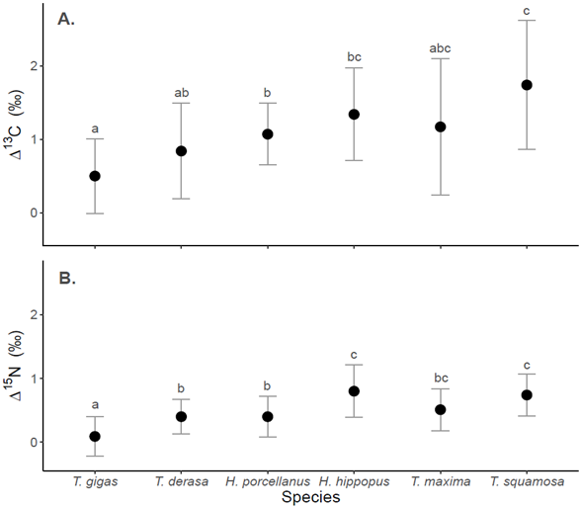

Supplementary Figure 3. Mean Δ¹³C (δ¹³C_{Host}-δ¹³C_{Symbiont}; A) and Δ¹⁵N (δ¹⁵N_{Host}-δ¹⁵N_{Symbiont}; B) of each giant clam species. Error bars represent one standard deviation. Different letters indicate significant differences between species (ANOVA; P < 0.05).

Symbiodiniaceae diversity and community structure

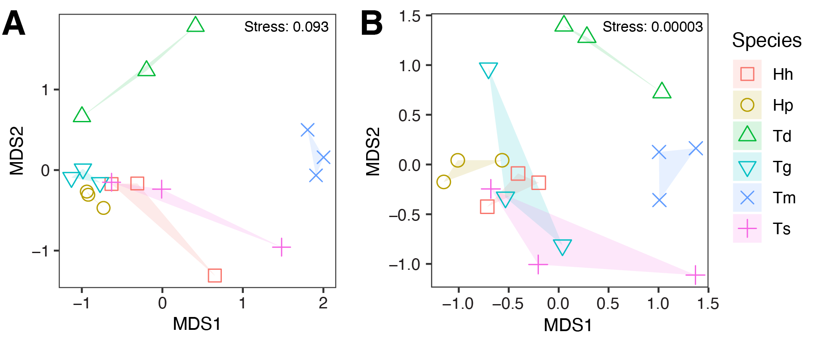
Supplementary Figure 4. Non-metric multi-dimensional scaling (NMDS) plots using Bray-Curtis dissimilarities based on (A) ITS2 sequences and (B) ITS2 type profiles of six giant clam species: Hippopus hippopus (Hh), Hippopus porcellanus (Hp), Tridacna derasa (Td), Tridacna gigas (Tg), Tridacna maxima (Tm), and Tridacna squamosa (Ts).

Phylogenetic signal analysis
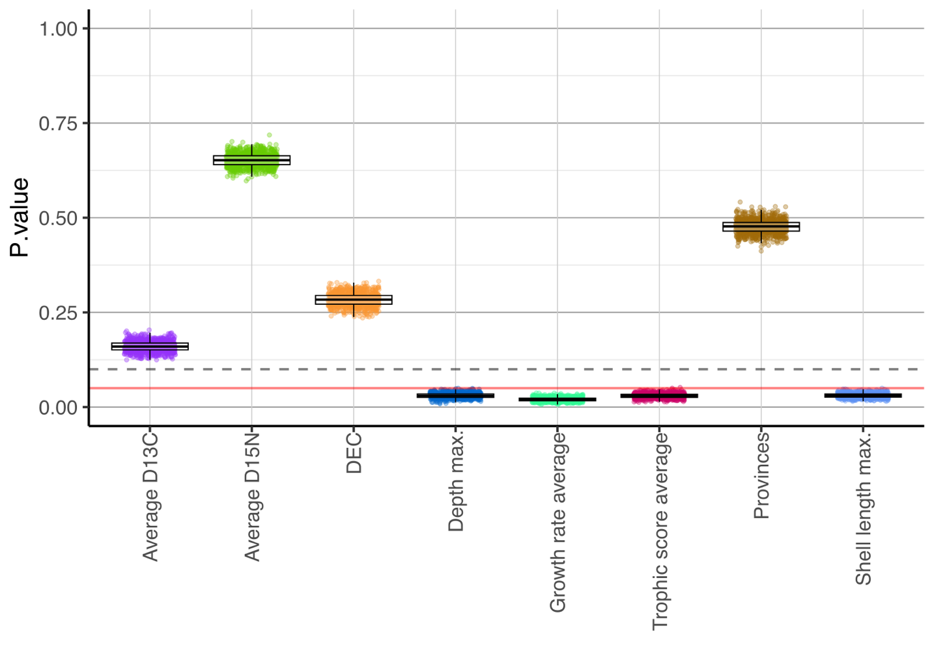Supplementary Figure 5. P.value of the eight ecological traits assessed for the phylogenetic signal analysis highlighting four significant traits: maximum depth, growth rate average, trophic niche score, and maximum shell length.

Discussion
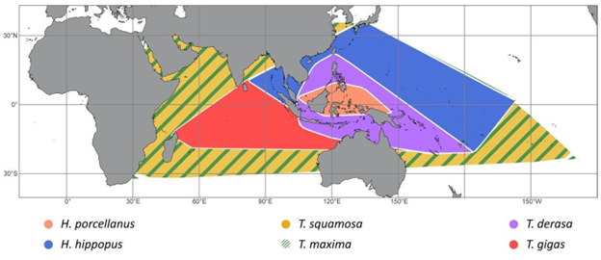

Supplementary Figure 6. Geographic distribution of the 6 giant clam species of interest. Orange: Hippopus porcellanus, blue: Hippopus hippopus, Yellow: Tridacna squamosa, Green: Tridacna maxima, Purple: Tridacna derasa, Red: Tridana gigas. Location data were obtained from Neo et al. 2017 [4].

References:
1. Schloss PD, Westcott SL, Ryabin T, Hall JR, Hartmann M, Hollister EB, et al. Introducing mothur: Open-source, platform-independent, community-supported software for describing and comparing microbial communities. Appl Environ Microbiol. 2009;75:7537–41.
2. Camacho C, Coulouris G, Avagyan V, Ma N, Papadopoulos J, Bealer K, et al. BLAST+: architecture and applications. BMC Bioinformatics [Internet]. 2009 [cited 2017 Nov 7];10:421. Available from: http://www.ncbi.nlm.nih.gov/pubmed/20003500
3. Eren AM, Morrison HG, Lescault PJ, Reveillaud J, Vineis JH, Sogin ML. Minimum entropy decomposition: Unsupervised oligotyping for sensitive partitioning of high-throughput marker gene sequences. ISME Journal [Internet]. 2015;9:968–79. Available from: http://dx.doi.org/10.1038/ismej.2014.195
4. Neo ML, Wabnitz CCC, Braley RD, Heslinga GA, Fauvelot C, Van Wynsberge S, et al. Giant clams (Bivalvia: Cardiidae: Tridacninae): a comprehensive update of species and their distribution, current threats and conservation status. Oceanography and Marine Biology: An annual review. 2017;55:87–387.

Data S2. (separate file)
Stable isotopes data, trophic niche scores and phylogenetic traits
Data S3. (separate file)
Description of the giant clam samples
Data S4. (separate file)
Most abundant ITS2 sequences

