**ITEC 4200 Advanced Database Semester Project**

Student Name: Aston Tsou

Semester: Spring 2018

Name of Project: Dealership Service Department

Email: astontsou@gmail.com

Phone number(s): 770 878 2269

**EXECUTIVE SUMMARY**

**Objective**

This database is designed to assist a dealership service department to track information about vehicles, customers, services, service tickets, technicians, and parts.

**Goals**

Our goal with this database project is to provide an efficient and effective method of storing and retrieving data for service department sales and operations. Also, queries and reports can be generated that provide useful information about the service costs and time to help in the company’s profitability.

**Solution**

The solution is the creation of multiple database tables including the relationships between those tables. The tables consist of the following: ***Customer***, ***Parts***, ***Service***, ***ServicePartList***, ***ServiceTechnician***, ***ServiceTicket***, ***Technician***, ***and Vehicle***. These tables represent the main entities of the application, and contain links that define the relationships between entities. Using these tables, we can create the queries and reports that will provide the necessary information. It will be implemented in using Oracle 11g Express.

**Benefits to Users**

The database will serve as a valuable tool for providing information in a fast, convenient, and reliable fashion. It will help to streamline operations, provide insights to trends, and help to identify customer preferences.

**Project Outline**

The project will contain the following major components:

* Schema Design
* Entity-Relationship Diagram
* Table Implementation
* Queries
* Reports

**Part II. Schema Design**

**VEHICLE** (VehicleId, VIN, Year, Make, Model, Color, Type)

**SERVICETECHNICIAN** (ServiceTechnicianId, TicketId, ServiceId, TechnicianId, Hours, Comments, Rate)

FK TicketId 🡪 SERVICETICKET

FK ServiceId 🡪 SERVICE

FK TechnicianId 🡪 TECHNICIAN

**SERVICE** (ServiceId, ServiceName, HourlyRate)

**SERVICETICKET** (TicketId, TicketNumber, VehicleId, CustomerId, DateIn, DateOut, MilesIn, MilesOut, Comments, DateProcessed, PartPrice, LaborPrice, Total)

FK VehicleId 🡪 VEHICLE

FK CustomerId 🡪 CUSTOMER

**TECHNICIAN** (TechnicianId, Type, LastName, FirstName)

**CUSTOMER** (CustomerId, LastName, FirstName, PhoneNumber, Email, Address, City, State, Zip)

**SERVICEPARTLIST** (ServicePartListId, PartId, TicketId, Amount, CostTotal)

FK PartId 🡪 PARTS

FK TicketId 🡪 SERVICETICKET

**PARTS** (PartNumber, Name, Description, PurchasePrice, RetailPrice)

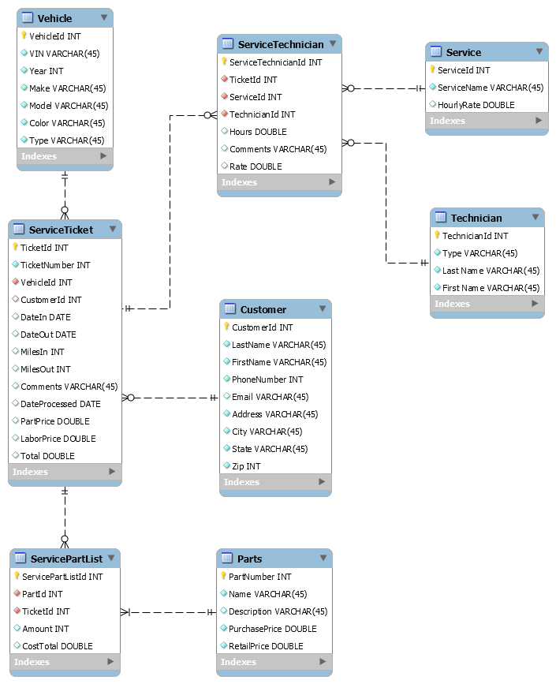

**Entity-Relationship Diagram**