Private Sub CommandButton1_Click()

Charts.Add

ActiveChart.ChartType = xl3DColumn

ActiveChart.SetSourceData Source:=Sheets("Sayfa1").Range("A1:B4"), PlotBy:= _

xlColumns

ActiveChart.Location Where:=xlLocationAsObject, Name:="Sayfa1"

ActiveChart.HasTitle = True

End Sub

Sub pasta()

ActiveSheet.Shapes.AddChart.Select

ActiveChart.ChartType = xlPie

ActiveChart.SetSourceData Source:=Range("$A$1:$B$4")

End Sub

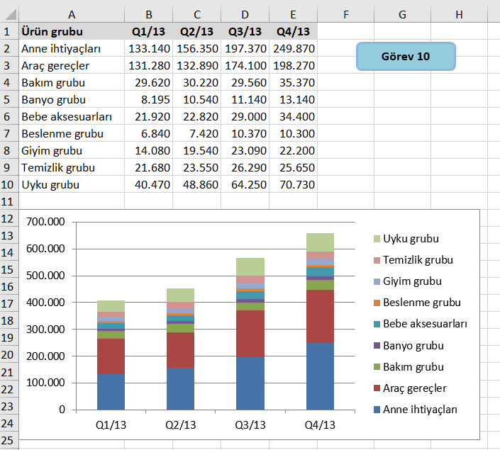

Option Explicit

Sub Form_Dugme()

Dim shp As Shape

Dim cht As Chart

'Mevcut grafikleri temizle

Do While ActiveSheet.ChartObjects.Count > 0

ActiveSheet.ChartObjects(1).Delete

Loop

'Yeni bir Chart yarat

Cells(1, 1).Select

Set shp = ActiveSheet.Shapes.AddChart(xlLine, 0, Range("A12").Top, 390, 195)

Set cht = shp.Chart

Application.ScreenUpdating = True

MsgBox "Shape.Name = " & shp.Name & vbCrLf & "Chart.Name = " & cht.Name, vbOKOnly, "Grafik nesneleri"

cht.ChartType = xlColumnStacked

cht.SetSourceData Source:=Range("$A$1:$E$10"), PlotBy:=xlRows

End Sub

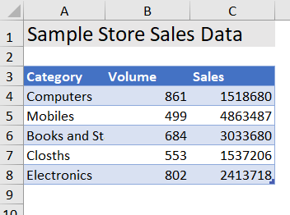

Sub ExAddingNewChartforSelectedData_Sapes_AddChart_Method()

Range("A3:C8").Select

ActiveSheet.Shapes.AddChart.Select

End Sub

Sub ExAddingNewChartforSelectedData_ChartObjects_Add_Method()

With ActiveSheet.ChartObjects.Add(Left:=Range("L1").Left, Width:=300, Top:=10, Height:=300)

.Chart.SetSourceData Source:=ActiveSheet.Range("A3:C8")

End With

End Sub

Sub ExDeletingChart()

ActiveSheet.ChartObjects(1).Delete

End Sub

Sub Ex_ChartType_xlConstant()

Dim cht As Object

Set cht = ActiveSheet.ChartObjects.Add(Left:=300, Width:=300, Top:=10, Height:=300)

With cht

.Chart.SetSourceData Source:=ActiveSheet.Range("A3:C8")

.Chart.Type = xlLine

End With

End Sub

Sub Ex_Chart_Combination()

Dim cht As Object

Set cht = ActiveSheet.ChartObjects.Add(Left:=300, Width:=300, Top:=10, Height:=300)

With cht

.Chart.SetSourceData Source:=ActiveSheet.Range("A3:C8")

.Chart.SeriesCollection(1).Type = xlColumn

.Chart.SeriesCollection(1).AxisGroup = 1

.Chart.SeriesCollection(2).Type = xlLine

.Chart.SeriesCollection(2).AxisGroup = 2

End With

End Sub

'Sub sbOpenPopularLinks()

'ThisWorkbook.FollowHyperlink "http://analysistabs.com/excel-vba/macros-for-absolute-beginners/"

'Application.Wait (Now + TimeValue("0:00:15"))

'ThisWorkbook.FollowHyperlink "http://analysistabs.com/excel-vba/codes-examples-macros-how-tos-most-useful-basics-advanced/"

'End Sub

Sub GenderPivot()

Dim AllData As Worksheet

Set AllData = Worksheets("All Data")

Dim satirsay As Integer

satirsay = AllData.Range("A1048576").End(xlUp).Row

Application.DisplayAlerts = False

On Error Resume Next

Worksheets("Gender1").Delete

Application.DisplayAlerts = True

Dim pc As PivotCache

Dim pt As PivotTable

Dim ws As Worksheet

Dim pf As PivotField

Dim SrcData As String

AllData.Activate

AllData.Range("A1").CurrentRegion.Select

SrcData = Selection.Address(1, 1, xlR1C1, True)

Set ws = ActiveWorkbook.Worksheets.Add

Set pc = ActiveWorkbook.PivotCaches.Create( _

SourceType:=xlDatabase, _

SourceData:=SrcData, _

Version:=xlPivotTableVersion14)

Set pt = pc.CreatePivotTable(TableDestination:=ws.Name & _

"!R3C1", TableName:="PivotTable1", _

DefaultVersion:=xlPivotTableVersion14)

Set pf = pt.AddDataField(pt.PivotFields("Key"), "Gender Sayısı", xlCount)

pf.NumberFormat = "#"

pt.PivotFields("Gender").Orientation = xlRowField

ws.Range("A5").Select

Dim ChartSheet1 As Chart

Set ChartSheet1 = Charts.Add

ws.Name = "Gender1"

ActiveChart.ChartType = xl3DPie

ActiveChart.ApplyDataLabels Type:=xlDataLabelsShowPercent

ActiveChart.ChartTitle.Text = "GENDER"

ActiveChart.Location Where:=xlLocationAsObject, Name:="Gender1"

End Sub