How to use the seat allocation software

Technical Requirements etc
The current version is called: Session Distancing Tool v4.2.jar

You need to have the latest version of java installed on your computer for it to work properly

Getting started
There is no formal installation or set process. To run the program, just double-click on the filename. You should see this:

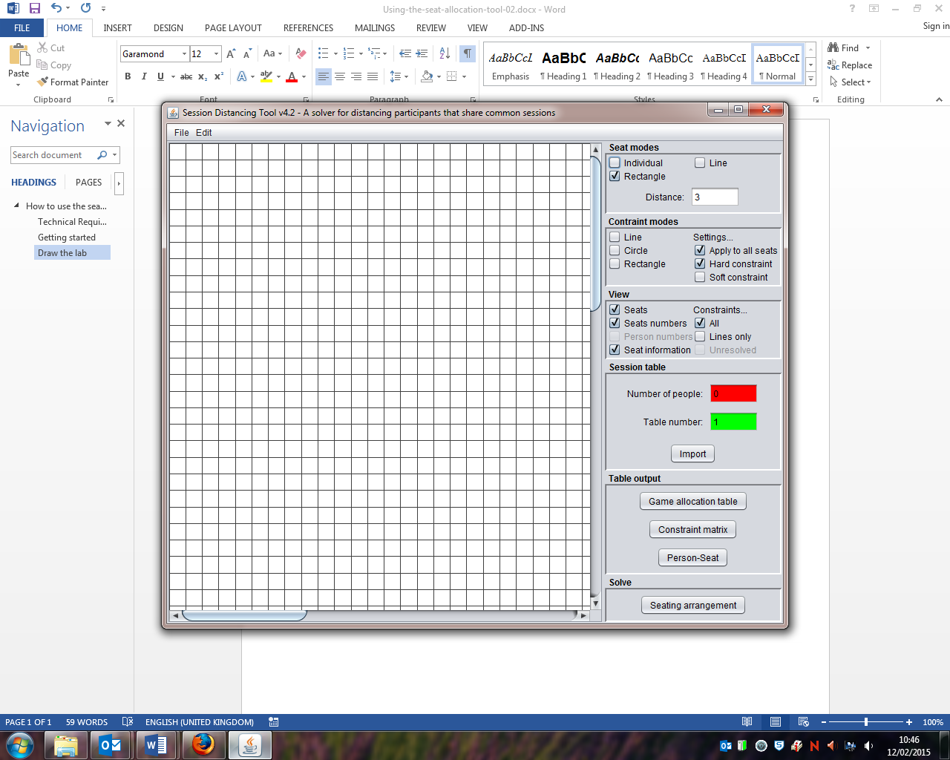

Draw the lab
To draw the lab put the mouse pointer somewhere in the grid, hold the left-button down to mark the starting corner and then drag to draw a rectangle shape. Each blue dot represents one computer. If your lab is not rectangular, you can draw computers in rows (lines) or as individual dots by choosing the appropriate option from ‘seat mode’

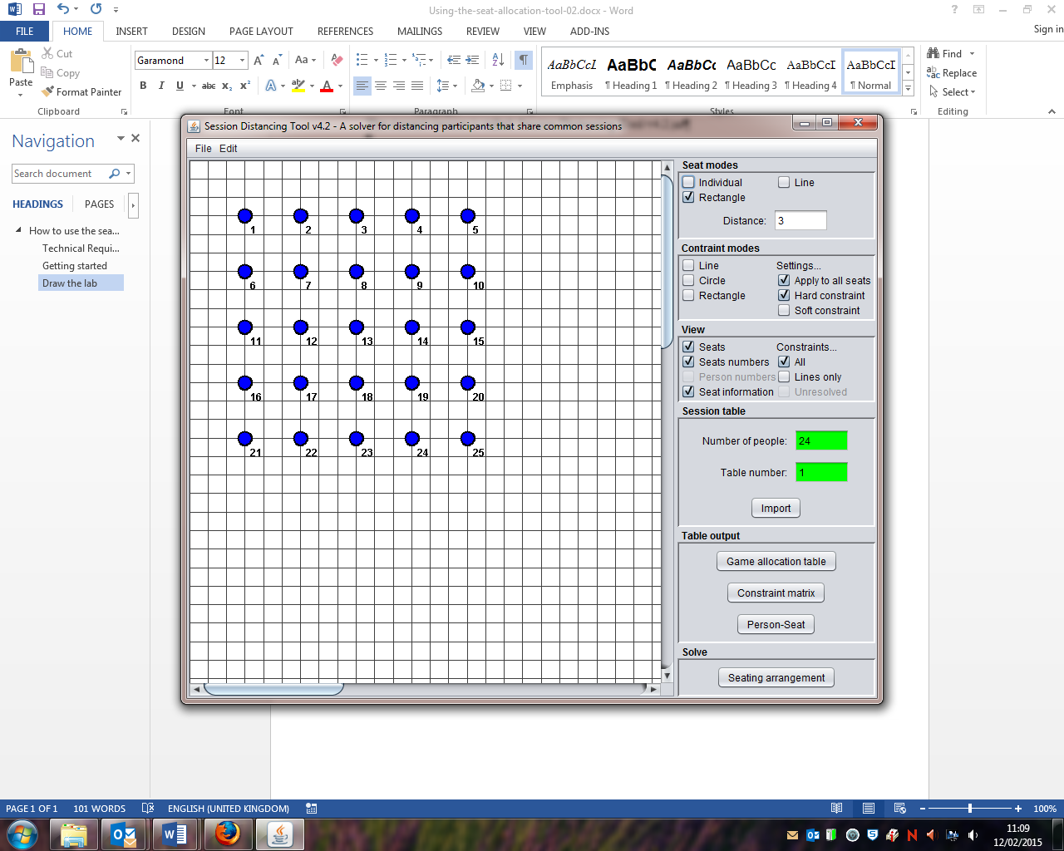
Choose how to draw the lab layout here
If there are individual computers in your lab that you want to exclude (e.g. because they are broken) then right-click on the appropriate dot and it will disappear.

Add ‘constraints’
Constraints are rules that tell the programme how to seat players. Hard constraints are rules that can never be broken, soft constraints are rules that can be broken if no other solution exists. In either case, the constraint is negative (i.e. players in the same game must/should not occupy seats linked by a constraint). You can also choose whether or not a constraint applies to a particular seat/computer or to all seats/computers – the default is all computers and I have never needed to change this.

As with drawing the lab, there are several different ways to add constraints. I find ‘line’ the easiest as you can build up the constraints in a step-by-step way and see exactly what you are doing. Circle and Rectangle apply constraints over areas. In what follows, I assume you will apply constraints as lines.


Choose how to draw constraints here

To apply a constraint you need to:

- Check that ‘apply to all seats’ is ticked
- Decide if you want to draw a ‘hard’ or ‘soft’ constraint
- Use the mouse to draw a line between the seats for which the rule should apply

For example, drawing a hard constraint between seats 2 and 3 has the effect of ensuring that no players in the same games sit in adjacent seats in any of the horizontal rows. Likewise, drawing a line between seats 2 and 7 will ensure that no players in the same game sit in adjacent seats in the vertical rows.

You can add as other constraints as necessary. For example, joining 3 to 9 and then 4 to 8 rules out adjacent seats on the diagonal lines. You could also say that, ideally, you do not want players within two seats of each other either, and so add soft constraints between:

- 2 and 4
- 2 and 12

Depending on the layout of your lab, you might also want to add soft constraints between:

- 3 and 12
- 3 and 14

To see the constraints for a particular seat, put the mouse point over that seat (no need to click). For the constraints described above, you should get the following:

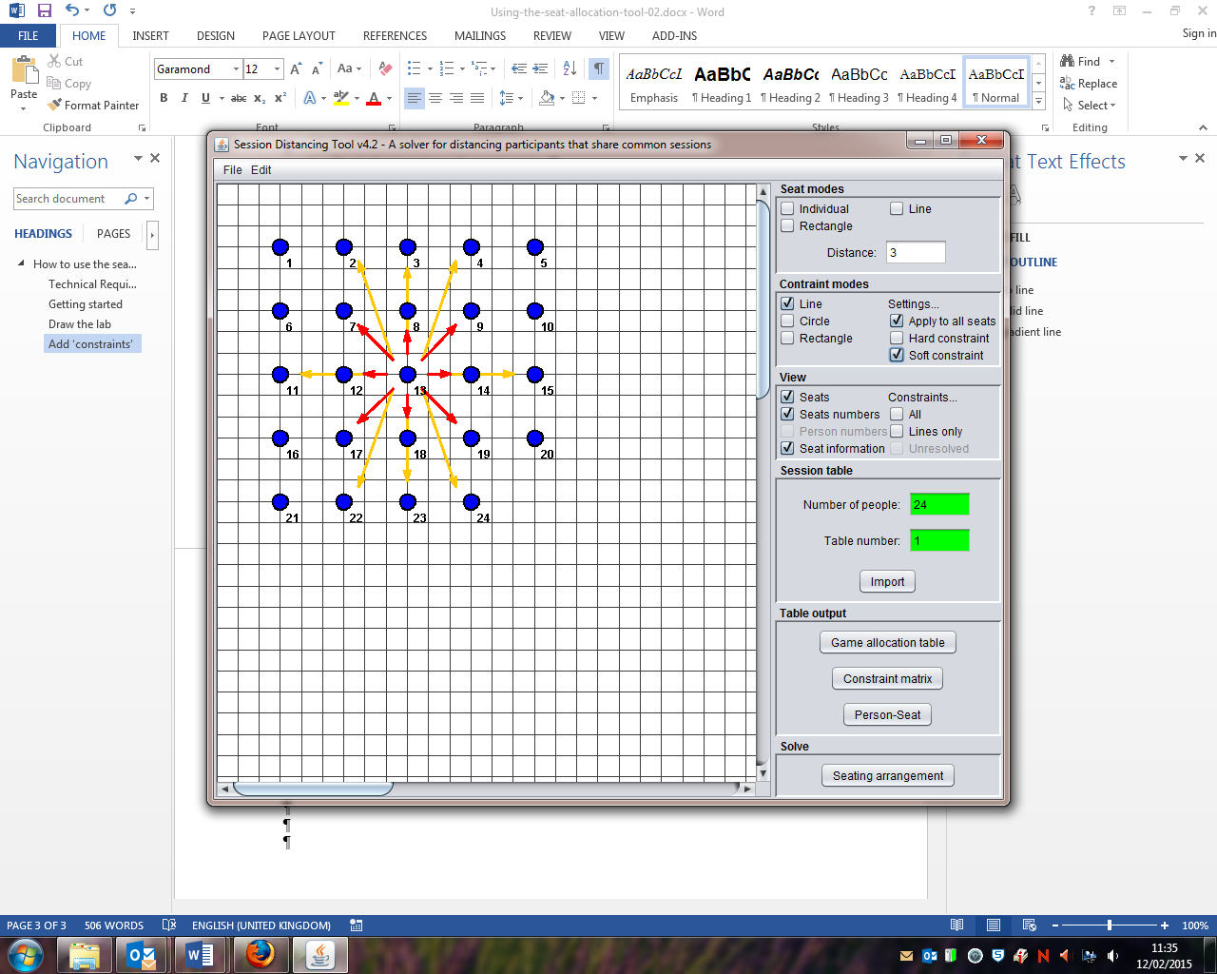

The more constraints you apply, the more difficult it is to find a solution. As removing constraints is an ‘all or nothing’ process – the edit option allows you to remove all constraints but not an individual one – you can loop between adding constraints and solving the seating arrangement (next step) to find the maximum number of constraints that can be used without any being violated.

Generating the seating allocation
Enter the number of players in the green box. The program automatically picks the largest even number based on the number of seats you have drawn but you can enter a lower one (18 in this example) if necessary. Leave ‘Table number’ set at 1.

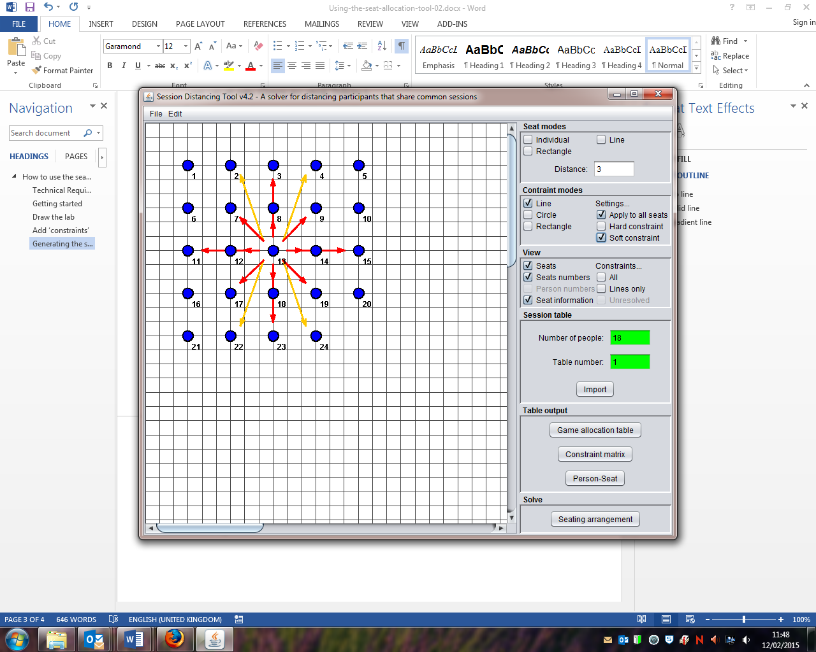
Click here to get the seating arrangement
Enter number of players here; leave table number as ‘1’
To generate the seating arrangement, click on the seating arrangement button. This brings up the dialog box shown below:

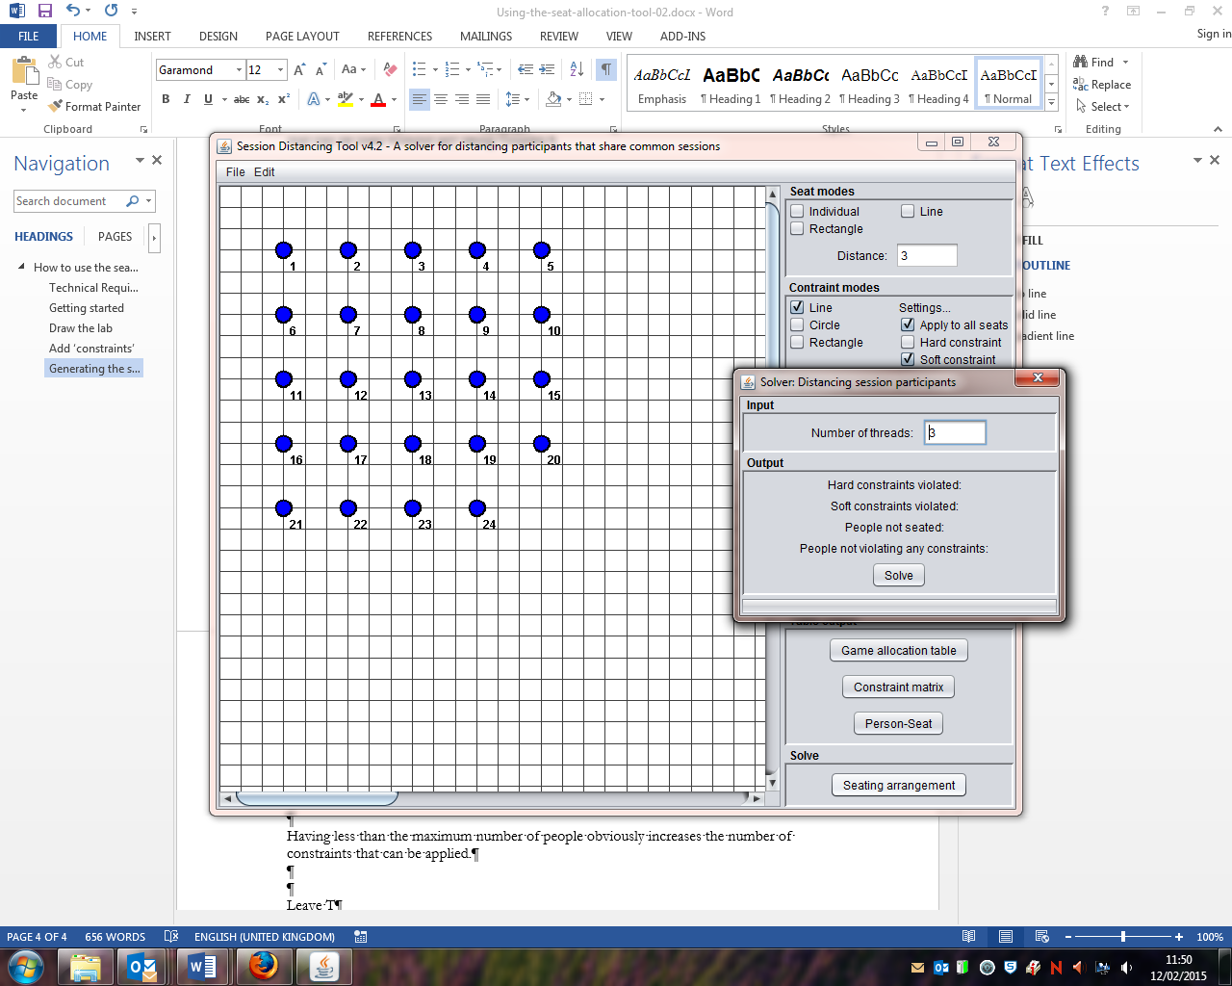
‘Number of threads’ refers to the amount of CPU power the programme will use. Increasing it means the programme will make more demands on your computer but solve the seating problem faster. Leaving it set to 3 seems to work fine in almost all circumstances.

Click on ‘Solve’ and then wait…

If the program is able to solve the seating arrangement and satisfy all constraints it will stop automatically. If the program cannot solve the seating arrangement completely you will be able to see how many constraints are violated and must then choose to stop the program yourself.

Viewing the seat allocations
It is possible to view the seat allocations on the lab layout. For example, hovering the mouse pointer over a particular seat/computer will show both the constraints for that seat and all the players linked to that seat. The colour coding shows the three different games any one player takes part in.

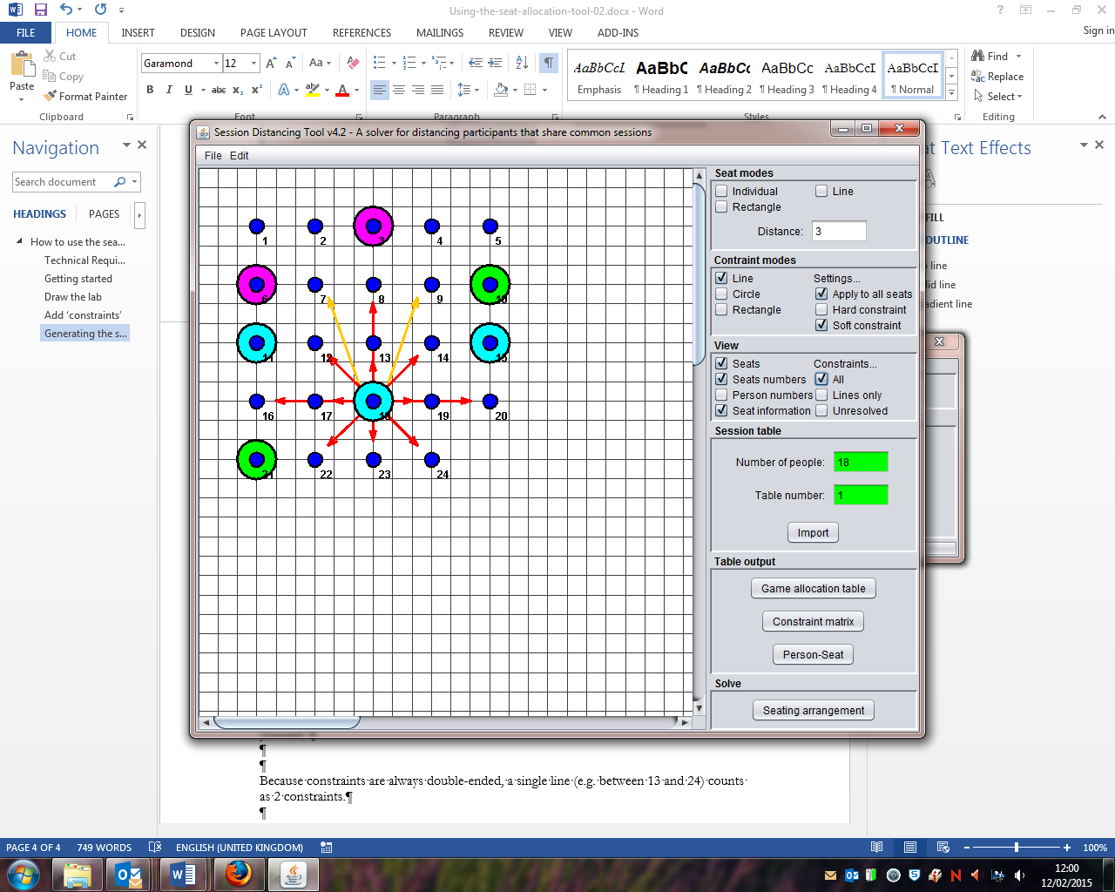
Click here to get a list of who should sit where.
Choose what to view on the grid here

There are two ways to see who sits where. One is to select ‘person numbers’ in the View options but a more useful way is to click on the ‘Person-Seat’ button. This opens a new window (see below) in which the seat and player numbers are listed in two columns. These can then be saved as a csv file or copied and pasted into a Word document or Spreadsheet.

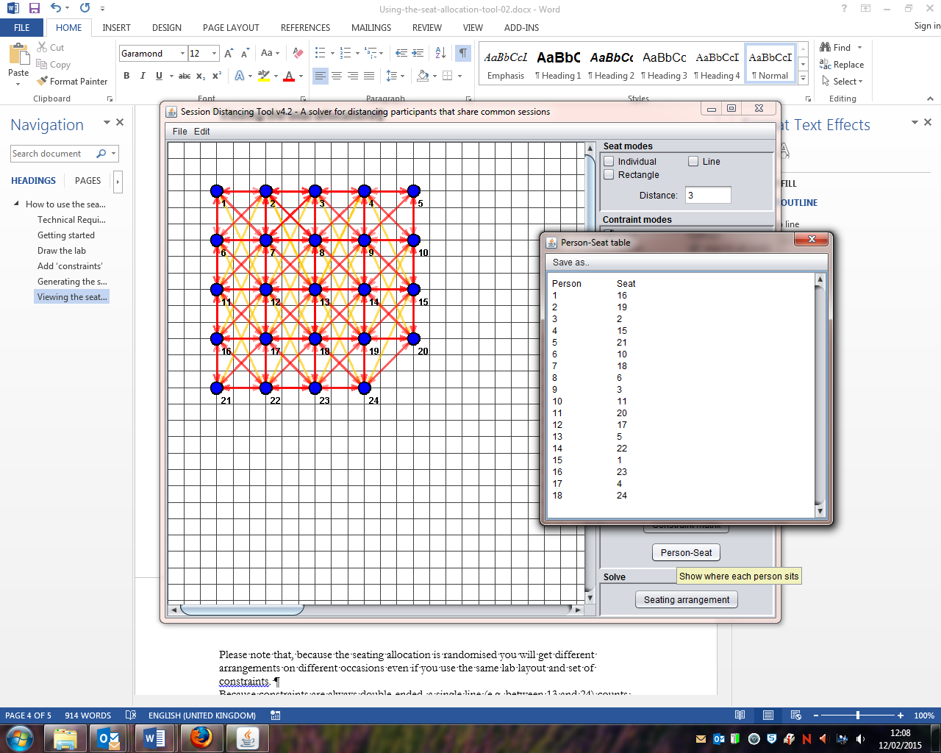
For the layout and constrains I used, the person-seat matrix was as shown on the left.
Please note that, because the seating allocation is randomised you will get different arrangements on different occasions even if you use the same lab layout and set of constraints.

Saving what you have done
The diagram, constraints and person-seat matrix can be saved by clicking on:

File > Save

You can also export the diagram as an image file if needed.

Using the Person-Seat Matrix
On the day of the Imitation Games, you need to do the following:

- Number the computers in the lab so that they match the arrangement in the diagram used to generate the person seat matrix
- Sort the logins according to the Player number (i.e. 1 through to 18 in this case)
- Make sure the right player (i.e. login) ends up at the right seat/computer.

This last part is actually the tricky. The two approaches are:

- Put the login details on the computers (e.g. login for Player 1 on Computer number 16, login for Player 2 on 19, 3 on 2 and so on) and make sure you sit the right kind of person at each computer; seems to work best for groups
- Hand out logins when players arrive and then guide them individually to the right computer (e.g. first ‘odd’ player gets login 1 and goes to computer 16; first ‘even’ players gets login 2 and goes to computer 19 etc); seems to work best for individuals as this is more sensitive to ‘no-shows’.

Contingency Planning
Once you have drawn the lab and set the constraints, creating the person-seat matrix is very easy. For this reason it is worth creating the person-matrix for all the people you expect to turn up and also for the next few even numbers down. This means that, if you do end up with 18 Players rather than 20 – more likely if you are playing games with individuals rather than groups – you have the seating allocation ready to go.

If you do find yourself having to hold on to login information until the number of players is confirmed, then it is useful to have somewhere that is not the computer lab where you can ‘hold’ people until you know how many have turned up. To avoid too much hanging around, you can use this time to give the introduction and briefing to participants. Once this is done, and final numbers confirmed, you can then take them to the lab and use whichever seating allocation is required.

