**Unit 10 Seminar**

**Title: DR Solutions Design and Review**

**Part A**  
The authors identified issues relating to expensive and time consuming migration of application and data to alternative providers (Opera-Martins et al., 2014). Other issues include vendors designing product architecture to be inoperable with other applications, inadequate industry standard to regulate interoperability and portability among providers, portability

Mitigation strategies as proposed by the authors are a careful review of contracts before signed – to identify grey areas, and potential ‘death traps’. Other mitigating strategies include incorporating standards of practice, use of open source applications, and identification of potential integration opportunities.

The use of cloud technology is gaining traction among large corporates and small businesses (Opera-Martins et al., 2014. This however has come with its unique challenges in addition to generic issues bedevilling the business environment. Morrow et al., (2019) highlight some concerns with the modern day cloud which include unauthorised exposure of data, responsibility/ownership, data compliance, flawed service contracts (often leading to vendor lock-in), and inadequate privacy policy.

Adoption of sufficient access control mechanism will aid in the mitigation of the concerns raised. Furthermore, adequate training, auditing, data encryption, and service level agreements need to be established. Cloud services users should constantly conduct vulnerability assessments, patching, detection and incidence response to mitigate against the concerns earlier raised.

**Part B**  
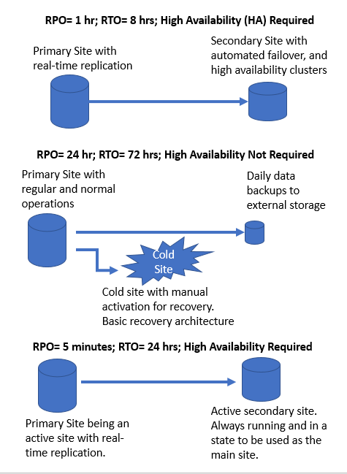

**Reference**

Morrow, T., LaPiana, V., Faatz, D., Hueca, A. and Richmond, N., 2019. Cloud security best practices derived from mission thread analysis.

Opara-Martins, J., Sahandi, R. and Tian, F., 2014. Critical review of vendor lock-in and its impact on adoption of cloud computing. International Conference on Information Society (i-Society 2014), London, UK, pp.92-97. doi: 10.1109/i-Society.2014.7009018.