**UML Modelling Tool**

1. **Abuse Case Diagram**

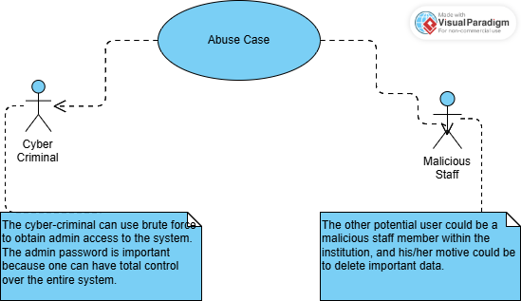

1. **Class Diagram**

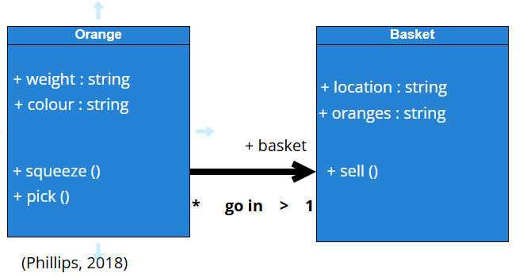

1. **Sequence Diagram**

