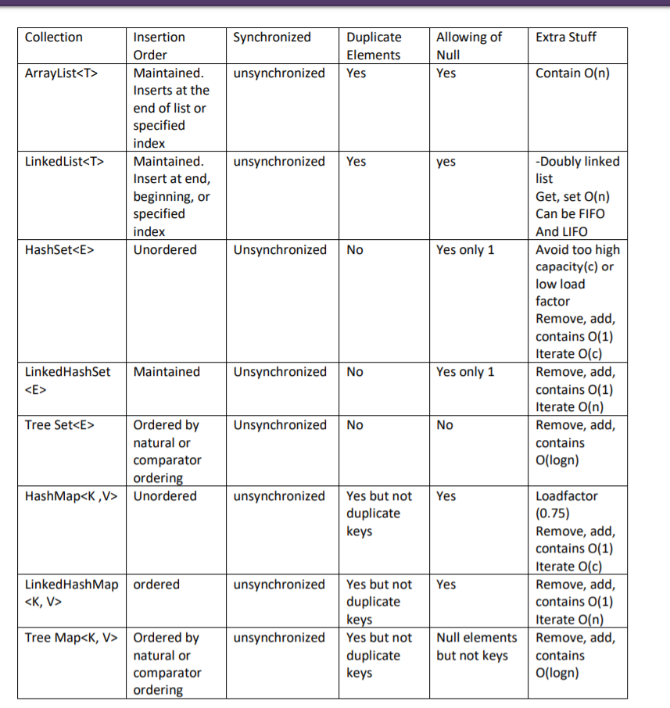

1. Hashmap can’t be sorted directly using comparable or comparator because HashMap is a key, value pair organized as a hash table and comparable and Comparator use a type parameter. To sort a map, use tree map which uses comparator or comparable.

2. The remove method in iterator is to safely remove elements in a collection while iterating through it. If you do that without iterator, it will throw a concurrent modification exception.

3. A HashSet is backed by a hash table (HashMap instance) which allows add, remove, contains, and size operations to be constant time.