Exercise1: Using a lot of constructor functions with the super element.

If input :(2,5) then Console:10

If input :1000

Then Console:30

OR:

**public** A (**int** c)

{

**this**.val=c;

}

OR:

**public** A(**int** a,**int** b)

{

**this**.val=a*b;

}

Class A:

**public** **int** val;

**public** A()

{

**this**.val=10;

}

**public** A (**int** c)

{

**this**.val=c;

}

**public** A(**int** a,**int** b)

{

**this**.val=a*b;

}

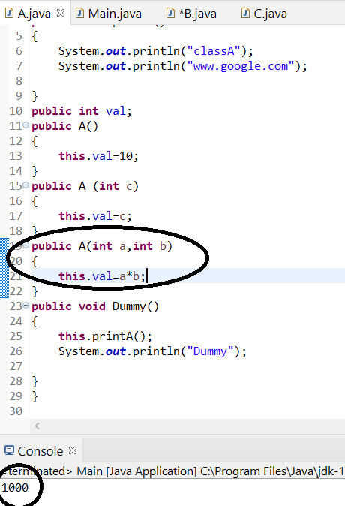

EX2:Using set and get with private.

**package** Two;

**public** **class** Pract1 {

**public** **static** **void** main(String[]args){

A1 n=**new** A1();

n.setval(77);

**int** y=n.getval();

System.***out***.println(y);

}

}

Console: 77

**package** Two;

**public** **class** A1 {

**private** **int** val;

**public** A1()

{

**this**.val=19;

}

**public** **void** setval(**int** k)

{

**this**.val=k;

}

**public** **int** getval()

{

**return** **this**.val;

}

}

-----------------------------------------------------------------------------------------------------------------------------

EX3: Application of the first part of the program(Simlecalc Class).

**package** Two;

**public** **class** Pract1 {

**public** **static** **void** main (String[] args)

{

Simlecalc calcadd= **new** Simlecalc(10,20);

**int** resultadd=calcadd.add();

System.***out***.println("The result Add is : "+resultadd);

Simlecalc calcsub=**new** Simlecalc(10,20);

**int** resultsub=calcsub.sub();

System.***out***.println("The result Sub is :"+resultsub);

}

}

Console:

The result Add is : 30

The result Sub is :-10

**package** Two;

**public** **class** Simlecalc {

**private** **int** x;

**private** **int** y;

**public** Simlecalc ()

{

**this**.x=0;

**this**.y=0;

}

**public** Simlecalc(**int** a, **int** b)

{

**this**.x=a;

**this**.y=b;

}

**public** **int** add()

{

**return** **this**.x+**this**.y;

}

**public** **int** sub ()

{

**return** **this**.x-**this**.y;

}

}

EX4: Application of the second part of the program(Simlecalc Class).

**package** Two;

**public** **class** Simlecalc {

**private** **int** x;

**private** **int** y;

**public** Simlecalc ()

{

**this**.x=0;

**this**.y=0;

}

**public** Simlecalc(**int** a, **int** b)

{

**this**.x=a;

**this**.y=b;

}

**public** **int** add()

{

**return** **this**.x+**this**.y;

}

**public** **int** sub ()

{

**return** **this**.x-**this**.y;

}

**public** **void** setx(**int** a) {

**this**.x=a;

}

**public** **void** sety(**int** a)

{

**this**.y=a;

}

**public** **int** getx()

{

**return** **this**.x;

}

**public** **int** gety()

{

**return** **this**.y;

}

}

**package** Two;

**public** **class** Pract1 {

**public** **static** **void** main (String[] args)

{

Simlecalc calcadd= **new** Simlecalc(10,20);

**int** resultadd=calcadd.add();

System.***out***.println("The result Add is : "+resultadd);

Simlecalc calcsub=**new** Simlecalc(10,20);

**int** resultsub=calcsub.sub();

System.***out***.println("The result Sub is :"+resultsub);

System.***out***.println("-----------------");

Simlecalc calca3=**new** Simlecalc();

calca3.setx(4);

calca3.sety(10);

**int** res3=calca3.add();

System.***out***.println("The Result is :"+res3);

System.***out***.println("-----------------");

calca3.setx(100);

calca3.sety(200);

System.***out***.println("The Result is :"+calca3.getx());

System.***out***.println("-----------------");

System.***out***.println("The Result is :"+calca3.gety());

}

}

**Console:**

The result Add is : 30

The result Sub is :-10

-----------------

The Result is :14

-----------------

The Result is :100

-----------------

The Result is :200

EX5: Application of the first part of the program(Anothercalca Class).

**package** Two;

**public** **class** Pract1 {

**public** **static** **void** main (String[] args)

{

Anothercal calca= **new** Anothercal(10,20);

**int** result=calca.add();

System.***out***.println(result);

calca.setx(100);

calca.sety(110);

result=calca.add();

System.***out***.println(result);

System.***out***.println(calca.getx());

System.***out***.println(calca.gety());

}

}

**package** Two;

**public** **class** Pract1 {

**public** **static** **void** main (String[] args)

{

Anothercal calca= **new** Anothercal(10,20);

**int** result=calca.add();

System.***out***.println(result);

calca.setx(100);

calca.sety(110);

result=calca.add();

System.***out***.println(result);

System.***out***.println(calca.getx());

System.***out***.println(calca.gety());

}

}

Console:

30

210

100

110

=====================================================================

EX6:using inherent with capsulate and encapsulate data inside the classes.

**package** Two;

**public** **class** Pract1 {

**public** **static** **void** main (String[] args)

{

Anothercal calca= **new** Anothercal(10,20);

**int** result=calca.add();

System.***out***.println(result);

result=calca.mul();

System.***out***.println(result);

result=calca.div();

System.***out***.println(result);

}

}

Console:

30

200

0

**package** Two;

**public** **class** Anothercal **extends** Simlecalc {

**public** Anothercal()

{

**super**();

}

**public** Anothercal (**int** a,**int** b)

{

**super**(a,b);

}

**public** **int** mul()

{

**return** **this**.getx()\***this**.gety();

}

**public** **int** div()

{

**int** y=**this**.gety();

**if**(y==0)

**return** 0;

**return** **this**.getx()/y;

}

}

EX7:Static method.

**package** Two;

**public** **class** A {

**public** **static** **int** Add(**int** a,**int** b)

{

**return** a+b;

}

**public** **static** **int** sub(**int** a,**int** b)

{

**return** a-b;

}

**public** **static** **int** mul(**int** a, **int** b)

{

**return** a*b;

}

**public** **static** **int** div(**int** a,**int** b)

{

**if** (b==0)

**return** 0;

**return** a/b;

}

}

**package** Two;

**public** **class** Pract1 {

**public** **static** **void** main (String[] args)

{

**int** result= A.*Add*(10,5);

System.***out***.println(result);

result=A.*sub*(12, 15);

System.***out***.println(result);

result=A.*mul*(100, 2);

System.***out***.println(result);

result=A.*div*(100, 5);

System.***out***.println(result);

}

}

Console:

15

-3

200

20

EX8: Overload application inside the classes.

**package** Two;

**public** **class** Overloading {

**public** **int** Add(**int** a, **int** b)

{

**return** a+b;

}

**public** **float** Add(**float** a,**float** b)

{

**return** a+b;

}

**public** **double** Add(**double** a,**double** b)

{

**return** a+b;

}

}

**package** Two;

**public** **class** Pract1 {

**public** **static** **void** main (String[] args)

{

Overloading m=**new** Overloading();

**int** R=m.Add(10, 90);

System.***out***.println("The Result of int input is:"+R);

**float** k=m.Add(1.5f, 3.5f);

System.***out***.println("The Result of int input is:"+k);

**double** DF=m.Add(77, 33);

System.***out***.println("The Result of int input is:"+DF);

}

}

Console:

The Result of int input is:100

The Result of int input is:5.0

The Result of int input is:110.0