# COVID 19 DETECTION USING CHEST X-RAY IMAGE

A PROJECT REPORT

*submitted by*

## ABDUL VASITH C (VDA18CS001)

## IHAB MUHAMMED IBRAHIM (VDA18CS019)

## MELBIN JACOB THOMAS (VDA18CS025)

## SUVIN KRISHNA R (VDA18CS043)

*to*

*the APJ Abdul Kalam Technological University*

*in partial fulfillment of the requirements for the award of the degree of*

Bachelor of Technology in

COMPUTER SCIENCE AND ENGINEERING



## DEPARTMENT OF COMPUTER SCIENCE AND ENGINEERING

COLLEGE OF ENGINEERING VADAKARA VADAKARA, KERALA - 673105

DECEMBER 2021

# DECLARATION

We undersigned hereby declare that the project report **“COVID 19 DETECTION USING CHEST X-RAY IMAGES”**, submitted for partial fulfillment of the requirements for the award of degree of Bachelor of Technology of the APJ Abdul Kalam Technological University, Kerala is a bonafide work done by me under supervision of **Mrs. DEEPTHI K**, Assistant Professor, Department of Computer Science and Engineering. This submission represents my ideas in my own words and where ideas or words of others have been included, I have adequately and accurately cited and referenced the original sources. I also declare that I have adhered to ethics of academic honesty and integrity and have not misrepresented or fabricated any data or idea or fact or source in my submission. I understand that any violation of the above will be a cause for disciplinary action by the institute or the University and can also evoke penal action from the sources which have thus not been properly cited or from whom proper permission has not been obtained. This report has not been previously formed the basis for the award of any degree, diploma or similar title of any other University.

ABDUL VASITH C VDA18CS001

IHAB MUHAMMED IBRAHIM VDA18CS019

MELBIN JACOB THOMAS VDA18CS025

Place: Vadakara

SUVIN KRISHNA R VDA18CS043

## DEPARTMENT OF COMPUTER SCIENCE AND ENGINEERING

**COLLEGE OF ENGINEERING VADAKARA**



**CERTIFICATE**

This is to certify that the report entitled **"COVID 19 DETECTION USING CHEST X-RAY IMAGE"** submitted by **ABDUL VASITH C (VDA18CS001), IHAB MUHAMMED IBRAHIM (VDA18CS019), MELBIN JACOB THOMAS (VDA 18CS025)** and **SUVIN KRISHNA R (VDA18CS043)** to the APJ Abdul Kalam Technological University in partial fulfillment of the requirements for the award of the Degree of Bachelor of Technology in Computer Science & Engineering is a bonafide record of the project work carried out by them under our guidance and supervision. This report in any form has not been submitted to any other University or Institute for any purpose.

### DEEPTHI K

Project Guide Professor & HOD

Dept. of Computer Science & Engineering

College of Engineering Vadakara

**DEEPTHI K**

Professor & HOD

Dept. of Computer Science & Engineering

College of Engineering Vadakara

Place: Vadakara

# ACKNOWLEDGEMENTS

We express our deep sense of gratitude to Dr. O A JOSEPH, Principal, College of Engineering, Vadakara and Mrs. DEEPTHI K, Head of the Department of Computer Science and Engineering for providing us with the guidance and facilities for the project. We extend our sincere thanks to Mrs. DEEPTHI K, Professor, Department of Computer Science and Engineering for the valuable guidance, constant encouragement and creative suggestions offered during this project and also in preparing this report. We express our sincere gratitude to the project coordinator Mrs. ANUPAMA, Assistant Professor, Department of Information Technology and Engineering for her valuable advice and guidance. We wish to express our gratitude towards her flexibility of project schedule. We also extend our sincere thanks to all other faculty members of Computer Science and Engineering Department for their co-operation, support and presence. We convey our heartfelt thanks to all my friends for their sincere suggestions and timely help. Nothing can be understood as simply as when a friend explains it. And it all seems possible if you have sincere friends. Next, we take this opportunity to express our gratitude towards our parents for their support and encouragement. Above all We thank GOD, the almighty for his grace without which it would not have been possible to complete this work in time

# ABSTRACT

The automatic identification and diagnosis of tomato leaves diseases are highly de- sired in field of agriculture information. Recently Artificial Neural networks (ANN) has made tremendous advances in many fields, close to computer vision such as clas- sification, object detection, segmentation, achieving better accuracy than humanlevel perception. In spite of its tremendous advances in computer vision tasks, ANN face many challenges, such as computational burden and energy, to be used in mobile phone and embedded systems. In this study, we propose an efficient smart mobile application model based on deep ANN to recognize plant leaf diseases. To build such application, can recognize the 3 types of plants; tomato,black pepper and maize. Trained on plant leafs dataset, to build our application 300 defective and 100 healthy images of tomato leaves,100 defective and 100 healthy images of black papper and 100 of healthy and 300 defective and 100 healthy images of maize are used in the smart mobile system, to perform a Tomato disease diagnostics

|  |  |
| --- | --- |
| **CONTENTS** |  |
| **ACKNOWLEDGEMENTS** | **i** |
| **ABSTRACT** | **ii** |
| **LIST OF FIGURES** | **v** |
| **1 INTRODUCTION** | **1** |
| 1.1 OBJECTIVE . . . . . . . . . . . . . . . . . . . . . . . . . . . . . | 1 |
| 1.2 MOTIVATION . . . . . . . . . . . . . . . . . . . . . . . . . . . . | 1 |
| 1.3 BASIC CONCEPTS . . . . . . . . . . . . . . . . . . . . . . . . . | 2 |
| 1.3.1 Artificial Intelligence . . . . . . . . . . . . . . . . . . . . | 2 |
| 1.3.2 Android . . . . . . . . . . . . . . . . . . . . . . . . . . . . | 3 |
| **2 LITERATURE SURVEY** | **4** |
| **3 Problem Definition** | **14** |
| **4 System Design** | **15** |
| 4.1 Feasibility Study . . . . . . . . . . . . . . . . . . . . . . . . . . . | 15 |
| 4.1.1 Economic Feasibility . . . . . . . . . . . . . . . . . . . . . | 15 |
| 4.1.2 Technical Feasibility . . . . . . . . . . . . . . . . . . . . . | 15 |
| 4.1.3 Operational Feasibility . . . . . . . . . . . . . . . . . . . . | 15 |
| 4.2 System Configuration . . . . . . . . . . . . . . . . . . . . . . . . . | 16 |
| 4.2.1 Hardware Requirements . . . . . . . . . . . . . . . . . . . | 16 |
| 4.2.2 SOFTWARE REQUIREMENTS . . . . . . . . . . . . . . . | 16 |
| 4.3 Software discription . . . . . . . . . . . . . . . . . . . . . . . . . . | 18 |
| 4.3.1 Android application . . . . . . . . . . . . . . . . . . . . . | 18 |
| 4.3.2 Machine learning algorithm . . . . . . . . . . . . . . . . . | 19 |
| 4.4 DIAGRAMS . . . . . . . . . . . . . . . . . . . . . . . . . . . . . | 20 |
| 4.4.1 ARCHITECTURE DIAGRAM . . . . . . . . . . . . . . . | 20 |

4.4.2 DATA FLOW DIAGRAMS . . . . . . . . . . . . . . . . . 20

4.5 Module description . . . . . . . . . . . . . . . . . . . . . . . . . . 21

1. Formulation of work plan 26
2. CONCLUSION 27
3. REFERENCES 29

# LIST OF FIGURES

4.1 Android Studio . . . . . . . . . . . . . . . . . . . . . . . . . . . . 17

4.2 Spyder . . . . . . . . . . . . . . . . . . . . . . . . . . . . . . . . . 18

4.3 program . . . . . . . . . . . . . . . . . . . . . . . . . . . . . . . . 18

4.4 Architecture diagram . . . . . . . . . . . . . . . . . . . . . . . . . 20

4.5 Data Flow Diagram 1 . . . . . . . . . . . . . . . . . . . . . . . . . 20

4.6 Home page . . . . . . . . . . . . . . . . . . . . . . . . . . . . . . 21

4.7 plant selection . . . . . . . . . . . . . . . . . . . . . . . . . . . . . 22

4.8 Image capturing . . . . . . . . . . . . . . . . . . . . . . . . . . . . 22

4.9 Result and remedy . . . . . . . . . . . . . . . . . . . . . . . . . . 23

5.1 Work plan . . . . . . . . . . . . . . . . . . . . . . . . . . . . . . . 26

# CHAPTER 1

**INTRODUCTION**

* 1. **OBJECTIVE**

We are try to develop a software to detect disease in plant leaf using image processing. This is a new approach to solve the issues in farming sector and It will overcome the existing issues in leaf disease detection. Our client side is an mobile application to take pictures of damaged leaf parts and display the results including the remedy required. In server side we use machine learning algorithm to detect the leaf is defective or not, if it defective identifies the type of disease. We are using a cloud platform to connect these two.

# MOTIVATION

Agricultural products are the primary need for every country. If plants are infected by diseases, this impacts the country’s agricultural production and its economic resources. With the development of modern ecological agriculture, more attention has been paid to crop yield and quality. The incidence of crops has increased year by year, and the types of diseases have become more and more complicated. More importantly, automatic monitoring and processing of diseases cannot be achieved. Therefore, it is particularly important to study more stable and efficient methods for the prevention and diagnosis of crop diseases. Based on our survey, we found that the disease on the leaf side further affects the production. So we decided to develop a software to detect disease in plant leaf easily.

# BASIC CONCEPTS

## Artificial Intelligence

Artificial intelligence (AI), is intelligence demonstrated by machines, unlike the natural intelligence displayed by humans and animals.the term "artificial intelligence" is often used to describe machines that mimic "cognitive" functions that humans associate with the human mind, such as "learning" and "problem solving". cessing

* + - 1. Image processing

Digital image processing is the use of a digital computer to process digital images through an algorithm.As a subcategory or field of digital signal processing, digital image processing has many advantages over analog image processing. It allows a much wider range of algorithms to be applied to the input data and can avoid problems such as the build-up of noise and distortion during processing. Steps involved in image processing are

* + - * 1. Image Acquisition. The image is captured by a sensor 2.Image Enhancement

3.Image Restoration. 4.Colour Image processing 5.Wavelets

6.Compression

1. Morphological Processing.
2. Image Segmentation.

Some of the important applications of image processing in the field of science and technology include computer vision, remote sensing, feature extraction, face de- tection, forecasting, optical character recognition, finger-print detection, optical sorting, argument reality, microscope imaging, lane departure caution etc.

* + - * 1. ANN

Artificial neural networks (ANNs), usually simply called neural networks (NNs), are computing systems vaguely inspired by the biological neural networks that constitute animal brains.Each connection, like the synapses in a biological brain, can transmit a signal to other neurons. An artificial neuron that receives a sig- nal then processes it and can signal neurons connected to it. The "signal" at a connection is a real number, and the output of each neuron is computed by some non-linear function of the sum of its inputs. The connections are called edges. Neurons and edges typically have a weight that adjusts as learning proceeds. The weight increases or decreases the strength of the signal at a connection. Neurons may have a threshold such that a signal is sent only if the aggregate signal crosses that threshold. Typically, neurons are aggregated into layers. Different layers may perform different transformations on their inputs. Signals travel from the first layer to the last layer possibly after traversing the layers multiple times.

## Android

Android is a mobile operating system based on a modified version of the Linux ker- nel and other open source software, designed primarily for touchscreen mobile devices such as smartphones and tablets. Android is developed by a consortium of developers known as the Open Handset Alliance and commercially sponsored by Google.It is free and open source software; its source code is known as Android Open Source Project (AOSP), which is primarily licensed under the Apache License. However most An- droid devices ship with additional proprietary software pre-installed.The source code has been used to develop variants of Android on a range of other electronics, such as game consoles, digital cameras, portable media players, PCs and others, each with a specialized user interface. Some well known derivatives include Android TV for tele- visions and Wear OS for wearables, both developed by Google.

# CHAPTER 2

**LITERATURE SURVEY**

### DCGAN-Based Data Augmentation for Tomato Leaf Disease Identification

*Year: 2020 | volume: 7 | journal article | publisher: IEEE*

This work introduces identification of tomato leaf disease using a new algorithm DC- GAN based augmentation. In this paper deep learning network is applied to identify the type of disease. And by using DCGAN network data augmentation for manually collected data set is done. They also uses AlexNet, GoogLeNet,VGG16Net and ResNet for the disease identification purpose. Here they tested 1500 of tomato leaf and it was collected from plant village project. There are 5 categories of leaf images for testing and training which are healthy ,tomato late blight water mold, tomato septoria leaf fun- gus, tomato target spot bacteria and tomato YLCV virus. The main process of tomato leaf disease identification are DCGAN augmentation for training and GoogLeNet for identification.Giving the accuracy of 94.33 compared to GAN network.

### Real-Time Detection of Apple Leaf Diseases Using Deep Learning Approach Based on Improved Convolutional Neural Networks

*Year: 2019 | Journal | Publisher: IEEE*

This paper proposes a deep learning approach that is based on improved convolutional neural networks (CNNs) for the real-time detection of apple leaf diseases. The model is trained to detect these five common apple leaf diseases which are Alternaria leaf spot, Brown spot, Mosaic, Grey spot, and Rust. Here the dataset is composed of laboratory images and complex images under real field conditions.it consists of about 26377 im- ages of diseased apple leaves. It is constructed via an data augmentation and image annotation technologies. Here the model using deep CNNs is proposed by introducing thr GoogLeNet Inception structure and Rainbow concatenation. And it have detection performance of 78.80 % with a detection speed of 23.13 FPS

### Bacterial foraging optimization based Radial Basis Function Neural Network for identification and classification of plant leaf diseases

*Year: 2017 | Journal | Publisher: IEE*

In this paper they have introduced a method named as Bacterial foraging optimization based Radial Basis Function Neural Network (BRBFNN) for identification and classi- fication of plant leaf diseases automatically. For assigning weight to RBFNN THEY USED Bacterial foraging optimization . it increases the speed and accuracy of the net- work. The dataset consists of 270 images for a particular disease, collected from crow- dAI.org . It worked on fungal diseases like common rust, cedar apple rust, late blight, leaf curl, leaf spot, and early blight. The project methodologies involves image input, pre-processing of image , feature extraction, optimization nd training of RBFNN using BFO, evaluation using RNFNN and segmented image. The proposed work consists of Regional growing algorithm for feature extraction, Bacterial foraging for training the network and Radial basis function neural network.

### Early Disease Classification of Mango Leaves Using Feed-Forward Neural Net- work and Hybrid Metaheuristic Feature Selection

*Year:2020 | Journal | Publisher: IEE*

In this research they are detecting early disease on plant leaves with small disease blobs, which can only be detected with higher resolution images, by ANN. After a pre-processing step using a contrast enhancement method, all the infested blobs are segmented for the whole dataset. A list of features are chosen by using feature selection algorithm. This features is used for inputting ANN. The dataset contains 450 images of mango leaves which belongs to 4 different types , 3 disease and 1 healthy. Anthracnose, Gall Midge and Powdery Mildew are the set of diseases. Here they a particular cham- ber for taking images of leaves. They also described CNN and Alexanet architecture for disease detection. It includes each level of comparison among these architecture. They considered 100 above feature for the accuracy and got 77.16% training accuracy and 76.74 % of testing accuracy..

### Image processing-based intelligent robotic system for assistance of agricultural crops

*Year: 2019 | Journal*

Nikhil Paliwal; Pankhuri Vanjani; Jing-Wei Liu; Sandeep Saini; Abhishek Sharma In- ternational Journal of Social and Humanistic Computing (IJSHC), Vol. 3, doi.org /10. 1504/IJSHC.2019.101602 In this paper propose improved algorithms for infection de- tection in leaves and field classification targeting a heterogeneous robotic system. Im- age processing methods was used to calculate the infection percentage in crops and machine learning algorithm k-means clustering for classifying the field. They used dif- ferent types of crops for disease identification. There 3,150 images of crop diseases for three different types of disease of crops maize ,black pepper and tomato. The primary objective of this paper includes the qualitative analysis of infection detection algorithms and further elaboration for the possible application of the suggested work in smart farm- ing.

### Smart mobile application to recognize tomato leaf diseases using Convolutional Neural Networks

*IEEE/ICCSRE2019, 22-24 July, 2019, Agadir, Morocco* In this paper they propose an efficient smart mobile application model based on deep CNN to recognize tomato leaf diseases.The existing leaf plant diseases detection methods rely on the use of computer with power of calculation. But these methods is unable to be used in mobile with minimum resources of calculation, So they used quantized CNN Models for disease identification with limited resources ,that speed up the process. They use 7176 images of tomato leaves for training the modal and it identify 10 most common types of tomato leaf diseases which are Bacterial Spot Xanthomonas campestris, Early Blight Alternaria solani, Late Blight Phytophthora infestans, Leaf Mold Passalora fulva, Septoria Leaf Spot Septoria lycopersici, Two Spotted Spider Mite Tetranychus urticae, Target Spot Corynespora cassiicola, Mosaic Virus, Yellow Leaf Curl Virus.They use MobileNet CNN architecture.and their adapted CNN Model have tested with many optimization algorithms such as Stocastic gradient descent, adadelta optimizer, adagrad, adagradda, Momentum, Adam, Ftrl, proximaladagrad and rmsprop optimizers.

### Identification of Plant Disease using Image Processing Technique

*International Conference on Communication and Signal Processing, April 4-6, 2019, India* The aim of their project is to develop a software that mechanically find and clas- sify plant diseases. The plant’s leaves photos are used for detecting diseases. They use image process technique. k-means cluster methodology is used for image segmentation

, GLCM is used to extracting the feature and random forest algorithm used for coaching. They use MATLAB for image processing. Here they clearly explained the steps needed for image processing which are Image Acquisition, image pre-processing, image seg- mentation and classification. And they classified the disease in to 3 categories bacterial, viral and fungal related. They identify diseases like Alternaria Alternata, Anthracnose, Bacterial Blight and Cercospora Leaf Spot.

### A Tomato Leaf Diseases Classification Method Based on Deep Learning

*2020 Chinese Control And Decision Conference (CCDC 2020)*

In this paper, a classification method of tomato leaf diseases based on deep learning was introduced to identify and classify common tomato leaf diseases. Tomato leaves were taken as the experimental object, and Resnet-50 residual network was adopted as the basic model, and Resnet-50 residual network was adopted as the basic model. Dis- ease position was extracted by convolutional layers and classification determined after iterative learning. Leaky-ReLU activation function and the larger 11×11 convolution kernel size were used to modify the network. The common diseases Spot blight, Late blight and Yellow leaf curl. Based on the improved Resnet-50 model, 6794 leaf images of 3 different diseases were selected and prepared for batch learning and training. After about 24 epochs, the recognition accuracy of the 3 diseases reached 98.3% in training set and 98.0% in test set, respectively.

### Plant Leaf Diseases Detection and classification Using Image Processing and Deep Learning Techniques

*2020 International Conference on Computer Science and Software Engineering (CSASE), Duhok, Kurdistan Region – Iraq* This paper presents a system that is used to classify

and detect plant leaf diseases using deep learning techniques. In their system they used convolutional neural network. They examine tomatoes, pepper, and potatoes leafs. The Data Set contains 20636 images of plants and images were obtained from (Plant Vil- lage dataset) website. 15 classes they were classified. 12 classes for diseases of different plants that were detected, such as bacteria, fungi, etc., and 3 classes for healthy leaves. And they got an accuracy of (98.29%) for training, and (98.029%) for testing for all data set that were used. The proposed system consists of several steps. Which are image ac- quisition, image pre processing, CNN structural design, training, testing and detection of plant leaf disease. They clearly explained the layer used in CNN. Which includes input layer, convolution layer, pooling layer, Non-Linear Layer, fully connected layer, normalize layer and softmax Layer.

### Identification of Maize Leaf Diseases Using Improved Deep Convolutional Neural Networks

*Received May 2, 2018, accepted May 29, 2018, date of publication June 6, 2018, date*

*of current version June 26, 2018.*

*Digital Object Identifier 10.1109/ACCESS.2018.2844405* This paper describes iden- tification of maize leaf diseases using improved deep convolutional neural network. To improve the identification accuracy of maize leaf diseases and reduce the number of net- work parameters, the improved GoogLeNet and Cifar10 models based on deep learning are proposed for leaf disease recognition in this paper. Two improved models that are used to train and test nine kinds of maize leaf images are obtained by adjusting the pa- rameters, changing the pooling combinations, adding dropout operations and rectified linear unit functions, and reducing the number of classifiers. . In addition, the num- ber of parameters of the improved models is significantly smaller than that of the VGG and AlexNet structures. During the recognition of eight kinds of maize leaf diseases, the GoogLeNet model achieves a top - 1 average identification accuracy of 98.9%, and the Cifar10 model achieves an average accuracy of 98.8%. The improved methods are possibly improved the accuracy of maize leaf disease, and reduced the convergence iterations, which can effectively improve the model training and recognition efficiency.

### Survey of Plant Disease Detection Using Image Classification Techniques

*2020 8th International Conference on Reliability, Infocom Technologies and Optimiza- tion (Trends and Future Directions) (ICRITO)Amity University, Noida, India. June 4-5, 2020*

This paper presents an overview of various kinds of plant disease and different machine learning algorithms applied in farming fields for malady identifying. They pointing purpose of disease analysis such as detecting leaf, stem, and fruit diseases, Quantify af- fected area, Find the reason of affected area, Determine the colour of the affected area, determine size and shape of fruits. They describe fungal, bacterial, viral diseases symp- toms. There 5 steps of images processing are Acquisition of image , Pre-processing of image , Segmentation of image ,Feature extraction from image ,Disease identification in image .They reviewed many literature and briefly explain the methods use in it ,and they concluded that deep learning algorithm provides the best possible results while using less computational efforts and requires less amount time for the prediction. Also conclude Digital image processing provides more effective, faster and cheaper results then manual analysis of the plants for the purpose of disease detection.

### An Investigation Into Machine Learning Regression Techniques for the Leaf Rust Disease Detection Using Hyperspectral Measurement

*IEEE JOURNAL OF SELECTED TOPICS IN APPLIED EARTH OBSERVATIONS AND*

*REMOTE SENSING Davoud Ashourloo, Hossein Aghighi, Ali Akbar Matkan, Moham- mad Reza Mobasheri, and Amir Moeini Rad*

This paper investigated on using partial least square regression (PLSR), support vec- tor regression (-SVR), and Gaussian process regression (GPR) methods for wheat leaf rust disease detection, evaluating the impact of training sample size on the results, the influence of disease symptoms effects on the predictions performances of the above- mentioned methods, and comparisons between the performances of SVIs and machine learning techniques. In this study, the spectra of the infected and non infected leaves in different disease symptoms were measured using a non imaging spectroradiometer in the electromagnetic region of 350 to 2500 nm. In order to produce a ground truth dataset, they employed photos of a digital camera to compute the disease severity and

disease symptoms fractions. Then, different sample sizes of collected datasets were uti- lized to train each method.To conduct this work, the spectral dataset from healthy and inoculated wheat leaves was collected at the leaf and canopy scales. Moreover, a series of RGB digital photos from all infected leaves were collected. These datasets were uti- lized to study the potential of GPR, SVR, and PLSR in disease detection. Each of these methods is trained with 25, 50, 75 100, 125, and 150 samples, at the leaf and canopy scales and their corresponding test samples were used to evaluate the performance of each approach.

### Detection and Classification of Disease Affected Region of Plant Leaves using Im- age Processing Technique

*Indian Journal of Science and Technology, Vol 9(48), DOI: 10.17485/ijst/2016/v9i48/ 104765, December 2016,Iqbaldeep Kaur*, Gifty Aggarwal and Amit Verma*

In this paper the image processing technique is presented for plant leaf disease detection and classification. Here, image acquisition is performed by considering RGB colour based disease affected leaf image. Histogram Equalization is used to further enhance the image contrast. K-means clustering is used to divide the image into parts. Image feature extraction is performed to extract the features of leaf disease symptoms. Support Vector Machine is used for the leaf disease detection and classification and finally ant colony optimization is applied for the optimization of concept. In this proposed approach, major disease detection, classification and optimization is performed by SVM and ACO. Support Vector Machine is statistical learning concept used as the classification and regression models. Ant Colony Optimization is swarm intelligence based concept well known for the local and global best optimized search solution. Here, they considered ACO approach to optimize the solution upto the maximum possible iterations for plant leaf disease detection.

### Multi-Organ Plant Classification based on Convolutional and Recurrent Neural networks

*Sue Han Lee, Student Member, IEEE, Chee Seng Chan, Senior Member, IEEE, and Paolo Remagnino, Senior Member, IEEE, DOI 10.1109/TIP.2018.2836321, IEEE Trans-*

*actions on Image Processing* In this approach, they introduce a hybrid generic organ convolutional neural network (HGO-CNN), which takes into account both organ and generic information, combining them using a new feature fusion scheme for species classification. Next, instead of using a CNN based method to operate on one image with a single organ, they extend our approach. Propose a new framework for plant structural learning using the recurrent neural network (RNN) based method. This novel approach supports classification based on a varying number of plant views, capturing one or more organs of a plant, by optimizing the contextual dependencies between them. They also present the qualitative results of our proposed models, based on fea- ture visualization techniques and show that the outcomes of visualizations depict our hypothesis and expectation. Finally, they show that by leveraging and combining the aforementioned techniques.

### Semi-automatic leaf disease detection and classification system for soybean culture

*IET Image Process., 2018, Vol. 12 Iss. 6, pp. 1038-1048,Sukhvir Kaur , Shreelekha Pandey , Shivani Goel,The Institution of Engineering and Technology 2018* This sys- tem is a rule based semi-automatic system using concepts of k-means is designed and implemented to distinguish healthy leaves from diseased leaves. In addition, a diseased leaf is classified into one of the three categories (downy mildew, frog eye, and Septoria leaf blight). Experiments are performed by separately utilizing color features, texture features, and their combinations to train three models based on support vector machine classifier. Results are generated using thousands of images collected from Plant Village dataset. Acceptable average accuracy values are reported for all the considered combi- nations which are also found to be better than existing ones. This study also attempts to discover the best performing feature set for leaf disease detection in Soybean. The system is shown to efficiently compute the disease severity as well. Visual examina- tion of leaf samples further proves the suitability of the proposed system for detection, classification, and severity calculation.

### Review of image processing approaches for detecting plant diseases

*IET Image Process., 2020, Vol. 14 Iss. 8, pp. 1427-1439,The Institution of Engineering and Technology 2019,Aditya Sinha1 , Rajveer Singh Shekhawat* In this study, a sum-

mary of prevalent techniques and methodologies used for the detection, quantification and classification of diseases is presented to understand the scope of improvement. The study pays attention to critical gaps that exist in available approaches and enhance them for the early prediction of diseases. Diseases affect almost all parts of plants, e.g. root, stem, flower, leaf; a manifestation in different ways for different parts of the plant of the same disease presents a challenge for researchers. This study extends the review work published by JGA Barbedo in 2013, as there have been significant advances and numerous new techniques introduced since then. A novel approach of classifying and categorisation of the existing techniques based on pathogen types is a significant con- tribution by the authors in this study.

### Plant Leaf Disease Detection and Classification Based on CNN with LVQ Algo- rithm

*M. Sardogan, A. Tuncer and Y. Ozen, "Plant Leaf Disease Detection and Classification Based on CNN with LVQ Algorithm," 2018 3rd International Conference on Computer Science and Engineering (UBMK), Sarajevo, 2018,pp. 382-385, doi: 10.1109*

This paper presents a Convolutional Neural Network (CNN) model and Learning Vec- tor Quantization (LVQ) algorithm based method for tomato leaf disease detection and classification. The dataset contains 500 images of tomato leaves with four symptoms of diseases.They have modeled a CNN for automatic feature extraction and classification. Color information is actively used for plant leaf disease researches. In our model, the filters are applied to three channels based on RGB components. The LVQ has been fed with the output feature vector of convolution part for training the network. The exper- imental results validate that the proposed method effectively recognizes four different types of tomato leaf diseases.

### Detection of unhealthy region of plant leaves using image processing and genetic algorithm

*V. Singh, Varsha and A. K. Misra, "Detection of unhealthy region of plant leaves using image processing and genetic algorithm," 2015 International Conference on Advances in Computer Engineering and Applications, Ghaziabad, 2015, pp. 1028-1032, doi:*

*10.1109/ICACEA.2015.7164858.*

This paper presents an algorithm for image segmentation technique used for automatic detection as well as classification of plant leaf diseases and survey on different diseases classification techniques that can be used for plant leaf disease detection. Image seg- mentation, which is an important aspect for disease detection in plant leaf disease, is done by using genetic algorithm.

# CHAPTER 3

**Problem Definition**

Our farmers face many problems in their field, mainly for detecting and treating plant diseases. To identify the plant diseases at an untimely phase is not yet explored. The main challenge is to reduce the usage of pesticides in the agricultural field and to in- crease the quality and quantity of the production rate. So we decided to develop a mobile application to identify leaf disease and its solution . The farmer is to select a particular diseased plant leaf and is sent for processing .This paper intends to study about the prediction of the plant leaf diseases, here we use artificial neural network (ANN) algorithm. Specifically, we concentrate on predicting the disease such as early blight , late blight and bacterial spot on tomato leaves, bacterial disease in black pep- per and cercospora leaf spot, rust and blight disease in maize. It would be useful for identifying different diseases in leaf.

# CHAPTER 4

**System Design**

* 1. **Feasibility Study**

This project investigated the feasibility of constructing a plant leaf disease identification software. The subject of the study was an examination of the possibilities for improv- ing the existing disease identification system, reducing costs, increasing efficiency and improving the accuracy. study so that the proposed system is useful for farmers. The feasibility study concentrates on the following, such as Operational Feasibility, Techni- cal Feasibility, Economic Feasibility.

## Economic Feasibility

The economic feasibility study evaluate the cost software development against the ulti- mate income or benefits get from the developed system. We only used software tools to develop this project, no other sensors required. There must be scope for profit after the success completion of the project. Also it is economically more feasible for end users.

## Technical Feasibility

Technical feasibility study compares the level of technology available in the software development firm and the level of technology required for the development of the prod- uct. The level of technology consists of the programming language here it is java and python , machine learning algorithm and the software tools are Spyder and android studio. So our project is technically feasible.

## Operational Feasibility

The operational feasibility study tests the operational scope of the software to be devel- oped. Our proposed system is very useful in the field of agriculture for the detection

of plant leaf disease. So our software must have high operational feasibility, since the usability is very high.

# System Configuration

The farmer takes a photo of the leaf and uploads it for processing using an Android application connected to our diagnostic model via a cloud database. Then the result is transferred to the Android application through the cloud service.

## Hardware Requirements

* + - 1. Core i5
      2. RAM 8GB
      3. HDD 128GB

## SOFTWARE REQUIREMENTS

### Android Studio

Android Studio is the official integrated development environment (IDE) for Google’s Android operating system, built on JetBrains’ IntelliJ IDEA software and designed specifically for Android development. It is available for download on Windows, macOS and Linux based operating systems or as a subscription-based service in 2020. It is a re- placement for the Eclipse Android Development Tools (E-ADT) as the primary IDE for native Android application development.Android Studio was announced on the Google I/O conference. It was in early access preview stage starting from version 0.1, then entered beta stage starting from version. The first stable build was released in Decem- ber 2014, starting from version 1.0. Then Kotlin replaced Java as Google’s preferred language for Android app development. Java is still supported, as is C++.



Figure 4.1: Android Studio

### Spyder

Spyder is a free and open source scientific environment written in Python, for Python, and designed by and for scientists, engineers and data analysts. It features a unique combination of the advanced editing, analysis, debugging, and profiling functionality of a comprehensive development tool with the data exploration, interactive execution, deep inspection, and beautiful visualization capabilities of a scientific package.Beyond its many built-in features, its abilities can be extended even further via its plugin system and API. Furthermore, Spyder can also be used as a PyQt5 extension library, allowing you to build upon its functionality and embed its components, such as the interactive console in software.. It is available cross-platform through Anaconda, on Windows, on macOS through MacPorts, and on major Linux distributions such as Arch Linux, Debian, Fedora, Gentoo Linux, openSUSE and Ubuntu.Spyder uses Qt for its GUI, and is designed to use either of the PyQt or PySide Python bindings. QtPy, a thin abstraction layer developed by the Spyder project and later adopted by multiple other packages, provides the flexibility to use either backend.



Figure 4.2: Spyder

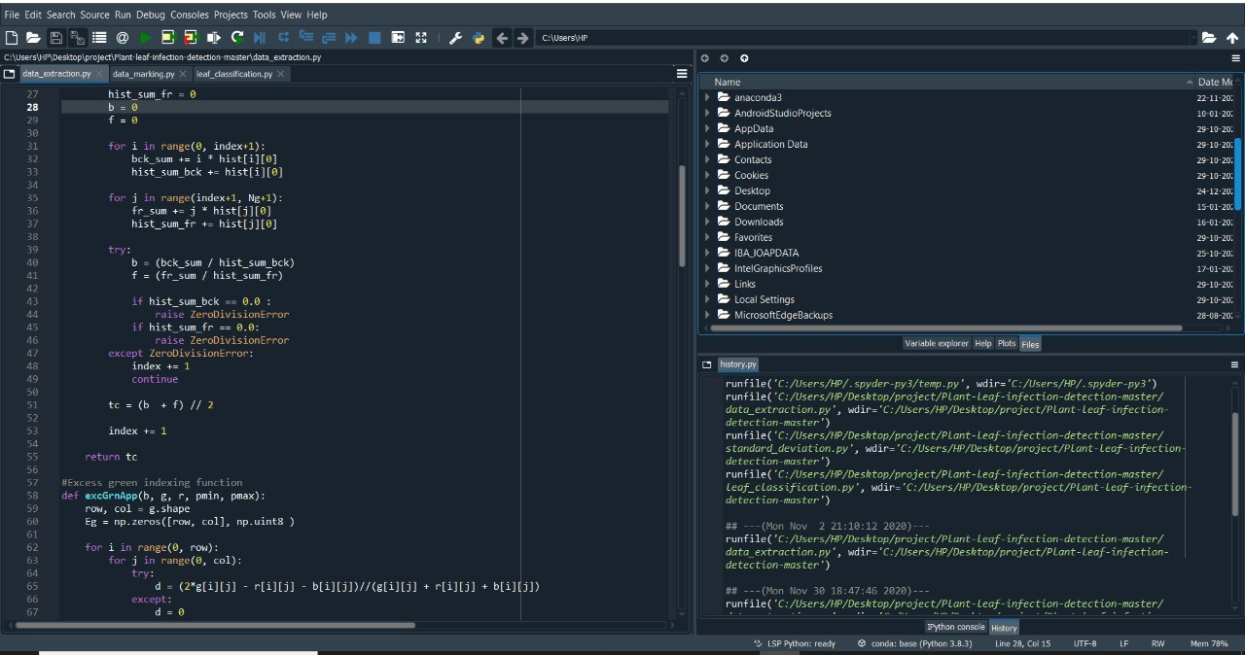

Figure 4.3: program

# Software discription

## Android application

### Front end

Front end of the Android application is created using XML(eXtensible Markup Lan- guage. XML is a simplified form of SGML(Standard Generalized Markup Language) intended for documents that are published on the Web. Like SGML, XML uses DTDs (Document Type Definitions) to define document types and the meaning of tags used in them. XML adopts conventions that make it easy to parse, such as that document enti- ties are marked by both a beginning and an ending tag, such as ... XML provides more kinds of hypertext links than HTML, such as bidirectional links and links relative to a document subsection. 4.3.2 Back end Back end of the Android application is created

using Firebase and Java.

### Back end

Back end of the Android application is created using Java. Java is a class-based, object- oriented programming language that is designed to have as few implementation de- pendencies as possible. It is a general-purpose programming language intended to let application developers write once, run anywhere (WORA), meaning that compiled Java code can run on all platforms that support Java without the need for recompilation.

## Machine learning algorithm

### ANN

We are using Artificial neural network as the machine learning algorithm in the server side. It is an example of supervised learning. Artificial neural network acquired the knowledge in the form of connected network unit. It is difficult for human to extract this knowledge. This factor has motivated in extracting the rule for classification. The procedure of classification is starts with dataset. The data set is divided into two parts: training sample and test sample. Training sample is used for learning of network while test sample is used for measuring the accuracy of classifier. The division of data set can be done by various method like hold-out method, cross validation, random sampling. In general learning steps of neural network is as follows:

* Network structure is defined with a fixed number of nodes in input, output and hidden layer.
* An algorithm is used for learning process

# DIAGRAMS

## ARCHITECTURE DIAGRAM

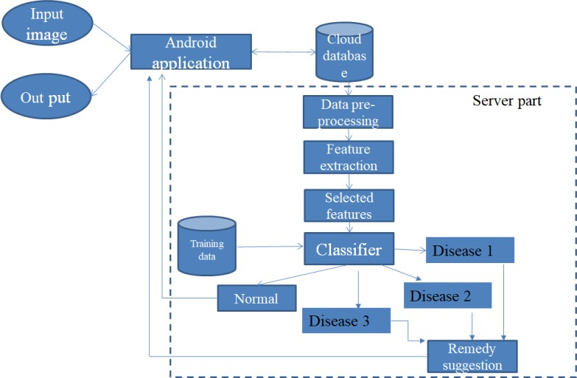

Figure 4.4: Architecture diagram

## DATA FLOW DIAGRAMS

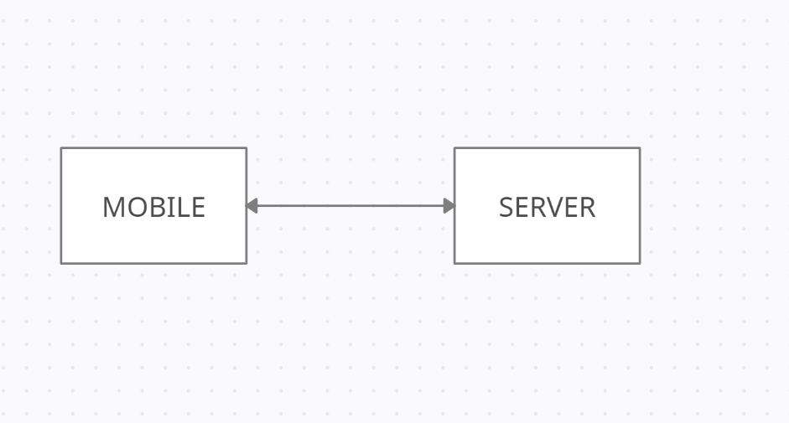

Figure 4.5: Data Flow Diagram 1

# Module description

### Android Application

Our android application consist of 4 pages, which are home page, plant selection page, image capturing page and the final page showing the result. In plant selection page there is an option for choosing the type of plant. We provided 3 type of plants, tomato, black pepper and maize. After selecting the plant type there is an option for uploading the leaf image. There are 2 method for uploading the leaf image. One is directly capturing the image through the camera and second one is browsing the image from phone gallery. And the next page will show the result which includes the name of disease and the remedy required. Otherwise it will show the message “THE LEAF IS HEALTHY” and the remedy box will display “IT HAS NO REMODY”. In this page there are two option, one redirecting to home page, “HOME” and another one for exit from the application, “EXIT”.

Figure 4.6: Home page

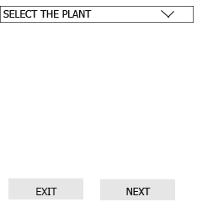

Figure 4.7: plant selection



Figure 4.8: Image capturing

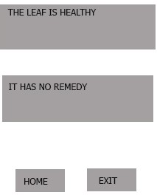

Figure 4.9: Result and remedy

### Server side

Our server side module receives the defected, it analyze and Identify the disease and send the remedy to the farmer.This is implemented by the help of machine learning algorithm. So we used the artificial neural network (ANN). The image from the android part is proceed here, it undergoes ;

1. Segmentation
2. Feature extraction
3. Feature selection
4. Image processing

For feature extraction we are using the feature such as mean, standard deviation, skewness, area, major and minor axis length, eccentricity, orientation, equivalent- diam- eter, rigidity, solidity, and pixel ratio .And the extracted data is passed to our proposed system. In which we have 4 classification. first one is for healthy data and remaining three for defective or diseased set. 3 type of tomato leaf disease are included which are bacterial spot, early blight and leaf blight. Then this is passed to the remedy suggestion

block. There we have set of remedy for particular diseases, which is appended with the disease name. After that it is transferred to the mobile application.

### Details collected for remedy making; Tomato

1. Early blight

It is a fungal disease.The symptomps are;

* + Small and brown wounds on older leaf
  + Concentric rings in a bull’s eye pattern in defected area
  + Surrounded tissue may turn yellow

The remedy for early blight includes;

* + To reduce disease severity, test the garden soil annually and maintain a suf- ficient level of potassium. Side dress tomato plants monthly with calcium nitrate for adequate growth.
  + Select one of the following fungicides: mancozeb (very good); chlorothalonil or copper fungicides (good).

1. Late blight

It is a fungal disease.The symptomps are;

* + Young leaf wounds are small and appear as dark.
  + Water-soaked spots.
  + These leaf spots will quickly enlarge and a white mold will appear at the margins of the affected area on the lower surface of leaves.

The remedy for early blight includes;

* + select one of the following fungicides: chlorothalonil (very good); copper fungicide, or mancozeb (good)
  + To reduce disease severity, test the garden soil annually and maintain a suf- ficient level of potassium. Side dress tomato plants monthly with calcium nitrate for adequate growth.

1. Bacterial spot

It is a bacterial disease.The symptomps are;

* + numerous small, angular to irregular, water-soaked spots on the leaves
  + The leaf spots may have a yellow halo. The centers dry out and frequently tear.

The remedy for early blight includes;

* + Remove all diseased plant material. Prune plants to promote air circulation. Spraying with a copper fungicide will give fairly good control the bacterial disease.
  + When harvesting seeds, allow the seeds to ferment in the tomato pulp for one week.
  + Soak seeds in a 20 percent bleach solution for 30 minutes (this may reduce germination)
  + Soak seeds in water that is 125 F. (52 C.) for 20 minutes.

# CHAPTER 5

**Formulation of work plan**

In September we will collect all research papers in our project "identification of plant leaf disease using image processing" . In October and November we will collect all data sets required for this project. The design phase will be in December and January. By this all data flow and user interface will be designed. The development phase is in April. So we will implement the project by February. All testing phase will be completed my April and in the end of May we will release our project

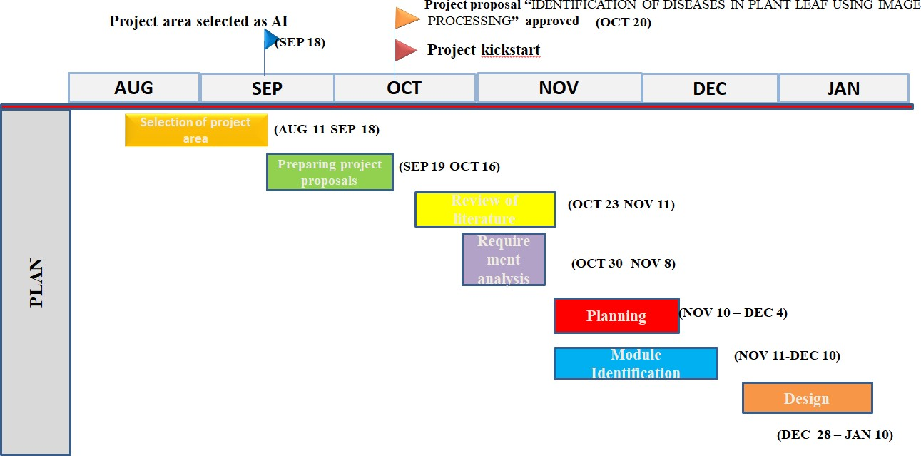

Figure 5.1: Work plan

# CHAPTER 6

**CONCLUSION**

Crop protection in agriculture is not a simple matter. It depends on a thorough knowl- edge of the crops grown and their likely pests, pathogens and weeds. In our system specialized machine learning models were developed, based on specific artificial neu- ral networks architectures, for the detection of plant diseases through leaves images of healthy or diseased plants. Our detector applied images captured in-place by various camera devices and also collected from various resources. Our experimental results and comparisons between various deep-architectures with feature extractors demonstrated how our machine-learning-based detector is able to successfully recognize different categories of diseases in various plants and also give solution for concern diseases. Pests/diseases are generally not a significant problem in organic systems, since healthy plants living in good soil with balanced nutrition are better able to resist pest/disease attack. We hope our proposed system will make a suggestive contribution to the agri- culture research. Using android studio developed the android application for farmers which help the farmers to capture images of defected plants and this images will up- loaded to the server from where the actual processing is done . And the result also displayed in the android application . The farmer need to select the plant type . And capture the image this image will be uploaded to the server . In the server the image has been passed through various steps of image processing.

1. Image Acquisition. The image is captured by a sensor
2. Image Enhancement
3. Image Restoration
4. Colour Image processing
5. Wavelets
6. Compression
7. Morphological Processing
8. Image Segmentation

it is classified based on the features of leaf in those mainly focusing on shape, clour, axis length .there are mainly three disease data set of tomato which are late blight, early blight ,bacterial spot each of this has different features

28

# CHAPTER 7

**REFERENCES**

1. Jiang, Y. Chen, B. Liu, D. He and C. Liang, “ Real-Time Detection of Apple Leaf Diseases Using Deep Learning Approach Based on Improved Convolutional Neu- ral Networks “ in IEEE Access, vol. 7, pp. 59069-59080, 2019, doi: 10.1109/AC- CESS.2019.2914929.
2. Siddharth Singh Chouhan1, Ajay Kaul1 , Uday Pratap Singh2 and Sanjeev Jain1

, Bacterial foraging optimization based Radial Basis Function Neural Network for identification and classification of plant leaf diseases. Doi Number 10.1109/ ACCESS . 2018.2800685, IEEE Access.

1. Qiufeng Wu 1 , Yiping Chen 2 , And Jun Meng1, DCGAN-Based Data Augmen- tation for Tomato Leaf Disease Identification DOI:10.1109/ACCESS.2020.299 7001
2. Tan Nhat Pham , LY Van Tran, and Son VU Troung Dao, Searly Disease Classifi- cation of Mango Leaves Using Feed-Forward Neural Network and Hybrid Meta- heuristic Feature Selection, DOI: Identifier 10.1109/ACCESS.2020.3031914
3. Image processing-based intelligent robotic system for assistance of agricultural crops by Nikhil Paliwal; Pankhuri Vanjani; Jing-Wei Liu; Sandeep Saini; Ab- hishek SharmaInternational Journal of Social and Humanistic Computing (IJSHC), Vol. 3, No. 2, 2019 doi.org/10.1504/IJSHC.2019.101602
4. Azeddine Elhassouny ENSIAS, Mohammed V University in Rabat Rabat, Mo- rocco and d Florentin Smarandache Dept. Mathematics, University of New Mex- ico New Mexico, USA, “Smart mobile application to recognize tomato leaf dis- eases using Convolutional Neural Networks” , IEEE/ICCSRE2019, 22-24 July, 2019, Agadir, Morocco.
5. Identification of Plant Disease using Image Processing Technique Abirami De- varaj, Karunya Rathan, Sarvepalli Jaahnavi and K Indira, International Confer- ence on Communication and Signal Processing, April 4-6, 2019, India.
6. Ankit Chhillar Amity School of Engineering and Technology Amity University Uttar Pradesh , Sanjeev Thakur Amity School of Engineering and Technology Amity University Uttar Pradesh sthakur3 and Ajay Rana Amity University Uttar Pradesh “Survey of Plant Disease Detection Using Image Classification Tech- niques.” 2020 8th International Conference on Reliability, Infocom Technologies and Optimization (Trends and Future Directions) (ICRITO) Amity University, Noida, India. June 4-5, 2020.
7. A Tomato Leaf Diseases Classification Method Based on Deep Learning Ding Jiang, Fudong Li, Yuequan Yang, Song Yu College of Information Engineering, Yangzhou University, Yangzhou 225127. 978-1-7281-5855-6/20/$31.00 c 2020 IEEE 1446 Authorized licensed use limited to: Cornell University Library.
8. 2020 International Conference on Computer Science and Software Engineering (CSASE), Duhok, Kurdistan Region – Iraq 978-1-7281-5249-3/20$31.00 ©2020 IEEE 259, “Plant Leaf Diseases Detection and Classification Using Image Pro- cessing and Deep Learning Techniques”, Marwan Adnan Jasim Department of Computer Science, College of Science, University of Diyala, Diyala, Iraq and Ja- mal Mustafa AL-Tuwaijari Department of Computer Science, College of Science, University of Diyala, Diyala, Iraq .
9. International Journal of Research and Engineering ISSN: 2348-7860 (O) | 2348- 7852 (P) | Vol. 5 No. 9 | September-October 2018 | PP. 516-523 Digital Object Identifier DOI. Plant Leaf Disease Detection and Classification using Image Pro- cessing Author(s): *1 Yin Min Oo, 2Nay Chi Htun, Affiliation(s): 1 Department of Information Technology, Pyay Technological University 2Department of In- formation Technology, Pyay Technological University.
10. IET Image Processing Review Article Review of image processing approaches for detecting plant diseases ISSN 1751-9659. Received on 17th September 2018 Revised 4th October 2019 Accepted on 9th December 2019 E-First on 13th May 2020. doi: 10.1049/iet-ipr.2018.6210 [www.ietdl.org](http://www.ietdl.org/) Aditya Sinha1 , Rajveer Singh Shekhawat1 1School of Computing & Information Technology, Manipal University Jaipur, India.
11. IET Image Processing Research Article Semi-automatic leaf disease detection and classification system for soybean culture. ISSN 1751-9659 Received on 3rd August 2017 Revised 24th November 2017 Accepted on 28th January 2018 E-First on 22nd February 2018 doi: 10.1049/iet-ipr.2017.0822 [www.ietdl.org](http://www.ietdl.org/) Sukhvir Kaur1 , Shreelekha Pandey1 , Shivani Goel2 1Computer Science and En- gineering Department, Thapar Institute of Engineering and Technology, Patiala, Punjab 147004, India 2Computer Science and Engineering Department, Bennett University, Greater Noida, UP, India.
12. Multi-Organ Plant Classification based on Convolutional and Recurrent Neural networks Sue Han Lee, Student Member, IEEE, Chee Seng Chan, Senior Mem- ber, IEEE, and Paolo Remagnino, Senior Member, IEEE. . Citation information: DOI 10.1109/TIP.2018.2836321, IEEE Transactions on Image Processing.
13. Indian Journal of Science and Technology, Vol 9(48), DOI: 10.17485/ijst/2016, December 2016. Detection and Classification of Disease Affected Region of Plant Leaves using Image Processing Technique, Iqbaldeep Kaur*, Gifty Aggar- wal and Amit Verma Computer Science and Engineering, Chandigarh Engineer- ing College, Landran - 140307, Punjab, India.
14. IEEE JOURNAL OF SELECTED TOPICS IN APPLIED EARTH OBSERVA- TIONS AND REMOTE SENSING 1 An Investigation Into Machine Learning Regression Techniques for the Leaf Rust Disease Detection Using Hyperspectral Measurement Davoud Ashourloo, Hossein Aghighi, Ali Akbar Matkan, Moham- mad Reza Mobasheri, and Amir Moeini Rad.
15. Received May 2, 2018, accepted May 29, 2018, date of publication June 6, 2018, date of current version June 26, 2018. Digital Object Identifier 10.1109/AC- CESS.2018.2844405 Identification of Maize Leaf Diseases Using Improved Deep Convolutional Neural Networks XIHAI ZHANG , (Member, IEEE), YUE QIAO

, FANFENG MENG, CHENGGUO FAN , AND MINGMING ZHANG

1. R. Chaerani and R. E. Voorrips, “Tomato early blight (Alternaria solani): The pathogen, genetics, and breeding for resistance,” J. Gen. Plant Pathol., vol. 72, no. 6, pp. 335–347, Dec. 2006.
2. M. A. H. Abas, N. Ismail, A. I. M. Yassin, and M. N. Taib, “VGG16 for plant image classification with transfer learning and data augmentation,” Int. J. Eng. Technol., vol. 7, pp. 90–94, Oct. 2018.
3. ] S.-E.-A. Raza, G. Prince, J. P. Clarkson, and N. M. Rajpoot, “Automatic de- tection of diseased tomato plants using thermal and stereo visible light images,” PLoS ONE, vol. 10, no. 4, Apr. 2015, Art. no. e0123262.
4. Q. Huu Cap, H. Uga, S. Kagiwada, and H. Iyatomi, “LeafGAN: An effective data augmentation method for practical plant disease diagnosis,” 2020, arXiv:2002. 10100. Available: [http://arxiv.org/abs/2002.10100.](http://arxiv.org/abs/2002.10100)
5. S. Prasad, S. K. Peddoju, and D. Ghosh, “Multi-resolution mobile vision system for plant leaf disease diagnosis,” Signal, Image Video Process., vol. 10, no. 2, pp. 379–388, Feb. 2016, doi: 10.1007/s11760-015-0751-y.
6. Y. Tian, G. Yang, Z. Wang, E. Li, and Z. Liang, “Detection of apple lesions in orchards based on deep learning methods of CycleGAN and YOLOV3-dense,” J. Sensors, vol. 2019, pp. 1–13, Apr. 2019.
7. ] C. Han, H. Hayashi, L. Rundo, R. Araki, W. Shimoda, S. Muramatsu, Y. Fu- rukawa, G. Mauri, and H. Nakayama, “GAN-based synthetic brain MR image generation,” in Proc. IEEE 15th Int. Symp. Biomed. Imag. (ISBI), Apr. 2018, pp. 734–738, doi: 10.1109/ISBI.2018.8363678.
8. C. Han, L. Rundo, R. Araki, Y. Nagano, Y. Furukawa, G. Mauri, H. Nakayama, and H. Hayashi, “Combining Noise-to-Image and Imageto-Image GANs: Brain MR image augmentation for tumor detection,” IEEE Access, vol. 7, pp. 156966– 156977, 2019, doi: 10.1109/ ACCESS.2019.2947606
9. S. D. Khirade and A. B. Patil, “Plant disease detection using image processing,” in Proc. Int. Conf. Comput. Commun. Control Autom., Feb. 2015, pp. 768–771, doi: 10.1109/ICCUBEA.2015.153.
10. E. C. Too, L. Yujian, S. Njuki, and L. Yingchun, “A comparative study of fine- tuning deep learning models for plant disease identification,” Comput. Electron. Agricult., vol. 161, pp. 272–279, Jun. 2019, doi: 10.1016/j. compag.2018.03.032
11. ] J. Shijie, J. Peiyi, H. Siping, and S. Haibo, “Automatic detection of tomato diseases and pests based on leaf images,” in Proc. Chin. Autom. Congr. (CAC), Oct. 2017, pp. 2510–2537, doi: 10.1109/CAC.2017.8243388.
12. A. K. Rangarajan, R. Purushothaman, and A. Ramesh, “Tomato crop disease clas- sification using pre-trained deep learning algorithm,” Procedia Comput. Sci., vol. 133, pp. 1040–1047, Jan. 2018, doi: 10.1016/j.procs. 2018.07.070.
13. D. P. Hughes and M. Salathe, “An open access repository of images on plant health to enable the development of mobile disease diagnostics,” 2015, arXiv:1511

.08060. <http://arxiv.org/abs/>1511 .08060

1. U. P. Singh, S. S. Chouhan, S. Jain, and S. Jain, “Multilayer convolution neural network for the classification of mango leaves infected by anthracnose disease,” IEEE Access, vol. 7, pp. 43721–43729, 2019, doi: 10. 1109/ACCESS.2019. 2907383.