Installation Guide
- Installation
- Go to resources/database and execute the appropriate query on the database
- Drop bpms-cases-7.5.0-SNAPSHOT.aar in webapps\intalio\WEB-INF\services
- Drop bpms-cases-7.5.0-SNAPSHOT.jar in webapps\intalio\WEB-INF\lib
- Copy the folder src\main\web\webapps\intalio from the source code and paste in webapps folder on the server
- Add to webapps\intalio\WEB-INF\jsp\sidebar.jsp
<script type="text/javascript" src="scripts/custom/workflow/acm_sidebar.js"></script>

- Add to webapps\intalio\WEB-INF\jsp\tasks.jsp the following two lines at the scripts level:

<script type="text/javascript" src="scripts/custom/workflow/cases.js"></script>
<script type="text/javascript" src="scripts/custom/workflow/acm_tasks.js"></script>

- In webapps\intalio\scripts\custom\workflow\workflow.js
  - Comment the following two lines (around lines 422/423)
$("#rowTaskHeader th:gt(9)").remove();
taskOptions.aoColumns = taskOptions.aoColumns.slice(0, 12);
  - Locate function updateData. Inside that function there is a line that adds the content of the hidden colmn is OthersTask
Something lie: items[items.length] = isOthersTask (around line 1088)
Before that column insert the line:
addACMContent(obj,items);
- In webapps\intalio\WEB-INF\classes\root\root-servlet.xml
- Add the following two lines to the props attribute of the root.urlMapping bean
<prop key="/cases.htm">casesView</prop>
<prop key="/case.htm">caseView</prop>
- Then add the following 2 beans
<bean id="casesView" class="org.springframework.web.servlet.mvc.ParameterizableViewController">
<property name="viewName" value="cases"/>
</bean>
<bean id="caseView" class="org.springframework.web.servlet.mvc.ParameterizableViewController">
<property name="viewName" value="case"/>
</bean>
- Restart server

User Guide
Creating the Case Object on a new process
- Create a metric with Intalio|bpms
  - Create any attributes in your metric to define the object, however, the following default attributes must be created
    - Id (UUID type)
The id will not appear in the case list. Add other attributes in the order you want them to appear on the screen

- Create a metric for this case’s object history. The case history name must be the same as the case metric’s name but with the “_history” word appended. I must contain the following attributes:
  - Id (UUID type)
  - caseId (String type)
  - status_activity_type (String)
  - status_activity(String)

Those colums will not appear in the history page. Add other attributes depending on your need in the order that you want them to show on the screen.
- Declare the metric so that the ACM module would know that this metric defines a Case Object. To so so, add a row to the tempo_casetype table. It requires the:
  - Id (technical name for the object without any special characters except “_” and “-“
  - Description as it will appear in the user interface
  - Diagram: path to the status process diagram (leave it empty at first, will be discussed later)
- Add two new custom metadata columns to your project
  - caseId
  - CaseType
- For every task,
  - map the caseId from the metric’s id attribute
  - map the caseType statically with the metric’s id value (for example : “Absence_Request” …lower/upper case are important)
- Create a status process
  - The status process can contain tasks and events. Empty events represent status changes, while tasks represents actual tasks.
Tasks can be in progress or completed., while an status can only be reached so completed
  - To make sure that the status process is updated by the process at relevant steps, make sure there is a history entry at every status process change.
To relate the entry to a specific activity in the diagram, use the status_activity attribute. This will indicate to the status diagram, that a change regarding the activity X has happened at this stage.
To indicate what kind of change happened, use the status_activity_type attribute.
- if the activity is an empty event, use the type “state”
- if it is a task, then either use:
    - "start_activity" if you want the task to be marked as “in progress”
    - “end_activity” if you want the task to be marked as “completed”
  - In the tempo_casetype table, update the url to the following
/intalio/console/processes/images/svg?id=$pid
where $pid dis the process pid. You can find the pid from the process console, by clicking on the relavant process 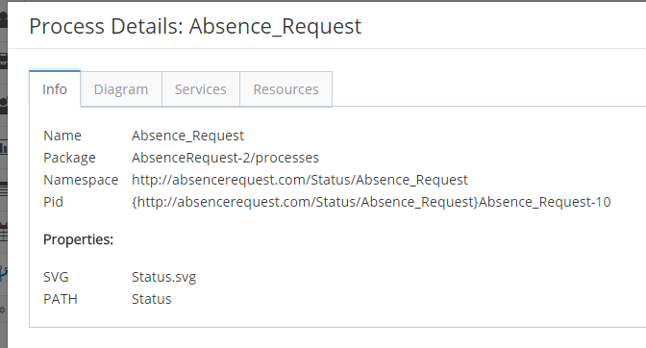

- Create a Case Form
  - Create an Ajax Form for the case
  - Create components that will display your case data.
The mapping between the case data that is stored in the DB and the form components will happen automatically. You only need to make sure that:
    - The component’s name matches the column name. The component must be a compoenent that have either of those methods possible:
      - SetTileText (fieldset, Title…)
      - setDate (DatePicker,TimePicker…)
      - setValue(DatePicker,TimePicker,Select,Text Area, Password Input …)
      - setText(TextOutput,TextInput)
    - The component’s name must be lowercase
    - Two components in the form don’t have the same lowercase name (which is a general rule in GI anyways)
  - Go to table tempo_casetype and update the case_form attribute with the URL to the Ajax form. The url is build like this:
/intalio/gi/apppath/$relativeFileOfAjaxFolderInWorkspace /IntalioInternal/ServerLaunch.html
so if the ajax form is named AbsenceRequest inside a folder Forms/CaseForms inside the project AbsenceRequest, the $ relativeFileOfAjaxFolderInWorkspace will be:
AbsenceRequest/Forms/CaseForms/AbsenceRequest.gi
and the final value of the case_form column will be:
/intalio/gi/apppath/AbsenceRequest/Forms/CaseForms/AbsenceRequest.gi/IntalioInternal/ServerLaunch.html
- From the resources forlder copy the content of the CaseForms folder into your form’s folder (so to AbsenceRequest.gi for instance). The content of the js folder must hence merge with the content of the existing js folder in the form’s folder and so on for the other folders such as rules,…

