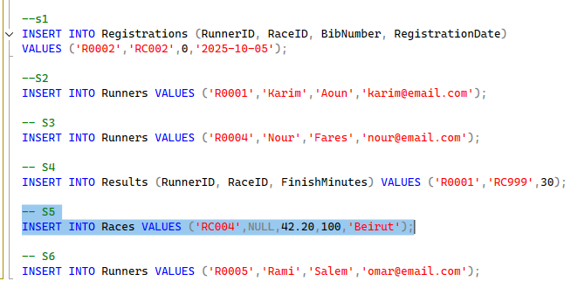

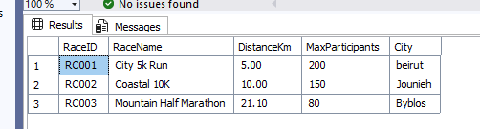

create database RaceDB;
use RaceDB;
create table Runners(
RunnerID char(5) primary key not null,
FirstName varchar(50) not null,
LastName varchar(50) not null,
Email varchar(100) unique not null,
ClubName varchar(50) null);

create table Races(
RaceID char(5) primary key not null,
RaceName varchar(100) not null,
DistanceKm decimal(5,2) check(DistanceKm>0) not null,
MaxParticipants int check(MaxParticipants>0) not null);

create table Registrations(
RegistrationID int primary key identity(1,1) not null,
RunnerID char(5) foreign key references Runners not null,
RaceID char(5) not null,
BibNumber int check(BibNumber>0) not null,
RegistrationDate date not null);

alter table Races add City char(50) null;

create table Results(
ResultID int primary key identity(1,1) not null,
RunnerID char(5) foreign key references Runners not null,
RaceID char(5) foreign key references Races not null,
FinishMinutes int check(FinishMinutes>0) not null);

alter table Runners drop column ClubName ;

alter table Registrations
add constraint FK_Registrations_RaceID foreign key (RaceID)
references Races (RaceID)
on update cascade;

insert into Races values ('RC001','City 5k Run','5.00','200','beirut');
insert into Races values ('RC002','Coastal 10K','10.00','150','Jounieh');
insert into Races values ('RC003','Mountain Half Marathon','21.10','80','Byblos');

insert into Registrations(RunnerID,RaceID,BibNumber,RegistrationDate) values ('RC0001','RC001','101','2025-10-01');
insert into Registrations(RunnerID,RaceID,BibNumber,RegistrationDate) values ('RC0002','RC001','102','2025-10-02');
insert into Registrations(RunnerID,RaceID,BibNumber,RegistrationDate) values ('RC0003','RC002','201','2025-10-03');

--s1
INSERT INTO Registrations (RunnerID, RaceID, BibNumber, RegistrationDate)
VALUES ('R0002','RC002',0,'2025-10-05');

--S2
INSERT INTO Runners VALUES ('R0001','Karim','Aoun','karim@email.com');

-- S3
INSERT INTO Runners VALUES ('R0004','Nour','Fares','nour@email.com');

-- S4
INSERT INTO Results (RunnerID, RaceID, FinishMinutes) VALUES ('R0001','RC999',30);

-- S5
INSERT INTO Races VALUES ('RC004',NULL,42.20,100,'Beirut');

-- S6
INSERT INTO Runners VALUES ('R0005','Rami','Salem','omar@email.com');

