create database LibraryDB;
use LibraryDB;

create table categories(
CategoryID int primary key not null,
CategoryName varchar(50) unique
);

create table Books(
BookID char(5) primary key not null,
Title varchar(100) not null,
Author varchar(50) not null,
CategoryID int not null foreign key references Categories(CategoryID),
PublishYear int not null check(1900<PublishYear and PublishYear<2026),
Copies int not null check(Copies>=0)
);

create table Members(
MemberID char(5) primary key not null,
FullName varchar(50) not null,
Email varchar(100) unique null,
Phone varchar(15) null,
City varchar(30) not null
);

create table Loans(
LoanID int identity(1,1) primary key,
MemberID char(5) not null foreign key references Members
on delete cascade,
BookID char(5) not null foreign key references Books,
LoanDate date not null,
Returndate date null,
Fine decimal(5,2) not null default 0 check(Fine>=0)
);

insert into Members values('M0001','Hadi Mansour','hadi@email.com','70123456','Beirut');
insert into Members values('M0002','Rima Haddad','rima@email.com','null','saida');
insert into Members values('M0003','Jad Karam','null','71234567','Beirut');
insert into Members values('M0004','Yara Sleiman','yara@email.com','03111222','Beirut');

insert into Categories values('1','Computer Science');
insert into Categories values('2','Fiction');
insert into Categories values('3','History');

insert into Books values('B0001','Database System Concepts','Abraham Silberschatz','1','2019','4');
insert into Books values('B0002','Clean Code','Robert Martin','1','2008','2');
insert into Books values('B0003','The Alchemist','Paulo Coelho','2','1988','5');
insert into Books values('B0004','Season of Mifration of the North','Tayeb Salih','2','1966','3');
insert into Books values('B0005','The ottoman Centuries','Lord Kinross','3','1977','1');
insert into Books values('B0006','Sapiens','Yuval Noah Harari','3','2014','2');

insert into Loans(MemberID,BookID,LoanDate,ReturnDate) values('M0001','B0001','2026-09-01','2026-09-15');
insert into Loans(MemberID,BookID,LoanDate,ReturnDate) values('M0001','B0003','2026-09-10','');
insert into Loans(MemberID,BookID,LoanDate,ReturnDate) values('M0002','B0002','2026-09-05','2026-09-25');
insert into Loans(MemberID,BookID,LoanDate,ReturnDate) values('M0003','B0004','2026-09-10','');
insert into Loans(MemberID,BookID,LoanDate,ReturnDate) values('M0004','B0005','2026-09-12','2026-10-01');
insert into Loans(MemberID,BookID,LoanDate,ReturnDate) values('M0002','B0006','2026-10-02','');

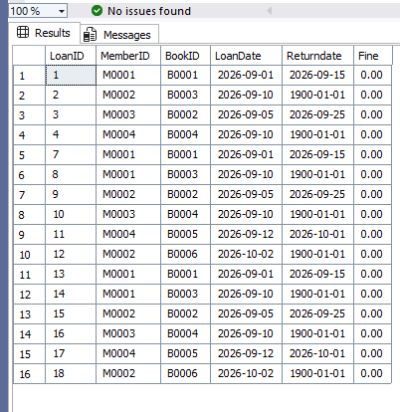
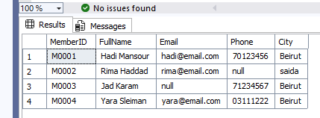
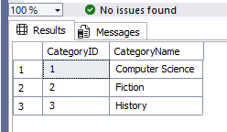

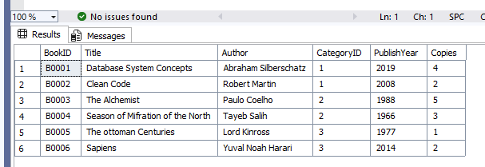

select * from Books where copies between 2 and 3;

update Loans
set fine = '2.50'
where fine = '0';

select Title, CategoryID from Books;

select LoanID,MemberID,BookID,LoanDate from Loans where ReturnDate!=0;

delete from Books where BookID = 'B0003';

select * from Books where Title like 'The';

select Distinct City from Members;

update Books set BookID ='B0010' where BookID ='B0001';

select Title,PublishYear,2026-PublishYear as BookAge from Books;

