Sample Software Architecture Document

Online Medical Representative Management 1.0

Mrep Inc.

MREP Revision History

Date | Version | Description | Author
03-05-2014 | 0.1 | Significant Use-Cases : the key requirements | Mrep Inc.  Architecture Team
05-05-2014 | 0.2 | Add class diagram | Mrep Inc.  Architecture Team
09-05-2014 | 0.3 | Add layer diagram | Mrep Inc.  Architecture Team
11-05-2014 | 0.4 | Add Deployment diagram | Mrep Inc.  Architecture Team
17-05-2014 | 1.0 | Review document | Mrep Inc.  Architecture Team

Table of Contents

1. Introduction 4
1.1 Purpose 4
1.2 Scope 5
1.3 Definitions, Acronyms and Abbreviations 5
1.4 References 5
1.5 Overview 5
2. Architectural Representation 6
3. Architectural Goals and Constraints 7
3.1 Technical Platform 7
3.2 Transaction 7
3.3 Security 7
3.4 Persistence 7
3.5 Reliability/Availability (failover) 7
3.6 Performance 8
3.7 Internationalization (i18n) 8
4. Use-Case View 8
4.1 Ordering Menus 8
4.2 Use-Case Realizations 9
5. Logical View 9
5.1 Overview 9
5.2 Architecturally Significant Design Packages 11
6. Process View 13
7. Deployment View 13
8. Implementation View 15
8.1 Overview 15
8.2 Layers 15
9. Data View 15
10. Size and Performance 16
11. Quality 16

Introduction
This document comes as a complement to the article “Developing a J2EE Architecture with Rational Software Architect using the Rational Unified Process®” [RUPghRSA]. It illustrates what can be the content of a Software Architecture Document (SAD) produced during the RUP Elaboration phase.
As stated in the companion article, a RUP Software Architect will typically perform height major steps in order to define a global architecture, and each time an activity is completed, a specific section of the SAD is enriched accordingly.

Architectural activities | Software Architecture Document
Step 1 - Identify and prioritize significant Use-Cases | Section 4
Step 2 - Define the candidate architecture | Section 3, 5.1, 10, 11
Step 3 - Define the initial Deployment Model | Section 7
Step 4 - Identify key abstractions | Section 9
Step 5 - Create an Analysis Model | Section 5
Step 6 - Create the Design Model | Section 5
Step 7 - Document concurrency mechanisms | Section 6, 7
Step 8 - Create the Implementation Model | Section 8

Purpose
The Software Architecture Document (SAD) provides a comprehensive architectural overview of the Online Medical Representative Management Application 1.0 offered by Mrep Inc. It presents a number of different architectural views to depict different aspects of the system. It is intended to capture and convey the significant architectural decisions which have been made on the system.

In order to depict the software as accurately as possible, the structure of this document is based on the “4+1” model view of architecture [KRU41].

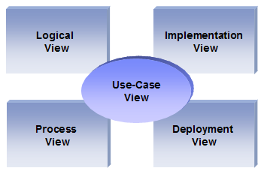
The “4+1” View Model allows various stakeholders to find what they need in the software architecture.

Scope
The scope of this SAD is to depict the architecture of the online Medical Representative Management Application 1.0 offered by Mrep Inc.

Definitions, Acronyms and Abbreviations

RUP: Rational Unified Process
UML: Unified Modeling Language
SAD: Software Architecture Document

References

[KRU41]: The “4+1” view model of software architecture, Philippe Kruchten, November 1995, http://www3.software.ibm.com/ibmdl/pub/software/rational/web/whitepapers/2003/Pbk4p1.pdf

[RSA]: IBM Rational Software Architect
http://www-306.ibm.com/software/awdtools/architect/swarchitect/index.html

[RUP]: The IBM Rational Unified Process : http://www-306.ibm.com/software/awdtools/rup/index.html

[RUPRSA]: Developing a J2EE Architecture with Rational Software Architect using the Rational Unified Process®, IBM DeveloperWorks, Jean-Louis Maréchaux, Mars 2005, http://www-128.ibm.com/developerworks/rational/library/05/0816_Louis/

Overview

In order to fully document all the aspects of the architecture, the Software Architecture Document contains the following subsections.
Section 2: describes the use of each view
Section 3: describes the architectural constraints of the system
Section 4: describes the functional requirements with a significant impact on the architecture
Section 5: describes the most important use-case realization. Will contain the Analysis Model and the Design Model
Section 6: describes design’s concurrency aspects
Section 7: describes how the system will be deployed. Will contain the Deployment Model
Section 8: describes the layers and subsystems of the application
Section 9: describes any significant persistent element. Will contain the Data Model
Section 10: describes any performance issues and constraints
Section 11: describes any aspects related to the quality of service (QoS) attributes

Architectural Representation

This document details the architecture using the views defined in the “4+1” model [KRU41], but using the RUP naming convention. The views used to document the Medical Representative Management application are:

Logical view
Audience: Designers.
Area: Functional Requirements: describes the design's object model. Also describes the most important use-case realizations.
Related Artifacts: Design model

Process view
Audience: Integrators.
Area: Non-functional requirements: describes the design's concurrency and synchronization aspects.
Related Artifacts: (no specific artifact)

Implementation view
Audience: Programmers.
Area: Software components: describes the layers and subsystems of the application.
Related Artifacts: Implementation model, components

Deployment view
Audience: Deployment managers.
Area: Topology: describes the mapping of the software onto the hardware and shows the system's distributed aspects.
Related Artifacts: Deployment model

Use Case view
Audience: all the stakeholders of the system, including the end-users.
Area: describes the set of scenarios and/or use cases that represent some significant, central functionality of the system.
Related Artifacts : Use-Case Model, Use-Case documents

Data view (optional)
Audience: Data specialists, Database administrators
Area: Persistence: describes the architecturally significant persistent elements in the data model
Related Artifacts: Data model

Architectural Goals and Constraints

This section describes the software requirements and objectives that have some significant impact on the architecture

Technical Platform

The Mrep Inc online application will be deployed onto a J2EE application server (Tomcat Web Server version 7).

Security

The system must be secured, so that only authenticated actors can login, and only authorized users can perform action or get information.
The application must implement basic security behaviors:
- Authentication: Login using at least a user name and a password
- Authorization: according to their profile (type), administrators only can change the settings / administration screens.
For internet access, the following requirements are mandatory
- Confidentiality: users passwords must be saved hashed
- Data integrity : Data sent across the network cannot be modified by a tier (use https in production mode)
- Auditing: Every sensitive action can be logged
- Non-repudiation : gives evidence a specific action occurred

Persistence

Data persistence will be addressed using a relational database. (mysql 5)

Reliability/Availability (failover)

The availability of the system is a key requirement by nature. The candidate architecture must ensure failover capabilities. Reliability/Availability will be addressed through the J2EE platform
Targeted availability is 16/7: 16 hours a day, 7 days a week
The time left (8 hours) is reserved for any maintenance activities

Performance

Adding call must be less than 1 min

Internationalization (i18n)

Only English required for the first phase but, the presentation layer must be able to support i18n. (By default the GWT – Google web toolkit supports i18n)
Other layers must be generic enough to work with any internationalization context

Use-Case View

This section lists use cases or scenarios from the use-case model if they represent some significant, central functionality of the final system.
The Application can be accessed by 3 types of employees:
- Administrator.
- Medical representative.
- Manager.

Each employee type will have certain possible functionalities.

Administrator setup the system

Administrator accesses the online application to add the required settings (adding zone, brick, territory) / register employees and add customers then prepare plan for the medical representative.

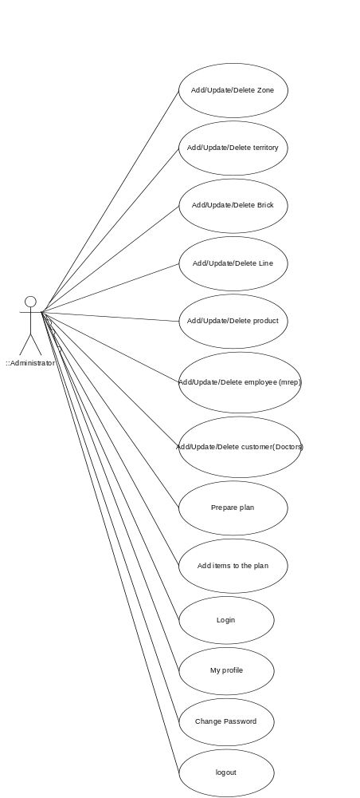

Login:

Actors | Administrator
Description | The administrator must be login first before executing any functionality.
Data | Admin user name , password
Stimulus (request) | When administrator performs successful login he must be able to view the main panel for administrations.
Response | Message appeared to indicate login has been failed or open the related GUI for the administrator.
Comments | The user may be administrator or medical rep or manager

Change Password:

Actors | Administrator
Description | The administrator wants to change his current password.
Data | Old password, new password, verify the new password
Stimulus (request) | The admin must be login first to his account then change password from the main menu
Response | Message indicates success or fail in saving the new password
Comments | The user may be administrator or medical rep or manager

Update/ View my profile:

Actors | Administrator
Description | View / update profile the administrator can view and update his own profile including password  The user type and username shouldn’t be editable.
Data | Employee Name, password, address, phone, brick and line.
Stimulus (request) | Select my account then my profile from the main menu
Response | Message indicates success or fail in saving the profile
Comments | The user shouldn’t be able to edit his username or user type.

Log Out:

Actors | Administrator
Description | Logout from the application and return back to login screen.
Data | No data required.
Stimulus (request) | Select my account then logout from the main menu
Response | Login page displayed
Comments | The user may be administrator or medical rep or manager

Add / update/ Delete Zone:

Actors | Administrator
Description | Add / Update / Delete Zone
Data | Zone name.
Stimulus (request) | After login successful, Select zone from settings menu, zone name must be entered.
Response | Message indicates success or fail in saving the zone
Comments | The Zone id is automatically generated by the system cannot be added or changed or filled in case of editing the zone name.

Add / Update/ Delete Territory:

Actors | Administrator
Description | Add/Update/Delete territory
Data | Territory name.
Stimulus (request) | Select territory from settings menu, territory name must be entered and also you must select the related zone
Response | Message indicates success or fail in saving the territory
Comments | The Territory id is automatically generated by the system cannot be added or changed or filled in case of editing the territory name.

Add/ Update/ Delete Brick:

Actors | Administrator
Description | Add / Update / Delete Brick
Data | Brick name
Stimulus (request) | Select Brick from settings menu, Brick name must be entered and also the related territory
Response | Message indicates success or fail in saving the Brick
Comments | The Brick id is automatically generated by the system cannot be added , changed or filled in case of editing the brick name.

Add/ Update/ Delete Line:

Actors | Administrator
Description | Add / Update / Delete line
Data | Line name
Stimulus (request) | Select line from settings menu, line name must be entered
Response | Message indicates success or fail in saving the line
Comments | The line id is automatically generated by the system cannot be added, changed or filled in case of editing the line name.

Add/ Update/ Delete Product:

Actors | Administrator
Description | Add / Update / Delete Product
Data | Product name
Stimulus (request) | Select product from settings menu, product name must be entered and also the related product line.
Response | Message indicates success or fail in saving the product
Comments | The user must be of type Administrator

Add/ Update/ Delete Employee:

Actors | Administrator
Description | Add/Update/Delete employee
Data
Stimulus (request) | Select employee from administration menu, the employee may be administrator / medical rep / manager  The below fields are mandatory attributes for the employee:  -----------------------------------------------------------------------  Employee name  User name  User pass  phone  address  Manager  Type  Brick  Line
Response | Message indicates success or fail in saving the employee
Comments | The user must be of type Administrator

Add / Update/ Delete Customer:

Actors | Administrator
Description | Add/Update/Delete customer (Doctor / hospital / pharmacy)
Data
Stimulus (request) | Select customer from administration menu, the customer may be Doctor / hospital / pharmacy  The below fields are mandatory attributes for the employee:  -----------------------------------------------------------------------  Customer (name)  phone  address  Tier  Specialty  Brick  Type
Response | Message indicates success or fail in saving the customer
Comments | The user must be of type Administrator

Add/ Update/ Remove Plan:

Actors | Administrator
Description | Add /update /remove plan
Data
Stimulus (request) | Select plan from administration menu  The below fields are mandatory attributes for the plan:  -----------------------------------------------------------------------  Plan (name)  Date  Rep  Brick
Response | Message indicates success or fail in saving the plan
Comments | The user must be of type Administrator

Add Items to the plan:

Actors | Administrator
Description | Add items to the plan
Data
Stimulus (request) | Select plan from administration menu, select add items to the plan all the customers in the plan brick will be displayed the administrator selects from the customers list according to the specialty and the tier and select add to the plan  After reviewing the plan selects confirm the current plan it will not be displayed or changed by any way after confirming the plan.
Response | Message indicates success or fail in confirming the plan
Comments | The user must be of type Administrator

Medical Representative

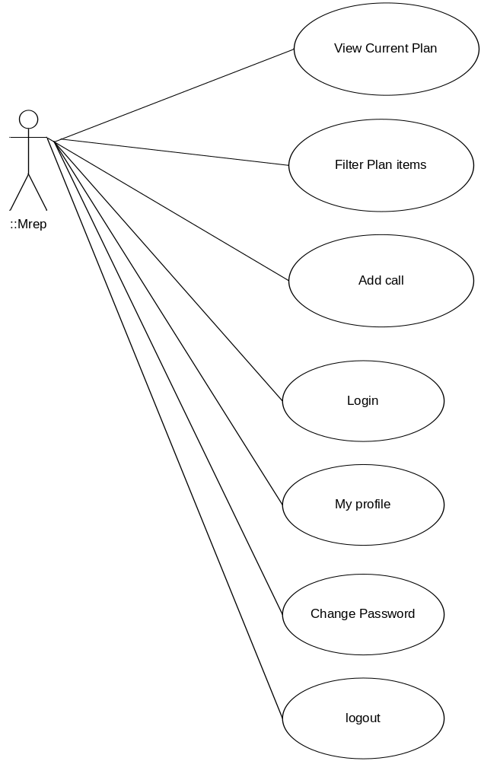

View Current plan:

Actors | Mrep (medical representative)
Description | View current plan
Data
Stimulus (request) | Select current plan from the main menu
Response | The current plan gets displayed with the option of add call
Comments | The user must be of type medical representative

Filter plan items:

Actors | Mrep (medical representative)
Description | Filter plan items
Data
Stimulus (request) | Select current plan from the current plan menu by tier and specialty
Response | The current plan gets displayed with the option of add call
Comments | The user must be of type medical representative

Add new call:

Actors | Mrep (medical representative)
Description | Add new call
Data
Stimulus (request) | Select current plan from then add call for every plan item call describe the medical representive for the doctor indicating all the details  - Customer information (id / name / specialty / Tier / brick )  - Doctor feedback  - Any samples given to the doctor  - Any marketing material given to the doctor  - Nearest pharmacy feedback  - Doctors rank for the medical company (good / normal / bad)
Response | The current plan gets displayed with the option of add call
Comments | The user must be of type medical representative

Login:

Actors | Mrep (medical representative)
Description | Login
Data
Stimulus (request) | When administrator performs successful login he must be able to view all the previous use cases through the GUI
Response | Message indicates success or fail in login
Comments | The user may be administrator or medical rep or manager

View/ update profile:

Actors | Mrep (medical representative)
Description | View / update profile the administrator can view and update his own profile including password  Except user type and username
Data
Stimulus (request) | Select my account then my profile from the main menu
Response | Message indicates success or fail in saving the profile
Comments | The user may be administrator or medical rep or manager

Change password:

Actors | Mrep (medical representative)
Description | Change password
Data
Stimulus (request) | Select my account then change password from the main menu
Response | Message indicates success or fail in saving the new password
Comments | The user may be administrator or medical rep or manager

Log Out:

Actors | Mrep (medical representative)
Description | logout
Data
Stimulus (request) | Select my account then logout from the main menu
Response | Login page displayed
Comments | The user may be administrator or medical rep or manager

Manager tracking

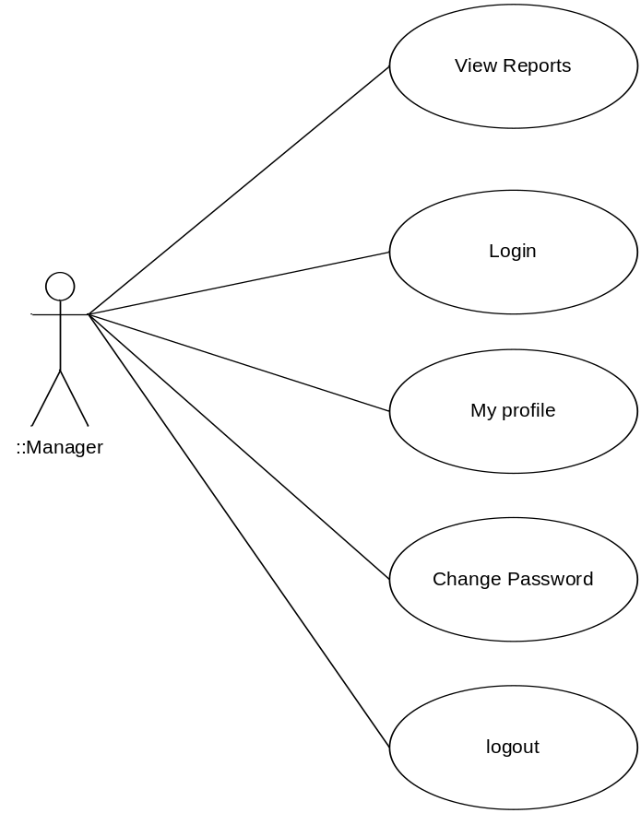

View Reports:

Actors | Manager
Description | View reports
Data
Stimulus (request) | Select required report from the reports menu
Response | The requested report gets displayed on the screen
Comments | The user must be of type manager

Login:

Actors | Manager
Description | Login
Data
Stimulus (request) | When administrator performs successful login he must be able to view all the previous use cases through the GUI
Response | Message indicates success or fail in login
Comments | The user may be administrator or medical rep or manager

View/ update profile:

Actors | Manager
Description | View / update profile the administrator can view and update his own profile including password  Except user type and username
Data
Stimulus (request) | Select my account then my profile from the main menu
Response | Message indicates success or fail in saving the profile
Comments | The user may be administrator or medical rep or manager

Change password:

Actors | Manager
Description | Change password
Data
Stimulus (request) | Select my account then change password from the main menu
Response | Message indicates success or fail in saving the new password
Comments | The user may be administrator or medical rep or manager

Log Out:

Actors | Manager
Description | logout
Data
Stimulus (request) | Select my account then logout from the main menu
Response | Login page displayed
Comments | The user may be administrator or medical rep or manager

Logical View

Overview

The online Medical Representative Management application is divided into layers based on the N-tier architecture
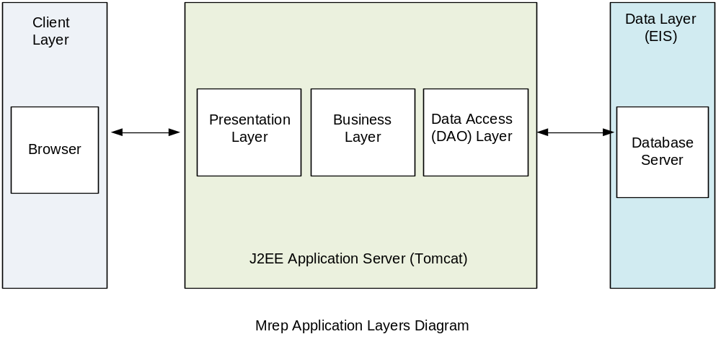

The layering model of the online Medical Representative Management application is based on a responsibility layering strategy that associates each layer with a particular responsibility.
This strategy has been chosen because it isolates various system responsibilities from one another, so that it improves both system development and maintenance.

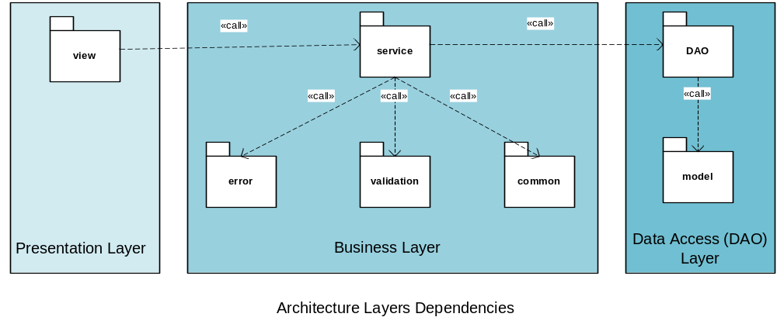

Each layer has specific responsibilities.
- The presentation layer deals with the presentation logic and the pages rendering
- The business layer manages the required operations to execute the required actions.
- The DAO (data access layer) is responsible for the access to the enterprise information system (MYSQL - database)

Architecturally Significant Design Packages

Mrep structure

This part descries the internal structure and dependencies between classes

Analysis Model

Participants:

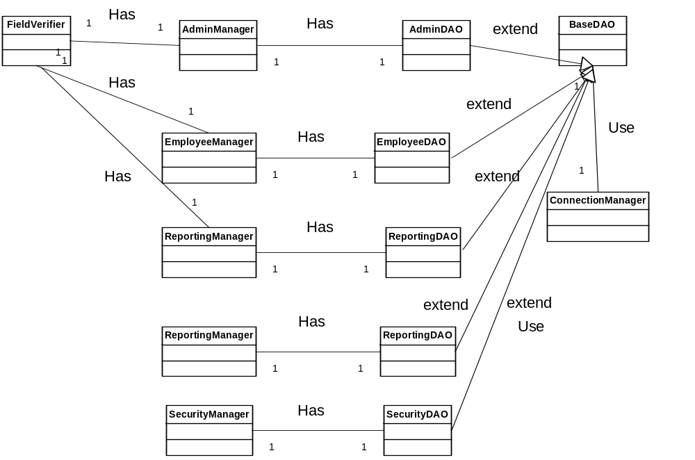

Basic Flow:

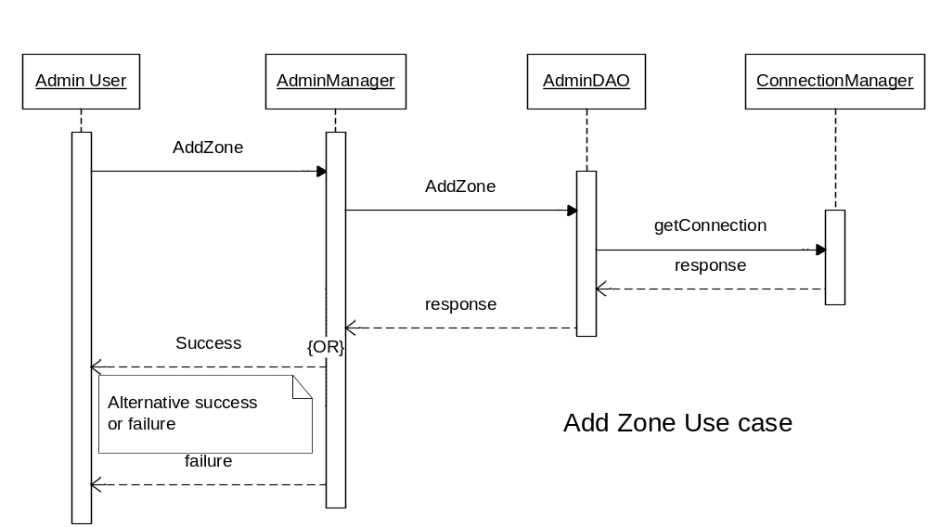

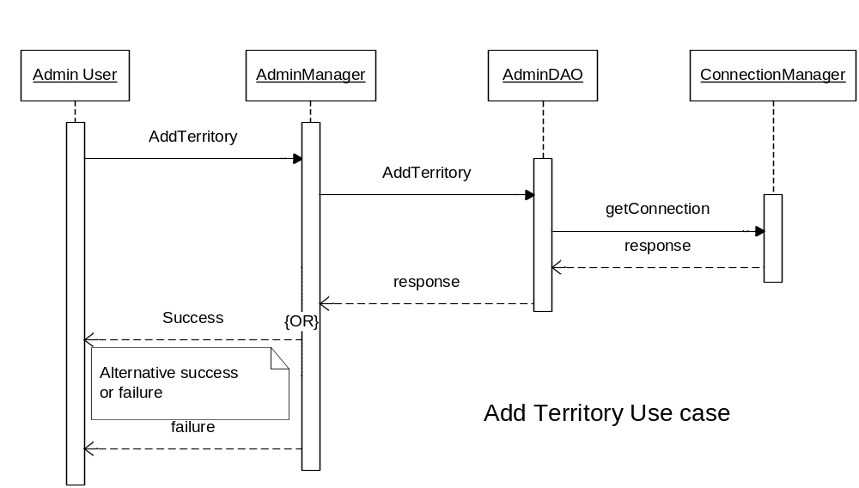

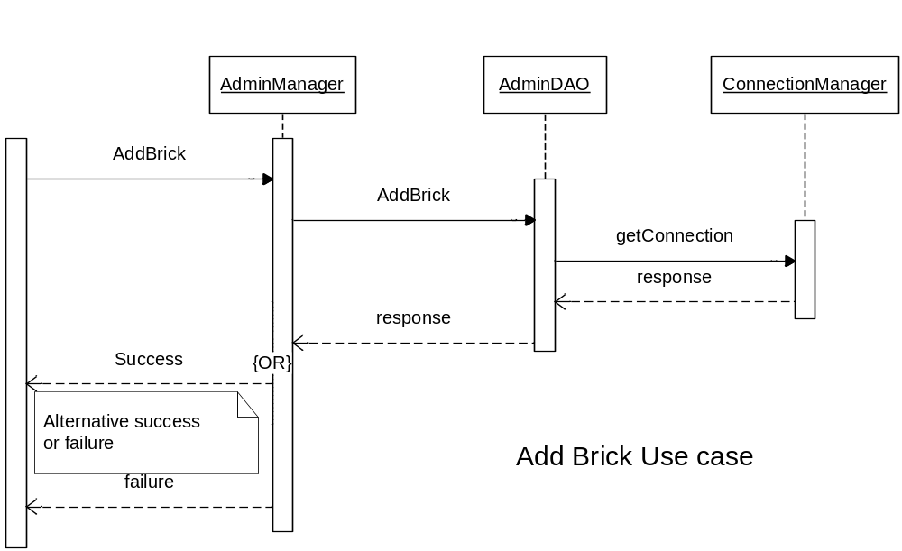

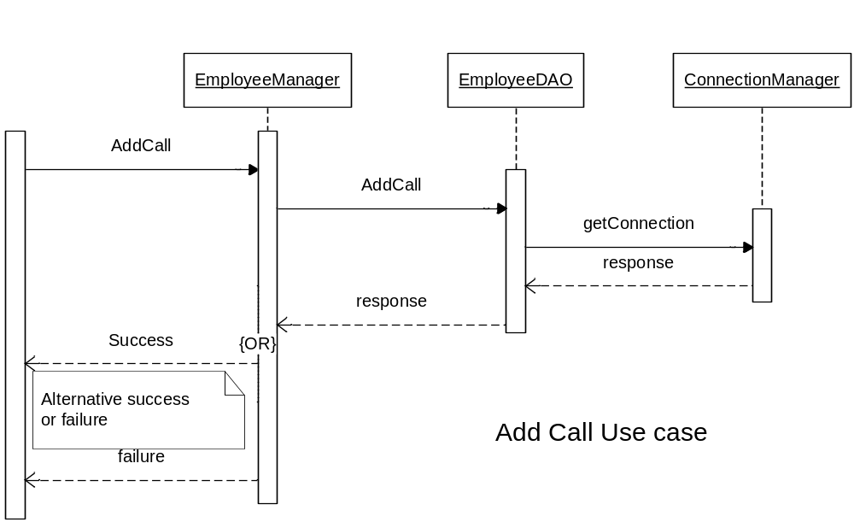

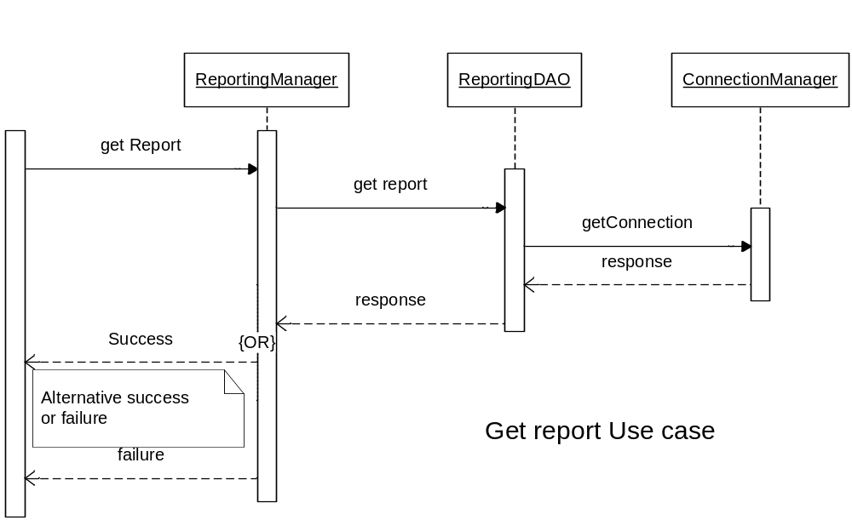

Design Model

Process Delivery

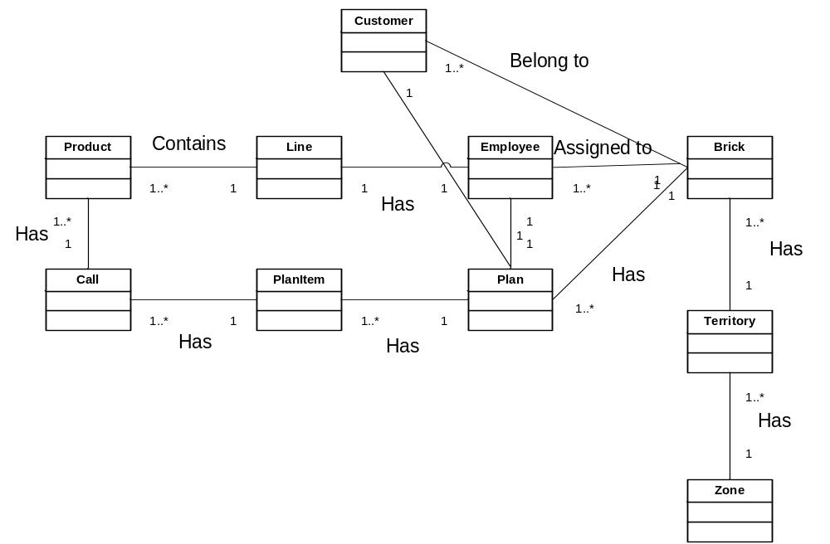

Process View

There’s only one process to take into account. The J2EE model automatically handles threads which are instances of this process.

Deployment View

Global Overview
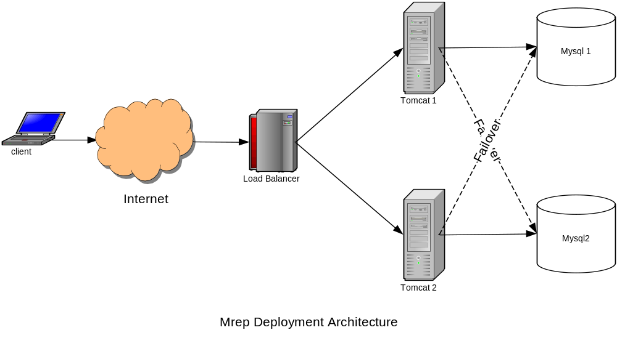

Detailed deployment model with clustering

- One HTTP Server will dispatch requests to two different clustered tomcat servers (load balancing + clustering)
- Two web clustered servers tomcat 1 and tomcat 2
- Two DB clustered servers mysql 1 and mysql 2

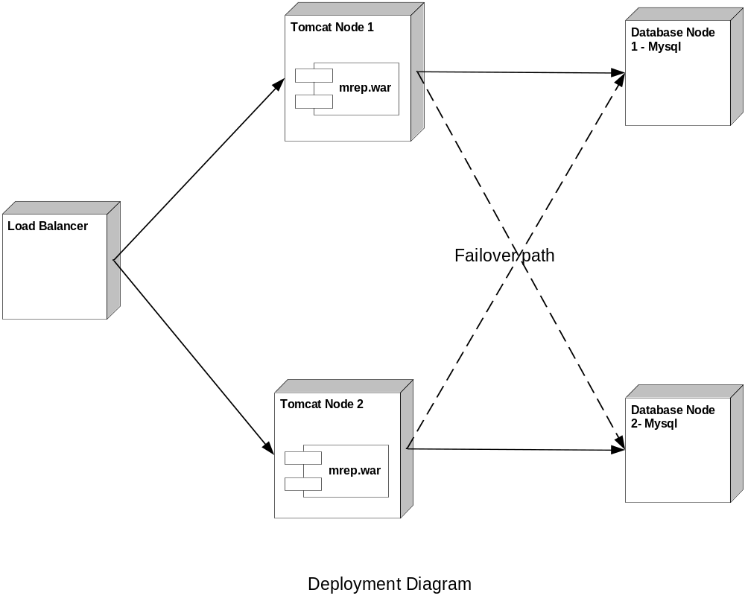

Implementation View

Overview

The Implementation view depicts the physical composition of the implementation in terms of Implementation Subsystems, and Implementation Elements (directories and files, including source code, data, and executable files).
Usually, the layers of the Implementation view do fit the layering defined in the Logical view

It is unnecessary to document the Implementation view in great details in this document. For further information, refer to the Online Medical Representative Management 1.0 workspace in Rational Software Architect.

Layers

Presentation Layer
The Presentation layer contains all the components needed to allow interactions with an end-user. It encompasses the user interface

Business Layer
The business layer contains implementation for all the required functions

DAO Layer
The data access layer contains all the required code to access the db DB

Data View

The ERD for all the used tables in the mrep application:
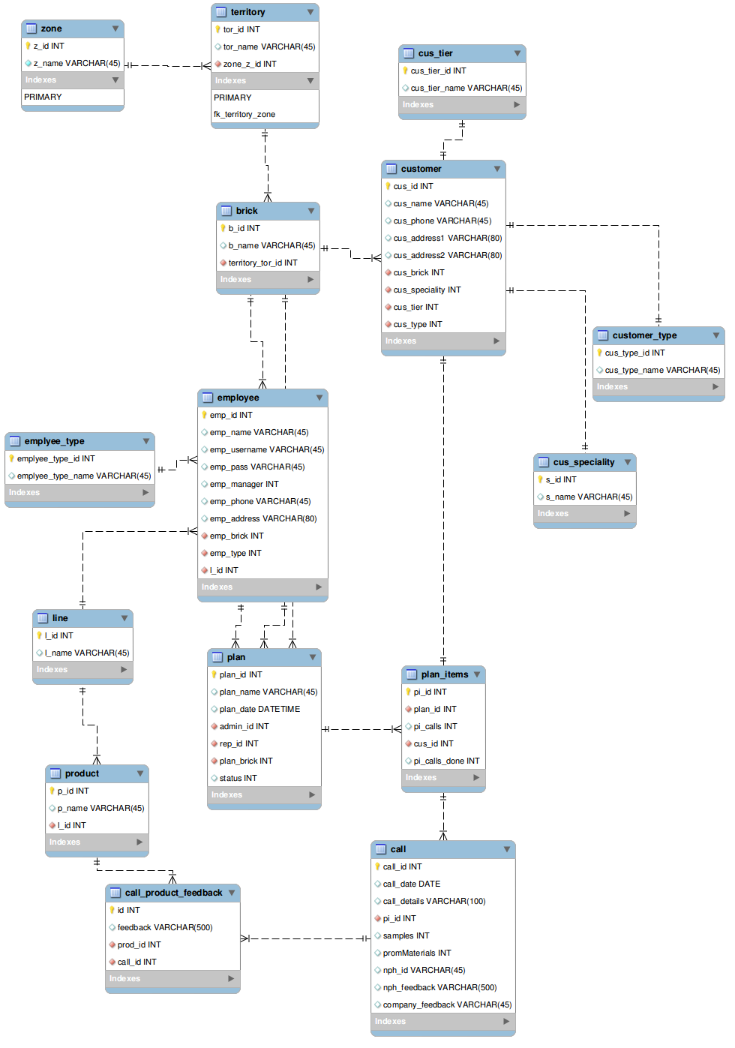

Size and Performance

Volumes:
- Estimated : 100 a day, with peaks in the early morning
- Mrep Inc registered individual customer : about 10000
- Mrep Inc employees : about 100

Performance:
- Time to add call with all the details : less that 1 min required

Quality

As far as the mrep application is concerned, the following quality goals have been identified:

Scalability:
- Description : System’s reaction when user demands increase
- Solution : J2EE application servers support several workload management techniques / new instances can be added without stop the application
Reliability, Availability:
- Description : Transparent failover mechanism, mean-time-between-failure
- Solution : : J2EE application server supports load balancing and clusters / the deployment diagram indicate the failover paths
Portability:
- Description : Ability to be reused in another environment
- Solution : The system will be fully J2EE compliant and thus can be deploy onto any J2EE application server
Security:
- Description : Authentication and authorization mechanisms
- Solution : J2EE native security mechanisms may be reused

