1. Except A1, there is no significant difference between the treatment (A3, B1, and B3) and control group (EE). The sample is balanced in terms of pre-treatment electricity consumption, gender, internet access, and living conditions. This fits our assumption of random sampling.

In the A1EE logit model, there is significant difference between treatment (A1) and control group (EE) in electricity consumption in July and December 2009, as well as gender at 5% level.

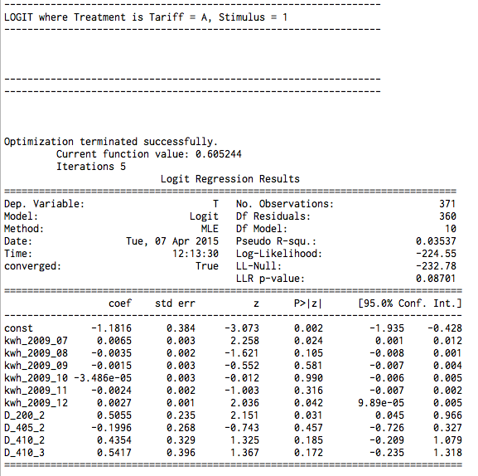

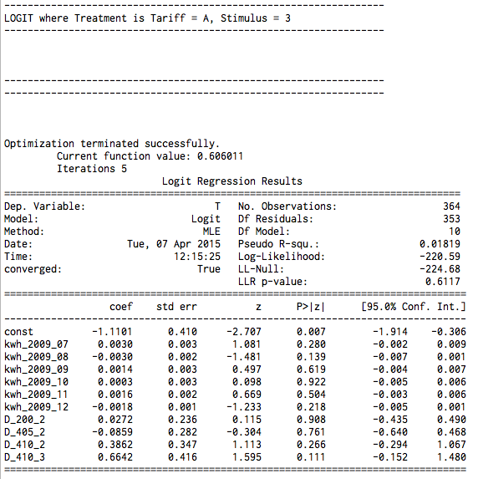

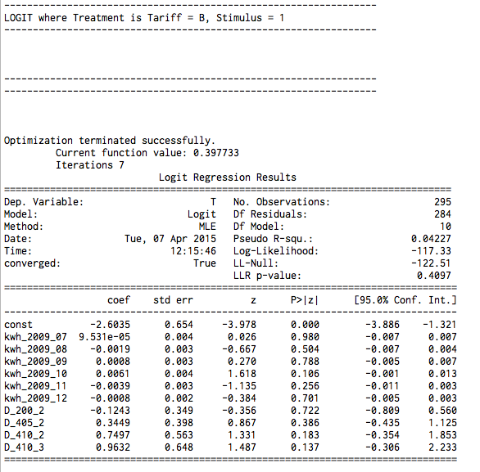

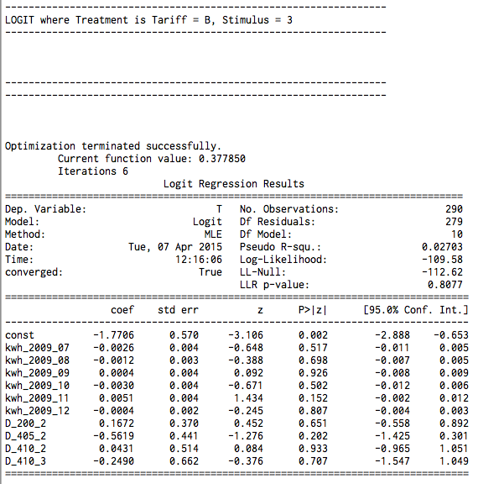

2. Benefit: Including all the available survey variables can help us to check if the assignment of treatment and control is randomized or not. In other words, it can help us to check if the two groups are balanced in terms of every possible attribute.

Potential problems: The major problem is collinearity since the available survey variables might be correlated with each other.

3. It would be appropriate to use a subset of survey data when 1) the subset includes all major determinants of treatment assignment, 2) the subset of variables are not correlated with each other, and 3) data are available for this subset.