Artificial Neural Networks
1. HEBB NET
The earliest and simplest learning rule for a neural net is generally known as the Hebb rule. Hebb proposed that learning occurs by modification of the synapse strengths (weights) in a manner such that if two interconnected neurons are both "on" at the same time, then the weight between those neurons should be increased. The original statement only talks about neurons firing at the same time (and does not say anything about reinforcing neurons that do not fire at the same time). However, a stronger form of learning occurs if we also increase the weights if both neurons are "off" at the same time. We use this extended Hebb rule because of its improved computational power and shall refer to it as the Hebb rule.
We shall refer to a single-layer (feedforward) neural net trained using the (extended) Hebb rule as a Hebb net. The Hebb rule is also used for training other specific nets that are discussed later. Since we are considering a single-layer net, one of the interconnected neurons will be an input unit and one an output unit (since no input units are connected to each other, nor are any output units interconnected). If data are represented in bipolar form, it is easy to express the desired weight update as
If the data are binary, this formula does not distinguish between a training pair in which an input unit is "on" and the target value is "off" and a training pair in which both the input unit and the target value are "off." Examples 1 and 2 (in Section 1.2) illustrate the extreme limitations of the Hebb rule for binary data. Example 3 shows the improved "performance achieved by using bipolar representation for both the input and target values.

1.1 Algorithm
Step 0. Initialize all weights:
wi = 0 (i = 1 to n).
Step 1. For each input training vector and target output pair, s : t, do steps 2-4.
Step 2. Set activations for input units:
xi = si (i = 1 to n).
Step 3. Set activation for output unit:
y= t.
Step 4. Adjust the weights for
Adjust the bias:
Note that the bias is adjusted exactly like a weight from a "unit" whose output signal is always 1. The weight update can also be expressed in vector form as:
This is often written in terms of the weight change , , as
and
There are several methods of implementing the Hebb rule for learning. The foregoing algorithm requires only one pass through the training set; other equivalent methods of finding the weights are described later, where the Hebb rule for pattern association (in which the target is a vector) is presented.

1.2 Application
Bias types of inputs are not explicitly used in the original formulation of Hebb learning. However, they are included in the examples in this section (shown as a third input component that is always 1) because without them, the problems discussed cannot be solved.
Logic functions
Example1: A Hebb net for the And function: binary inputs and targets
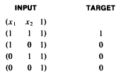
For each training input: target, the weight change is the product of the input vector and the target value, i.e.,
The new weights are the sum of the previous weights and the weight change. Only one iteration through the training vectors is required. The weight updates for the first input are as follows:
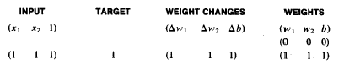
The response of the net will now be correct for the first input pattern. Presenting the second, third, and fourth training inputs shows that because the target value is 0, no learning occurs. Thus, using binary target values prevents the net from learning any pattern for which the target is "off":
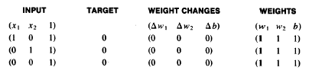

Example2: A Hebb net for the And function: binary inputs, bipolar targets
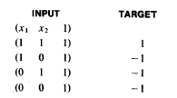
Presenting the first input, including a value of 1 for the third component, yields the following:
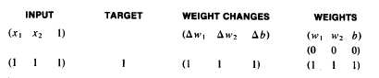
The response of the net will now be correct for the first input pattern.
Presenting the second, third, and fourth training patterns shows that learning continues for each of these patterns (since the target value is now -1, rather than 0, as in Example 1).
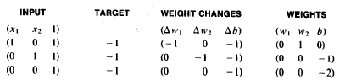
However, these weights do not provide the correct response for the first input pattern.
The choice of training patterns can play a significant role in determining which problems can be solved using the Hebb rule. The next example shows that the And function can be solved if we modify its representation to express the inputs as well as the targets in bipolar form. Bipolar representation of the inputs and targets allows modification of a weight when the input unit and the target value are both "on" at the same time and when they are both "off" at the same time. The algorithm is the same as that just given, except that now all units will learn whenever there is an error in the output.

Example3: A Hebb net for the And function: bipolar inputs and targets
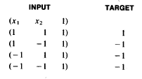
Presenting the first input, including a value of 1 for the third component, yields the following:
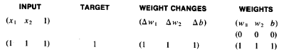
The response of the net will now be correct for the first input point (and also, by the way, for the input point (1, -1)). Presenting the second input vector and target results in the following situation:
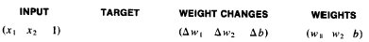
The response of the net will now be correct for the first two input points, (1,1) and (1, -1), and also, incidentally, for the input point (-1, 1). Presenting the third input vector and target yields the following:
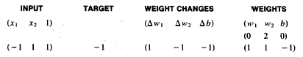
The response of the net will now be correct for the first three input points (and also, by the way, for the input point (-1,-1)). Presenting the last point, we obtain the following:
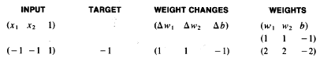

Hebbian Learning Rule
For the Hebbian learning rule the learning signal is equal simply to the neuron's output. We have
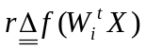
The increment of the weight vector becomes
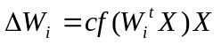
The single weight is adapted using the following increment:
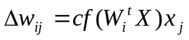
This can be written briefly as:
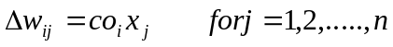
This learning rule requires the weight initialization at small random values around wi=0 prior to learning. The Hebbian learning rule represents a purely feedforward, unsupervised learning. The rule implements the interpretation of the classic statement : "When an axon of cell A is near enough to excite a cell B and repeatedly or persistently takes place in firing it, some growth process or metabolic change takes place in one or both cells such that A's efficiency, as one of the cells firing , is increased."
The rule states that if the crossproduct of output and input, or correlation term oixj is positive, this results in an increase of weight wij; otherwise the weight decreases. It can be seen that the output is strengthened in turn for each input presented. Therefore, frequent input patterns will have most influence at the neuron's weight vector and will eventually produce the largest output.
Since its inception, the Hebbian rule has evolved in a number of directions. In some cases, the Hebbian rule needs to be modified to counteract unconstrained growth of weight values, which takes place when excitations and responses consistently agree in sign. This corresponds to the Hebbian learning rule with saturation of the weights at a certain, preset level. Throughout this text note that other learning rules often reflect the Hebbian rule principle. Below, most of the learning rules are illustrated with simple numerical examples. Note that the subscript of the weight vector is not used in the examples since there is only a single weight vector being adapted there.
Example: This example illustrates Hebbian learning with discrete and continuous activation functions of a very simple network. Assume the network shown in the following figure with the initial weight vector:
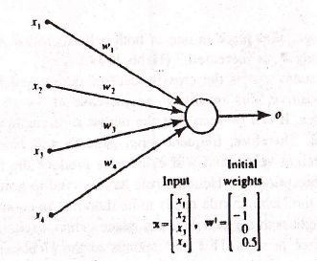

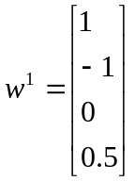

Needs to be trained using the set of three input vectors as below:
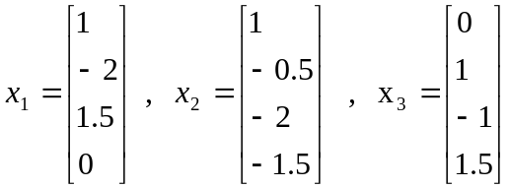
For an arbitrary choice of learning constant c=1. since the initial weights are of nonzero value, the network has apparently been trained beforehand. Assume first that bipolar discrete neurons are used, and thus f(net)=sign(net).

Step1: Input x₁ applied to the network results in activation net₁ as below:
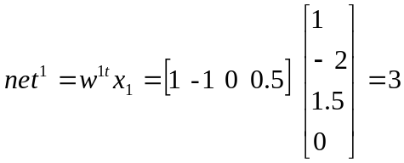
The update weights are:
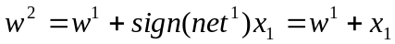
and plugging numerical values we obtain:
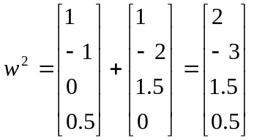
where the superscript on the right side of the expression denotes the number of the current adjustment step:
Step2: This learning step is with x₂ as input:
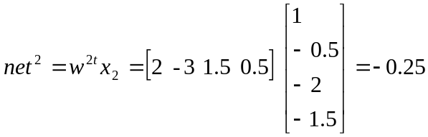
the updated weights are:
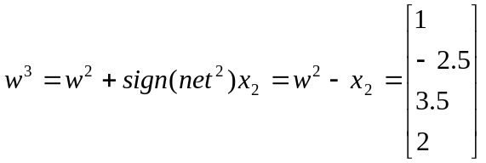
Step3: For input x₃, we obtain in this step:
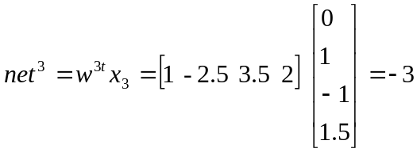
the updated weights are:
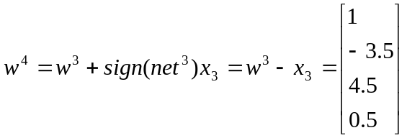
It can be seen that learning with discrete f(net) and c=1 results in adding or subtracting the entire input pattern vectors to and from the weight vector, respectively. In the case of a continuous f(net), the weight incrementing / decrementing vector is scaled down to a fractional value of the input pattern.
Revisiting the Hebbian learning example, with continuous bipolar activation function f(net), using input x₁ and initial weights w₁, we obtain neuron output values and the updated weights for 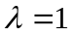 as summarized in step1. the only difference compared with the previous case is that instead of f(net)=sign(net), now the neuron's response is computed from the following function:
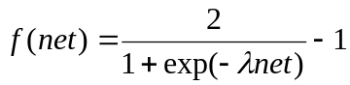
Step1: Input x₁ applied to the network results in activation net₁ as below:
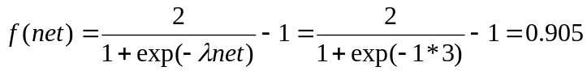
The update weights are:
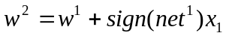
and plugging numerical values we obtain:
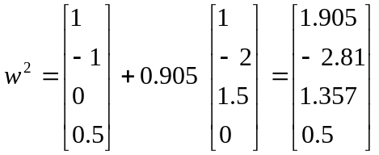
where the superscript on the right side of the expression denotes the number of the current adjustment step:
Step2: This learning step is with x₂ as input:
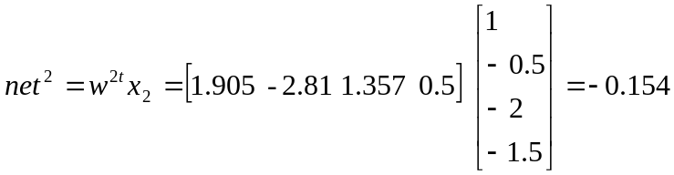
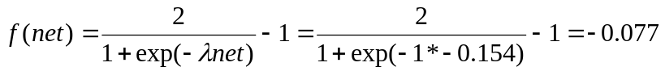
the updated weights are:
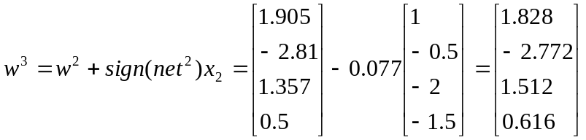
Step3: For input x₃, we obtain in this step:
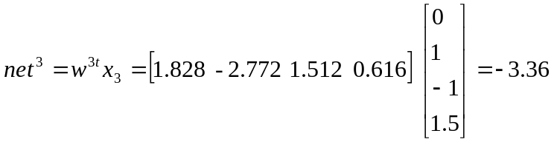
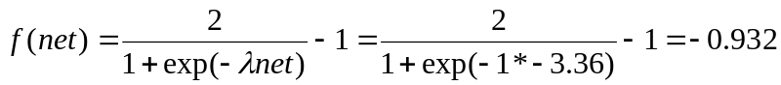
the updated weights are:
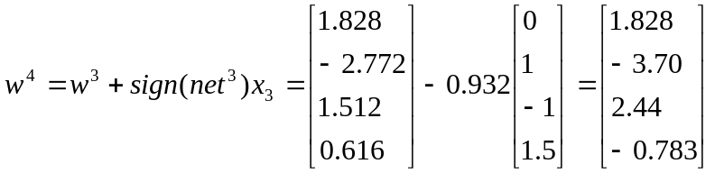

Perceptron Learning Rule
For the perceptron learning rule, the learning signal is the difference between desired and actual neuron's response. Thus, learning is supervised and the learning signal is equal to:
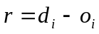
Where 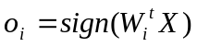, and d_{i}, is the desired response as shown in figure. weight adjustments in this method, 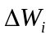, and 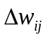 , are obtained as follows:
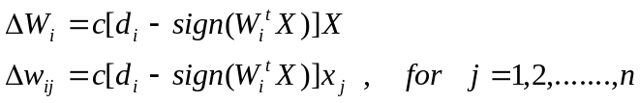
……..1
……..2
Note that this rule is applicable only for discrete neuron response, and the
Relationships express the rule for the bipolar discrete case. Under this rule, weights are adjusted if and only if , is incorrect. Error as a necessary condition of learning is inherently included in this training rule. Obviously, since the desired response is either 1 or -1, the weight adjustment (1) reduces to
……..3
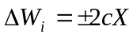
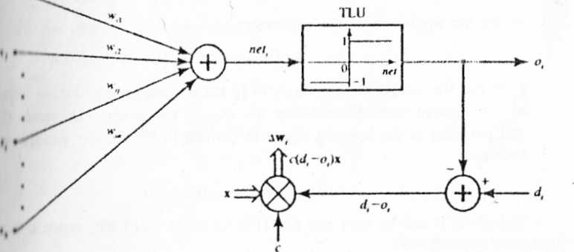
Where a plus sign is applicable when d_{i}=1, and sign(W^{t}X)=-1, and a minus sign is applicable when d_{i}=-1, and sign(W^{t}X)=1. The reader should notice that the weight adjustment formula (3) cannot be used when 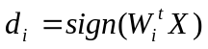. The weight adjustment is inherently zero when the desired and actual responses agree. As we will see throughout this text, the perceptron learning rule is of Central importance for supervised learning of neural networks. The weights are initialized at any values in this method.
Perceplron learning rule.

EXAMPLE: This example illustrates the perceptron learning rule of the network shown in Figure . The set of input training vectors is as follows:
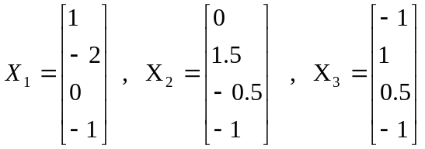
and the initial weight vector w¹ is assumed identical as in Example hebbian learning rule. The learning constant is assumed to be c = 0.1. The teacher's desired responses for x₁, x₂,x₃ are d₁= -1,d₂ = - 1, and d₃ = 1, respectively. The learning according to the perceptron learning rule progresses as follows.

Step1: Input is x₁ , desired output is d₁:
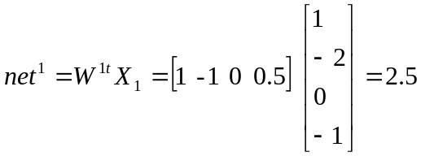
Correction in this step is necessary since d₁ sign (2.5). We thus obtain
updated weight vector,
w² = w¹ + 0.1(-1 - l)x₁
Plugging in numerical values we obtain
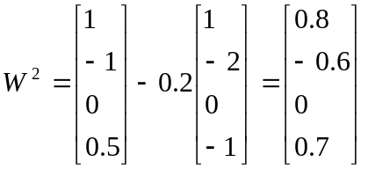

Step 2: Input is x₂, desired output is d₂. For the present weight vector w² we compute the activation value net² as follows:
net²= w^{2t}x₂ = [0 1.5 -0.5 -1 ] 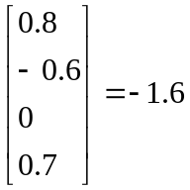
Correction is not performed in this step since d₂ = sign (-1.6)
Step 3: Input is x₃, desired output is d₃ , present weight vector is w³. Computing net³ we obtain:
net³ = w^{3t}x₃ = [ - 1 1 0.5 - 1] 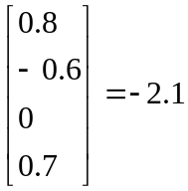
Correction is necessary in this step since d₃ sign (-2.1). The updated weight values are, w⁴ = w³ + 0.1 ( 1 + 1 ) x₃
or 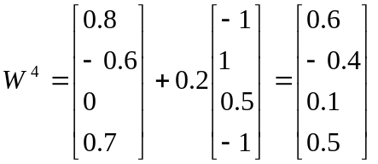
This terminates the sequence of learning steps unless the training set is recycled. It is not a coincidence that the fourth component of x₁, x₂, and x₃ in this example is invariable and equal to -1. Perceptron learning requires fixing of one component of the input vector, although not necessarily at the -1 level.
The reader may ask what this training has achieved, if anything. At this
point the answer can be very preliminary. The real objectives of training
and its significance will require more thorough study later in this text. Our
preliminary answer for now is that if the same training set is resubmitted,
the respective output error should be, in general, smaller. Since the binary
perceptron does not provide fine output error information, we may look at
its input. The reader may verify it to see that net⁴ = 0.9 obtained after three
training steps as a response to resubmitted pattern x₁, is closer to net < 0
than the initial activation value in the first training step, net¹ = 2.5. By
observing successive net values for continued training we would see the
trend of improving answers.

Delta Learning Rule
The delta learning rule is only valid for continuous activation functions, and in the supervised training mode. The learning signal for this rule is called delta and is defined as follows
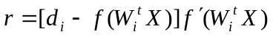 ………..1
The term 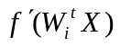 is the derivative of the activation function f(net) computed for 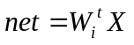. The explanation of the delta learning rule is shown in the following figure. This learning rule can be readily derived from the condition of least squared error between o_{i} and d_{i} Calculating the gradient vector with respect to w_{i} of the squared error defined as:
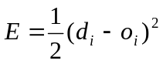 …………2
The weight adjustment becomes:
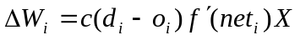 …………..3

The constant c has been assumed to be arbitrary constant. The weights are initialized at any values for this method of training. The delta rule was introduced only recently for neural network training. This rule parallels the discrete perceptron training rule. It also can be called the continuous perceptron training rule. The delta learning rule can be generalized for multilayer networks.
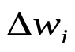

x₁

x₂

x_{j}

x_{n}
w₁₁

w₁₂

w_{1j}

w_{1n}

f(net₁)

Continuous
perceptron
o_{i}
f'(net₁)
d_{i}
d_{i}-o_{i}
r
c
x

+ - -
+

EXAMPLE: This example discusses the delta learning rule as applied to the network shown in figure. Training input vectors, desired responses, and initial weights are identical to those in Example perceptron learning rule. The delta learning requires that the value f'(net) be computed in each step. For this purpose, we can use the following result derived:
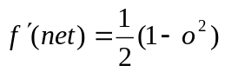
valid for the bipolar continuous activation function. The result is useful since it expresses the slope of The activation function through the neuron's output signal. Using (3) for the arbitrarily chosen learning constant c=0.1. and for the bipolar continuous activation function f(net) , the delta rule training can be summarized as follows.
Step 1: Input is vector x₁, initial weight vector is w¹
net¹=w^{1t}x₁ =2.5
o¹= f(net¹)
where
then o¹= f(net¹) = 0.848
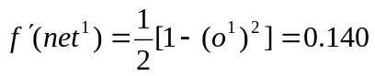
w² = c (d₁ – o¹) f'(net¹)x₁ + w¹
= [0.974 -0.948 0 0.526]^{t}

Step2: Input is vector x₂ , weight vector is w² :
Net²=w^{2t}x₂ = -1.948
o²= f(net²) = -0.75
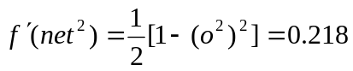
w³ = c (d₂ – o²) f'(net²)x₂ + w²
= [0.974 -0.956 0.002 0.531]^{t}

Step3 : Input is vector x₃ , weight vector is w³ :
Net³=w^{3t}x₃ = -2.46
o³= f(net³) = -0.842
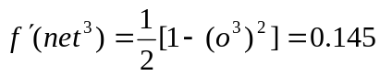
w⁴ = c (d₃ – o³) f'(net³)x₃ + w³
= [0.947 -0.929 0.016 0.505]^{t}
Obviously, since the desired values are 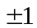 in this example, the corrections will be performed in each step, since d₁ , -f(net₁) 0 throughout the entire training. This method usually requires small c values, since it is based on moving the weight vector in the weight space in the negative error gradient direction.

Widrow-Hoff Learning Rule
The Widrow-Hoff learning rule is applicable for the supervised training of neural networks. It is independent of the activation function of neurons used since it minimizes the squared error between the desired output value d_{i} and the neuron's activation value 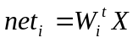. The learning signal for this rule is defined as follows
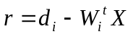 --------1
The weight vector increment under this learning rule is:
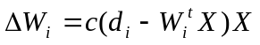 ---------2
or, for the single weight the adjustment is:
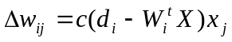 for j=1,2,……,n -----------3

This rule can be considered a special case of the delta learning rule. Indeed, assuming in equation1 in delta learning rule that 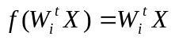, or the activation function is simply the identity function f(net) = net, we obtain f'(net) = 1, and (equation1 in delta learning rule) becomes identical to (1). This rule is sometimes called the LMS (least mean square) learning rule. Weights are initialized at any values in this method.

Example: Perform two training steps using the widrow-Hoff learning rule for c=0.25 and data pairs , and the initial weights are:
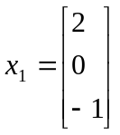 , d₁ = -1 , 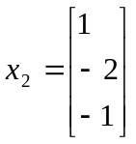 , d₂ = 1 w₁ = [1 0 1]
Step 1: Input is vector x₁, initial weight vector is w¹
net¹=w^{1t}x₁ = 1
f(net¹) = net¹
w² = w¹ + c (d₁ – net¹)x₁
= [ 1 0 1] + 0.25 ( -1 -1) 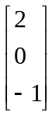
= [ 0 0 1.5]
Step 2: Input is vector x₂, weight vector is w²
net²=w^{2t}x₂ = -1.5
w³ = w² + c (d₂ – net²)x₂
= [0.625 -1.25 0.875]
Correlation Learning Rule
By substituting r=d_{i} , into the general learning rule (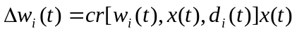) we obtain the correlation learning rule. The adjustments for the weight vector and the single weights, respectively, are
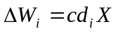
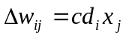 for j =1 ,2,…..,n
This simple rule states that if d_{i}, is the desired response due to x_{j}, the corresponding weight increase is proportional to their product. The rule typically applies to recording data in memory networks with binary response neurons. It can be interpreted as a special case of the Hebbian rule with a binary activation function and for o_{i}=d_{i}. However, Hebbian learning is performed in an unsupervised environment, while correlation learning is supervised. While keeping this basic difference in mind, we can observe that Hebbian rule weight adjustment and correlation rule weight adjustment become identical. Similar to Hebbian learning, this learning rule also requires the weight initialization w = 0.

Winner-Take-All Learning Rule
This learning rule differs substantially from any of the rules discussed so
far in this section. It can only be demonstrated and explained for an ensemble
of neurons, preferably arranged in a layer of p units. This rule is an example of
competitive learning, and it is used for unsupervised network training. Typically, winner-take-all learning is used for learning statistical properties of inputs. The learning is based on the premise that one of the neuron ; in the layer, say the m'th, has the maximum response due to input x. as shown in the following figure. This neuron is declared the winner. As a result of this winning event, the weight vector w_{m}
Wm= [w_{m1} w_{m2} …… w_{mn}]^{t}
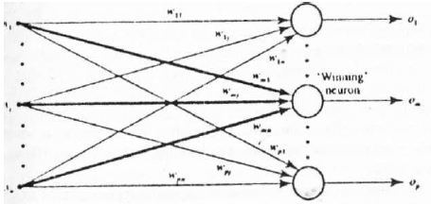
containing weights highlighted in the figure is the only one adjusted in the given unsupervised learning step. Its increment is computed as follows:
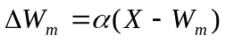 ----------1
or, the individual weight adjustment becomes
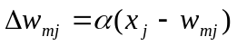 for j =1,2,……,n ----------2
where > 0 is a small learning constant, typically decreasing as learning progresses. The winner selection is based on the following criterion of maximum activation among all p neurons participating in a competition:
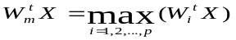 -------------3
This criterion corresponding to finding the weight vector that is closest to the input x. The rule (1.2) then reduces to incrementiry w_{m} by a fraction of x-w_{m}. Note that only the winning neuron fan in weight vector is adjusted. Alter the adjustment. its fan in weights tend to better estimate the input pattern in question. In this method, the winning neighborhood is sometimes extended beyond the single neuron winner so that it includes the neighboring neurons. Weights are typically initialized at random values and their lengths are normalized during learning in this method.

Outstar Learning Rule
Outstar learning rule is another learning rule that is best explained when neurons are arranged in a layer. This rule is designed to produce a desired response d of the layer of p neurons. The rule is used to provide learning of repetitive and characteristic properties of input/output relationships. This rule is concerned with supervised learning : however, it is supposed to allow the network to extract statistical properties of the input and output signals. The weight adjustments in this rule are computed as follows:
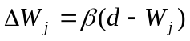 ----------------1
or, the individual weight adjustments are:
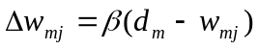 for m=1,2,…..,p ---------------------2
Note that in contrast to any learning rule discussed so far, the adjusted weights are fanning out of the j'th node in this learning method and the weight vector in (1) is defined accordingly as:
w_{j}=[w_{1j} w_{2j} …… w_{pj}]^{t}
Arbitrarily selectable  is a small positive learning constant decreasing during training. The rule typically ensures that the output pattern becomes similar to the undistorted desired output after repetitively applying (1,2) on distorted output versions.

