**Online Bus Ticket Booking System**

Hamza Tarar

Department of Computer Science, Forman Christian College

COMP 111: Programming II

Ma’am Samia Asloob Qureshi

June 19, 2022

**Project-Documentation**

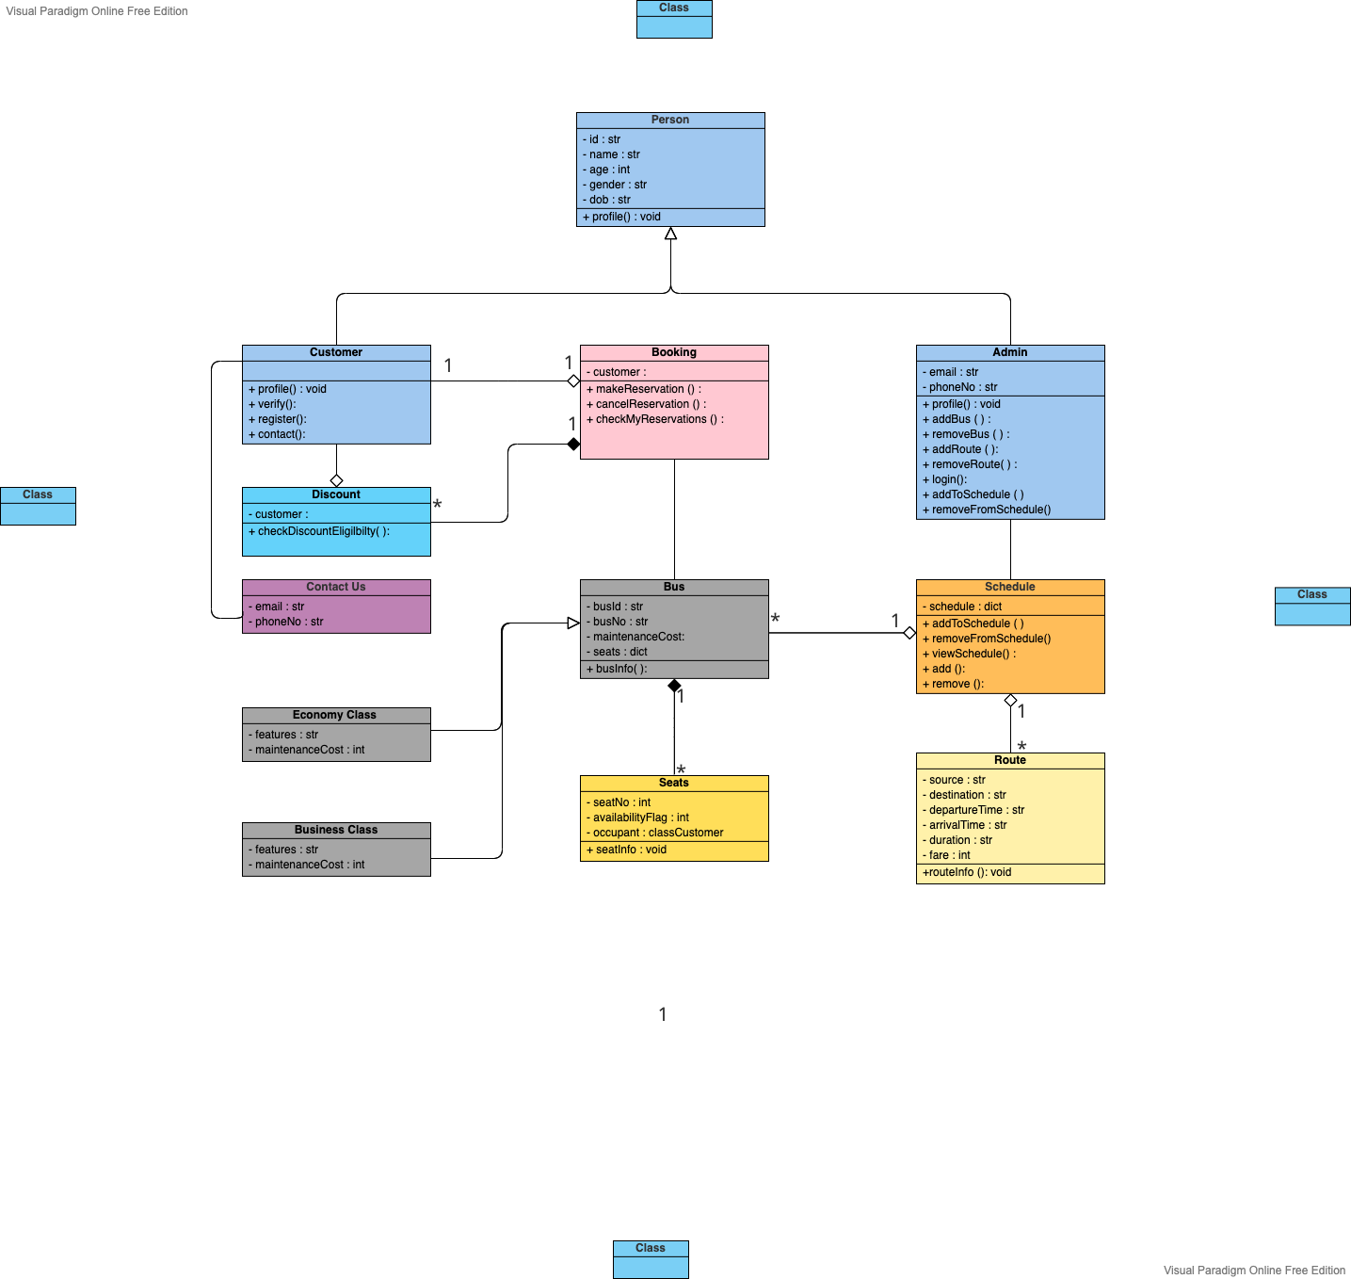**UML**

**Classes**

Following are the classes in this project

**Person**: Id, Name, Age, Gender, Dob

**Customer:** Phone Number

**Admin**: Email, Phone Number

**Booking:** Customer

**Discount:** Customer

**Schedule:** Schedule

**Bus:** bus Id, bus No type, seats

**Economy Class:** features (class attribute), Maintenance Cost

**Business Class:** features (class attribute), Maintenance Cost

**Seats**: Seat No, availability Flag, occupant

**Route:** to, from, arrival Time, Departure Time, Total Time, Fare

**Contact Us:** email, phone Number

**Menu**

**Customer:**

1. Make a new Reservation
2. Cancel Reservation
3. Check My Reservations
4. View Schedule
5. Contact Us
6. Check for Discount

**Admin:**

1. View Schedule
2. Add Bus
3. Remove Bus
4. Add Route
5. Remove Route
6. Edit Schedule

**Working**

**Make a new Reservation**

When customer login, he can make a new reservation. When he selects make a new reservation, then he has to select his route by entering route id which can be obtain from schedule. Then he has to select bus type on which he wishes to travel. Customer gets a discount of 10% if he reserves more than 3 seats.

**Cancel Reservation**

A customer can cancel his reservation by selecting cancel reservation option and entering his ticket number.

**Check My Reservations**

Customer can check his pervious reservations by entering his CNIC.

**View Schedule**

Customer can check schedule of buses.

**Contact Us**

When customer click contact us, he gets email and phone number to contact.

**Admin**

When admin logs in he can, view schedule, add and remove buses and routes.

Id of Economy class bus starts with e and b for business class.