NAMES: MANIRAGUHA ELYSE FILS

CLASS : EAT-B

REG NUMBER: 21RP 03289

COLLEGE : RP-IPRC MUSANZE

PREPARED MINI PROJECT.

1.PROJECT NAME:SAFETY GLOVES FOR BLIND PEOPLE.

2.IMPORTANCE: The HC-SR04 ultrasonic sensor uses SONAR to determine the distance of an object just like the bats do. It offers excellent non-contact range detection with high accuracy and stable readings in an easy-to-use package from 2 cm to 400 cm or 1” to 13 feet.

For presence detection, ultrasonic sensors detect objects regardless of the color, surface, or material (unless the material is very soft like wool, as it would absorb sound.) To detect transparent and other items where optical technologies may fail, ultrasonic sensors are a reliable choice.

3. COMPNENTS NEEDED IN THIS MY PROJECT.

1.ARDUINO UNO BOARD: The Arduino Uno is an open-source microcontroller board based on the Microchip ATmega328P microcontroller and developed by Arduino.cc and initially released in 2010. The board is equipped with sets of digital and analog input/output pins that may be interfaced to various expansion boards and other circuits.

2.ultrsonic sensor: Ultrasonic transducers and ultrasonic sensors are devices that generate or sense ultrasound energy. They can be divided into three broad categories: transmitters, receivers and transceivers.

3.LED:  light-emitting diode is a semiconductor device that emits light when current flows through it. Electrons in the semiconductor recombine with electron holes, releasing energy in the form of photons. The color of the light is determined by the energy required for electrons to cross the band gap of the semiconductor.

4. BUZZER: buzzer or beeper is an audio signaling device, which may be mechanical, electromechanical, or piezoelectric. Typical uses of buzzers and beepers include alarm devices, timers, train and confirmation of user input such as a mouse click or keystroke.

5.JUMPER WIRES:  jump wire is an electrical wire, or group of them in a cable, with a connector or pin at each end, which is normally used to interconnect the components of a breadboard or other prototype or test circuit, internally or with other equipment or components, without soldering.

6. BREAD BOARD:  breadboard, solderless breadboard, or protoboard is a construction base used to build semi-permanent prototypes of electronic circuits. Unlike a perfboard or stripboard, breadboards do not require soldering or destruction of tracks and are hence reusable.

4.CIRCUIT DIAGRAM

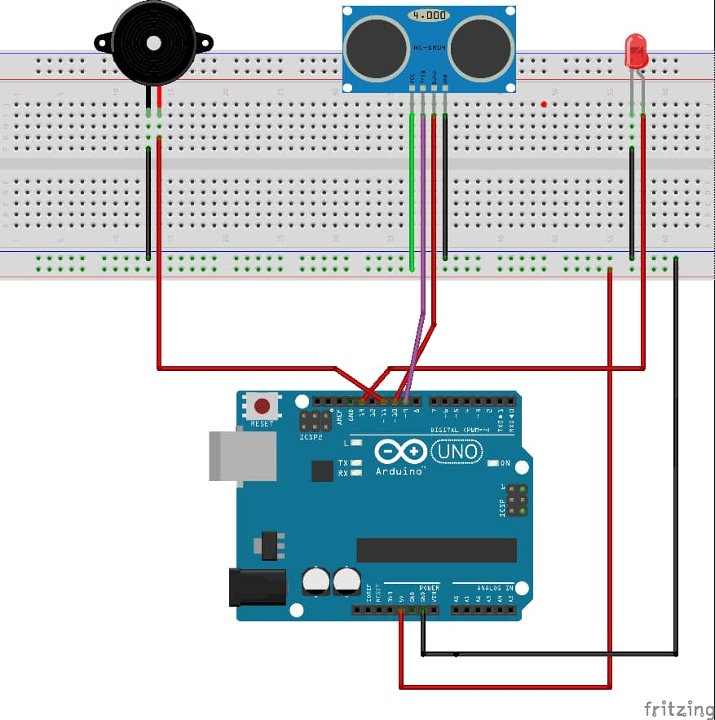

**SOURCE CODE:**

// defines pins numbers

const int trigPin = 9;

const int echoPin = 10;

const int buzzer = 11;

const int ledPin = 13;

// defines variables

long duration;

int distance;

int safetyDistance;

void setup() {

pinMode(trigPin, OUTPUT); // Sets the trigPin as an Output

pinMode(echoPin, INPUT); // Sets the echoPin as an Input

pinMode(buzzer, OUTPUT);

pinMode(ledPin, OUTPUT);

Serial.begin(9600); // Starts the serial communication

}

void loop() {

// Clears the trigPin

digitalWrite(trigPin, LOW);

delayMicroseconds(2);

// Sets the trigPin on HIGH state for 10 micro seconds

digitalWrite(trigPin, HIGH);

delayMicroseconds(10);

digitalWrite(trigPin, LOW);

// Reads the echoPin, returns the sound wave travel time in microseconds

duration = pulseIn(echoPin, HIGH);

// Calculating the distance

distance= duration*0.034/2;

safetyDistance = distance;

if (safetyDistance <= 5){

digitalWrite(buzzer, HIGH);

digitalWrite(ledPin, HIGH);

}

else{

digitalWrite(buzzer, LOW);

digitalWrite(ledPin, LOW);

}

// Prints the distance on the Serial Monitor

Serial.print("Distance: ");

Serial.println(distance);

}

**Youtube link:**

https://youtu.be/79oKcn8ScM0