Monitoring system
Software Requirements Specification

Contact person:
Igor Belsky
igor.belsky@vrpconsulting.com

Purpose of the document
The document describes the Monitoring System user and functional requirements. The following stakeholders should read this document:

- product owner;
- project manager;
- business analysts;
- developers;
- quality assurance engineers.

Changelog

Date | Version | Author | Description
27.07.2018 | 0.1.0 | I.Belsky | First version

Contents
Overview 5
Logs and projects management use cases 5
UC-LG-01: Log in to system 5
UC-LG-02: Save log message to system 5
UC-LG-03: View log messages 6
UC-LG-04: Configure project 6
UC-LG-05: View full log message 6
Interface requirements 7
FR-01: Filter for UI-04 7
FR-02: Form for UI-01 7
FR-03: Form for UI-03 7
FR-04: Form for UI-05 8
Messages 8
Responses 8
Technical requirements 9
Classes diagram 9
Figure 1: Classes diagram. 9
Views 10
Figure 2: Login form UI-01. 10
Figure 3: Projects form UI-02. 10
Figure 4: Create/update project form UI-03. 11
Figure 5: Search of logs UI-04. 11
Figure 6: Review log UI-05. 12
Glossary 13

Overview
The aim of the application is to accept log messages from a third party application by REST, save them and provide these messages. Firstly, a administrator has to configure a project with submodules for the third party application and after that, the application can accept the log messages. Secondly, after saving log messages in the system, the administrator is able to search log messages by defined filters and review them.

Logs and projects management use cases

UC-LG-01: Log in to system
Goal: Authentication in system.
Actor: Project administrator.
Precondition: Actor is not authenticated.
Postcondition: Actor is authenticated.

Main flow:
1. Actor authenticates by form FR-02 and pushes button FR-02(3).
2. The system tries to authenticate the actor.
3. The system grants user privileges.
4. The system shows list of projects UI-02.

Alternative flows:
2a. If the actor supplies invalid login or password FR-02 then the system shows M-01.

UC-LG-02: Save log message to system
Goal: Accept log message from third party application.
Actor: Third party application.
Precondition: A project for saving of log file is configured by UC-LG-04.
Postcondition: The log message is saved in database of system.

Main flow:
1. Actor sends the log message to the system.
2. The system tries to authenticates the actor.
3. The system saves the log message in the system.
4. The system sends a response to actor RS-01.

Alternative flows:
2a. If the project of the actor is configured wrong then system sends error response RS-02.
2b. If a format message is wrong then system sends error response RS-02.

UC-LG-03: View log messages
Goal: View log messages of third party application.
Actor: Project administrator.
Precondition: The actor is authenticated. The message is saved by UC-LG-02.
Postcondition: The system shows list of log messages.

Main flow:
1. Actor fills some filters from FR-01 (UI-04) and pushes button of FR-01(5).
2. The system displays found log messages UI-04.

Alternative flows:
2a. If the log messages were not found then system displays M-02 message.

UC-LG-04: Configure project
Goal: Configure project for accepting the log messages.
Actor: Project administrator.
Precondition: The actor is authenticated.
Postcondition: New project is configured in the system.

Main flow:
1. Actor fills form FR-03 and pushes button FR-03(4).
2. The system validates data and saves new project.

Alternative flows:
2a. If the new project exists then system displays M-03 message .

UC-LG-05: View full log message
Goal: View full log message of third party application from UC-LG-03.
Actor: Project administrator.
Precondition: The systems shows list of log messages from UC-LG-03.
Postcondition: The system shows a full found log message.

Main flow:
1. Actor activates a log message from FR-01(6).
2. The system displays log message FR-04.

Interface requirements

FR-01: Filter for UI-04
Id | Title | Type | Description
1 | After | Text | Start of date of the filter.
2 | Before | Text | End of date of the filter.
3 | Severity | Text | Severity of search.  Available values:  - High;  - Low.
4 | Regexp | Text | Regexp of search.
5 | Submit | Action | Apply the filters.
6 | Message | Action | Log message.

FR-02: Form for UI-01
Id | Title | Type | Description
1 | Username | Text | User name of administrator.
2 | Password | Text | Password administrator.
3 | Submit | Action | Authenticates the user.

FR-03: Form for UI-03
Id | Title | Type | Description
1 | Name | Text | Name of the project.
2 | Submodules | Text | Submodules of the project.
3 | Description | Text | Description of the project.
4 | Submit | Action | Creates the project.
5 | Cancel | Action | Clothes the page.
6 | Delete | Action | Deletes a module.
7 | Ok/Exists | Text | Validates project/module name.

FR-04: Form for UI-05
Id | Title | Type | Description
1 | Log message | Text | Full log message.
2 | New search | Action | Go to UI-04.
3 | Home | Action | Go to UI-02.

Messages
M-01: Wrong login or password.
Referenced from: UC-LG-01.
Message: Wrong login or password.

M-02: No messages for this project.
Referenced from: UC-LG-03.
Message: No messages for this project.

M-03: A project with the same name exists.
Referenced from: UC-LG-04.
Message: A project with the same name exists.

Responses
RS-01: Success status message.
Referenced from UC-LG-02
Message: {“status”:”success”}

RS-02: Error status message.
Referenced from UC-LG-02
Message: {“status”:”error”}

Technical requirements

Classes diagram

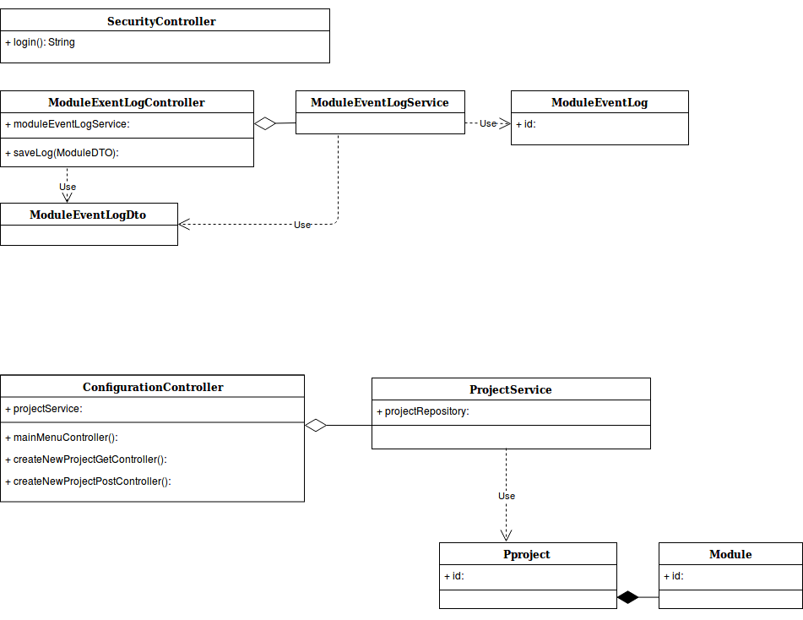
Figure 1: Classes diagram.

Views

Figure 2: Login form UI-01.
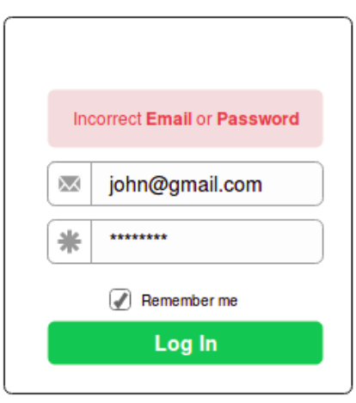

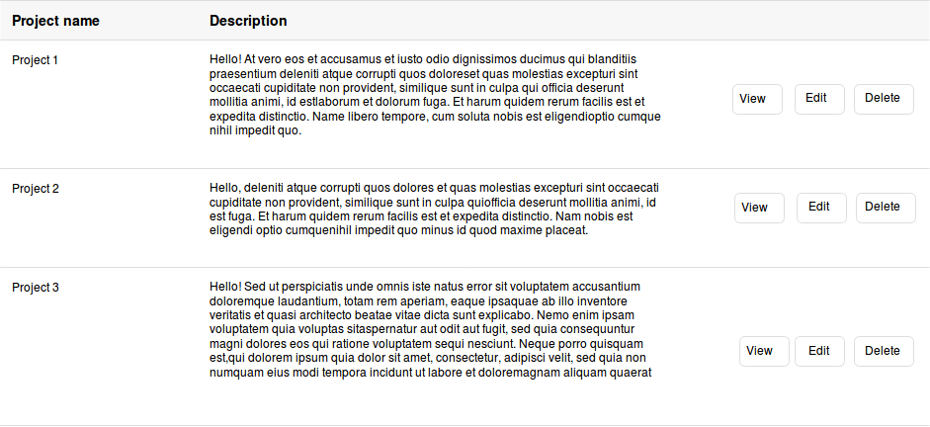
Figure 3: Projects form UI-02.

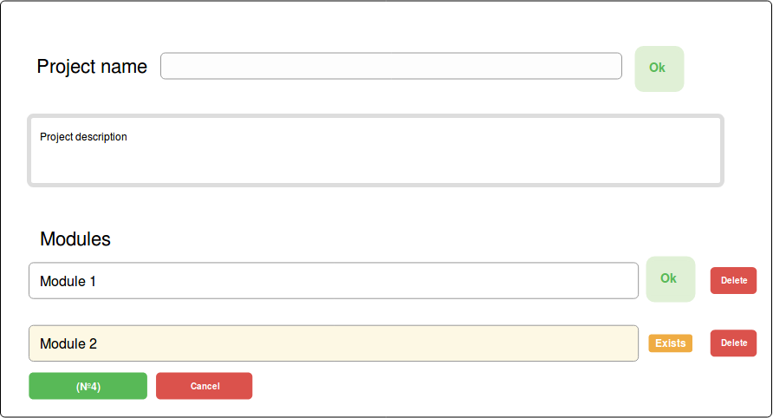
Figure 4: Create/update project form UI-03.

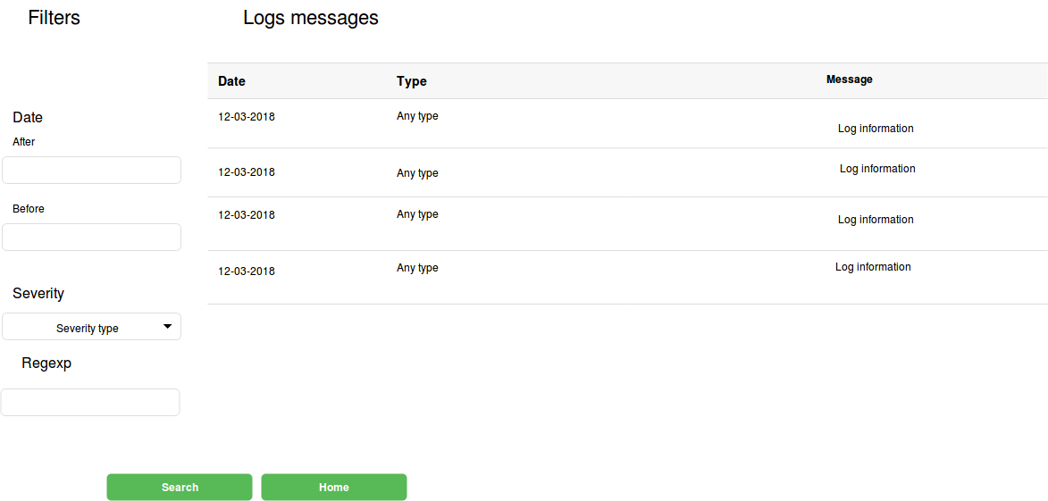
Figure 5: Search of logs UI-04.

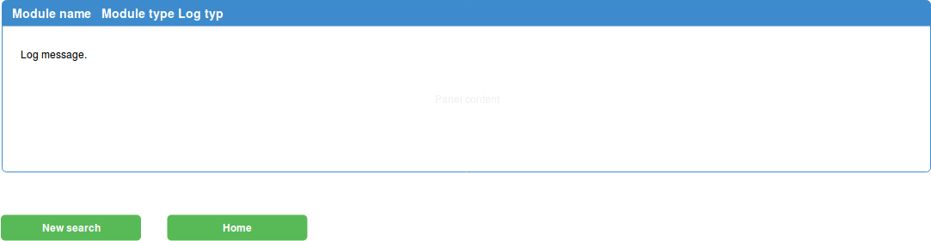
Figure 6: Review log UI-05.

Glossary
Third party system – application which sends logs information to the system.
Project administrator – a person who set third party system to send information to the system.

