IST 263 Project Milestone 6 – First Draft Using CSS
Name: Ines Harouchi
Description:
My idea for the website project is to create a “Guide to Syracuse University” from the perspective of a
senior about to start my final year. This website would allow me to reflect on my time in college, from
navigating my two majors to taking advantage of the incredible resources that Syracuse has to offer. It
would include general information about the school, a reflection on my own experience, tips and
resources for new students, and my recommendations around campus and the city.

What is the URL of the page you choose to work on for this part?
https://iharouch.github.io/ist263/project6/index.html
I worked on the home page of my website

Paste a screen shot of the wireframe you created for this page below.
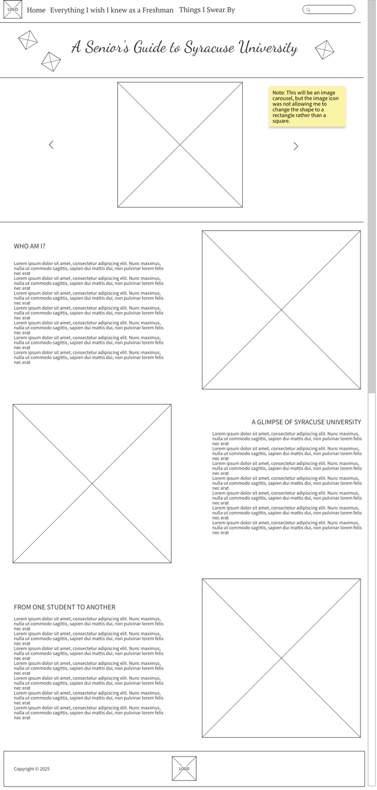
Provide the URL of the HTML validator for your page below.
https://validator.w3.org/nu/?doc=https%3A%2F%2Fiharouch.github.io%2Fist263%2Fproject6%2Findex.html

If something went wrong in this part, describe what happened and how you can fix it moving forward.
Examples of problems could be, page isn’t responsive, page doesn’t look like wireframe, etc.
Nothing really went wrong, but I couldn’t figure out how to have small icons located randomly in the banner, so I just switched to two icons on either side of the title which I still like as a design. I also had to use the w3schools website to learn how to build the image carousel as we hadn’t done that before in class. This part took the most time as I had to keep doing trial and error until I got it to work.
One thing that doesn’t look exactly like my wireframe is the spacing of the text and the images since the text is a lot shorter than on the planned page. This gives the page a lot of white space that isn’t shown in the wireframe. I have not yet decided whether I like this extra space or if I want to rework the page to change that.
Another thing that is slightly different is the absence of the search bar as I have not yet learned how to incorporate that onto a webpage, but I will make sure to look at documentation online for the final draft of the project. I also decided against making a logo for this website since it would be related to Syracuse University, and I believe that the Syracuse “S” is copyrighted, which I would’ve wanted to use. Instead, I removed the first logo from the navigation bar, and I replaced the one in the footer with a quote.

