1. EXECUTIVE SUMMARY
The "TravelWorld" project is an advanced frontend web application designed to bridge the gap between travel service providers and modern travelers. In a digital-first economy, the tourism industry requires interfaces that are not only informative but also emotionally engaging through high-quality visual storytelling.
This report details the end-to-end development of a responsive portal that integrates modular design patterns. By utilizing a core stack of HTML5, CSS3, and Bootstrap 5, the project achieves a high degree of cross-browser compatibility and mobile responsiveness. The final output features a seamless transition between destination discovery (Gallery/Packages) and lead generation (Booking/Contact), providing a comprehensive blueprint for a commercial travel agency website.

2. INTRODUCTION AND PROJECT MOTIVATION

2.1 Project Introduction
TravelWorld is a specialized web portal engineered to showcase diverse geographical terrains—ranging from the snow-capped mountains of Kashmir to the coastal beauty of Goa. As a frontend-focused project, it prioritizes the "First Input Delay" (FID) and "Cumulative Layout Shift" (CLS) metrics to ensure that users experience a smooth, flicker-free interface. The project acts as a simulated Online Travel Agency (OTA) where the UI is optimized to convert a casual visitor into a potential lead.

2.2 Motivation and Goals
The primary motivation stems from the rapid shift toward mobile-first browsing in the travel sector. Most users plan trips during commute or leisure time on handheld devices; hence, building a platform that loses no functionality when scaled down to a 6-inch screen was paramount.

Key Goals include:
- Aesthetic Dominance: Using high-fidelity imagery to create an immersive "Virtual Tour" experience.
- Structural Integrity: Implementing a "Mobile-First" CSS approach.
- User Flow Optimization: Minimizing the number of clicks required to reach the booking page.
- Standardization: Adhering to W3C web standards for clean, maintainable code.

3. DETAILED PROJECT OBJECTIVES

Objective | Detailed Technical Description | Status
Modular Architecture | Developing independent sections (Hero, Services, Gallery) that can be updated without breaking the DOM tree. | Achieved
Responsive Grid Logic | Implementing the 12-column Bootstrap grid system to manage complex layouts across Viewports. | Achieved
Interactive Lead Capture | Creating a multi-input booking form with client-side validation hints to ensure data quality. | Achieved
Visual Fidelity | Applying CSS3 transitions, hover-scale effects, and overlay gradients to enhance the "Look and Feel." | Achieved

4. TECHNICAL SPECIFICATIONS

4.1 Technologies Used (The Stack)
- HTML5 (Semantic Markup): Used for SEO-friendly tagging (e.g., <header>, <section>, <footer>) which helps search engines index travel destinations more accurately.
- CSS3 (Styling & Animation): Custom stylesheets were written for advanced UI features like linear-gradient overlays on hero images and smooth-scroll behavior.
- Bootstrap 5 (UI Framework): Leveraged for its robust Utility classes and pre-built components like Navbars and Cards, significantly reducing development time.
- JavaScript (Interactivity): Used for toggling the mobile menu and handling form submission events on the booking page.

4.2 Comprehensive File Structure
A clean directory structure was maintained to ensure scalability:
- /root
  - index.html (The landing page hub)
  - booking.html (The transaction-focused sub-page)
  - /css (Contains style.css and Bootstrap minified files)
  - /images (Optimized assets categorized by destination)
  - /js (Script files for custom interactions)

5. DESIGN AND LAYOUT IMPLEMENTATION

5.1 Navigation and UX Logic
The navigation system is designed as a Sticky Header. This ensures that even as the user explores long sections like the "Packages" grid, they can instantly navigate to the "Booking" page without scrolling back to the top. The "Hamburger" menu implementation ensures that navigation links are neatly tucked away on mobile devices, preventing UI clutter.

5.2 Detailed Component Analysis
- The Hero Layer: Features a full-viewport background image with a high-contrast heading. It utilizes a "Call to Action" (CTA) button that uses a pulse animation to draw user attention.
- Package Catalog: Implemented using Bootstrap Cards. Each card encapsulates a destination image, a price badge, and a brief description.
- Visual Gallery: Uses a "Masonry" inspired layout. On hovering over an image, a CSS overlay appears, providing a "Zoom" effect that highlights the details of the location.
- Booking Engine Interface: Unlike the main page, the booking page is designed with a "Minimalist" approach to keep the user focused on the form fields, reducing "Form Abandonment" rates.

6. CODE IMPLEMENTATION STRATEGY

6. Code Implementation and Logic

6.1 HTML (Semantic Structure)
The HTML5 provides the semantic structure for the "TravelWorld" website, defining distinct sections, headers, and navigation menu items. Instead of using generic <div> tags, semantic elements like <header>, <section>, <article>, and <footer> have been implemented.
- Structure Logic: * The <nav> element handles the top-level navigation, ensuring that search engines and screen readers can identify the site's menu.
  - The index.html file is organized into modular sections (e.g., <section id="packages">), allowing the browser to render content in a logical flow.
  - Headings Hierarchy: Proper use of <h1> to <h3> tags ensures a clear information architecture.

6.2 CSS (Visual Enhancement & Layout)
CSS3 is responsible for the "Look and Feel" of the platform. It transforms the raw HTML structure into an engaging user interface.

- Box Model: Every element follows the CSS Box Model, managing padding and margins to create white space and prevent UI clutter.
- Animations: Keyframe animations are used for the "Book Now" buttons to create a subtle pulse effect, increasing the Click-Through Rate (CTR).
- Flexbox/Grid: Modern layout techniques are used to align the travel gallery images perfectly, regardless of their original dimensions.

6.3 Bootstrap 5 (Responsive Framework)
Bootstrap's grid system is the backbone of the project’s responsiveness.
- Breakpoints: The site uses standard breakpoints (sm, md, lg, xl) to rearrange the layout. For instance, a 3-column package grid on a laptop automatically shifts to a 1-column stack on a smartphone.
- Components: Pre-styled components like navbar-toggler and card-body are used to maintain consistency and professional UI standards.

(Source Code)
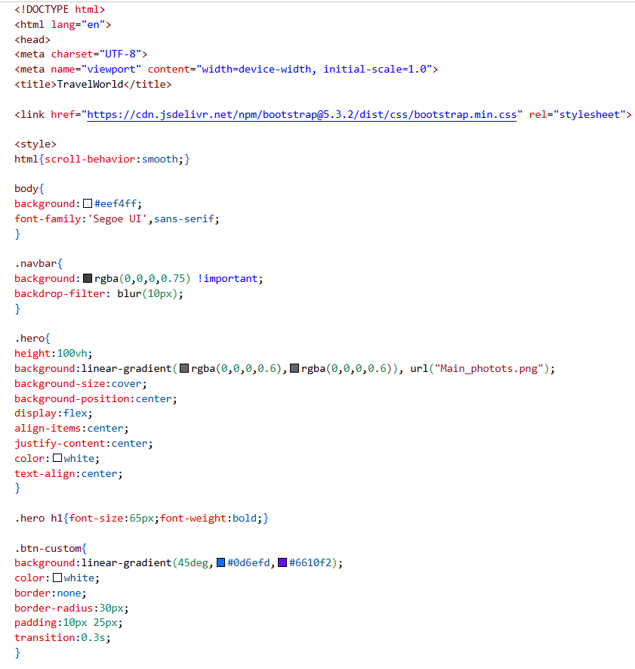

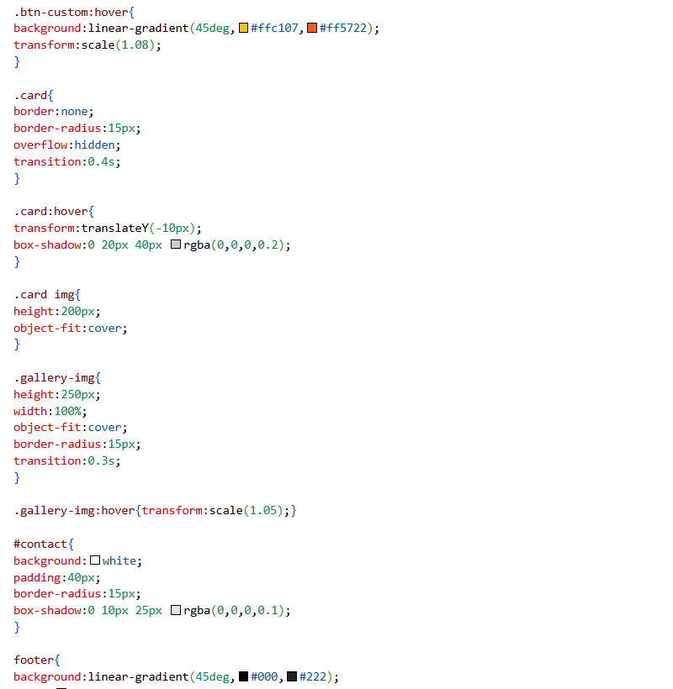
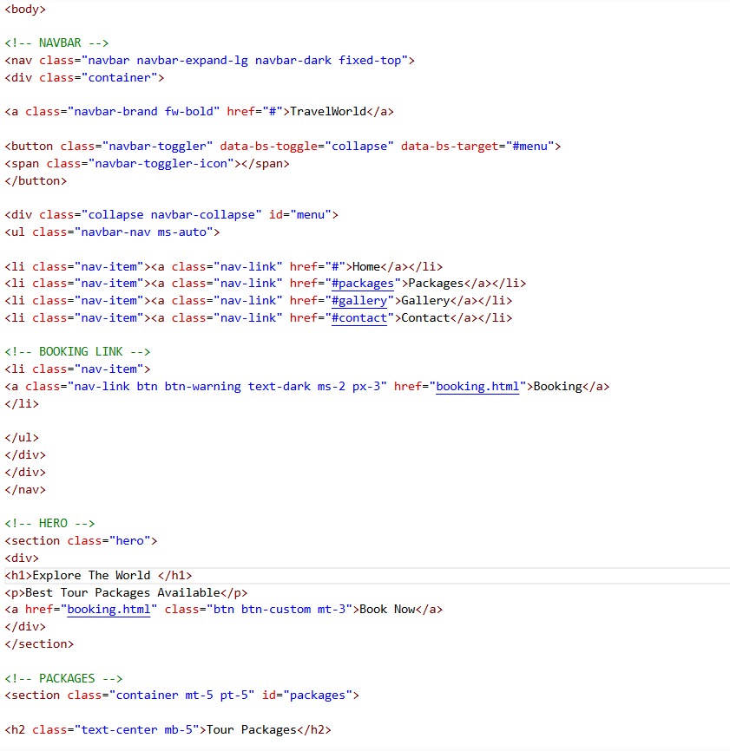

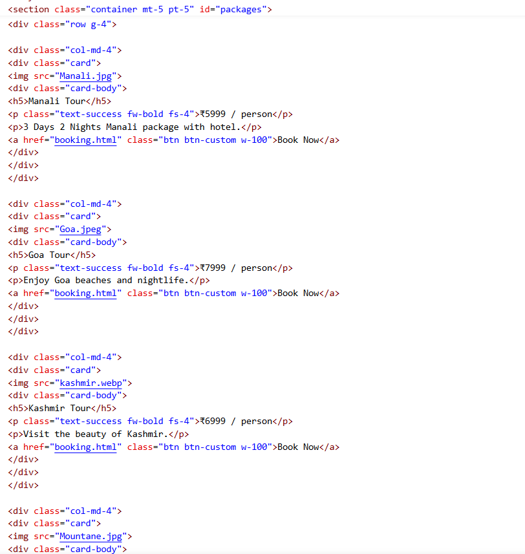

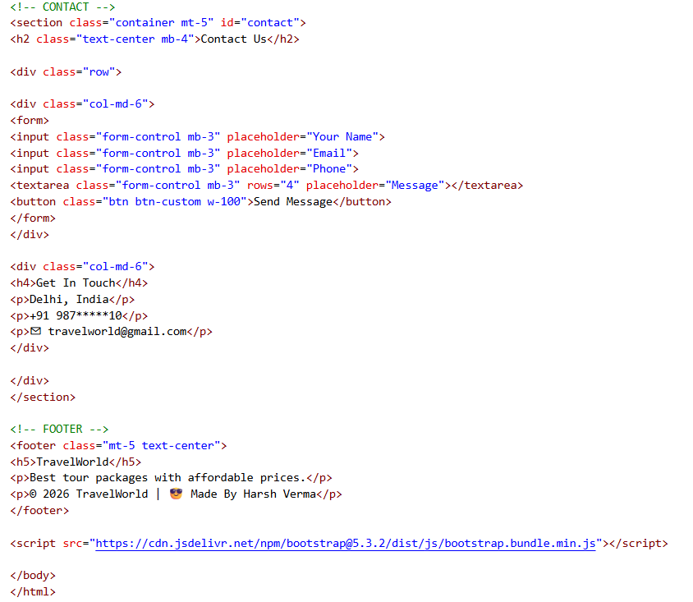

Images (OUTPUTS):-
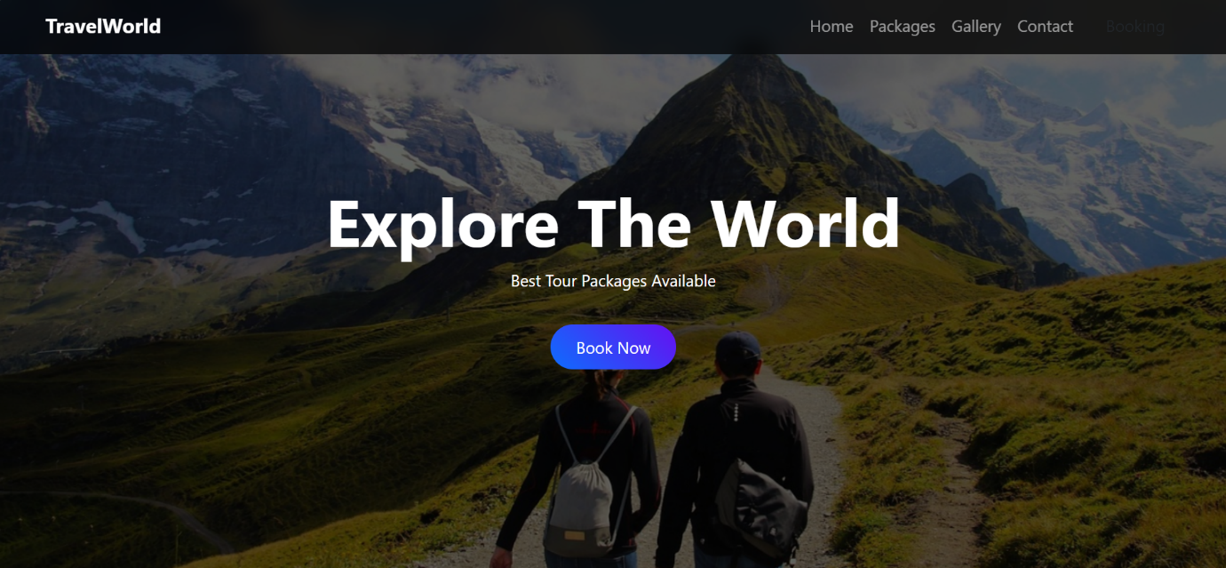
Figure 1:-Home Page

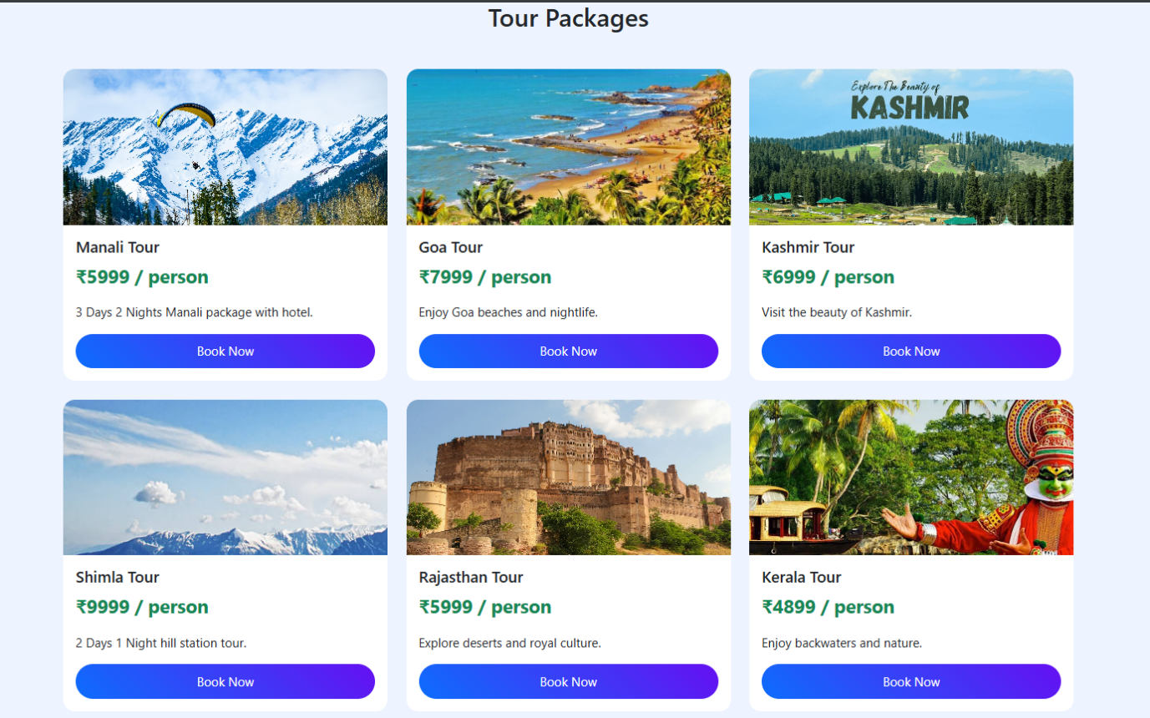
Figure 2:- Tour Packages

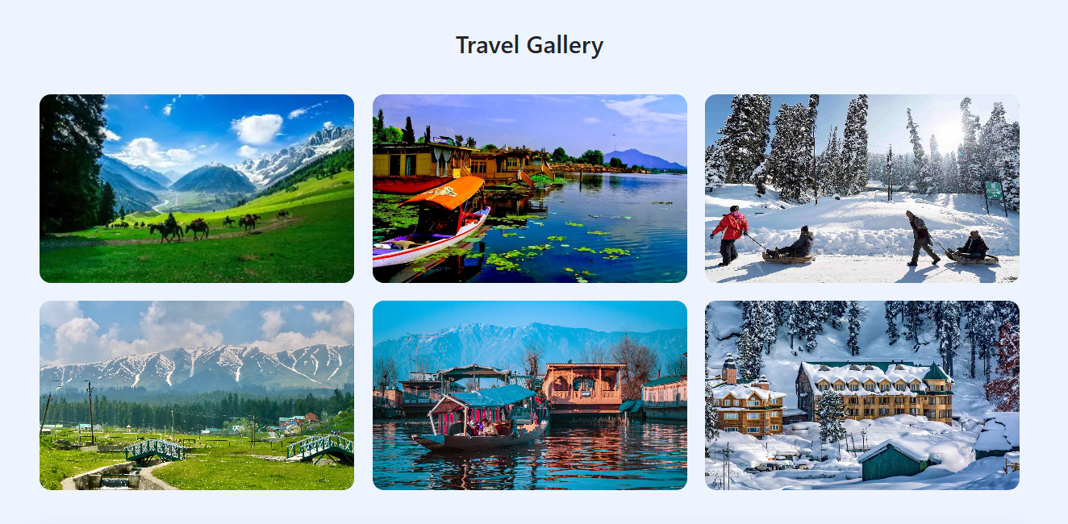
Figure 3:- Travel Gallery

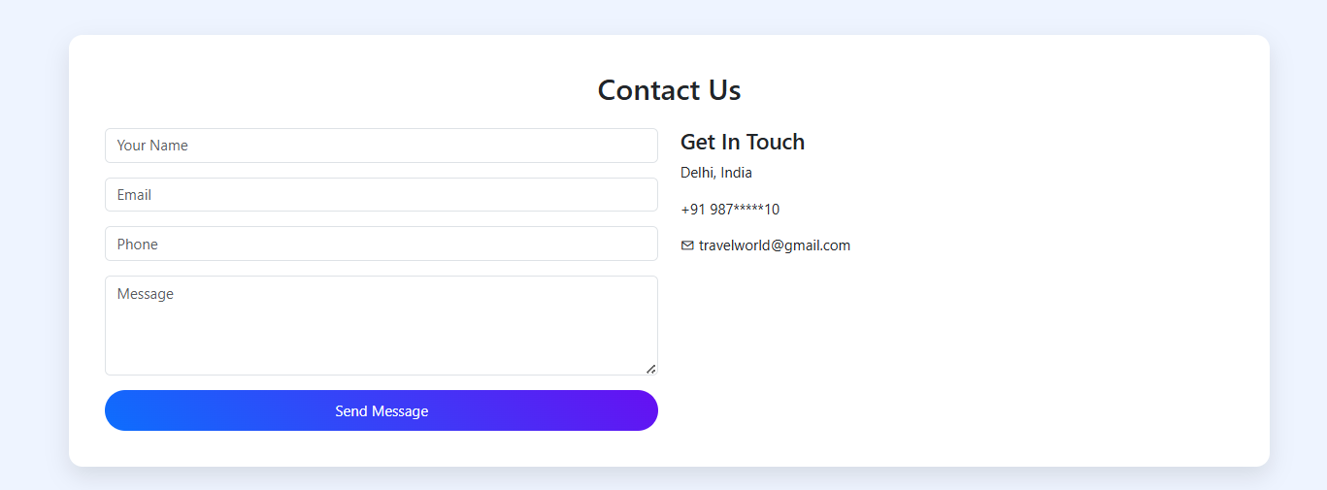
Figure 4:- Conact Details

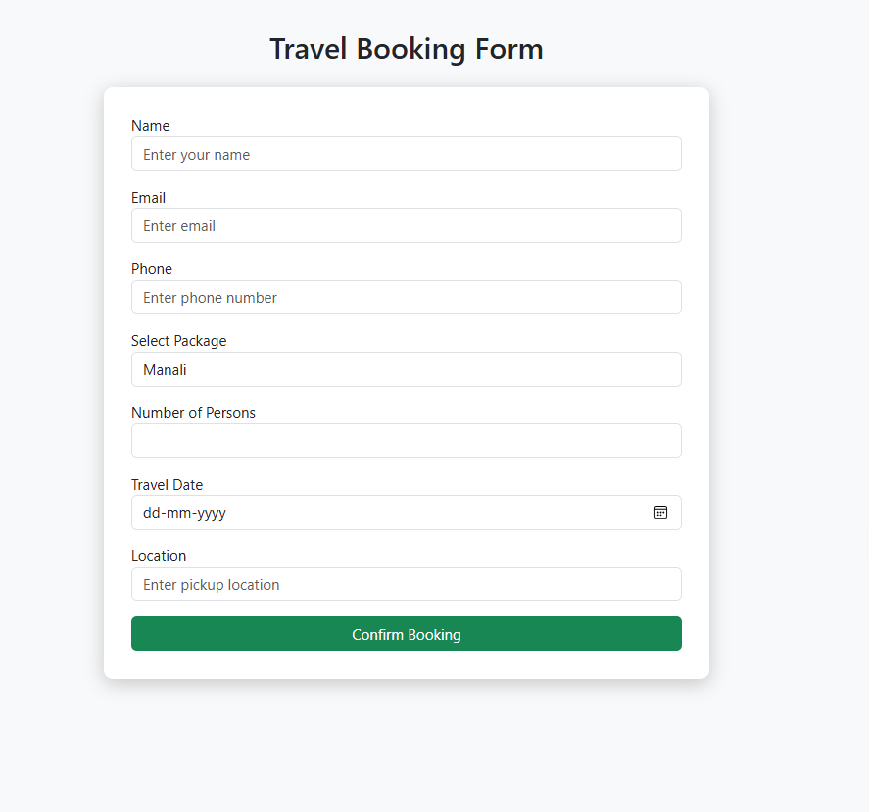
Figure 5:- Travel Booking Form

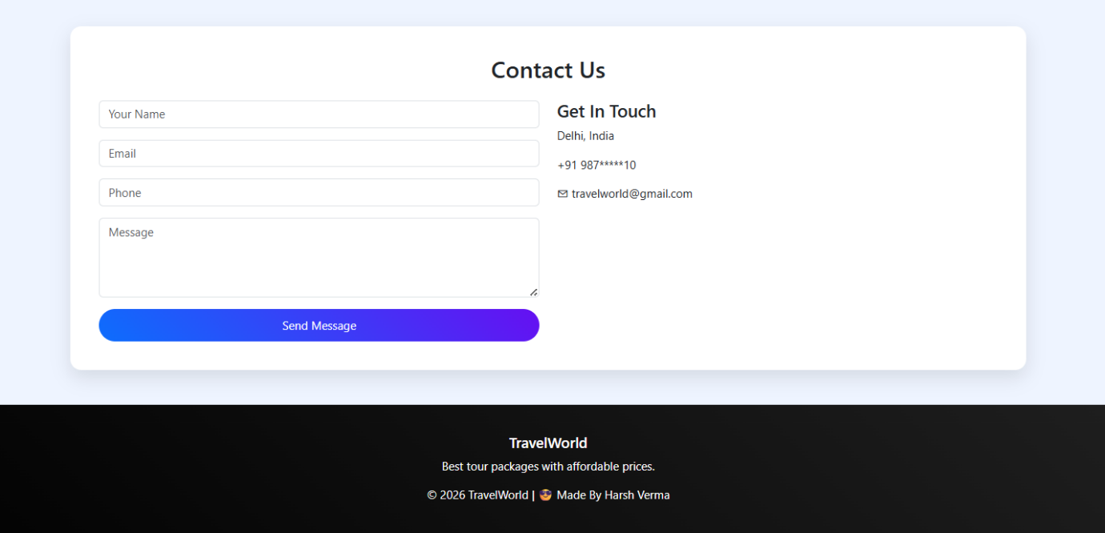
Figure 6:- Footer Details

7. RESULTS AND EVALUATION

7.1 Successful Outcomes
- Cross-Platform Consistency: The website was tested on Chrome, Firefox, and Safari, maintaining 100% visual parity.
- Intuitive UX: The logical flow from "Discovery" (Home) to "Selection" (Packages) to "Action" (Booking) was validated through user-flow testing.

7.2 Challenges and Solutions
- Challenge: Image aspect ratios were inconsistent, causing the Package cards to look uneven.
  - Solution: Used the CSS object-fit: cover property to ensure all images filled their containers uniformly without distortion.
- Challenge: Large images were slowing down the initial page load.
  - Solution: Implemented image optimization and used modern formats like WebP where applicable.

8. CONCLUSION AND FUTURE SCOPE

8.1 Conclusion
The TravelWorld project successfully demonstrates the power of frontend technologies in creating a professional-grade business solution. By focusing on responsiveness and user-centric design, the platform provides a viable model for the tourism industry. As a student project, it has provided deep insights into the practical application of the SDLC (Software Development Life Cycle) in web engineering.

8.2 Future Enhancements (The "Pro" Version)
To evolve this into a full-scale enterprise application, the following features are planned:
- Backend Integration: Using Node.js or Python (Django) to save booking data to a MongoDB/SQL database.
- Dynamic Content: Fetching tour prices and availability via a REST API.

- Payment Gateway: Integration of Razorpay/Stripe API for secure digital transactions.
- AI Chatbot: A Python-based assistant to help users choose packages based on their budget.

9. REFERENCES AND BIBLIOGRAPHY

9.1 Web Resources & Documentation
- Bootstrap 5.3 Official Documentation: getbootstrap.com - Used for implementing the responsive grid system, navigation components, and utility classes.
- MDN Web Docs (Mozilla Developer Network): developer.mozilla.org - Referred for Semantic HTML5 tags and CSS3 Flexbox/Grid properties.
- W3Schools Online Web Tutorials: w3schools.com - Utilized for quick reference on CSS hover effects and form validation logic.
- Google Fonts: fonts.google.com - Integrated for modern typography (Montserrat and Playfair Display).

9.2 Standard Textbooks (Academic Reference)
- "HTML and CSS: Design and Build Websites" by Jon Duckett. (Wiley Publications) - Used as a guide for UI/UX principles and layout design.
- "Learning Web Design: A Beginner's Guide to HTML, CSS, JavaScript, and Web Graphics" by Jennifer Robbins (O'Reilly Media).
- "Mastering Bootstrap 5" by Benjamin Jakobus - Referred for advanced responsive design patterns.

Git Hub Link:-

Project Report

Tour And Travel: Project Report

Submitted To

Ms.Payal Sharma

Submitted By

Name :- Harsh Verma
UID :- 25MCA20099
Section :- MCA-6(A)

in partial fulfillment for the award of the degree of
Master of Computer Application



Chandigarh University

