PROJECT DOCUMENTATION
Corporate Wireless Setup
Secure Staff Wi-Fi and Isolated IoT Network for InnoConn
Submitted by
Harsh Vishwakarma
Tool: Cisco Packet Tracer | Date: October 2026

1. Introduction
InnoConn is a technology startup setting up a new office. The company needs a functional internal wireless network for employee laptops and a separate, secure connection for smart devices. All wireless clients must be able to reach the company Main-Server.
This project designs, configures and tests that network in Cisco Packet Tracer. Staff laptops and smart devices are placed on separate wireless networks, each protected with WPA2-PSK (AES), and both can reach the server's web service.

1.1 Objectives
- Design a wired backbone (server and switch) that connects to wireless access.
- Provide secure wireless access for employee laptops using WPA2-PSK with AES encryption.
- Provide a separate wireless network for smart devices on its own subnet.
- Automate client addressing with DHCP and keep the server on a static IP.
- Prove end-to-end connectivity with ping and HTTP tests and capture traffic in Simulation mode.

1.2 Scope
The project covers Layer 2 and Layer 3 setup of a single-office LAN: cabling, IP addressing, DHCP, wireless security, NAT-based isolation and verification. Internet access and enterprise authentication (RADIUS) are outside scope and listed as future work.

2. Requirements and Components

2.1 Devices used
Device | Name | Role
Server-PT | Main-Server | Hosts the HTTP service that all clients reach
Switch 2960-24TT | Office-Switch | Wired aggregation for the server and both routers
Wireless Router WRT300N | Staff-Router | Wireless access point and DHCP server for staff devices
Wireless Router WRT300N | Smart-Router | Separate wireless network for smart devices (added for isolation)
Laptop x3 | Emp-Laptop0, 1, 2 | Employee wireless clients (WPC300N module)
Tablet PC | Tablet PC0 | Employee wireless tablet
Smartphone x2 | Smart-phone0, Smartphone1 | Smart-device wireless clients
Home IoT devices | Thermostat IoT0, Webcam IoT4 | Smart devices on the IoT Wi-Fi
Table 1: Device list. In the Packet Tracer file the switch is labelled Switch0, the Staff-Router Wireless Router0 and the Smart-Router Smart-Router1.

2.2 Design decision: why two routers
The Packet Tracer WRT300N supports only one SSID. The project asks for a separate, secure connection for smart devices, so a second WRT300N is used. It sits on its own subnet behind NAT, which gives both a distinct wireless network and traffic isolation from the staff LAN.

3. Topology and Architecture
The Main-Server, Staff-Router and Smart-Router all connect to the Office-Switch. The Staff-Router bridges the wired LAN to the staff wireless clients (three laptops and a tablet). The Smart-Router connects through its Internet (WAN) port and serves the IoT subnet through NAT for two smartphones, a webcam and a thermostat.
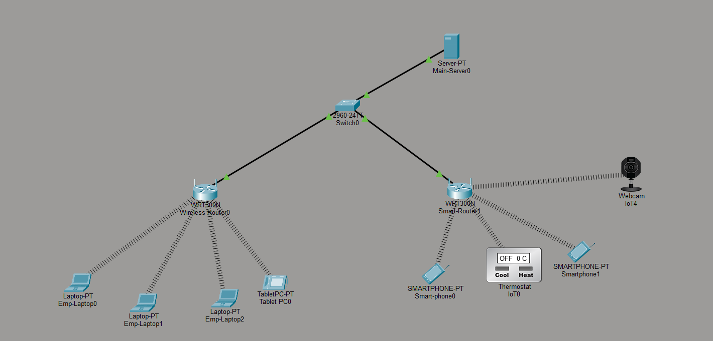
Figure 1: Packet Tracer topology of the project
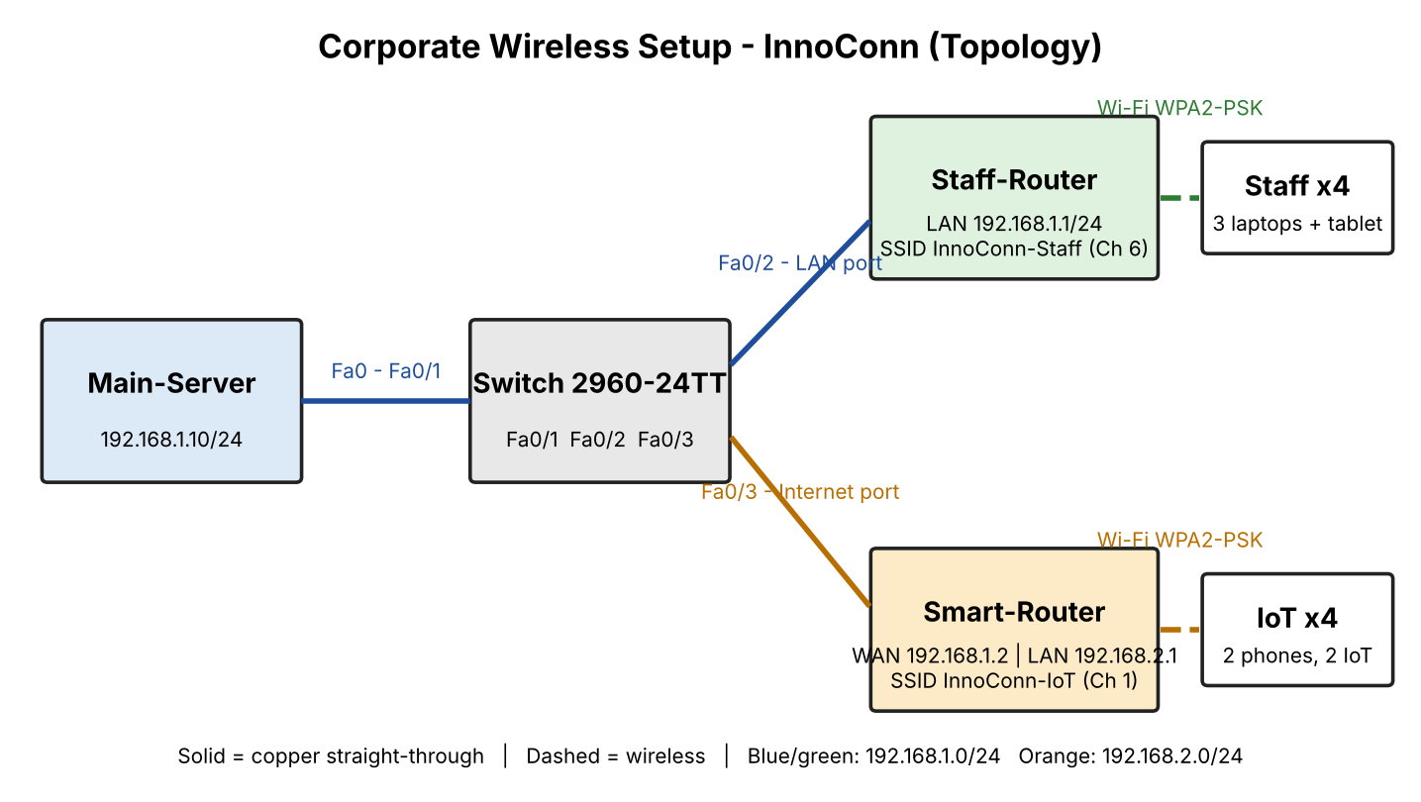
Figure 2: Logical diagram with ports and addresses (clients grouped)

3.1 Cabling plan
From | To | Cable | Purpose
Main-Server Fa0 | Switch Fa0/1 | Copper straight-through | Server access
Switch Fa0/2 | Staff-Router Ethernet 1 (LAN) | Copper straight-through | Staff LAN extension
Switch Fa0/3 | Smart-Router Internet port | Copper straight-through | IoT router uplink
3 laptops, Tablet PC0 | Staff-Router (wireless) | Wi-Fi, WPA2-PSK | Staff Wi-Fi
2 smartphones, webcam, thermostat | Smart-Router (wireless) | Wi-Fi, WPA2-PSK | IoT Wi-Fi
Table 2: Connections
The Staff-Router is connected through a LAN port, not its Internet port, so its wireless clients share the 192.168.1.0/24 subnet with the server.

4. IP Addressing
Two private /24 subnets are used. Subnet A holds the server, the switch-side devices and staff wireless clients. Subnet B belongs to the IoT network behind the Smart-Router.

4.1 Subnet plan
Network | Subnet | Mask | Gateway | Usable hosts
Staff / Server LAN | 192.168.1.0 | 255.255.255.0 (/24) | 192.168.1.1 | 254
IoT LAN | 192.168.2.0 | 255.255.255.0 (/24) | 192.168.2.1 | 254
Table 3: Subnets

4.2 Device addresses
Device / Interface | IP address | Assignment | Notes
Staff-Router LAN | 192.168.1.1/24 | Static | Default gateway for subnet A, DHCP server
Main-Server | 192.168.1.10/24 | Static | Gateway 192.168.1.1, HTTP on
Smart-Router WAN | 192.168.1.2/24 | Static | Gateway 192.168.1.1
Smart-Router LAN | 192.168.2.1/24 | Static | Gateway for subnet B, DHCP server
Staff clients (3 laptops, tablet) | 192.168.1.100+ | DHCP | Pool 192.168.1.100-149 (50 users)
IoT clients (2 phones, webcam, thermostat) | 192.168.2.100+ | DHCP | Pool 192.168.2.100-149 (50 users); Smart-phone0 received 192.168.2.101
Table 4: Address table
Static addresses are kept below .100 and the DHCP pools start at .100, so dynamic leases never collide with infrastructure addresses.

5. Implementation and Configuration

5.1 Main-Server

- Open Desktop > IP Configuration and set a static address: 192.168.1.10, mask 255.255.255.0, gateway 192.168.1.1.
- Open Services > HTTP and make sure HTTP is On, so clients can load the server's page at http://192.168.1.10.
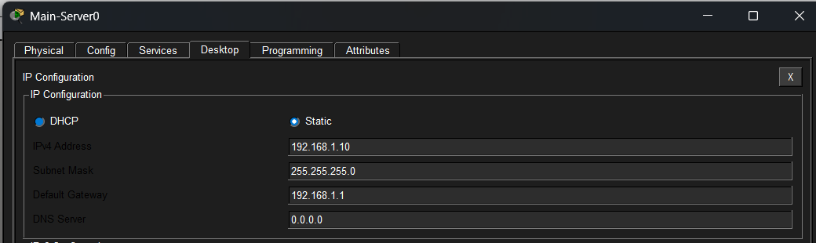  Figure 3: Main-Server static IP configuration | 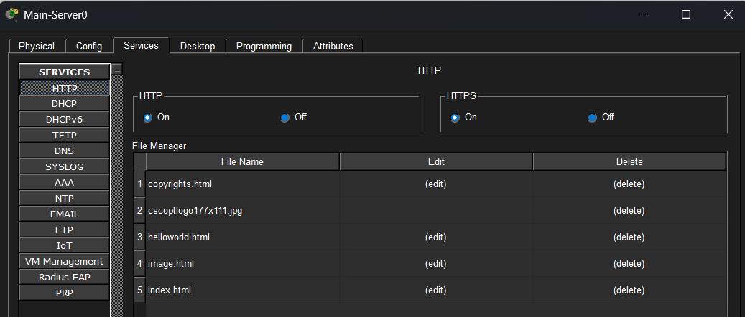  Figure 4: HTTP service enabled on Main-Server

5.2 Staff-Router (GUI > Setup and Wireless)

- Setup > Router IP: 192.168.1.1, subnet mask 255.255.255.0.
- DHCP server enabled, start IP 192.168.1.100, maximum users 50.
- Wireless > Basic: SSID InnoConn-Staff, channel 6.
- Wireless > Security: WPA2 Personal, encryption AES, with a team-chosen passphrase.
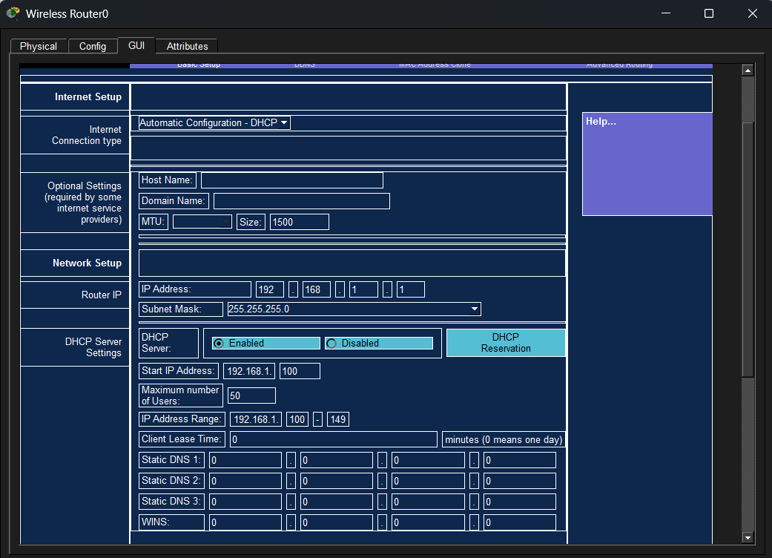  Figure 5: Staff-Router: router IP and DHCP settings | [ Paste screenshot: Staff-Router wireless settings: SSID InnoConn-Staff, channel 6, WPA2-PSK, AES ]

5.3 Smart-Router (GUI > Setup and Wireless)

- Setup > Internet connection type: Static IP, address 192.168.1.2, mask 255.255.255.0, gateway 192.168.1.1.
- Network setup > Router IP: 192.168.2.1, mask 255.255.255.0, DHCP enabled, start 192.168.2.100, 50 users.
- Wireless > Basic: SSID InnoConn-IoT, channel 1 (different from channel 6 to avoid interference).
- Wireless > Security: WPA2 Personal, AES, with a different passphrase from the staff network.
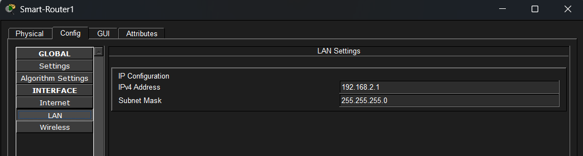  Figure 6: Smart-Router LAN settings (192.168.2.1/24) | 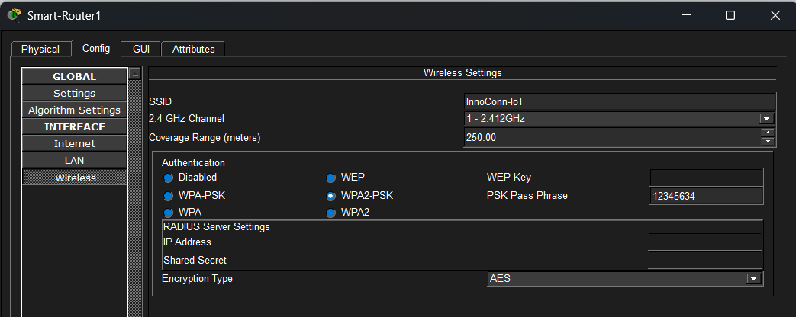  Figure 7: Smart-Router wireless: InnoConn-IoT, channel 1, WPA2-PSK, AES

5.4 Wireless clients

- Laptops: power off, replace the wired module with WPC300N, power on.
- On each laptop, open Config > Wireless0, set SSID InnoConn-Staff with WPA2-PSK (AES), and set IP configuration to DHCP.
- Smartphones and IoT devices: Config > Wireless0, SSID InnoConn-IoT, authentication WPA2-PSK, IP configuration DHCP.
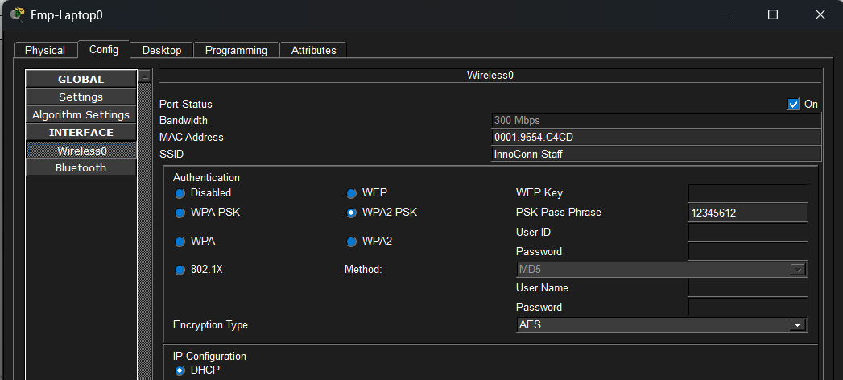  Figure 8: Emp-Laptop0 wireless settings (InnoConn-Staff, DHCP) | 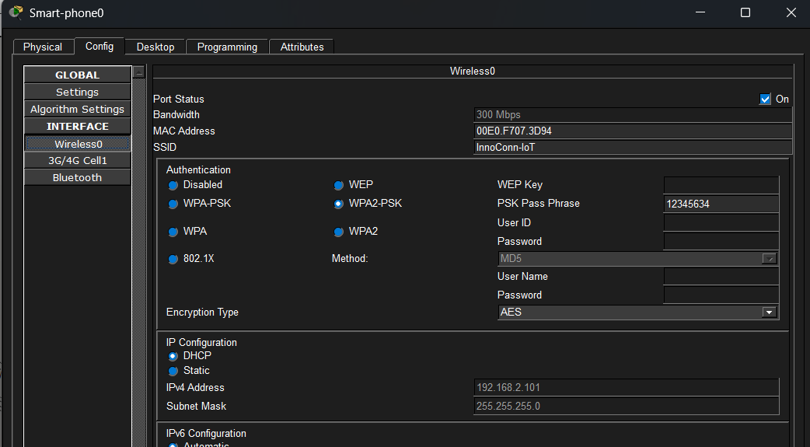  Figure 9: Smart-phone0 wireless settings (InnoConn-IoT, DHCP, address 192.168.2.101)

6. Security Design
Control | How it is applied
WPA2-PSK with AES | Both SSIDs use WPA2 Personal. AES (CCMP) encryption protects wireless frames, replacing weaker WEP/TKIP options.
Separate SSIDs and passphrases | Staff and smart devices use different networks and keys, so a leaked IoT key does not expose staff Wi-Fi.
Subnet and NAT isolation | IoT clients sit on 192.168.2.0/24 behind NAT on the Smart-Router. They can reach the server, but traffic from the staff LAN to the IoT subnet is not routed: a staff ping to an IoT address returns Destination host unreachable.
Static server address | The server address never changes, so access rules and documentation stay valid.
Different channels | Staff Wi-Fi uses channel 6 and IoT Wi-Fi uses channel 1, which reduces co-channel interference between the two networks.
Table 5: Security controls
Limitation: WPA2-PSK uses one shared key per network. For larger deployments WPA2-Enterprise with RADIUS gives per-user authentication.

7. Testing and Verification
Testing proves end-to-end connectivity from wireless clients on both networks to the server and checks that the isolation behaves as designed. Every test below was run in Packet Tracer, and the figures are the evidence.
No. | Test | Command / action | Expected result | Result
T1 | Laptop gets DHCP lease | ipconfig on a laptop | IP in 192.168.1.100-149, gateway 192.168.1.1 | Pass
T2 | Phone gets DHCP lease | Wireless0 settings of Smart-phone0 | IP in 192.168.2.100-149 (got 192.168.2.101) | Pass
T3 | Laptop to gateway (Emp-Laptop1) | ping 192.168.1.1 | Replies, 0% loss | Pass
T4 | Laptop to server (Emp-Laptop2) | ping 192.168.1.10 | Replies, 0% loss | Pass
T5 | Phone to server (Smartphone1) | ping 192.168.1.10 | Replies, 0% loss (through NAT) | Pass
T6 | Laptop web access (Emp-Laptop1) | Browser: http://192.168.1.10 | Server web page loads | Pass
T7 | Phone web access (Smart-phone0) | Browser: http://192.168.1.10 | Server web page loads | Pass
T8 | Isolation check (Emp-Laptop2) | ping 192.168.2.105 | No reply: Destination host unreachable | Pass
Table 6: Test plan and results. The first reply of a ping can time out while ARP resolves; run it twice.
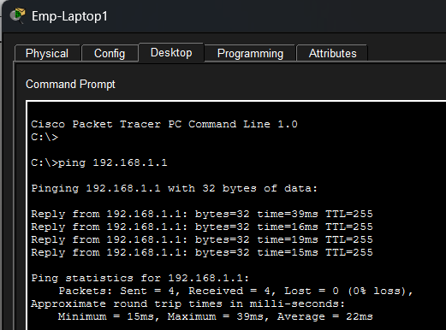  Figure 10: T3: Emp-Laptop1 pings the Staff-Router gateway | 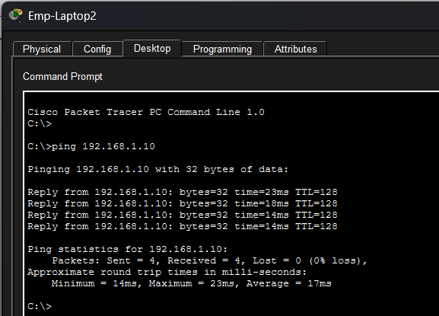  Figure 11: T4: Emp-Laptop2 pings Main-Server
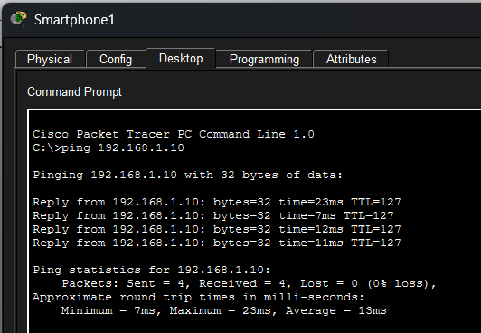  Figure 12: T5: Smartphone1 pings Main-Server through NAT (TTL 127) | 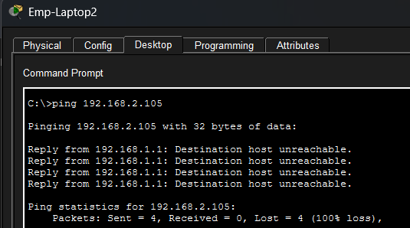  Figure 13: T8: Emp-Laptop2 pings an IoT address, destination host unreachable
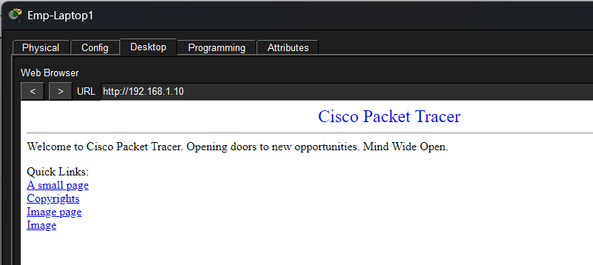  Figure 14: T6: Emp-Laptop1 opens http://192.168.1.10 | 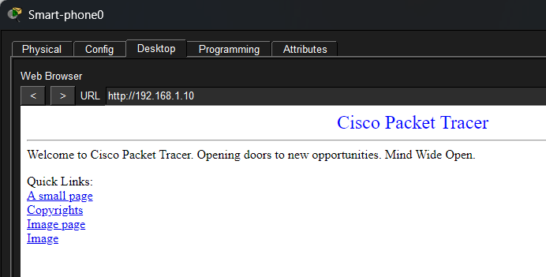  Figure 15: T7: Smart-phone0 opens http://192.168.1.10
Isolation result: the staff laptop's ping to the IoT subnet is answered by 192.168.1.1 with Destination host unreachable, because the Staff-Router has no route to 192.168.2.0/24. The IoT clients sit behind the Smart-Router, so they can reach the server (T5, T7) while staff devices cannot start connections into the IoT subnet. The phone's TTL of 127 against 128 on the same-subnet ping shows it crossed one router hop.

8. Simulation Mode
Packet Tracer Simulation mode shows how packets travel through the topology and how the devices handle them.

- Switch to Simulation mode and set the event filter to ICMP and HTTP.
- Add a simple PDU (ping) from Smart-phone0 to Main-Server0 and press Capture / Forward.
- Follow the packet: Smart-phone0, Smart-Router1 (NAT translates 192.168.2.x to 192.168.1.2), Switch0, Main-Server0, then the reply back.
- Open the PDU details at a device to read the layers and the source and destination addresses.
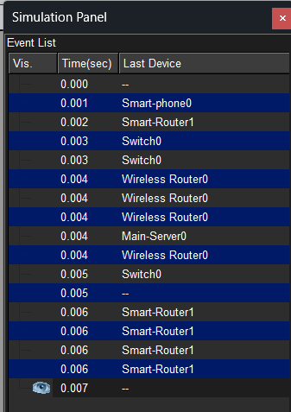  Figure 16: Simulation event list for the ping from Smart-phone0 to Main-Server0 | 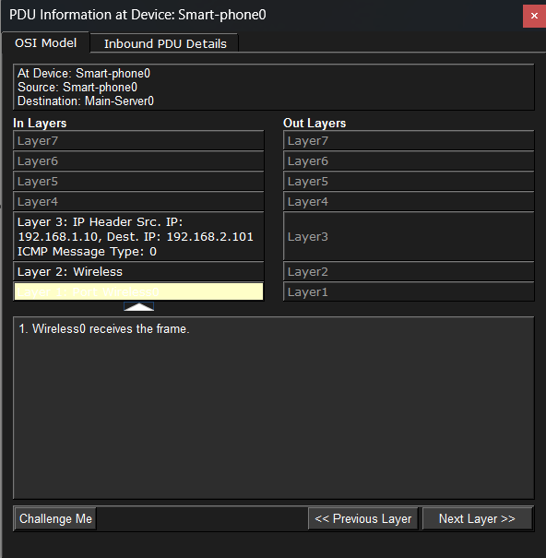  Figure 17: PDU at Smart-phone0, OSI model: ICMP echo reply arriving on Wireless0
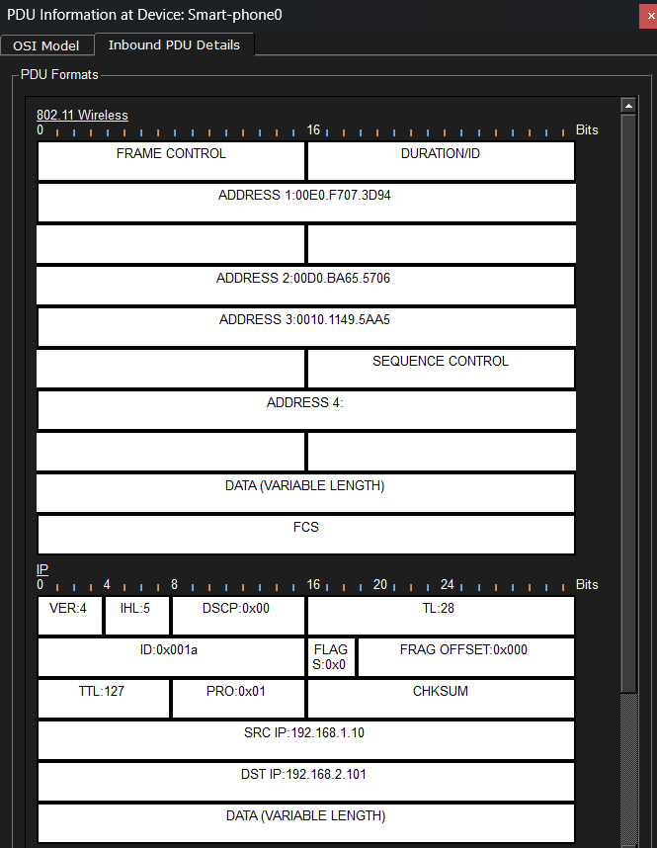  Figure 18: Inbound PDU details: 802.11 frame and IP header (source 192.168.1.10, destination 192.168.2.101, TTL 127) | 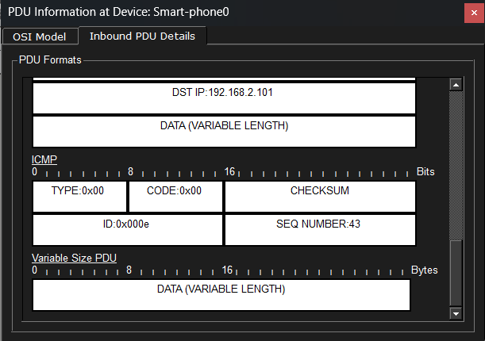  Figure 19: Inbound PDU details: ICMP type 0x00, the echo reply
Observed: the event list shows the packet leaving Smart-phone0, crossing Smart-Router1 and Switch0, reaching Main-Server0, and the reply returning to Smart-phone0. Wireless Router0 also appears in the list because the switch floods frames out of its other ports. At Smart-phone0 the reply is an ICMP echo reply (type 0x00) from 192.168.1.10 to 192.168.2.101.

9. Troubleshooting Notes
Problem | Check
Client does not associate | SSID, WPA2 passphrase and authentication type must match exactly. Confirm the laptop has the WPC300N module.
Client has 169.254.x.x address | DHCP is not enabled on the router, or the client is not set to DHCP.
Phone cannot reach server | Check the Smart-Router WAN static IP and gateway (192.168.1.2 / 192.168.1.1) and that the server gateway is correct.
Laptop cannot reach server | The Staff-Router must be cabled through a LAN port, not the Internet port.
First ping times out | Normal ARP delay. Send the ping again.
Table 7: Common faults and checks

10. Conclusion and Future Scope
The project builds a wired and wireless office network for InnoConn with two protected wireless networks, DHCP for clients, a static server and NAT-based separation of smart devices. The tests in section 7 verify connectivity from wireless clients on both networks to the Main-Server, and the isolation test confirms the staff and IoT networks are separated.

Future scope
- Replace the second router with VLANs, one SSID per VLAN on a wireless controller or access points.
- Use WPA2-Enterprise or WPA3 with a RADIUS server for per-user authentication.
- Add ACLs on a Layer 3 device for explicit allow rules between IoT and staff networks.
- Add syslog and SNMP monitoring for wireless events.

Project files
Packet Tracer file: Corporate_Wireless_Setup.pkt | Also submitted: chart, presentation (PPT) and demonstration video.

