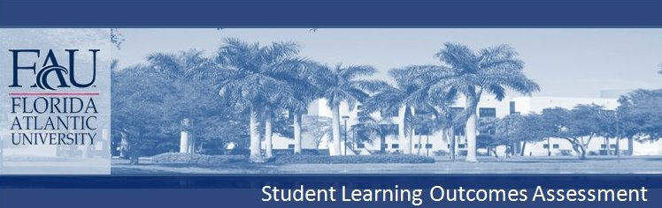
COLLEGE OF
Biological Sciences
Degree Level & Name BS

The principal mission of the Department of Biological Sciences is to train students for careers in biological sciences or pursue advanced training in graduate and professional schools. Through both education and research, our department seeks an increased appreciation and respect for our environment and awareness of the impact of our decisions on local, regional and global issues concerning the economy, personal health and welfare, and the environment.

CONTENT KNOWLEDGE (Declarative Knowledge): Students will demonstrate an
understanding of cell structure, cell physiology and the molecular processes of cells.
Students will be able to describe features that distinguish the major groups of
organisms and the developmental and physiological mechanisms fundamental to all living organisms. Students will demonstrate an understanding of the principles of organismal biology, genetics, evolution and ecology. Students receiving the BS degree in biological sciences are required to successfully complete the following core courses:

BSC 1010: Biological Principles
BSC 1011: Biodiversity
PCB 4023: Molecular and Cell Biology
PCB 4043: Principles of Ecology
PCB 3063: Genetics

Students’ knowledge of the material will be assessed by examinations, typically using
multiple‐choice and short‐answer questions. In upper division courses, examinations
consist of advanced objective questions and high level problem solving.

CONTENT KNOWLEDGE (Technical Skills): Students will demonstrate proper
laboratory practice, use of equipment, and ability to use basic and advanced
techniques in several areas of biology.

CHARLES E. SCHMIDT COLLEGE OF SCIENCE
DEPARTMENT OF BIOLOGICAL SCIENCES
B.S. BIOLOGICAL SCIENCES
Students receiving a BS degree in biological sciences are required to successfully complete the following core laboratory courses:

BSC 1010L: Biological Principles Laboratory
BSC 1011L: Biodiversity Laboratory
In BSC 1010L, students are tested on concepts by short answer and essay questions; in BSC 1011L, students are tested on their technical skills by practical examinations.

COMMUNICATION (Written Communication, Oral Communication): Students will demonstrate the ability to speak and write effectively on biological topics. BSC 1010L and BSC 1011L students are assigned to discussion groups of eight to ten students where they discuss course concepts and are evaluated for group participation. Students are tested for written communication skills by essay and short answer examinations.
Tests of both critical thinking and communications skills have recently been implemented in several Biological Sciences courses using Calibrated Peer Review (CPR), a write to learn method that offers valuable formative instruction for student learning in a course. Because both written communication and critical thinking are used during CPR assignments, both outcomes are improved by this method.

CRITICAL THINKING (Analytical Skills): Students will use critical thinking to evaluate data by applying basic principles of scientific methodology including (1) the nature of scientific explanations, (2) threats to the validity and reliability of observations, (3) the limitations of measurement scales, (4) using experimental and quasi-experimental designs to test hypotheses and (5) appropriate interpretation and correlation of experimental data.

Tests of both critical thinking and communications skills have recently been implemented in several Biological Sciences courses using Calibrated Peer Review (CPR), a write to learn method that offers valuable formative instruction for student learning in a course. Because both written communication and critical thinking are used during CPR assignments, both outcomes are improved by this method.

In addition, the Department also has begun testing students for Critical Thinking with the California Critical Thinking Skills Test (CCTST) in Bioprinciples (BSC 1010), General Microbiology (MCB 3020) and several other advanced courses. CCTST use offers insight into FAU students' critical thinking abilities and shows gains for both classes and individuals.

COMPLETE BS DEGREE REQUIREMENTS APPEAR IN FAU'S UNIVERSITY CATALOG

