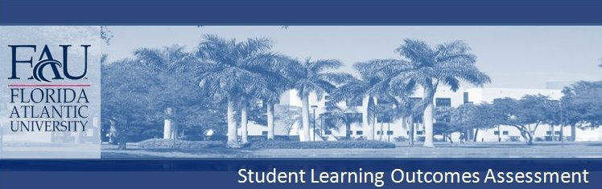
COLLEGE OF
Biological Sciences
Degree Level: MS, thesis or non-thesis, including MST

The Biology Department of Florida Atlantic University offers two Masters degrees: M.S. and M.S.T. The program is tailored to the needs and interests of the student, in five areas: Biotechnology, Microbiology, Ecology, Marine Biology, and Environmental Sciences. Students may enroll on a full or part-time basis; all receive guidance from a faculty advisor. Normally, the degree is completed within two years full-time or four years part-time. A Masters degree in biology prepares students for graduate study in Ph.D., health profession programs, teaching, research, or careers in business or government.s Option
MS + Thesis: The thesis option is designed for students whose career goals include a research emphasis, including the possibility of enrolling in a Ph.D. program. Students who choose the thesis option take 36 credits of course work; Up to one third of those hours devoted to independent research under the supervision of a faculty member, culminating in a thesis. Students may choose advisors from the Biology faculty, or from other faculty members who have affiliate appointments within the department. See the Graduate catalog for more details.
MS-Non-thesis, Option1:The non-thesis option is designed for students interested in the field of medicine, education at the elementary, middle and high school level, or those who simply wish to further their knowledge of biology. Non-thesis students are required to complete a minimum of 36 semester hours of course work and complete a written comprehensive examination, administered by a minimum of three-faculty members with interests in the student’s field of specialization (typically, organismal or molecular biology). Although not required for the non-thesis option, the faculty encourages independent research.MS in Teaching Degree: Non-Thesis Option #2
MS-Non-thesis, Option2: The Masters of Science in Teaching (MST) is designed for graduate students who are interested in furthering their knowledge in biological sciences for a career in teaching at various levels, including Elementary, Secondary, Early Childhood Education and Community College. MST graduate students work closely with an advisor to develop a program of courses that best fit their needs and interests. MST students are required to complete a minimum of 30 semester hours of course work. In addition, students must take 6 credits in approved courses in education or another cognate field if they plan to teach in high school and hold a rank III secondary certificate, or if they intend to teach in a community college. Six additional credits (beyond the 30 credits minimum) of education internship are required, except for those students with two years of teaching experience or who have completed student teaching or a teaching internship at a secondary school or junior college level. Students must pass a written comprehensive examination administered by the student’s committee (a minimum of three-faculty members) covering biological sciences. Students must also take approved courses in education (or another cognate field) if they plan to teach in high school and hold a rank III secondary certificate or if the student intends to teach at a community college.
CRITICAL THINKING (Analytical Skills): Students will use critical thinking to evaluate data by applying basic principles of scientific methodology including (1) the nature of scientific explanations, (2) threats to the validity and reliability of observations, (3) the limitations of measurement scales, (4) using experimental and quasi-experimental designs to test hypotheses and (5) appropriate interpretation and correlation of experimental data.

Tests of both critical thinking and communications skills have recently been implemented in several Biological Sciences courses using Calibrated Peer Review (CPR), a write to learn method that offers valuable formative instruction for student learning in a course. Because both written communication and critical thinking are used during CPR assignments, both outcomes are improved by this method.

In addition, the Department also has begun testing students for Critical Thinking with the California Critical Thinking Skills Test (CCTST) in Bioprinciples (BSC 1010), General Microbiology (MCB 3020) and several advanced courses. CCTST use offers insight into FAU students' critical thinking abilities and shows gains for both classes and individuals.

The Department hopes soon to extend both CPR and CCTST use to Graduate students at both the MS & PhD levels.

COMMUNICATION (Written Communication, Oral Communication):
Tests of both critical thinking and communications skills have recently been implemented in several Biological Sciences courses using Calibrated Peer Review (CPR), a write to learn method that offers valuable formative instruction for student learning in a course. Because both written communication and critical thinking are used during CPR assignments, both outcomes are improved by this method.

COMPLETE MS REQUIREMENTS APPEAR IN FAU'S UNIVERSITY CATALOG

