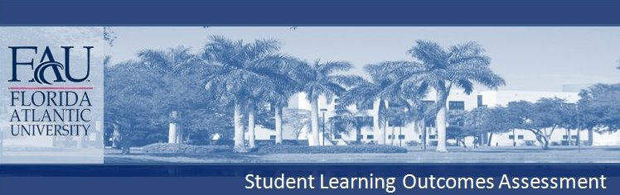
COLLEGE OF BUSINESS
SCHOOL OF ACCOUNTING
B.B.A. & B.S. ACCOUNTING

General Business Knowledge

Majors are required to complete the interdisciplinary College of Business Core with grades of “C” or higher in the following courses:
BUL 4421 – Business Law 1 MAN 3506 – Operations Management
ENC 3213 – Writing for Management MAN 4720 – Global Strategy and Policy
FIN 3403 – Principles of Financial Management MAR 3023 – Marketing Management
MAN 3025 – Intro to Mgmt & Org Behavior QMB 3600 – Quantitative Methods in Admin

Business Law
Content Knowledge: Declarative Knowledge
Students will acquire knowledge in legal and ethical aspects of business decision-making, managerial responsibilities within the law, and legal and economic implications of non-compliance.

Communication
Communication: Written and Oral
Students will acquire common written and oral communication skills needed to function within an entry-level management position. Students will produce traditional business documents that are clear and follows standard conventions and style, punctuation, grammar, spelling, sentence structure, paragraph formation, proper word choice. Students will also learn the basic skills of oral presentations.

Finance
Content Knowledge: Declarative Knowledge, Procedural Knowledge (research and technical)
Critical Thinking: Analytical Skills, Practical Skills.
Students will demonstrate knowledge of basic financial concepts, including cash flows, cost of capital, and valuation.

Management
Content Knowledge: Declarative Knowledge
Students will acquire common concepts and knowledge to function in an entry-level management position: managing structure and design, managing organizational culture, managing teams, human resources, managing employee diversity, motivation, and leadership.

Operations Management
Content Knowledge: Declarative Knowledge, Procedural Knowledge (technical)
Critical Thinking: Analytical Skills
Students will apply mathematical and statistical techniques to address issues in inventory control, project management, statistical process control, and forecasting.

Strategic Management
Content Knowledge: Declarative Knowledge
Communication: Oral
Critical Thinking: Analytical Skills
Students will acquire strategic management concepts, knowledge, analytical skills and oral communication techniques to function in an entry-level management position.

Marketing
Content Knowledge: Declarative Knowledge
Students will demonstrate Declarative Knowledge of marketing research, target marketing and elements of the marketing mix.

Quantitative Methods in Administration
Content Knowledge: Declarative Knowledge, Procedural Knowledge (technical)
Critical Thinking: Analytical Skills
Students will demonstrate proficiency in the use of quantitative methods and decision making tools and techniques for business applications. Students will demonstrate content knowledge and critical thinking skills using probabilistic and deterministic business models in administrative and operational problem solving and decision-making.

Accounting
Content Knowledge: Declarative Knowledge
Students will demonstrate knowledge of basic concepts in financial accounting (the Conceptual Framework, accounting transactions and financial statement effects, financial statement presentation, articulation of financial statements, and the time value of money), cost accounting (internal control framework, transaction flow, cost behavior and relationships, product costing, budget concepts) and tax accounting (major inclusions and exclusions, timing of income and deductions, cost recovery calculation, non-taxable exchanges, and taxation of flow-through entities), and accounting processes and controls in a computerized environment. Students will obtain knowledge related to professional careers in accounting, tax, and related areas of business and government, or graduate or professional education in Accounting and related fields.

Content Knowledge: Technical Skills
Students will have practical and applied knowledge of Accounting Information Systems and their practices including understanding processes and building Accounting systems, controls, and information systems in regulated environment.

Critical Thinking: Analytical Skills
Students will also demonstrate their ability to think critically about accounting problems and issues. Also, they will be able to diagnose the design and operation of accounting information systems as affected by information theory, computers and behavioral concepts.

Communication: Written
Students will demonstrate their abilities to communicate effectively on accounting issues and problems.

