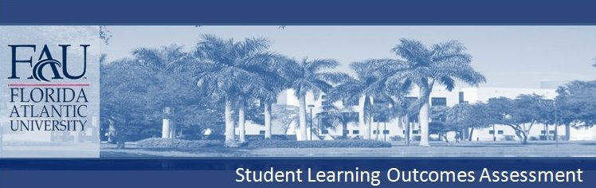
COLLEGE OF BUSINESS
ECONOMICS DEPARTMENT
B.B.A. & B.S. ECONOMICS

Economics
Content Knowledge: Declarative Knowledge, Procedural Knowledge (research skills)
Students will demonstrate a basic understanding of fundamental microeconomic concepts, including supply and demand, rational behavior, and the role of prices in resource allocation. Students will demonstrate knowledge of economic research methods. The methods include collecting relevant and reliable resource and reference material, and identification of relevant economic theories.

Critical Thinking: Analytical and Creative Skills
Students will demonstrate the ability to graphically analyze supply and demand curves. Students will be able to perform research to imaginatively resolve economic problems using relevant economics theoretical foundations. Students will demonstrate an ability to apply economic theory in the form of critical analysis of a particular topic and argue a position.

Communication: Oral & Written
Students will demonstrate the ability to write a grammatically correct, well-organized paper focused on a main point or theoretical argument in Economics. Also, students will prepare and deliver an effective speech on an Economics topic.

