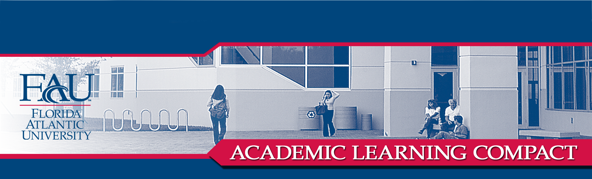
B.S. COMPUTER ENGINEERING

COLLEGE OF ENGINEERING & COMPUTER SCIENCE
DEPARTMENT OF COMPUTER SCIENCE AND ENGINEERING

COMMUNICATION (Written communication, Oral communication): Students will produce written reports and oral presentations on topics relating to computing.

All students are required to complete COT 4935 (Senior Seminar), in which they give oral presentations and submit written reports regarding ethical, social, and legal issues related to computing. Students must make their points in these reports and presentations in a manner that is clear and effective.

CONTENT KNOWLEDGE (Declarative Knowledge, Research Skills, Technical Skills) and
COMMUNICATION (Team/Collaborative communication) and
CRITICAL THINKING (Practical skills): Students will work in teams to plan and execute an engineering design to meet an identified need.

In the required EGN 4410C (Engineering Design I) and EGN 4411C (Engineering Design II), students work in interdisciplinary teams to carry through the complete engineering design process, from conceptualization to implementation including presentations. The course guidelines for EGN 4410C and EGN 4411C provide for formal assessment of each student against specific criteria by the faculty teaching the course and by the student peers. These criteria are intended to guarantee that each student has:
• An understanding of professional ethical responsibilities.
• A working knowledge of fundamentals, engineering tools, and experimental methodologies.
• An understanding of the social, economic, and political contexts in which engineers must function.
• An ability to plan and execute an engineering design to meet identified need.
• An ability to function on multidisciplinary teams.
• An ability to communicate effectively (oral, written, and graphic).
• Preparation for real-world practice.

CONTENT KNOWLEDGE (Technical Skills) and
CRITICAL THINKING (Analytical Skills, Practical Skills): Students will demonstrate knowledge of, and proficiency in, the application of standard methods regarding software implementation and programming, and will demonstrate the ability to implement and test computer programs. In particular, students will develop programming proficiency in C++.

Students are required to complete the CE core courses COT 3002 (Foundations of Computer Science) and COP 3530 (Data Structures and Algorithms). In these courses, students complete C++ programming assignments and projects. These assignments and projects are judged based on correctness of code, clarity of code, and run-time efficiency.

CONTENT KNOWLEDGE (Technical skills) and
CRITICAL THINKING (Analytical skills, Practical skills): Students will demonstrate knowledge and analytical skills regarding the mathematical foundations of computer engineering.

Students are required to complete MAD 2104 (Discrete Mathematics) and STP 4821 (Stochastic Models for Computer Science). In these courses, students take tests and complete assignments that exercise their ability to prove theorems, apply theorems to real computing situations, and compare rigorously obtained mathematical predictions to results obtained by computer simulations.

CONTENT KNOWLEDGE (Declarative knowledge, Technical skills): Students will demonstrate proficiency in the areas of electronics, computer architecture, and computer design.

Students are required to complete CAD 3331C (Introduction to Microprocessors) and CDA 3201C (Introduction to Logic Design), as well as completing two courses from the Computer Engineering Core Systems Group and two courses from the Computer Engineering Core Technology Group. In these courses students take tests, complete lab reports, and complete assignments that enhance their ability to design and analyze circuits, their understanding of microprocessor and microcontroller architecture, their ability to design and code assembly language programs, and their understanding of the hardware-software interface.

Approved 12-02-2005

