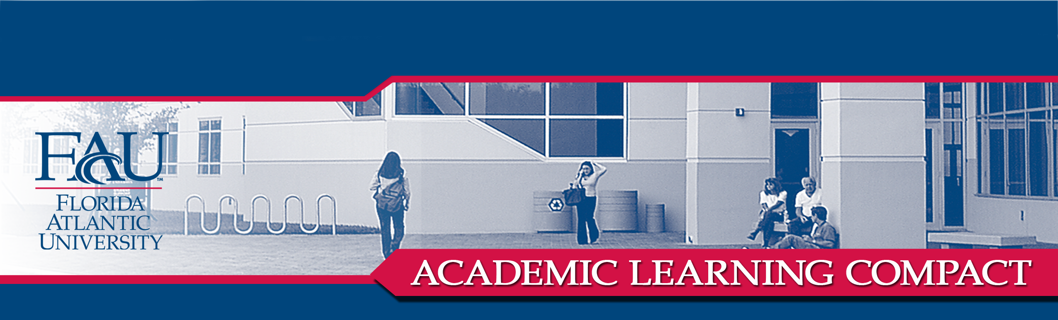
B.S. COMPUTER SCIENCE

COLLEGE OF ENGINEERING & COMPUTER SCIENCE
DEPARTMENT OF COMPUTER SCIENCE AND ENGINEERING

COMMUNICATION (Written Communication, Oral Communication): Students will produce written reports and oral presentations on topics relating to computing.

All students are required to complete the COT 4935 (Senior Seminar), in which they give oral presentations and submit written reports regarding ethical, social, and legal issues related to computing. Students must make their points in these reports and presentations in a manner that is clear and effective.

CONTENT KNOWLEDGE (Technical Skills) and
CRITICAL THINKING (Analytical Skills, Practical Skills): Students will demonstrate knowledge of, and proficiency in, the application of the standard methods regarding software implementation and programming, and will demonstrate the ability to implement and test computer programs.

Students are required to complete COT 3002 (Foundations of Computer Science), COP 3530 (Data Structures and Algorithms), and COT 4400 (Design and Analysis of Algorithms). In these courses, students complete C++ programming assignments and projects. These assignments and projects are judged based on correctness of code, clarity of code, and run-time efficiency.

CONTENT KNOWLEDGE (Declarative Knowledge, Technical Skills): Students will demonstrate knowledge regarding computer hardware and the major categories of computer software.

Students must complete two hardware courses in the CS core, CDA 3201A (Introduction to Logic Design) and CDA 3331C (Introduction to Microprocessor Systems). Students must also complete the following courses that regard major categories of software systems: COP 4610 (Computer Operating Systems) and COP 3540 (Introduction to Database Structures). In the latter two courses, in addition to learning concepts relative to the overall structure of operating systems and database systems, the students master programming techniques specific to these systems.

CONTENT KNOWLEDGE (Declarative Skills, Technical Skills) and
CRITICAL THINKING (Analytical Skills, Practical Skills): Students will demonstrate knowledge and analytical skills regarding the mathematical foundations of computer science.

Students are required to complete the following CS core courses: MAD 2104 (Discrete Mathematics), STA 4821 (Stochastic Models for Computer Science), and COT 4420 (Formal Languages and Automata Theory). In these courses, students take tests and complete assignments that exercise their ability to prove theorems, apply theorems to real computing situations, and compare rigorously obtained mathematical predictions to results obtained by computer simulations.

CONTENT KNOWLEDGE (Technical Skills) and
CRITICAL THINKING (Analytical Skills, Practical Skills): Students will demonstrate knowledge of standard software engineering methodologies, and be able to critically apply these methodologies in the planning and execution of a problem design to meet an identified need.

CONTENT KNOWLEDGE (Declarative Knowledge, Technical Skills): Students will develop analytical skills, and demonstrate proficiency in, the areas of algorithmic design, development, and analysis, including the ability to critically compare and select among competing structures and methods.

Content regarding important data structures and algorithmic methods, as well as the analytical skills required in designing and analyzing algorithms, are studied in COT 3002 (Foundations of Computer Science), COP 3530 (Data Structures and Algorithms), and COT 4400 (Design and Analysis of Algorithms). Students will be exercised through tests and sequences of programming assignments that involve algorithmic design and data structure selection. The overall software life cycle is studied in CEN 4010 (Principles of Software Engineering). Students in this class complete tests, assignments, and a course project involving the requirements analysis, design, implementation, testing, and documentation of software.


Approved 12-02-2005

