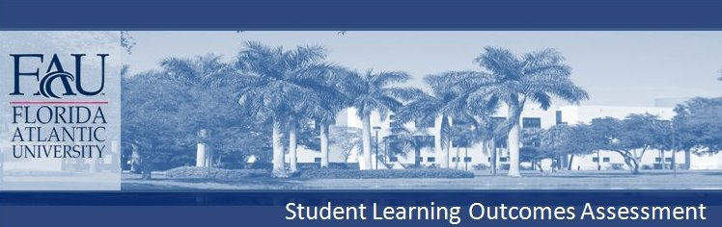
COLLEGE OF ENGINEERING AND
COMPUTER SCIENCE
Department of Computer and Electrical Engineering and Computer Science
B.S. Computer Science

In the below classes, student satisfaction of Program Outcomes are assessed by the instructor completing the Departmental Student Achievement of Outcomes Forms, which are then analyzed by the Department's Assessment and Evaluation Committee.

COMMUNICATION (Written communication, Oral communication): Students will produce written reports and oral presentations on topics relating to computing.

All students are required to complete COT 4935 (Senior Seminar), in which they give oral presentations and submit written reports regarding ethical, social, and legal issues related to computing. Students must make their points in these reports and presentations in a manner that is clear and effective.

Students give a team oral and written report in the capstone course CEN 4010 (Principles of Software Engineering).

CRITICAL THINKING (Analytical Skills, Practical Skills): Students will demonstrate knowledge of standard software engineering methodologies, and be able to critically apply these methodologies in the planning and execution of a problem design to meet an identified need.

The overall software life cycle is studied in CEN 4010 (Principles of Software Engineering). Students in this class complete tests, assignments, and a course project involving the requirements analysis, design, implementation, testing, and documentation of software.

The analytical skills required in designing, implementing, and analyzing algorithms, are intensively studied in COT 4400 (Design and Analysis of Algorithms).

CONTENT KNOWLEDGE (Declarative Knowledge, Declarative Skills, Technical Skills):
Students will demonstrate knowledge of, and proficiency in, the application of the standard methods regarding software implementation and programming, and will demonstrate the ability to implement and test computer programs.

Students will demonstrate knowledge regarding computer hardware and the major categories of computer software.

Students will demonstrate knowledge and analytical skills regarding the mathematical foundations of computer science.

Students are required to complete COT 3002 (Foundations of Computer Science), COP 3530 (Data Structures and Algorithms), and COT 4400 (Design and Analysis of Algorithms). In these courses, students complete C++ programming assignments and projects. These assignments and projects are judged based on correctness of code, clarity of code, and run-time efficiency.

Students must complete two hardware courses in the CS core, CDA 3201A (Introduction to Logic Design) and CDA 3331C (Introduction to Microprocessor Systems). Students must also complete the following courses that regard major categories of software systems: COP 4610 (Computer Operating Systems) and COP 3540 (Introduction to Database Structures). In the latter two courses, in addition to learning concepts relative to the overall structure of operating systems and database systems, the students master programming techniques specific to these systems.

Students are required to complete the following CS core courses: MAD 2104 (Discrete Mathematics), STA 4821 (Stochastic Models for Computer Science), and COT 4420 (Formal Languages and Automata Theory). In these courses, students take tests and complete assignments that exercise their ability to prove theorems, apply theorems to real computing situations, and compare rigorously obtained mathematical predictions to results obtained by computer simulations.



