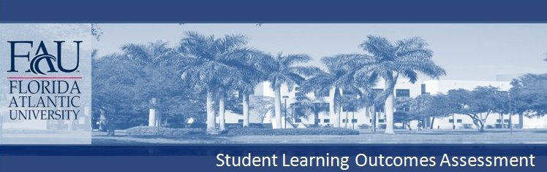
COLLEGE OF DESIGN & SOCIAL INQUIRY
School of Public Administration
B.P.M. Public Management
The Bachelor of Public Management program requires the following courses:
PAD 3003 Public Management and Administration
PAD 3104 Organizational Behavior and Administrative Communication
PAD 4223 Public Budgeting and Finance
PAD 4414 Public Personnel and Supervisory Practices
PAD 4604 Administrative Process and Ethics
PAD 4702 Quantitative Inquiry for Public Mangers
PAD 4704 Research Methods in Public Management
PAD 4933 Capstone Seminar in Public Management
Plus 9 credits of public administrative electives

CONTENT KNOWLEDGE (Declarative Knowledge): BPM students will demonstrate that they have learned the theoretical frameworks, practical applications, and general terminology of public administration. Specifically, students will acquire knowledge about administrative structures, concepts of organizational behavior and administrative communication, budgeting and finance, human resource management, ethics and ethical reasoning, and administrative processes within the United States.

CONTENT KNOWLEDGE (Technical Skills; Research Skills): BPM students will demonstrate that they have learned the methods and strategies used to implement budgetary policy, techniques of statistical reasoning, interpretation and critique of statistical data, and conduct of basic statistical analyses. Students will be able to discuss the general steps in the research process and in the use of quantitative and qualitative research designs.

COMMUNICATION (Written Communication; Oral Communication): BPM students will produce written communications, such as research papers, issue assessments, and case studies that are grammatically correct and include a thesis statement, body and conclusion. Students will demonstrate effective oral communication skills by presenting a well‐ organized and well‐conceptualized oral presentation in the field of public management.

CRITICAL THINKING (Analytical skills, Creative skills, Practical skills): Students will be able to raise vital questions and problems, gather and assess relevant information, generate
well‐reasoned solutions and conclusions, think open‐mindedly, and communicate effectively with others on issues and topics appropriate to the field of public management.

While enrolled in PAD 4933 (Capstone Seminar in Public Management), all Bachelor of Public Management (BPM) students will submit a portfolio to the BPM Coordinator that will contain a collection of work completed and identified by the student. The portfolio will evidence mastery of the set of skills acquired throughout the BPM program; the portfolio may include course material from other courses a student has taken outside the BPM program.

Portfolios may include, but are not limited to, the following materials: I. Personal and Professional Information
a. Current Resume
b. Personal Background
c. Classes taken: year, grade, and general content.
d. A personal statement of a student’s professional philosophy and goals.
e. Documentation of effort to improve oneʹs professional training (e.g., seminars, programs, internship, volunteer work)
f. A self‐evaluation
g. An evaluation of the BPM program
II. Course Artifacts
a. Examples of written work (e.g., research papers, class writing examples)
b. Journals and logs (for students who complete the government internship)
c. Videotapes/audiotapes of student presentations d. Group projects/papers
e. Tests and quizzes f. Lists of books read
III. Professional Information
a. List of Professional Activities b. Letters of Recommendation

Each student’s portfolio will be graded by the BPM Coordinator using a 4‐point scale (Emerging, Competent, Accomplished, Distinguished). Grading is based on the following criteria:
• Portfolio structure (Organization)
• Selection of portfolio content
• Evidence of content skills (declarative knowledge, research skills, technical skills)
• Evidence of communication skills (written communication, oral communication)
• Evidence of critical thinking skills (analytical skills, creative skills, practical skills)
• Quality of self‐reflection
• Presentation (Articulation)


DEGREE REQUIREMENTS APPEAR IN FAU'S UNIVERSITY CATALOG

