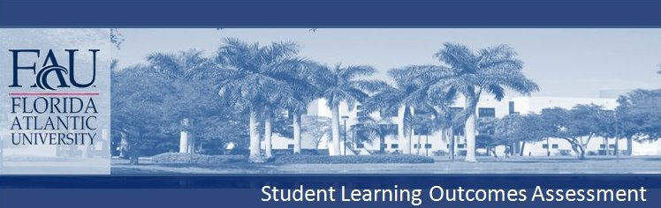
COLLEGE OF BUSINESS
MARKETING DEPARTMENT
B.B.A. & B.S. HOSPITALITY MANAGEMENT

General Business Knowledge

Majors are required to complete the interdisciplinary College of Business Core with grades of “C” or higher in the following courses:
BUL 4421 – Business Law 1 MAN 3506 – Operations Management
ENC 3213 – Writing for Management MAN 4720 – Global Strategy and Policy
FIN 3403 – Principles of Financial Management MAR 3023 – Marketing Management
ISM 3011 – Management Information Systems QMB 3600 – Quantitative Methods in Admin
MAN 3025 – Intro to Mgmt & Org Behavior

Business Law
Content Knowledge: Declarative Knowledge
Students will acquire knowledge in legal and ethical aspects of business decision-making, managerial responsibilities within the law, and legal and economic implications of non-compliance.

Communication
Communication: Written and Oral
Students will acquire common written and oral communication skills needed to function within an entry-level management position. Students will produce traditional business documents that are clear and follows standard conventions and style, punctuation, grammar, spelling, sentence structure, paragraph formation, proper word choice. Students will also learn the basic skills of oral presentations.

Finance
Content Knowledge: Declarative Knowledge, Procedural Knowledge (research and technical)
Critical Thinking: Analytical Skills, Practical Skills.
Students will demonstrate knowledge of basic financial concepts, including cash flows, cost of capital, and valuation.

Management Information Systems
Content Knowledge: Technical Skills
Students will demonstrate proficiency with software programs (word processing, spreadsheet, and database) and their applications to business practices.

Management
Content Knowledge: Declarative Knowledge
Students will acquire common concepts and knowledge to function in an entry-level management position: managing structure and design, managing organizational culture, managing teams, human resources, managing employee diversity, motivation, and leadership.

Operations Management
Content Knowledge: Declarative Knowledge, Procedural Knowledge (technical)
Critical Thinking: Analytical Skills
Students will apply mathematical and statistical techniques to address issues in inventory control, project management, statistical process control, and forecasting.

Strategic Management
Content Knowledge: Declarative Knowledge
Communication: Oral
Critical Thinking: Analytical Skills
Students will acquire strategic management concepts, knowledge, analytical skills and oral communication techniques to function in an entry-level management position.

Marketing
Content Knowledge: Declarative Knowledge
Students will demonstrate Declarative Knowledge of marketing research, target marketing and elements of the marketing mix.

Quantitative Methods in Administration
Content Knowledge: Declarative Knowledge, Procedural Knowledge (technical)
Critical Thinking: Analytical Skills
Students will demonstrate proficiency in the use of quantitative methods and decision making tools and techniques for business applications. Students will demonstrate content knowledge and critical thinking skills using probabilistic and deterministic business models in administrative and operational problem solving and decision-making.

Hospitality Management
Content Knowledge: Declarative Knowledge
Students will demonstrate content knowledge gathered from general principles of hospitality management, hospitality law, hospitality revenue/marketing management and hospitality performance analysis.

Communication: Oral & Written
Students will demonstrate their abilities to write and present on a hospitality related project.

Critical Thinking: Analytical, Creative, and Practical Skills
Students will also analyze hospitality performance cases.

