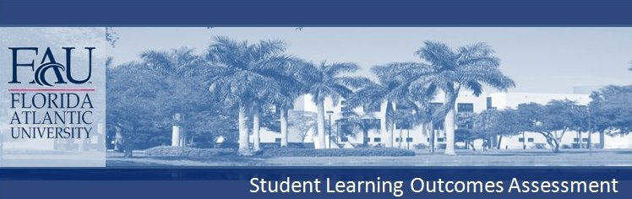

Pre-Health Professions Program
Certificate Program in Pre-Health Professional Studies

Content:

The Pre-Health Professions Certificate Program is designed to prepare students to apply to medical, dental, veterinary and other health professions graduate programs. Courses required for the certificate include (1) required prerequisite courses for these programs; (2) courses not required but strongly recommended for success in their chosen graduate program admissions test and in their basic medical science courses; and (3) courses that enhance the students knowledge about their chosen profession.

- Content of prerequisite courses will prepare students for the admissions test required by their profession. Given that this program has no control over the content or administration of these courses, our input into change of content can only be advisory to the respective department.
- Content of other science courses will prepare students for the admissions test and for their first two years of basic medical sciences course work. Input into change of content can only be advisory to the respective department. We will however use outcomes to modify which courses are included in the certificate program.
- Content of professional courses (e.g., Intro to Preprofessional Studies; Premed success; Basic Clinical Skills; Externship) and other aspects of the program (interview preparation, etc) will provide students with the knowledge and skills required to successfully negotiate the admissions process.

Critical thinking:

The Pre-Health Professions Certificate Program is designed to prepare students to apply to medical, dental, veterinary and other health professions graduate programs. The courses that we offer unique to this program are designed for professional preparation. However, other components of the program may be modified to include emphasis on critical thinking, especially critical reading, skills.

- Preprofessional students will be expected to develop excellent critical reading skills.

Communication:

The Pre-Health Professions Certificate Program is designed to prepare students to apply to medical, dental, veterinary and other health professions graduate programs. The importance of written and oral communication skills is critical to the success of pre-professional students.

- Students in the Preprofessional Program will develop excellent oral communication skills.
- Students in the Preprofessional Program will be challenged to formulate well-thought out and articulate responses to questions typically asked on medical, dental, or veterinary school interviews.
- Students will learn how to communicate their passion for the chosen profession in the interview process.

