**FAU LIBRARIES**

**LIBSAT SURVEY RESULTS REPORT**

**FALL SEMESTER 2009**

**Prepared by: Dr. Darlene Parrish and Malka Schyndel**

**Date Submitted: January 20, 2010  
Date Revised: January 25, 2010**

**Executive Summary**

This report includes a summary of the responses of the LibSAT customer satisfaction survey for the period August through December 2009, and an analysis of the survey itself and makes some recommendations for improvement. LibSAT was first tested by Library staff members and then officially launched on the FAU Boca Campus Library home page on August 24th. Shortly thereafter, two more online access points were added on the Jupiter and Davie Campus Library home pages. The survey period lasted until December 11, 2009.

There were a total of **456** respondents for all campus libraries including Boca, Davie, Fort Lauderdale, Harbor Branch, Jupiter, and Port St. Lucie, about **78.6%** were either undergraduate or graduate students, **12.4%** were faculty and **9%** were other library users. Most of the respondents, about **79%,** identified themselves as being from the Boca Campus, with **9%** from Davie and **11%** from the other four campuses.

About one third of the respondents are accessing library services remotely, and more respondents seem to prefer to search for information on their own, but like the availability of assistance when required. Approximately **88%** of respondents indicated some level of agreement that the Library is very important to them, and about **78%** showed some degree of agreement that they are very satisfied with the services of this Library. However, about **13%** of respondents indicated some degree of dissatisfaction with library services.

It appears that respondents seem to be satisfied with library services, but there does seem to be some dissatisfaction with **“Collections,”** including books, journals, etc.**,** and **“Library Electronic Resources (e.g. databases, electronic journals, electronic books)**.” In the area of facilities, respondents expressed dissatisfaction with **“Parking**,” **“Seating/Workspace**,” **“Restrooms,” “Facilities for security of personal belongings,”** and **“Hours of access and operation.”** As far as policies and procedures, respondents expressed some dissatisfaction with **“Fines/Fees,” “Holds/Renewals”** and **“Interlibrary Loan” policies.** Additionally, in the area of equipment, respondents expressed some dissatisfaction with **“Printers,”** (there was only a **40.6%** level of satisfaction), **“Copiers,” “Computers equipped with specialized software…,”** and **“Computer workstations.”**

There were a total of **1,040** individual comments from **456** respondents for all campus locations. However, since one comment can be identified with more than one category, there are a total of **1,373** categorized comments. There were a total of **550** positive comments for all campus locations. As far as the individual categories, it appears that respondents are most satisfied with the staff, since the category **“About the staff”** received the largest number, **20.9% (n=550),** of all positive comments followed by **“Services”** with **15.8%** and **“Electronic Databases”** at **10.5%. “Facilities”** also received some positive comments (about **7.5%**), but the majority of the comments, about **20.7% (n=666),** were negative.

There were a total of **666** negative comments for all campus locations. Even though for all campus locations the largest percentage of positive comments, (**20.9%) (n=550),** was **“About the staff,”** for the Davie Campus, **15.1 %** of all its negative comments **(n=86)** were **“About the staff.”** The areas for all campuses with the highest percentage of negative comments were related to facilities, equipment, and collections.

**CONTENTS**

**PART I: QUANTITATIVE DATA RESULTS**

Introduction 5

Limitations of LibSAT Survey Results 5

Results of Context Questions 6

Results of Overall Questions 9

Results of Services Questions 11

Results of Staff Questions 12

Results of Facilities Questions 13

Results of Policies Questions 14

Results of Equipment Questions 15

Summary 15

**PART II: QUALTITATIVE DATA RESULTS**

Introduction 16

Summary of Positive Comments 16

Summary of Negative Comments 16

Facilities 16

Seating/Workspace 19

Hours of Access and Operations 21

Equipment 22

Computer workstations 24

Collections 26

**PART II: QUALTITATIVE DATA RESULTS (con.)**

Periodicals 27

Books 27

Electronic resources 28

Shelving 29

Final Recommendations 30

**PART I: QUANTITATIVE DATA RESULTS**

**Introduction**

This report includes a summary of the results of the LibSAT survey for the period August through December 2009, and an analysis of the survey itself. LibSAT was officially launched on the Florida Atlantic University (FAU) Boca Campus Library home page on August 24th, and shortly thereafter, a link was included on the Jupiter and the Davie Campus Library home pages, providing two more online access points. At the end of the fall semester, on December 11th, the link to LibSAT on the FAU Boca Campus Library home page was “hidden” and so was the link to the Jupiter Campus Library home page, but the link to the Davie Campus Library home page can still be accessed.

There were a total of **456** respondents for all campus libraries including Boca, Davie, Fort Lauderdale, Harbor Branch, Jupiter, and Port St. Lucie. Most of the respondents, about **79%,** identified themselves as being from the Boca Campus, with **9%** from Davie and **11%** from the other four campuses. As far as the monthly breakdown for the total number of responses, the largest number was in September with **147,** and the smallest number, **18,** occurred in December.

**Limitations of LibSAT Survey Results**

One definite limitation of the LibSAT survey is the response rate, which was **1.6%.,** if you are basing your response rate on the FAU community population of approximately 28,000. However, you also have to consider how many people actually “touched” the FAU Libraries home page and saw the survey.

Approximately **74%** of the **456** respondents selected the regular survey, which takes about 7 minutes to complete. Only **26%** of respondents selected the in-depth survey, which has a completion time of about 15 minutes. The question categories for the regular survey include “Overall” (questions about overall satisfaction with the Library) and “Context” (questions about the respondent, satisfaction with services, and usage). However, in addition to “Overall” and “Context,” the in-depth survey also includes question categories entitled “Services” (additional questions about services), “Staff,” “Facilities,” “Policies,” and “Equipment.” Since the response rate of the in-depth survey was only **26%,** this is a definite limitation.

Additionally, included in the total number of **456** respondents are those who may have only answered a few questions and not the entire survey, whether regular or in-depth, before submitting it. Since respondents were not required to complete the entire survey before submitting it, the total number of responses for individual questions will vary and decrease significantly with the in-depth survey, which is another limitation. As a result of this limitation, the total number of responses or statistical sample (e.g. **n=360)** for each question reported in the results will be given when discussing the results.

**Results of Context Questions**

The “Context” category of questions included questions about the respondent, satisfaction with services, and usage. The largest percentage of respondents**, 47.6% (n=410),** identified themselves as being undergraduate students with graduate students second at **31%.** Here is a chart showing the distribution of types of respondents.

**I am…(select the best fit)**

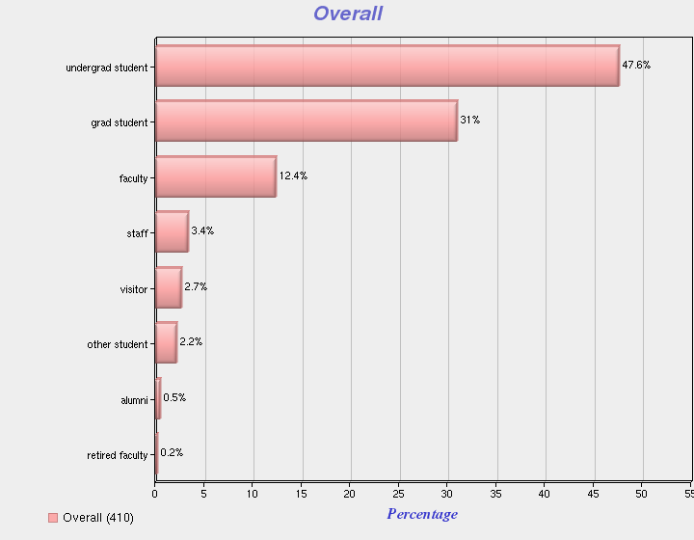

Most of the respondents, **66.4% (n=363),** indicated that they use library services on campus, but **33.6%** indicated that they use them remotely, as is evidenced by the chart below.

**I use Library services primarily…**

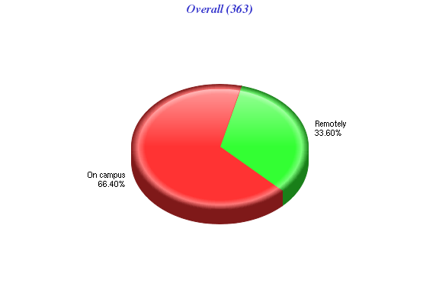

“Study alone” was indicated by the most respondents, **44.9% (n=350),** as the primary reason for using the Library, but “research” was a close second with **40%.** Here is the complete distribution of responses for the following question:

**The primary reason for using this Library…(select the best fit)**

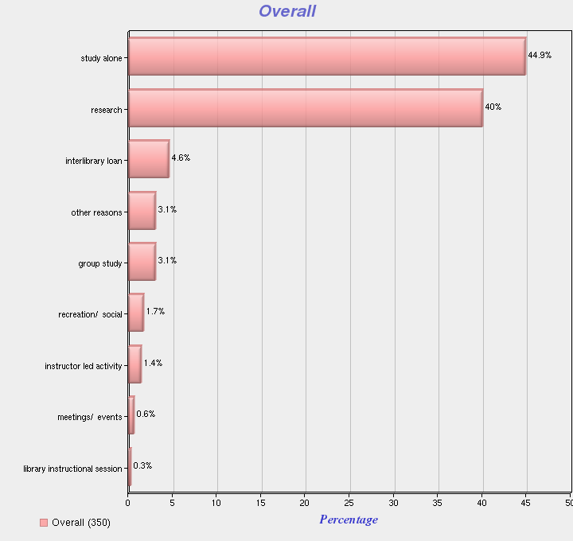

As far as the aspects of service that most impact satisfaction, “accessible information” had the highest number of responses at **70.8% (n=373),** followed by “convenient location” at **65.1%,** as the chart below indicates.

**The aspects of service that most impact my satisfaction include ... (choose all that apply)**

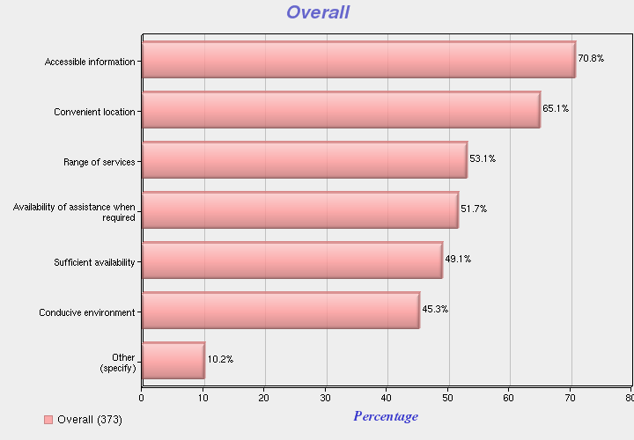

Evenings and afternoons seem to be the most convenient time for respondents to use the library, since the percentages were **59.1%** and **57.7% (n=359)** respectively. Weekends were third with **49.6%** followed by “late night” at **45.7%** and mornings at **44.8%.** Here is a chart with the distribution of responses.

**It is most convenient for me to use the services of the Library ... (choose all that apply)**

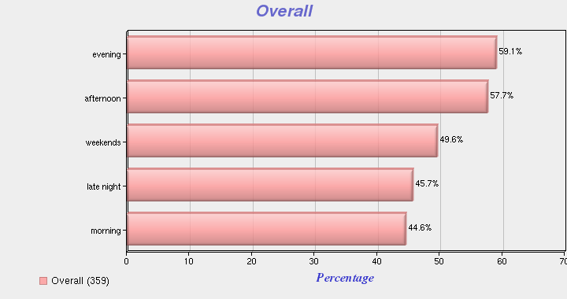

Within the “context” category there was a question about the method the respondents preferred when looking for information this past year. There were only **72 (n=72)** total respondents for this question, and the largest number, **55.6%,** indicated that they look for information “on their own, without assistance,” **25%** indicated that they “access Library’s online systems from a location other than the library,” and only **6.9%** indicated that they “request assistance from a Library staff member.” Here is a chart showing the distribution of responses.

**With respect to this Library, in the past year...When looking for information, the method I prefer is ... (select the best fit)**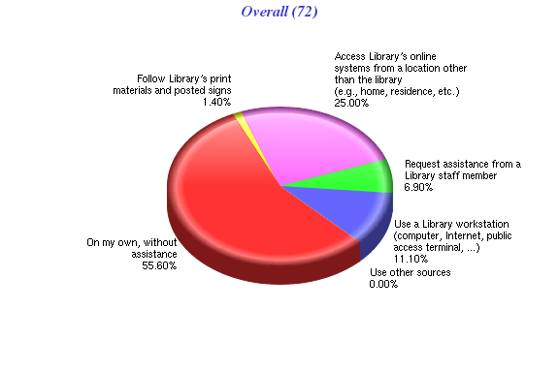

**Results of Overall Questions**

Respondents of questions in the “Overall” satisfaction category were asked to indicate a level of agreement with various statements using a 7-point Likert scale by selecting one of the following: “strongly disagree,” “disagree,” “somewhat disagree,” “neither agree nor disagree,” somewhat agree,” “agree,” or “strongly agree.” The first question states **“This Library is very important to me,”** and the majority of respondents, **87.7% (n=414),** indicated some level of agreement, and only **9.4%** indicated some level of disagreement, as the chart below shows.   
  
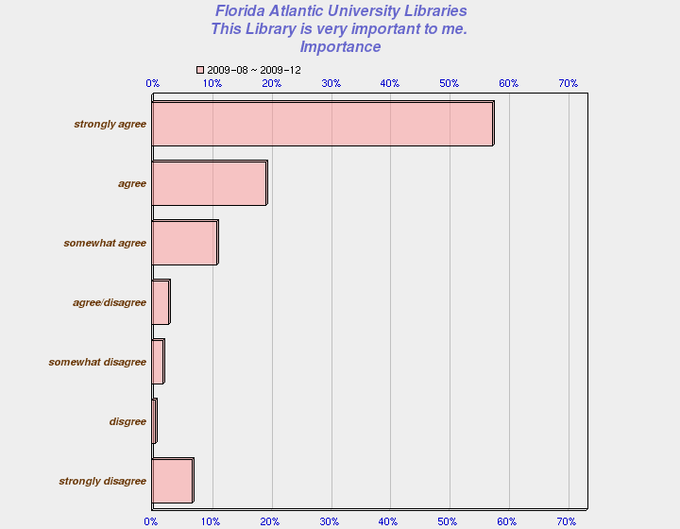

The second question states **“I am very satisfied with the services of this Library,” 78.1% (n=411)** of the respondents showed some degree of satisfaction, but **12.9%** indicated some degree of dissatisfaction. Here is the distribution of responses.

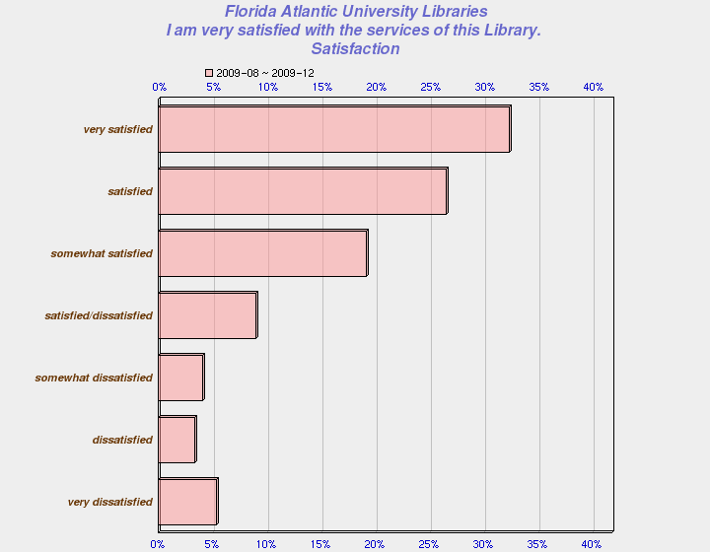

The third question states **“The services of this Library consistently meet or exceed my expectations,”** **74.6% (n=412)** of respondents showed some degree of agreement, but **14.3%** expressed some degree of disagreement. It is interesting to note that **11.2%** of the respondents would neither agree nor disagree with the statement, so there could be some ambiguity associated with this question. Here is a chart showing the distribution of responses.

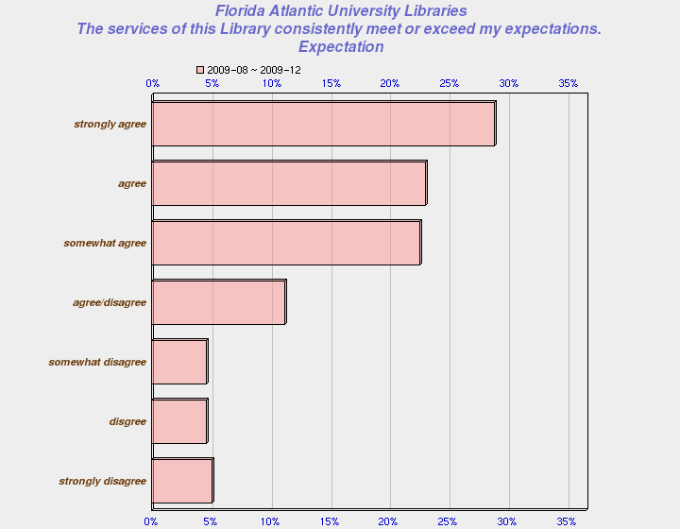

The fourth questions states “**The quality of Library services is very high,” 76.8% (n=410)** of respondents showed some degree of agreement, whereas, **13.9%** showed some degree of disagreement, as the chart below indicates.  
  
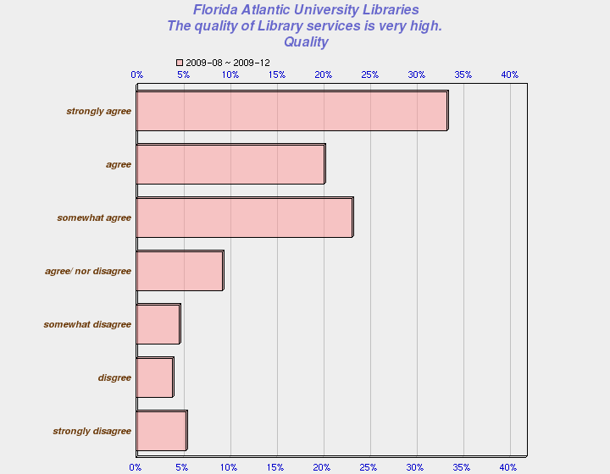

**Results of Services Questions**

Respondents of these questions were asked to indicate a level of satisfaction and importance with specific services (e.g. Library Catalog) using 7-point Likert scales from “very dissatisfied” to “very satisfied” with a neutral point in the middle (“neither dissatisfied nor satisfied”) and “very unimportant” to “very important” with a neutral point in the middle (“neither important nor “unimportant”).

It appears that respondents seemed most satisfied with **“Library Programs and Special Events”** with **85.6%** indicating some level of satisfaction, followed by **“Attending instructional sessions”** at **83%.** Respondents seem to be least satisfied with **“Collections”** with **20.4%** indicating some level of dissatisfaction, followed by **“Library Electronic Resources (e.g. databases)”** at **15.9%.** Here are the complete details.

The question reads “**Please indicate your level of satisfaction with and the importance of the following services provided by this Library ...”**

* **Attending instructional sessions** **- 83% (n=65) i**ndicated some level of satisfaction and **74.6% (n=63)** indicated some level of importance. Only **3%** indicated some level of dissatisfaction and **11.1%** some level of unimportance.
* **Collections – 59.4%** (**n=64)** indicated some level of satisfaction with **20.4%** indicating some level of dissatisfaction. **83.6% (n=61)** indicated some level of importance.
* **Library Catalog – 74.7% (n=63)** indicated some level of satisfaction with **11.1%** indicating some level of dissatisfaction. **93.4% (n=61),** indicated some level of importance.
* **Instructional Services – 39% (n=59)** indicated some level of satisfaction with only **5.1%** indicating some level of dissatisfaction. However, **55.9%** indicated “neither dissatisfied nor satisfied,” which might indicate a problem with this question. **52.7% (n=57)** indicated some level of importance.
* **Reference Desk – 75% (n=60)** showed some level of satisfaction and only **5%** some level of dissatisfaction. **87.9%** (**n=58)** indicated some level of importance.
* **Circulation Desk** - **83.3% (n=60)** showed some level of satisfaction with the “Circulation Desk” and only **1.7%** were “somewhat dissatisfied.” **91.2% (n=57)** indicated some level of importance.
* **Interlibrary Loan** - **82.5% (n=63)** indicated some level of satisfaction with “Interlibrary Loan” and only **4.8%** indicated “somewhat dissatisfied.” **95.1% (n=61)** indicated some level of importance.
* **Library Electronic Resources** (e.g., databases, electronic journals, electronic books) - **79.4% (n=63)** showed some level of satisfaction and **15.9%** showed some level of dissatisfaction. **95% (n=61**) indicated some level of importance.
* **Use of EZproxy…** - **82.6% (n=63)** showed some level of satisfaction and only **6.3%** were “somewhat dissatisfied.” **96.7 (n=61)** indicated some degree of importance.
* **Media Center** - **82.5% (n=63)** indicated some level of satisfaction and **6.3%** were “somewhat dissatisfied.” **95.1% (n=61)** indicated some level of importance.
* **Library Programs and Special Events** - **85.8% (n=63)** indicated some level of satisfaction and **96.7%** indicated some level of importance.

**Results of Staff Questions**

There were only two “yes” or “no” “Staff” questions. The first question reads “Did Library Staff meet, greet or initiate contact with you at any time?” **54.8% (n=73)** of the respondents responded “no,” and **45.2%** responded “yes.” Here is the chart with results.

**Did Library Staff meet, greet or initiate contact with you at any time?**

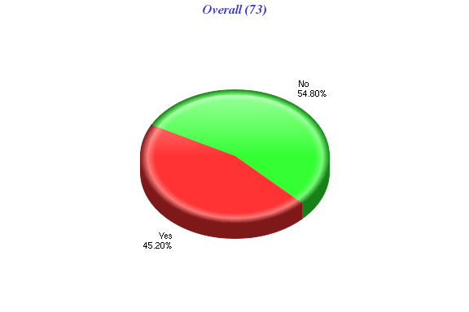

The second question reads “I requested assistance of a Library staff member…” **54.3% (n=70)** of the respondents responded “no” and **45.7%** responded “yes.” It appears that students prefer to conduct research on their own. Here is the chart with results.

**I requested assistance of a Library staff member…**

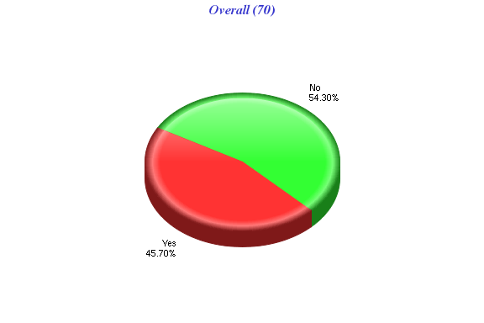

**Results of Facilities Questions**

Respondents of these questions were asked to indicate a level of satisfaction and importance with specific facilities (e.g. Seating/Workspace) using 7-point Likert scales. It appears that some respondents are satisfied with **“Hours of access and operation,”** since **78.8%** indicated some level of satisfaction; however, **13.1%** also indicated some level of dissatisfaction. The next highest category, as far as some level of satisfaction, was **“The Library building (e.g. general cleanliness)”** at **75.4%.** Respondents seem to be least satisfied with **“Parking”** with **50.9%** indicating some level of dissatisfaction, followed by **“Seating/Workspace” at 20.4%.** Here are the complete details.

The question reads “**Please indicate your level of satisfaction with and the importance of the following facilities of this Library…**”

* **Hours of access and operation** – **78.8%** (**n=61)** indicated some level of satisfaction with **13.1%** indicating some level of dissatisfaction. **94.9% (n=59)** indicated some level of importance, so this is an important issue.
* **Accessibility (access within and into building)** – **75.8% (n=58)** indicated some level of satisfaction and **6.8%** indicating some degree of dissatisfaction, but **17.2%** indicated “neither dissatisfied nor satisfied,” so there may be a problem with this question. **83.2% (n=53)** indicated some level of importance.
* **Seating/Workspace** – **66.1% (n=59)** indicated some level of satisfaction with **20.4%** indicating some level of dissatisfaction. **91.2% (n=57)** indicated some level of importance.
* **Restrooms** – **66.7% (n=60)** indicated some level of satisfaction with **20%** indicating some level of dissatisfaction. **93.1% (n=58)** indicated some level of importance, this is an important issue.
* **Facilities for personal safety** – Only **44.6% (n=56)** indicated some level of satisfaction and only **3.6%** indicated some level of dissatisfaction, but **51.8%** indicated “neither dissatisfied nor satisfied.” This probably means there is a problem with the question. **69.1%** **(n=55)** indicated some level of importance, with **27.3%** indicating “neither important nor unimportant.”
* **Facilities for security of personal belongings** - Only **27.6% (n=58)** indicated some level of satisfaction and **17.2%** indicating some level of dissatisfaction, but **55.2%** indicating “neither dissatisfied nor satisfied.” This probably means there is a problem with the question. Additionally, only **42.9% (n=56)** indicated some level of importance.
* **Facilities for security of Library materials and property** – **41.8% (n=55)** indicated some level of satisfaction with **54.5%** indicating “neither dissatisfied nor satisfied.” Again, it seems there is problem with this question. **62.3% (n=53)** indicated some level of importance with **35.8%** indicating “neither dissatisfied nor satisfied.”
* **The Library building (e.g. cleanliness)** – **75.4 (n=61)** indicated some level of satisfaction with **11.4%** indicating some level of dissatisfaction. **93.1% (n=58)** indicated some level of importance, so this is an important issue.
* **Parking** – Only **25.5%** indicated some level of satisfaction with **50.9%** indicating some level of dissatisfaction, which means that “parking” is a major issue. **84.8% (n=59)** indicated some level of importance.
* **Access to Library from a remote location ... Via phone, online, etc.** – **69.5%** (**n=59**) indicated some level of satisfaction with **13.6%** indicating some level of dissatisfaction and **16.9%** indicated “neither dissatisfied nor satisfied.” **83%** (**n=59**) indicated some level of importance.

**Results of Policies Questions**

Respondents of these questions were asked to indicate a level of satisfaction and importance with specific policies (e.g. Lending policies) using 7-point Likert scales It appears that respondents are most satisfied with **“Lending policies,“ 85.5%** indicating some level of satisfaction, followed by **“Borrowing/Returning materials”** at **77.0%.** Respondents seem to be least satisfied with **“Fines/Fees …”** with **18.0%** indicating some level of dissatisfaction, followed by **“Hold/Renewals”** at **12.5%**. Here are the complete details.

The question reads “**Please indicate your level of satisfaction with and the importance of the following policies and procedures of this Library…**”

* **Lending policies** – **85.5%** (**n=77)** indicated some level of satisfaction and only **2.6%** indicating some level of dissatisfaction, but **11.7%** indicated “neither dissatisfied nor satisfied.” **82.2% (n=73)** indicated some level of importance.
* **Fines/Fees(costs/rules, collections/payments, dispute resolution)** – Only **40.3% (n=72)** indicated some level of satisfaction and **18.0%** indicated some degree of dissatisfaction, but **41.7%** indicated “neither dissatisfied nor satisfied,” so there may be a problem with this question. **52.1% (n=69)** indicated some level of importance and **33.3%** indicated “neither dissatisfied nor satisfied.
* **Borrowing/Returning materials** - **77.0% (n=74)** indicated some level of satisfaction and only **5.4%** indicating some level of dissatisfaction with **17.8%** indicating “neither dissatisfied nor satisfied.” **78.9% (n=71)** indicated some level of importance.
* **Hold/Renewals** – **54.1% (n=72)** indicated some level of satisfaction and **12.5%** indicating some level of dissatisfaction with **33.3%** indicating “neither dissatisfied nor satisfied.” **72.4% (n=69)** indicated some level of importance.
* **Interlibrary Loans** – **65.1% (n=74)** indicated some level of satisfaction and **12.2%** indicated some level of dissatisfaction, with **23%** indicating “neither dissatisfied nor satisfied.” **76.4%** **(n=72)** indicated some level of importance.
* **Access to restricted or limited-use facilities, equipment, information or other services** – Only **30.9% (n=68)** indicated some level of satisfaction and **7.3%** indicated some level of dissatisfaction, but **61.89%** indicated “neither dissatisfied nor satisfied, which could mean that there is problem with this question. Additionally, only **53.1%** indicated there was some degree of importance.
* **Policy enforcement** – **50% (n=68)** indicated some level of satisfaction and only **7.3%** indicating some level of dissatisfaction, but **42.6%** indicated “neither dissatisfied nor satisfied,” which could indicate a problem with the question. Lastly, **54%** indicated some level of importance.

**Results of Equipment Questions**

Respondents of these questions were asked to indicate a level of satisfaction and importance with specific equipment (e.g. printers) using 7-point Likert scales. Respondents seemed the most satisfied with **“Computer workstations”** with **75.0%** indicating some level of satisfaction, but least satisfied with **“Copiers”** with **18.6%** indicating some level of dissatisfaction, followed by **“ Computers equipped with specialized software…”** at **13%.** Here are the complete details.

The question reads “**Please indicate your level of satisfaction with and the importance of the following equipment at this Library…**”

* **Printers** –Only **40.6%** (**n=56)** indicated some level of satisfaction and **2.6%** indicating some level of dissatisfaction, but **38.9%** indicated “neither dissatisfied nor satisfied.” **73.7% (n=53)** indicated some level of importance.
* **Copiers** - Only **42.6% (n=54)** indicated some level of satisfaction and **18.6%** indicated some degree of dissatisfaction, but **38.9%** indicated “neither dissatisfied nor satisfied.” **75%** indicated some level of importance.
* **Computer workstations** - **75.0% (n=52)** indicated some level of satisfaction and **12.4%** indicating some level of dissatisfaction. **84.6% (n=52)** indicated some level of importance.
* **Computers equipped with specialized software/database/hardware** – Only **37.1% (n=54)** indicated some level of satisfaction and **13%** indicated some level of dissatisfaction, **50%** indicated “neither dissatisfied nor satisfied,” so this could indicate a problem with the question. Only **61.4% (n=52)** indicated some level of importance.
* **Audio, Video, Microform Equipment (Listening/Viewing Stations)** – Only **47% (n=53)** indicated some level of satisfaction and **7.6%** indicated some level of dissatisfaction, but **60.4%** indicated “neither dissatisfied nor satisfied.” Only **47%** **(n=51)** indicated some level of importance.
* **Express Checkout Equipment** – Only **38.4% (n=52)** indicated some level of satisfaction and **9.5%** indicated some level of dissatisfaction, but **51.9%** indicated “neither dissatisfied nor satisfied, which could mean that there is problem with this question or users are not familiar with this equipment. Only **46%** indicated there was some degree of importance.

**Summary**  
 About one third of the respondents are accessing library services remotely, and more respondents seem to prefer to search for information on their own, but like the availability of assistance when required. It appears that most respondents believe that the Library is important and are satisfied with library services overall; however, **12.9%** of respondents did indicate some level of dissatisfaction. Also, it seems that most respondents agree that the quality of library services is high, but there is a slight decrease in the number of respondents who believe that the library services meet or exceed their expectations.

It appears that respondents seem to be satisfied with library services, but there does seem to be some dissatisfaction with **“Collections,”** including books, journals, etc.**,** and **“Library Electronic Resources (e.g. databases, electronic journals, electronic books)**.” In the area of facilities, respondents expressed dissatisfaction with **“Parking**,” **“Seating/Workspace**,” **“Restrooms,” “Facilities for security of personal belongings,”** and **“Hours of access and operation.”** As far as policies and procedures, respondents expressed some dissatisfaction with **“Fines/Fees,” “Holds/Renewals,”** and **“Interlibrary Loan” policies.** Additionally, in the area of equipment, respondents expressed some dissatisfaction with **“Printers,”** (there was only a **40.6%** level of satisfaction), **“Copiers,” “Computers equipped with specialized software…,”** and **“Computer workstations.”**

**PART II: QUALITATIVE DATA RESULTS**

**Introduction**

There were a total of **1,040** individual comments from **456** respondents for all campus locations for the period of August 24th through December 11th. However, since one comment can be identified with more than one category, there are a total of **1,373** categorized comments. Approximately **79%** of the comments came from respondents from the Boca Campus, with **9%** from Davie, and **11%** from the other four campuses.

**Summary of Positive Comments**

There were a total of **550** positive comments for all campus locations. As far as the individual categories, it appears that respondents are most satisfied with the staff, since the category **“About the staff”** received the largest number, **20.9% (n=550),** of all positive comments followed by **“Services”** with **15.8%** and **“Electronic Databases”** at **10.5%. “Facilities”** also received some positive comments (about **7.5%**), but the majority of the comments, about **20.7% (n=666),** were negative.

**Summary of Negative Comments**

There were a total of **666** negative comments for all campus locations. Even though for all campus locations the largest percentage of positive comments, (**20.9%) (n=550),** was **“About the staff,”** for the Davie Campus, **15.1 %** of all its negative comments **(n=86)** were **“About the staff.”** The areas for all campuses with the highest percentage of negative comments were related to facilities, equipment, and collections.

In analyzing the quantitative data and qualitative results, we can see where our patrons think we most need to improve, since respondents often indicated that a statement was high in importance, but the level of dissatisfaction and number of negative comments was also high. As a result, we have been able to identify the most important issues the Libraries will need to focus on, with recommendations for improvement.

* **Facilities** (defined as physical assets and space within the library such as furniture, lighting, clean bathrooms, etc.) - **76.67% (n=180) of comments about facilities are negative. Respondents have expressed concerns about lighting, cleanliness of restrooms, space, furniture and security**.

**Excerpts of comments for the Boca Campus:**

“Renovate and expand the Library!”

“The carpeting throughout is aging and starting to smell like the insides of an aging Boeing 737. In about two more years, it will be smelling like the floorboard of a Manhattan taxicab.”  
  
“cleaner restrooms and workstations”  
  
“Using the Library facilities: they need more chairs and desks for students to use. during peak hours it is hard to find a chair.”

“The new library at University of Florida is set up with lots of windows, big comfy chairs, laptops to check it out and more desktops set up for student use. I think the FAU library would be nicer if they incorporated some of these things”

“With the environment. I would like more windows to allow natural light and more open areas with more comfortable chairs and study areas”

“chairs and tables. some are old and uncomfortable”

“The layout and design of our current Library is in need of an overhaul. There is a lack of study areas and  
 rooms for a campus our size”  
  
“disability accessibility”  
  
“The study rooms I have used are cramped with random furniture and not cooled well. This leads to leaving doors open and hearing or making noises that could be disturbing to others”

“The small size of our Library. I have strugled to read because many of the lighting fixtures over study areas are not working or there is none. The Donuts place in the library is a joke!”

“lighting, noise, uncomfortable chairs …”

“Update the restrooms! and clean them more often.!”

“bathrooms are old and most times smelly and messy. i don't like those chair that incline backwards. some chair are old.”

“The bathroom filth. The cleaning staff even opens the door with gloves used when pushing trash into the trash bag to make it more compact. The whole bathroom smells of urine and the staff do not understand the importance of hygenic standards and the invisibility of germs.”

“The restrooms need to be demolished and redone to a more modern feel and cleaner atmosphere and engaging. similar to the ones on the 4th floor or Jewish center”

“It may sound silly to you, but it is definitely the temperature. I would love to study in the library and have books at hand, but I am only able to spend 10 minutes sitting there. It is too cold for me.”

“[Need] Better meeting space”

“[Need] comfy chairs or couches to read”

“individual study stations are uncomfortable and there need to be more of them”

“More people to help people out instead of putting in donkin donuts and making it a social environment”  
  
“Take the combination locks off the bathroom door. Equal access to everyone for bathrooms. What is this? The 1950s. Special bathrooms and water fountains, etc for special people?”  
  
“Restroom are harder to find on upper level floors.”  
  
“I feel like the 3rd and 4th floor get ignored on how much they are cleaned. It smells in the study rooms and has a dusty smell near the books.”  
 **Excerpts of comments for the Jupiter Campus :**“[Not satisfied with] The number of private study/group rooms”  
  
“Just wish our library was larger”

“lack of study rooms”

Excerpts of comments for the Davie Campus:   
  
*“More signs- elevators rest rooms”*

“[Need] Well kept bathrooms”

“There is no shelter/coverage for pedestrians walking to and from the building in the rain. On weekends, it feels quite deserted at times and makes me nervous to be there alone (in quiet remote parts of the library, in the upper restrooms and outside walking to/from the car).”

“The restrooms are missing hooks, toilet paper, sometimes there is water all over the floor.”

“Please increase security visibility on weekends inside and outside of the library. Just seeing a security guard making rounds would make me feel safer and encourage me to use the library more frequently**.”**

**Recommendation(s)**:

-- Continue space planning with the aim of refurbishing older areas within our libraries.   
-- Consider conducting an environmental audit of our libraries (especially in Boca) in order to improve the   
performance and functionality of our buildings, light and air flow management.  
-- Make sure the bathrooms, particularly in Boca, are regularly checked for cleanliness throughout the day and night by the custodial staff.

* **Seating/Workspace - 84.0% (n=25) of comments about seating/workspace are negative. Patrons say that it is hard to find a good or quiet place to study.**

**Excerpts of comments for the Boca Campus:**

“I am old school. I think libraries should be quiet places to read, study and research. We need more quiet areas where noise making toys like cell phones, ipods, etc are not allowed. I also don't care much for food and drink being allowed in a library. A person should eat and drink before they come to the library. Libraries are not meant to be cafeterias nor restaurants.”

“Provide quiet environment conducive to studying. (many students are loud, talk on cellphones.)”

“noise level needs to be reduced or have selected floors designated as quiet study area”

“Not allow cell phone usage inside”

“In terms of having enough space for students to study, this library is far from it, especially given the steadily growing student population at FAU.”

“individual study stations are uncomfortable and there need to be more of them”

“The loud talking of other peers. It is difficult to study in areas that have access to printers and certain book collections. There should be more quiet zones implemented”

“I feel that it is necessary to have a section, whether on the fourth floor or not, that is accessible to graduate and Ph.d students. It can logically be assumed that students in these two programs are in the library to do serious research and get work done. It is impossible to be productive in the library when students are talking, chatting, or visiting social networking sites on line. Coupled with the fact that you have removed a majority of the computers, it is impossible to access a computer to do research and/or work when they are taken by students who are not doing work. So, what you can do to improve the experience is have a section, in a quiet area, specifically for graduate students so they may work”

“Move study tables and cubicals away from the groupstudy rooms and the elevators.”

“More comfortable seating / study areas”

“The loud talking of other peers. It is difficult to study in areas that have access to printers and certain book collections. There should be more quiet zones implemented”

“[Need] better quiet areas, preferably enforced quiet areas with computers.”

“move the study tables on the third floor of the east wing to the northwest corner of the east wing. This would provide students who are in the library to learn a quirter area to do so.”

“The amount of quiet study areas, especially ones that have access to computers. The experiences I have had in the 2nd floor computer lab in Boca are unpredictable; I do not think that students can depend on using it for a quiet place to work or study while using a computer. A primary reason I use the lab is for printing articles and have on more than one occasion have been unable to print things, even with the help of so-called lab "assistants."

“studying rooms and studying areas. there are too many distraction and quiet areas aren't enforced”

“I am least satisfied with the locations of study tables and the amount of talking that goes on in the library. The study tables are supposed to be a quit area for students with a lot of stuff but frequently people go to the tables to hang out and socialize. It also doesn't help that the tables are located directly in front of the elevator doors, which is an extremely common spot for loud, obnoxious socialization. It is very distracting.”

“I am least satisfied with the enforcement of rules in the library. People continually talk and fool around regardless of the signs posted. They should be asked to leave. Also the women that work on the thrid floor are extremely rude to students!”

“the individual workspaces and the group study rooms. They need to be a bit larger (the groups study rooms) and in more diverse places (the individual workspaces).”

“Group study rooms. Are they available? Where?”

“Every other day it seems that I am distracted by someone yelling in a group studyroom or by someone who can't respect his/her fellow students and persist on talking as loud as they can in front of the elevators.”

“Group study rooms were very limited before this Fall semester. With the new population growth, the library needs to reserve other facilities to accomodate the need for group study rooms. During exam periods these rooms are vital to the success of student study groups.”

“[Not satisfied with] ALOWING TALKING ON CEL PHONES AND ALOWING KIDS TO PLAY GAMES AND TAKE UP AL THE COMPUTERS”

**Excerpts of comments for the Davie Campus:**

“Placement of large tables in the quiet study areas on the upper floors-defeats the purpose”

“Please move the large tables and couches into areas that are clearly marked "group study. Please post more ‘QUIET ZONE’ notices near the study carrels.”

**Recommendation(s)**:

-- Review the usage of our space and endeavor to make improvements (within the limits of our budget) to enhance the study environment in the libraries, balancing the demand for computers, quiet study, group study and lap top usage.

-- Space permitted, add more individual quiet study workstations with power points.

-- Introduce “Silence please” signage to indicate quiet areas. The signs will assist users and staff in identifying and maintaining quiet and discussion areas.  The signage will be reviewed after it has been in place for one year.

-- Mobile phones should not be used in quiet study areas. These quiet areas should be monitored, particularly during exam periods.

-- Look for the best approach to manage social networking.

* **Hours of Access and Operations - 81.82% (n=44) of comments about hours are negative. Patrons do not believe the opening hours meet their needs.**

**Excerpts of comments for the Boca Campus:**

“Hours of operation. They keep getting shorter and shorter.”

“The hours; the library should be open before 8am daily so students can have access to materials before classes begin. The Jewish Life Center lab gets full every night and every morning.”

“The library should be open later on fridays and open earlier on the weekends.”

“The library should continue expanding its hours during exam week for students.”

**Excerpts of comments for the Jupiter Campus**:

“its never open when I need it!”

“shorter library hours this year”

“The hours of the library. By the time I get out of class, the library is already closed. It's such a waste. Also, I have limited options at the Jupiter campus research-wise and as a non-science major.”

“I would appreciate if the library would be open later (until 11 pm).”

“Extend library hours to midnight or almost midnight. Even 10:00 would be nice.”

“keep library open - hours are VERY limiting; especially in between semesters and any time other than finals. Even then, it is not open long enough”

“increase library hours so my students have a place to study”

“I am very upset to see the Jupiter FAU library’s hours have been cut so badly. As a graduate student who works full time, I typically cannot get to the library most nights until 6PM or later. Now that is it is closing at 9PM, I barely have any time to use the facility. I have not seen a cut in my tuition and FAU continues to take every possible opportunity to nickel and dime me to death, yet I continue to see cuts in the services that my tuition is supposed to be paying for. It is already bad enough that the Boca FAU Library is about as conducive to studying as Grand Central Station, with all of the people talking and yelling and the unsanitary conditions on the bathroom, but now someone has gotten the great idea to shut down the nice, quiet Jupiter library. What next? Cut out the professors and just have the students taking turns teaching the class each week? This school is atrocious. If I were not already so far along, I would transfer in a heartbeat. Perhaps the FAU administration should be reminded that above all, FAU is supposed to be an educational institution, a business dependent of students coming to learn. The library is supposed to be students place to learn and study. If students cannot come here to learn and study because of the inadequate conditions, it does not do much for FAU’s reputation as a place quality students want to come to learn. Without its students FAU would be out of business. Cutting back on the services students expect and need to get their education does not stay a secret to potential students considering FAU. Unfortunately, I was not warned about the insubstantial conditions of the institution before I made my decision so because I don’t want others to have to suffer through the same horrible experiences I’ve had to, I have made it my business to make sure that other potential students considering FAU are aware of the sad excuse for a school this really is. I’ve already turned-off 3 of my associates, professional who’d been accepted to FAU, from coming here for Grad school. All three have started in their programs at other FL schools and are much happier with the circumstances than FAU grad students. It would be really nice to get to use the library during reasonable hours. There’s got to be better ways to make up the budget.”

**Excerpts of comments for the Davie Campus**:

“PLEASE Expand hours on the weekend!”

“longer hours please”

**Recommendation(s):**

-- Continue to monitor use and opening hours, particularly at the Jupiter branch library.

* **Equipment** (viewing, listening, communicating, replication, scanning and data capture devices) - **75.81% (n=62) of comments about equipment are negative. Respondents expressed concerns about copiers, printers, availability of computers and specialized computer software and microfilm/microfiche readers.**

**Excerpts of comments for the Boca Campus:**

“The Microfilm and Microfishe equipment could be more self-explanatory. It's a bit confusing at times. Also, the Owl card machines often have not worked when I've needed them.”

“The copiers on the main floor. It is extremely disruptive to have the copiers serve both as printers (for AL workstations) and also as an actual copier. Many times students have taken pages I have copied.”

“improve technology”

“MORE ELECTRICAL OUTLETS FOR USE OF LAP-TAPS”

“Computer stations that are not working and no library staff member is aware if it has been reported and when it will get repaired.”

“The copiers are out of service and the printers are either out of paper or printing quality is poor. “

“… There always seems to be at least 2 computers not working per row”  
  
“Using the library's printers and copiers, they are very often out of order.”

“The printer is sometimes hard to work with as only certain computers on certain days can print.”

“Sometimes there are not enough copies available for all who need them.”

“The internet not working in the study rooms as well as in the public areas. Also, the printers have given me trouble on numerous occasions.”

“Well, it's kind of a smalll issue. But it would be nice to have some machines where there are headphones. One of my assignments this semester requires me to see something on youtube. So to be able to hear videos can help.”

“Have a on-site tech person to assist with copier and printer problems instead of the librarians or assistants.”

“getting more computers, have optional color printing, have a card reader that reads your owl card properly (2nd floor lab had a problem with this), more, high quality printers and copiers.”

“the copy machines need fixing, the slot to put your card in is labeled wrong.”

“There needs to be a tech person who services the equipment on a continual bases, especially around midterm and finals. These high usage periods destroy the equipment and the library staff is ill-equipped to handle the problem and the frustration of the patron.”

“The computers in the library are not serviced or maintained. Broken keys making it impossible to login. Prompt service is not available nor is there someone in the library to resolve these issues. Call the help desk is a key phrase with the library staff.”

**Excerpts of comments for the Davie Campus:**

“materials- equipment- new books- need for new technological tools for students at every level.”

“add new equipment and expand available specialized librarian instructional sessions.”

“the mediocre equipment which is sparse. “

“display computer tools, no stylus for lecture use- smart board or other techno- advance for use of instruction via computer.”

“[Lack of] available audio visual for classroom usage.”

“we need newer, more and better equipment and instruction for faculty to support use.”

**Recommendation(s):**

-- Consider installing additional printers.

-- Improve our photocopiers by replacing them with new copiers that include photocopying, scanning and printing.  
-- Investigate the use of duplex printers that allow the automatic printing of a sheet of paper on both sides.   
-- Provide information on where help is available for using the printers and photocopiers.  
-- Work on implementing wireless printing.

* **Computer workstations** - **74.16% (n=89) of comments about computer workstations are negative. Respondents complain that a computer workstation is not available when they need one.**

**Excerpts of comments for the Boca Campus:**

“Install more computers. There are surges of students before paper deadlines, etc, and during those times there are not enough computers to go around. Perhaps there should be a section where the computers are ONLY used for printing. Most often, students are just surfing the web aimlessly while I'm waiting twenty to print two pages out.”

“Provide students with more workstation with outlets.”

“I am least satisfied with the fact that the computers have been removed from the middle section of the library at the ground floor.”

“I am least satisfied with teh fact that it seems there are a number of computers, particularly in the high traffic areas that are out of order. I think it should be fixed. we have 28,000 plus studends at FAU and there isnt always enough computers.”

“number of computers available. As the university continues to grow so must its resources. Therefore, I think we need to expand the library and add more computers.”

“As a graduate student in English, it is necessary for me to spend a good deal of time in the library. I am constantly doing research, making copies of journal articles, printing material, and generally working. After several recent visits to the library I have become extremely frustrated with the lack of computer access and available journals. I spent four hours in the library and needed to be on a computer to look up articles in journals and print some information. Of the four hours I was in the library, I waited three hours for a computer to be free so I may do my research. During one of these visits, I needed a specific article from a microfilm file. After locating the information, I tried to scan the article so that I could print it and the machine was not working. I went to the desk and was told to go to circulation. I went to circulation, they sent me back to reference. The person at the reference desk came and looked at the machine but could not figure it out. He told me he called tech support and someone would be out right away. At this point I had been in the library for four hours and needed the article for a research paper. After waiting thirty minutes for someone to show, I left. During my visits to the library I notice that students are generally chatting, (most, not all) or a cell phone is ringing, or they are on the web doing things other than work. This is very frustrating when a person has serious work to do and needs to use the library resources. I do not think that as a graduate student I should have to show up at the library on Sundays or late at night to be able to use the resources of the library. Overall, when looking for journals, in print or on-line, we do not have the majority of them available to us, books that should be in the library available for check out we do not have. Also, because of all the moving around of things in the library, things are not where they are stated they are in the catalog and in addition, the journals are scattered around the library, 2nd floor, 3rd floor, fourth floor.etc. In regards to this, obviously you cannot check out journals and it is necessary to make photo copies. The photo copies are expensive on the upper floors, more so than at other locations, and either broken, out of ink, or in use.”

“I have extensively listed my concerns about the library throughout this survey. We need to greatly improve on some major areas that are hindering research for serious students. I understand the need to redecorate the library, however, you have removed a good chunk of the already hard to access computers. There is no set place where a graduate student can study or use the services, such as a computer or copier, without having to wait for an available station only to find out that the information needed is in a journal we do not have in the library or on line. The fact that graduate students are unable to do any productive work in the library seriously hinders thier education and makes them question thier choice of schools when all the others, whatever thier problems are, have at least a better library.”

“… they have no one working in the computer lab on the second floor.”

“The use of computers for video games and facebook while students who need to use it for schoolwork wait around for one to become avalable.”

“[I am least satisfied with] the public access to computers. some computers are not used for research or educational purposes but for recreation, which can be excessive.”

“The number of workstations with outlets for students with laptops. They should be scattered throughout the library.”

“The computers are slow and often not loaded with software that is required for class. This past spring I needed access to AMOS for my class on structural equation modeling, but the library computers were not loaded with this software.”

**Excerpts of comments for the Davie Campus:**

“I would recommend expanding the learning resource computer area for the FAU students”

“If you are'nt student of Broward College and you need the computers like FAU students they don't let you us their section. You need to be a Broward College students for their used of printers, well they send you to Liberty art building in case of any below problem.”

**Recommendation(s):**

-- Improve our computer ratio, based on the ratio of the number of effective full-time students.  
-- Improve our facilities for laptop users by adding more power points to meet the demand of laptop users.

* **Collections** (in general) – **60.53% (n=76) of comments about collections are negative. Patrons express concerns about the collections not meeting their research needs.**

**Excerpts of comments for the Boca Campus**:

“I also note that some of the newer books of interest to me end up on the Jupiter campus library! I would like to be able to browse through the DVDs/ films etc just to see what is available. My students still have difficulty accessing reliable news and research in international contexts. This is an ongoing issue.”

“Library needs more databases, journals, movies & videos, etc. that facilitate research.”

“Also expanding the resources available so the library catalog can be comparable to other local universities such as FIU and University of Miami. Clearly, advocating for federal, state and university funding of the library is very important.”

“Limited collection of books & journals & priority given to non-library type activities (performances, fund-  
raising, etc.)”

“The condition of printed material could be improved. Please stop buying paperback books and stick with good quality hardcover books. I would also like to see more material from both sides of any controversial issue such as abortion, gun control, liberalism vs. conservatism, etc. I feel the library should be completely objective about all topics. I am liberal on some issues, conservative on others and at times moderate of libertarian on others. I see a distinct, subjective liberal bias in all materials offered by the library. I have been using the library on Boca campus since 1989. This is the one issue I have not seen very much progress on.”

“update collection”

“Offer equal amounts of materials from all points of view on any given subject or issue especially the [controversial] topics and issues.”

“I feel the library needs to have the available of more case studys in all subjects. Often i find only the abstract available.”

“Many goverment document microfiches, microfilms seem to be lost. Once there were 3 copies of every federal document, ie paper, ai?, gov doc microfiche. Often I can only find pieces of the census data. What happened?”

Excerpts of comments for the Jupiter Campus:

“Jupiter campus students do not deserve a smaller selection of materials just because the Jupiter campus serves less students.”

“I have limited options at the Jupiter campus research-wise and as a non-science major.”

“Its a small library so it sometimes doesn't have what I need.”

“[Need] … more local resources on palm beach”

“I do not like these annual cut lists where decision makers seem to arbitrarily drop valuable materials and simultaneously purchase items which were not requested, sometimes marginally useful, and often not very good. I think the quality of library holdings has gone backwards during the last 4-6 years due to university 'priority shifts'”

**Excerpts of comments for the Davie Campus:**

“Availability of reference resources.”

“I wish the Davie campus of FAU had more scholarly literature to choose from while doing a research project.”

“more current journals and books for research.”

* **Periodicals** - **69.57% (n=23) of comments about periodicals are negative.**

**Excerpts of comments for the Boca Campus:**

“We need more journals to compete effectively with other universities in the SUS. The budget cuts are going to make thing worse for the foreseeable future.”

“The lack of current and past journals, the variety of journals”

“[Not satisfied with] the availability of journals (online or hardcopy). We don't subscribe to as many journals as other public universities do. I realize it is a financial issue, but it is arguably the most important aspect of going to college, so the money should be available when necessary.”

“include more journals from other countries. Right now, the U.S., Canada, Australia dominate the research journals.it would be interesting to see other perspectives”

“journals are often missing, specifically in the literature section”

* **Books** (including e-books) – **56.0% (n=52) of comments about books are negative.**

**Excerpts of comments for the Boca Campus:**

“bring in new books or make them available online”

“Expand the selection of books available through netlibrary, etc., if more books are available.”

“Get duplicate copies of the books that go to Jupiter, or just get those copies into the main campus's library. This is the only University in which the main campus's library does not have copies of all books, even those found at satellite campuses.”

“The physical collection of books on nursing is pathetic and dated.”

“More new books in some areas of (developing) science/technology would be good.”

“Spanish linguistics books and journals not available”

“[Not satisfied with the] variety and currency of the leisure and recreational reading collection”

“[Not satisfied with] The offer of the new releases in fields of Computer Science and IT, and the lack of the books needed for courses and Qualifying exam.”

“[Not satisfied with] the very meager collection of books in my field of social science.”

“Many books are only available through IL to the Jupiter campus”

“[Not satisfied with the] quality of books and variety of books. We need new books.”

“Get some more books in different countries experiences. Example Lebanese American's”

**Excerpts of comments for the Jupiter Campus:**

“The collection of physical books in the Jupiter library is subpar; a wider selection of material is needed for the library to maximize its effectiveness.”

Excerpts of comments for the Davie Campus:

“The book collection and the databases are not as expansive as Nova University's. I do not enjoy going to Nova but have had to do so frequently to meet my research needs.”

“Also the availability of certain books is poor.”

“[Need] more current journals and books for research.”

**Recommendation(s):**

-- Promote our suggestion form that is available on the library website for building the collections.  
-- Improve the efficiency of intercampus loans.  
-- Do a detailed analysis of the survey responses to identify areas of the collection which need targeted purchasing to meet our users needs.

* **Electronic resources (e.g. databases, electronic journals) – 27.16% (n=81) of comments about electronic resources are negative.**

**Excerpts of comments for the Boca Campus:**

“The web researching interface could be improved to be more user friendly and easier to navigate. When trying to get a pdf of an article, for instance, a few different windows end up opening. Its confusing. Also, I have to IL many resources or use other university libraries website. I wish FAU had a wider subscription base for scientific articles.”

“For some reason, the online databases are extremely slow to work with and have very frequent errors and loading problems when I use any off-campus computer. This has been going on since the library changed the Ez-proxy log-in system about a year ago (using date of birth instead of the last four S#). This is very troublesome for me, as I need to frequently access the databases for my intensive research. Fixing this problem should be a *priority.*”

“There are a lot of magazines and journals that we were able to get full text on that we are no longer able to recieve. I am not one of those people who wait till the last minute to do an assignment but when I need something I typically need it now. Conseqently, I have to pay a lot of money for articles that should be available through FAU.”

“[Need] more articles”

**Excerpts of comments for the Davie Campus:**

“Additional reference material that can be accessed online.”

**Recommendation(s):**

-- Investigate a way to search multiple databases together, thus making it easier to navigate and also improve searching response time.

* **Shelving (**defined as books listed as available in the catalogue but cannot be found on shelf**) – 91.67% (n=12) of comments are negative.**

**Excerpts of comments for the Boca Campus:**

“one instance where the checkout system between branches wasn't being kept up to date. I drove 25 miles to get a book that wasn't available. The book seems lost in the system - I never was able to get it.”

“About 10% of the books I look for are listed as available, but cannot be found on the shelf. “

“Numerous times books that are listed in the catalogs are not on the shelves and can't be located. The library should go through its collections and find out what's really missing.”

“several times I've tried to locate books in the library catalog that were listed as available at the Boca Raton library. Unfortunately the books were missing or not in their proper place on the shelves.”

“… Also, because of all the moving around of things in the library, things are not where they are stated they are in the catalog”

“… Also, some books are missing, and still marked as available in system.”

“the books are often not in order as if they are re-shelved incorrectly.which means I have to look through an entire section to make sure it was not misshelved.”

“Determining which texts listed in the catalog are actually on the shelves in the library, and replacing lost books quickly.”

**Excerpts of comments for the Jupiter Campus:**

“missing books”

“My main complaint is with ILIAD. At Palm Beach Community College, all I needed to do to request a loan within the community college system was make a request via the PBC website. I did not have to deal with ILIAD unless I wanted to go outside the community college system. The request was sent instantly to the other PBC campus and was delivered within a day or so. This is simply not the case with FAU. FAU requires ILIAD in order to request a book from Boca. The main problem with this is that the computer is not always up to date. Even though the book is said to be "in circulation" at Boca, many times it is not. I once had to wait two weeks to receive a request that was supposedly "in circulation." Why is it that the community college has a better request system than FAU?”

**Recommendation(s):**

-- Review our processes for lost books and books reported missing, with a view to speed up the replacement of requested items. Respondents from Boca and Jupiter libraries report that Items found in the catalogue are not found on the library shelves.

**FINAL RECOMMENDATIONS**

* Resurvey population in the spring semester of 2010, beginning on February 1st, to compare statistics of spring with fall semester.
* Resurvey population in the summer semester of 2010, in order to have a full year of responses to use when improvements are made as a point of comparison.
* Try to improve response rate with more aggressive marketing by doing the following: send out a university-wide email to faculty and students from Dr. Miller; provide more access points to survey from other campuses; use video screen in lobby to advertise survey.
* Consider using LibQUAL +Lite during the 2011 academic year.
* Create a web page to show respondents of negative comments (selected) that problems are being addressed or resolved.