**FAU LIBRARIES**

**LIBSAT SURVEY RESULTS: FALL SEMESTER 2010  
WITH COMPARISONS TO FALL 2009**

**Prepared by: Dr. Darlene Parrish and Malka Schyndel**

**Date Submitted: February 4, 2011  
Date Revised: February 11, 2011**

**Executive Summary**

This report includes an analysis of the LibSat survey responses, both quantitative and qualitative for the period August through December 2010 and a comparison with the results of fall 2009. It also includes some recommendations for future improvements. The LibSAT survey for the fall 2010 was launched on August 23rd and unlike the 2009 launch there were efforts made to market the survey, which included signs advertising the survey at public service desks and on the library monitor. It was also advertised on the Library Assessment web page. There were a total of **336** respondents, which was about a **20.2%** decrease from the fall of 2009, for all campus libraries including Boca, Davie, Fort Lauderdale, Harbor Branch, Jupiter, and Treasure Coast. About **89.4%** of respondents were either undergraduate or graduate students. Only **10** faculty members (**3%** of the total) participated in the survey in 2010, as compared to **52** in 2009 (**12.4%** of the total). Most of the respondents, about **82%,** identified themselves as being from the Boca Campus, with **7%** from Jupiter, and **11%** from the other four campuses.

About one third of the respondents are still accessing library services remotely, and more respondents indicated that their primary reason for using the library was research and that accessible information most impacts their satisfaction. Most respondents still believe that the Library is important and are satisfied with library services overall and less were dissatisfied in 2010. More respondents seem more satisfied with the **“Library Electronic Resources,” “Library Catalog,”** and **“Attending instructional sessions.”** Respondents seem less satisfied with “**Interlibrary Loan,”**  **“Collections,”** and **“…Boca Campus Library’s computer lab.”** Respondents also seem less satisfied with **“Media Center** and **“Reference”** and indicated less importance. **“Library Programs and Special Events”** also saw a decrease in satisfaction, but it could be because respondents have never attended a library program or special event.

As far as facilities, respondents seem more satisfied with “**Hours of access and operation,” “Accessibility (access within and into building). “** Respondents seem less satisfied with **“Parking, “ “Seating/Workspace,” “The Library building (e.g. cleanliness),”** “**Facilities for security of personal belongings,”**and **“Restrooms.”** Overall, respondents did not seem very satisfied with library equipment. There still was some dissatisfaction with **“Computer workstations,”** and respondents seemed less satisfied with **“Audio, Video, Microform Equipment …,”**  **“Printers,”** and “**Copiers.”**  Satisfaction with library policies is not very high. Respondents seem most satisfied with **“Lending policies,“** followed by **“Borrowing/Returning materials.”** Respondents seem less satisfied with **“Access to restricted or limited-use facilities…,”**  **“Policy enforcement,” “Fines/Fees(costs…).”**

There were a total of **796** individual comments from **336** respondents for six campus locations. However, since one comment can be identified with more than one category, there are a total of **1,767** categorized comments. There were a total of **680** positive comments for all campus locations. As far as the individual categories, it appears that respondents are most satisfied with the **“Collections”**, since this category received the largest number, **15% (n=680),** of all positive comments followed by **“Facilities”** with **11.3%, “Services”** at **11.1%, ”About staff”** at **10.3 %, and “Policies”** at **3.6%.**

There were a total of **838** negative comments for all campus locations. The areas for all campuses (but mostly for Boca) with the highest percentage of negative comments were related to **“Facilities,” ”Seating/Study space”** (which would include **quiet space, group study space**, and **individual study space**), “**Computer workstations,” “Equipment,” “Printing,” “Bathrooms,” ” Web site,” “Policies,”** and **“Shelving.”**

**CONTENTS**

**PART I: QUANTITATIVE DATA RESULTS**

Introduction 5

Limitations of LibSAT Survey Results 5

Results of Context Questions 6

Results of Overall Questions 11

Results of Services Questions 14

Results of Staff Questions 15

Results of Facilities Questions 17

Results of Policies Questions 18

Results of Equipment Questions 19

Summary 20

**PART II: QUALTITATIVE DATA RESULTS**

Introduction 21

Summary of Positive Comments 21

Summary of Negative Comments 21

Staff 21

Facilities 22

Seating/Study Space 23

Computer Workstations 24

Equipment 25

Printing 25

Bathrooms 26

**PART II: QUALTITATIVE DATA RESULTS (con.)**

Web Site 26

Policies 26

Shelving 28

Conclusion 28

Final Recommendations 29

**PART I: QUANTITATIVE DATA RESULTS**

**Introduction**

This report includes a summary of the LibSat survey results for the period August through December 2010 and a comparison with the fall 2009 survey results. Additionally, any responses to improvements based on the results of the fall 2009 survey will be noted.

LibSAT was launched for a second time on the Florida Atlantic University (FAU) Boca Campus Library home page on August 23, 2010, and shortly thereafter, a link was included on the Jupiter, Treasure Coast, and Davie Campus Library home pages, and on the Harbor Branch catalog search page. This time there were some efforts to market the LibSat survey, with the assistance of Terri Berns and her staff, which included signs at the service desks and on the Library lobby monitor. At the end of the fall semester, on December 10th, the link to LibSAT on the FAU Boca Campus Library home page was “hidden” and so were the links on the other campus library home pages and Harbor Branch catalog search page.

The total number of respondents for all campus libraries including Boca, Davie, Fort Lauderdale, Harbor Branch, Jupiter, and Port St. Lucie was **336**, which was about a **20.2%** decrease from the fall of 2009. The total number of respondents for fall 2009 was actually **421** and not **456** as previously reported, since Counting Opinions corrected an error, so that participants simply starting the survey and not answering any questions were not added to the total number of respondents. Most of the respondents, about **82%,** identified themselves as being from the Boca Campus, with **7%** from Jupiter and about **11%** from the other four campuses. As far as the monthly breakdown for the total number of responses, the largest number was in September with **110,** and the smallest number, **13,** occurred in December, which compares to the fall 2009 results.

**Limitations of LibSAT Survey Results**

One definite limitation of the LibSAT survey is the response rate, which was **1.2%,** which is a **.4%** decrease from fall 2009**,** if you are basing your response rate on the FAU community population of approximately 28,000.

Approximately **76.5%** of the **336** respondents selected the regular survey, which takes about 7 minutes to complete. Only about **23.5%** of respondents selected the in-depth survey, which has a completion time of about 15 minutes. The question categories for the regular survey include “Overall” (questions about overall satisfaction with the Library) and “Context” (questions about the respondent, satisfaction with services, and usage). However, in addition to “Overall” and “Context,” the in-depth survey also includes question categories entitled “Services” (additional questions about services), “Staff,” “Facilities,” “Policies,” and “Equipment.” Since the response rate of the in-depth survey was only about **23.5%,** this is a definite limitation.

**Results of Context Questions**

The “Context” category of questions included questions about the respondent, satisfaction with services, and usage. The largest percentage of respondents**, 69.5% (n=329)** identified themselves as being undergraduate students, which is an increase from 2009 by **13.2%. G**raduate students were second at 28.9**%,** which is a slight decrease from 2009 by **1.8%.** There were less faculty members who participated in the survey, only **10** in 2010, which is **3%** of the total number of respondents as compared to **52** in 2009, which is **12.4%** of the total number of respondents for a decrease of **9.4%.** Here is a chart showing the distribution of types of respondents.

**I am…(select the best fit)**

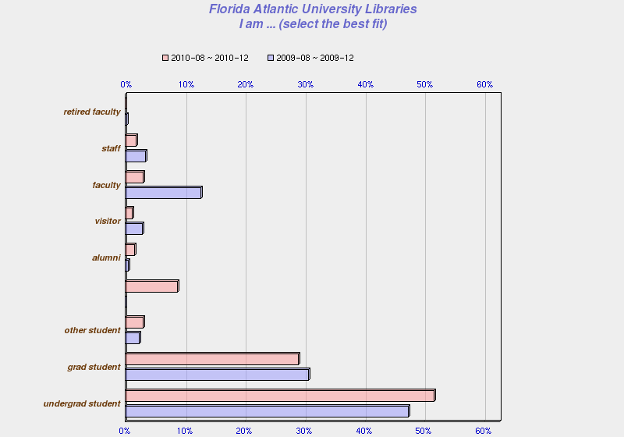

Most of the respondents, **68%, (n=300)** indicated that they use library services on campus, which is a slight increase of **1.4%** from 2009**,** and **32%** indicated that they use them remotely (a slight decrease from 2009 of **1.4%),** as is evidenced by the chart below.

**I use Library services primarily…**

**Fall 2010 Responses**

Fall 2009 Responses

“Research” was indicated by the most respondents, **54.8% (n=301),** as the primary reason for using the Library, which was a significant increase of **14.7%** from 2009. “Study alone” was second at **31.9%,** which is a decrease of **13.1%.** Here is the complete distribution of responses for the following question:

**The primary reason for using this Library… (select the best fit)**

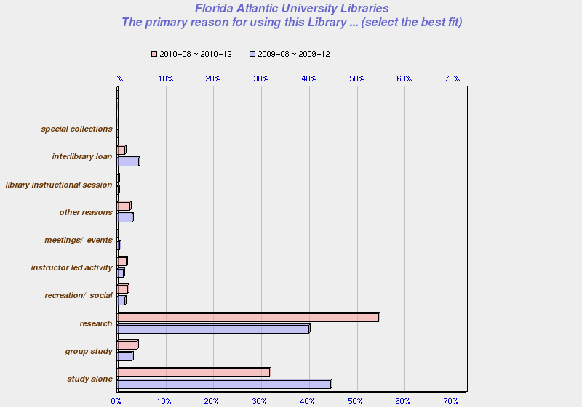

As far as the aspects of service that most impact satisfaction, “accessible information” had the highest number of responses at **21.2% (n=261),** which is a slight increase of **.7%** from 2009,followed by “convenient location” at **18.3%,** with a slight decrease of **.6%** from 2009, as the chart below indicates.

**The aspects of service that most impact my satisfaction include ... (choose all that apply)**

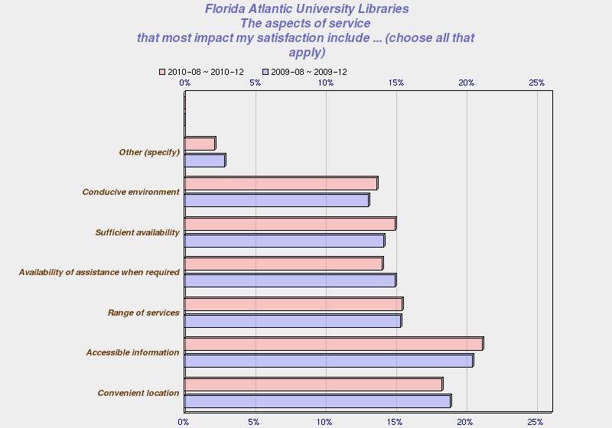

Evenings and afternoons still seem to be the most convenient time for respondents to use the library, since the percentages were **25%** and **22% (n=251)** respectively. Mornings were third with **20%,** which was an increase of **2.6%** from 2009, followed by “weekends” at **17.9%,** which was a decrease of **1.4%** from 2099. Here is a chart with the distribution of responses.

**It is most convenient for me to use the services of the Library ... (choose all that apply)**

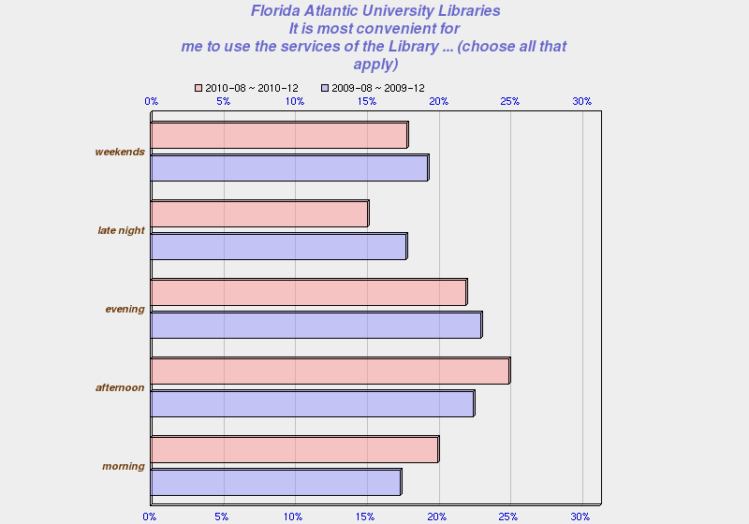

Within the “context” category there was a question about the method the respondents preferred when looking for information this past year. The largest number of respondents, **41.9% (n=62),** indicated that they look for information **“on their own, without assistance,”** which is a decrease of **13.7%** from 2009. More respondents indicated that they **“access Library’s online systems from a location other than the library,”** about **35.5%,** which is a significant increase of **10.5**%. The number of respondents, **8.1%,** who indicated that they “request assistance from a Library staff member” slightly increased by **1.2%** from 2009. Here is a chart showing the distribution of responses.

**With respect to this Library, in the past year...When looking for information, the method I prefer is ... (select the best fit)** 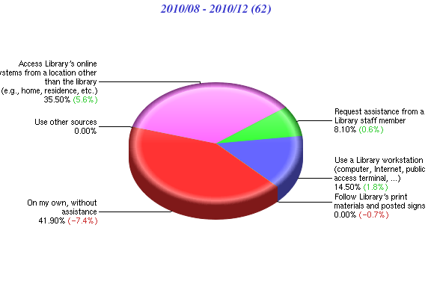

Follow Library’s print materials and posted signs **0.00%**

Use other resources **0.00%**

Access Library’s online systems from a location other than the Library (e.g. home, residence, etc.) **35.50%**

Use a library workstation (computer, Internet, public access terminal…) 14.50**%**

Request assistance from library staff member **8.10%**

On my own, without assistance **41.90%**

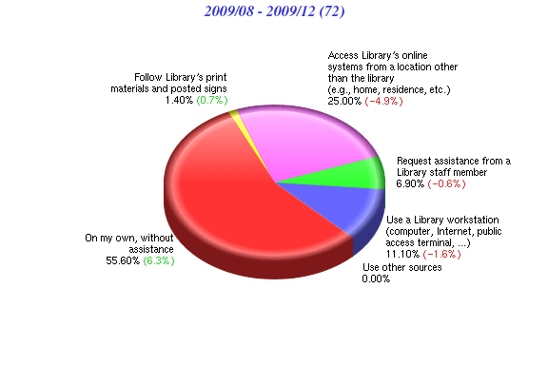

Use other sources **0.00%**

Use a library workstation (computer, Internet, public access terminal…) **11.10%**

Request assistance from a library staff member **6.90%**

Follow Library’s print materials and posted signs **1.40%**

Access Library’s online systems from a location other than the Library (e.g. home, residence, etc.) **25.00%**

On my own, without assistance **55.60%**

**Results of Overall Questions**

Respondents of questions in the “Overall” satisfaction category were asked to indicate a level of agreement with various statements using a 7-point Likert scale by selecting one of the following: “strongly disagree,” “disagree,” “somewhat disagree,” “neither agree nor disagree,” somewhat agree,” “agree,” or “strongly agree.”

The first question states **“This Library is very important to me,”** and the majority of respondents, **91.3% (n=334),** indicated some level of agreement, which is an increase of **3.6%** from 2009, only **5.4%** indicated some level of disagreement, which an improvement of **4%** from 2009, as the chart below shows.

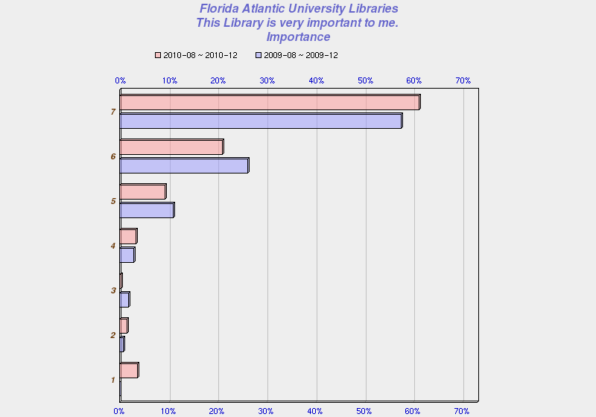

The second question states **“I am very satisfied with the services of this Library,” 82.3% (n=334)**of the respondents showed some degree of satisfaction, which is an improvement of **4.2%** from 2009 and about **8.4%** indicated some degree of dissatisfaction, which is an improvement of **4.5%** from 2009. Here is the distribution of responses.

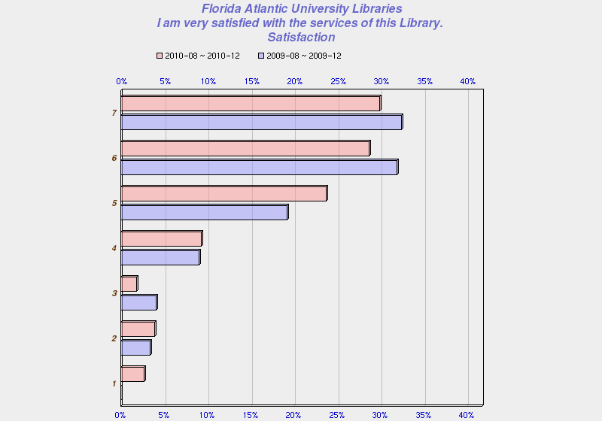

The third question states **“The services of this Library consistently meet or exceed my expectations,”** **79.6% (n=334)** of respondents showed some degree of agreement, which is an improvement of **5%** from 2009, and about **10.2%** indicated some level of disagreement with that statement, which is an improvement of about **4.1%**, as indicated by the chart below showing the distribution of responses.

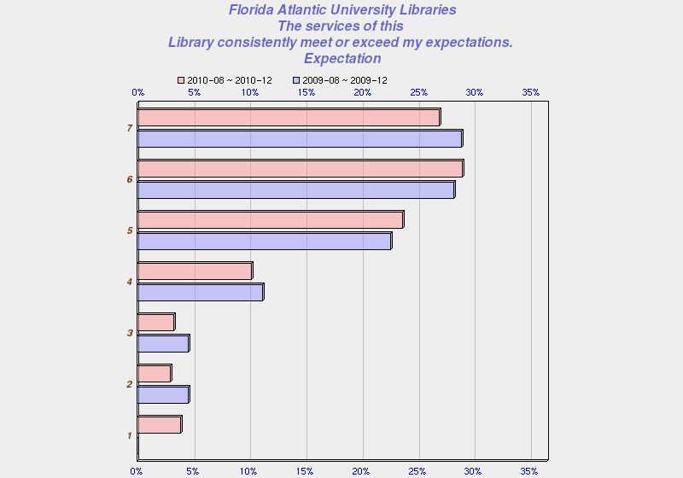

The fourth questions states “**The quality of Library services is very high,”** about **79.6% (n=333)** of respondents showed some degree of agreement, so there was a small increase by **2.8%** from 2009, and **10.2%,** which is an improvement of **3.7%** from 2009**,** showed some degree of disagreement, as the chart below indicates.

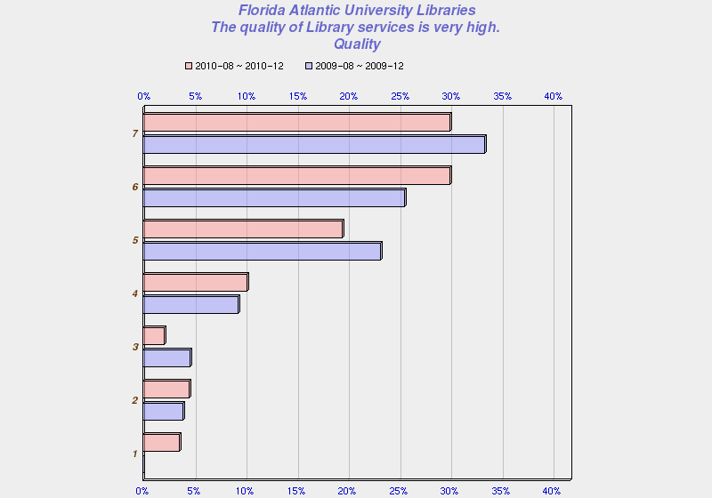

**Results of Services Questions**

Respondents of these questions were asked to indicate a level of satisfaction and importance with specific services (e.g. Library Catalog) using 7-point Likert scales from “very dissatisfied” to “very satisfied” with a neutral point in the middle (“neither dissatisfied nor satisfied”) and “very unimportant” to “very important” with a neutral point in the middle (“neither important nor “unimportant”).

It appears that in 2010 respondents seemed most satisfied with **“Library Electronic Resources”** with **87.8%** indicating some level of satisfaction, which is an **8.4%** increase from 2009, followed by **“Library Catalog”** at **83%** and **“Attending instructional sessions”** at **82.5%.**

Respondents seem to be least satisfied with “**Interlibrary Loan”** with **11.1%** indicating some level of dissatisfaction followed by **“Collections”** at **10.6%,** which still appears to be a problem, and **“…Boca Campus Library’s computer lab”** at **9.4%.** Additionally, there was a significant decrease in the number respondents who indicated some level of satisfaction with the **“Media Center,”** and **“Reference”** and a decrease in the level of importance for both.

**“Library Programs and Special Events”** also saw a significant decrease in the level of satisfaction; however, **71.4%** of respondents indicated “neither dissatisfied nor satisfied, and only **2.4%** indicated some level of dissatisfaction, so it could mean that respondents have never attended a library program or special event or there is a problem with the question. Here are the complete details.

The question reads “**Please indicate your level of satisfaction with and the importance of the following services provided by this Library ...”**

* **Attending instructional sessions** **- 82.5% (n=63) i**ndicated some level of satisfaction, compared to **83%** in 2009, so there was a slight decrease. Only **3%** indicated some level of dissatisfaction, and **76.7% (n=60)** indicated some level of importance, which is slightly higher than 2009.
* **Used the Boca Campus Library’s computer lab (on second floor) –** This was a new category for 2010. About **73.6% (n=53)** indicated some level of satisfaction and only about **9.4%** some level of dissatisfaction. **78.8% (n=52)** indicated some level of importance.
* **Collections – 66% (n=47)** indicated some level of satisfaction, which is about a **7%** increase from 2009, with **10.6%** indicating some level of dissatisfaction, which is an improvement from **20.4%** in 2009 . **83% (n=47)** indicated some level of importance, which is only a slight decrease from 2009.
* **Library Catalog – 83% (n=47)** indicated some level of satisfaction, which is an improvement from **74.7%** in 2009, with only **2.1%** indicating some level of dissatisfaction. **87.2% (n=47)** indicated some level of importance, which is a decrease from 2009 at **93.4%.**
* **Instructional Services – 45.2% (n=42)** indicated some level of satisfaction as compared to **39%** in 2009, with only **4.8%** indicating some level of dissatisfaction. However, **50%** indicated “neither dissatisfied nor satisfied,” which might indicate a problem with this question, since it is similar to “Attending Instructional Sessions.” About **55% (n=44)** indicated some level of importance, a slight increase from 2009.
* **Reference Desk – 54.5% (n=44)** showed some level of satisfaction, compared to **75%** in 2009, which is a significant decrease of **20.5%,** with **9.1%** indicating some level of dissatisfaction, which increased by **4.1%** from 2009. **60.5%** (**n=**43**)** indicated some level of importance, compared to **87.9%** in 2009, which is a decrease of **27.4%** in the level of importance. **36.4%** of respondents to the satisfaction and importance question were “neither dissatisfied nor satisfied.”
* **Circulation Desk** – **71.1% (n=45)** showed some level of satisfaction, compared to **83.3%** in 2009 and only **2.2%** were “somewhat dissatisfied.” **26.7%** were “neither dissatisfied nor satisfied,” and **66.7% (n=45)** indicated some level of importance, compared to **91.2%** in 2009, which is a significant decrease.
* **Interlibrary Loan** – **57.8% (n=45)** indicated some level of satisfaction, compared to **82.5%** in 2009, which is a **24.7%** decrease in level of satisfaction. **11.1%** indicated some level of dissatisfaction, which is an increase of **6.3%,** and **31.1%** indicated “neither dissatisfied nor satisfied. **73.9% (n=46)** indicated some level of importance, compared to **95.1%** in 2009, which is also a significant decrease of **21.2%**.
* **Library Electronic Resources** (e.g., databases, electronic journals, electronic books) – **87.8% (n=49)** showed some level of satisfaction, compared to **79.4%** in 2009, which is an improvement. **8.2%** showed some level of dissatisfaction, which is a decrease from 2009. **91.8% (n=49**) indicated some level of importance, compared to **95%** in 2009.
* **Use of EZproxy…** - **76% (n=50)** showed some level of satisfaction, compared to **82.6%** in 2009, but only **8%** showed some level of dissatisfaction. **80% (n=50)** indicated some degree of importance, compared to **96.7%** in 2009.
* **Media Center** – **44.2% (n=43)** indicated some level of satisfaction, compared to **82.5**% in 2009, which is a significant decrease of **38.3%**, and **7%** had some level of dissatisfaction, and **48.8**% were “neither dissatisfied nor satisfied.” **56.8% (n=44)** indicated some level of importance, compared to **95.1**% in 2009, which is a decrease in the level of importance of **38.3%** and could indicate that this service is not being used as much.
* **Library Programs and Special Events** – **26.2% (n=42)** indicated some level of satisfaction, compared to **85.8**% in 2009, which is a decrease in the level of satisfaction by **59.6%,** but only **2.4%** indicating some level of dissatisfaction. However, **71.4**% of respondents were “neither dissatisfied nor satisfied,” which could mean that there is a problem with this question or respondents have never attended a library program or special event. **37.2%** indicated some level of importance, compared to **96.7**% in 2009, which is a significant decrease of **59.5%**, but **60.5%** indicated “neither important nor unimportant.”

**Results of Staff Questions**

There were only two “yes” or “no” “Staff” questions. The first question reads “Did Library Staff meet, greet or initiate contact with you at any time?” **51.7% (n=60)** of the respondents responded “no,” and **48.3%** responded “yes.” There was a 3.1% increase from 2009 in the number of respondents who responded “yes.” Here is the chart with results.

**Did Library Staff meet, greet or initiate contact with you at any time?**

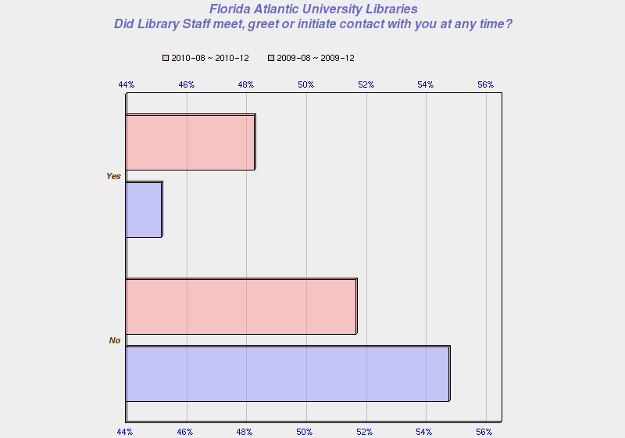

The second question reads “I requested assistance of a Library staff member…” **57.6% (n=59)** of the respondents responded “no” and **42.2%** responded “yes,” so there was a decrease of **3.3%** in the number of respondents who asked for assistance. It appears that students prefer to conduct research on their own. Here is the chart with results.

**I requested assistance of a Library staff member…**

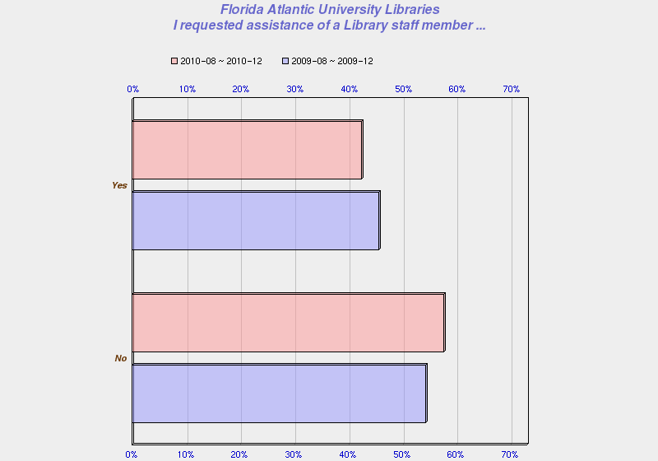

**Results of Facilities Questions**

Respondents of these questions were asked to indicate a level of satisfaction and importance with specific facilities (e.g. Seating/Workspace) using 7-point Likert scales. It appears that most respondents are satisfied with **“Hours of access and operation,”** with **78.8%** indicating some level of satisfaction, which is the same as 2009; however, **15.6%** also indicated some level of dissatisfaction. The next highest category, as far as some level of satisfaction, was **“Accessibility (access within and into building) “**at **77.3%.**

Respondents seem to be least satisfied with **“Parking”** with **37.2%** indicating some level of dissatisfaction, followed by **“Seating/Workspace”** at **19%** . Unfortunately, there did not seem to be any improvement in satisfaction with the area of **“Seating/Workspace,”** where some improvements were made based on the 2009 results. **“The Library building (e.g. cleanliness)”** at **13.6%** showing some level of dissatisfaction, followed by “**Facilities for security of personal belongings”** at **12.2%** and **“Restrooms”** at **11.6%,** so this continues to be an issue. Here are the complete details.

The question reads “**Please indicate your level of satisfaction with and the importance of the following facilities of this Library…**”

* **Hours of access and operation** – **77.8%** (**n=45)** indicated some level of satisfaction, compared to 78.8% in 2009, which shows a slight decrease, with **15.6%** indicating some level of dissatisfaction, which is an increase from 2009. **93.3% (n=45)** indicated some level of importance, so it continues to be an important issue.
* **Accessibility (access within and into building)** – **77.3% (n=44)** indicated some level of satisfaction, compared to **75.8%** in 2009, and 2**.3%** indicating some degree of dissatisfaction, which is a slight improvement from 2009. **20.5%** indicated “neither dissatisfied nor satisfied,” and **78% (n=41)** indicated some level of importance, which is a decrease from 2009.
* **Seating/Workspace** – **64.3% (n=42)** indicated some level of satisfaction, compared to **66.1%**, so there is a slight decrease, with **19%** indicating some level of dissatisfaction, so in a comparison with 2009, it appears that this is still a concern. Although, **83.3% (n=42)** indicated some level of importance, which is a decrease from 2009.
* **Restrooms** – **76.7% (n=43)** indicated some level of satisfaction, compared to **66.7%** in 2009, so there is some improvement, with **11.6%** still indicating some level of dissatisfaction. **92.9% (n=42)** indicated some level of importance, so this continues to be an important issue.
* **Facilities for personal safety** – Only **42.9% (n=42)** indicated some level of satisfaction, compared to 44.6% in 2009, and only 4**.8%** indicated some level of dissatisfaction. However, **52.4%** indicated “neither dissatisfied nor satisfied,” so this could mean there is a problem with the question. **61.5%** **(n=39)** indicated some level of importance, with **33.3%** indicating “neither important nor unimportant,” so there was not much change from 2009.
* **Facilities for security of personal belongings** - Only **24.4% (n=41)** indicated some level of satisfaction, compared to 27.6% in 2009, and **12.2%** indicating some level of dissatisfaction. However, **63.4%** indicating “neither dissatisfied nor satisfied,” so this could mean there continues to be a problem with the question. Additionally, only **42.1% (n=38)** indicated some level of importance.
* **Facilities for security of Library materials and property** – **43.9% (n=41)** indicated some level of satisfaction, compared to **41.8%** in 2009, with only **2.4%** indicating some level of dissatisfaction, and **53.7%** indicating “neither dissatisfied nor satisfied.” Again, there seems to be a problem with this question. **55.3% (n=38)** indicated some level of importance with **36.8%** indicating “neither important nor unimportant.”
* **The Library building (e.g. cleanliness)** – **72.7% (n=44)** indicated some level of satisfaction, compared to **75.4%** in 2009, which shows a slight decrease in satisfaction, with **13.6%** indicating some level of dissatisfaction. **90.5% (n=42)** indicated some level of importance, so this continues to be an important issue.
* **Parking** – Only **41.9% (n=43)** indicated some level of satisfaction, compared to **25.5%** in 2009, so there is some improvement, with **37.2%** indicating some level of dissatisfaction, which means that “parking” is still an issue. **85.4% (n=41)** indicated some level of importance.
* **Access to Library from a remote location ... Via phone, online, etc.** – **76.1%** (**n=46**) indicated some level of satisfaction, compared to **69.5%** in 2009, with **6.5%** indicating some level of dissatisfaction, which indicates some improvement from 2009. **17.4%** indicated “neither dissatisfied nor satisfied, ” and **86.4%** (**n=44**) indicated some level of importance.
* **Group Study Rooms – 34.1% (n=41)** indicated some level of satisfaction with **9.8%** indicating some level of dissatisfaction, with **56.1%** of respondents indicating “neither dissatisfied nor satisfied,” so it could be that the respondents are not using the group study rooms or do not have an opinion.

**Results of Policies Questions**

Respondents of these questions were asked to indicate a level of satisfaction and importance with specific policies (e.g. Lending policies) using 7-point Likert scales It appears that respondents are most satisfied with **“Lending policies,“ with 75.4%** indicating some level of satisfaction, which is a **10.1%** increase, followed by **“Borrowing/Returning materials”** at **73.3%.** In **2009,** respondents also seemed most satisfied with these two areas.

Respondents seem least satisfied with **“Access to restricted or limited-use facilities…,”** where the satisfaction level was **29.1%.** However, **63.6%** indicated “neither dissatisfied nor satisfied, which could mean that there is problem with this question. Respondents also seemed to be less satisfied with **“Policy enforcement”** with **30.9%** indicating some level of satisfaction, followed by **“Fines/Fees(costs…)”** at 4**8.3%.** Here are the complete details.

The question reads “**Please indicate your level of satisfaction with and the importance of the following policies and procedures of this Library…**”

* **Lending policies** – **75.4%** (**n=61)** indicated some level of satisfaction, which is a decrease from **85.5%** in 2009, with only **4.9%** indicating some level of dissatisfaction. **19.7%** indicated “neither dissatisfied nor satisfied” and **82% (n=61)** indicated some level of importance, which is about the same as 2009.
* **Fines/Fees(costs/rules, collections/payments, dispute resolution)** – **48.3%** **(n=60)** indicated some level of satisfaction, which is an increase from **40.3%** in 2009,and **8.3%** indicated some degree of dissatisfaction, with **43.3%** indicating “neither dissatisfied nor satisfied.” **55% (n=60)** indicated some level of importance, which is almost the same as 2009.
* **Borrowing/Returning materials** – **73.3%** **(n=60)** indicated some level of satisfaction, which is a small decrease from **77.0%** in 2009, with only **6.7%** indicating some level of dissatisfaction. **20%** indicated “neither dissatisfied nor satisfied,” and **72.9% (n=59)** indicated some level of importance.
* **Hold/Renewals** – **59.3%** **(n=59)** indicated some level of satisfaction, which is a small increase from **54.1%** in 2009, with only **5.1%** indicating some level of dissatisfaction. **35.6%** indicating “neither dissatisfied nor satisfied,” and **71.2% (n=59)** indicated some level of importance.
* **Interlibrary Loans** – **56.9%** **(n=58)** indicated some level of satisfaction, which is a decrease from **65.1%** in 2009, with only **5.2%** indicating some level of dissatisfaction. **37.9%** indicated “neither dissatisfied nor satisfied, “and **72.4%** **(n=58)** indicated some level of importance.
* **Access to restricted or limited-use facilities, equipment, information or other services** – Only **29.1% (n=55)** indicated some level of satisfaction, which is about the same as 2009 at **30.9%,** with **7.3%** indicating some level of dissatisfaction. **63.6%** indicated “neither dissatisfied nor satisfied, which could mean that there is problem with this question. Additionally, only **41.8% (n=55)** indicated there was some degree of importance.
* **Policy enforcement** – Only **30.9%** **(n=55)** indicated some level of satisfaction, as compared to **50%** in 2009, which is a definite decrease, with **10.9%** indicating some level of dissatisfaction. **58.2%** indicated “neither dissatisfied nor satisfied,” which could indicate a problem with this question. Lastly, only **45.5% (n=55)** indicated some level of importance.

**Results of Equipment Questions**

Respondents of these questions were asked to indicate a level of satisfaction and importance with specific equipment (e.g. printers) using 7-point Likert scales. Overall, respondents did not seem very satisfied with library equipment, but they did seem most satisfied with **“Computer workstations”** with **61.4%** indicating some level of satisfaction, which is still a significant decrease in satisfaction of **13.6%** from 2009, and **15.9%** indicated some level of dissatisfaction.

Respondents appear to be least satisfied with “**Audio, Video, Microform Equipment (Listening/Viewing Stations)”** with only **30.2%** indicating some level of satisfaction; however, **61.9%** indicated “neither dissatisfied nor satisfied,” which could mean respondents are not using this equipment or there is a problem with this question. Next category that respondents are least satisfied with is **“Printers”** at **39.5%** followed by **“Copiers”** at **54.8%.** Here are the complete details.

The question reads “**Please indicate your level of satisfaction with and the importance of the following equipment at this Library…**”

* **Printers** –Only **39.5%** (**n=43)** indicated some level of satisfaction, which is slightly less than **40.6% in 2009,** with **18.6%** indicating some level of dissatisfaction, so it appears that printing is still a problem. However, **41.9%** indicated “neither dissatisfied nor satisfied,” and **71.1% (n=45)** indicated some level of importance.
* **Copiers** – **54.8%** **(n=42)** indicated some level of satisfaction, which is an improvement from **42.6%** in 2009, with **16.7%** indicating some degree of dissatisfaction. **28.6%** indicated “neither dissatisfied nor satisfied,” and **72.1% (n=43)** indicated some level of importance.
* **Computer workstations** – **61.4%** **(n=44)** indicated some level of satisfaction, which is less than **75.0%** in 2009, with **15.9%** indicating some level of dissatisfaction. **82.2% (n=45)** indicated some level of importance.
* **Computers equipped with specialized software/database/hardware** – Only **36.6%** **(n=41)** indicated some level of satisfaction, compared to **37.1%** in 2009, so there is a slight decrease, with **9.8%** indicating some level of dissatisfaction. **53.7%** indicated “neither dissatisfied nor satisfied,” which could indicate a problem with the question. Only **58.1% (n=43)** indicated some level of importance.
* **Audio, Video, Microform Equipment (Listening/Viewing Stations)** – Only **30.2%** **(n=53)** indicated some level of satisfaction, which is a decrease from **47%** in 2009, with **7.1%** indicating some level of dissatisfaction. However, **61.9%** indicated “neither dissatisfied nor satisfied,” which could mean there is a problem with this question. Only **54.5%** **(n=44)** indicated some level of importance.
* **Express Checkout Equipment** – Only **27.5%** **(n=40)** indicated some level of satisfaction, compared to **38.4%** in 2009, with **10%** indicating some level of dissatisfaction. However, **62.5%** indicated “neither dissatisfied nor satisfied, which could mean that there is problem with this question or users are not familiar with this equipment. Only **45.56% (n=44)** indicated there was some degree of importance.

**Summary**  
 Most of the survey respondents are undergraduates and about one third of the respondents are still accessing library services remotely. More respondents indicate that their primary reason for using the Library is research and that information that is accessible most impacts their satisfaction. Evenings and afternoons are still the most convenient times for respondents to use the Library, followed by mornings.

Most respondents still believe that the Library is important and are satisfied with library services overall, and in 2010 the number of respondents increased for both categories. Additionally, fewer respondents indicate that they are dissatisfied with library services. More respondents seem satisfied with the **“Library Electronic Resources,”** which is an improvement from 2009, followed by **“Library Catalog”** and **“Attending instructional sessions.”** Respondents seem less satisfied with “**Interlibrary Loan,”**  **“Collections,” and “…Boca Campus Library’s computer lab.”** Respondents also appear to be less satisfied with **“Media Center** and **“Reference”** and indicate that they have less importance. **“Library Programs and Special Events”** also saw a significant decrease in satisfaction, but this could be due to the fact that respondents have never attended a library program or special event.

As far as library facilities, **“Hours of access and operation,”** has the highest level of satisfaction, which is the same as 2009, followed by **“Accessibility (access within and into building). “** Respondents seem to be least satisfied with **“Parking, “ “Seating/Workspace,” “The Library building (e.g. cleanliness),”** “**Facilities for security of personal belongings,”**and **“Restrooms,”** which continues to be an issue. Overall, respondents did not seem very satisfied with library equipment. They did seem somewhat satisfied with **“Computer workstations,”** but still with a significant number indicating dissatisfaction, and they seemed least satisfied with “**Audio, Video, Microform Equipment …,”**  **“Printers,”** and “**Copiers.”**

Satisfaction with library policies was not very high. Respondents are more satisfied with **“Lending policies, “followed** by **“Borrowing/Returning materials,”** so there is not much change since 2009. Respondents seem least satisfied with **“Access to restricted or limited-use facilities…,”**  **“Policy enforcement,” f**ollowed by **“Fines/Fees(costs…).”**

**PART II: QUALITATIVE DATA RESULTS**

**Introduction**

There were a total of **796** individual comments from **336** respondents for all campus locations for the period of August 23th through December 10th. However, since one comment can be identified with more than one category, there are a total of **1,767** categorized comments. Approximately **88%** of the comments came from respondents from the Boca Campus, with only **3%** from Davie and **9%** from the other four campuses. Last year there were **106** negative comments from Davie, as compared to only **21** in 2010, which is probably due to the improvements that have been made, based on the 2009 LIbSat survey results. Selected survey respondent comments are included in this section as highlights.

**Summary of Positive Comments**

There were a total of **680** positive comments for all campus locations. As far as the individual categories, it appears that respondents are most satisfied with the **“Collections”**, since this category received the largest number, **15% (n=680),** of all positive comments followed by **“Facilities”** with **11.3%, “Services”** at **11.1%, ”About staff”** at **10.3 %, and “Policies”** at **3.6%.**

**Summary of Negative Comments**

There were a total of **838** negative comments for all campus locations. The areas for all campuses (but mostly for Boca) with the highest percentage of negative comments were related to facilities: seating/study space (quiet space, group study, individual study), computer workstation access, equipment, printing, bathrooms, web site, and policies.

In analyzing the quantitative data and qualitative results, we can see where our patrons think we most need to improve, since respondents often indicated that a statement was high in importance, but the level of dissatisfaction and number of negative comments was also high. As a result, we have been able to identify the most important issues the Libraries will need to focus on, with some recommendations**.**

**Staff**- **35.78% (n=109) of comments about staff are negative.**

Staff ranks lower in satisfaction in 2010 as compared to 2009 regarding services and approachability at public service points. For the most part, we are perceived as “knowledgeable”, “helpful”, and “friendly.” Respondents seem less satisfied with “**Interlibrary Loan,”**  **“Media Center,”** **“Reference,”** and **“Circulation.”** However, the negative comments appear to indicate the dissatisfaction with specific individuals or instances rather than a general service point experience. Additionally, there appears to be confusion about where to go for research assistance, which may contribute to the dissatisfaction.

**Excerpts of comments for the Boca Campus:**

“I just asked an employee for help and she did not help me. She stayed on the computer doing whatever it was she was doing. She told me I could use any computer to look up my books and pointed to one behind her. The computer behind for some reason was unable to look up the books. She saw me there and didn't say anything. Someone else came up to her and asked for help finding a book and she helped him. I had to ask why I could not get on. She then told me that the computer was not working. She did not offer to help me find my books. The guy she helped was a white male. I am a biracial female. I do not know if that was why. But it certainly feels like it. I know in the Indian culture darker skin is devalued.”

“People are not very friendly at the front desk. They will direct you as of what to do, but will never take the time to actually come and help you until you ask a couple of times, or beg for help!”

“I had an amazing conversation with a librarian who was holding an information session on an article I was having difficulty getting the full text version. She made me feel like I could go to the library and receive help from the capable staff. I went to the library. Not only was the staff unable to help me, they seemed reluctant to do more than I had done on my own. It was a waste of the trip from West Palm Beach and I will endeavor to never use the resources of the testy librarians at FAU again if I do not have to. Really, customer service should be a priority. If I am asking for help, I have already utilized the resources available to me and need an expert; not a sourpuss.”

“Except for a few members, most of them seem to have no idea. Look confused. I have better luck on my own. Since they send you on wild goose chases and complicate things!”

“Some are very unwilling to help.”

“Those staff members whose educational background is limited and not multidisciplinary.”

“There are not enough of them.”

“There's not always a staff member that can help.”

“The staff do not always know what to do and just direct me to go around and around in circles. Finally I usually just have to go myself to a specialist office.”

**Recommendation**:

-- One area we could look at improving would be the relationship between the Circulation Desk staff and the Reference Desk staff, so that users are not confused about where they need to go for research assistance.

**Facilities** (defined as physical assets and space within the library such as equipment, furniture, climate control, bathrooms, etc.) – **70.19% (n=265) of comments about facilities are negative. Not having enough space and equipment for our users is still a major concern.**

Problems contributing to a negative rating include: not having enough seating/study space, dissatisfaction with the availability of computer workstations**,** dissatisfaction with equipment, such as the printers and electrical outlets, poor restroom conditions, and some dissatisfaction with our web site.

**Excerpts of comments about facilities in general for the Boca Campus:**

“Dirty library, bad place for studying, too many people, not enough space, non-availability of current books, filthy bathrooms.”

“[Least satisfied with] some of the run down furniture/environment of the Boca library.”

“[Should have] cleaner work tables.”

“The study area on the first floor, past the computer area and right next to your vending machines and the water fountain, gets incredibly hot compared to other areas of the library.”

“Change the moldy carpets.”

“IMPROVE THE LIGHTING, ESPECIALY IN THE REF STACKS.”

“I am scared to be on the 4th floor. I don't like to go up there and search for materials. I don't feel as safe there, due to the isolation.”

“The facilities: - The entrance (including the plaza) is a major eye sore and desperately needs a revamp with pavers, maybe a fountain. Make it look grand and enticing. - There's no covered entrance so when it rains (and it often rains in South Florida) then you have to get soaked going from the west end of the Breezeway to the front door. There NEEDS to be a way to get into the main library from the east entrance. - The study rooms are extremely cramped and too often we can't get a blackboard, which is essentially to group problem study. - The restrooms are decrepit. - There are never enough computers to access the internet and there's no cash-to-[owl] card machine on the west side by the largest set of computers. Most people use the library as a recreational place between classes to grab D&D and surf the internet. But during the day the computers are always spoken for and people hover around. - There are no magazines/newspapers to hang out and read, nor are there any DVD rental machines or CDs to check out. At the very least, there should be a kiosk where I can put on headphones and listen to FAU/Hoot? Wisdom Recordings CDs. - Adding insult to injury, there is very little in the way of FAU spirit. There's no red and blue, there are no Owl heads. This is why FAU isn't considered a "real" university, why it has so much trouble establishing its identity. Please add more FAU spirit.”

* **Seating/Study space - 73.91% (n=23)** of comments about **seating** are negative. Additionally**, 68.00% (n=50)** of comments about **quiet space** are negative. **76.00% (n=25)** of comments about **group study space** are negative. **78.26% (n=23)** of comments about **individual study space** are negative. **Users are still not pleased with the quality and quantity of the seating and study spaces.**

**Excerpts of comments for seating/study space for the Boca Campus:**

“The chairs are AWFUL very very very uncomfortable”

“Adding more tables, chairs, and private desks in the silent area of the library.”

“Students studying in groups and talking loud while I am trying to study. There should be either more study rooms for groups so they can study there or there should be personal study rooms for people like who like to study on her own. Also, there could be more enforcement by library workers to make students respect the silence needed by others around.”

“[Least satisfied] with the noisy environment of the fourth floor of the library. Although the fourth floor is designated as a silent area, I still find myself asking people to be quiet. Many of them often talk on their phone or loudly chat with their friends in the study rooms on the fourth floor. This is a major distraction for me; it's also a disappointment since I would expect some drastic measures have to be taken to reinforce the silence code.”

“Have a place that is strictly for students who want to STUDY.”

“[Least satisfied with] the lack of study space in this building.”

“[Least satisfied with the] lack of group study room availability.”

“[Least satisfied with the] Lack of space for faculty (i.e. locked study carrels).”

“The cleanliness of the study rooms. They are very dirty. I usually bring Clorox clean ups & fabreeze with me to wipe down the table and spray the chair. Also the rooms are too small to fit 4 people in them. In order to have everyone sit, we all have to stand and shimmy past one another.”

**Excerpts of comments for seating/study space for the Davie Campus:**

“[We need] more room, more quiet.”

* **Computer workstations** – **54.55% (n=55) of comments about computer workstations are negative. Respondents complain that a computer is not available when they need one. At certain times of the year there are not enough computer workstations to meet the demand.**

**Excerpts of comments for the Boca Campus:**

“Verify that equipment is in good conditions to serve tits purpose. For example, there are many computers but half of them have deficiencies (have files missing and don't allow students to log into internet, mouse is not working, login page is corrupt and won't allow student to login, etc, etc, etc.)”

“Availability of computers. You simply do not have enough. Don't take my word for it - take a couple of trips over to the computer section during midday and look to see how many people are hovering waiting for a computer to open up. Maybe it will surprise you.”

“I was surprised to find that the computers used to access the catalog had been moved from the central location in the lobby to somewhere else. When I looked around, every available computer was being used, and I wasn't sure if they were for the catalogues or general internet work. It is problematic if students can use computers for general internet connection and there are none specified for catalogue searching only.”

“I see way too many students using computers to play games and check facebook. There should be a section of computers strictly for the use of school work. On two occasions I could not find an open computer - you need to make an area for serious students only where the computer is checked out and they sign an agreement and someone walks around to see that work is actually being done.”

“The amount of noisy children who are allowed to use the computers and play games while we, the students have to go elsewhere to use computer.”

“Create more areas with computers, maybe on different levels.”

* **Equipment** (viewing, listening, communicating, replication, scanning and data capture devices) – **63.16% (n=19) of comments about equipment are negative. Respondents expressed concerns about copiers, availability of specialized computer software, and microfilm/microfiche readers.**

**Excerpts of comments for the Boca Campus:**

“Update owl card copier system.”

“I know it is old technology, but the microfilm equipment is a nightmare, especially the scanner interface.”

“Copier machines need to have techs, when needed, available to fix so librarians can attend to customers”

**Excerpts of comments for the TCC Campus:**

“Today I found the article but could not get the pdf file to download, the html version had poor graphic images that were very difficult to read. As a seasoned but retired researcher, this fact I found aggravating.”

* **Printing** – **62.50% (n=16) of comments about printing are negative. Users continue to report that the printing at the Boca Library is still not very reliable.**

**Excerpts of comments for the Boca Campus:**

“How wrong can a library go on printers? The Owl card machines are horrible and never work properly.”

“Fix the online server printers! That or just redo the entire servers, from the first line of code to the last. It would make things more efficient and wouldn't have so many problems.

“The server wasn’t working for me when I wanted to print so I had to walk up and down the library trying to find the other online printer but then that didn't work so I went back down and tried again with the lobby online printer. Finally I went to the computer lab across from the library and tried to print there but then it wouldn't work on either printer there and I didn't have enough money to print otherwise. Finally I talked to the specialist in the computer lab and he checked the server and said they were working. He even checked the server for my files and they were there but weren’t showing up when I accessed the online printers. So finally he resets the printer server and still nothing for me so he just printed it for me. This caused me to walk all over the place when I was supposed to be in class. Luckily I was just able to get the prints”

“[Least satisfied with] printers. In the 2nd floor lab, I recently tried to print a color page for an assignment. My card was charged 30 cents for each page so I know I sent it to the correct printer but the printer required a password to activate. I asked first floor circulation, second floor, and the media center and they told me there is no one here from Toshiba to fix it for the whole weekend. I think that someone else besides Toshiba should have passwords for the weekends. Also for some reason FAU has installed big flat screen TVs in the library, they simply replay the few same ads and seem to be a big waste of money. Also the pricing for printing is not consistent in all areas of the library; on first floor it costs more.”

* **Bathrooms** – **92.00% (n=25) of comments are negative. Patrons are still dissatisfied with the condition of bathrooms at the Boca Library.**

One user said that the “bathroom facilities on the first floor, next to Dunkin Donuts, is the most malodorous and rank area in the library.”

* **Web site** – **92.00% (n=10) of comments are negative, which is an increase from 2009. Most negative comments deal with the access point to the catalog and the Library’s resources and services that are available on our web site to our users.**

**Excerpts of comments for the Boca Campus:**

“[Least satisfied with] the online navigation through fau's site. The user interface is not newbie friendly. It’s fine for me but I’m sure for others who aren't tech savvy, it's irritating. The flow from site to site is pretty horrible. Especially when it comes down to the catalog searching. Too many pages to get through to get to where you need like in electronic journal. You don't specify the difference between things like "General One" "Academic Full text" etc. It's just there in a list, with no way to differentiate the usefulness of it. Get a better method of user login, typing in a bunch of numbers from the OWL card and then a password is very irritating. Certain web browsers like chrome will at least save it so it's not so annoying to keep inputting, but still I’m sure it's annoying for others. Conclusion, get someone with better experience on web designing to fix the flow and user friendliness of the library site. it's far too layered and can easily be simplified down.”

“Overly busy website with hard-to-use dropdowns.”

“The Website only works when it wants to and I can never find what I'm looking for.”

“Make it easier to go back from a page you are on.”

“Continue to streamline the website.”

**Excerpts of comments for the Davie Campus:**

“[Most satisfied with the] Online databases - But you could improve the menus. It is very easy to get lost when performing research.

**Policies** – **80.00% (n=80) of comments are negative.**

We cannot as easily generalize about what people are least satisfied with through their comments. These responses are more varied. However, hours of operations, fines/fees, policy enforcement, holds/renewals, limited-use facilities (study rooms), and Interlibrary Loan policies came up repeatedly.

**Excerpts of comments for the Boca Campus:**

“Get rid of cell phones and people who do not belong here.”

“There are too many students playing computer games. Please consider restricting computer use to academic work.”

“[Least satisfied with] 1. The amount and volume of talking on the first and second floor. 2. A group of children come in every week and take up multiple computers which WE as students pay for with tuition. Not acceptable to have children play video games on library computers in a college.”

“The study rooms should be open for ALL students not only groups of students, because there is no enforcement of quiet in the library and is often the only place with quiet. Also-2 hour limit? Absolutely ridiculous it needs to be for as long as you need it so long as you're studying.”

“That I am required to return to circulation just to "re-check-out" a study room every two hours. Sometimes we need to use the room for much longer. It would be more convenient to have up to 3 or 4 hours, provided that we return the key if we leave earlier. If there was a more convenient way of asking for the room again after two hours, that would also be helpful.”

“Study rooms for groups larger than 4 are too small, I was told I could not reserve a room so I had no way of telling my group where to go when they got to library, the students literally had to walk around from room to room looking for me. I asked why wasn't there a sign in sheet at the circulatingdesk so the students could see what room I was checked into and was told that wasn't policy - then it'stime to change the policy and use common sense.”

“The fact that I'm a PBSC student and I can't use my own laptop in the library only FAU students can which is not fair.”

“Zero notification when books are close to being due!”

“I am least satisfied with Interlibrary Loan. It is a great service, however the loan period is not quite long enough.”

“Why is there not a warning e-mail system for ILL due dates? These are the hardest to keep track of, the most difficult to find in your library record, and the most important to return on time so the other institutions will continue to lend.”

“Should not have to type Owl id every time we use Ez-proxy, we're already logged in through MyFAU!”

“[Least satisfied with] online based holding and renewal.”

**Excerpts of comments for the Jupiter Campus**:

“[Least satisfied with] The early library closing times. The 24-hour study room is sometimes not conducive to studying.”

**Excerpts of comments for the Davie Campus**:

“A more stringent recall policy should be put in place. When a book is recalled, Borrowers should have ten day to return and then be subjected to fines in order to encourage swift return of material.”

**Excerpts of comments for the TCC Campus**:

“Have longer hours maybe instead of closing at 9 maybe 11 some people work till 5 or 6. Longer hours for weekend also.”

**Shelving** (defined as books listed as available in the catalogue but cannot be found on shelf**) – 92.86% (n=14) of comments are negative.**

**Excerpts of comments for the Boca Campus:**

“[Least satisfied with] Being able to find materials in the stacks that are listed as AVAILABLE but are not in the correct location. Usually every time I come in, I fail to find 50% of the books that I have come to get that are listed as available. The books are always disorganized and are NEVER in the correct places.”

“I can never find what I'm looking for online. Working on my thesis, I've been to the library several times. Books I need are never in the correct place and the Librarians are very unwilling to help. I've tried IL but they won't give me the books because it's "in the library" however I'll search the entire shelf and the books are nowhere to be found. This library is a disaster and I'm very disappointed and flustered.”

“One time I came in for 4 books, all listed as available on the library website. I did not find a single one of them, and I even looked on the shelves below and above the shelf where the books should have been. ALL were misplaced/missing/gone.”

“[Least satisfied with] The way books are arranged because they way they are set up it is hard to find books.”

**Conclusion**

Although the number of respondents was not as high as we had anticipated, the information received from the almost 800 comments was particularly valuable and we were pleased that so many users took the time to write and share their opinions and feedback on our services.

The survey results continue to highlight physical and environmental needs, especially with regards to adding more study space, computers, more tables, etc. We are currently using the feedback to make adjustments with our physical space in particular and to assist the Wimberly Library Renovation Committee with the planning of the library renovation. An upcoming goal for the Library Assessment Team is to take the comments and ratings from LibSat on facilities and combine it with a standalone study to create a focused report on laptop/desktop PC needs in the Library.

**RECOMMENDATIONS**

* Resurvey population in the fall semester of 2011, in order to use comparative data over a three-year time period.
* We recognize that survey competition on campus is a problem. Our goal next year is to try to increase the response rate by sending out targeted email messages throughout the survey period, reminding students, staff and faculty to complete the survey.
* Provide a direct link from the Libraries web page to improvements that have been made based on LibSat survey results, so that we can show that we are responding to our users’ concerns.
* Work with Counting Opinions to revise some of the problem questions, where a large percentage of respondents indicated “neither dissatisfied nor satisfied” when completing a Likert scale question.