**FAU LIBRARIES**

**LibSat Survey Results for Fall 2011 with Comparisons to 2009 and 2010 and**

**Overall Averages for 2009-2011**

**Prepared by: Dr. Darlene Parrish and Malka Schyndel**

**Date Submitted: May 22, 2012**

**Executive Summary**

This report includes an analysis of the LibSat survey responses, both quantitative and qualitative for the period August through December 2011 and a comparison with the results of fall 2009 and 2010 and overall averages for 2009-2011. It also includes some recommendations for future improvements. The LibSat survey for the fall 2011 was launched for a third consecutive time on the FAU Libraries web site on August 29th, which is later than 2009 and 2010 and extended into the first week of January (although we are only counting responses through December 31st).

In 2011, there were more efforts made to market the survey, which included advertisements on the FAU Libraries home pages, *FAU Today*, and an email sent out to all FAU faculty, staff, and students. There were a total of **415** respondents, which was about a **19%** increase from the fall of 2009, for all campus libraries including Boca, Davie, Fort Lauderdale, Harbor Branch, Jupiter, and Treasure Coast. About **81.3%** of respondents were either undergraduate or graduate students. More faculty members participated in the survey in 2011 (a total of **42** or **10.3%** of the total respondents), as compared to **10** in 2010 (only **3%** of the total). Most of the respondents, about **84%,** identified themselves as being from the Boca Campus, with **8%** from Jupiter, and **8%** from the other four campuses.

About **74.1%** of the respondents indicated that they are using library services on campus, which is an increase of **6.1%** from 2011, and more respondents indicated that their primary reason for using the library was “**study alone**” followed closely by “**research**” and that “**convenient location**” most impacts their satisfaction. Most respondents still believe that the Library is important and are satisfied with library services overall, but less were satisfied in 2011. More respondents seem more satisfied with **“Accessing the Internet from the Library,” “Accessing an online database provided by the Library” and “Library Electronic Resources.”** Respondents seem less satisfied with “**Collections,”**  “**Media Center**,” and also “**Library Electronic Resources**” (although the percentage of satisfaction for “**Library Electronic Resources**” was **77.9%**, which is fairly high). The levels of satisfaction for “**Instructional Services**” (**34%**) and “**Library Programs and Special Events**” (**30.6%**) were low, but there may be problems with these questions. Also, we will need to monitor the levels of satisfaction for “**Interlibrary Loan**,” since it dropped from **82.5%** in 2009 to **57.8%** in 2010 to **54.8%** in 2011.

As far as facilities, respondents seem more satisfied with “**Access to Library from a remote location…Via phone, online, etc.**,” **“Accessibility (access within and into building) “** and “**Hours of access and operation.” R**espondents seem less satisfied with **“Parking, “ “Restrooms,” and “Seating/Workspace.”** Unfortunately, there did not seem to be any improvement in satisfaction with the area of **“Seating/Workspace,”** where some improvements were made based on the 2009 results. There also seemed to be a concern about “**Facilities for security of personal belongings, “The Library building (e.g. cleanliness),”** although the average satisfaction percentage for the years 2009-2011 was about **74.2%,** which is fairly high**.**

Satisfaction with library policies is not very high. Respondents seem more satisfied with **“Lending policies,“** followed by **“Borrowing/Returning materials,”** but there has been a steady decrease in level of satisfaction for these two areas from 2009 to 2011.Respondents seem less satisfied with **“Access to restricted or limited-use facilities…,”**  **“Policy enforcement,” “Fines/Fees(costs…).”**  Overall, respondents seemed less satisfied with library equipment, but there was some improvement as far as satisfaction with **“Computer workstations,”** and “**Printers**.”

There were a total of **935** individual comments from **415** respondents for six campus locations. However, since one comment can be identified with more than one category, there are a total of **2,359** categorized comments. There were a total of **1,037** positive comments for all campus locations. As far as the individual categories, it appears that respondents are most satisfied with the **“Services”**, since this category received the largest number, **19.4% (n=1,037)**, of all positive comments followed by **“Facilities”** with **15.1%, “Staff”** at **11.2%, ”Equipment”** at **6.5 %**, **Accessing Information and Services via the Library web site (ease of use)** at **6.4%**, **and “Collections”** at **6.1%.**

There were a total of **1,206** negative comments for all campus locations. The areas for all campuses (but mostly for Boca) with the highest percentage of negative comments were related to **“Facilities,”** (which would include **seating/study spaces, equipment, hours of operation**, and **bathrooms**) with **25.7% (n=1,206)**, “**Service”** at **8.3%**,and **“Policies”** at **6.9%**.

**CONTENTS**

**PART I: QUANTITATIVE DATA RESULTS**

Introduction 5

Limitations of LibSat Survey Results 5

Results of Context Questions 6

Results of Overall Questions 12

Results of Services Questions 13

Results of Staff Questions 14

Results of Facilities Questions 15

Results of Policies Questions 16

Results of Equipment Questions 17

Summary 18

**PART II: QUALITATIVE DATA RESULTS**

Introduction 19

Summary of Positive Comments 19

Summary of Negative Comments 19

**PART I: QUANTITATIVE DATA RESULTS**

**Introduction**

This report includes a summary of the LibSat survey results for the period August through December 2011 and a comparison with the fall 2009 and 2010 survey results and overall averages for 2009-2011. Additionally, any responses to improvements based on the survey results for fall 2009 or 2010 will be noted.

LibSat was launched for a third consecutive year on the Florida Atlantic University (FAU) Boca Campus Library home page on August 29, 2011, and shortly thereafter, a link was included on the Jupiter, Treasure Coast, and Davie Campus Library home pages, and on the Harbor Branch catalog search page. There were more efforts this year to market the LibSat survey, with the assistance of Terri Berns and her staff, which included LibSat survey announcements in FAU Today and emails sent to all FAU faculty, students, and staff. The link to the LibSat survey was not hidden until the beginning of January, but we are counting only the responses received from August through the end of December 2011.

The total number of respondents for the regular and in-depth surveys for all campus libraries including Boca, Davie, Fort Lauderdale, Harbor Branch, Jupiter, and Port St. Lucie was **415** in 2011 and **336** in 2010, which is about a **19%** increase. Most of the respondents, about **84%,** identified themselves as being from the Boca Campus, with approximately **8%** from Jupiter and the remaining **8%** from the other four campuses. As far as the monthly breakdown for the total number of responses, the largest number was in November with **280,** possibly as result of sending out email reminders to all FAU faculty, students, and staff, and the smallest number, **8,** occurred in August, which does not compare to the fall 2009 or 2010 results.

**Limitations of LibSat Survey Results**

One definite limitation of the LibSat survey is the response rate, which is still quite low at about **1.5%,** which is a **.3%** increase from fall 2010**,** if you are basing your response rate on the FAU community population of approximately 28,000 (although this number is probably higher).

Approximately **75.9% (315)** of the 4**15** respondents selected the regular survey, which takes about 7 minutes to complete and **100** or about **24%** of respondents selected the in-depth survey, which has a completion time of about 15 minutes. This is a slight increase of .5% from 2010 for the number of respondents selecting the in-depth survey. The question categories for the regular survey include “Overall” (questions about overall satisfaction with the Library) and “Context” (questions about the respondent, satisfaction with services, and usage). However, in addition to “Overall” and “Context,” the in-depth survey also includes question categories entitled “Services” (additional questions about services), “Staff,” “Facilities,” “Policies,” and “Equipment.” Since the response rate of the in-depth survey was about **24%,** this is a definite limitation.

**Results of Context Questions**

The “Context” category includes questions about the respondent, and satisfaction with services and usage. The largest percentage of respondents**, 59.1% (n=406)** identified themselves as being undergraduate students, which is more than the overall average for 2009-2011 of **52.6%**, and graduate students were second at 22.2**%.** There were more faculty members who participated in the survey, **10.3%**, which is better than the overall average for 2009-2011 at **9.1%**. Here is a chart showing the distribution of types of respondents.

**I am…(select the best fit)**

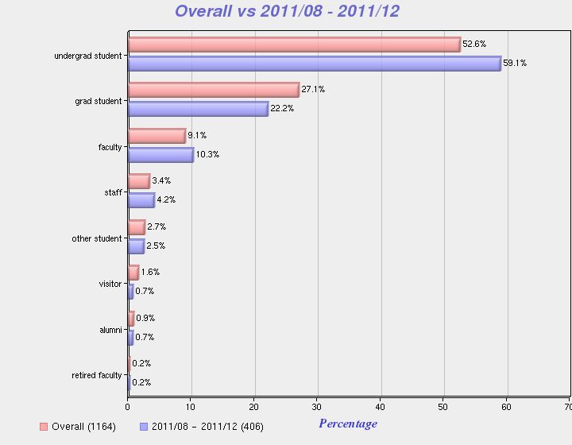

Most of the respondents in 2011, **74.10%, (n=367),** indicated that they use library services on campus, which is **4.3%** more than the overall average of **69.80%,** with only **25.90%** indicating that they use them remotely**,** as is evidenced by the chart below.

**I use Library services primarily…**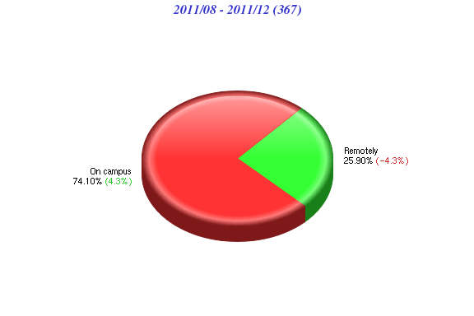

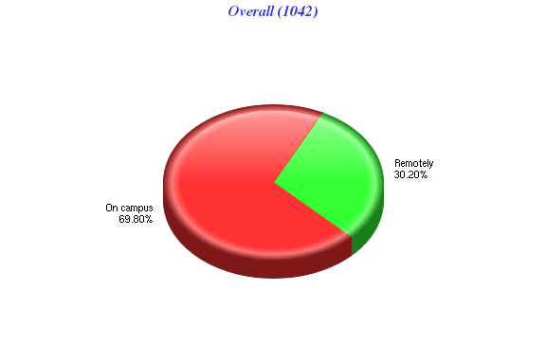

“**Study alone**” was indicated as the primary reason for using the Library by **38.8% (n=363)** of the respondents, which is only a slight difference of **1.6%** from “**research**”**.** “**Research**” was the second most popular category indicated as the primary reason for using the Library by **37.2%** of respondents. The third and fourth most popular reasons were “**group study**” at **10.7**%, which could be due to improvements made in group study rooms and “**interlibrary loan**” at **5.5**%. The overall average for 2009-2011 indicated that “research” was still the primary reason for using the Library by **43.6% (**n=1026**)** of the respondents. Here is the complete distribution of responses for the following question:

**The primary reason for using this Library… (select the best fit)**

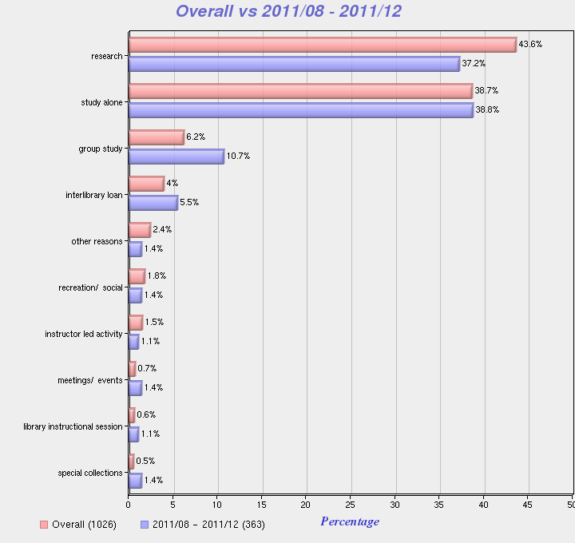

Survey respondents in 2011 indicated that the aspect of service that most impacted satisfaction was “**convenient location**” with the highest number of responses at **73.8% (n=321),** followed by “**accessible information**” at **69.8%.** However, “**accessible information**” at **75.1%** was the aspect of service that most impacted satisfaction, as far as the overall average for 2009-2011, as the chart below indicates.

**The aspects of service that most impact my satisfaction include ... (choose all that apply)**

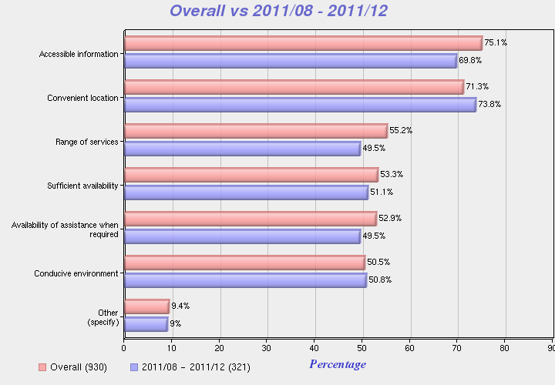

“**Evenings**” and “**afternoons**” still seem to be the most convenient time for respondents to use the Library, since the percentages were **62%** and **61.3% (n=305)** respectively. “**Late night**” was third with **49.2%,** which is a **2.8%** increase compared to the overall average of 46.4%. “**Weekends**” and “**mornings**” had the same percentage of responses at **46.6%**. Here is a chart with the distribution of responses.

**It is most convenient for me to use the services of the Library ... (choose all that apply)**

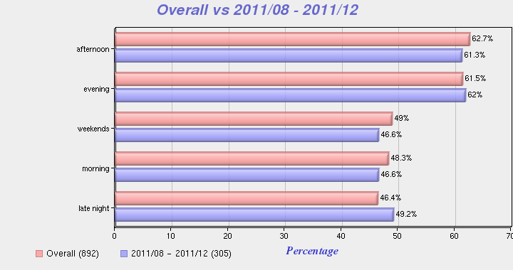

Within the “context” category there was a question about the method the respondents preferred when looking for information this past year. The largest number of respondents, **41.3% (n=75),** indicated that they look for information **“on their own, without assistance,”** which is only a slight decrease of **.6%** from 2010. In 2009 the percentage was **55.60%**, which is significantly higher. Less respondents indicated that they **“access Library’s online systems from a location other than the library,”** about **26.7%,** which is a decrease from the overall average (**29.10%)** of **2.4%,** which could be due to the increase in residential students**.** The number of respondents, **12.0%,** who indicated that they “**request assistance from a Library staff member**,” was more than the overall average of **8.9%** by **3.1%.** Here is a chart showing the distribution of responses.

**With respect to this Library, in the past year...When looking for information, the method I prefer is ... (select the best fit)** 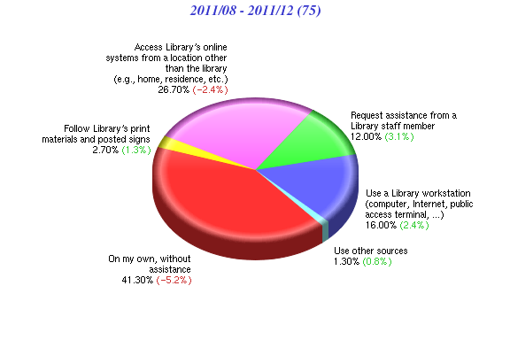

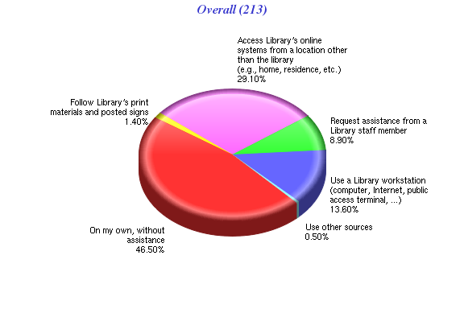

**Results of Overall Questions**

Respondents of questions in the “Overall” satisfaction category were asked to indicate a level of agreement with various statements about the importance of the Library and overall satisfaction using a 7-point Likert scale by selecting one of the following: “strongly disagree,” “disagree,” “somewhat disagree,” “neither agree nor disagree,” somewhat agree,” “agree,” or “strongly agree.”

The first question states **“This Library is very important to me,”** and the majority of respondents, **86.5% (n=407),** indicated some level of agreement and **8%** indicated some level of disagreement. Question two states **“I am very satisfied with the services of this Library,” 77.6% (n=406)** of the respondents showed some degree of satisfaction, and about **13.5%** indicated some degree of dissatisfaction. A third question states **“The services of this Library consistently meet or exceed my expectations,”** **75.1% (n=406)** of respondents showed some degree of agreement, and about **14.8%** indicated some level of disagreement with that statement. Lastly, question four states “**The quality of Library services is very high,”** about **75.8% (n=405)** of respondents showed some degree of agreement, and **13.8%** of the respondents showed some degree of disagreement with this statement. The table below provides a comparison of the 2011 responses with the overall average percentages of satisfaction for the years 2009-2011. For all questions, the overall average satisfaction percentages were higher than for 2011.

|  |  |  |  |
| --- | --- | --- | --- |
| **Respondents Indicating Some Degree of Satisfaction on a 7-Point Likert Scale**  **Comparison of 2011 with Overall Average Percentages for 2009-2011** | | | |
| **LibSat Survey Question** | **2011** | **Average for 2009-2011** | **Difference** |
| **This Library is very important to me.** | **86.5%** | **88.5%** | **-2.0%** |
| **I am very satisfied with the services of this Library.** | **77.6%** | **79.3%** | **-1.7%** |
| **The services of this Library consistently meet or exceed my expectations.** | **75.1%** | **75.4%** | **-.3%** |
| **The quality of Library services is very high.** | **75.8%** | **77.4%** | **-1.6%** |

**Results of Services Questions**

Respondents of these questions were asked to indicate a level of satisfaction and importance with specific services (e.g. Library Catalog) using 7-point Likert scales from “very dissatisfied” to “very satisfied” with a neutral point in the middle (“neither dissatisfied nor satisfied”) and “very unimportant” to “very important” with a neutral point in the middle (“neither important nor “unimportant”).

It appears that in 2011 respondents seemed most satisfied with **“Accessing the Internet from the Library”** with **90.7%** indicating some level of satisfaction, followed by **“Accessing an online database provided by the Library”** at **87.5%** and **“Library Electronic Resources”** at **77.9%.**

Respondents seem to be least satisfied with **“Collections”** with **14.1%** of the respondents indicating some level of dissatisfaction, followed by the “**Media Center”** at **11.4%** and **“Electronic Resources”** at **10.3% (**although the percentage of satisfaction for **“Electronic Resources”** was **77.9%,** which is fairly high.

The levels of satisfaction for “**Instructional Services**” (**34%**) and “**Library Programs and Special Events**” (**30.6%**) were low, but there may be problems with these questions. Also, we will need to monitor the levels of satisfaction for “**Interlibrary Loan**,” since it dropped from **82.5%** in 2009 to **57.8%** in 2010 to **54.8%** in 2011. Here are the complete details.

The question reads “**Please indicate your level of satisfaction with and the importance of the following services provided by this Library ...”**

* **Attending instructional sessions** **- 75% (n=52)** of respondents **i**ndicated some level of satisfaction, which is a decrease from 2009 and 2010, with **23.1%** indicating “neither dissatisfied nor satisfied,” so there might be some confusion about the question. **60.8%** (**n=51)** indicated some level of importance. The average satisfaction percentage for the years 2009-2011 was **80.2%**.
* **Collections – 56.2% (n=64)** indicated some level of satisfaction, which is a decrease from 2009 and 2010. **14.1%** of the respondents indicated some level of dissatisfaction, and **29.7%** indicated “neither dissatisfied nor satisfied.” **70.5% (n=61)** of respondents indicated some level of importance. The average satisfaction percentage for the years 2009-2011 was **60.5%.**
* **Library Catalog – 67.3% (n=64)** indicated some level of satisfaction and **89.3%** **(n=178)** for “Accessing the online catalogue.” **26.6%** indicated “neither dissatisfied nor satisfied,” and **80.3%** indicated some level of importance. The average satisfaction percentage for the years 2009-2011 was **75%.**
* **Instructional Services –** Only **34% (n=59)** indicated some level of satisfaction, with **59.3%** indicating “neither dissatisfied nor satisfied,” so this question could be a problem, since it is similar to “**Attending Instructional Sessions**.” In addition, only **44.6% (n=56)** indicated some level of importance. The average satisfaction percentage for the years 2009-2011 was **39.4%.**
* **Reference Desk – 55.8% (n=61)** showed some level of satisfaction, which is a **1.3%** increase from 2010. **36.1%** indicated “neither dissatisfied nor satisfied,” and **60.5%** (**n=58)** indicated some level of importance. The average satisfaction percentage for the years 2009-2011 was **61.8%.**
* **Circulation Desk** – **59.1% (n=61)** showed some level of satisfaction, which is a **12%** decrease from 2010. **32.8%** indicated “neither dissatisfied nor satisfied,” and **70.7% (n=58)** indicated some level of importance. The average satisfaction percentage for the years 2009-2011 was about **71.2%.**
* **Interlibrary Loan** – **54.8% (n=64)** indicated some level of satisfaction, yet only **6.3%** indicated some level of dissatisfaction. There was a significant decrease of **27.4%** in level of satisfaction from 2009 to 2010 and a small decrease of 3% from 2010 to 2011, so we will need to monitor this category. **39.1%** of respondentsindicated “neither dissatisfied nor satisfied, and **70% (n=60)** indicated some level of importance. The average satisfaction percentage for the years 2009-2011 was about **65%.**
* **Library Electronic Resources** (e.g., databases, electronic journals, electronic books) – **77.9% (n=68)** showed some level of satisfaction, but **10.3%** of the respondents indicated some level of dissatisfaction. **90.5% (n=63**) indicated some level of importance, which means that this area is important to respondents. The average satisfaction percentage for the years 2009-2011 was about **81.7%.**
* **Use of EZproxy…** - **72.8% (n=66)** of respondentsshowed some level of satisfaction, with **24.2%** indicating “neither dissatisfied nor satisfied.” **72.6% (n=62)** indicated some degree of importance, but there has been a steady decline in importance beginning with **96.7%** in **2009** and **80%** in 2010. The average satisfaction percentage for the years 2009-2011 was about **77.1%.**
* **Media Center** – **41% (n=61)** indicated some level of satisfaction, but **11.4%** of the respondents indicated some level of dissatisfaction. **47.5**% were “neither dissatisfied nor satisfied,” which could mean that this service is not being used as much, and **59.6% (n=57)** still indicated some level of importance. The average satisfaction percentage for the years 2009-2011 was about **55.9%.**
* **Library Programs and Special Events** – **30.6% (n=59)** indicated some level of satisfaction, which is an increase of **4.4%** from 2010, but **66.1%** of the respondents indicated “neither dissatisfied nor satisfied,” which could mean there is a problem with this question or respondents have never attended a library program or special event. Only **33.9% (n=56)** indicated some level of importance and **55.4%** indicated “neither important nor unimportant.” The average satisfaction percentage for the years 2009-2011 was about **47.5%.** Since there was a significant drop in satisfaction from 2009 **(85.5%)** to 2010 **(26.2%)** and only a small increase for 2011**,** we will need to investigate monitor this category.
* **Accessing an online database provided by the Library** – **87.5% (n=212)** of respondents indicated some level of satisfaction and **91.3% (n=208)** indicated some level of importance, but since this category was not reported before, the average for 2009-2011 cannot be calculated.

In addition, the PC, Laptop, and Mobile Device Survey used the trigger questions “Accessed the Internet while at the Library,” with results as follows”

* **Accessing the Internet from the Library** – **90.7% (n=216)** indicated some level of satisfaction and **92.5% (n=211)** indicated some level of importance. Since this category was added for the “PC, Laptop, and Mobile Device Survey, the satisfaction average for 2009-2011 cannot be calculated.

**Results of Staff Questions**

There were only two “yes” or “no” “Staff” questions. The first question reads “**Did Library Staff meet, greet or initiate contact with you at any time?**” **56.4% (n=78)** of the respondents answered “no,” and **43.6%** answered “yes.” The second question reads “**I requested assistance of a Library staff member…**” **54.5% (n=77)** of respondents answered “no” and **45.5%** responded “yes.” It still appears that students prefer to conduct research on their own.

**Results of Facilities Questions**

Respondents of these questions were asked to indicate a level of satisfaction and importance with specific facilities (e.g. Seating/Workspace) using 7-point Likert scales. It appears that most respondents are satisfied with **“Access to Library from a remote location ... Via phone, online, etc.,”** with **76.3%** indicating some level of satisfaction. The next highest categories, as far as some level of satisfaction, were **“Accessibility (access within and into building) “**at **75.9%,** and “**Hours of access and operation”** at **75.4%.**

Respondents seem to be least satisfied with **“Parking”** at **47.6%** indicating some level of dissatisfaction, followed by **“Restrooms”** at **31.2%.** Unfortunately, there did not seem to be any improvement in satisfaction with the area of **“Seating/Workspace,”** where some improvements were made based on the 2009 results, since the percentage of dissatisfaction was **27.5%**.

There also seemed to be a concern about **Facilities for security of personal belongings, “**since the percentage of dissatisfaction was **21.8%** and **“The Library building (e.g. cleanliness)”** at **20.4%**, although the average satisfaction percentage for the years 2009-2011 was about **74.2%,** which is fairly high**.** Here are the complete details.

The question reads “**Please indicate your level of satisfaction with and the importance of the following facilities of this Library…**”

* **Hours of access and operation** – **75.4%** (**n=65)** indicated some level of satisfaction, but still **20%** indicated some level of dissatisfaction. **96.7% (n=59)** indicated some level of importance, so it continues to be an important issue. The average satisfaction percentage for the years 2009-2011 was about **77.3%.**
* **Accessibility (access within and into building)** – **75.9% (n=58)** indicated some level of satisfaction, with **13.7%** indicating some degree of dissatisfaction, and **79.3% (n=53)** indicating some level of importance. The average satisfaction percentage for the years 2009-2011 was about **76.3%.**
* **Seating/Workspace** – **61.2% (n=62)** indicated some level of satisfaction, compared to **64.3%**, so there is a slight decrease. **27.5%** indicated some level of dissatisfaction, and **87.6% (n=56)** indicated some level of importance, so it appears this issue is still a concern. The average satisfaction percentage for the years 2009-2011 was about **63.9%.**
* **Restrooms** – **54% (n=61)** indicated some level of satisfaction, with **31.2%** still indicating some level of dissatisfaction. **91.4% (n=58)** indicated some level of importance, so this continues to be an important issue. The average satisfaction percentage for the years 2009-2011 was about **65.8%.**
* **Facilities for personal safety** – Only **48.3% (n=56)** indicated some level of satisfaction; however, **50%** indicated “neither dissatisfied nor satisfied,” so this could mean there is a problem with the question. **63.2%** **(n=49)** indicated some level of importance. The average satisfaction percentage for the years 2009-2011 was about **45.3%.**
* **Facilities for security of personal belongings** - Only **27.2% (n=55)** indicated some level of satisfaction, with **21.8%** indicating some level of dissatisfaction. However, **50.9%** indicated “neither dissatisfied nor satisfied,” so this could mean there continues to be a problem with the question. Additionally, only 58**% (n=50)** indicated some level of importance. The average satisfaction percentage for the years 2009-2011 was about **32.6%.**
* **Facilities for security of Library materials and property** – **43.7% (n=55)** indicated some level of satisfaction, with only **5.5%** indicating some level of dissatisfaction, and **47.3%** indicating “neither dissatisfied nor satisfied.” Again, there seems to be a problem with this question. **57.1% (n=49)** indicated some level of importance. The average satisfaction percentage for the years 2009-2011 was about **43.1%.**
* **The Library building (e.g. cleanliness)** – **74.6% (n=59)** indicated some level of satisfaction, compared to **72.7%** in 2009, which shows a slight increase in satisfaction, with **20.4%** still indicating some level of dissatisfaction. **96.3% (n=54)** indicated some level of importance, so this continues to be an important issue. The average satisfaction percentage for the years 2009-2011 was about **74.2%.**
* **Parking** – Only **32.9% (n=61)** indicated some level of satisfaction, compared to **41.9%** in 2010, so there is decrease in satisfaction, with **47.6%** indicating some level of dissatisfaction, which means that “parking” is still an issue. **76.9% (n=41)** indicated some level of importance. The average satisfaction percentage for the years 2009-2011 was about **33.4%,** which is low.
* **Access to Library from a remote location ... Via phone, online, etc.** – **76.3%** (**n=59**) indicated some level of satisfaction, with **6.8%** indicating some level of dissatisfaction, and **16.9%** indicating “neither dissatisfied nor satisfied. ” **83%** (**n=53**) indicated some level of importance. The average satisfaction percentage for the years 2009-2011 was about **74%.**
* **Group Study Rooms – 46.7% (n=60)** indicated some level of satisfaction, so this is an increase from 2010 at **34.1%**, but **18.3%** are stillindicating some level of dissatisfaction. **35%** of respondents indicated “neither dissatisfied nor satisfied,” and **62.3%** indicating some level of importance.

**Results of Policies Questions**

Respondents of these questions were asked to indicate a level of satisfaction and importance with specific policies (e.g. Lending policies) using 7-point Likert scales It appears that respondents are most satisfied with **“Lending policies,“ with 70.3%** indicating some level of satisfaction, followed by **“Borrowing/Returning materials”** at **66.3%.** In2009 and 2010,respondents also seemed most satisfied with these two areas, but there has been a steady decrease in level of satisfaction from 2009 to 2011.

Respondents seem least satisfied with **“Access to restricted or limited-use facilities…,”** where the satisfaction level was **35.2%.** However, **56.3%** indicated “neither dissatisfied nor satisfied, which could mean that there is problem with this question. Respondents also seemed to be less satisfied with **“Policy enforcement”** with **36.5%** indicating some level of satisfaction, followed by **“Fines/Fees (costs…)”** at **41.2%.** Here are the complete details.

The question reads “**Please indicate your level of satisfaction with and the importance of the following policies and procedures of this Library…**”

* **Lending policies** – **70.3%** (**n=74)** indicated some level of satisfaction, which is a decrease of 5.1% from 2010, with **20.3%** indicating “neither dissatisfied nor satisfied” and **76.8% (n=69)** indicating some level of importance. The average satisfaction percentage for the years 2009-2011 was about **77.1%**.
* **Fines/Fees(costs/rules, collections/payments, dispute resolution)** – **41.2%** **(n=73)** indicated some level of satisfaction, which is a decrease of **7.1%** for 2010,with **26%** indicating some degree of dissatisfaction, and **32.9%** indicating “neither dissatisfied nor satisfied.” **58.8% (n=68)** indicated some level of importance, which is almost the same as 2009. The average satisfaction percentage for the years 2009-2011 was about **43.3%**.
* **Borrowing/Returning materials** – **66.3%** **(n=74)** indicated some level of satisfaction, which is a decrease from **73.3%** in 2010. **25.7%** indicated “neither dissatisfied nor satisfied,” and **75% (n=68)** indicated some level of importance. The average satisfaction percentage for the years 2009-2011 was about **72.2%**.
* **Hold/Renewals** – **53.5%** **(n=71)** indicated some level of satisfaction, which is a decrease from **59.3%** in 2010, with **36.6%** indicating “neither dissatisfied nor satisfied,” and **57.9% (n=69)** indicating some level of importance.
* **Interlibrary Loans** – **54.1%** **(n=72)** indicated some level of satisfaction, which is a decrease from **56.9%** in 2010, with 11**.1%** indicating some level of dissatisfaction. **34.7%** indicated “neither dissatisfied nor satisfied, “and **58.8%** **(n=68)** indicated some level of importance, which is a decrease from **72.4%** in 2010.
* **Access to restricted or limited-use facilities, equipment, information or other services** – Only **35.2% (n=71)** indicated some level of satisfaction, which is an increase of **6.1%** from 2010,with **8.4%** indicating some level of dissatisfaction. **56.3%** indicated “neither dissatisfied nor satisfied, which could mean that there is problem with this question. Additionally, only **37.9% (n=66)** indicated there was some degree of importance.
* **Policy enforcement** – Only **36.5%** **(n=71)** indicated some level of satisfaction, as compared to **30.9%** in 2010, which is an increase, but **21%** indicating some level of dissatisfaction. **42.3%** indicated “neither dissatisfied nor satisfied,” which could still indicate a problem with this question. Lastly, **61.2% (n=67)** indicated some level of importance, so it is an important issue.

**Results of Equipment Questions**

Respondents of these questions were asked to indicate a level of satisfaction and importance with specific equipment (e.g. printers) using 7-point Likert scales. Overall, respondents did not seem very satisfied with library equipment, but they did seem most satisfied with **“Computer workstations”** with **60.3%** indicating some level of satisfaction, which is still a significant decrease in satisfaction of **14.7%** from 2009. Although, **20.6%** still indicated some level of dissatisfaction. The next highest category was “**Printers**” at **57.7**%, which is actually an increase in satisfaction of **18.2**% from 2010, so it appears some improvements have helped.

Respondents appear to be less satisfied with “**Audio, Video, Microform Equipment (Listening/Viewing Stations)**,” with only 37.5% of respondents indicating some level of satisfaction, followed by “**Computers equipped with specialized software/database/hardware”** at **42.1%** and **“Copiers”** with **46.7%.** Here are the complete details.

The question reads “**Please indicate your level of satisfaction with and the importance of the following equipment at this Library…**”

* **Printers** – **57.7%** (**n=59)** indicated some level of satisfaction, which is a definite increase from 2010 of **18.2%,** with only **6.8%** indicated some level of dissatisfaction , which could be a result of improvements made based on 2009 and 2010 survey results. **35.6%** indicated “neither dissatisfied nor satisfied,” and **70.9% (n=55)** indicated some level of importance.
* **Copiers** – **46.7%** **(n=60)** indicated some level of satisfaction, which is a decrease of **8.1%** from 2010, with **13.3%** indicating some degree of dissatisfaction. **40%** indicated “neither dissatisfied nor satisfied,” and **69.6% (n=56)** indicated some level of importance.
* **Computer workstations** – **60.3%** **(n=58)** indicated some level of satisfaction, which is slightly less than **61.4%** in 2010, with **20.6%** indicating some level of dissatisfaction. **82.1% (n=56)** indicated some level of importance, so it still remains an important issue.
* **Computers equipped with specialized software/database/hardware** – Only **42.1%** **(n=57)** indicated some level of satisfaction, which is a **5.5%** increase from 2010, with **7%** indicating some level of dissatisfaction. **50.9%** indicated “neither dissatisfied nor satisfied,” which could indicate a problem with the question or that respondents do not use this equipment. Only **59.5% (n=52)** indicated some level of importance.
* **Audio, Video, Microform Equipment (Listening/Viewing Stations)** – Only **37.5%** **(n=56)** indicated some level of satisfaction, which is an increase of **7.3%** from 2010, with **7.2%** indicating some level of dissatisfaction. **55.4%** indicated “neither dissatisfied nor satisfied,” which could mean there is still a problem with this question. Only **50%** **(n=52)** indicated some level of importance.
* **Express Checkout Equipment** – Only **29.8%** **(n=57)** indicated some level of satisfaction, which is only a slight increase of **2.3%** from 2010, with **10.6%** indicating some level of dissatisfaction. However, **59.6%** indicated “neither dissatisfied nor satisfied, which could mean that there is problem with this question or respondents are not using this equipment. Only **46.1% (n=52)** indicated there was some degree of importance.

**Summary**  
 Most of the survey respondents indicated that they are from the Boca Campus and are undergraduates, but there was an increase in the number of faculty and staff respondents, so the sample appeared to be more representative of the FAU population. More respondents indicated that they are using Library services on campus, rather than remotely. More respondents indicated that their primary reason for using the Library is “**study alone,**” closely followed by “**research**” and that a “**convenient location**” most impacts their satisfaction. “**Evenings**” and “**afternoons**” are still the most convenient times for respondents to use the Library, but the third highest category was “**late night**.”

Most respondents still believe that the Library is important and are satisfied with library services overall. However, the number of respondents in 2011 indicating a degree of satisfaction decreased for both categories. Additionally, there were more respondents who indicated that they were dissatisfied with library services.

As far as library services, more respondents seem satisfied with the **“Accessing the Internet from the Library,”** followed by **“Accessing an online database provided by the Library”** and **“Library Electronic Resources.”** Also, more respondents indicated that these three categories are important**.** Respondents seem less satisfied with “**Collections,”** followed by the “**Media Center”** and there seemed also to be some dissatisfaction with **“Library Electronic Resources”** even though the percentage of respondents indicating a level of satisfaction and importance was fairly high. In addition, the levels of satisfaction for “**Interlibrary Loan**,” significantly decreased from 2009 to 2010, and there was still a slight decrease indicated by the survey responses for 2011.

In summarizing the responses for library facilities, respondents seem to be more satisfied with **“Access to Library from a remote location ... Via phone, online, etc.,”** followed by **“Accessibility (access within and into building) ,“** “**Hours of access and operation,”** and **“The Library building (e.g. cleanliness).** Respondents still seem to be less satisfied with **“Parking,” “Restrooms”** and **“Seating/Workspace.”** Overall, respondents still seem less satisfied with library equipment, but they do seem to be more satisfied with “**Printers**,” and “**Computer Workstations”** and less satisfied with “**Copiers**” and “**Audio, Video, Microform Equipment ….”**

Satisfaction with library policies was still not very high. Respondents are more satisfied with **“Lending policies, “followed** by **“Borrowing/Returning materials,”** so there is not much change since 2010. Respondents still seem less satisfied with **“Access to restricted or limited-use facilities…,”**  **“Policy enforcement,” f**ollowed by **“Fines/Fees(costs…).”**

**PART II: QUALITATIVE DATA RESULTS**

**Introduction**

There were a total of **935** individual comments from **415** respondents for all campus locations for the period of August 29th through December 31st. However, since one comment can be identified with more than one category, there are a total of **2,359** categorized comments. Approximately **85.5%** of the comments came from respondents from the Boca Campus, with **9.1%** from Jupiter, **3.4%** from Davie campus, and **2%** from the other three campuses.

**Summary of Positive Comments**

There were a total of **1,037** positive comments for all campus locations. As far as the individual categories, it appears that respondents are most satisfied with the **“Services”**, since this category received the largest number, **19.4% (n=1,037)**, of all positive comments followed by **“Facilities”** with **15.1%, “Staff”** at **11.2%, ”Equipment”** at **6.5 %**, **Accessing Information and Services via the Library web site (ease of use)** at **6.4%**, **and “Collections”** at **6.1%.**

**Summary of Negative Comments**

There were a total of **1,206** negative comments for all campus locations. The areas for all campuses (but mostly for Boca) with the highest percentage of negative comments were related to **“Facilities,”** (which would include **seating/study spaces, equipment, hours of operation**, and **bathrooms**) with **25.7% (n=1,206)**, “**Service”** at **8.3%**,and **“Policies”** at **6.9%**.