Use of Direct Quotations

Excerpted examples from faculty instructions to students

Example one:

1. To support your thesis and develop individual major points of your discussion, quote relevant passages from the literary text you are analyzing and explain precisely how each passage supports not only the specific point of the paragraph in which it appears but also your central idea for your entire paper. Strike a balance between quotations and your own discussion; your essay should consist primarily of your own analysis of the text you’ve chosen, with selected quotations playing a supporting role.

Lead into each quoted passage with an introductory phrase or sentence. Avoid stringing quotations together; be sure to provide analysis of each passage before moving on to your next point.

Examples for formatting quoted passages, using MLA (Modern Language Association) format:

**Poetry** (short passages of three lines or less):

Yeats opens his second stanza in “Sailing to Byzantium” with a metaphor portraying old age:

“An aged man is but a paltry thing, / A tattered coat upon a stick […]” (9-10).

**Longer passages of poetry** (four lines or more):

Yeats opens his second stanza of “Sailing to Byzantium” with a metaphor portraying old age:

An aged man is but a paltry thing,

A tattered coat upon a stick, unless

Soul clap its hands and sing, and louder sing

For every tatter in its mortal dress. (9-12)

**Prose** (short passages of less than four lines of typed text):

Proust’s statement, “And suddenly the memory revealed itself,” suggests the essence of

involuntary memory (1803).

**Longer passages of prose** (four lines or more):

Proust finally makes the connection between his recollection and his present experience:

And suddenly the memory revealed itself. The taste was that of the little piece of madeleine which on Sunday mornings at Combray (because on those mornings I did not go out before mass), when I went to say good morning to her in her bedroom, my aunt Leonie used to give me, dipping it first in her own cup of tea or tisane. (1803)

Example Two:

**Essay–Areopagitica**

Carefully reread Areopagitica from “Dionysius Alexandrinus was about the year 240 . . .” (210) through “things which heretofore were governed only by exhortation” (212). In this brief passage, Milton has much to say about food and eating. Why? What analogies is Milton trying to establish between eating and reading? In what particular respect does he say that reading is not analogous to eating? Before addressing these questions, you will want to read the following Biblical passages, all of which Milton keeps in mind: Leviticus 11.1-23, Mark 7.1-23, and Acts 10.1-29.

Use brief quotations from Milton’s prose, smoothly incorporated into your own sentences and documented in the following manner: Milton argues that “instead of suppressing sects and schisms,” censorship of the press “raises them and invests them with a reputation” (230).

Example Three:

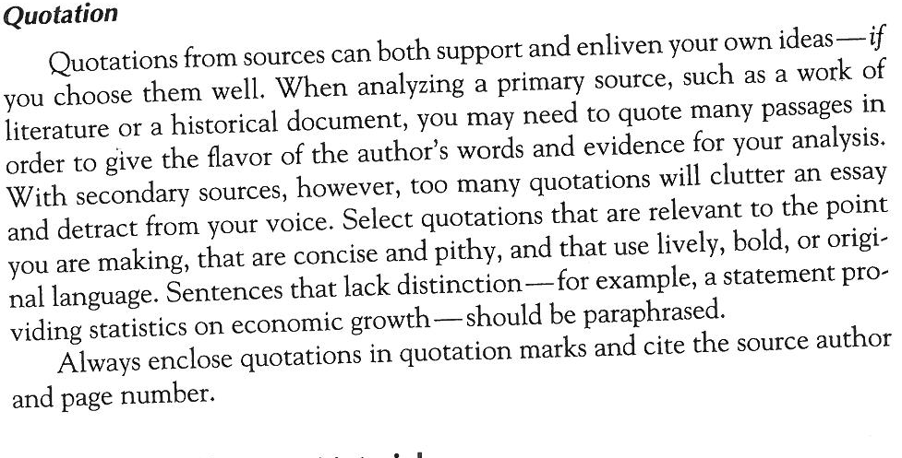

Example Four:

**Citation:**  You will absolutely need to give examples from the text you are examining. For such a short paper, where you are only citing from course readings, you don’t need to present a bibliography or use footnotes. You should simply cite your sources parenthetically, identifying the book or article as well as the page number.

Keep your examples short and to the point; a good rule of thumb is to give a sentence-long example, and then your explanation. **Avoid citing long passages; take only the part of the passage that speaks exactly to your point.** The goal of giving these citations isn’t to let the text speak for you, but to use examples to give you something to anchor **your own** ideas. For example:

**On a number of occasions, Roumain depicts the village as a living entity: “There sprang up a rhythmic circulation between the beating heart of the drum and the movements of the men” (Roumain 28).**

From here, you’ll want to explain exactly what’s important about the quote, paying attention to what’s going on in the novel when it occurs, its language, and how it fits in with your argument. From this example, to make your point about “the village as a living entity” you could emphasize how the “men” are not looked at as individuals here, and how they appear to move as one in the passage. You’d also want to explain how the language connects these bodies to the “beating heart of the drum.”