**FAU LIBRARIES**

**LibSat Survey Results for Fall 2012 with Comparisons to 2011**

**Prepared by:**

**Dr. Darlene Parrish and Malka Schyndel**

**Date Submitted: April 18, 2013**

**Executive Summary**

This report includes an analysis of the LibSat survey responses, both quantitative and qualitative for the period August through December 2012 and a comparison with the results of fall 2011. It also includes some recommendations for future improvements. The LibSat survey for the fall 2012 was launched for a fourth consecutive time on the FAU Libraries web site on August 30, 2012, which is only one day later than the launch date for 2011. The results of this survey are based on the analysis of responses gathered from August 30, 2012 through December 31, 2012.

Unfortunately, there was about a **56%** decrease in the total number of responses from 2011 to 2012 for all campus libraries including Boca, Jupiter, Davie, and Harbor Branch. In 2012, there were only **183** respondents, as compared to **415** in 2011. Efforts were made to market the survey, which included advertisements on the FAU Libraries home pages and *FAU Today.* A request for an email to be sent to all FAU faculty, staff, and students advertising the survey was made, but it was denied due to a change in university policy, which made a huge difference.

About **83%** of respondents were either undergraduate or graduate students. Only **17** faculty members participated in the survey in 2012 as compared to **42** in 2011, which is almost a **60%** decrease. Most of the respondents, about **84%,** identified themselves as being from the Boca Campus, with approximately **5%** from Jupiter and **5%** from Davie and about **4%** from HBOI.

About **73.0%** of the respondents indicated that they are using library services on campus, which is a decrease of **1.1%** from 2011, and more respondents indicated that their primary reason for using the library was “**study alone**” followed by “**research**” and that “**convenient location**” most impacts their satisfaction. There was an increase from 2011 in the number of respondents who believe that the Library is important and are satisfied with library services overall. More respondents seem more satisfied with **“Accessing the Internet from the Library,” “Accessing an online database provided by the Library”** and **“Circulation Desk.”** Respondents seem less satisfied with the “**Media Center**,” followed by **“Interlibrary Loan”** and **“Collections.”** Although **37.5%** of respondents for the **“Interlibrary Loan”** question and **31.3%** for **“Collections”** indicated “neither dissatisfied nor satisfied,” which could indicate a problem.

As far as facilities, respondents seem more satisfied with **“Accessibility (access within and into building),” “Hours of access and operation”** and **“The Library building (e.g. cleanliness).** Respondents seem less satisfied with **“Seating/Workspace”** and **“Restrooms**;” however, the results show some increase in satisfaction in both of these areas since 2011. There was also an increase in importance for “**Facilities for personal safety,** and **“Facilities for security of personal belongings.“** It is interesting to note that **“Seating/Workspace,” “Hours of access and operation,” “The Library building (e.g. cleanliness),”** out of all the main question categories (e.g. **“Services”**)were the top three areas of importance as indicated by respondents.

In most of the categories relating to satisfaction with library policies there has been an increase since 2011. Respondents seem more satisfied with **“Lending policies,“** followed by **“Borrowing/Returning materials.”** Respondents seem less satisfied with **“Policy enforcement,” “Access to restricted or limited-use facilities…,”** and **“Fines/Fees(costs**…)” in that order. Overall, respondents seemed less satisfied with library equipment, but there was some improvement as far as satisfaction with **“Computer workstations,”** and “**Printers**.”

The analysis of the fall 2012 LibSat survey comments or qualitative data results (Part II), is in progress.

**CONTENTS**

**PART I: QUANTITATIVE DATA RESULTS**

Introduction 5

Limitations of LibSat Survey Results 5

Results of Context Questions 5

Results of Overall Questions 12

Results of Services Questions 13

Results of Staff Questions 14

Results of Facilities Questions 14

Results of Policies Questions 15

Results of Equipment Questions 16

Summary 17

**PART II: QUALITATIVE DATA RESULTS**

Introduction 18

Summary of Positive Comments 18

Summary of Negative Comments 189

**PART I: QUANTITATIVE DATA RESULTS**

**Introduction**

This report includes a summary of the LibSat survey results for the period August through December 2012 and a comparison with the fall 2011 results. LibSat was launched for a fourth consecutive year on the Florida Atlantic University Libraries’ home page on August 30, 2012. Links to the survey were also included on the Jupiter and Davie Campus Library home pages and on the HBOI catalog search page. Efforts were made to market the survey, thanks to Terri Berns and her staff, which included advertisements on the FAU Libraries home page and in *FAU Today.* A request was made for an email to be sent to all FAU faculty, staff, and students to advertise the survey, but was denied due to a change in University policy, which made a very significant difference in the response rate for 2012.

The total number of respondents for the regular and in-depth surveys for all campus libraries including Boca, Davie, Jupiter, and HBOI was **183** in 2012 and **415** in 2011, which is about a **56%** decrease. Most of the respondents, about **84%,** identified themselves as being from the Boca Campus, with approximately **5%** from Jupiter and **5%** from Davie and about **4%** from HBOI. As far as the monthly breakdown for the total number of responses, the largest number was in November with **62,** and the smallest number, **7,** occurred in August, which is comparable to the results for 2011.

**Limitations of LibSat Survey Results**

One definite limitation of the LibSat survey is the response rate, which is very low at about **.6%** and is a **.9%** decrease from fall 2011**,** if you are basing your response rate on the FAU community population of approximately 30,000.

Approximately **70% or 128** of the **183** respondents selected the regular survey, which takes about 7 minutes to complete and **55** or about **30%** of respondents selected the in-depth survey, which has a completion time of about 15 minutes. This is a slight increase of **6%** from 2011 for the number of respondents selecting the in-depth survey. The question categories for the regular survey include “**Overall**” (questions about overall satisfaction with the Library) and “**Context**” (questions about the respondent, satisfaction with services, and usage). However, in addition to “**Overall**” and “**Context**,” the in-depth survey also includes question categories entitled “**Services**” (additional questions about services), “**Staff,**” “**Facilities**,” “**Policies**,” and “**Equipment**.” Since the response rate of the in-depth survey was about **30%,** this is a definite limitation.

**Results of Context Questions**

The “**Context**” category includes questions about the respondent, and satisfaction with services and usage. The largest percentage of respondents**, 56.4% (n=182)** identified themselves as being undergraduate students, which is a decrease of **2.7%** from 2011, and the second largest percentage was graduate students at **28.5%,** which is an increase of **6.3%** from 2011.The next largest percentage of respondents was faculty members at **9.5%** of the respondents, but overall the total number of respondents decreased by **56%**, which is a significant drop. Here is a chart showing the distribution of types of respondents.

**I am…(select the best fit)**

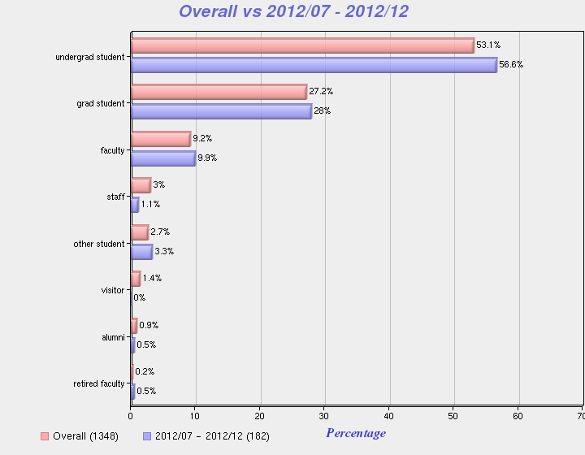

Most of the respondents in 2012, **73.0%, (n=159),** indicated that they use library services on campus, with only **23.0%** indicating that they use them remotely**,** as is evidenced by the chart below.

**I use Library services primarily…**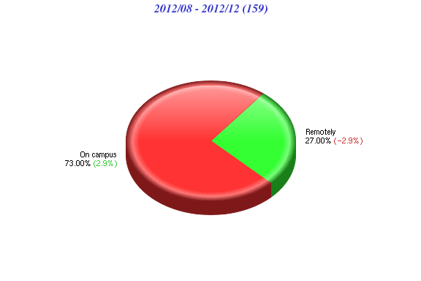

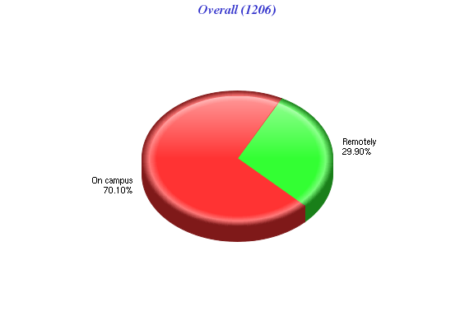

“**Study alone**” was indicated again as the primary reason for using the Library by **41.1%** which is an increase of **2.3%** from 2011**. “Research**” was the second most popular category indicated as the primary reason for using the Library by **36.2%** of respondents. The third and fourth most popular reasons were “**group study**” at **8.6**%, which could be due to improvements made in group study rooms and “**interlibrary loan**” at **6.7%.** The overall average for 2009-2012 indicated that “**research**” was still the primary reason for using the Library by **42.7% (**n=1194**)** of the respondents. Here is the complete distribution of responses for the following question:

**The primary reason for using this Library… (select the best fit)**

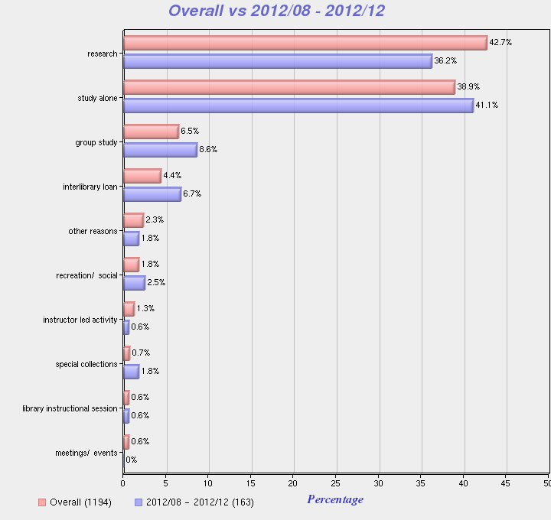

Survey respondents in 2012 indicated that the aspect of service that most impacted satisfaction was “**convenient location**” with the highest number of responses at **76.4%,** which is an increase of **2.6%** from 2011,followed by “**accessible information**” at **66.7%.** However, “**accessible information**” at **74.1%** was the aspect of service that most impacted satisfaction, as far as the overall average for 2009-2012, as the chart below indicates.

**The aspects of service that most impact my satisfaction include ... (choose all that apply)**

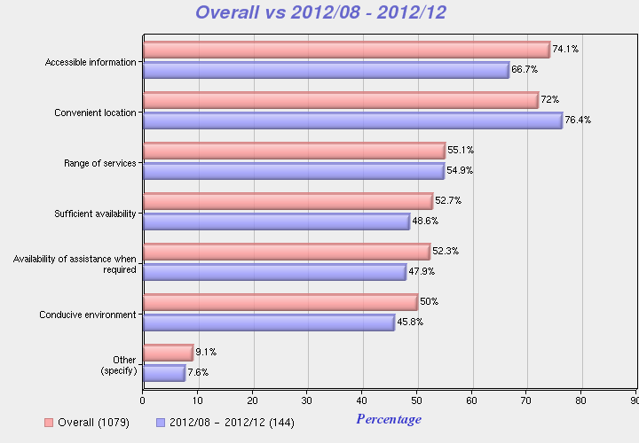

“**Evening**” and “**afternoon**” still seem to be the most convenient time for respondents to use the Library, since the percentages were **59.7%** and **57.8% (n=139)** respectively. “**Morning**” was third with **48.2%,** which is a 1**.6%** increase compared to 2011. “**Weekends**” was fourth at **46%** and “l**ate night**” was last at **45.3%.** Here is a chart with the distribution of responses.

**It is most convenient for me to use the services of the Library ... (choose all that apply)**

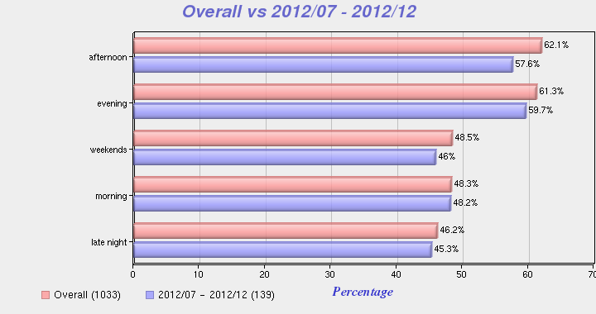

Within the “context” category there was a question about the method the respondents preferred when looking for information this past year. The largest number of respondents, **57.5% (n=40),** indicated that they look for information **“on their own, without assistance,”** which is a decrease of **6.2%** from 2011. Less respondents indicated that they **“access Library’s online systems from a location other than the library,”** about **22.5%,** which is a decrease from the overall average (**28.1%)** of **5.6%,** which could be due to the increase in residential students**.** The number of respondents, **7.5%,** who indicated that they “**request assistance from a Library staff member**,” was less than the overall average of **8.7%** by **1.21%.** Here is a chart showing the distribution of responses.

**With respect to this Library, in the past year...When looking for information, the method I prefer is ... (select the best fit)**

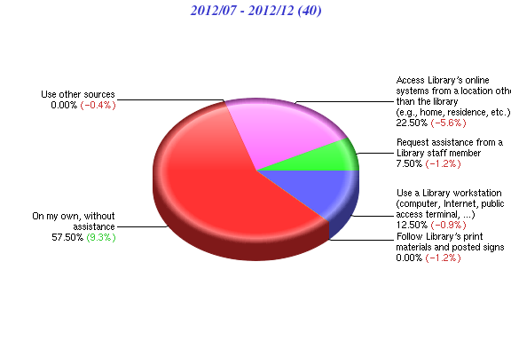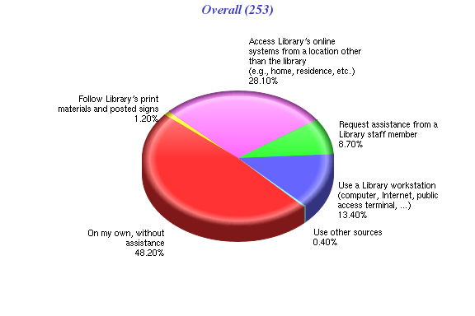

**Results of Overall Questions**

Respondents of questions in the “Overall” satisfaction category were asked to indicate a level of agreement with various statements about the importance of the Library and overall satisfaction using a 7-point Likert scale by selecting one of the following: “strongly disagree,” “disagree,” “somewhat disagree,” “neither agree nor disagree,” somewhat agree,” “agree,” or “strongly agree.”

The first question states **“This Library is very important to me,”** and the majority of respondents, **88.4% (n=179),** indicated some level of agreement, which is an increase of **1.9%** from 2011. Question two states **“I am very satisfied with the services of this Library,” 78.1% (n=178)** of the respondents showed some degree of satisfaction, which is a slight increase of **0.5%** from 2011. A third question states **“The services of this Library consistently meet or exceed my expectations,”** only about **69% (n=177)** of respondents showed some degree of agreement, which is a decrease of about **6.1%** from 2011. Lastly, question four states “**The quality of Library services is very high,”** about **73% (n=178)** of respondents showed some degree of agreement, this is a decrease of about **2.8%** from 2011. The table below provides a comparison of the 2012 results with 2011. Overall satisfaction remained fairly high at **78.1%** for 2012, but there were decreases in perceptions of meeting or exceeding expectations and quality of services.

|  |  |  |  |
| --- | --- | --- | --- |
| **Respondents Indicating Some Degree of Satisfaction on a 7-Point Likert Scale**  **Comparison of 2012 with 2011** | | | |
| **LibSat Survey Question** | **2011** | **2012** | **Difference** |
| **This Library is very important to me.** | **86.5%** | **88.4%** | **+1.9%** |
| **I am very satisfied with the services of this Library.** | **77.6%** | **78.1%** | **+0.5%** |
| **The services of this Library consistently meet or exceed my expectations.** | **75.1%** | **69%** | **-5.6%** |
| **The quality of Library services is very high.** | **75.8%** | **73%** | **-2.8%** |

**Results of Services Questions**

Respondents of these questions were asked to indicate a level of satisfaction and importance with specific services (e.g. Library Catalog) using 7-point Likert scales from “very dissatisfied” to “very satisfied” with a neutral point in the middle (“neither dissatisfied nor satisfied”) and “very unimportant” to “very important” with a neutral point in the middle (“neither important nor “unimportant”).

It appears that in 2012 respondents seemed most satisfied with **“Accessing the Internet from the Library”** with **89.6%** indicating some level of satisfaction, followed by **“Accessing an online database provided by the Library”** at **89%;** these two categories were also the top categories for level of importance. **“Circulation Desk”** at **81.4%** was ranked number three as far as level of satisfaction. There was also an **18.7%** increase in the respondents who indicated that the **“Reference Desk”** was important and **16%** increase for the **“Circulation Desk.”**

The areas where respondents seem to be not quite as satisfied include the **“Media Center”** with only **40%** indicating some level of satisfaction, followed by **“Interlibrary Loan”** at **53.1%** and **“Collections**” at **59.4%.** The levels of satisfaction for “**Instructional Services**” (**34.4%**) and “**Library Programs and Special Events**” (**20.7%)** were still low, but there may be problems with these questions due to the large percentage of respondents indicating “neither dissatisfied nor satisfied.” Here are the complete details.

The question reads “**Please indicate your level of satisfaction with and the importance of the following services provided by this Library ...”**

* **Attending instructional sessions** **- 70.5% (n=34)** of respondents **i**ndicated some level of satisfaction, which is a decrease of **4.5%** from 2011. **61.7%** (**n=51)** indicated some level of importance.
* **Collections – 59.4% (n=32)** indicated some level of satisfaction, which is a slight increase from 2011 of **3.2%**. **31.3%** of the respondents indicated “neither dissatisfied nor satisfied,” which could indicate some confusion about the question. **72.1% (n=29)** of respondents indicated some level of importance, which is only a slight increase of **1.6%.**
* **Library Catalog – 68.8% (n=32)** indicated some level of satisfaction and **83.6%** **(n=91)** for **“Accessing the online catalogue.”** **85.7%** indicated that the catalog still had some level of importance, a **5.4%** increase from 2011.
* **Instructional Services –** Only **34.4% (n=29)** indicated some level of satisfaction, with **58.6%** indicating “neither dissatisfied nor satisfied,” which could indicate come confusion with “**Attending Instructional Sessions**.” In addition, only **50.1% (n=28)** indicated some level of importance, a **6.1%** increase over 2011.
* **Reference Desk – 63.4% (n=30)** showed some level of satisfaction, which is a **7.6%** increase from 2011. **30%** indicated “neither dissatisfied nor satisfied,” and **79.2%** (**n=29)** indicated some level of importance, an **18.7%** increase, which is significant.
* **Circulation Desk** – **81.4% (n=32)** showed some level of satisfaction, which is a significant increase of **22.3%** from 2011. **86.7% (n=30)** indicated some level of importance, which is also a significant increase of **16%** from 2011.
* **Interlibrary Loan** – **53.1% (n=32)** indicated some level of satisfaction, a decrease of **1.7%** from 2011. However, **37.5%** of the respondents were “neither dissatisfied nor satisfied,” which could mean a problem with this question. **79.3%** indicated some level of importance, an increase of **9.3%** from last year.
* **Library Electronic Resources** (e.g., databases, electronic journals, electronic books) – **81.3% (n=32)** showed some level of satisfaction, an increase of **3.4%** from 2011. **86.2% (n=29**) indicated some level of importance; this area remains important to respondents.
* **Use of EZproxy…** - **66.7% (n=33)** of respondentsshowed some level of satisfaction, with **24.2%** indicating “neither dissatisfied nor satisfied.” **76.7% (n=30)** indicated some degree of importance, which is a **13.8%** decrease in importance from 2011.
* **Media Center** – **40% (n=30)** indicated some level of satisfaction, but **56.7%** of the respondents were “neither dissatisfied nor satisfied,” which could mean that this service is not being used as much, and **51.7% (n=29)** still indicated some level of importance, which is a decrease from 2011.
* **Library Programs and Special Events** – **20.7% (n=29)** indicated some level of satisfaction, which is a decrease of **9.94%** from 2011, but **75.9%** of the respondents indicated “neither dissatisfied nor satisfied,” which could mean respondents have not attended a library program or special event. Only **35.7% (n=28)** indicated some level of importance. We will need to continue to monitor this category.
* **Accessing an online database provided by the Library** – **89% (n=100)** of respondents indicated some level of satisfaction and **96.8% (n=208)** indicated some level of importance, which are increases from 2011 so users appear to be satisfied and find this service important.
* **Accessing the Internet from the Library** – **89.6% (n=106)** indicated some level of satisfaction and **92.9% (n=99)** indicated some level of importance. Since there was only a slight change from 2011, users seem satisfied with this service and believe it is important.

**Results of Staff Questions**

There were only two “yes” or “no” “Staff” questions. The first question reads “**Did Library Staff meet, greet or initiate contact with you at any time?**” **43.9% (n=41)** of the respondents answered “no,” and **56.1%** answered “yes.” The second question reads “**I requested assistance of a Library staff member…**” **59% (n=39)** of respondents answered “no” and **41%** responded “yes.” It still appears that students prefer to conduct research on their own.

**Results of Facilities Questions**

Respondents of these questions were asked to indicate a level of satisfaction and importance with specific facilities (e.g. **“Seating/Workspace”)** using 7-point Likert scales. The category “**Facilities for security of Library materials and property”** was not included in the report this year, as there continues to be a problem with this question. In addition, “**Parking”** was also not included in the report, since we cannot control the **“Parking”** situation, even though it continues to be a problem and an important issue.

Respondents were most satisfied with **“Accessibility (access within and into building),”** with **78.2%** indicating some level of satisfaction. The next highest categories, as far as some level of satisfaction, were **“Hours of access and operation”** at **77.1%,** which was also the top category for importance, and “**The Library building (e.g. cleanliness)”** at **74.3%**;however, **22.9%** of respondents indicated some level of dissatisfaction with both these areas.

Respondents seem to be least satisfied with **“Seating/Workspace”** at **36.3%** indicating some level of dissatisfaction, followed by **“Restrooms”** at **28.6%** and **“Hours of access and operation”** and **“The Library building (e.g. cleanliness),”** both at **22.9%.** Interestingly, respondents indicated an increase in importance of **“Facilities for personal safety**” and **“Facilities for security of personal belongings** “with percentages of **75%** and **80%,** respectively. Here are the complete details.

The question reads “**Please indicate your level of satisfaction with and the importance of the following facilities of this Library…**”

* **Hours of access and operation** – **77.1%** (**n=35)** indicated some level of satisfaction, an increase of **1.7%** from 2011**,** but still **22.9%** indicated some level of dissatisfaction. **97.2% (n=35)** indicated some level of importance, so it continues to be an important issue.
* **Accessibility (access within and into building)** – **78.2% (n=32)** indicated some level of satisfaction, with **15.6%** indicating some degree of dissatisfaction, and **91.1% (n=34)** indicating some level of importance, which is a significant increase of **11.8%** from 2011, so this issue has become more important.
* **Seating/Workspace** – **64.7% (n=34)** indicated some level of satisfaction, which shows some improvement of **3.5%** from 2011. Although **36.3%** still indicated some level of dissatisfaction, with **100%** **(n=33)** of the respondents indicating some level of importance, so this issue is still a major concern.
* **Restrooms** – **68.6% (n=35)** indicated some level of satisfaction, with **28.6%** still indicating some level of dissatisfaction. **93.7% (n=33)** indicating some level of importance, so this continues to be an important issue.
* **Facilities for personal safety** – Only **54.9% (n=31)** indicated some level of satisfaction; however, **38.7%** indicated “neither dissatisfied nor satisfied,” so this could mean there is a problem with this question. **75%** **(n=32),** an increase of **11.8%** from 2011,indicated some level of importance.
* **Facilities for security of personal belongings** - Only **38.8% (n=31)** indicated some level of satisfaction, an increase of **11.6%** from 2011**,** with **19.3%** indicating some level of dissatisfaction. However, 4**1.9%** indicated “neither dissatisfied nor satisfied,” so there still may a problem with the question. Additionally, **80% (n=30)** indicated some level of importance, which is a significant increase of **22%** from2011.
* **The Library building (e.g. cleanliness)** – **74.3% (n=35)** indicated some level of satisfaction, so there was very little change from 2011, with **22.9%** still indicating some level of dissatisfaction. **97% (n=33)** indicated some level of importance, so this continues to be an important issue.
* **Access to Library from a remote location ... Via phone, online, etc.** – **69.7%** (**n=33**) indicated some level of satisfaction, which is a decrease of **6.6%** from 2011, and **24.2%** indicating “neither dissatisfied nor satisfied.” **78.2%** (**n=32**) indicated some level of importance.
* **Group Study Rooms – 38.7% (n=31)** indicated some level of satisfaction, so this is a decrease from 2011 of **8%**, but **12.9%** are stillindicating some level of dissatisfaction. **48.4%** of respondents indicated “neither dissatisfied nor satisfied,” and **68.8%** indicating some level of importance.

**Results of Policies Questions**

Respondents of these questions were asked to indicate a level of satisfaction and importance with specific policies (e.g.” Lending policies”) using 7-point Likert scales It appears that respondents are most satisfied with **“Lending policies,“ with 79%** indicating some level of satisfaction, followed by **“Borrowing/Returning materials”** at **77.8%.** In2011,respondents also seemed most satisfied with these two areas.

Respondents seem least satisfied with “**Access to restricted or limited-use facilities, equipment, information or other services,”** as only **28.2%** of respondents indicated some level of satisfaction; however, **65.6%** indicated “neither dissatisfied nor satisfied, which could mean that there is a problem with the wording of this question. . **“Policy enforcement”** was next with asatisfaction level of **30.3%**. Respondents also seemed to be less satisfied with **“Fines/Fees (costs…)”** at **38.9%** indicating some level of satisfaction. Here are the complete details.

The question reads “**Please indicate your level of satisfaction with and the importance of the following policies and procedures of this Library…**”

* **Lending policies** – **79%** (**n=38)** indicated some level of satisfaction, which is an increase of **8.7%** from 2011, with **83.7% (n=37)** indicating some level of importance.
* **Fines/Fees(costs/rules, collections/payments, dispute resolution)** – **38.9%** **(n=36)** indicated some level of satisfaction, which is a decrease of **2.3%** for 2011,with **52.8%** indicating “neither dissatisfied nor satisfied.” **55.6% (n=36)** indicated some level of importance, which is almost the same as 2011.
* **Borrowing/Returning materials** – **77.8%** **(n=36)** indicated some level of satisfaction, which is an increase of **11.5% from** 2011. **74.3% (n=35)** indicated some level of importance.
* **Hold/Renewals** – **69.5%** **(n=36)** indicated some level of satisfaction, which is an increase of **16%** from 2011, **77.1% (n=35)** indicating some level of importance.
* **Interlibrary Loans** – **45.9%** **(n=37)** indicated some level of satisfaction, which is a decrease of **8.2%** in 2011, with **10.8%** indicating some level of dissatisfaction. **43.2%** indicated “neither dissatisfied nor satisfied, “and **62.9%** **(n=35)** indicated some level of importance, which is an increase of **4.1%** in 2011.
* **Access to restricted or limited-use facilities, equipment, information or other services** – Only **28.2% (n=32)** indicated some level of satisfaction, which is a decrease of **7%** from 2011, **and 65.6%** indicated “neither dissatisfied nor satisfied, which could mean that there is a problem with the wording of this question. Additionally, only **44% (n=32)** indicated there was some degree of importance.
* **Policy enforcement** – Only **30.3%** **(n=33)** indicated some level of satisfaction, which is a decrease of **6.2%** from 2011, and **21.2%** indicating some level of dissatisfaction. **48.5%** indicated “neither dissatisfied nor satisfied,” which could still indicate a problem with this question. Lastly, **52.9% (n=34)** indicated some level of importance.

**Results of Equipment Questions**

Respondents of these questions were asked to indicate a level of satisfaction and importance with specific equipment (e.g. “Printers”) using 7-point Likert scales. In all categories except for two, there was some increase in the level of satisfaction. Respondents did seem most satisfied with **“Printers”** with **60.6%** indicating some level of satisfaction, which is an increase of **2.9%** from 2011. The next highest category was **“Computer workstations”** at **57.1%,** which is a slight decrease of **3.2%** from 2011.

Respondents appear to be least satisfied with “**Audio, Video, Microform Equipment (Listening/Viewing Stations)**,” with only **21.5%** of respondents indicating some level of satisfaction. This indicates a **16%** decrease in satisfaction from 2011, which is a concern.The **“Express checkout equipment”** category is not being reported, since the question is confusing for respondents, as the Library has “self-checkout” equipment. Here are the complete details.

The question reads “**Please indicate your level of satisfaction with and the importance of the following equipment at this Library…**”

* **Printers** – **60.6%** (**n=33)** indicated some level of satisfaction, which is a slight increase of **2.9%** from 2011 and **9.1%** indicated some level of dissatisfaction , which is a slight increase of **2.3%** from 2011. **30.3%** indicated “neither dissatisfied nor satisfied,” and **77.1% (n=35)** indicated some level of importance.
* **Copiers** – 5**4.6%** **(n=33)** indicated some level of satisfaction, which is an increase of **7.9%** from 2011, with only **6%** indicating some degree of dissatisfaction. **39.4%** indicated “neither dissatisfied nor satisfied,” and **70.5% (n=34)** indicated some level of importance.
* **Computer workstations** – **57.1%** **(n=33)** indicated some level of satisfaction, which is **3.2%** less than 2011, with only **3.2%** indicating some level of dissatisfaction. **88.3% (n=34)** indicated some level of importance, so it still remains a very important issue.
* **Computers equipped with specialized software/database/hardware** – Only **51.6%** **(n=29)** indicated some level of satisfaction, which is a **9.5%** increase from 2011, with **48.3%** indicating “neither dissatisfied nor satisfied,” which could indicate that many respondents do not use this equipment. Only **64.5% (n=31)** indicated some level of importance.
* **Audio, Video, Microform Equipment (Listening/Viewing Stations)** – Only **21.5%** **(n=28)** indicated some level of satisfaction, which is a decrease of **16%** from 2011, with **7.2%** indicating some level of dissatisfaction. **71.4%** indicated “neither dissatisfied nor satisfied,” which could mean there is still a problem with this question or respondents do not use AV equipment. Only **53.3%** **(n=30)** indicated some level of importance.

**Summary**  
 Most of the survey respondents indicated that they are from the Boca Campus and are undergraduates. Unfortunately, there was about a **56%** decrease in the total number of responses from 2011 to 2012 for all campus libraries including Boca, Jupiter, Davie, and Harbor Branch. In 2012, there were only **183** respondents, as compared to **415** in 2011.

More respondents indicated that they are using Library services on campus, rather than remotely. More respondents indicated that their primary reason for using the Library is “**study alone,**” followed by “**research**” and that a “**convenient location**” most impacts their satisfaction. “**Evenings**” and “**afternoons**” are still the most convenient times for respondents to use the Library, but the third highest category was **“morning.”**

More respondents in 2012 believe that the Library is important and are satisfied with library services overall. However, there was a decrease in satisfaction from 2011 about the quality of library services, and the Library consistently meeting or exceeding expectations.

As far as library services, more respondents seem satisfied with the **“Accessing the Internet from the Library,”** followed by **“Accessing an online database provided by the Library”** and **“Circulation Desk.”** Respondents seem less satisfied with the “**Media Center** followed by **“Interlibrary Loan”** and **“Collections.”** Although **37.5%** of respondents for the **“Interlibrary Loan”** question and **31.3%** for **“Collections”** indicated “neither dissatisfied nor satisfied,” which could indicate a problem with the question.

In summarizing the responses for library facilities, respondents seem to be more satisfied with **“Accessibility (access within and into building) ,“** followed by“**Hours of access and operation,”** and **“The Library building (e.g. cleanliness).** Respondents still seem to be less satisfied with **“Seating/Workspace”** and **“Restrooms**;” however, respondents did indicate an increase in satisfaction in both of these areas since 2011. There was also an increase in importance for “**Facilities for personal safety,** and **“Facilities for security of personal belongings. “**

It appears that respondents are most satisfied with **“Lending policies, “**followed by **“Borrowing/Returning materials,”** as far as library policies. Respondents seem least satisfied with **“Access to restricted or limited-use facilities…,”** followed by **“Policy enforcement”** and **“Fines/Fees (costs…).”**

In most categories, except for two of library equipment there was some increase in the level of satisfaction. Respondents did seem most satisfied with **“Printers”** followed by **“Computer workstations”** and least satisfied with “**Audio, Video, Microform Equipment (Listening/Viewing Stations),**” as there was a 1**6%** decrease in satisfaction from 2011, which is a concern.

**PART II: QUALITATIVE DATA RESULTS**

**Introduction**

The analysis of the fall 2012 LibSat survey comments or qualitative data results (Part II), is in progress.

**Recommendations**

Here are some recommendations for improvements based on the quantitative results of the LibSat 2012 survey.

1. Develop more creative ways to market and administer the LibSat survey to improve the low response rate.
2. Market the survey more at the other campuses including Jupiter, Davie, and Harbor Branch.
3. Continue to communicate results to library administration and department heads and provide assistance in identifying areas of concern where possible changes could be made.
4. Conduct a “Lunch and Learn” for all library staff members to solicit more input for improvements.
5. Identify “problem” questions in the survey and seek assistance from Ian Reid of Counting Opinions about changing the wording.
6. Identify areas of concern based on the survey results and make recommendations for conducting further assessment to appropriate departments or units. Some areas of concern are already being assessed.