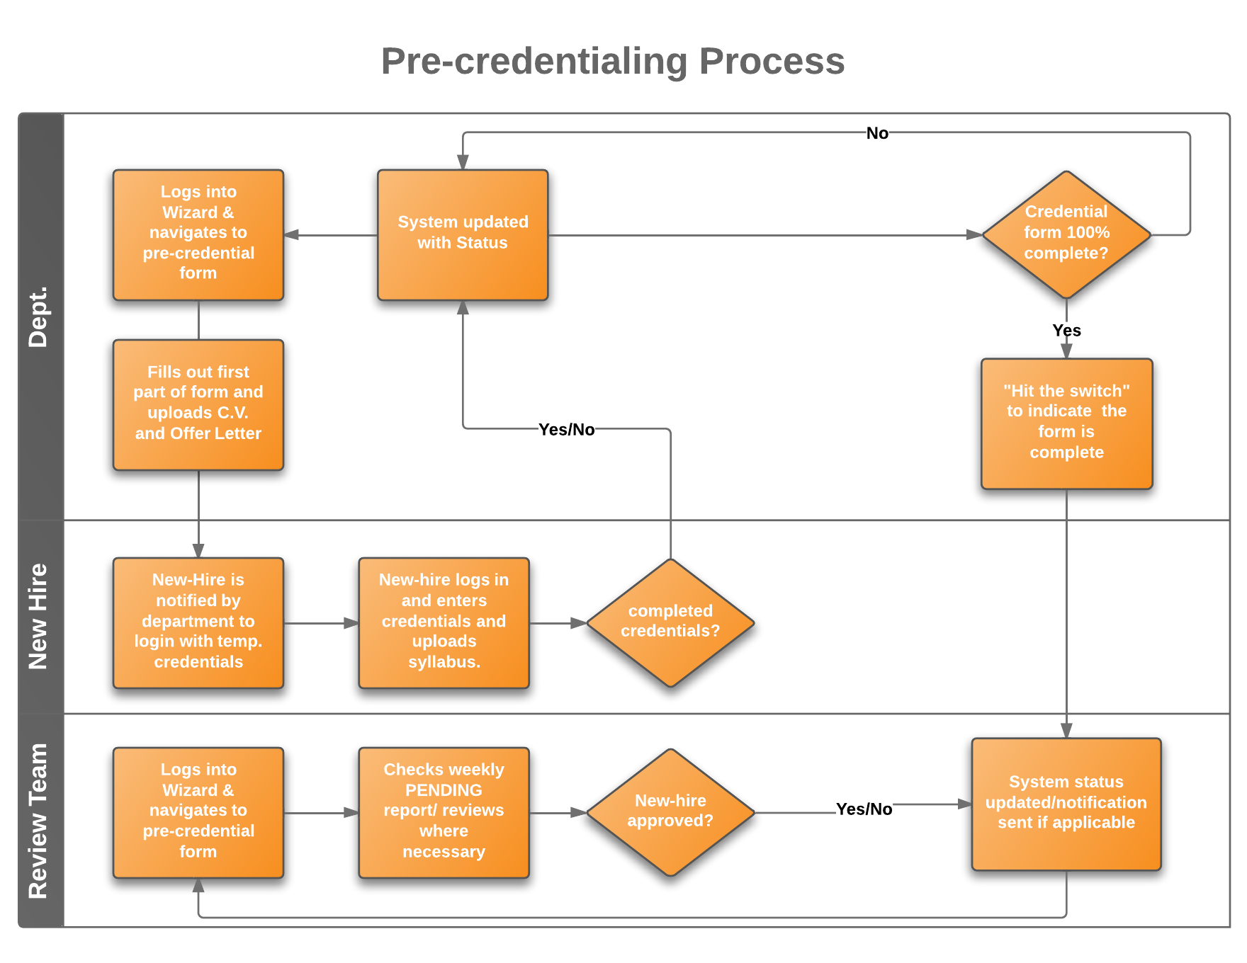
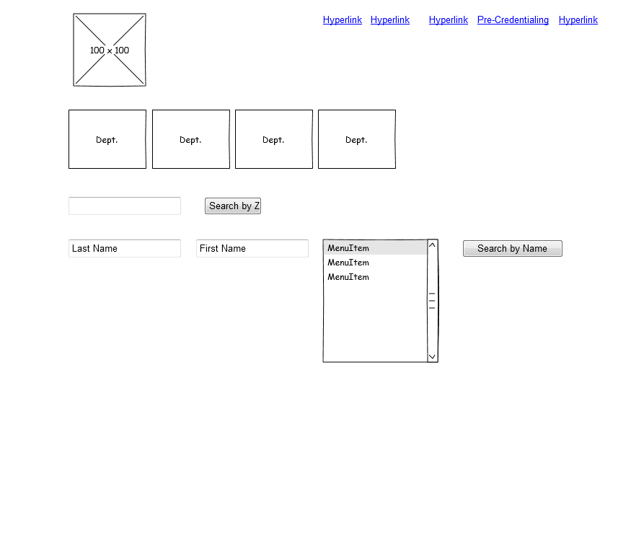
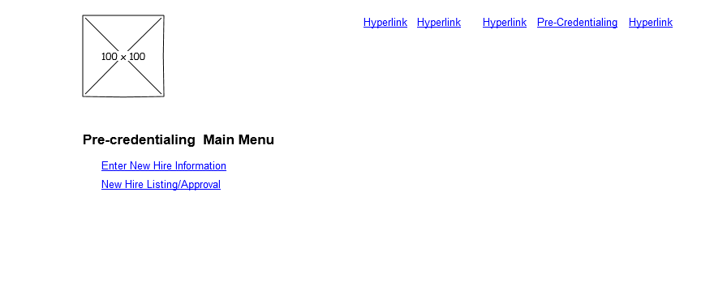
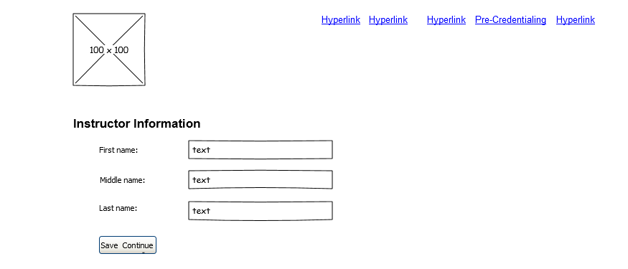
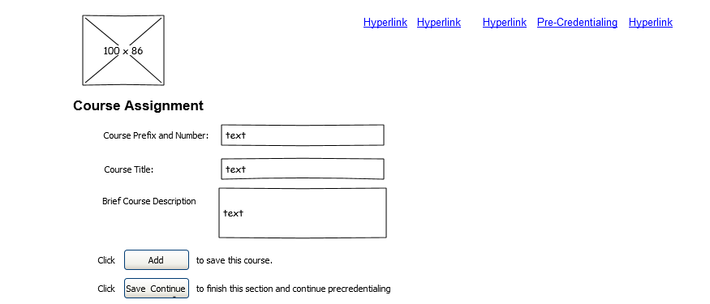
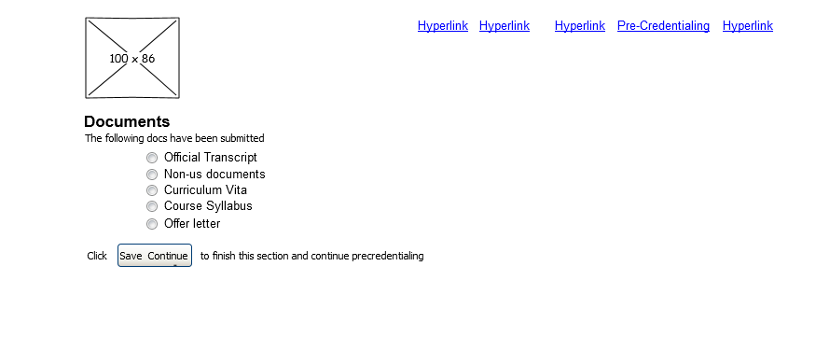
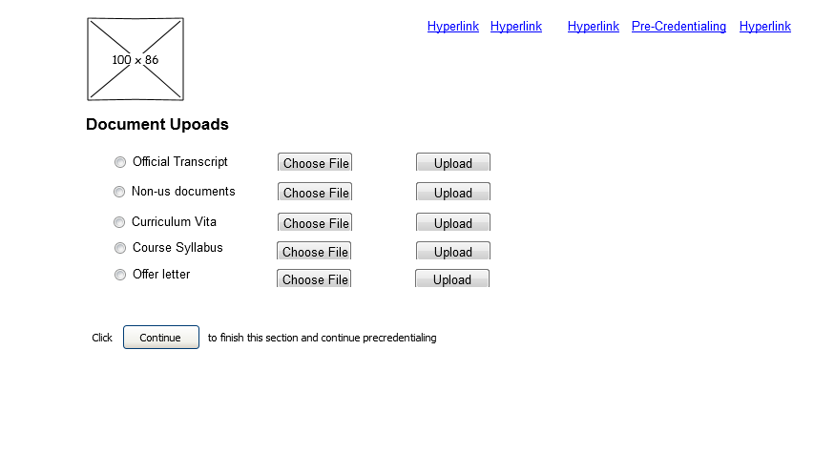
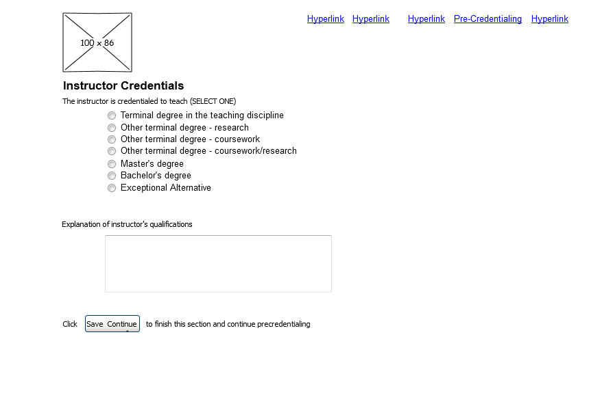
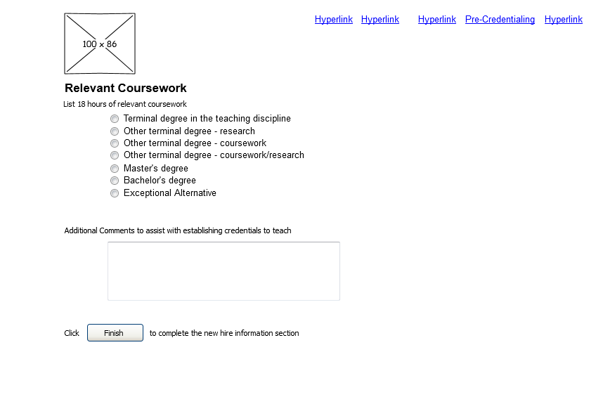
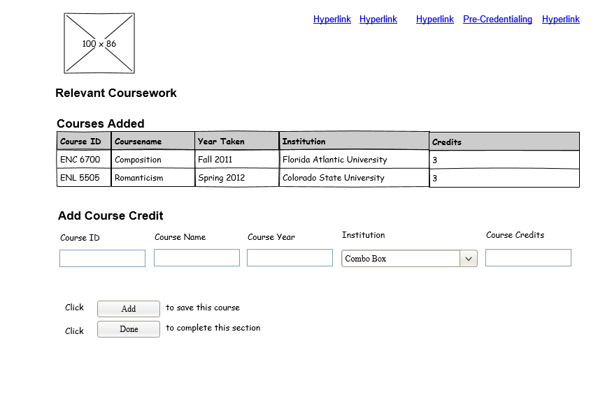
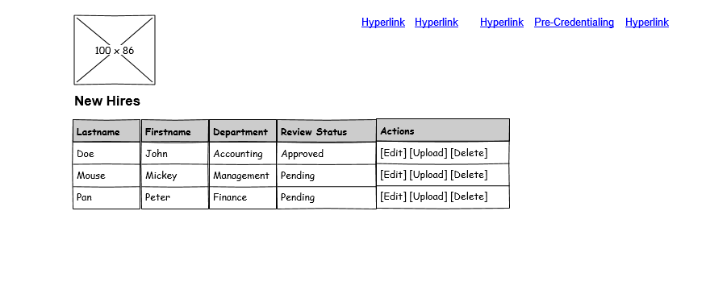
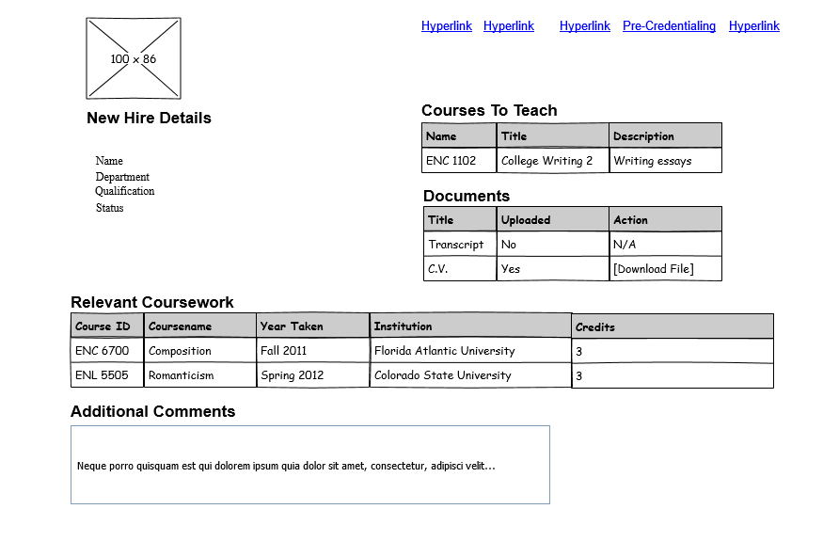
Pre-Credentialing New Hires in Wizard
Functional Specification
Isaac Hartstein
Last Updated: Feb. 19, 2013
- C O N F I D E N T I A L -

About this Specification
This specification is simply a starting point for the design of the Pre-credentialing, not a final blueprint. As we build the product we’ll discover a lot of things that don’t work exactly as planned. We’ll invent new features, we’ll change things, we’ll refine wording, etc. By no means should you consider this spec to be some kind of cast-in-stone law.
Overview
Pre-Credentialing in Wizard will improve the on-boarding process for new hires. Specifically, it will allow the Provost’s office to certify the credentials and qualifications of adjuncts and GTAs.
Here a brief summary of how the process will work:
- Department will log into Wizard and go to the Pre-Credentialing area where they will fill input new hire information into a form.
- Department will fill out the first part of the form and upload the new hire offer letter and C.V.

- Department will notify new hire to login and complete the form.

- The new hire will be granted access to complete the form. Once logged in he/she will enter credentials and upload their syllabus.

- Once the information is completed the department will notify the review team thru Wizard.

- The Review Team will log into Wizard and go to the Pre-Credentialing area where they will review the information.

- The Review Team will have a feedback mechanism built into the system to communicate with the department and vice versa.

- A weekly report listing all PENDING new-hires will be generated. A reminder will be sent out to check this report.

- An internal process to reconcile the new-hire information with incoming Banner data will be created.

Design Goals
All design and engineering decisions will be taken with the following principle in mind:
Simple is better than complicated.
We will always try to eliminate choices that the user must make. Every bump on the user experience must be relentlessly sanded down. We want our users to say: “This is the easiest thing in the world and it just works!”
Non Goals
This version will not address the following features:
- The look and feel of Wizard or any of its subcomponents.
- The redesign of Wizard.
- General clean-up of Wizard (verbiage, extraneous info, etc.)
- Email notifications sent to the review team when a new-hire’s credentials are ready for review.

Scenarios
In designing products, it helps to imagine a few real life stories of how actual (stereotypical) people would use them. We'll look at two scenarios.
Scenario 1: Dr. Mike the Department Chair.
Dr. Mike is a busy Department Chair. He is the Chair for the Department of Redundancy Department. During the course of a typical day, he has many demands on his time including meetings with many very important people and making hiring decisions. Fortunately, one of Dr. Mike’s favorite activities is hiring new faculty members. Unfortunately, Dr. Mike doesn’t like paperwork so he procrastinates and waits until the first week of the new semester to offer the position to a new instructor.
Once this happens Dr. Mike has to scramble to fill out the paperwork to get the new hire certified by the Office of the Provost. The Office of the Provost is very upset with Dr. Mike because it takes time to verify the new instructor’s credentials. Dr. Mike, on the other hand doesn’t see what the big deal is.
Fed up, The Office of the Provost sets up an electronic form Dr. Mike (or his proxy) can fill out online. Now, when Dr. Mike extends an offer of employment he logs into Wizard, enters the new hire’s information into the system, uploads their documents.
This fast tracks the certification process. The Office of the Provost is happy. Dr. Mike is happy and the new hire is happy because he/she can be cleared to teach as quickly as possible.
Scenario 2: Cindy The Review Team Member
Cindy is smart. She is a professor of astrophysics. She’s also a mother of five children, and an avid golfer. She is also a member of The Review Team. In short, Cindy is busy. She relishes every spare minute she can find. Unfortunately, for Cindy, some Department Chairs (who shall remain nameless) wait until the last minute to hire new instructors. This in turn robs Cindy of her most coveted spare time.
Luckily, the new electronic pre-credentialing process is going to save Cindy a lot of time. She will be able to log into Wizard, go to the Pre-Credentialing section and get details on all of the pending new hires. She’ll be able to review and approve/reject them as well as have access to reports summarizing the pending new hires.

Pre-Credentialing Flowchart
We'll have time later to go into mind-numbing detail, but for now, let's look at a quick flowchart of the service so you get the big picture. This flowchart is not complete, but it does give you the right idea for the "storyboard" of using the system:
Screen by Screen Specification
Wizard consists of quite a few different screens. Most screens will follow a standard format. This document is more concerned with the functionality and the interaction design, not the exact look and layout.
Each screen in Wizard is known by a canonical name which will always appear, in this document, with an underline, so you know we're referring to a screen by name, for example, Home Page.
Log-in Screen
The Log-in Screen will not change at all. It will be business as usual for all users
Open Issue
Allowing new hires to log into the system creates some unique challenges. If we make Wizard publicly available we may have to do a complete security audit of the application. This is kind of a big deal due to the fact that Wizard hooks directly into sensitive data.
Home Page
The Home Page looks like this:
Clicking on the link that says "Pre-Credentialing" goes to Pre-credentialing Menu.
Pre-credentialing Menu
The Pre-credentialing Menu will be the main hub for departments and the review team to access pre-credentialing features. It looks like this:
The options available will of course be restricted by user types etc. In other words departments will not be able to “Approve” a new hire.
Clicking on Enter New Hire Information will guide the user thru the process of adding a new hire into the system. The process will be implemented in a step-wise fashion. The idea is to hand hold the user thru entering an applicant into the system. The first screen they see will be Instructor Information screen.

Instructor Information
This screen will be used to capture the instructor’s name (and perhaps additional information like dept.) It looks like this:

Course Assignment
This screen will be used to capture the instructor’s course assignment It looks like this:

Documents
This screen will be used to capture docs submitted to the Provost’s office. It looks like this:

Document Uploads
This screen will be used to upload documents. It looks like this:
Instructor Credentials
This screen will be used to enter instructor credentials. It looks like this:

Relevant Coursework 1
This screen will be used to enter the relevant coursework. It looks like this:

Relevant Coursework 2
This screen will be used to enter the relevant coursework. It looks like this:

New Hire List
This screen will be used to list the new hires. It looks like this:
New Hire Details
This screen will be used to list the details of new hires. It looks like this:
THIS PAGE IS INTENTIONALLY BLANK
IT’S ALSO THE END OF THE DOCUMENT

