Computer Networks

CSE 421

Final Lab Assignment:

Harry Potter (project:2)

Lab section 04

Contents

Abstraction: 3

Introduction: 3

Topology: 4

Router configurations: 4

Conclusion: 9

# Abstraction:

This document presents the documentation of the network topology and router configuration of “Harry potter” network project. The aim is to connect several areas of the wizard world. Total 4 areas are present. In the networks, NAT, ACL, DHCP, STATIC and RIPv2 is connect the areas and users.

# Introduction:

The aim of this project is the development a secret network that connects the wizard world. As specified, all of the requirements have been fulfilled. The wizards are having trouble communicating with each other in the muggle world. As such, by taking advantage of the technology, they want to build a secret network to enable them to communicate. The representation of the requirements is given below. A network is created and used to enable them to use the internet as per their specification.

# Topology:

The topology of the project is taken from ‘Cisco Packet Tracer’:

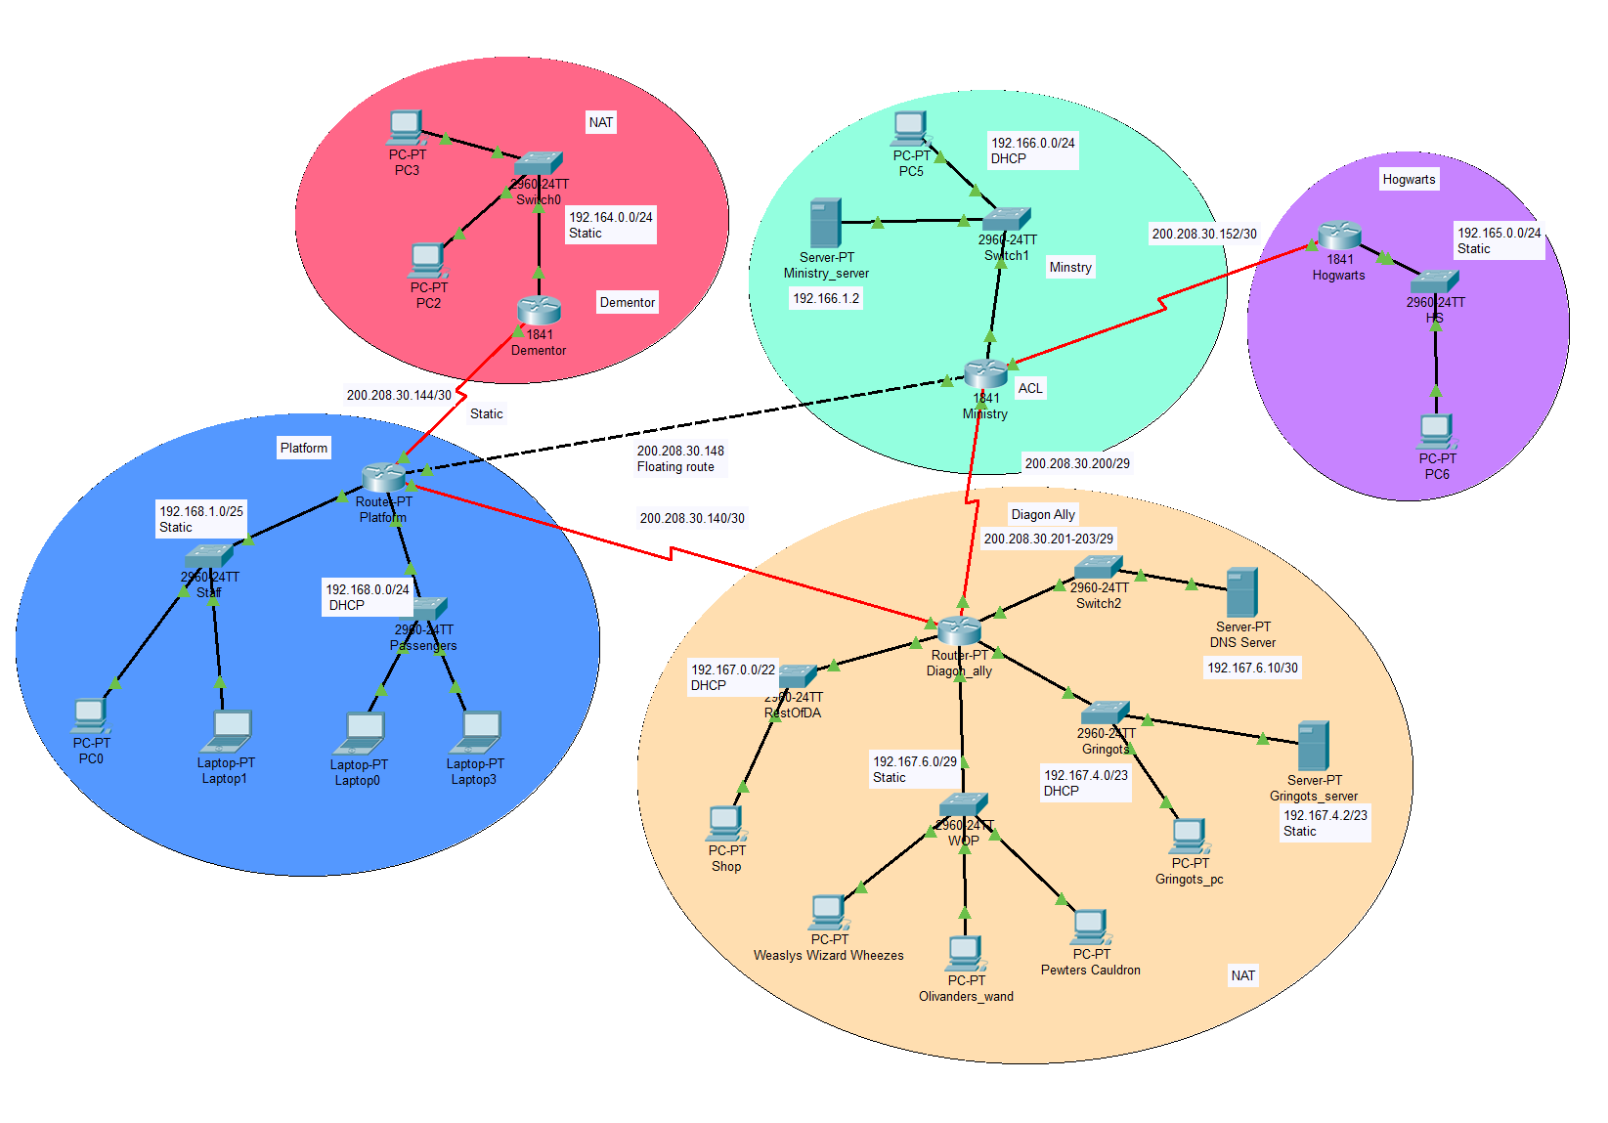

# Router configurations:

Note: The commands are copied from running-config of each router and edited to look better.

* + **Platform router:**
    - hostname Platform
    - ip dhcp excluded-address 192.168.0.0 192.168.0.10
    - ip dhcp pool PASSENGERS
    - network 192.168.0.0 255.255.255.0
    - default-router 192.168.0.1
    - interface FastEthernet0/0
    - ip address 192.168.1.1 255.255.255.128
    - interface FastEthernet1/0
    - ip address 192.168.0.1 255.255.255.0
    - interface Serial2/0
    - ip address 200.208.30.141 255.255.255.252
    - clock rate 64000
    - interface Serial3/0
    - ip address 200.208.30.145 255.255.255.252
    - clock rate 64000
    - interface FastEthernet7/0
    - ip address 200.208.30.149 255.255.255.252
    - ip route 200.209.30.200 255.255.255.248 200.208.30.150 121
    - router rip
    - version 2
    - network 192.168.0.0
    - network 192.168.1.0
    - network 200.208.30.0
    - no auto-summary
  + **Dementor router**
  + hostname Dementor
  + interface FastEthernet0/0
  + ip address 192.164.0.1 255.255.255.0
  + ip nat inside
  + interface Serial0/1/0
  + ip address 200.208.30.146 255.255.255.252
  + ip nat outside
  + router rip
  + version 2
  + network 192.164.0.0
  + network 200.208.30.0
  + no auto-summary
  + access-list 1 permit 192.164.0.0 0.0.0.255
  + access-list 1 permit any
  + ip nat pool DEMENTOR 200.208.30.146 200.208.30.146 netmask 255.255.255.248
  + ip nat inside source list 1 pool DEMENTOR overload
  + **Diagon Ally router**
  + hostname Diagon_ally
  + ip dhcp excluded-address 192.167.0.0 192.167.0.10
  + ip dhcp excluded-address 192.167.4.0 192.167.4.10
  + ip dhcp pool RESTOFDA
  + network 192.167.0.0 255.255.252.0
  + default-router 192.167.0.1
  + dns-server 192.167.6.10
  + ip dhcp pool GRINGOTS
  + network 192.167.4.0 255.255.254.0
  + default-router 192.167.4.1
  + dns-server 192.167.6.10
  + interface FastEthernet0/0
  + ip address 192.167.0.1 255.255.252.0
  + ip nat inside
  + interface FastEthernet1/0
  + ip address 192.167.6.1 255.255.255.248
  + ip nat inside
  + interface Serial2/0
  + ip address 200.208.30.142 255.255.255.252
  + ip nat inside
  + interface Serial3/0
  + ip address 200.208.30.201 255.255.255.248
  + ip nat outside
  + clock rate 64000
  + interface FastEthernet4/0
  + ip address 192.167.4.1 255.255.254.0
  + ip nat inside
  + interface FastEthernet5/0
  + ip address 192.167.6.9 255.255.255.252
  + interface Serial6/0
  + ip address 200.208.30.150 255.255.255.252
  + clock rate 64000
  + router rip
  + version 2
  + network 192.167.0.0
  + network 192.167.4.0
  + network 192.167.6.0
  + network 200.208.30.0
  + no auto-summary
  + ip nat pool GRINGOTS 200.208.30.203 200.208.30.203 netmask 255.255.255.248
  + ip nat pool RESTOFDA 200.208.30.201 200.208.30.201 netmask 255.255.255.248
  + ip nat pool WOP 200.208.30.202 200.208.30.202 netmask 255.255.255.248
  + ip nat inside source list 1 pool WOP overload
  + ip nat inside source list 2 pool RESTOFDA overload
  + ip nat inside source list 3 pool GRINGOTS overload
  + ip classless
  + ip route 192.164.0.0 255.255.255.0 200.208.30.149 255
  + access-list 1 permit 192.167.6.0 0.0.0.7
  + access-list 2 permit 192.167.0.0 0.0.3.255
  + access-list 3 permit 192.167.4.0 0.0.1.255
  + **Ministry router**
  + hostname Ministry
  + ip dhcp excluded-address 192.166.0.0 192.166.0.10
  + ip dhcp pool MINISTY
  + network 192.166.0.0 255.255.255.0
  + default-router 192.166.0.1
  + interface FastEthernet0/0
  + ip address 200.208.30.150 255.255.255.252
  + interface FastEthernet0/1
  + ip address 192.166.0.1 255.255.255.0
  + interface Serial0/0/0
  + ip address 200.208.30.205 255.255.255.248
  + interface Serial0/1/0
  + ip address 200.208.30.153 255.255.255.252
  + ip access-group 1 in
  + ip access-group 1 out
  + clock rate 64000
  + router rip
  + version 2
  + network 192.166.0.0
  + network 192.166.1.0
  + network 200.208.30.0
  + no auto-summary
  + ip route 192.164.0.0 255.255.255.0 200.208.30.149 121
  + access-list 1 deny host 200.208.30.202
  + access-list 1 deny host 200.208.30.146
  + access-list 1 permit any
  + **Hogwarts router**
  + hostname Ministry
  + ip dhcp excluded-address 192.166.0.0 192.166.0.10
  + ip dhcp pool MINISTY
  + network 192.166.0.0 255.255.255.0
  + default-router 192.166.0.1
  + interface FastEthernet0/0
  + ip address 200.208.30.150 255.255.255.252
  + interface FastEthernet0/1
  + ip address 192.166.0.1 255.255.255.0
  + interface Serial0/0/0
  + ip address 200.208.30.205 255.255.255.248
  + interface Serial0/1/0
  + ip address 200.208.30.153 255.255.255.252
  + ip access-group 1 in
  + ip access-group 1 out
  + clock rate 64000
  + router rip
  + version 2
  + network 192.166.0.0
  + network 192.166.1.0
  + network 200.208.30.0
  + no auto-summary
  + ip route 192.164.0.0 255.255.255.0 200.208.30.149 121
  + access-list 1 deny host 200.208.30.202
  + access-list 1 deny host 200.208.30.146
  + access-list 1 permit any

# Conclusion:

The project is to be developed in to a usable network that will ensure connectivity between the secret world of ‘Harry potter’.