The Second Brain: An AI Research System You Can Audit
  - How it is built, how it remembers, how it reasons, and how to use it on any project
Prepared by Isa Haskologlu, PhD · © 2026 · CC BY 4.0
2026-09-29
Table of Contents

Read This First
The answer in one sentence. The Second Brain is an AI research assistant (Claude Code) working inside a plain-text knowledge base (an Obsidian vault) under written rules. Every claim it keeps can be traced to a source page, every decision is recorded, and every output can be audited.
Three things to remember:
- It remembers on purpose. Knowledge, project status, decisions and preferences each go into a different, inspectable place. Nothing important lives only inside the AI’s “memory”.
- It works like a well-run research team, not a chatbot. Work is split into steps with explicit dependencies. Independent evidence is gathered in parallel, and a fresh reviewer checks results before anything is written.
- It is general-purpose. The same core ran a terrorism data analysis and a (hypothetical) investment review. The core stays the same; only the project folder changes.
What it is not. It does not make AI output true. It makes AI output checkable. Most notes in the vault are still marked “needs verification”, and that label is shown, not hidden.

1. The Problem It Solves
Situation. Researchers, analysts and executives already use AI assistants to read, summarize and draft.
Complication. A general chatbot has four structural weaknesses for serious work:
Weakness | What it looks like in practice
It forgets | Every new chat starts from zero. Context, decisions and preferences are lost.
It invents | Citations, page numbers and quotations can be fabricated and still sound plausible.
It cannot show its work | There is no trail from a statement back to the page it came from.
It does not scale | Long projects exceed what fits in one conversation.
Question. How do you get AI speed without giving up the standards of research: provenance, verification and reproducibility?
Answer. Put the AI inside a system that enforces those standards: a structured knowledge base, written operating rules, an explicit memory design and a workflow graph. That system is the Second Brain.
Analogy for non-technical readers. Think of a well-run research lab: the library holds original sources untouched (01-Library/); the lab notebook records one finding per page with its citation (02-Wiki/); each project binder holds status and decisions (03-Projects/); the lab manual says how work must be done (CLAUDE.md, RESEARCH_PROTOCOL.md); the peer reviewer checks work before it is filed (fresh-context verification); and a calibrated second opinion (Jev) sorts repeated, narrow judgments into clear and uncertain cases. It is an aid to judgment, never a source of evidence. Claude is the tireless research assistant who works in this lab and follows the manual.

2. The System at a Glance
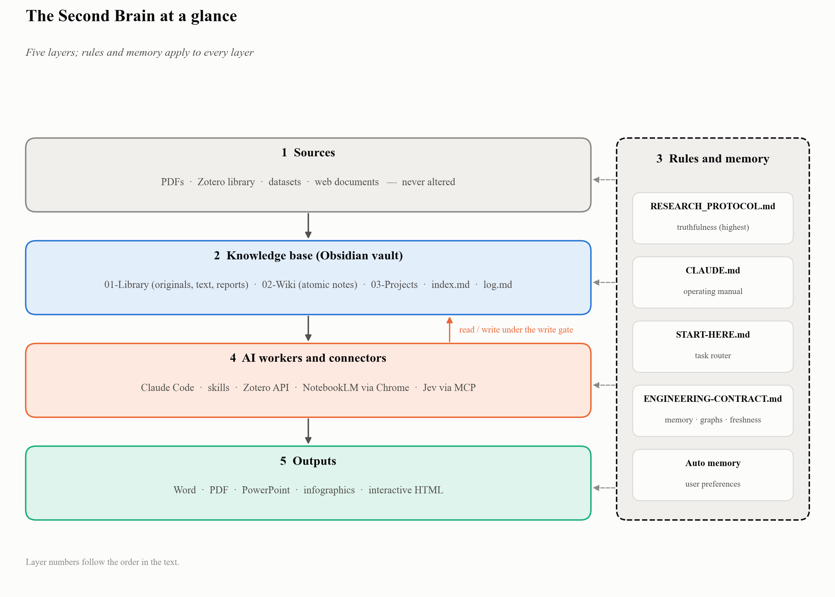
Figure 1: System architecture
The system has five layers. Information flows from the top down; rules apply to every layer.
Layer | Components | Role
1. Sources | PDFs, Zotero library, datasets, web documents | Raw material, never altered
2. Knowledge base | Obsidian vault: 01-Library/, 02-Wiki/, 03-Projects/, index.md, log.md | Durable, linked, plain-text memory
3. Rules and memory | CLAUDE.md, RESEARCH_PROTOCOL.md, 00-System/START-HERE.md, 00-System/ENGINEERING-CONTRACT.md, Claude auto-memory | How work is done and what is remembered
4. AI workers and connectors | Claude Code, skills, Zotero API, NotebookLM (via Chrome), Jev (via MCP) | Do the reading, checking and building
5. Outputs | Word, PDF, PowerPoint, infographics, interactive HTML | Deliverables for people
What the vault holds:
Part | What it holds
Atomic wiki notes | One idea per note, each with its sources; new notes stay marked needs-verification until a person checks them
Links between notes | Explained relationships that connect ideas across notes
Original source files | PDFs and books, kept exactly as they arrived
Extracted text | Searchable text with page markers, so notes can cite pages
Activity log | A dated record of each work session
Project workspaces | One folder per project

3. The Components, One Zoom Level Down

3.1 Obsidian: the knowledge base
Obsidian is a note-taking application that works on a folder of plain Markdown files. The vault is that folder. Three properties make it suitable:
- Plain text. Every note is a readable .md file. There is no lock-in: Git, any editor and any AI tool can read it.
- Wikilinks and graph view. [[note-name]] links turn notes into a navigable network, and Obsidian draws it as a graph.
- Metadata. Each wiki note starts with a YAML header: title, dates, language, tags, page type, verification status and sources.
Folder map.
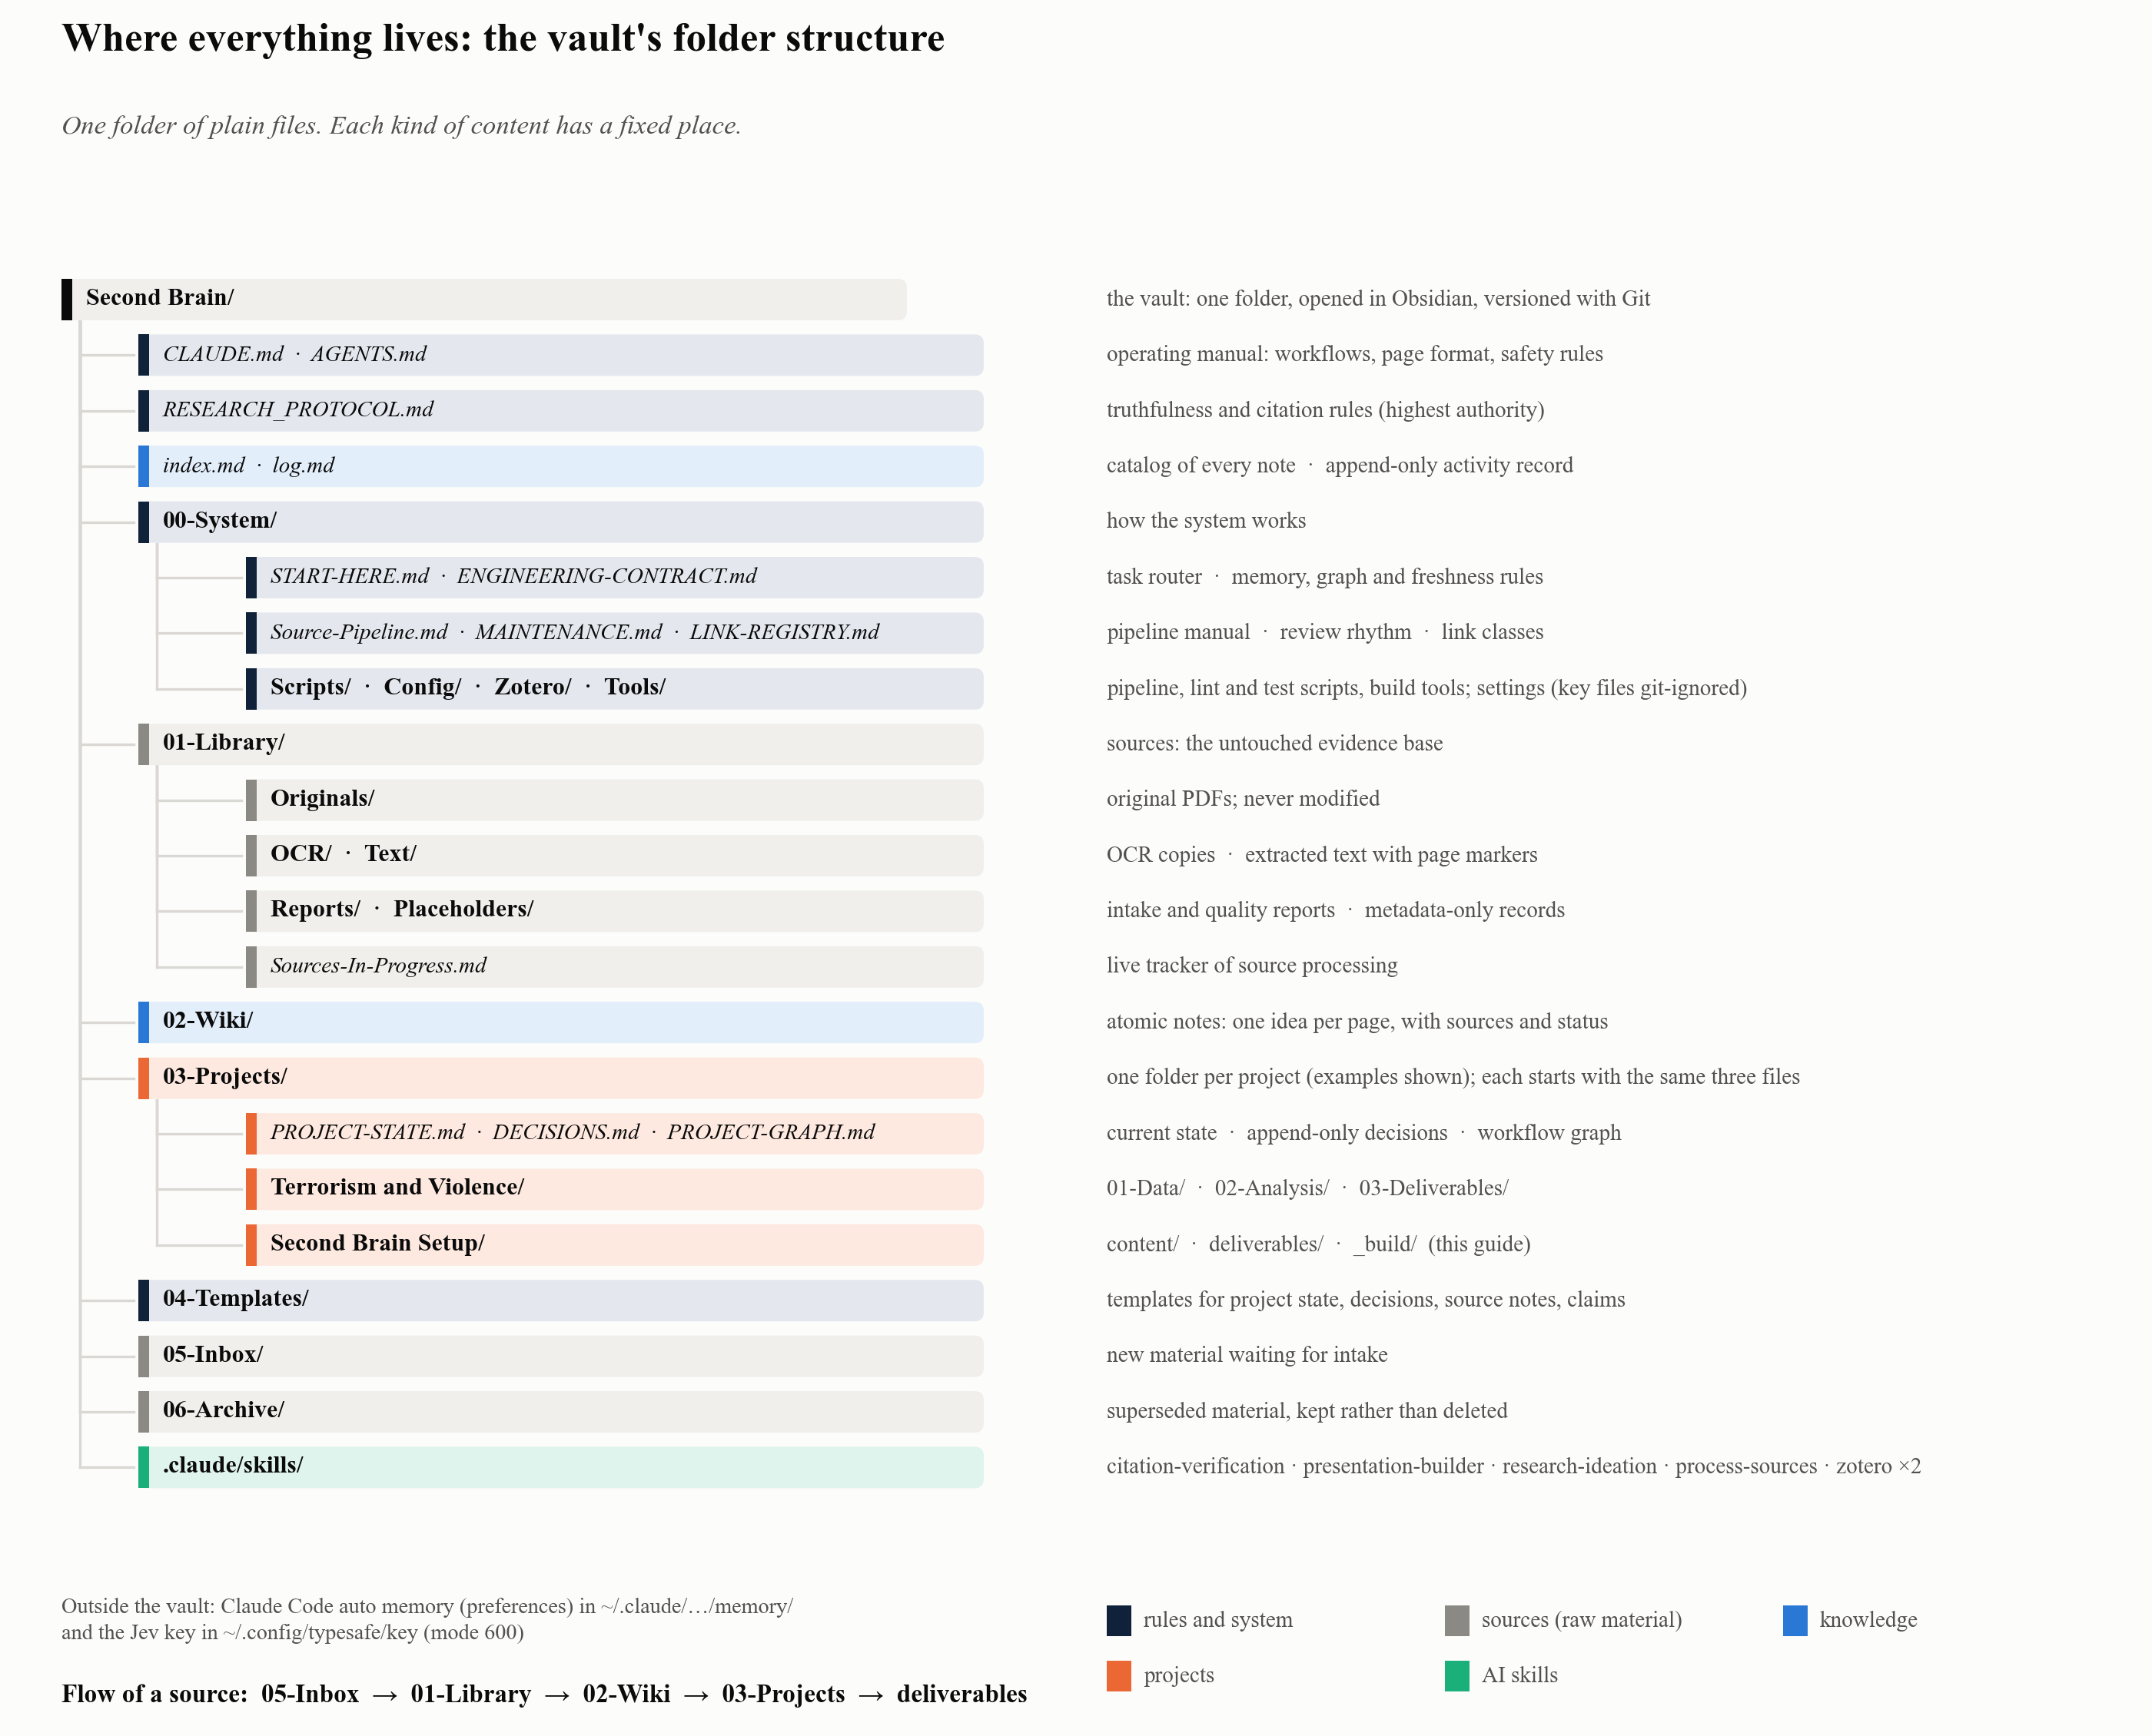
Figure 2: The vault’s folder structure: where each kind of file lives
Folder | Holds | Rule
00-System/ | Operating manuals, scripts, configuration | Changed deliberately
01-Library/ | Originals, OCR’d copies, extracted text, quality reports | Originals are never modified
02-Wiki/ | Atomic notes: one idea per page | Neutral: never bent to fit a project thesis
03-Projects/ | One folder per project: state, decisions, graph, deliverables | Project-specific rules may add, never weaken
04-Templates/ | Reusable note templates | —
05-Inbox/ | New material before intake | Temporary
index.md / log.md | Catalog of all notes / chronological activity record | Log is append-only

3.2 The rulebook
Four documents govern every session, in a fixed order of authority:
- RESEARCH_PROTOCOL.md: highest authority on truthfulness. No invented citations, quotations or metadata. Source claims are kept separate from interpretation. Uncertainty and disagreement are stated openly.
- CLAUDE.md: the operating manual. Defines workflows (ingest, query vault, save, lint wiki, weekly review), page structure, file naming and change-safety rules.
- 00-System/START-HERE.md: the router. It tells the AI which few files to load for a given task, and in which order.
- 00-System/ENGINEERING-CONTRACT.md: memory types, the write gate, freshness, context budgets, workflow graphs and link rules.
Why a written rulebook matters. Behaviour is set by files that anyone can read, change and version-control, not by hidden prompts. Every session loads the same rules.

3.3 The source pipeline: from PDF to trustworthy text
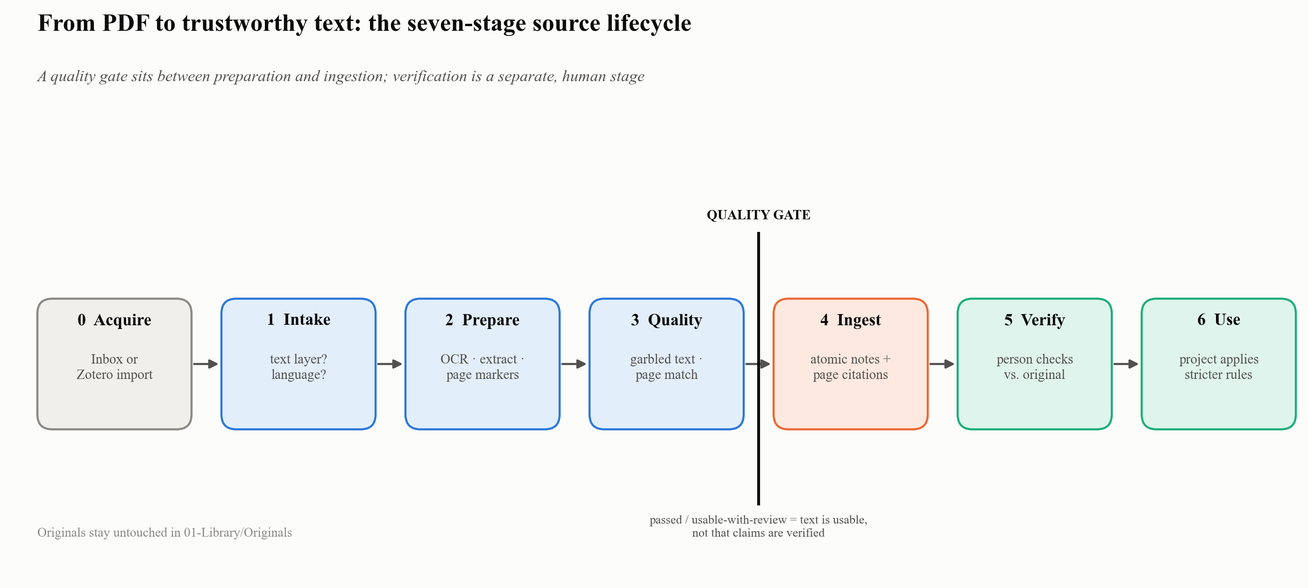
Figure 3: Seven-stage source lifecycle
Stage | What happens | Tool
0 Acquisition | Source placed in 05-Inbox/ or imported from Zotero | Manual / zotero_import.py
1 Intake review | Is there a text layer? Which language? | inspect-pdf.py
2 Format preparation | OCR if scanned; text extraction; page markers added | process-source.py, add-page-markers.py
3 Quality review | Garbled-character detection, page correspondence → quality_status | validate-text.py
4 Neutral ingestion | Atomic wiki notes with page-level citations | ingest workflow
5 Verification | A person checks claims and quotations against the original | citation-verification skill
6 Project use | A project applies the knowledge under its own stricter rules | Project folder
Quality gate. A source must reach passed or usable-with-review before ingestion. Passing means the text is technically usable. It does not mean the claims are verified; that happens only at Stage 5.

3.4 Memory engineering: what is remembered, where, and why
A chatbot has one kind of memory: the conversation. The Second Brain splits memory by function, so each kind can be found, checked and corrected.
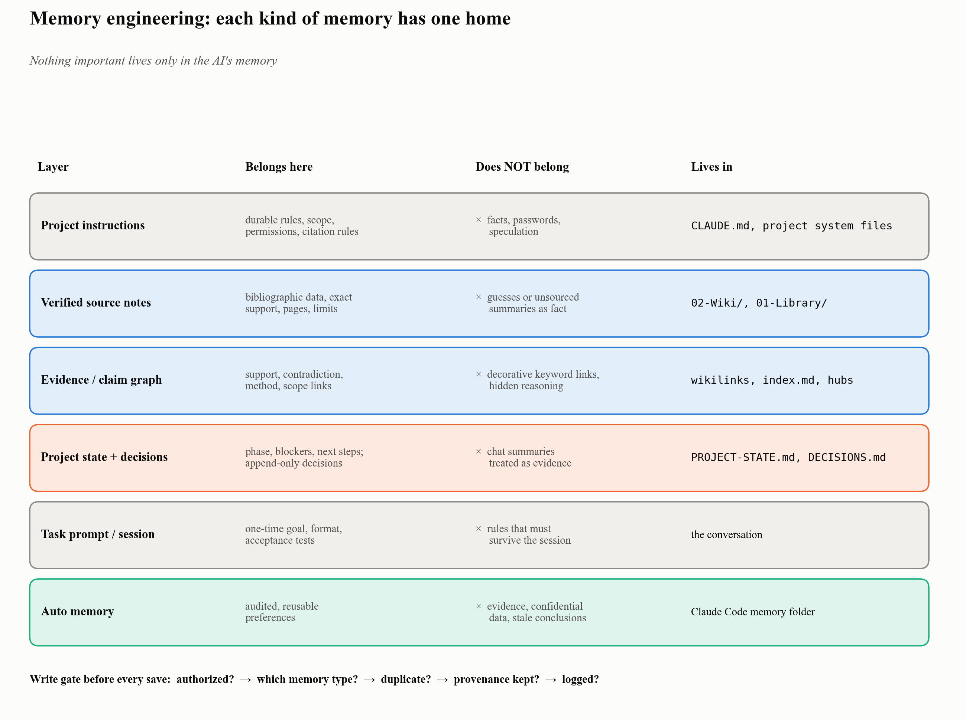
Figure 4: Memory architecture
Memory layer | What belongs there | What does not | Where it lives
Project instructions | Durable workflow, scope, permissions, citation and verification rules | Substantive facts, passwords, speculation | CLAUDE.md, project system files
Verified source notes | Bibliographic data, exact support, pages, methods, limits, verification status | Model guesses or unsourced summaries presented as fact | 02-Wiki/, 01-Library/
Evidence / claim graph | Explicit support, contradiction, method and scope relationships | Decorative keyword links, hidden reasoning | Wikilinks, index.md, hubs
Project state and decisions | Current phase, blockers, next actions; append-only decision record | Chat summaries treated as evidence | PROJECT-STATE.md, DECISIONS.md
Task prompt / session | One-time objective, output format, acceptance tests | Rules that must survive future sessions | The conversation
Auto memory | Audited, non-sensitive, reusable preferences (e.g., “all outputs in English, Times New Roman”) | Evidence, confidential data, stale conclusions | Claude Code memory folder, outside the vault
(The layer table is adapted from the author’s graduate course materials on research systems.)
Four rules make memory trustworthy:
- Write gate. Before anything is saved: was the write authorized? Which memory type is it? Does an equivalent record already exist? Is provenance preserved? Is the change logged?
- Freshness. Time-sensitive notes carry freshness_class (durable / periodic / dynamic), valid_as_of and review_after. A policy note past its review date is flagged before it is presented as current.
- Evidence strength in words, not fake precision. Claims are labelled Strong / Moderate / Limited / Contested / Insufficient, with the reason stated. No unexplained numeric confidence.
- Nothing important lives only in AI memory. Auto memory is for preferences. Facts live in source notes.

3.5 Graph engineering: two kinds of graph
“Graph engineering” covers two distinct ideas.

(a) The workflow graph: how work is organised
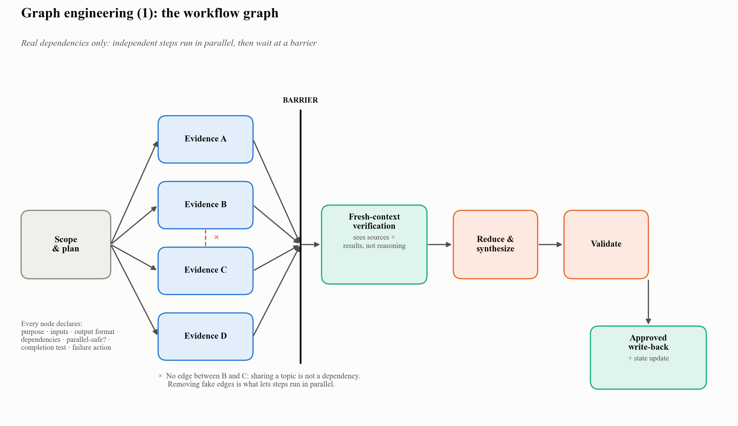
Figure 5: Workflow graph with fan-out, barrier and fresh-context verification
Every complex task becomes a graph of nodes (bounded steps) connected by edges (real dependencies only).
Scope and plan
→ independent evidence nodes (fan-out, in parallel)
→ evidence-complete barrier
→ fresh-context verification
→ reduce and synthesize
→ schema and quality validation
→ approved write-back and state update
Each node declares its purpose, inputs, output format, dependencies, whether it can run in parallel, its completion test and what happens if it fails.
- Real edges only. Draw an edge only if the next step needs the previous step’s data or decision. “They are on the same topic” is not an edge. Removing these fake edges is what allows parallel work.
- Fresh-context verification. The checker receives the scope, the sources and the normalized results, but not the worker’s reasoning. It re-tests claims against sources, as an independent reviewer would.
- Per-node context. Each step sees only what it needs. Small contexts give better focus and fewer errors.
Example (Terrorism and Violence project). Data acquisition branched into independent analyses: geographic hot spots, group operations, designation cross-checks. These waited at a barrier, then fed a forecasting step and a Europe/US risk step. A fresh-context audit re-computed the published numbers before the report, workbook, decks and interactive page were finalized.

(b) The knowledge graph: how knowledge connects
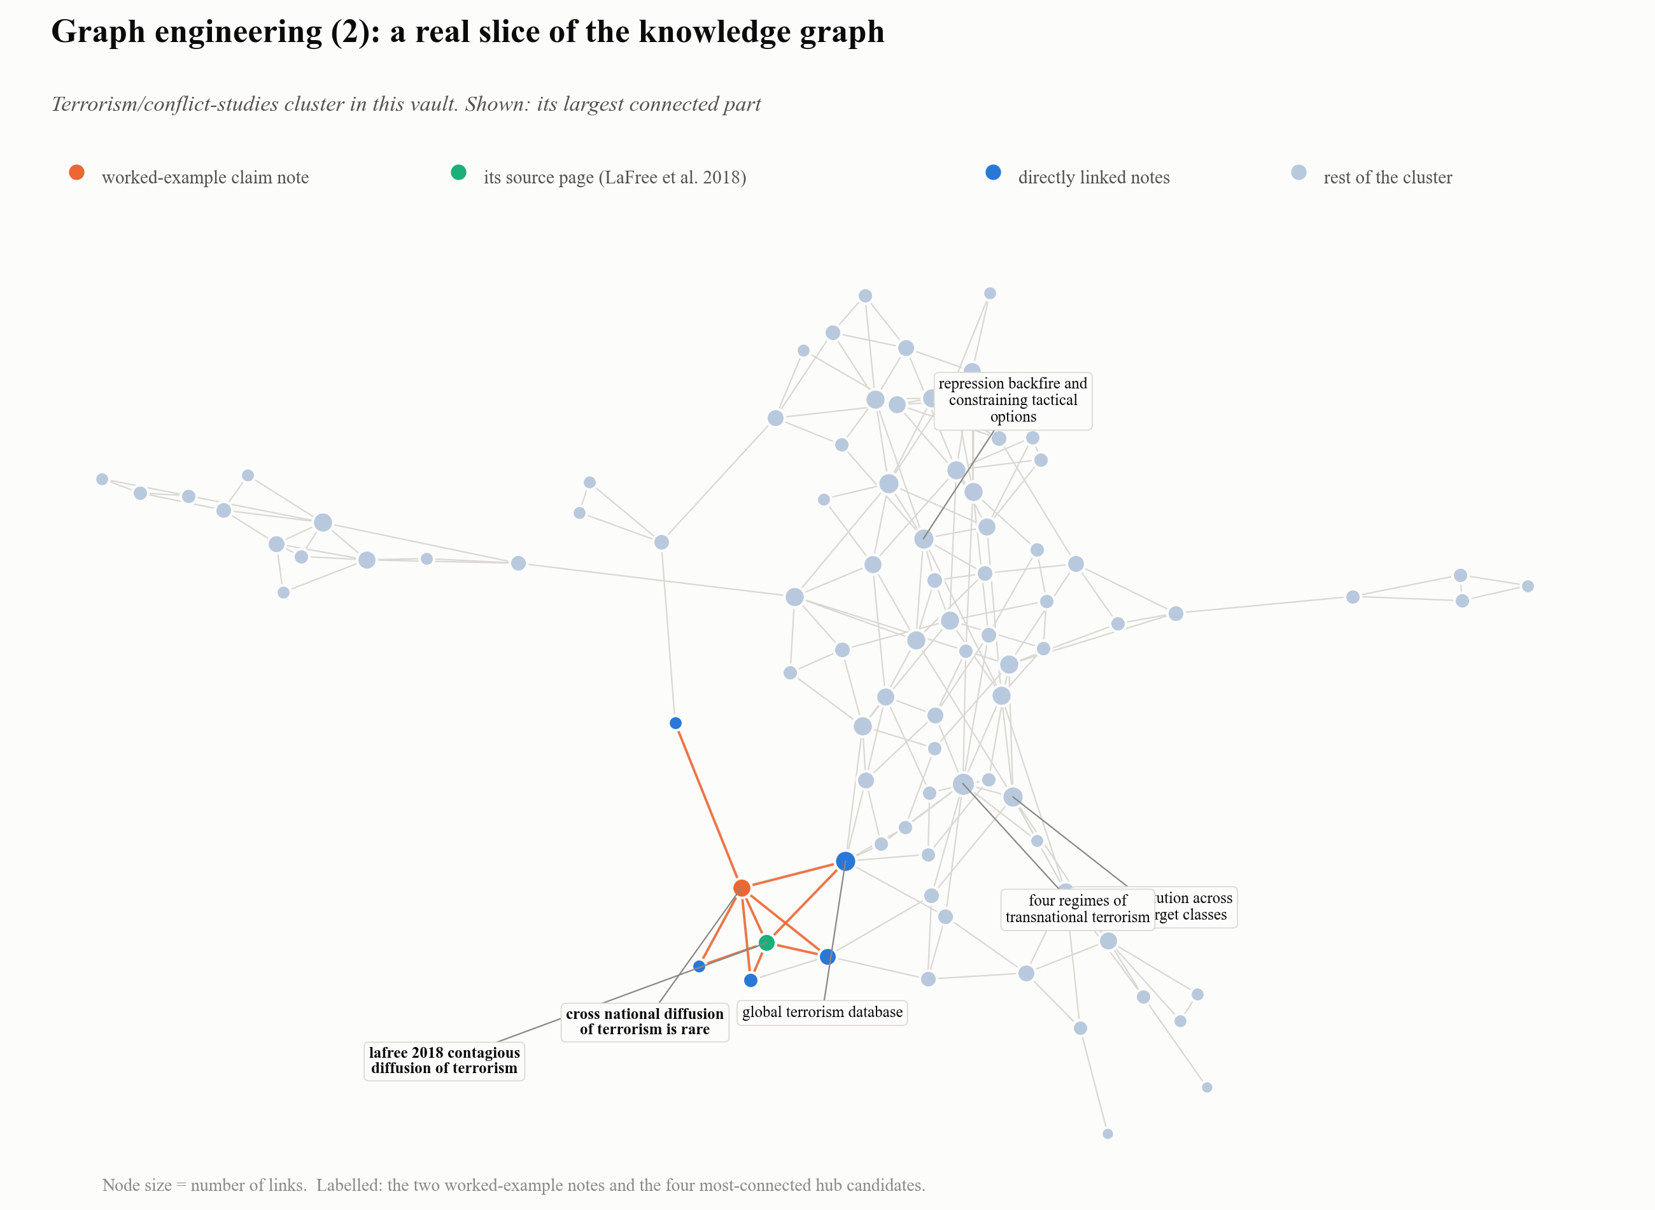
Figure 6: A real slice of the vault’s knowledge graph: the terrorism/conflict-studies cluster, with the worked-example notes highlighted
Notes link to each other with typed, explained relationships: claim → supporting source → method → limitation → contradiction. The rules:
- A link must explain a relationship, not just a shared keyword.
- Missing link targets are classified as resolved, planned (a deliberate future note), broken, renamed or external-to-wiki. They are not “fixed” by creating empty pages.
- Notes that connect three or more substantial pages are flagged as hub candidates.
- A read-only linter (lint-vault.py) reports orphans, broken links and missing metadata without changing anything.
Why it matters. Retrieval is index-first and bounded: the AI searches index.md, loads at most five notes per batch, and follows links only to fill a named gap. It never reads the whole vault. This keeps answers grounded and the context small.

3.6 Integrations and what each one adds
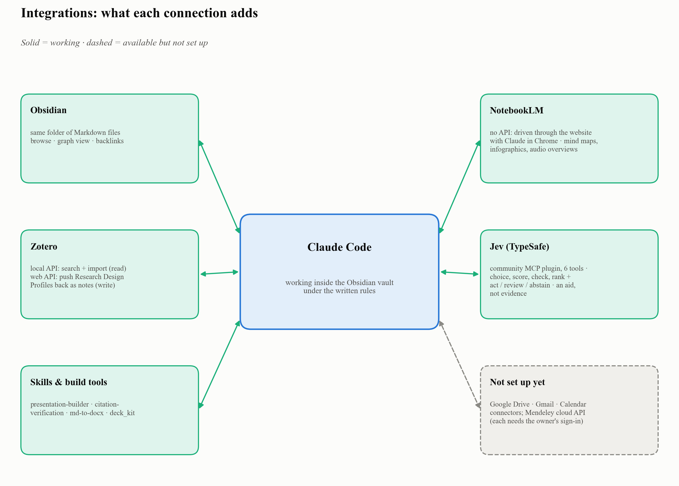
Figure 7: Integration map
Integration | How it connects | What it adds | Observed limits
Obsidian | Same folder; Claude reads and writes Markdown | Human-friendly browsing, graph view, search, backlinks | Obsidian itself has no AI in this setup; it is the interface
Zotero | Local API (read-only, on the same machine) for search and import; Web API with a write key for pushing notes back | Bibliographic metadata with provenance; PDFs flow into the pipeline. After ingestion, a Research Design Profile (question, argument, theory, variables, method, data, findings, verbatim abstract) is written back to Zotero as a child note | Local API cannot write; the write key is stored in a git-ignored file
NotebookLM | No public API. Claude operates the NotebookLM website through Claude in Chrome (browser automation) | Formats Claude does not produce itself: mind maps, NotebookLM infographics, audio overviews; cross-source questions over a notebook | Usage quotas can halt a batch; outputs go stale when upstream facts are corrected and must be regenerated
Jev (TypeSafe) | Community-maintained Claude Code plugin (jev@jev-mcp) that bundles an MCP server with six decision tools and an agent skill; authenticated by a TypeSafe API key stored in a protected file | Bounded, calibrated judgments (choice, score, check, ranking, triage) with probabilities, a confidence value and an act / review / abstain recommendation | A decision aid only: it does not make a source true, verify a citation, or replace domain judgment. Not an official TypeSafe or Anthropic product
Skills | Packaged instructions Claude loads on demand | Repeatable workflows: presentation-builder, citation-verification, research-ideation, zotero-sources, process-sources | Only as good as the written procedure
Build tools | Shared scripts in 00-System/Scripts/ | One-command Word (md-to-docx.sh), decks (deck_kit.py), forecasting bake-off (forecast_bakeoff.py) | Standards (English, Times New Roman) are enforced in code
Available, not set up | Google Drive, Gmail and Calendar connectors; Mendeley cloud API | Would add document and schedule context; a second reference manager | Each needs the owner’s own sign-in (OAuth); not yet authorized

Jev: bounded judgments that show their uncertainty

Figure 8: Conceptual view of a calibrated Jev decision: clear cases proceed, borderline cases go to a person, unsupported cases are set aside. Illustration from the Jev installation deck
Claude gives Jev a defined task, the allowed answers and the relevant text. Jev returns a typed result instead of a free-form essay:
- a choice, score, check or ranking;
- probabilities and a confidence value;
- a recommendation to act, review or abstain.
Claude and the user remain responsible for the final action.
Why it matters. Jev improves repeated decisions by separating clear cases from uncertain ones. The value appears when one semantic rule must be applied across many items, and uncertainty should change the next step. The results are more consistent labels across a batch, faster prioritisation of material to inspect, and a visible review path for borderline cases. Typical uses are research screening, dataset labelling and course-material triage.
Division of labour (from the companion installation guide):
Part | Best use
Claude | Reasoning, writing, planning, interpretation
Jev | Choice, yes/no probability, scoring, ranking, triage
Ordinary code | Counting, dates, formulas, thresholds, file operations
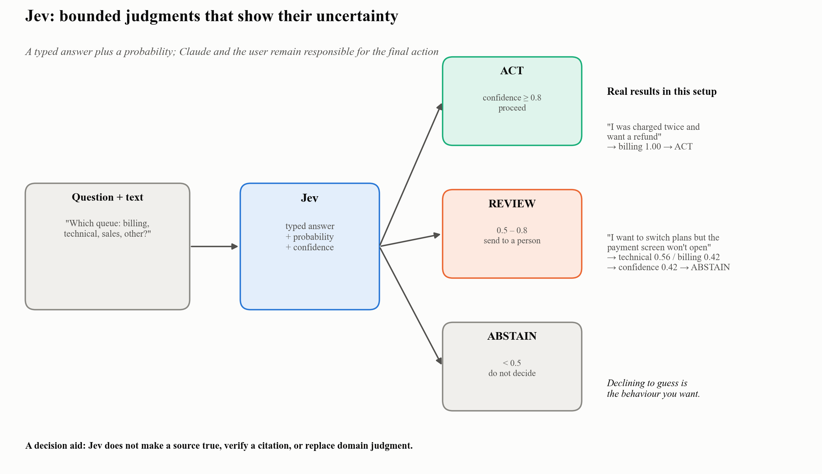
Figure 9: Jev decision gate
Confidence | Action | Meaning
≥ 0.8 | act | Confidence is high enough to proceed
0.5 – 0.8 | review | Send the item to a person
< 0.5 | abstain | Uncertainty is too high
The thresholds are Jev’s defaults; calibrate them on labelled examples from your own task before automating anything.
Real results from this setup:
- A clear customer message (“My card was charged twice and I want a refund”) → billing, probability 1.00, confidence 1.00 → act (255 ms).
- An ambiguous one (“I want to switch plans but the payment screen won’t open”) → technical 0.56 vs. billing 0.42, confidence 0.42 → abstain. The system declined to guess. That is the behaviour you want.
What Jev is not. “Jev is a decision aid. It does not make a source true, verify a citation, or replace domain judgment.” Its output is never presented as research evidence, factual verification, citation verification or source validation. It is not used for arithmetic or date comparison. (Source: the audited Jev installation deck.)

Jev and Claude: fast judgments and deep reasoning
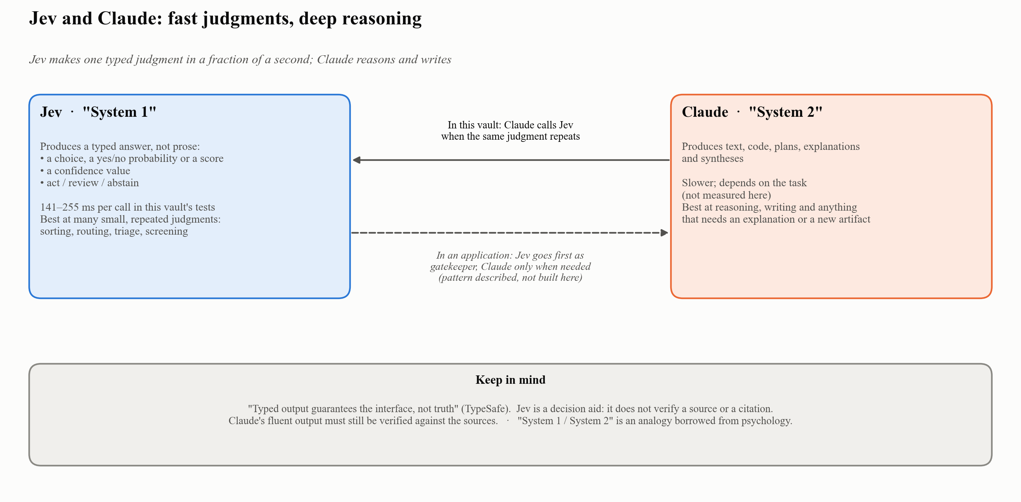
Figure 10: Jev as “System 1”, Claude as “System 2”
TypeSafe describes Jev as its first “System One” model: it “understands natural language and returns typed answers and probabilities rather than generating text or reasoning explanations” (TypeSafe skill documentation). The name borrows a familiar distinction from psychology (external analogy): fast, instinctive System 1 judgments versus slow, deliberate System 2 reasoning.
 | Jev (System 1) | Claude (System 2)
Produces | Typed answers: a choice, a yes/no probability, a score, with a confidence value and an act / review / abstain recommendation. No prose. | Text, code, plans, explanations, syntheses
Speed | 141–255 ms per call in this vault’s tests | Longer; depends on the task (not measured here)
Best at | Many small, repeated judgments: sorting, routing, triage, screening | Reasoning, writing, anything that needs an explanation or a new artifact
Keep in mind | “Typed output guarantees the interface, not truth” (TypeSafe) | Fluent output must still be verified against sources
Two ways to combine them.
- In this vault, Claude calls Jev. Claude runs the workflow and calls Jev through MCP whenever the same bounded judgment repeats, for example classifying many notes or routing ambiguous cases to review.
- In an application, Jev can go first as a gatekeeper. Code sends every incoming item to Jev (“Is this support email urgent?”, “Is this change risky?”) and calls Claude only when deep reasoning or new text or code is needed. TypeSafe’s own summary of the pattern: “Code owns the workflow; the model supplies programmable common sense.” This pattern is described here for completeness; it has not been built in this vault.
Names you may see. In TypeSafe’s SDK the judgment types are called Choice (pick one option), Noul (probability that a condition holds) and Score (position on an ordered scale). In Claude Code, the same judgments appear as MCP tools: jev_classify, jev_check, jev_score, plus jev_ask, jev_triage and jev_models.
Pricing is not covered here; check TypeSafe’s current documentation.

Jev and graph engineering: different things that work together
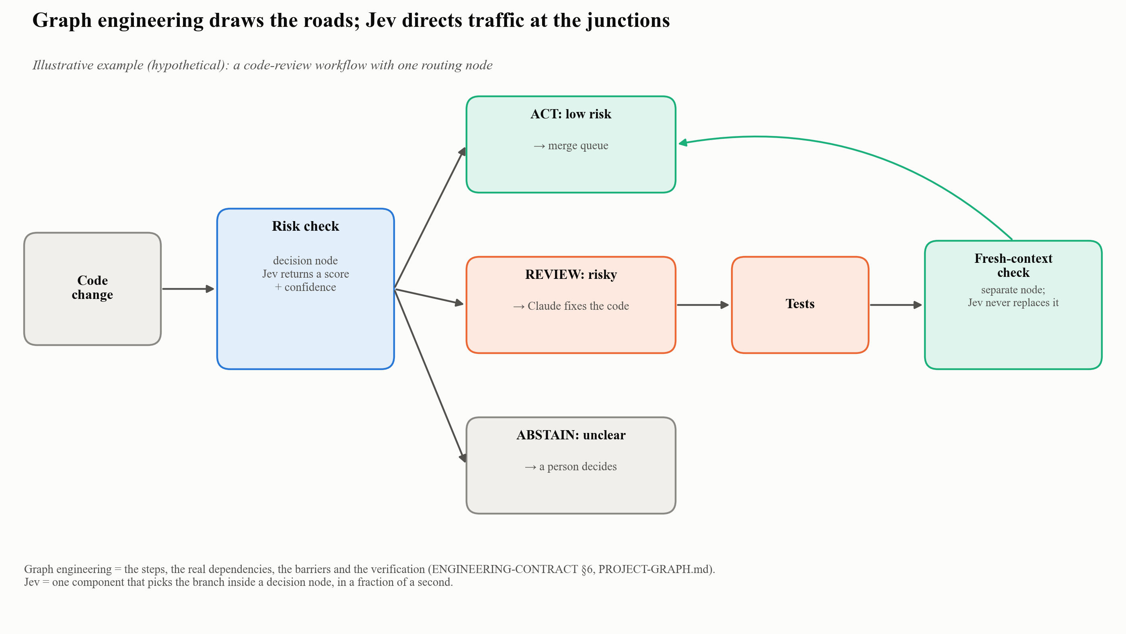
Figure 11: Graph engineering draws the roads; Jev directs traffic at the junctions
They are easy to confuse because both appear in “decision” diagrams, but they are different kinds of thing:
 | Jev | Graph engineering
What it is | A model: one component | A design method: how the steps of a task are organised
Its job | Make one fast, typed judgment (choice, yes/no probability, score) | Define the steps (nodes), the real dependencies between them (edges), barriers and verification
Analogy | The clerk who stamps each file “approved” or “rejected” in an instant | The organisation chart and workflow manual that say which department does what
In this vault | MCP tools jev_classify, jev_check, jev_score, … | 00-System/ENGINEERING-CONTRACT.md §6 and each project’s PROJECT-GRAPH.md
Outside this vault | TypeSafe SDK primitives Choice, Noul, Score | Agent-graph frameworks such as LangGraph, CrewAI or LlamaIndex (external examples; not used here)
How they fit together. A graph has decision or routing nodes, points where the workflow must choose which way to go. Traditionally that choice is made by a large model such as Claude, which is slower and costlier than needed for a narrow decision. Jev fits inside exactly those nodes: it picks the branch in a fraction of a second, and the graph’s edges take the work where it needs to go.
Illustrative example (hypothetical). A code-review workflow:
- Graph engineering defines the path: code change → risk check → (if risky) Claude fixes the code → tests → fresh-context check.
- Jev sits inside the risk-check node and returns a risk score with a confidence value.
- The graph routes on that answer: act (low risk) → merge queue; review (risky) → Claude, working as System 2, fixes the code; abstain (unclear) → a person decides.
One rule does not change: Jev picks the branch, but it never replaces the verification node. The graph is the skeleton and the roads; Jev is the fastest traffic officer at the junctions.

Installing Jev: three components, eight steps
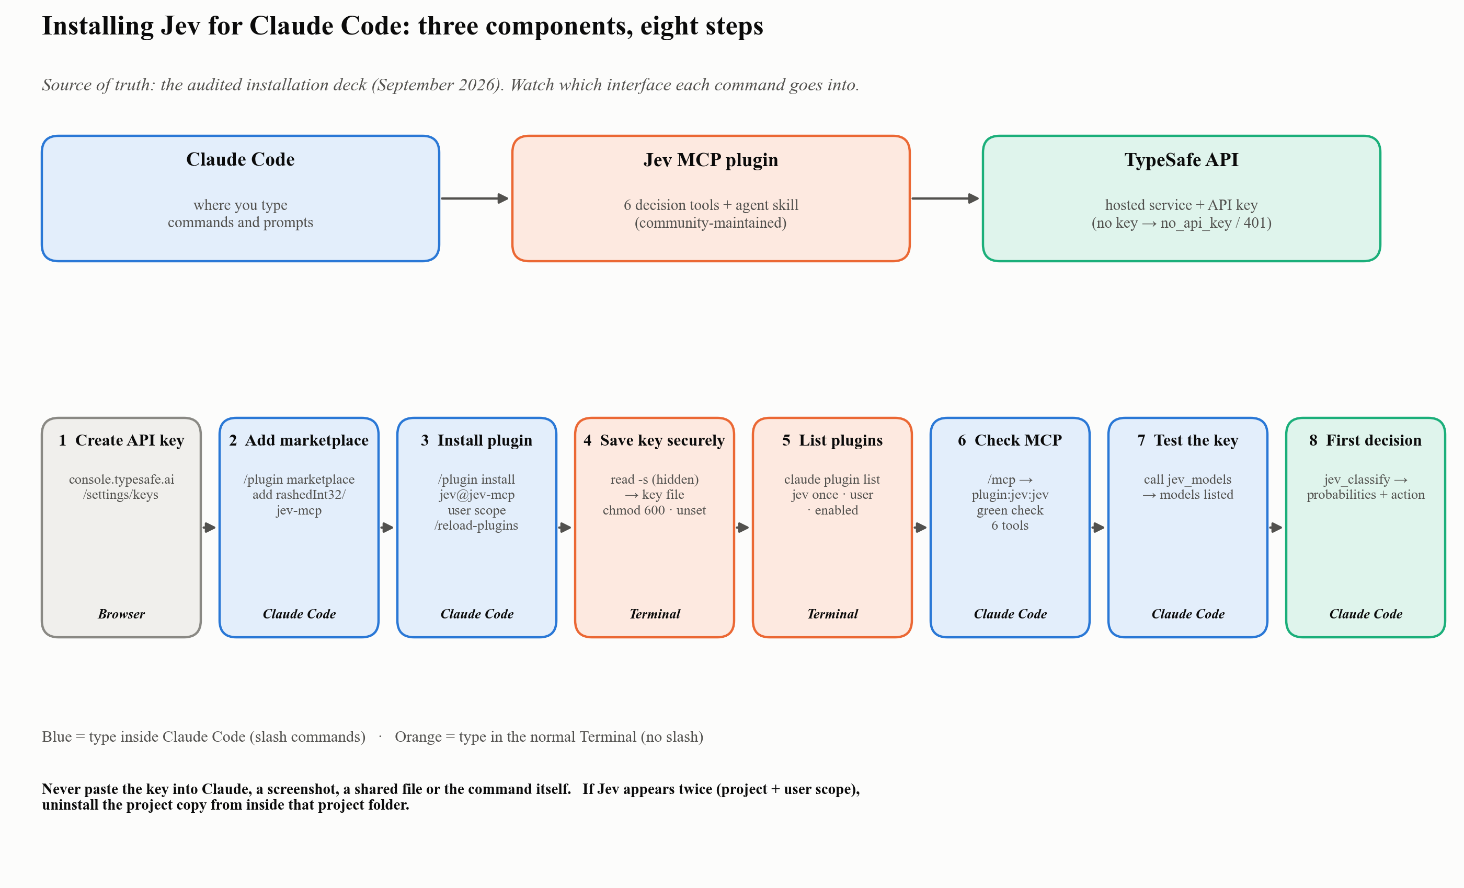
Figure 12: Installing Jev for Claude Code
Component | What it is
Claude Code | The terminal assistant where you type commands and prompts
Jev MCP plugin | Six decision tools for classification, scoring, checking and triage; the plugin also installs its agent skill
TypeSafe API | The hosted service and API key that let Jev make calibrated judgments
Commands go into two different interfaces. Slash commands (/plugin, /mcp, /reload-plugins) are typed inside Claude Code. Shell commands (claude plugin list, the key file) are typed in the normal Terminal. When a command fails, check first that it went into the right one.
# | Step | Where | Check
1 | Create a TypeSafe API key (console.typesafe.ai → Settings → Keys) | Browser | Key copied once; never pasted into chat
2 | /plugin marketplace add rashedInt32/jev-mcp | Inside Claude Code | “Successfully added marketplace: jev-mcp”
3 | /plugin install jev@jev-mcp → Install for you (user scope) → /reload-plugins | Inside Claude Code | Jev appears once, at user scope
4 | Save the key in ~/.config/typesafe/key through a hidden prompt; chmod 600 | Normal Terminal | Key never shown on screen or typed into a command
5 | claude plugin list | Normal Terminal | jev@jev-mcp once · scope user · enabled
6 | /mcp | Inside Claude Code | plugin:jev:jev · green check · 6 tools
7 | “Call the Jev jev_models tool…” | Inside Claude Code | Models listed: the key is valid
8 | A first jev_classify decision | Inside Claude Code | Probabilities, confidence, act / review / abstain
The full command-by-command version, with troubleshooting, is in Appendix A, Step 6.

3.7 Four building blocks, one system
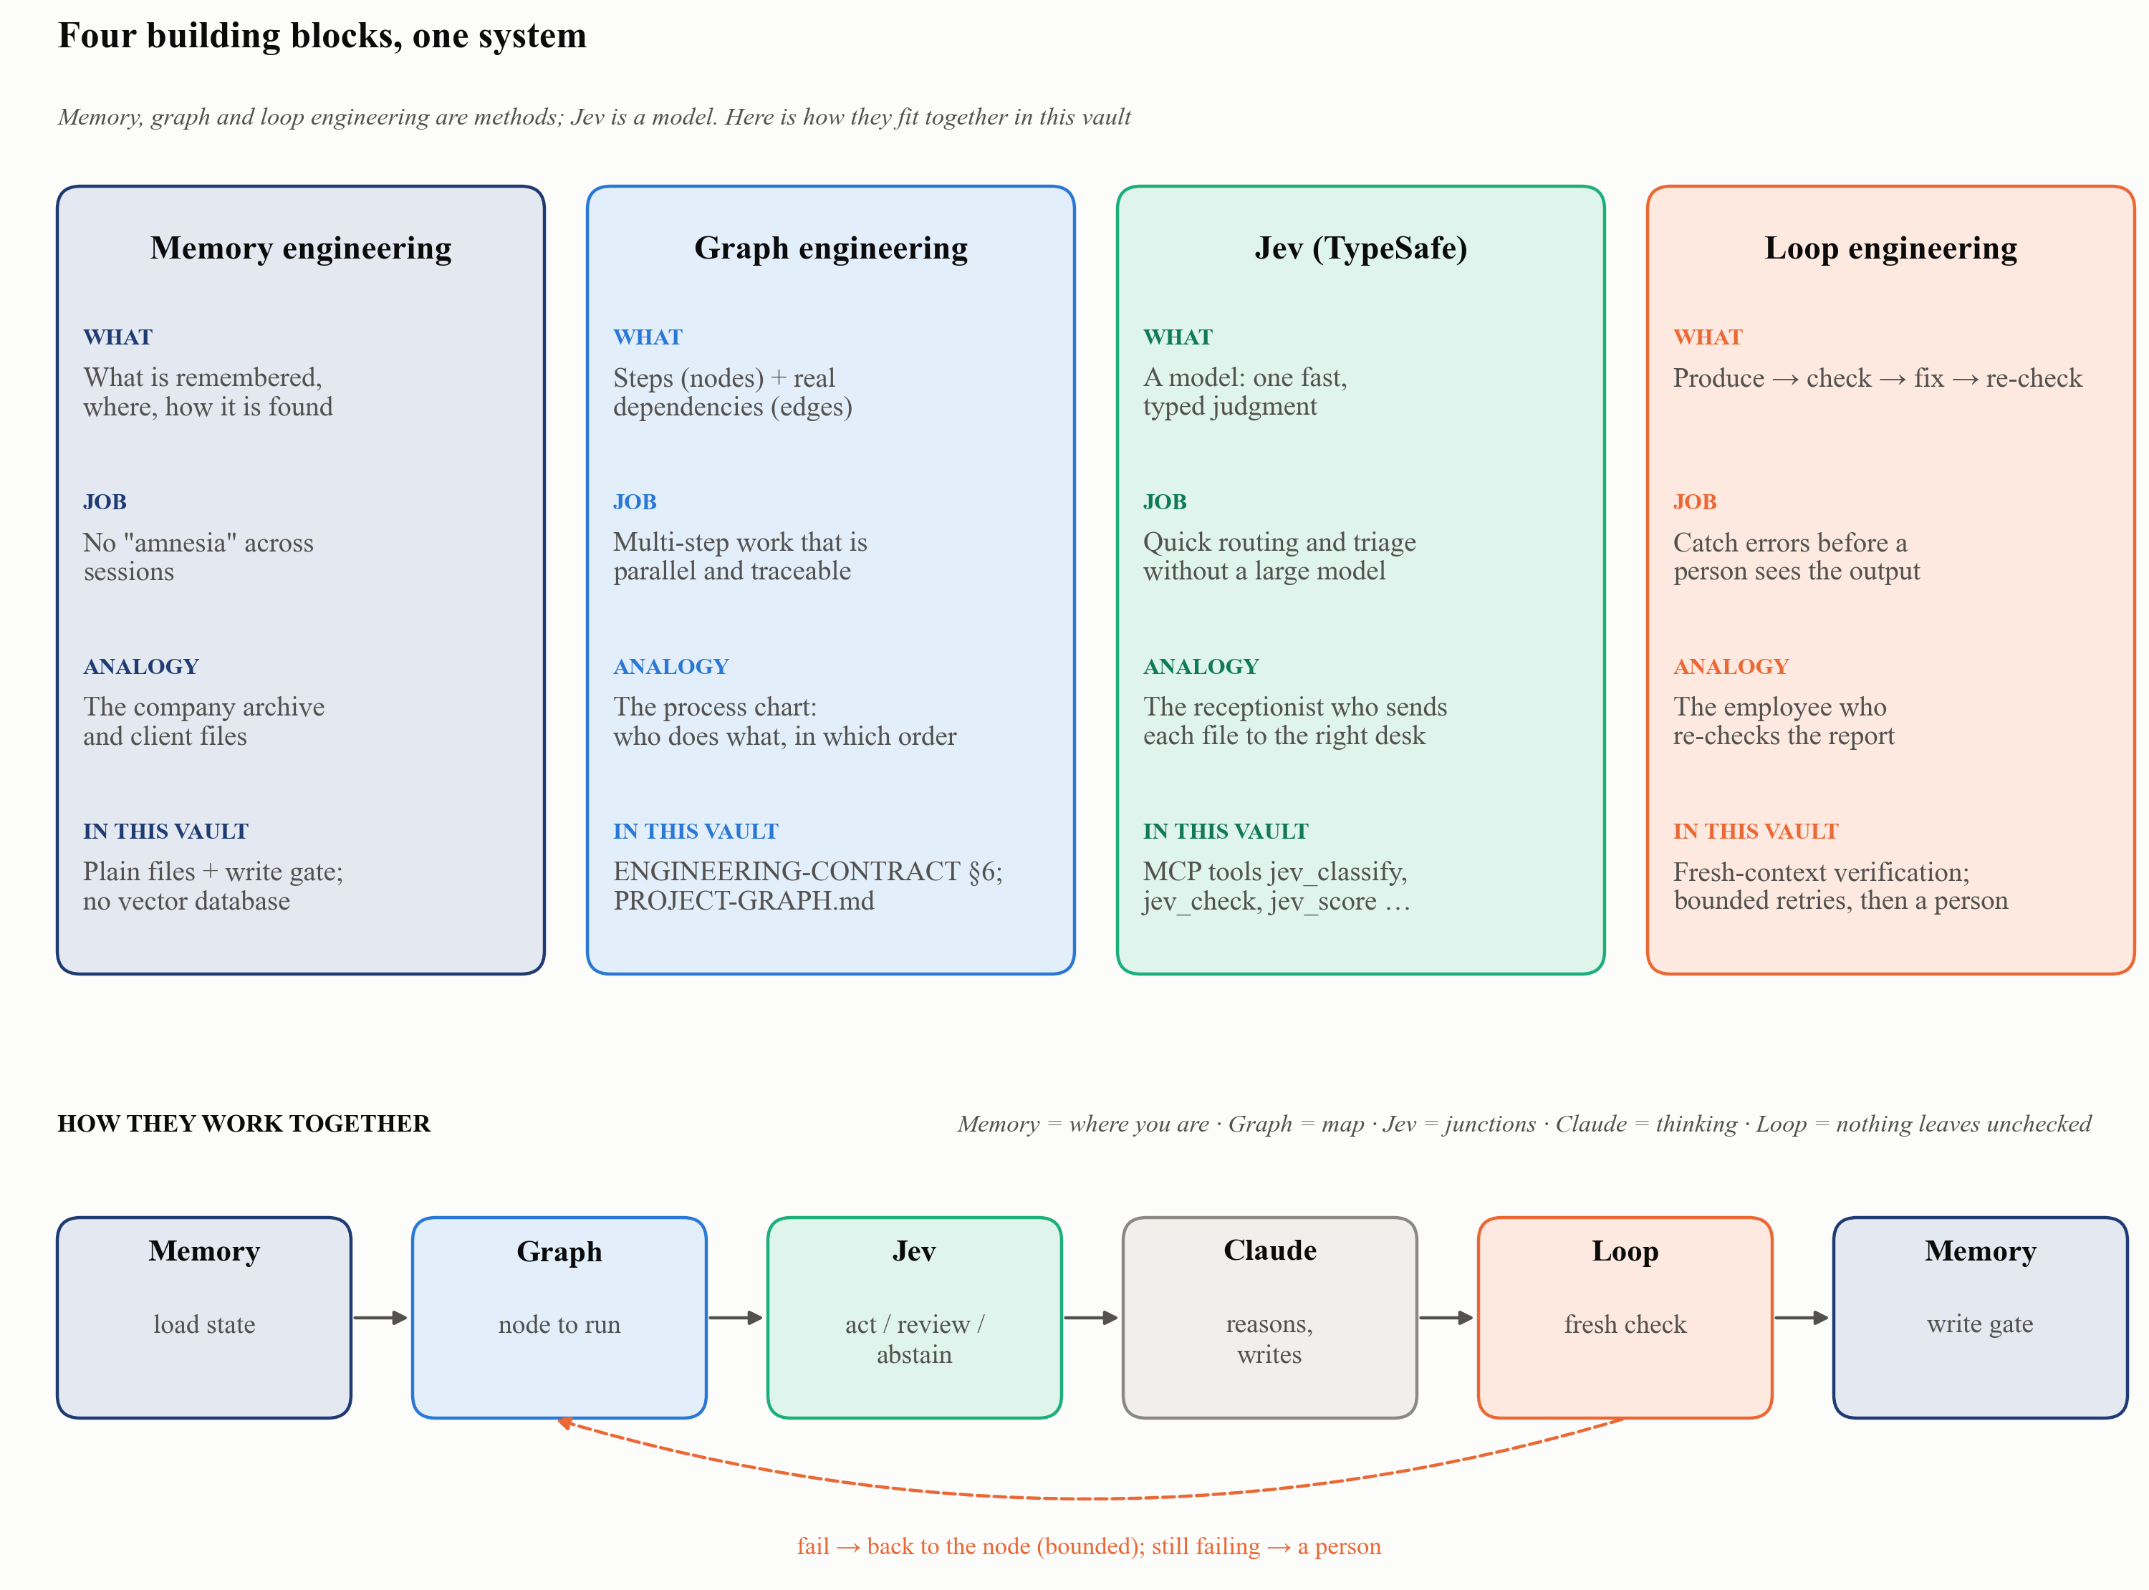
Figure 13: Memory engineering, graph engineering, Jev and loop engineering, and how they connect
A modern AI assistant is no longer “one prompt, one answer”. It plans steps, remembers, decides and checks its own work. Four ideas describe how, and they are often confused:
 | Memory engineering | Graph engineering | Jev (TypeSafe) | Loop engineering
What it is | A method: decide what is remembered, where, and how it is retrieved | A method: map the task as steps (nodes) and real dependencies (edges) | A model: a fast component that makes one typed judgment | A method: produce → check → fix → re-check
Its job | Prevent “amnesia”; keep long projects consistent across sessions | Make multi-step work manageable, parallel and traceable | Make quick routing and triage decisions without a large model | Catch and fix errors before a person sees the output
Workplace analogy | The company archive and client files | The organisation’s process chart: who does what, in which order, with which approvals | The receptionist who reads each document and instantly sends it to the right desk | The careful employee who re-checks a report before handing it in
In this vault | Plain files: PROJECT-STATE.md, DECISIONS.md, 02-Wiki/, log.md, auto memory; index-first retrieval; write gate. No vector database. | ENGINEERING-CONTRACT.md §6 (node contract, real edges, barriers); each project’s PROJECT-GRAPH.md | MCP tools jev_classify, jev_check, jev_score, jev_triage, jev_ask, jev_models | Fresh-context verification; on failure, return to the failing node, retry only when safe, then escalate to a person (ENGINEERING-CONTRACT §6); weekly lint and review (MAINTENANCE.md); QA-and-fix cycles on every deliverable
Outside this vault (examples) | Vector databases (e.g., Milvus/Zilliz), Mem0, LangChain memory, Redis | LangGraph, CrewAI, LlamaIndex Workflows | TypeSafe SDK primitives Choice, Noul, Score | ReAct-style agent loops; critic/reflection loops; custom while-loops
The “outside” column lists commonly cited external tools as examples only; none is used or evaluated in this vault.

How they work together in this vault
- Memory: remember before acting. Each session starts with the router and the project’s current state (START-HERE.md → PROJECT-STATE.md → index.md), so the work starts from what was already decided, not from zero.
- Graph: draw the map. PROJECT-GRAPH.md defines the steps and their real dependencies: scope → parallel evidence → barrier → verification → synthesis → approved write.
- Jev: route quickly at the decision points. Where the same narrow judgment repeats (which of 50 files deserve a close read? which queue does this item belong to?), Jev answers in a fraction of a second, with act / review / abstain.
- Claude: reason and write. Claude does the deep work: reading, synthesising, drafting.
- Loop: check, fix, re-check, within limits. A fresh-context verifier re-tests the claims against the sources. If a check fails, the work goes back to the failing node. Retries are allowed only when safe and recorded, and anything still unresolved goes to a person, never “loop until it looks right”.
- Memory again: write back. Only verified results pass the write gate into the wiki, the state file, the decision record and the log, ready for the next session.
In one sentence: the graph draws the map, memory remembers where you are, Jev picks the road at each junction, Claude does the thinking, and the loop makes sure nothing leaves until it has been checked.
Two warnings the analogies can hide.
- A loop is only as good as its checker. Re-reading your own work with the same assumptions misses the same mistakes, which is why the vault’s checker gets a fresh context.
- A loop needs a stopping rule. Without a retry limit and an escalation path, “fix it until it’s right” can run forever or quietly lower the standard.

4. Worked Example: Follow One Source Through the System
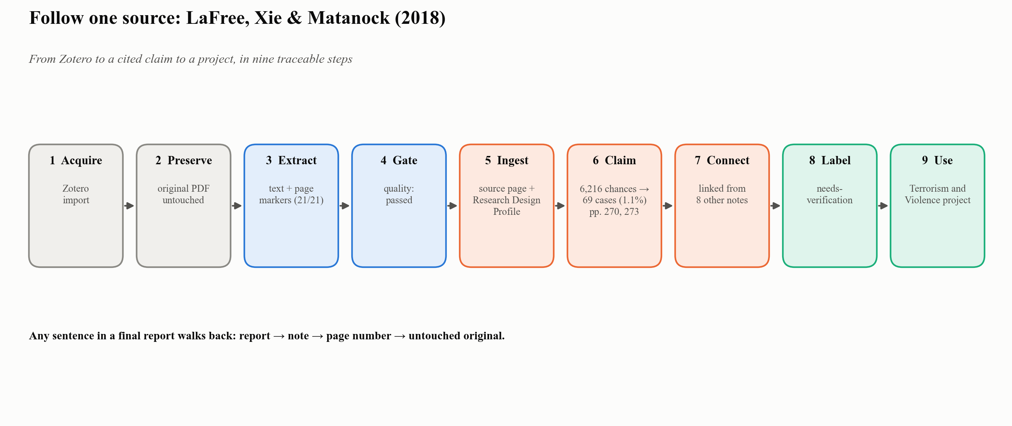
Figure 14: One source, end to end
The source: LaFree, Xie and Matanock (2018), “The Contagious Diffusion of Worldwide Terrorism: Is It Less Common Than We Might Think?”, Studies in Conflict & Terrorism.
Step | What happened | Where you can see it
1. Acquire | Pulled from the Zotero library during the 2026-09-02 collection-by-collection ingestion | 01-Library/Reports/…__zotero.md
2. Preserve | The PDF is stored unchanged | 01-Library/Originals/LaFree - 2018 - …pdf
3. Extract | Native text extracted with --- PDF PAGE n --- markers (21 of 21 pages have text) | 01-Library/Text/…__text.txt
4. Quality gate | quality_status: passed | 01-Library/Reports/…__quality.md
5. Ingest | A source page (with Research Design Profile) plus atomic claim notes | 02-Wiki/lafree-2018-contagious-diffusion-of-terrorism.md and others
6. One atomic claim | “Cross-national diffusion of terrorism is rare”: of 6,216 opportunities for contagious diffusion (1970–2013), 69 occurred (1.1%), with page citations (pp. 270, 273) | 02-Wiki/cross-national-diffusion-of-terrorism-is-rare.md
7. Connect | Linked to diffusion types, LISA spatial statistics, geographic concentration since 2003; referenced by 8 other notes | Related Notes section; Obsidian graph
8. Label honestly | status: needs-verification until a person checks the page numbers against the PDF | YAML header
9. Use in a project | The note is part of the conflict-studies cluster that served as the interpretive backbone of the Terrorism and Violence project | Project state
The point. Any sentence in a final report can be walked back to a note, to a page number, to an untouched original, in a few clicks.

5. One Core, Many Projects
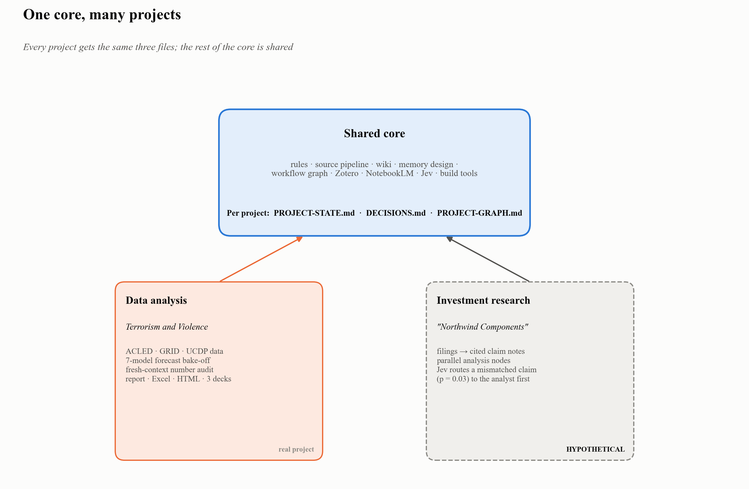
Figure 15: Same core, different projects
Every project gets the same three files. Everything else depends on the project.
File | Purpose
PROJECT-STATE.md | Objective, phase, blockers, next actions: the single current truth
DECISIONS.md | Append-only record of consequential choices, with reasons and revisit triggers
PROJECT-GRAPH.md | The workflow graph: nodes, real dependencies, completion gates
A standard ten-point prompt creates a project: create the folder → state → decisions → graph if complex → find related notes through the index → list missing information and assumptions → show the structure → write → update state after each session → record only real decisions → never restructure personal notes without permission.

Case A: Data analysis (Terrorism and Violence)
- Question: How has terrorism evolved since 9/11, and what are the risks for Europe and the US?
- What the system did: Documented data provenance (ACLED, GRID, UCDP, Europol TE-SAT) with coverage caveats. Ran descriptive analyses as parallel graph nodes. Compared seven forecasting models in one rolling-origin backtest (Theta won on this data; the tool re-runs per series). Ran a fresh-context audit of published numbers. Delivered a report, Excel workbook, interactive HTML and three audience versions of one deck.
- What the second brain added: a terrorism/conflict-studies literature cluster (94 indexed notes, ingested from Zotero) linked to the data. The forecasting tool became shared, vault-wide infrastructure.

Case B: Investment research (hypothetical, illustrative only)
This example is invented to show how the method transfers. “Northwind Components” is a fictional company. The Jev results are real tool outputs on invented inputs (run 2026-09-28).
- Setup: Filings, earnings-call transcripts and analyst notes go to 01-Library/. Claims (“segment X grew 18%”) become atomic notes with page citations. The investment memo is a project folder.
- Graph: separate parallel nodes for financials, competitors, management guidance and risks → barrier → fresh-context check of every number against the filing → memo.
- Jev as a triage step, not a verifier. Before the analyst’s check, Jev screens each draft claim against the passage it cites and routes it:
Draft claim | Jev screening result | Routing | Who decides
“Total revenue grew 18%”; the cited passage says total grew 12% and the data-center segment grew 18% | Supported by the passage? probability 0.03 → no | Flagged, sent to the front of the review queue | The analyst checks the filing and corrects the claim
“Data-center segment revenue grew 18%; industrial shrank” | Supported by the passage? probability 0.90 → yes | Lower review priority | The analyst still confirms it against the filing
“Management says the new plant will double capacity by 2027” | Source type: management guidance (confidence 1.00) | Tagged as forward-looking | Treated as unverified intent, never as fact
- Value: the analyst’s attention goes first to the claims most likely to be wrong, and forward-looking statements stay labelled. Verification itself stays with the analyst and the source document. Jev does no arithmetic here: it judges whether a passage supports a claim’s wording, and the numbers are compared by the analyst or by code.
Other fits (by design, not yet run as projects): policy monitoring with freshness dates, literature reviews, due diligence, grant proposals, internal knowledge bases.

6. Before and After
 | General AI chat | The Second Brain
Memory | Lost between chats | State, decisions, knowledge and preferences each in a defined, inspectable place
Sources | Often unnamed or invented | Original preserved; page-level citation; quality gate
Uncertainty | Hidden behind fluent prose | Explicit labels: needs-verification, evidence strength, freshness, abstain
Large tasks | One long conversation | Workflow graph with parallel nodes and independent verification
Reuse | Start over each time | Knowledge base and tools compound across projects
Audit | Not possible | Git history, log.md, DECISIONS.md, linter, automated acceptance tests

7. Honest Limits
- Verification is still human work. Some notes and sources will need a person to check them against the original. The system labels them, so that work is visible rather than hidden.
- Structure has a cost. Setup, intake and verification take longer than asking a chatbot. The payoff comes with reuse and with stakes.
- Integrations are uneven. Zotero is programmatic; NotebookLM works only through the web interface (subject to quotas); several connectors need the owner’s sign-in.
- Jev is a decision aid, not evidence. It scores the question it is given against the text it is given. A badly posed question gets a confident answer to the wrong question. Content sent to Jev leaves the machine for the TypeSafe service, so confidential, student-identifiable or regulated data must not be sent.
- Rules are guidance to the AI, not physical enforcement. They work because they are loaded every session and checked by tests and review. People still approve every consequential write.
- Benefits are design intentions. No controlled study of time saved or error reduction has been run in this vault.

8. Glossary
Term | Meaning
Atomic note | A wiki page holding one primary idea with its sources
Barrier | A point in a workflow that waits until all required parallel steps finish
Claude Code | Anthropic’s AI assistant that works directly on files and tools on your computer
Fan-out | Splitting work into independent steps that can run in parallel
Fresh-context verification | Checking results with a reviewer that sees sources and outputs but not the worker’s reasoning
Freshness class | durable / periodic / dynamic: how quickly a claim can go out of date
Jev | TypeSafe’s model for bounded, calibrated judgments, used in Claude Code through a community MCP plugin with six tools
MCP | Model Context Protocol: the standard way tools such as Jev plug into Claude
Scope (plugin) | Where a Claude Code plugin is installed: user (you, every project), project (shared through the repository) or local (you, this repository only)
Provenance | The traceable origin of a claim: source, page, processing history
Skill | A packaged, reusable procedure Claude loads when a task calls for it
Vault | The Obsidian folder that holds the whole knowledge base
Write gate | The checklist that must pass before anything is saved

Appendix A. Build Your Own: A Tell–Show–Do Setup Guide
Each step has three parts. Tell says why the step exists. Show gives the file, command or setting. Do is a check you can run to confirm the step worked. Follow the steps in order; each builds on the previous one.
Security rule for every step. Never paste an API key into a Claude conversation, a screenshot, a shared document, a Git repository or the text of a command. Enter keys at a hidden Terminal prompt (read -s) so they are never shown or recorded, and keep key files out of version control. Rotate any key that has been exposed.

Prerequisites
Tool | Purpose
Claude Code | The AI assistant that works on your files
Obsidian | Viewer and editor for the vault
Git | Version history for the whole vault
Python 3.11+ with PyYAML; poppler (pdftotext, pdfinfo), ocrmypdf, Tesseract language packs | Source pipeline
pandoc (plus a LaTeX engine for PDF) | Word and PDF deliverables
Zotero desktop (optional) | Reference library integration
Node.js 20.12 or newer | Required by the Jev plugin, which launches through npx (check with node --version)
A TypeSafe account (for Jev) | Issues the API key

Step 1: Create the vault skeleton
- Tell. A fixed folder structure means that both people and the AI always know where things belong.
- Show. Create these folders in one directory and open it in Obsidian as a vault: 00-System/, 01-Library/{Originals,OCR,Text,Reports,Processed}/, 02-Wiki/, 03-Projects/, 04-Templates/, 05-Inbox/. Add index.md and log.md, then run git init.
- Do. Obsidian opens the folder, and git status shows the new files.

Step 2: Write the rulebook
- Tell. Behaviour is set by files that anyone can read, not by hidden prompts.
- Show.
  - RESEARCH_PROTOCOL.md: no invented citations, quotations or metadata; separate source claims from interpretation; state uncertainty.
  - CLAUDE.md: workflows (ingest, query vault, save, lint wiki, weekly review), the page template with YAML frontmatter (status: needs-verification by default), file naming, change-safety rules.
- Do. Start a Claude Code session in the vault and ask: “Which file wins if CLAUDE.md and RESEARCH_PROTOCOL.md conflict?” The correct answer is RESEARCH_PROTOCOL.md.

Step 3: Add memory and graph engineering
- Tell. This step separates kinds of memory and turns large tasks into graphs with real dependencies.
- Show.
  - 00-System/START-HERE.md: task router and context budget (at most three system documents at start; wiki notes in batches of five).
  - 00-System/ENGINEERING-CONTRACT.md: memory types and write gate; provenance labels; freshness classes; index-first retrieval; workflow-graph node contract; link classification.
  - Templates for PROJECT-STATE.md and DECISIONS.md in 04-Templates/.
- Do. Add a read-only linter and an acceptance test script (this vault uses lint-vault.py and test-vault-system.py). Run them; they must pass without modifying any file.

Step 4: Install the source pipeline
- Tell. The AI should never read a scanned PDF blind. Text is extracted once, page-marked and quality-checked.
- Show. Install the pipeline dependencies, then run the pipeline on a PDF:
- python3 00-System/Scripts/inspect-pdf.py --file "05-Inbox/new-source.pdf"
python3 00-System/Scripts/process-source.py --file "01-Library/Originals/Author - Year - Title.pdf"
cat "01-Library/Reports/Author - Year - Title__quality.md"
- Do. The text file contains --- PDF PAGE n --- markers, and the report shows quality_status: passed or usable-with-review.

Step 5: Connect Zotero
- Tell. Bibliographic metadata comes from your library, not from the AI’s memory.
- Show.
  - In Zotero: Zotero → Preferences → Advanced → General (Edit → Preferences on Windows) → check “Allow other applications on this computer to communicate with Zotero.” This enables read-only local access.
  - For write-back (Research Design Profiles as Zotero notes): create a Web API key with write access at zotero.org and save it with ! to a git-ignored file (this vault uses 00-System/Config/.zotero-web-api-key).
- Do. /zotero-sources doctor reports that the API is reachable; /zotero-sources collections lists your collections.

Step 6: Add Jev (calibrated judgments)
Source of truth: the audited Jev installation deck (17 slides, September 2026). Supplementary details come from its companion guide and are marked as such.
- Tell. Some repeated decisions should come with a probability and the option to abstain. You are installing three things: Claude Code (where you type), the Jev MCP plugin (six decision tools plus an agent skill, community-maintained rather than an official TypeSafe or Anthropic product) and a TypeSafe API key (without it, calls fail with no_api_key or 401). The separate TypeSafe workflow skill is optional and is not required for Jev.
- Know the two interfaces. The normal Terminal prompt ends with % or $: shell commands, no slash. Inside Claude Code, the prompt starts with the Claude chevron: slash commands, typed one at a time, with Esc to close menus.
Show and do, step by step:
- Create a TypeSafe API key (browser). Go to https://console.typesafe.ai/settings/keys, sign in, create a key with a clear name (e.g., “Claude Code – MacBook”), and copy it once into a password manager. Use a direct TypeSafe key; keys from other AI gateways will not authenticate (companion guide).
- Add the marketplace (inside Claude Code):
- /plugin marketplace add rashedInt32/jev-mcp
- If an “Add Marketplace” box opens, enter only rashedInt32/jev-mcp; never paste the install command into that box. Check: Successfully added marketplace: jev-mcp.
- Install the plugin (inside Claude Code):
- /plugin install jev@jev-mcp
/reload-plugins
- When asked, choose Install for you (user scope). No separate skill installation is needed. Check: Jev appears once, at user scope.
- Save the key in a protected file (normal Terminal, one line at a time):
- mkdir -p ~/.config/typesafe
read -s "KEY?Paste your TypeSafe API key, then press Enter: "
printf '%s' "$KEY" > ~/.config/typesafe/key
chmod 600 ~/.config/typesafe/key
unset KEY
- Paste the real key at the hidden prompt; nothing appears on screen. Never type a placeholder such as YOUR_KEY, which produces 401. The plugin looks for TYPESAFE_API_KEY, then JEV_API_KEY, then this file; the file is the most reliable option (companion guide).
- Check the installation (normal Terminal): claude plugin list. Check: jev@jev-mcp appears once, scope user, status enabled. A separate TypeSafe skill entry is optional, and your version numbers may be newer.
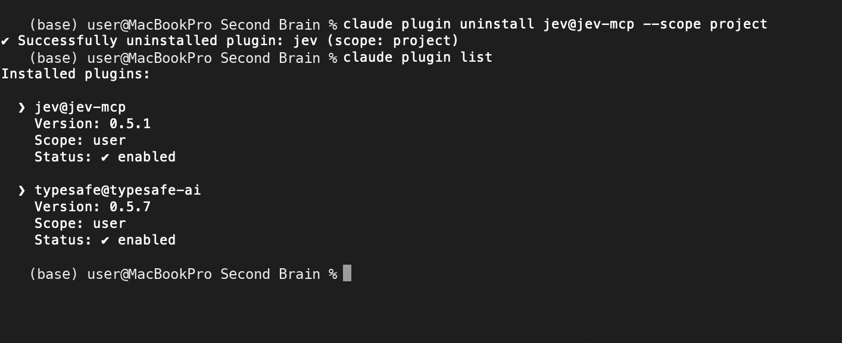
Figure 16: A clean installation: Jev once at user scope. The TypeSafe skill entry is optional. Screenshot from the audited deck
- Confirm the MCP connection (inside Claude Code): /mcp. Check: plugin:jev:jev with a green check and six tools. Press Esc to close. A green check shows the connection, not that the key works.
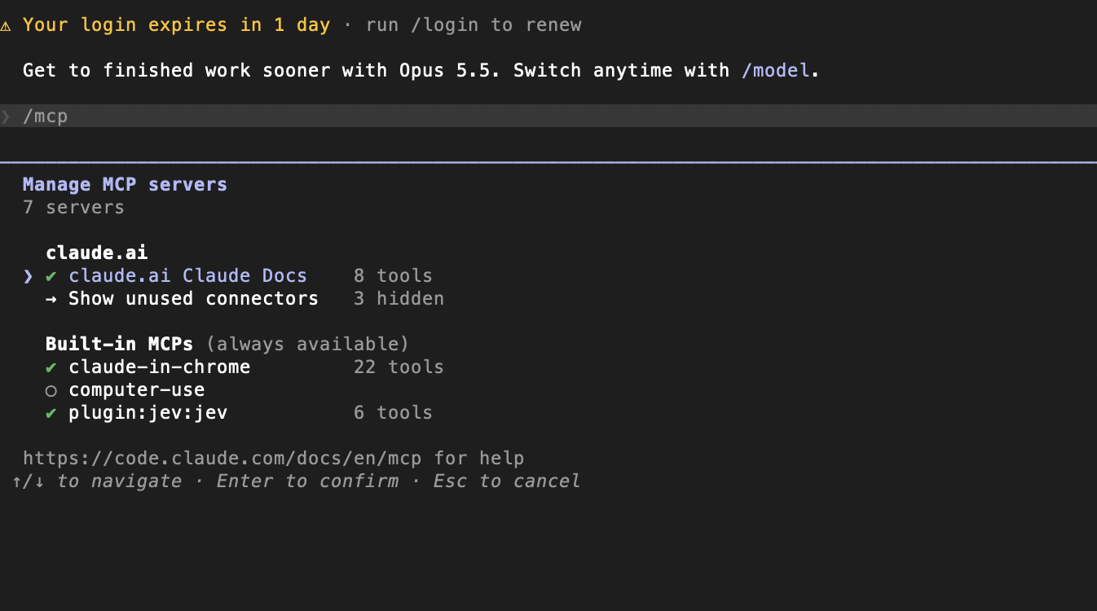
Figure 17: The Jev MCP server connected with six tools. Screenshot from the audited deck
- Test the key (inside Claude Code): “Call the Jev jev_models tool and show me the available models.” Check: models are listed (jev-latest, recommended; jev-preview, whose behaviour may change). A 401 means the saved key is missing, invalid or expired: replace it, restart Claude Code and test again.
- Run a first real decision (inside Claude Code): “Use Jev to classify: ‘My card was charged twice and I want a refund.’ Choices: billing, technical, sales, other. Show all probabilities and confidence.” Check: billing 1.00, confidence 1.00, recommended action act.
Fix a duplicate installation. If claude plugin list shows Jev twice (project scope and user scope), an older project copy can override the newer user copy inside that repository. Remove the project copy from inside that project folder; run from your home folder, the command may only find the user installation:
cd "/path/to/the/project/where-Jev-is-installed"
claude plugin uninstall jev@jev-mcp --scope project
claude plugin list
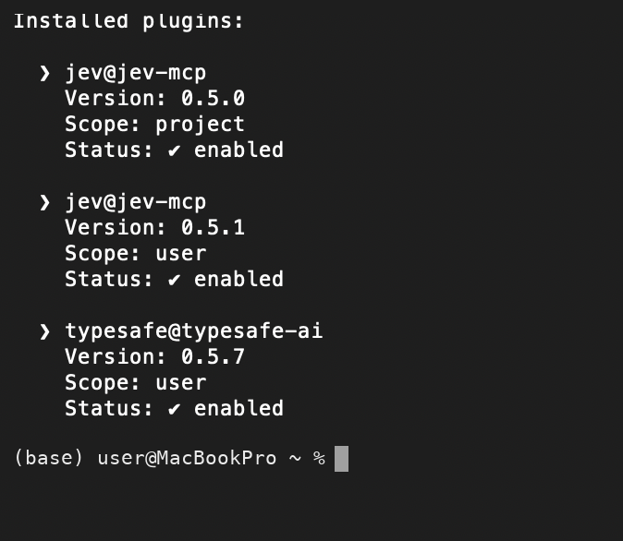
Figure 18: The duplicate-installation symptom: Jev at both project and user scope. Screenshot from the audited deck
Troubleshooting by symptom:
Symptom | Fix
no_api_key | Create ~/.config/typesafe/key, set permission 600, restart Claude Code
401 authentication | Generate a new TypeSafe key and replace the file contents
Red × in /mcp | Restart Claude Code; if it persists, run claude --debug in the normal Terminal (check Node.js ≥ 20.12; the first launch can take a few seconds while npx downloads the package)
“Marketplace source invalid” | Run /plugin marketplace add, then enter only rashedInt32/jev-mcp
Project uninstall targets user | cd into the affected project before using --scope project
Plugin update installed | /reload-plugins; restart Claude Code only if the old version stays loaded
Optional: let Claude use Jev automatically. Add this rule to the project’s CLAUDE.md:
Use Jev automatically when the task applies the same bounded judgment to many items, the allowed outputs are explicit, and confidence changes the next action. Use ordinary reasoning for one-off discussion. Do not ask Jev to perform arithmetic or date comparison. Never present Jev output as research evidence, factual verification, citation verification, or source validation.
Good uses: classifying many notes or records; ranking passages after ordinary retrieval; routing ambiguous cases for review. Do not send student-identifiable data, unpublished confidential research, or secrets, credentials and regulated data. Use synthetic, redacted or de-identified text wherever possible.
Final checklist: key created · marketplace added · plugin installed once at user scope · key saved in ~/.config/typesafe/key (mode 600) · plugin:jev:jev green with six tools · jev_models succeeds · jev_classify returns probabilities and confidence. Then describe the real task, ask Claude to use Jev, and review uncertain cases instead of automating them blindly.

Step 7: Use NotebookLM (optional)
- Tell. NotebookLM produces formats Claude does not produce itself: mind maps, infographics, audio overviews.
- Show. There is no API. Install the Claude in Chrome extension, sign in to NotebookLM in Chrome, and ask Claude to add a vault document as a source and generate the output.
- Do. Treat outputs as derived material. Regenerate them whenever the underlying facts are corrected, and expect usage quotas.

Step 8: Start your first project
- Tell. Every project gets the same state, decision and graph files, so any future session can pick up where the last one stopped.
- Show. Paste this form into Claude Code, with your own values in place of the [brackets]. Leave a field blank if you don’t know it yet.
- Create a new project in the Second Brain.
Project name: [short name, e.g. Drivers of Civil War]
Objective: [one or two sentences: the question this project answers]
Audience: [who will read the outputs, e.g. students, executives, reviewers]
Final deliverables: [e.g. Word report, infographic, diagrams, slide deck]
Available sources: [vault folders, Zotero collections or files, or "search the vault"]
Scope and limits: [what is in and out: period, regions, source types]
Success criteria: [how the result will be judged, e.g. "I will review the outputs"]
Deadline or review date: [YYYY-MM-DD]
Language: [e.g. English]
- What happens when you send it. You don’t type any instructions after the form. Claude recognises it and follows the NEW PROJECT Workflow written in 00-System/VAULT-WORKFLOWS.md. CLAUDE.md, which is loaded at the start of every session, points it there. The workflow has eleven steps:
  - It plans first and waits. It briefly shows the folders and files it intends to create, then stops. Nothing is written until you approve.
  - It creates the project folder in 03-Projects/, with a short English name.
  - It writes PROJECT-STATE.md. This is the project’s one-page memory: the objective, current state, open items, last decision and why, a “Tried and rejected — don’t retry” list, and a session log. Your form’s fields (audience, deliverables, sources, scope, success criteria, deadline, language) are copied into it.
  - It creates DECISIONS.md for genuine, consequential decisions only, each with its reason. It stays empty rather than being padded.
  - It creates PROJECT-GRAPH.md only if the work has several dependent steps. The graph maps real dependencies only, so independent steps can later run side by side and be checked before they are combined.
  - It adds the project to the Project Router in 00-System/START-HERE.md, so future sessions can find it.
  - It looks for related notes through index.md, in small batches, without loading the whole vault.
  - It lists what is missing and what it assumed. Blank or vague fields and sources it could not find appear here. A blank field never blocks the start; the assumption is written down so you can correct it.
  - It follows RESEARCH_PROTOCOL.md: no invented sources, citations or quotations. Unverified claims are marked as such.
  - It keeps the record at the end of every work session. It updates PROJECT-STATE.md and adds a session-log entry: what was done, what was decided and why, what is open, and which approaches were tried and rejected.
  - It never deletes, merges, renames or restructures your existing notes without your permission.
- When it finishes, it reports the files it created, the related notes it found, the missing information and assumptions, and a suggested first step. It also names the skill that fits your deliverables: a slide deck, a course page or an explainer video. The short command new project: [name] starts the same workflow; Claude then asks for the fields it needs.
- Do. Close the session, open a new one and ask “Where are we on this project?” A good answer comes from PROJECT-STATE.md, not from memory of the chat.

Step 9: Keep it healthy
- Tell. A knowledge base decays without maintenance.
- Show. Weekly: weekly review and lint wiki (both read-only). Monthly: re-run the acceptance tests and review freshness dates. Record preferences, not facts, in auto memory.
- Do. The lint report lists orphans, broken links and unsupported claims. You decide what to fix; nothing is merged or deleted automatically.

Appendix B. Sources and Provenance for This Guide
- System files: CLAUDE.md, RESEARCH_PROTOCOL.md, 00-System/START-HERE.md, 00-System/ENGINEERING-CONTRACT.md, 00-System/Source-Pipeline.md, 00-System/Zotero/README.md, 00-System/ACCEPTANCE-RESULTS.md.
- Activity records: log.md (including the 2026-08-13 engineering build, Steps 5–12), Git history, project state files for the two named projects.
- Jev (source of truth): Installing Jev for Claude Code, audited presentation v2 (September 2026; 17 slides), with its companion guide for supplementary details. Upstream references cited in that deck: github.com/typesafe-ai/skills, github.com/rashedInt32/jev-mcp, code.claude.com/docs/en/plugins, code.claude.com/docs/en/mcp, console.typesafe.ai/settings/keys, typesafe.ai.
- Live tool results: the Jev outputs in Sections 3.6 and 5, run on 2026-09-28 on invented inputs, plus an earlier session result.
- Explanation methods (external, general knowledge): Minto’s Pyramid Principle (answer first); Paivio’s dual coding and Mayer’s multimedia principles (one diagram per idea, labels on the diagram); Sweller’s worked-example effect (follow one source); the C4 model’s zoom levels (context before components); Tell–Show–Do instruction (this appendix).
- Verification state: claims in the guide were re-checked against vault files after drafting; three wording corrections were made (see the project’s verification log).

License and How to Cite
© 2026 Isa Haskologlu, PhD. This work is licensed under the Creative Commons Attribution 4.0 International License (CC BY 4.0): https://creativecommons.org/licenses/by/4.0/. You may share and adapt it for any purpose, provided you give appropriate credit, link to the license, and indicate if changes were made.
Suggested citation (APA 7): Haskologlu, I. (2026). The Second Brain: An AI research system you can audit [Guide and interactive hub]. https://claude.ai/artifact/EMh3hwYGRD6KdTSQFMEPVh

