Installing Jev for Claude Code
A beginner friendly setup and verification guide
macOS and Claude Code
This guide shows exactly where to type each command, how to obtain and store the TypeSafe API key, how to verify the connection, and how to fix the most common installation problems. Follow the steps in order. Do not paste your API key into a Claude conversation.
Prepared 29 September 2026

What Jev Is
Jev is a model and API for making a narrow, typed judgment over text that you supply. Instead of asking Claude for an unrestricted answer, Claude calls a Jev tool with a clearly defined question and response format. The task might be choosing one category, assigning a score, checking a claim against a supplied passage, or deciding which items need human review.
A Jev response can include the selected answer, probabilities for the available options, a confidence value, and a recommended action. The action can allow a confident result to proceed, send an uncertain result for review, or abstain when the available information does not support a reliable decision.

Conceptual view of a calibrated Jev decision with proceed, review, and abstain paths

What Jev Does Not Do
Jev does not search your files unless Claude supplies the relevant content. It does not prove that a claim is true, create research evidence, or replace subject matter judgment. It helps structure a decision and expose uncertainty so that Claude can decide whether to proceed or ask for human review.

Why Jev Matters
Jev is most useful when the same semantic judgment must be applied repeatedly or when uncertainty should change what happens next. Its main impact is greater consistency across items and a clearer way to separate confident cases from borderline ones.

Conceptual view of repeated academic materials being grouped, prioritized, and flagged for review
Work | How Jev can help | Human responsibility
Research | Rank candidate passages, classify notes, and flag uncertain matches | Read the sources and decide what counts as evidence
Dataset review | Apply the same label definitions across many rows and identify borderline cases | Define the labels, inspect errors, and approve consequential decisions
Course planning | Group materials, compare workload signals, and prioritize items for review | Set learning goals and make the final instructional choices

The practical gain is not that Jev makes every decision automatically. The gain comes from applying one explicit decision standard repeatedly while preserving a visible route to human review.

What You Are Installing
The required setup contains one Jev plugin. That plugin already bundles the Jev MCP server and its agent skill. A separate TypeSafe workflow skill may be installed for additional guidance, but it is optional and is not required for Jev to work.
Component | Purpose | Publisher
Jev MCP plugin | Installs six Jev tools plus the bundled agent skill | Independent community developer
TypeSafe workflow skill | Optional guidance for designing TypeSafe workflows | TypeSafe AI

The Simple Mental Model
Claude handles research, explanation, synthesis, and writing. Jev handles narrow semantic decisions such as choosing one label, estimating whether a statement is true, or scoring an item on a defined scale. Ordinary code handles arithmetic and deterministic rules.
Part | Best use
Claude | Reasoning, writing, planning, and interpretation
Jev | Choice, yes or no probability, scoring, ranking, and triage
Code | Counting, dates, formulas, thresholds, file operations, and side effects

Two Places Where You Will Type Commands
- Normal Terminal: the macOS Terminal application. Commands here do not begin with a slash.
- Inside Claude Code: the interactive Claude session. Built in commands here begin with a slash, such as /mcp.
The guide labels every command with the correct interface. If a command fails, first confirm that you entered it in the right place.

Before You Begin

Required Accounts and Software
1. A working Claude Code installation and an active Claude login.
2. Node.js version 20.12 or newer. The Jev MCP plugin launches through npx.
3. A TypeSafe account and a direct TypeSafe API key.
4. Internet access during installation and whenever Jev is called.
Normal Terminal
node --version
npx --version
claude --version

If Node reports a version lower than 20.12, update Node before continuing. The exact update method depends on how Node was installed on your Mac.

Choose the Installation Scope
Use user scope for a personal installation. It makes the plugins available in every local project on this computer. Project scope writes to the repository and can affect collaborators. Local scope applies only to you in the current repository.
Scope | Who receives it | Recommended here
user | You, in every project on this computer | Yes
project | Everyone using the repository settings | Only for shared team policy
local | Only you, only in the current repository | Optional

Step 1 Create a TypeSafe API Key
1. Open a browser and go to https://console.typesafe.ai/settings/keys
2. Sign in to TypeSafe AI.
3. Create a new API key.
4. Copy the full key once. Store it temporarily in a password manager or keep it on the clipboard until Step 4.
Use a direct TypeSafe key. A Claude, OpenAI, OpenRouter, or Vercel key will not authenticate against the direct TypeSafe endpoint.
Never paste the key into a Claude conversation, a screenshot, a repository file, or a shared document. The MCP server reads the key from a protected local file.

What a Successful Key Does
The key authorizes calls from the local Jev MCP process to TypeSafe. A missing key produces no_api_key. A key that TypeSafe rejects produces a 401 authentication error.

Step 2 Add the Jev Plugin Marketplace
The Jev MCP plugin is a community maintained plugin rather than an official TypeSafe or Anthropic product. Review its repository before installing it in a sensitive environment.
Inside Claude Code
/plugin marketplace add rashedInt32/jev-mcp

Run this command and wait for the marketplace dialog or success message. If Claude opens an Add Marketplace box, enter only rashedInt32/jev-mcp and press Enter. Do not paste the install command into the marketplace source field.
The expected message is Successfully added marketplace: jev-mcp.

Step 3 Install the Jev MCP Plugin
Inside Claude Code
/plugin install jev@jev-mcp

When Claude asks where to install the plugin, choose Install for you user scope and press Enter. User scope makes one installation available across your local projects.
After the installation finishes, reload plugins in the same Claude Code session.
Inside Claude Code
/reload-plugins

No separate skill installation is required. The Jev plugin already includes its MCP server and agent skill. The separate TypeSafe workflow skill is optional.

Step 4 Store the API Key Securely
Run the following commands in the normal macOS Terminal. The read command hides what you paste, so the key does not appear on screen or in the command itself.
Normal Terminal run each line in order
mkdir -p ~/.config/typesafe
read -s "KEY?Paste your TypeSafe API key, then press Enter: "
printf '%s' "$KEY" > ~/.config/typesafe/key
chmod 600 ~/.config/typesafe/key
unset KEY

1. After the read command, paste the API key and press Enter.
2. The pasted characters will remain invisible. That is expected.
3. Run the remaining three commands to save the key, restrict the file permissions, and clear the temporary variable.
Do not type placeholder text such as YOUR_KEY or ts_... into the key file. A placeholder produces a 401 authentication error.

Key Resolution Order
The plugin checks TYPESAFE_API_KEY, then JEV_API_KEY, then ~/.config/typesafe/key. The key file is usually the most reliable option because some MCP clients filter environment variables.

Step 5 Confirm the Plugin Installation
Change into the project where you plan to use Claude, then list the plugins.
Normal Terminal
cd "/path/to/your/project"
claude plugin list

A clean installation should show one Jev entry at user scope. A separate TypeSafe workflow skill entry may also appear, but it is optional.
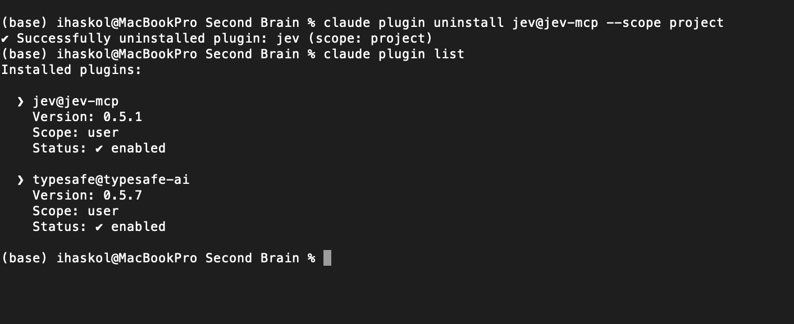
Example of a clean installation after the older project scoped copy was removed
Plugin | Expected scope | Expected status
jev@jev-mcp | user | enabled
typesafe@typesafe-ai | user | optional

Step 6 Start Claude and Verify the MCP Connection
Normal Terminal while inside your project folder
claude

Inside Claude Code
/mcp

Look for plugin:jev:jev with a green check mark and six tools. A green check means the MCP process connected to Claude. It does not by itself prove that the API key works.
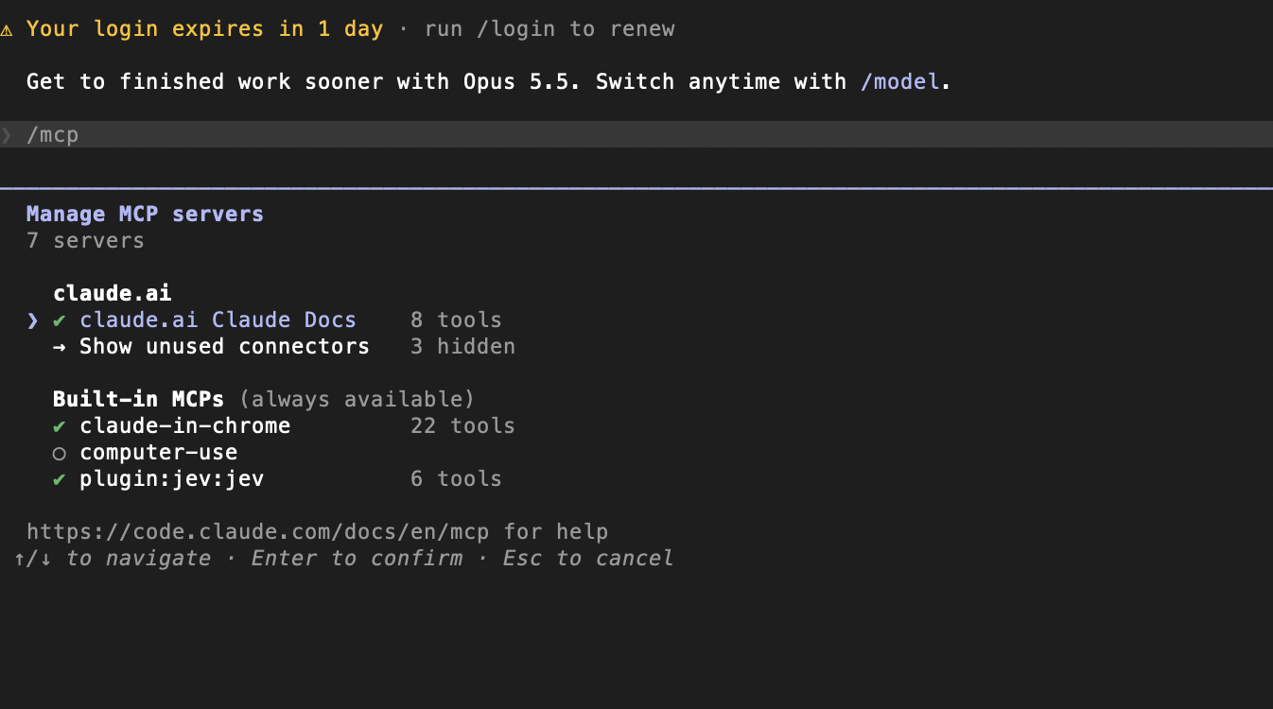
The Jev MCP server is connected and exposes six tools
If the line shows a red x, exit Claude completely and start it again. The first launch can take several seconds because npx downloads the published package. If the red x remains, see Troubleshooting.

Step 7 Verify the API Key
Close the MCP panel with Esc. Ask Claude to call the models tool rather than answering from memory.
Inside Claude Code
Call the Jev jev_models tool and show the available models. Do not answer from memory.

A successful response confirms that the plugin is connected and the TypeSafe API key is valid.
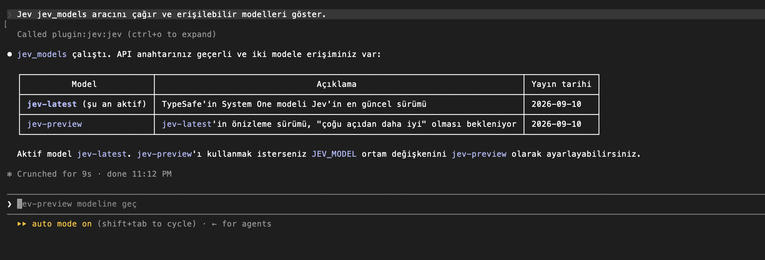
Successful jev_models call with jev-latest active
Use jev-latest for normal work. Treat jev-preview as an experimental option whose behavior may change.

Step 8 Run the First Live Decision
Use a simple classification request. Tell Claude to call Jev explicitly and request all probabilities.
Inside Claude Code
Use the Jev MCP tool to classify this message:
"My card was charged twice and I want a refund."
Options: billing, technical, sales, other.
Show every probability, the confidence value, and the recommended action.

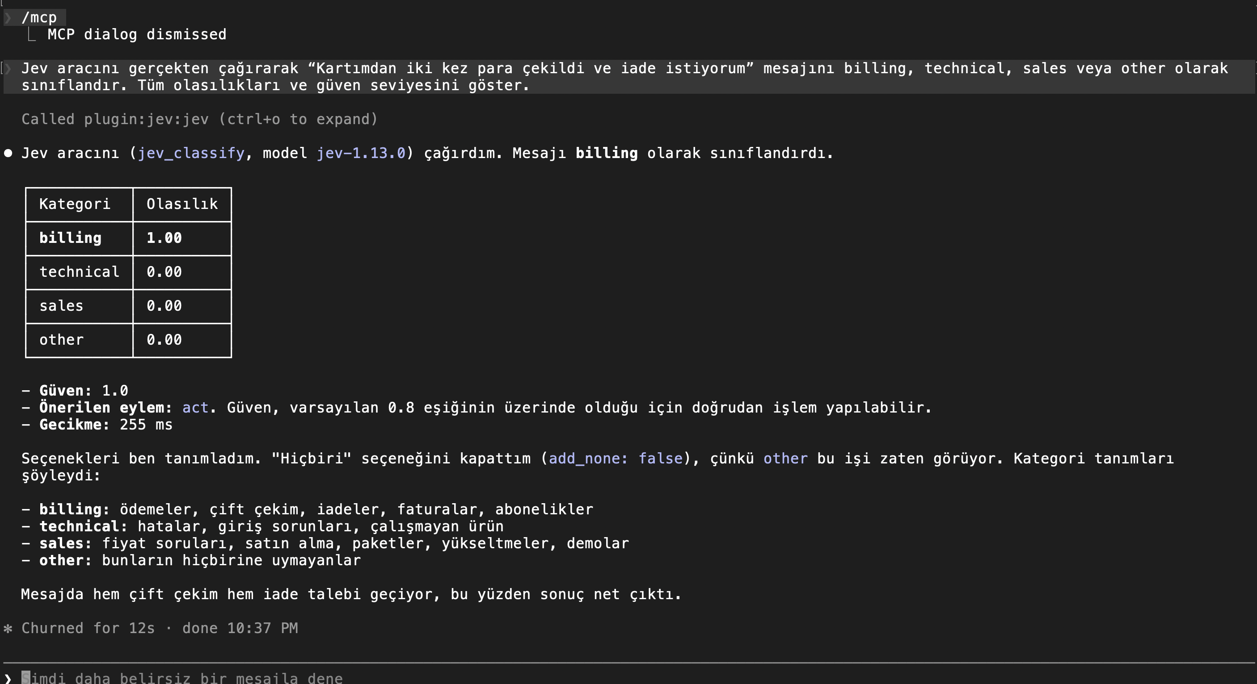
A successful live classification through jev_classify

How to Read the Result
- Probability shows how Jev distributes weight across the options.
- Confidence summarizes how decisive the result is. It does not guarantee correctness.
- act means the confidence passed the action threshold.
- review means a person or another process should check the result.
- abstain means the result is too uncertain for automatic action.

Plugin Scopes and Duplicate Versions
Claude can enable the same plugin at user, project, and local scope. Local settings override project settings, and project settings override user settings. An older project scoped copy can therefore override a newer user scoped copy inside that repository.
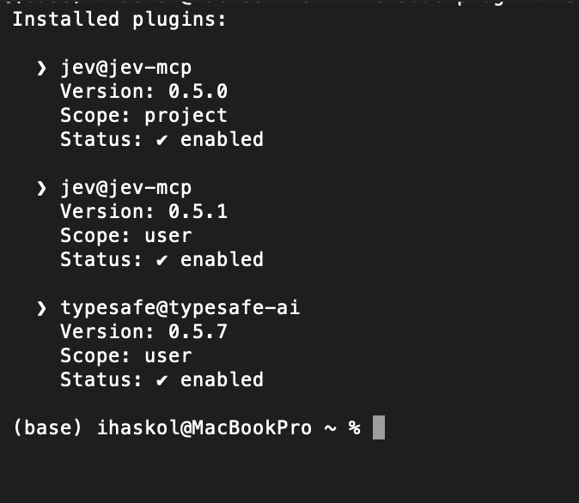
Example of duplicate Jev versions at project and user scope

Remove an Accidental Project Scoped Copy
First change into the affected project. The command will not find the project scoped entry if you run it from your home directory.
Normal Terminal
cd "/path/to/the/affected/project"
claude plugin uninstall jev@jev-mcp --scope project
claude plugin list

Project scope is shared through the repository settings. If the repository belongs to a team, use Claude's plugin panel and choose Disable for me unless you intend to remove the plugin for all collaborators.

Troubleshooting
Symptom | Meaning | Fix
no_api_key | No key reached the MCP server | Create ~/.config/typesafe/key, restart Claude, and retry
401 authentication | A key was found but TypeSafe rejected it | Create a new direct TypeSafe key and overwrite the key file
Red x in /mcp | The MCP process did not connect | Restart Claude, check Node 20.12+, then run claude --debug
Plugin appears twice | Several scopes enable the plugin | Run claude plugin list and remove the unintended scope
Marketplace source rejected | Two commands were pasted into one source field | Enter owner/repo only, then run install separately
Project uninstall not found | The command ran outside the project folder | cd into the project and repeat the uninstall

Diagnostic Commands
Normal Terminal
node --version
npx --version
claude plugin list
claude mcp list
claude --debug

Using Jev Automatically in a Project
Installing the plugin gives Claude access to Jev, but it does not guarantee that Claude will call Jev for every suitable task. A CLAUDE.md rule can guide Claude's tool choice. A scripted workflow or hook is required when the call must happen deterministically every time.

Suggested CLAUDE.md Rule
Place this text in the project CLAUDE.md file
Do not wait for me to request Jev explicitly.
Use Jev automatically when the task applies the same bounded judgment to many items,
the allowed outputs are explicit, and confidence changes the next action.
Use ordinary reasoning for one-off discussion.
Do not ask Jev to perform arithmetic or date comparison.
Never present Jev output as research evidence, factual verification,
citation verification, or source validation.
Do not send confidential research data, student information, credentials, or restricted text.
Keep raw probabilities for audit. Send low confidence results to human review.
If a Jev call fails, report the failure and do not invent probabilities.

Good Uses
- Screening many abstracts for relevance to a defined research question.
- Ranking passages returned by keyword or vector search.
- Classifying open ended survey responses with a fixed codebook.
- Checking whether course materials align with stated learning objectives.
- Triage of many files before Claude reads the most relevant subset.

Poor Uses
- Writing a literature review, lecture, examination, or research argument.
- Calculating statistics, dates, totals, or grades.
- Making a high impact decision without human review.

Privacy and Research Integrity
Content sent to a Jev tool goes to the configured TypeSafe service. Before using jev_triage with file paths, confirm which files may leave the local machine. The plugin refuses obvious credential files, but that does not replace your own data governance decisions.

Minimum Safety Rules
1. Remove student names, identifiers, and protected educational records before sending text.
2. Do not send embargoed manuscripts, restricted interview transcripts, API keys, or licensed content without permission.
3. Keep the original source and the Jev decision separate. A probability is a judgment, not evidence.
4. Calibrate thresholds on labeled examples from your own task before automating actions.
5. Require human review for grading, discipline, hiring, publication, or destructive actions.

Maintenance Commands
Normal Terminal
claude plugin update jev@jev-mcp
claude plugin list

Third party marketplaces do not necessarily auto update. Review release notes and recheck /mcp after an update.

Final Checklist
[ ] Claude Code launches successfully.
[ ] Node.js is version 20.12 or newer.
[ ] The direct TypeSafe API key is stored in ~/.config/typesafe/key.
[ ] The key file has permission mode 600.
[ ] claude plugin list shows one enabled Jev plugin at user scope.
[ ] A separate TypeSafe workflow skill is treated as optional.
[ ] /mcp shows plugin:jev:jev with a green check and six tools.
[ ] jev_models returns at least one accessible model.
[ ] A live classification returns probabilities and confidence.
[ ] The project CLAUDE.md contains appropriate privacy and review rules.

Exact Installation Sequence
Exact sequence with interface changes shown explicitly
Start Claude Code, then run these slash commands inside it:
/plugin marketplace add rashedInt32/jev-mcp
/plugin install jev@jev-mcp
/reload-plugins
Return to the normal Terminal, then run:
mkdir -p ~/.config/typesafe
read -s "KEY?Paste your TypeSafe API key, then press Enter: "
printf '%s' "$KEY" > ~/.config/typesafe/key
chmod 600 ~/.config/typesafe/key
unset KEY
claude plugin list
claude

Sources and Version Notes
This guide reflects the interfaces and plugin versions available on 29 September 2026. Commands and model aliases may change. Consult the current documentation before installing in a managed or high sensitivity environment.
Claude Code plugin installation and scope documentation
https://code.claude.com/docs/en/plugins/install
Claude Code plugin overview
https://code.claude.com/docs/en/plugins
TypeSafe official skill repository
https://github.com/typesafe-ai/skills
Jev MCP community plugin repository
https://github.com/rashedInt32/jev-mcp
TypeSafe console
https://console.typesafe.ai/settings/keys
TypeSafe website
https://typesafe.ai/

