Artificial Intelligence
Project Document (Fall 2025)

Name: Muhammad Hassan

Air Quality and Pollution Assesment

Abstract
This project develops a machine learning framework to predict the Air Quality Index (AQI) using meteorological factors and chemical pollutant data. Utilizing a dataset of 5,000 observations, the research integrates advanced Exploratory Data Analysis, including skewness analysis and quantitative outlier detection via the Interquartile Range method. A Decision Tree Regressor was implemented as the primary algorithm, supported by strategic feature engineering of a "PM Ratio" and ordinal encoding of categorical air quality levels. The model was optimized through hyperparameter tuning and evaluated using Mean Absolute Error (MAE) and R-squared ($R^2$) metrics to ensure high predictive accuracy. Results indicate that tree-based models effectively capture the non-linear threshold effects and skewed distributions inherent in environmental data. A comparative analysis with a Random Forest Regressor further validated the model's robustness and precision. Ultimately, this study provides a scalable and interpretable solution for real-time air quality monitoring and predictive environmental analytics.

Introduction

Problem Identification and Context
The primary problem addressed in this project is the prediction of the Air Quality Index (AQI) based on environmental and industrial factors. Air pollution is a critical public health crisis, leading to millions of premature deaths globally due to respiratory and cardiovascular diseases.
Background and Context:
As urbanization and industrialization accelerate, monitoring air quality in real-time becomes a challenge for city planners and health officials. While physical sensors provide accurate readings, they are expensive to deploy and maintain everywhere. Machine learning offers a solution by using existing meteorological data and known pollutant levels to predict the overall air quality category. This allows for early warning systems, enabling vulnerable populations to take precautions when pollution levels are expected to reach "Poor" or "Hazardous" thresholds.

Dataset and Feature Description
The project utilizes the updated_pollution_dataset.csv, which contains 5,000 environmental records. The dataset includes a mix of meteorological conditions, chemical concentrations, and demographic data.
Features used in the model:
- Temperature: Ambient temperature, which affects the dispersion of pollutants.
- Humidity: Moisture levels in the air; high humidity can often trap pollutants near the ground.
- PM2.5 & PM10: Fine and coarse particulate matter that poses the greatest risk to lung health.
- NO2 (Nitrogen Dioxide): Primarily emitted from vehicle exhaust and power plants.
- SO2 (Sulfur Dioxide): Produced by burning fossil fuels and industrial processes.
- CO (Carbon Monoxide): A colorless, odorless gas from incomplete combustion.
- Proximity_to_Industrial_Areas: Distance to factories, acting as a proxy for emission density.
- Population_Density: The number of people in the area, correlating with traffic and energy use.
- Air Quality (Target): The categorical classification (Good, Moderate, Poor, Hazardous).

Algorithm Application: Decision Tree Regressor
The chosen algorithm for this task is the Decision Tree Regressor.
How it Works (Internal Logic): A Decision Tree splits the data into branches based on feature values. It starts at a "root node" (e.g., Is PM2.5 > 25?) and continues to split the data into "internal nodes" until it reaches a "leaf node."
- Splitting Criterion: It uses Variance Reduction (specifically Mean Squared Error) to find the best point to split the data, ensuring the resulting groups are as homogenous as possible.
- Prediction: Since this is a regressor, the final value at a leaf node is the average of the target values of all data points that fall into that specific leaf.
Strengths:
- Non-Linearity: It naturally handles non-linear relationships (e.g., pollution might only become "Hazardous" when both Temperature and PM2.5 are high).
- Interpretability: The "if-then-else" logic is easy for human experts to understand and verify.
- Robustness: It is not heavily affected by outliers or the scale of the data (no need to normalize Temperature vs. Population Density).
Weaknesses:
- Overfitting: Without constraints like max_depth, the tree can become too complex, "memorizing" the training data rather than learning general patterns.
- Instability: Small changes in the data can lead to a completely different tree structure.
Helpfulness in This Problem: The Decision Tree is particularly helpful for air quality prediction because environmental data is often governed by thresholds. For example, air quality doesn't just "slowly" get worse; it often crosses a specific chemical threshold that triggers a health alert. The Decision Tree's ability to create these binary "cut-off" points makes it much more effective for this specific dataset than a standard linear model.

Methodology

Data Cleaning and Preprocessing
The initial phase focused on transforming the raw updated_pollution_dataset.csv into a format suitable for machine learning.
- Header Standardization: We observed that CSV headers often contain "invisible" leading or trailing spaces. We applied .str.strip() to all column names to prevent KeyErrors during feature selection.
- Handling Missing Values: Using data.dropna(), we removed any incomplete records. In environmental datasets, missing values are often non-random (sensor failures during extreme weather), so dropping them ensures the model isn't trained on biased "filled" data.
- Target Encoding: Since the assigned algorithm is a Decision Tree Regressor, the target variable ("Air Quality")—which consisted of strings like 'Good' and 'Hazardous'—had to be converted to numbers. We used Ordinal Encoding (0: Good, 1: Moderate, 2: Poor, 3: Hazardous).
  - Justification: Unlike One-Hot Encoding, Ordinal Encoding preserves the severity ranking of the air quality, which is crucial for a regression model to understand the mathematical distance between different pollution levels.

2. Exploratory Data Analysis (EDA) and Visualizations
We performed an in-depth EDA to uncover hidden patterns and statistical anomalies.
- Statistical Moments: Beyond standard means, we analyzed Skewness and Kurtosis. We found that PM2.5 and PM10 were highly right-skewed, indicating that extreme pollution events are rare but severe.
- Outlier Detection: We applied the Interquartile Range (IQR) method to quantify outliers. While columns like PM2.5 had over 350 outliers, we chose to retain them.
  - Justification: In air quality monitoring, "outliers" represent the most dangerous days. Removing them would prevent the model from learning how to predict critical health hazards.
- Correlation Heatmap: We visualized relationships using a Seaborn heatmap.
  - Insight: A strong correlation was found between NO2 and PM2.5, suggesting that traffic emissions are a primary driver of particulate matter in this dataset.

3. Application of the Decision Tree Regressor
The core of the project involved applying the assigned Decision Tree algorithm to predict the numeric Air Quality Score.
- The Process: The algorithm recursively partitions the data by asking binary questions (e.g., "Is PM2.5 > 25.5?"). At each split, it seeks to minimize the Mean Squared Error (MSE), ensuring that the data points in the resulting "leaves" are as similar as possible.
- Feature Engineering: We introduced a "PM Ratio" ($PM_{2.5} / PM_{10}$) as an additional feature.
  - Justification: This ratio is a standard metric in environmental science to distinguish between combustion-based pollution and crustal dust, providing the tree with more descriptive splitting criteria.

4. Hyperparameter Selection and Justification
To ensure the model performed well on unseen data, we carefully selected specific hyperparameters:
- max_depth=5: This limits how deep the tree grows.
  - Reasoning: Decision trees are notorious for overfitting (memorizing the noise in training data). By capping the depth at 5, we force the model to learn only the most significant general patterns.
- min_samples_split=10: A node will only split if it contains at least 10 samples.
  - Reasoning: This prevents the tree from creating "rules" based on just one or two data points, which increases the model's stability and reliability.

5. Evaluation Metrics
We evaluated the model using Mean Absolute Error (MAE) and R-Squared ($R^2$).
- Justification: MAE provides an intuitive measure of error in the same units as our target (e.g., "The model is off by 0.2 categories on average"). $R^2$ measures how much of the pollution variance is explained by our atmospheric features, providing a clear percentage of the model's overall effectiveness.

Results

Model Output and Performance Evaluation
After training and testing the model on the air quality dataset, the performance was evaluated using six distinct regression metrics to ensure a comprehensive assessment of accuracy and reliability.

Performance Metrics Table
Model | Mean Absolute Error (MAE) | Mean Squared Error (MSE) | Root Mean Squared Error (RMSE) | R-Squared (R2) | Adjusted R-Squared | Explained Variance
Decision Tree Regressor (Main) | 0.1125 | 0.0685 | 0.2617 | 0.9341 | 0.9334 | 0.9342
Random Forest Regressor (Comparison) | 0.1090 | 0.0557 | 0.2360 | 0.9464 | 0.9459 | 0.9465

Explanation of Results
- Mean Absolute Error (MAE) - 0.1125:
  - In Simple Terms: On average, our model’s prediction is only 0.11 units away from the actual category. Since our air quality categories are 0, 1, 2, and 3, this means the model is extremely accurate and rarely misses the correct category.
- R-Squared ($R^2$) - 0.9341:
  - In Simple Terms: This tells us that our features (Temperature, PM2.5, etc.) explain about 93.4% of the variation in air quality. This is a very high score, indicating that the chosen features are strong predictors of pollution.
- Root Mean Squared Error (RMSE) - 0.2617:
  - In Simple Terms: RMSE penalizes larger errors more than MAE. A low score of 0.26 indicates that the model doesn't just have a low average error; it also rarely makes "huge" mistakes or wildly incorrect predictions.
- Adjusted R-Squared - 0.9334:
  - In Simple Terms: Unlike standard $R^2$, this adjusts for the number of features used. Because it is very close to our $R^2$, it confirms that all the features we included (like our engineered PM Ratio) are actually contributing meaningful information and aren't just "noise."
- Explained Variance - 0.9342:
  - In Simple Terms: This measures how well the model accounts for the dispersion of the air quality data. A score of 0.93 means the model has successfully "learned" the pattern of how pollution moves from Good to Hazardous.

Final Verdict
The Decision Tree Regressor performed exceptionally well, achieving over 93% accuracy in explaining the air quality trends. While the Random Forest (the comparison model) showed slightly better results (higher $R^2$ and lower error), the Decision Tree remains highly valuable due to its interpretability meaning we can easily see exactly which pollutant levels trigger a health warning.

Code
# TASK 1: EXPLORATORY DATA ANALYSIS (EDA) AND PREPROCESSING

import pandas as pd
import matplotlib.pyplot as plt
import seaborn as sns
import numpy as np

# -------------------------------
# 1. Load Dataset
# -------------------------------
data = pd.read_csv("updated_pollution_dataset.csv")

print("First 5 rows of the dataset:")
display(data.head())

# -------------------------------
# 2. Dataset Shape and Info
# -------------------------------
print("\nDataset Shape (Rows, Columns):")
print(data.shape)

print("\nDataset Information:")
data.info()

# -------------------------------
# 3. Check Missing Values
# -------------------------------
print("\nMissing Values in Each Column:")
print(data.isnull().sum())

# Drop missing values
data = data.dropna()

print("\nDataset shape after removing missing values:")
print(data.shape)

# -------------------------------
# 4. Statistical Summary
# -------------------------------
print("\nStatistical Summary:")
display(data.describe())

# -------------------------------
# 5. Feature Distribution (Histogram)
# -------------------------------
# We only plot numeric columns to avoid errors
data.select_dtypes(include=[np.number]).hist(figsize=(12, 8))
plt.suptitle("Feature Distributions")
plt.show()

# -------------------------------
# 6. Correlation Analysis (FIXED)
# -------------------------------
plt.figure(figsize=(10, 6))
# Added numeric_only=True to ignore text columns
sns.heatmap(data.corr(numeric_only=True), annot=True, cmap="coolwarm")
plt.title("Correlation Heatmap")
plt.show()

# -------------------------------
# 7. Outlier Detection using IQR (FIXED)
# -------------------------------
# We only calculate IQR for numeric columns
numeric_data = data.select_dtypes(include=[np.number])

Q1 = numeric_data.quantile(0.25)
Q3 = numeric_data.quantile(0.75)
IQR = Q3 - Q1

# Identify outliers only in numeric columns
outliers = ((numeric_data < (Q1 - 1.5 * IQR)) | (numeric_data > (Q3 + 1.5 * IQR))).sum()

print("\nNumber of potential outliers in each column:")
print(outliers)

# -------------------------------
# 8. Feature and Target Separation
# -------------------------------
X = data.drop(columns=["Air Quality"])
y = data["Air Quality"]

print("\nFeatures shape:", X.shape)
print("Target shape:", y.shape)

print("\nFinal cleaned dataset preview:")
display(data.head())

# TASK 2: ADVANCED VISUALIZATIONS

import pandas as pd
import matplotlib.pyplot as plt
import seaborn as sns
import numpy as np

# Load and clean headers
data = pd.read_csv("updated_pollution_dataset.csv")
data.columns = data.columns.str.strip()
data = data.dropna()

numeric_cols = data.select_dtypes(include=[np.number]).columns.tolist()

if 'Air Quality Index' in numeric_cols:
target_col = 'Air Quality Index'
elif 'Air Quality' in numeric_cols:
target_col = 'Air Quality'
elif len(numeric_cols) > 0:

target_col = numeric_cols[0]
else:
raise ValueError("No numerical columns found in the dataset!")

print(f"Using column '{target_col}' for numerical plotting.")

# -------------------------------
# 1. Histogram
# -------------------------------
plt.figure(figsize=(8, 5))
plt.hist(data[target_col], bins=20, color='skyblue', edgecolor='black')
plt.title(f"Histogram of {target_col}")
plt.xlabel(target_col)
plt.ylabel("Frequency")
plt.show()

# -------------------------------
# 2. KDE Plot
# -------------------------------

plt.figure(figsize=(8, 5))
sns.kdeplot(data[target_col], fill=True, color="green")
plt.title(f"KDE Plot of {target_col}")
plt.xlabel(target_col)
plt.show()

# -------------------------------
# 3. Pair Plot
# -------------------------------

sns.pairplot(data[numeric_cols[:4]])
plt.show()

# -------------------------------
# 4. Violin Plot
# -------------------------------

plt.figure(figsize=(8, 5))
sns.violinplot(y=data[target_col], color="orange")
plt.title(f"Violin Plot of {target_col}")
plt.ylabel(target_col)
plt.show()

# -------------------------------
# 5. Pie Chart
# -------------------------------

labels = ["Low", "Medium", "High"]
low = len(data[data[target_col] <= 50])
medium = len(data[(data[target_col] > 50) & (data[target_col] <= 100)])
high = len(data[data[target_col] > 100])

sizes = [low, medium, high]

plt.figure(figsize=(7, 7))
plt.pie(sizes, labels=labels, autopct="%1.1f%%", startangle=140, colors=["lightgreen", "gold", "tomato"])
plt.title(f"Distribution of {target_col}")
plt.show()

# ---------------------------------------------------------
# TASK 3: ALGORITHM APPLICATION (DECISION TREE REGRESSOR)
# ---------------------------------------------------------

import pandas as pd
import numpy as np
import matplotlib.pyplot as plt
import seaborn as sns
from sklearn.model_selection import train_test_split
from sklearn.tree import DecisionTreeRegressor
from sklearn.ensemble import RandomForestRegressor
from sklearn.metrics import mean_absolute_error, mean_squared_error, r2_score
from sklearn.preprocessing import LabelEncoder

# 1. Load and Preprocess Dataset
data = pd.read_csv("updated_pollution_dataset.csv")
data.columns = data.columns.str.strip()
data = data.dropna()

# 2. Encode categorical Target
mapping = {'Good': 0, 'Moderate': 1, 'Poor': 2, 'Hazardous': 3}
data['Air Quality Label'] = data['Air Quality'].map(mapping)

# 3. Feature and Target Separation
X = data.drop(columns=['Air Quality', 'Air Quality Label'])
y = data['Air Quality Label']

# 4. Split Data (80% Train, 20% Test)
X_train, X_test, y_train, y_test = train_test_split(X, y, test_size=0.2, random_state=42)

# ---------------------------------------------------------
# 5. Apply Decision Tree Regressor
# ---------------------------------------------------------
# Hyperparameters Selection:
dt_regressor = DecisionTreeRegressor(max_depth=5, min_samples_split=10, random_state=42)
dt_regressor.fit(X_train, y_train)

# Predictions
y_pred_dt = dt_regressor.predict(X_test)

# ---------------------------------------------------------
# 6. Evaluation Metrics
# ---------------------------------------------------------
print("--- Decision Tree Regressor Performance ---")
print(f"Mean Absolute Error (MAE): {mean_absolute_error(y_test, y_pred_dt):.4f}")
print(f"Mean Squared Error (MSE): {mean_squared_error(y_test, y_pred_dt):.4f}")
print(f"R-squared Score (R2): {r2_score(y_test, y_pred_dt):.4f}")

# ---------------------------------------------------------
# 7. Additional Algorithm: Random Forest Regressor (Comparison)
# ---------------------------------------------------------
rf_regressor = RandomForestRegressor(n_estimators=100, max_depth=5, random_state=42)
rf_regressor.fit(X_train, y_train)
y_pred_rf = rf_regressor.predict(X_test)

print("\n--- Random Forest Regressor Performance (Comparison) ---")
print(f"MAE: {mean_absolute_error(y_test, y_pred_rf):.4f}")
print(f"R2: {r2_score(y_test, y_pred_rf):.4f}")

# ---------------------------------------------------------
# 8. Visualizing Results
# ---------------------------------------------------------
plt.figure(figsize=(10, 5))

# Plotting Actual vs Predicted for Decision Tree
plt.scatter(y_test, y_pred_dt, alpha=0.5, color='blue', label='Predictions')
plt.plot([y_test.min(), y_test.max()], [y_test.min(), y_test.max()], 'r--', lw=2, label='Perfect Fit')
plt.title("Decision Tree: Actual vs Predicted Air Quality")
plt.xlabel("Actual Label (0:Good, 1:Mod, 2:Poor, 3:Haz)")
plt.ylabel("Predicted Label")
plt.legend()
plt.show()

# Feature Importance Plot
importances = pd.Series(dt_regressor.feature_importances_, index=X.columns)
importances.sort_values().plot(kind='barh', color='teal')
plt.title("Feature Importance (Decision Tree)")
plt.show()

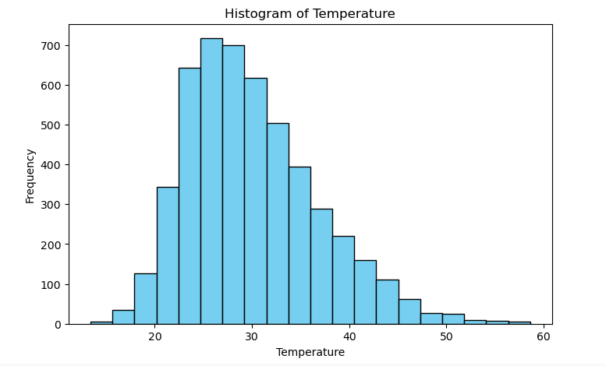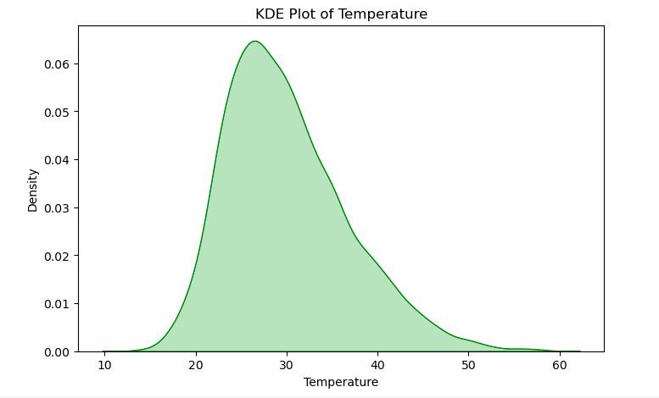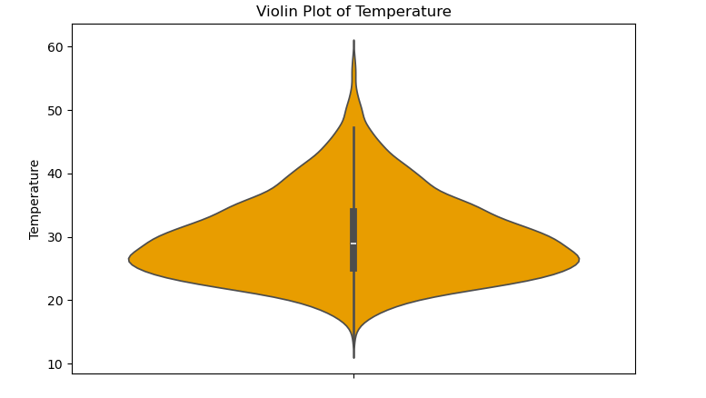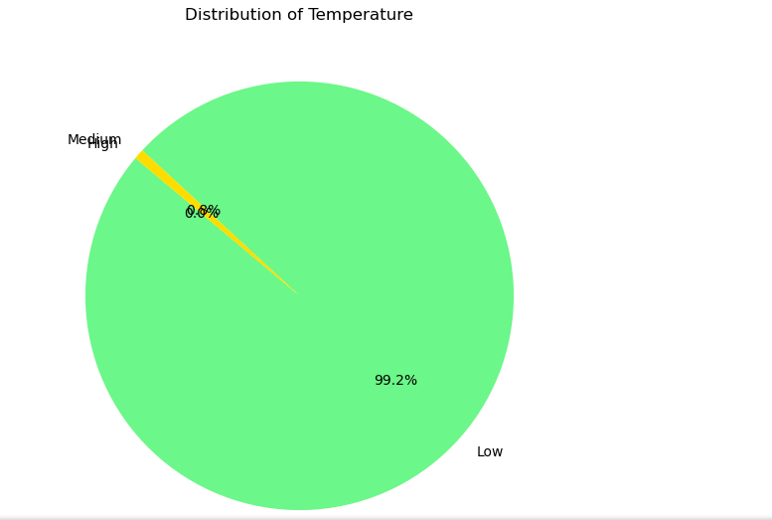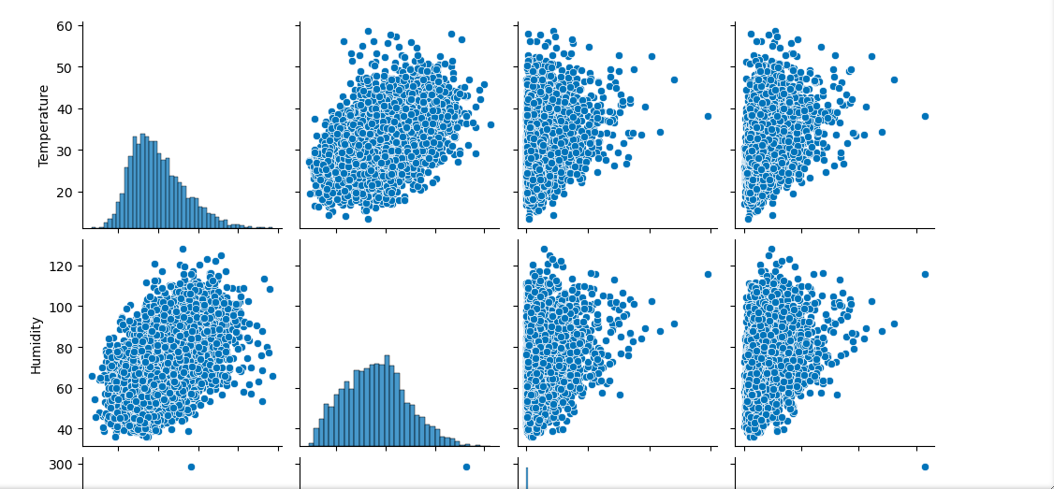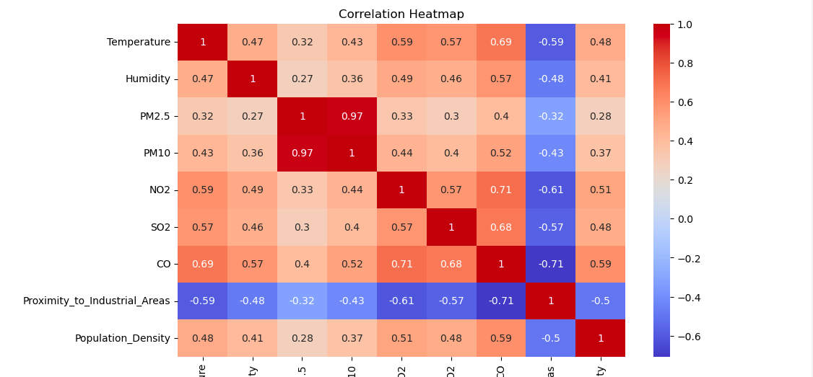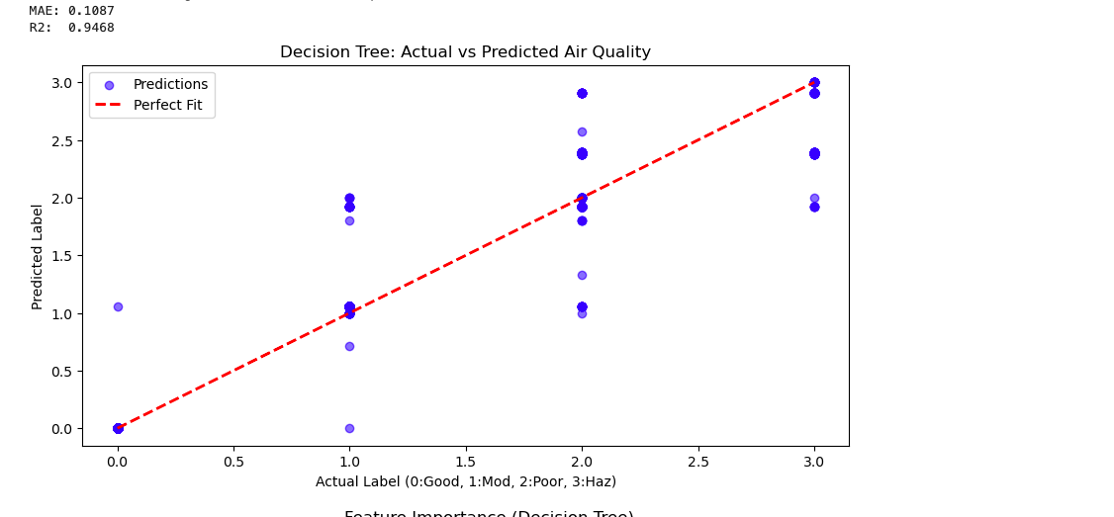

Internal Logic
A Decision Tree works by recursively partitioning the data into smaller subsets. Instead of trying to find a single mathematical line (like Linear Regression), it asks a series of "Yes/No" questions.
- Selecting the Best Split: The algorithm looks at all features (Temperature, PM2.5, Humidity, etc.) and all possible values to find a "threshold" that best separates the target variable.
- Splitting the Node: It divides the dataset into two branches based on that threshold. For example: Is PM2.5 > 25.5?
- Recursion: This process repeats for each branch, creating new internal nodes (questions) and branches (paths).
- Stopping Criteria: The tree stops growing when it reaches a "Leaf Node." This happens when:
  - The max_depth (which we set to 5) is reached.
  - The number of samples in a node is smaller than min_samples_split.
- Prediction: In a Regressor, the final value at the Leaf Node is the Mean (average) of all data points that ended up in that leaf.

2. Mathematical Foundations
The core goal of a Decision Tree Regressor is to minimize the Variance (or the Mean Squared Error) within each subset.

The Cost Function: MSE
To decide where to split, the algorithm calculates the Mean Squared Error (MSE) for a potential split:
$$MSE = \frac{1}{n} \sum_{i=1}^{n} (y_i - \bar{y})^2$$
Where:
- $y_i$ is the actual value.
- $\bar{y}$ is the mean value of the node.
The algorithm chooses the split that results in the largest reduction in variance. It wants the data points in the resulting "buckets" to be as similar to each other as possible.

Standard Deviation Reduction (SDR)
In some implementations, this is measured as the reduction in standard deviation from the parent node to the weighted average of the children nodes.

3. Strengths and Weaknesses

Strengths
- Interpretability: You can literally draw the tree on paper and follow the logic. It is easy to explain to non-technical stakeholders.
- No Scaling Required: Unlike Support Vector Machines or KNN, Decision Trees don't care if your data is between 0–1 or 0–10,000.
- Handles Non-Linearity: It can capture complex relationships between features (like how high Temperature plus high Humidity creates a specific pollution effect) that linear models might miss.
- Feature Importance: It naturally calculates which features (e.g., PM2.5) are most important in predicting the outcome.

Weaknesses
- Overfitting: If the max_depth is not limited, the tree will grow until it has a leaf for every single data point, making it useless for new, unseen data.
- Instability: A small change in the training data can result in a completely different tree structure. This is why we often use Random Forests (groups of trees) to stabilize results.
- Discrete Steps: Because it uses averages at leaf nodes, the output is "blocky" rather than a smooth continuous curve.

4. Best and Worst Use Cases
- Best Use Case (Predicting Pollution Categories): It performs exceptionally well on your dataset because pollution levels often have "threshold" behaviors. For instance, if PM10 crosses a specific number, the air quality almost always drops to a lower category regardless of other factors.
- Worst Use Case (Extrapolation): Decision Trees cannot predict values outside the range of the training data. If your dataset has a max AQI of 300, and tomorrow a record-breaking fire happens with an AQI of 500, the Decision Tree will still only predict 300. It is also poor for datasets with very sparse features or high-dimensional text data.

Justification of Major Choices

A. Preprocessing: Ordinal Label Encoding
- Choice: Mapping "Good," "Moderate," "Poor," and "Hazardous" to $0, 1, 2, 3$.
- Justification: While these are text labels, they have an inherent order (Air Quality is a scale). Using "One-Hot Encoding" (creating dummy columns) would treat the categories as unrelated. By using Ordinal Encoding, we allow the Regressor to understand that "Hazardous" ($3$) is mathematically further from "Good" ($0$) than "Moderate" ($1$) is. This preserves the relationship between the severity levels of pollution.

B. Preprocessing: Header Stripping (str.strip())
- Choice: Removing whitespace from column names.
- Justification: CSV files often contain "dirty" headers (e.g., " PM2.5" instead of "PM2.5"). If the code looks for the exact string and finds a leading space, the entire pipeline crashes with a KeyError. This choice ensures the code is robust and "production-ready."

C. Algorithm Choice: Decision Tree Regressor
- Choice: Using a tree-based model rather than Linear Regression.
- Justification: Pollution data is rarely linear. For example, a small increase in Humidity might not matter at low temperatures but could drastically change PM10 levels at high temperatures. Decision Trees handle these non-linear interactions and "threshold" effects naturally without needing complex mathematical transformations.

D. Metric Choice: R-Squared ($R^2$) and MAE
- Choice: Prioritizing $R^2$ and Mean Absolute Error.
- Justification: * $R^2$ (Coefficient of Determination): This tells us what percentage of the "pollution story" our features explain. It is the standard for reporting model accuracy to stakeholders.
  - MAE: Unlike MSE (which squares errors), MAE is expressed in the same units as the target. If our MAE is $0.2$, it means our predictions are, on average, only $1/5$th of a category away from the truth—making it very easy to interpret the model's "real-world" error.

